Table 1. Immunohistochemical staining of parathyroid tumors. This table presents data on the immunohistochemical staining results for parathyroid tumors, including the percentage of reacted cells and reaction characteristics for markers AMA, CaSR, and VDR. It also includes microscopic images and descriptions of the reactions observed in different tumor types, along with magnification details.
Name | % of reacted cells, reaction characteristics
АМА | 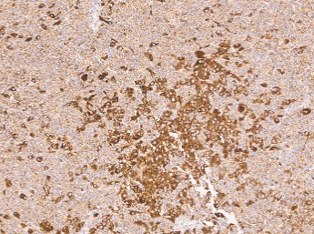  Parathyroid adenoma, focal pronounced reaction in oncocytic cells, magnification x400 | 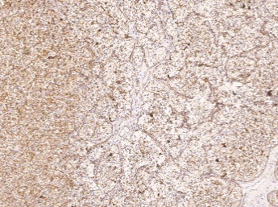  Parathyroid adenoma, diffuse moderate-weak reaction, magnification x400 |   Parathyroid adenoma, no reaction, x400 magnification
CaSR | 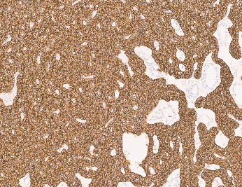  Parathyroid adenoma, diffuse severe reaction, magnification x400 | 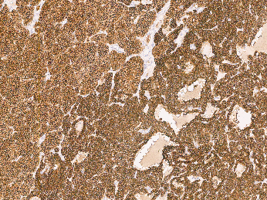  Adenoma of the parathyroid gland, CaSR in different cell groups, magnification x400 | 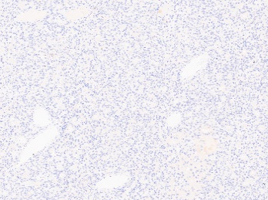  Parathyroid adenoma, no reaction, x400 magnification
VDR | 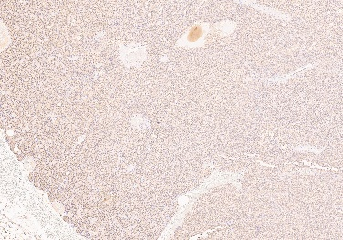  Parathyroid adenoma, diffuse moderate reaction, magnification x400 | 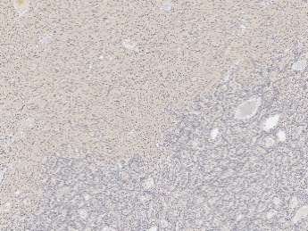  Parathyroid adenoma, VDR in different cell groups, magnification x400 | 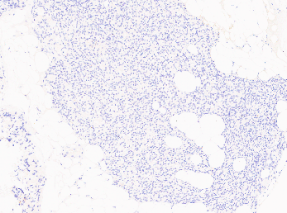  Parathyroid adenoma, no reaction, x400 magnification

