Supplementary Information for
Mining Natural Microbial Diversity for Tool-Compatible Chassis Discovery
Min Jae Kim^{1†}, Minsun Kim ^{2†}, Jun Hyeok Choi³, Myung Hyun Noh²,
Hyun Gyu Lim^{3,}*, Gyoo Yeol Jung^{1,2}*
¹Department of Chemical Engineering, Pohang University of Science and Technology, 77 Cheongam-Ro, Nam-Gu, Pohang, Gyeongbuk 37673, Republic of Korea
²Center for Bio-based Chemistry, Korea Research Institute of Chemical Technology (KRICT), 406-30 Jongga-Ro, Jung-Gu, Ulsan, 44429, Republic of Korea
³Department of Biological Sciences and Bioengineering, Inha University, 100 Inha-Ro, Michuhol-Gu, Incheon 22212, Republic of Korea
†These authors contributed equally to this work
*Corresponding authors: Hyun Gyu Lim and Gyoo Yeol Jung
Department of Chemical Engineering, Pohang University of Science and Technology, 77 Cheongam-Ro, Nam-Gu, Pohang, Gyeongbuk 37673, Republic of Korea
Tel.: +82 54-279-2391, Fax: +82 54-279-5528
E-mail: hyungyu.lim@inha.ac.kr (H.G.L.) gyjung@postech.ac.kr (G.Y.J)

Supplementary Figures

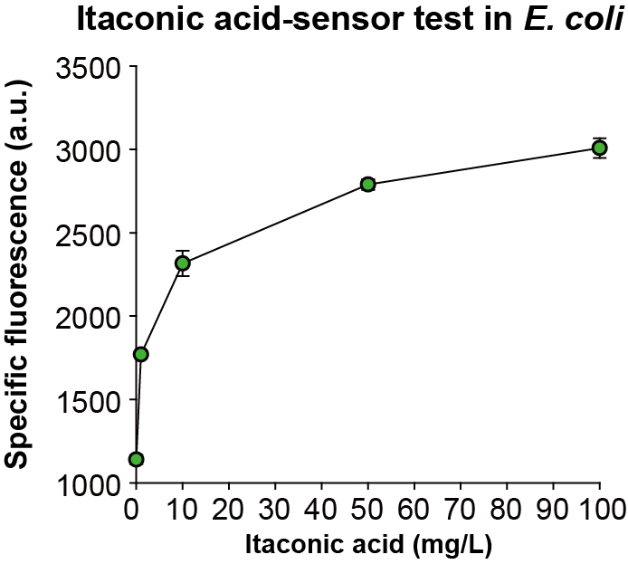

Supplementary Figure 1. Validation of the itaconic acid-responsive biosensor in Escherichia coli
Specific fluorescence of W-SENS strain with itaconic acid supplementation (0, 1, 10, 50, 100 mg/L) in MSM medium with 4 g/L of glucose.

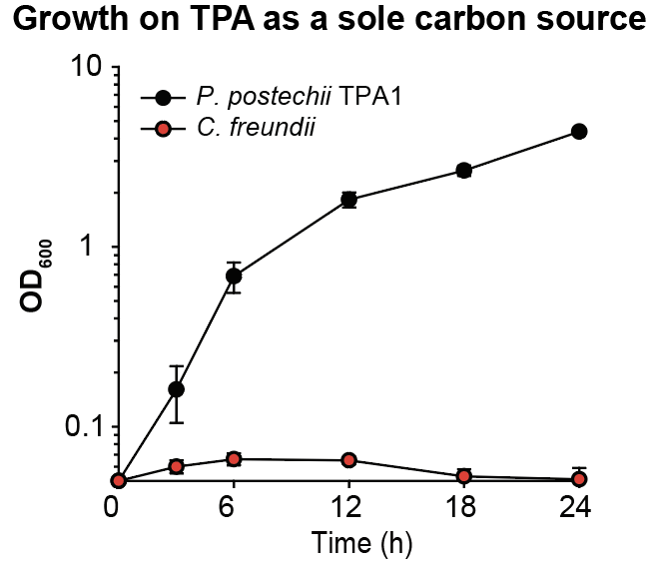

Supplementary Figure 2. Growth comparison of Pseudomonas postechii TPA1 and isolated Citrobacter freundii on TPA as a sole carbon source
Growth profiles of TPA1 (black) and C. freundii (red) in a minimal medium with TPA as the sole carbon source (66 mM). No significant growth was observed for C. freundii. Error bars represent the standard deviations from three independent cultures (n = 3).

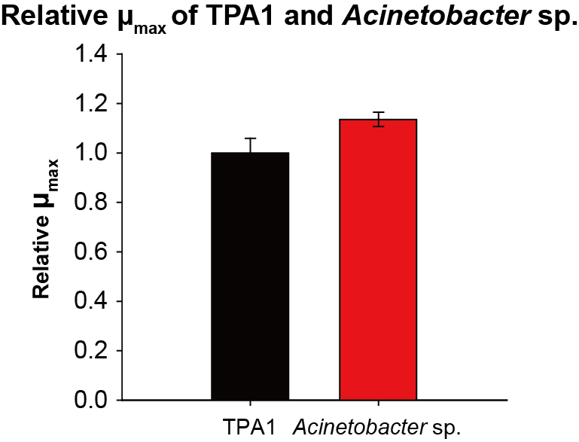

Supplementary Figure 3. Relative growth rates of Pseudomonas postechii TPA1 and isolated Acinetobacter species
Relative growth rates of Pseudomonas postechii TPA1 and an Acinetobacter sp. isolated from the conventional growth-based selection were calculated during the exponential phase (3–6 h) of a 3 mL test tube culture of MSM medium supplemented with 66 mM TPA. The growth rate of the Acinetobacter sp was normalized using the TPA1 as a reference, showing a 1.1-fold higher growth rate than the control. Error bar indicates the standard deviations of three independent cultures (n = 3).
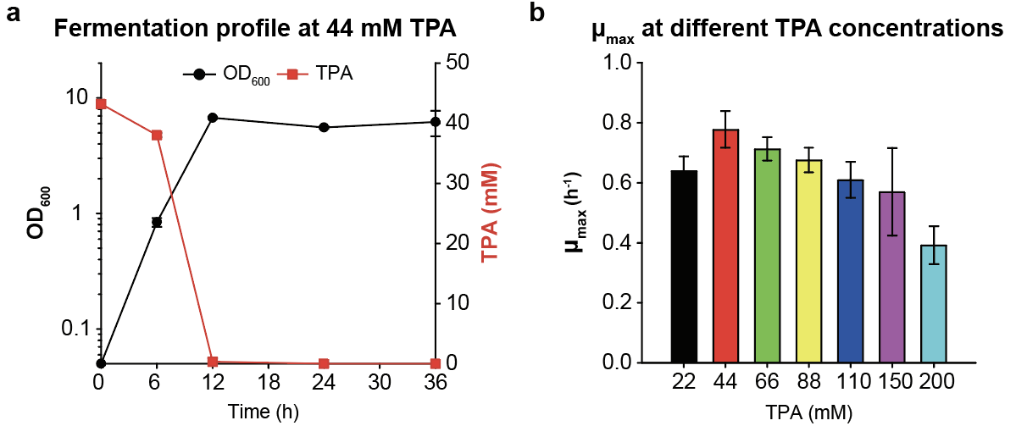

Supplementary Figure 4. Comparison of the cell growth of Pseudomonas postechii TPA1 on various concentrations of TPA
a Fermentation profile of Pseudomonas postechii TPA1 grown in a minimal medium supplemented with 44 mM TPA. b Maximum growth rate (μ_{max}, h⁻¹) of Pseudomonas postechii TPA1 at various TPA concentrations (22, 44, 66, 88, 110, 150, 200 mM). μ_{max} was calculated during the exponential phase of TPA1 (3–6 h). Error bar indicates the standard deviations of three independent cultures (n = 3).
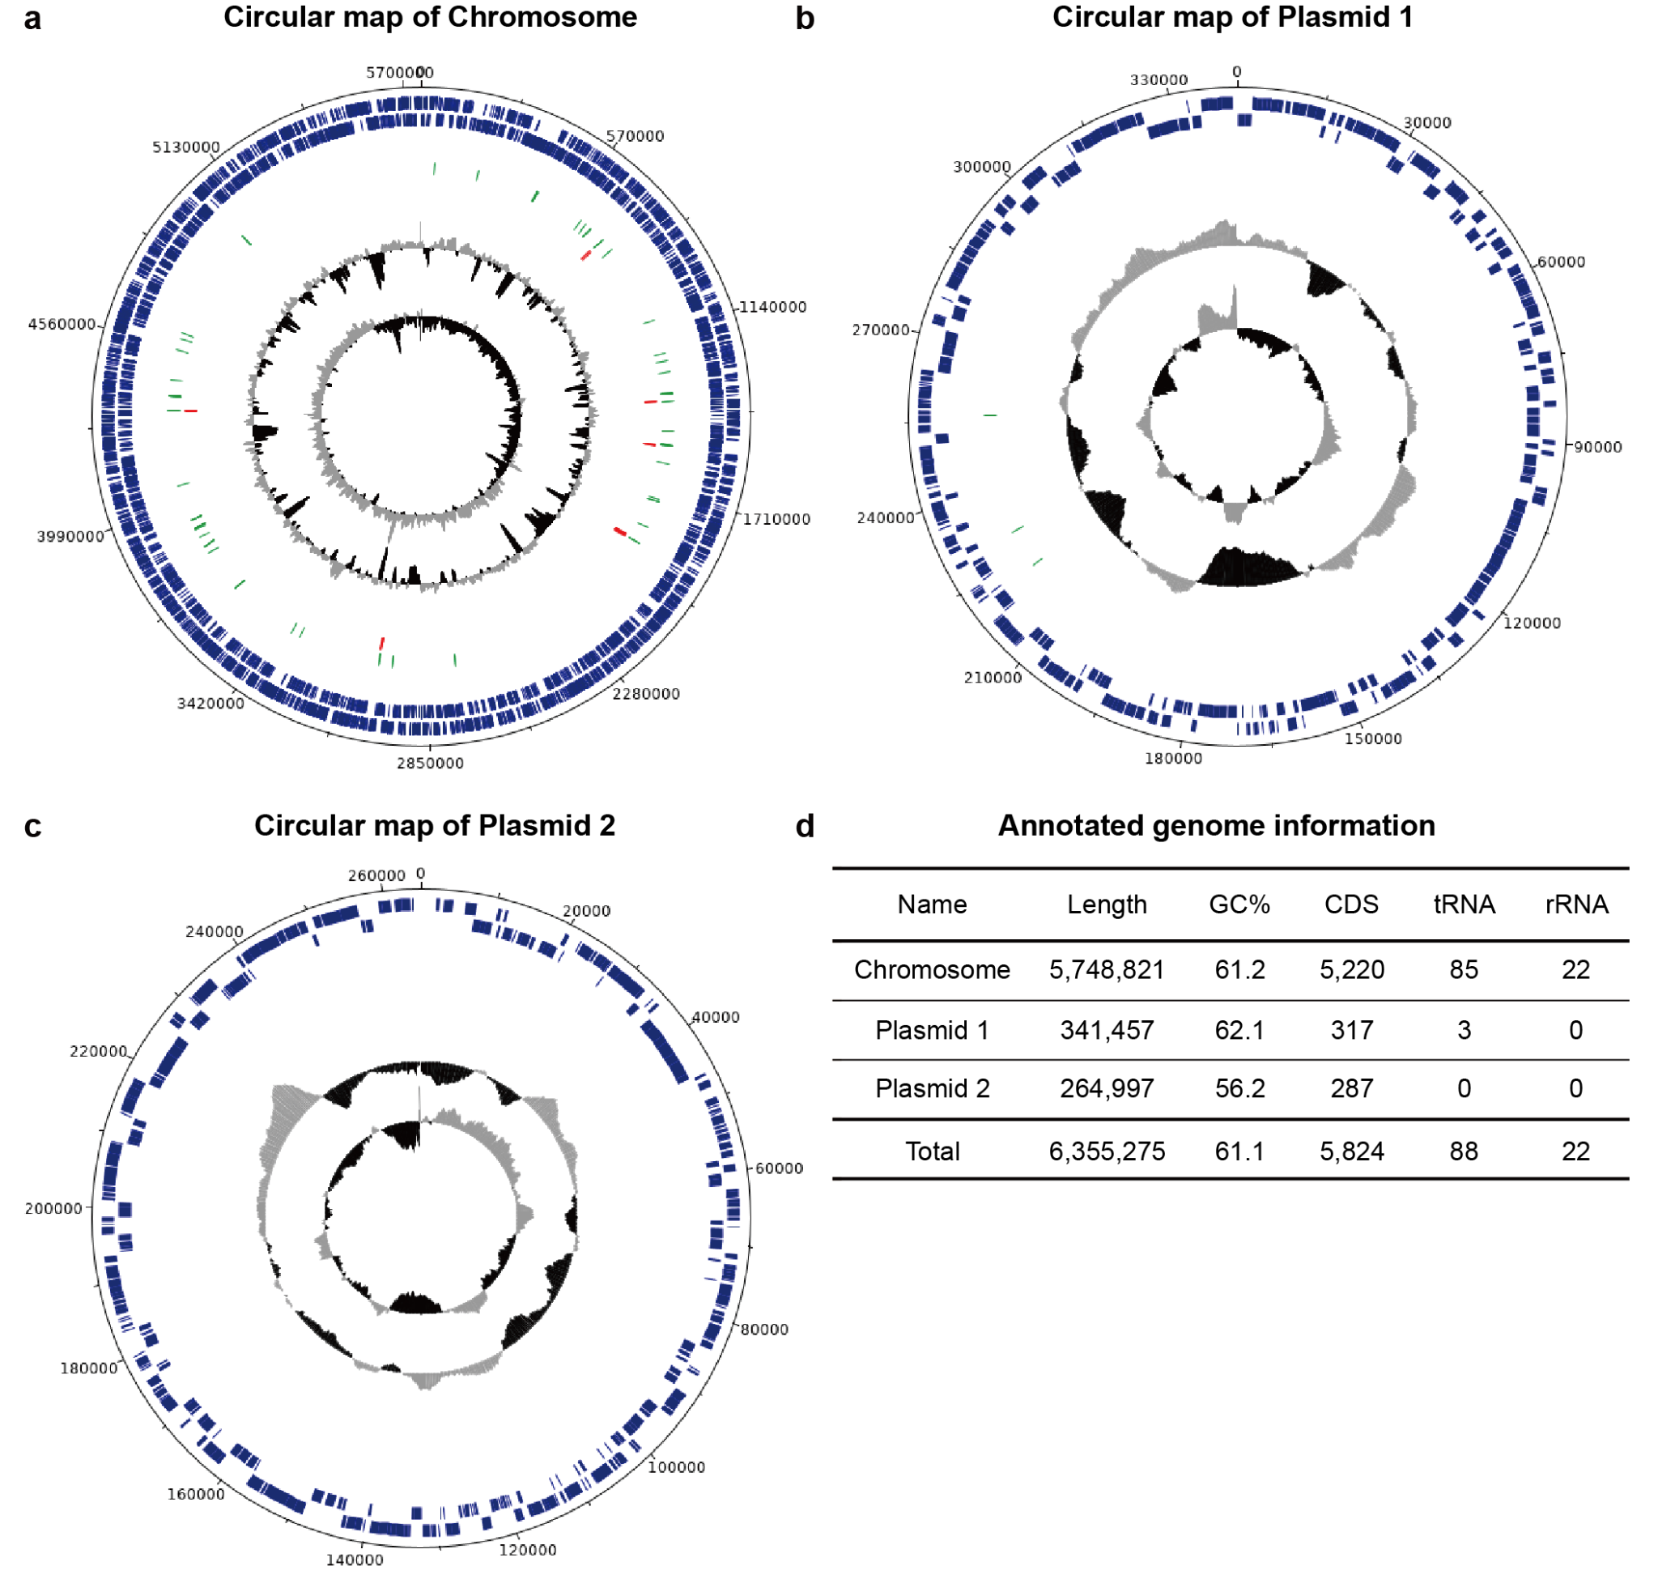

Supplementary Figure 5. Genome information of Pseudomonas postechii TPA1
a-c Circular maps of a chromosome, b plasmid 1, and c plasmid 2 in P. postechii TPA1. Starting from the outer circle, the forward coding sequence (dark blue, outer circle), reverse coding sequence (dark blue, inner circle), tRNA (green), rRNA (red), GC plot (black: below average, grey: above average), and GC skew (black: below average, grey: above average) are depicted. The images were drawn using DNAplotter (https://www.sanger.ac.uk/science/tools/dnaplotter). d Annotated genome information, analysed by Rapid Annotations using the Subsystems Technology (RAST) server.

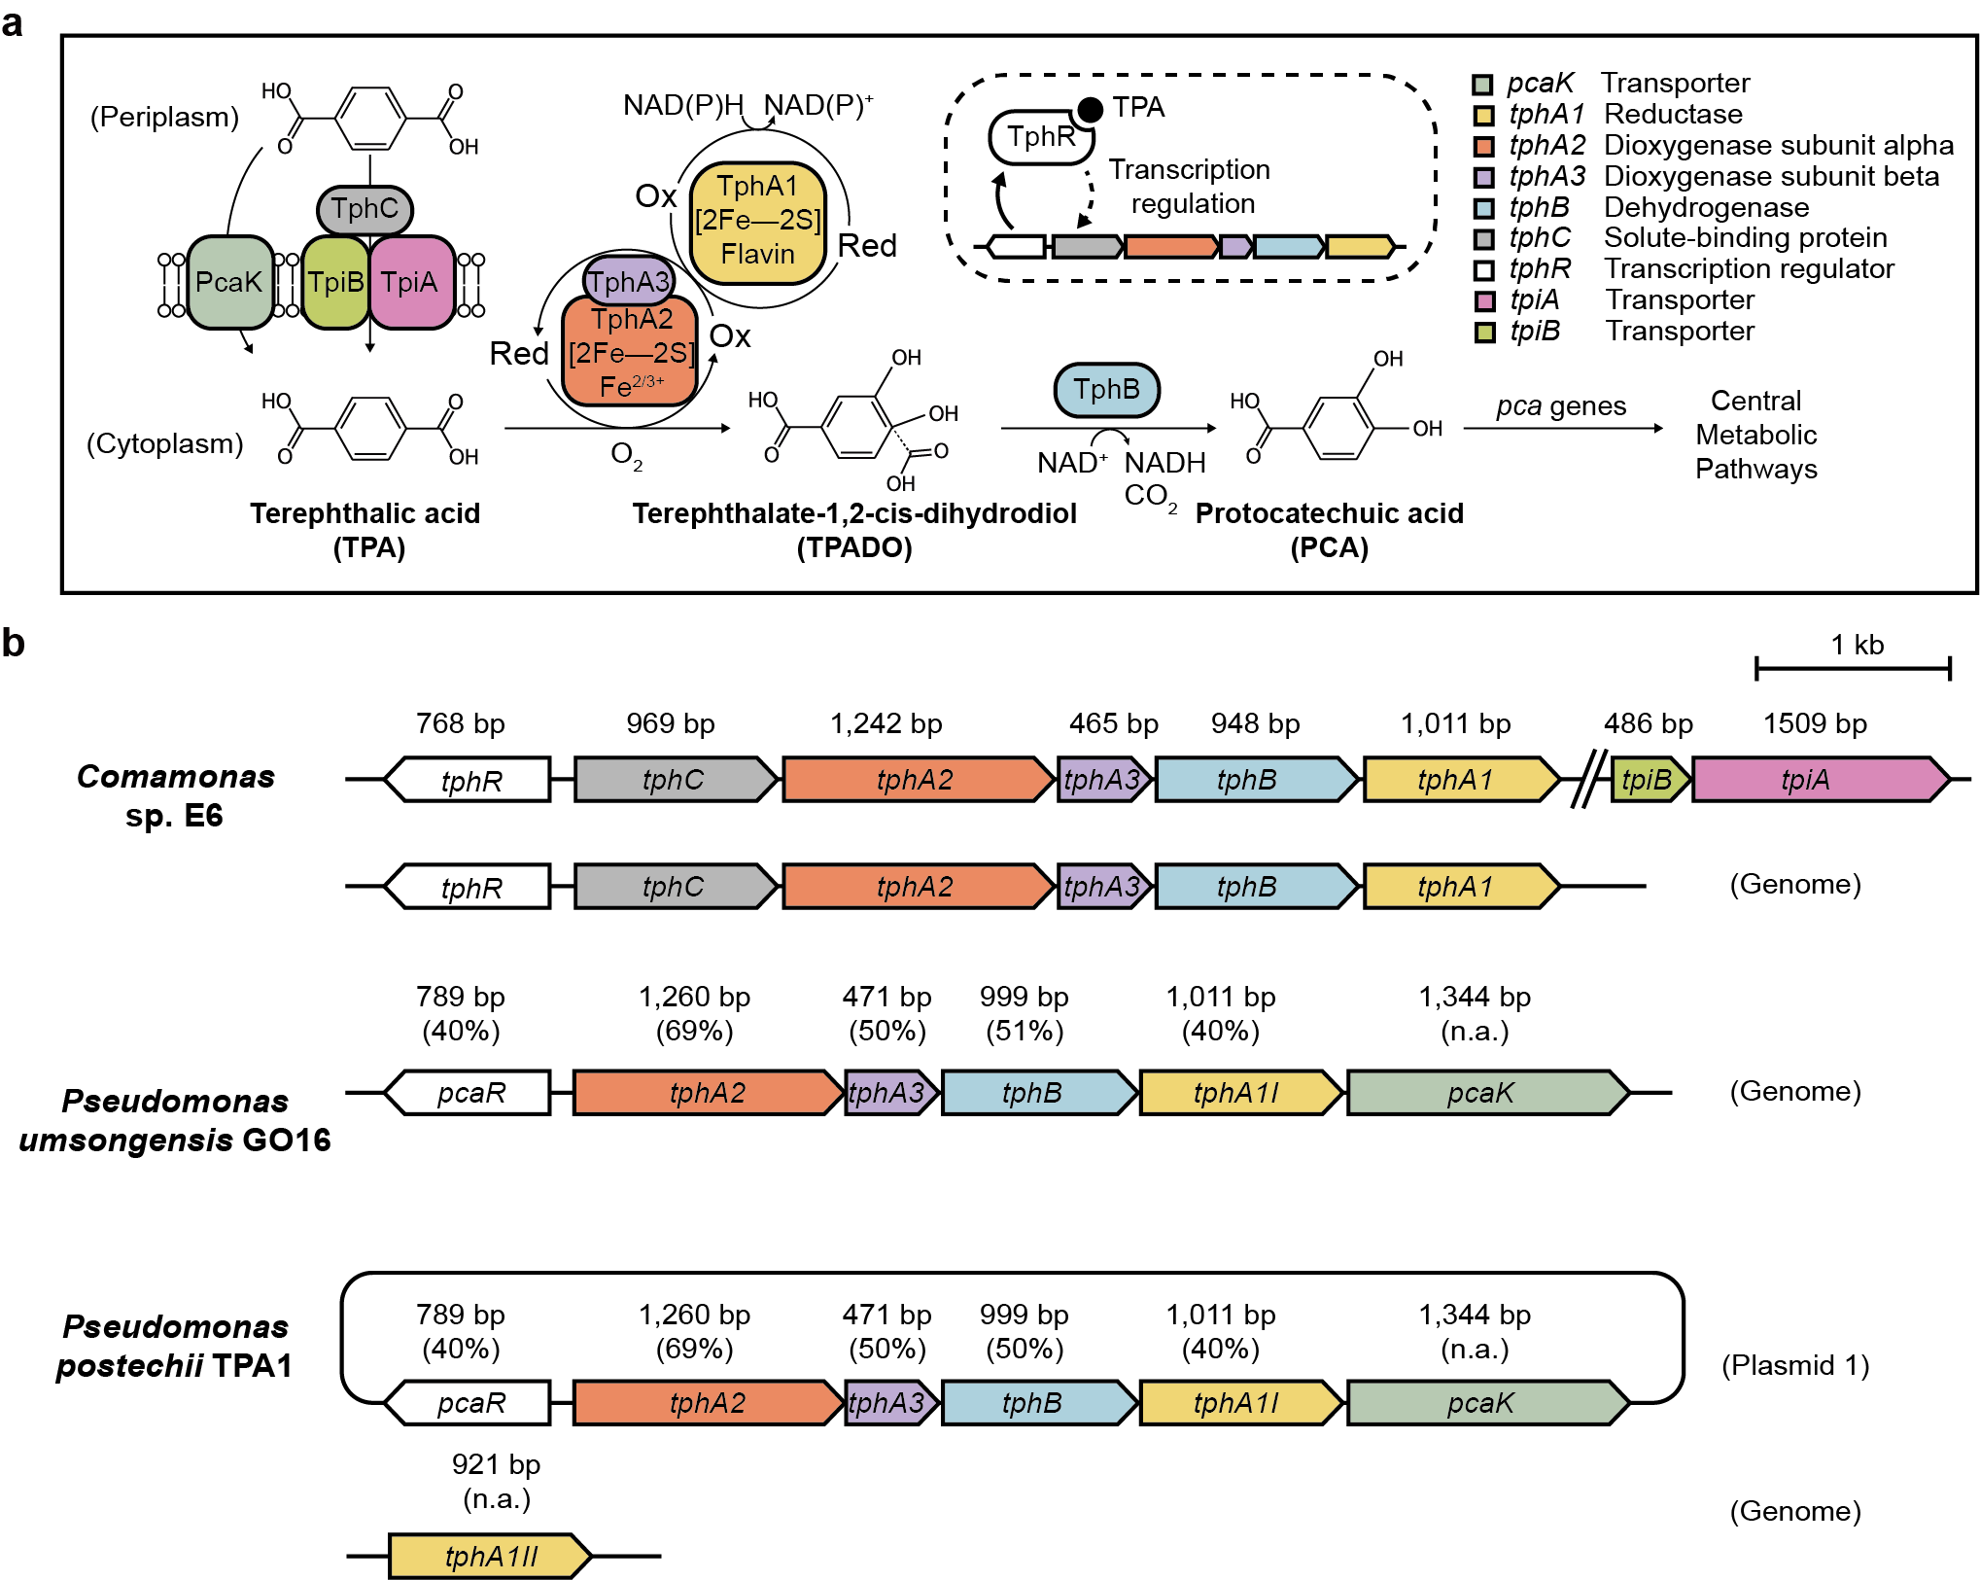

Supplementary Figure 6. Comparison of tph operon between TPA-converting bacteria
a The pathway for transport and enzymatic conversion of TPA into protocatechuate and TPA-induced regulation of tph expression^{1,2}. The name of each gene and the translated product corresponding to the color are annotated. b The organization of genes within tph operon across Comamonas sp. E6, P. umsongensis GO16, and P. postechii TPA1 are compared in parallel, and their genomic locations, lengths, identities are indicated. Identities between corresponding genes were calculated using BLASTp (https://blast.ncbi.nlm.nih.gov/).

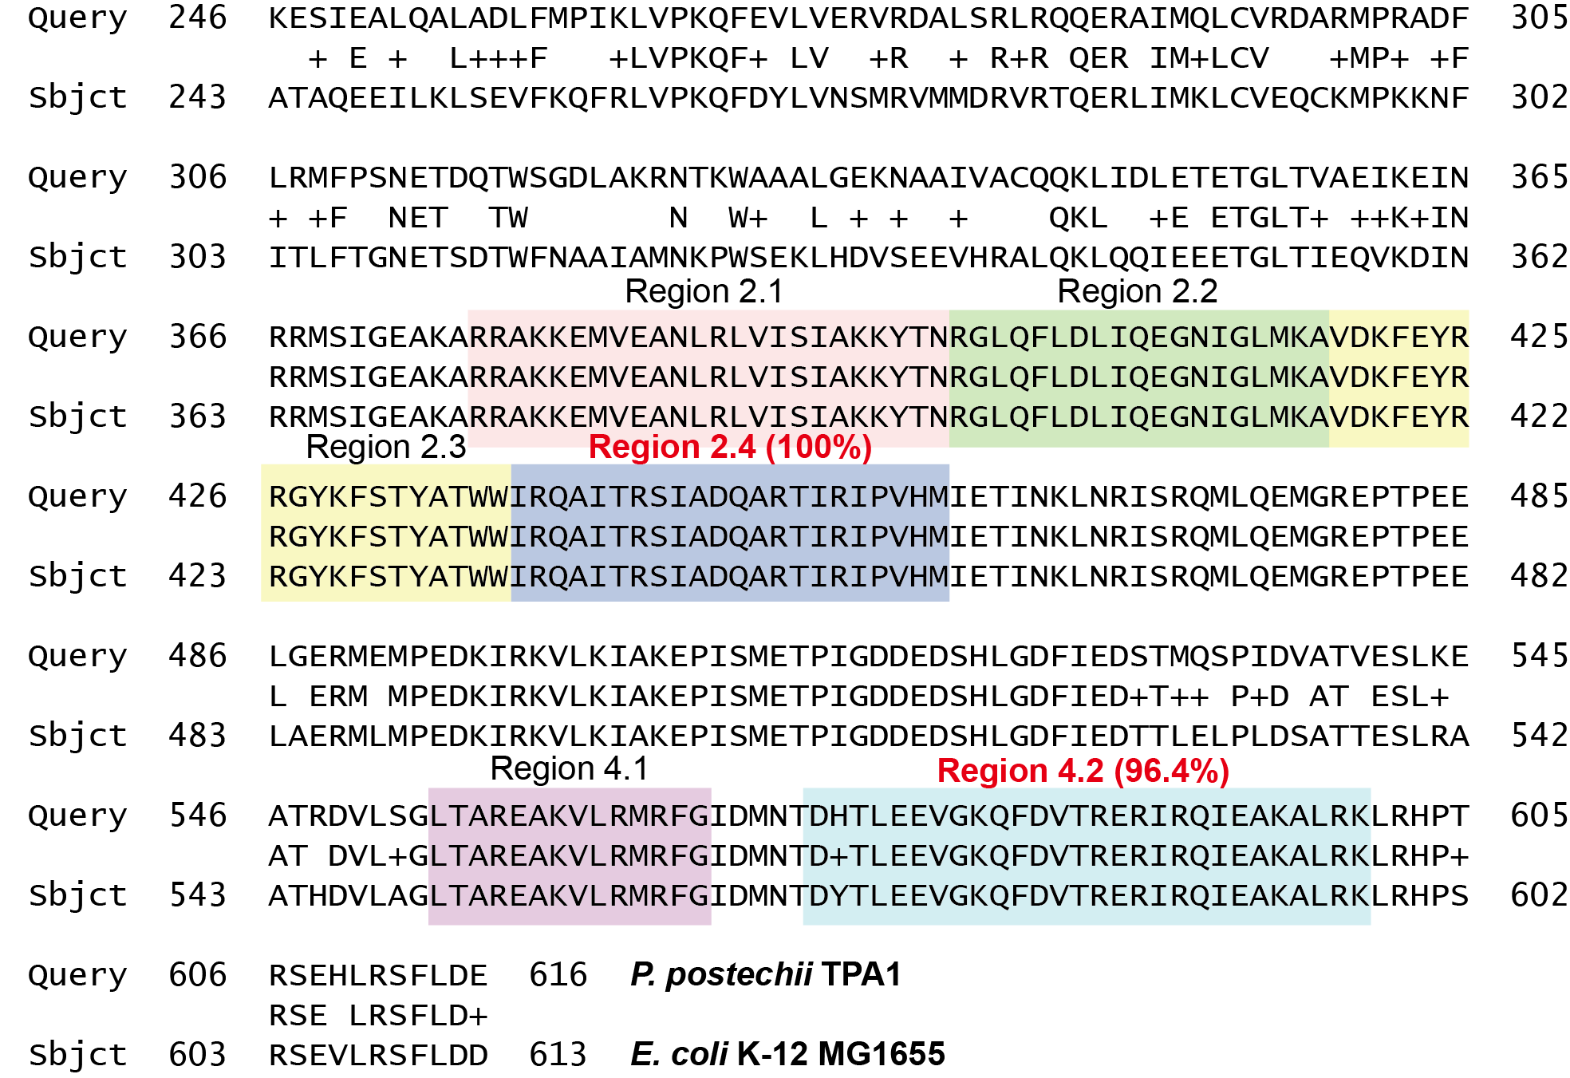

Supplementary Figure 7. Sequence alignment of housekeeping sigma factor σ⁷⁰ from E. coli and P. postechii TPA1
A partial σ⁷⁰ amino acid sequence of TPA1 was compared with that of E. coli. Regions 2.4 and 4.2 of E. coli σ⁷⁰ are known to interact with the -10 and -35 boxes of the promoter^{3,4}. Sequence alignment was performed using BLAST (https://blast.ncbi.nlm.nih.gov/Blast.cgi).
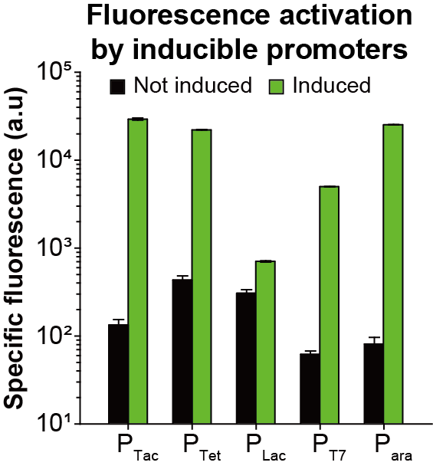

Supplementary Figure 8. GFP expression regulation under common inducible promoters in Pseudomonas postechii TPA1
Specific fluorescence of GFP expressed under various inducible promoters in Pseudomonas postechii TPA1 is measured with (green bar) and without (black bar) inducers. The cells were cultured in 3 mL minimal medium with TPA as the sole carbon source (66 mM), and their specific fluorescence was measured at 12 h. The corresponding inducer (1 mM IPTG for P_{tac}, P_{lac}, P_{T7}, 100 μg/L anhydrotetracycline for P_{tet}, 10 g/L arabinose for P_{ara}) was added at the beginning of the culture. Expression of the GFP gene was activated by 221, 51, 2, 81, and 314-fold, under P_{tac}, P_{tet}, P_{lac}, P_{T7}, P_{ara}, respectively. Error bar indicates the standard deviations of three independent cultures (n = 3).
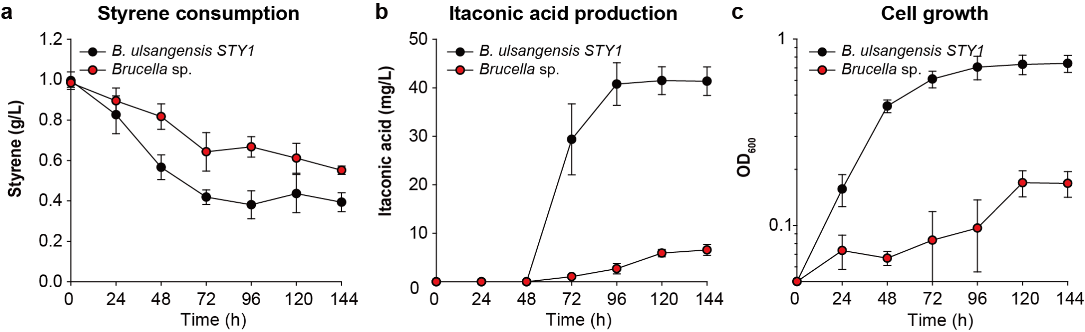

Supplementary Figure 9. Comparison of two Brucella species isolated from the final SCOUT population
a Styrene consumption, b itaconic acid titer, and c cell growth in B. ulsangensis STY1 (black) and the other Brucella species (red). Error bar indicates the standard deviations of three independent cultures (n = 3).
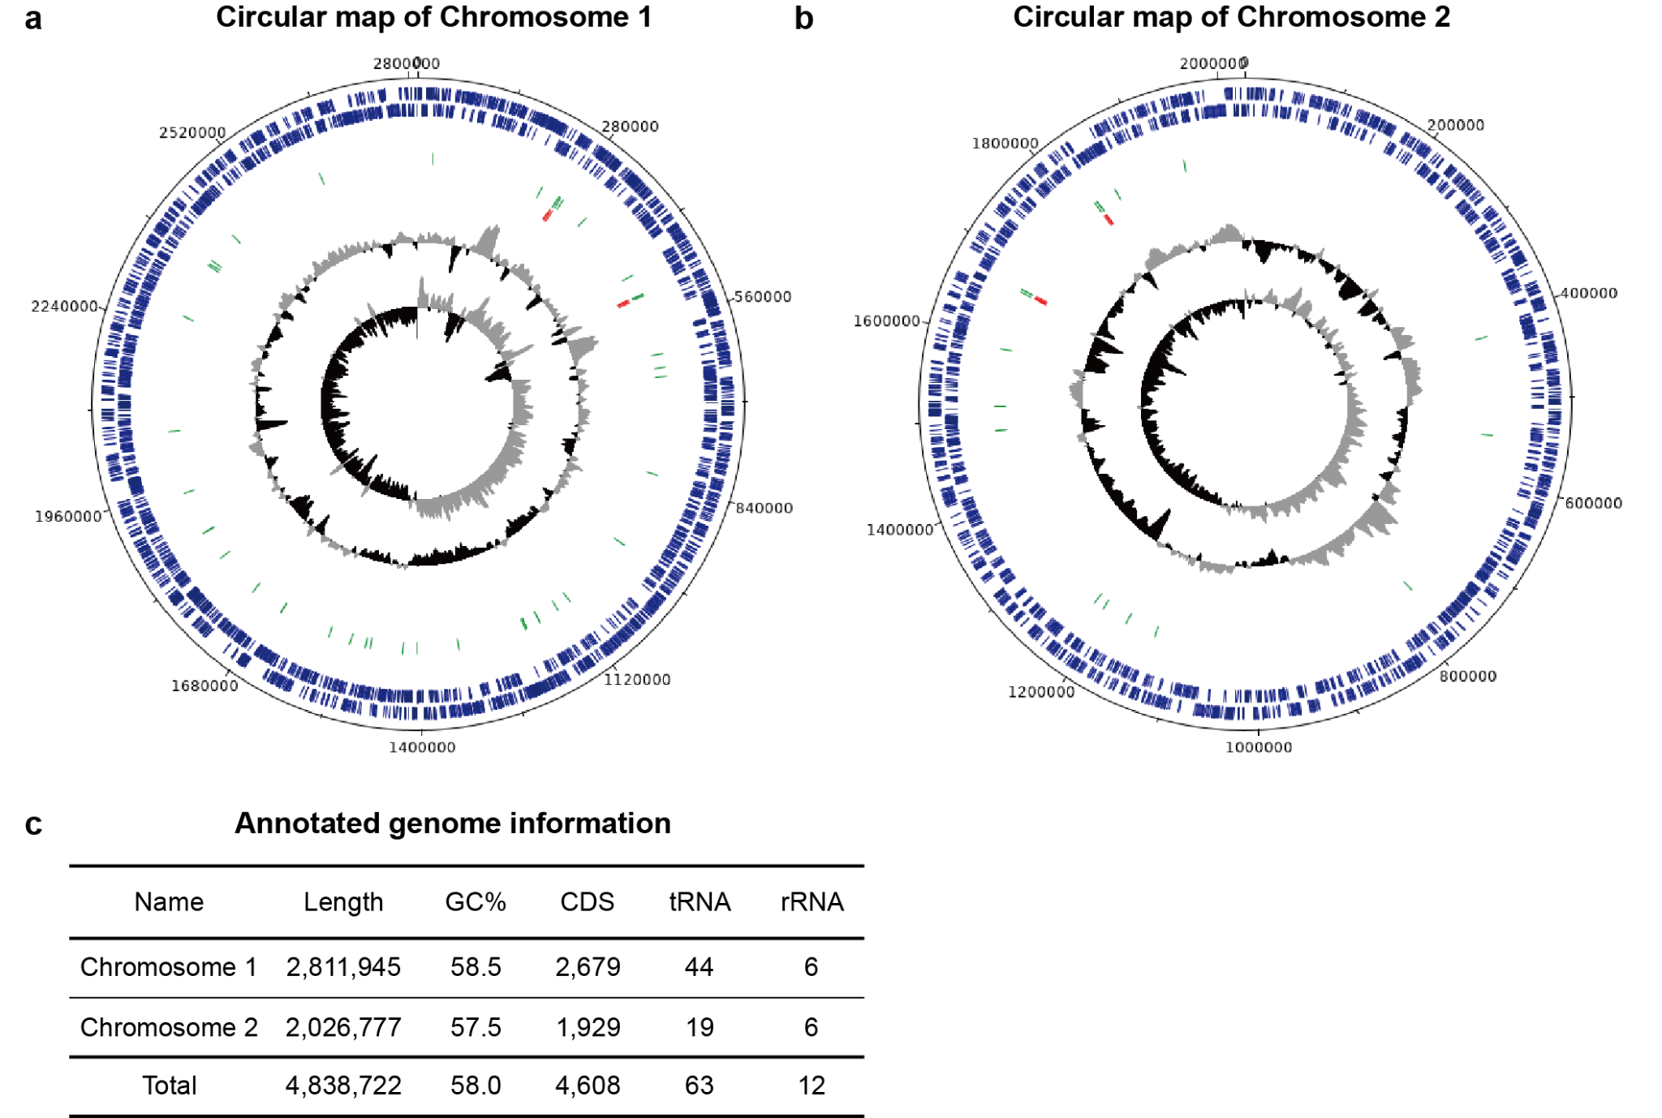

Supplementary Figure 10. Genome information of Brucella ulsangensis STY1
Circular maps of a chromosome 1, b chromosome 2. Starting from the outer circle, the forward coding sequence (dark blue, outer circle), reverse coding sequence (dark blue, inner circle), tRNA (green), rRNA (red), GC plot (black: below average, grey: above average), and GC skew (black: below average, grey: above average) are depicted. The images were drawn using DNAplotter (https://www.sanger.ac.uk/science/tools/dnaplotter). c Annotated genome information, analysed by Rapid Annotations using the Subsystems Technology (RAST) server.

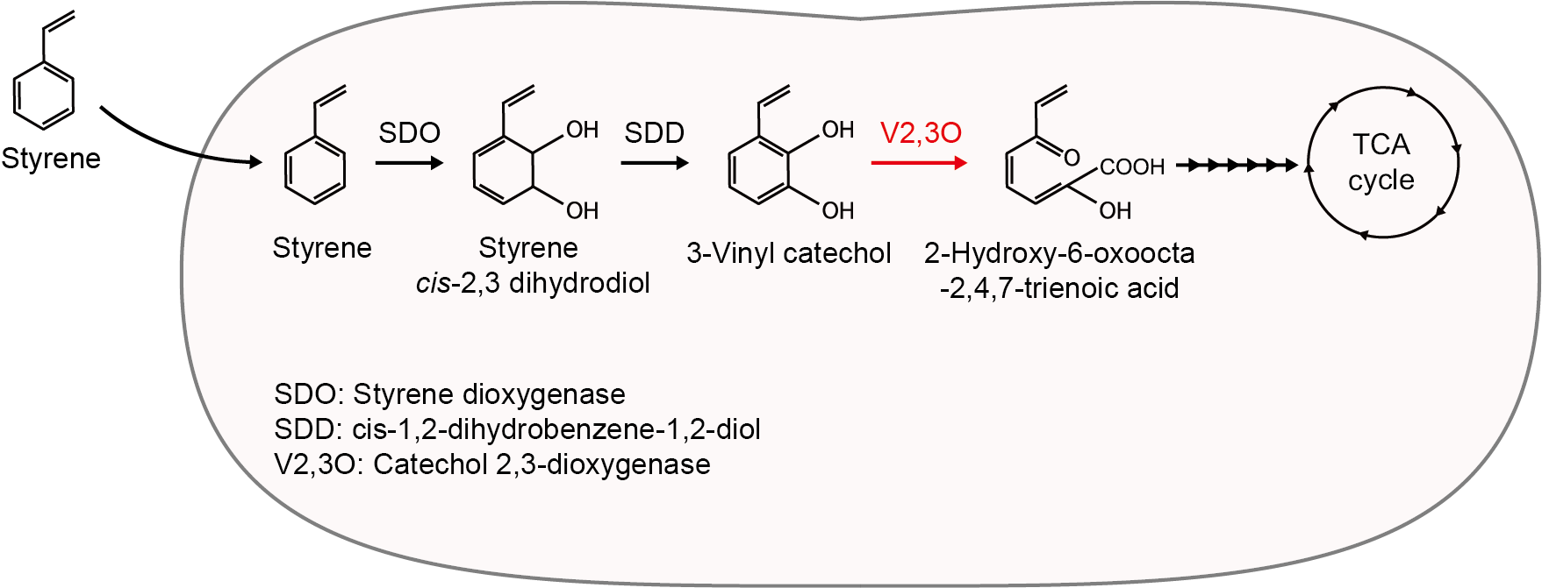

Supplementary Figure 11. Putative styrene-converting pathway of Brucella ulsangensis STY1
The styrene converting pathway by direct ring cleavage⁵. Catechol 2,3-dioxygenase (Locus_tag: STP1_01556) indicated in red was sampled from annotated genes of STY1 using de novo assembly of the whole genome. KAAS (KEGG Automatic Annotation Server, https://www.genome.jp/tools/kaas/) was used to identify putative styrene-degrading genes by comparison with genomic data of 12 different Brucella species.
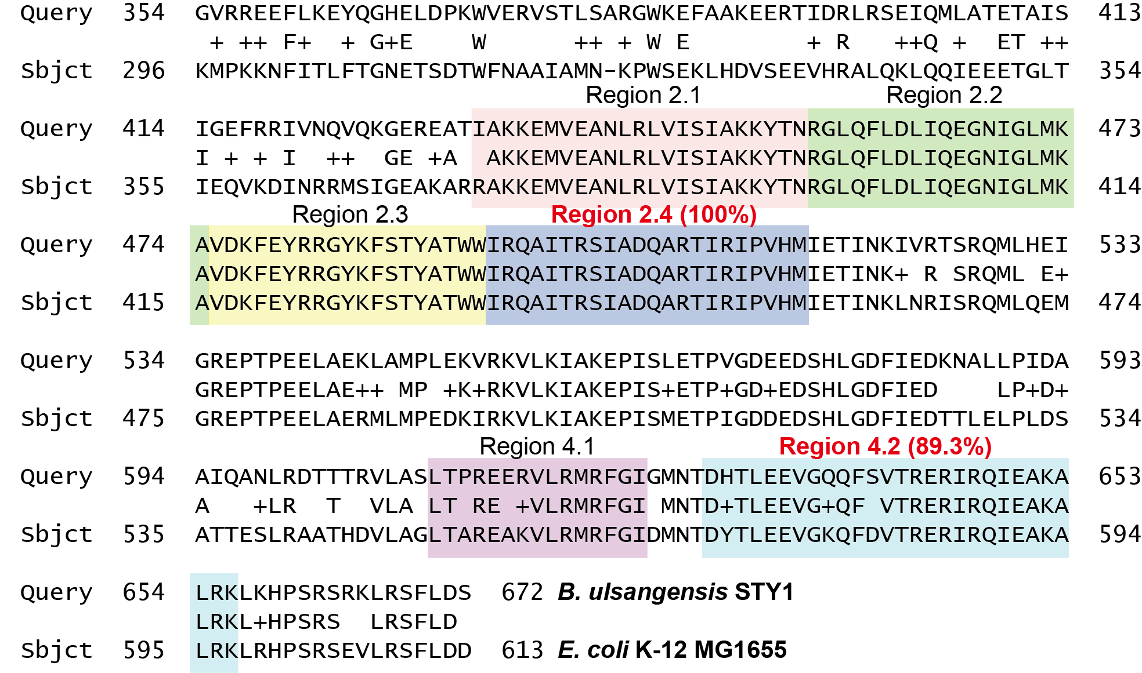

Supplementary Figure 12. Sequence alignment of housekeeping sigma factor σ⁷⁰ from Escherichia coli and Brucella ulsangenesis STY1
A partial σ⁷⁰ amino acid sequence of Brucella ulsangenesis STY1 was aligned with that of E. coli. Regions 2.4 and 4.2 of E. coli σ⁷⁰ are known to interact with the -10 and -35 boxes of the promoter^{3,4}. Sequence alignment was performed using BLAST (https://blast.ncbi.nlm.nih.gov/Blast.cgi).

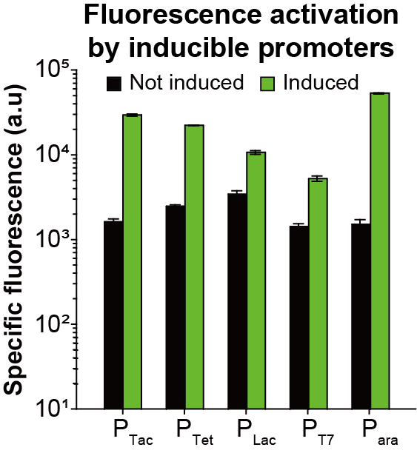

Supplementary Figure 13. Expression of GFP under the control of various inducible promoters in Brucella ulsangenesis STY1
Specific fluorescence of GFP expressed under various inducible promoters in STY1 is measured with (green bar) and without (black bar) induction. The culture was performed in serum bottles with 10 mL MSM medium supplemented with 1 g/L of styrene and 2 g/L of yeast extract. Specific fluorescence was measured 12 hours after the start of the culture. Inducer was added at the beginning of the culture, resulting in 14.7, 9.0, 3.1, 3.7, and 34.9-fold increased fluorescence, respectively (Tac, Tet, Lac, T7, ara). Error bar indicates the standard deviations of three independent cultures (n = 3).

Supplementary Tables

Supplementary Table 1. List of strains and plasmids used in this study
Names | Description | Resources
Strains
E. coli Mach-T1^{R} | F– φ80(lacZ)ΔM15ΔlacX74 hsdR(r_{K}–m_{K}⁺) ΔrecA1398 endA1 tonA | Invitrogen
Pseudomonas postechii TPA1 | A novel environmental isolate | This study
TPA-ITA | P. postechii TPA1/ pSCOUT | This study
TPA-Indigo | P. postechii TPA1/ pIND | This study
Brucella ulsangenesis STY1 | A novel environmental isolate | This study
STY1-ITA | B. ulsangnesis STY1/ pSCOUT | This study
STY1-Indigo | B. ulsangnesis STY1/ pIND | This study
E. coli S17-1 λ pir | F– recA thi pro hsdR– hsdM+ RP4-2-Tc::Mu-Km::Tn7 λpir | ATCC BAA-2428
S17 Δasd | E. coli S17-1 λ pir Δasd | This study
TPA-tac | P. postechii TPA1/ pRtac | This study
TPA-tet | P. postechii TPA1/ pRtet | This study
TPA-lac | P. postechii TPA1/ pRlac | This study
TPA-ara | P. postechii TPA1/ pRara | This study
TPA-T7 | P. postechii TPA1/ pRT7 | This study
STY-tac | B. ulsangnesis STY1/ pRtac | This study
STY-tet | B. ulsangnesis STY1/ pRtet | This study
STY-lac | B. ulsangnesis STY1/ pRlac | This study
STY-ara | B. ulsangnesis STY1/ pRara | This study
STY-T7 | B. ulsangnesis STY1/ pRT7 | This study
E. coli W | Strain for itaconic acid sensor validation | ATCC 9637
W-SENS | E. coli W/ pSENS | This study
Plasmids
pACYCDuet_1  pRSF1010 | p15A, LacI, Cm^{R}, E. coli expression vector  oriV, Sm^{R}, Broad host range plasmids | Novagen  ⁶
pRC | pRSF1010/ Cm^{R}, Km^{R}, Selection marker exchanged | This study
pSENS | pRC / P_{J23106}_ictR_T_{BBa_B1001}, P_{cc1}_sgfp T_{BBa_B1001}, oriT, | This study
pSCOUT | pSENS / P_{J23100}_ cad_ P _{J23108}_prpD _T_{BBa_B1001} | This study
pRtac | pRC / P_{tac}_ sgfp, LacI | This study
pRtet | pRC / P _{J23109}_tetR_T_{BBa_B1002}, P_{Ltet0}_ sgfp _T_{BBa_B1001} | This study
pRlac | pRC / P_{lac}_ sgfp _T_{BBa_B1001}, LacI | This study
pRara | pRC / P _{araC}_araC, P_{ara}_ sgfp _T_{BBa_B1001}, LacI | This study
pRT7 | pRC / P_{T7}_ sgfp _T_{7,} P_{lac_} T7 RNAP, LacI | This study
pIND | pRC / P _{J23100}_sfp _T_{7,} P _{J23100_}bpsA_T_{BBa_B1001} | This study
pKD46 | Amp^{R}, Red recombinase expression vector | ⁷
pCP20 | Cm^{R}, Flippase expression vector | ⁷

Supplementary Table 2. Designed 5’ UTR sequences and their predicted expression levels in this study
Gene | 5′ UTR sequence (5′-3′)ª | Predicted expression level^{b} (a.u.)
itcR | AAAAACACAAAAAGGAGCATCTAAA | 510,075
cad | AAAGCGGAAAGTAAGGAGGTTAGAT | 911,518
prpD | CAACAAAAAAAAAGGAGCATCCTAC | 620,368
sgfp (Pccl) | TTCTGCATACAAAGGAGCATCCCCA | 1,026,267
sgfp (P_{lac}, P_{tac}, P_{T7}) | AGCGGATAACAATTACGAGGGAAAG | 1,828,513
sgfp (P_{tet}, P_{ara}) | ATTGCGTGAGAAAGGAGCATCGGGA | 2,064,841
T7 RNAP | GCGGATAACAATTAAGGAGTCCGCG | 16,662
tetR | AGCCGAAGTCTCGAAGGAGCAGGCG | 94,345
sfp | TACAACTCGGAAAGAGTTAGAGACA | 1,970
bpsA | GCCTATTATCAATTATCAATTCCCT | 367,464
ªUnderlined sequences overlap with the lac operator.
^{b}Values were calculated using UTR Designer (https://sbi.postech.ac.kr/utr_designer).

Supplementary Table 3. Growth performance of reported TPA-consuming bacteria
Strainsª | Origin/ Engineering strategy | μ_{max}^{b,c} | Note^{d} | References
P. postechii TPA1 | An environmental isolate | 0.78 h⁻¹ | 44 mM TPA in 12 h | This study
Acinetobacter baylyi ADP1 (IP250) | Introduction of TPA degrading genes (tph) from Commamonas sp. E6  Evolved by adaptive laboratory engineering | 0.26 h⁻¹ | 10 mM TPA in 12 h | ⁸
Acinetobacter baylyi ADP1 (IP250) |  | ~0.23 h⁻¹ | n.a. | ^{8,9}
P. putida KT2440  (tph operon) | Introduction of TPA degrading genes (tph) from Commamonas sp. E6 | 0.57 h⁻¹ | 45 mM TPA in 38 h | ⁹
P. putida sp. | Introduction of TPA degrading genes (tph) from R. jostii RHA1  Deletion of ped operon | n.a. | 56.2 mM TPA in 36 h | ¹⁰
Commamonas sp. E6 | An environmental isolate | ~0.20 h⁻¹ | n.a. | ^{8,9}
Commamonas sp. E6 | An environmental isolate | 0. 50 h⁻¹ | 10 mM TPA in ~15 h | ^{8,9}
Comamonas testosteroni KF-1 | Introduction of f PDC producing genes (2-pyrone-4,6-dicarboxylic acid) | n.a. | ~22 mM TPA in 20 h | ¹¹
P. umsongnesis GO16 | An environmental isolate | 0.17 h⁻¹ | 44 mM TPA and 44 mM ethylene glycol in 12 h (5-L scale) | ¹²
P. umsongnesis GO16 | An environmental isolate | n.a. | 15~18 mM TPA in 10 h | ¹³
Rhodococcus jostii RHA1 | An environmental isolate | ~0.20 h⁻¹ | n.a. | ^{8,9}
Rhodococcus jostii PET | An environmental isolate | n.a. | ~ 44 mM TPA and 44 mM ethylene glycol (PET hydrolysates) in 36 h | ¹⁴
ªAll strains were capable of utilizing TPA as a sole carbon source
^{b}All strains were cultured at flask scale in minimal medium at 30℃ unless otherwise mentioned.
^{c}n.a. Not available from related literature
^{d}Time required for complete consumption of TPA

References
1. Kincannon, W. M. et al. Biochemical and structural characterization of an aromatic ring-hydroxylating dioxygenase for terephthalic acid catabolism. Proc Natl Acad Sci USA 119, e2121426119 (2022).
2. Hosaka, M. et al. Novel tripartite aromatic acid transporter essential for terephthalate uptake in Comamonas sp. strain E6. Appl. Environ. Microbiol. 79, 6148–6155 (2013).
3. Paget, M. S. B. & Helmann, J. D. The sigma70 family of sigma factors. Genome Biol. 4, 203 (2003).
4. Bervoets, I. et al. A sigma factor toolbox for orthogonal gene expression in Escherichia coli. Nucleic Acids Res. 46, 2133–2144 (2018).
5. Oelschlägel, M., Zimmerling, J. & Tischler, D. A Review: The Styrene Metabolizing Cascade of Side-Chain Oxygenation as Biotechnological Basis to Gain Various Valuable Compounds. Front. Microbiol. 9, 490 (2018).
6. Scholz, P. et al. Complete nucleotide sequence and gene organization of the broad-host-range plasmid RSF1010. Gene 75, 271–288 (1989).
7. Datsenko, K. A. & Wanner, B. L. One-step inactivation of chromosomal genes in Escherichia coli K-12 using PCR products. Proc Natl Acad Sci USA 97, 6640–6645 (2000).
8. Pardo, I. et al. Gene amplification, laboratory evolution, and biosensor screening reveal MucK as a terephthalic acid transporter in Acinetobacter baylyi ADP1. Metab. Eng. 62, 260–274 (2020).
9. Werner, A. Z. et al. Tandem chemical deconstruction and biological upcycling of poly(ethylene terephthalate) to β-ketoadipic acid by Pseudomonas putida KT2440. Metab. Eng. 67, 250–261 (2021).
10. Bao, T., Qian, Y., Xin, Y., Collins, J. J. & Lu, T. Engineering microbial division of labor for plastic upcycling. Nat. Commun. 14, 5712 (2023).
11. Delmulle, T. et al. Engineering Comamonas testosteroni for the production of 2-pyrone-4,6-dicarboxylic acid as a promising building block. Microb. Cell Fact. 22, 188 (2023).
12. Narancic, T. et al. Genome analysis of the metabolically versatile Pseudomonas umsongensis GO16: the genetic basis for PET monomer upcycling into polyhydroxyalkanoates. Microb. Biotechnol. 14, 2463–2480 (2021).
13. Tiso, T. et al. Towards bio-upcycling of polyethylene terephthalate. Metab. Eng. 66, 167–178 (2021).
14. Diao, J., Hu, Y., Tian, Y., Carr, R. & Moon, T. S. Upcycling of poly(ethylene terephthalate) to produce high-value bio-products. Cell Rep. 42, 111908 (2023).

