Supplementary Material

eTable 1. Univariate analysis of variables associated with 90-day mortality

Variable | HR | 95% CI | p
Age | 1.04 | 1.02-1.07 | 0.001
Gender (ref. female) | 0.86 | 0.51-1.46 | 0.575
BMI | 0.97 | 0.92-1.02 | 0.185
Urgent surgery | 1.02 | 0.60-1.74 | 0.951
Complicated elective surgery | 0.98 | 0.57-1.68 | 0.951
Cancer | 0.95 | 0.56-1.61 | 0.858
SAPS II score | 1.06 | 1.03-1.07 | <0.001
SOFA score | 1.11 | 1.04-1.18 | 0.001
CCI>4 | 2.73 | 1.55-4.82 | 0.001
Skeletal muscle index  - Middle versus lowest tertile  - Highest versus lowest tertile | 0.57  0.42 | 0.31-1.05  0.22-0.82 | 0.070  0.010
Myosteatosis  - Middle versus lowest tertile  - Highest versus lowest tertile | 1.07  3.19 | 0.49-2.36  1.70-5.99 | 0.867  <0.001
Sarcobesity  - Middle versus lowest tertile  - Highest versus lowest tertile | 0.94  1.22 | 0.49-1.83  0.66-2.28 | 0.864  0.525

eFigure 1. Impact of skeletal muscle index (panel A) and myosteatosis (panel B) on 1-year survival. Estimation of survival is described by a Kaplan-Meier survival curve after dividing the population into 3 groups defined by tertiles of the index distribution.
A
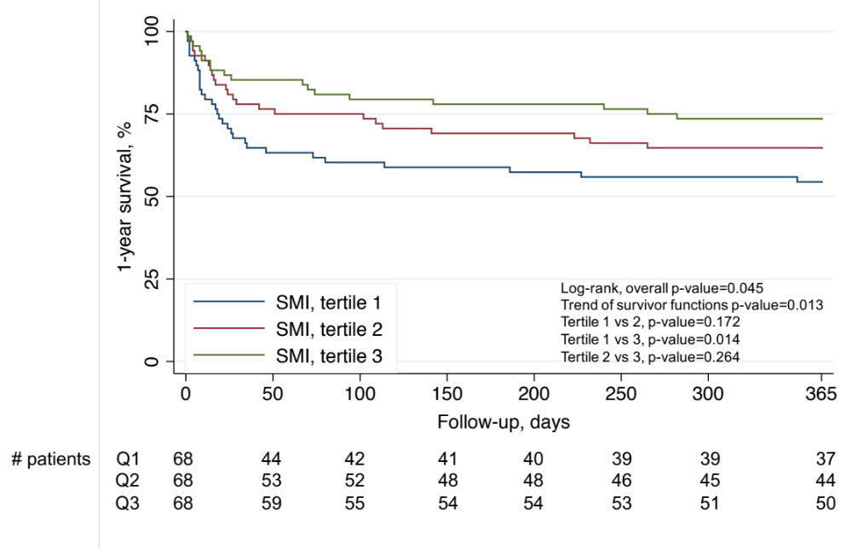
B
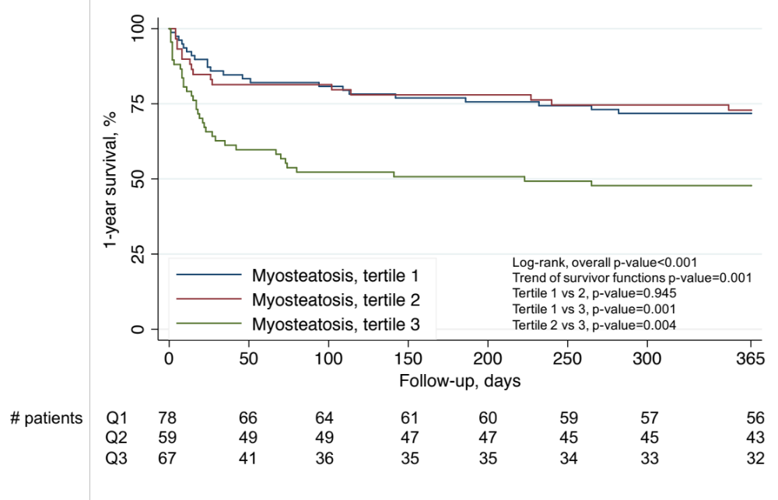

eTable 2. Multivariate analysis of variables associated with 90-day mortality, without myosteatosis

Model 1. Only Skeletal muscle index > Harrell’s C=0.768

Variable | HR | 95% CI | p
SAPSII score | 1.05 | 1.04-1.07 | <0.001
CCI>4 | 2.44 | 1.38-4.31 | 0.002
Skeletal muscle index  - Middle versus lowest tertile  - Highest versus lowest tertile | 0.47  0.36 | 0.26-0.87  0.19-0.71 | 0.017  0.003

eTable 3. Multivariate analysis of variables associated with 90-day mortality, without Skeletal muscle index

Model 2. Only Myosteatosis > Harrell’s C=0.768

Variable | HR | 95% CI | p
SAPSII score | 1.05 | 1.03-1.07 | <0.001
CCI>4 | 2.42 | 1.36-4.29 | 0.003
Myosteatosis  - Middle versus lowest tertile  - Highest versus lowest tertile | 1.00  2.31 | 0.45-2.22  1.23-4.34 | 0.994  0.010

eFigure 2. Proportion of 90-day mortality reported by combination of low or high SMI (i.e. according to the 50% percentile of SMI) with low or high myosteatosis (i.e. according to the 50% percentile of myosteatosis). P-value for trend was reported. * p<0.05, ** p<0.01 versus Low SMI/High Myosteatosis group.
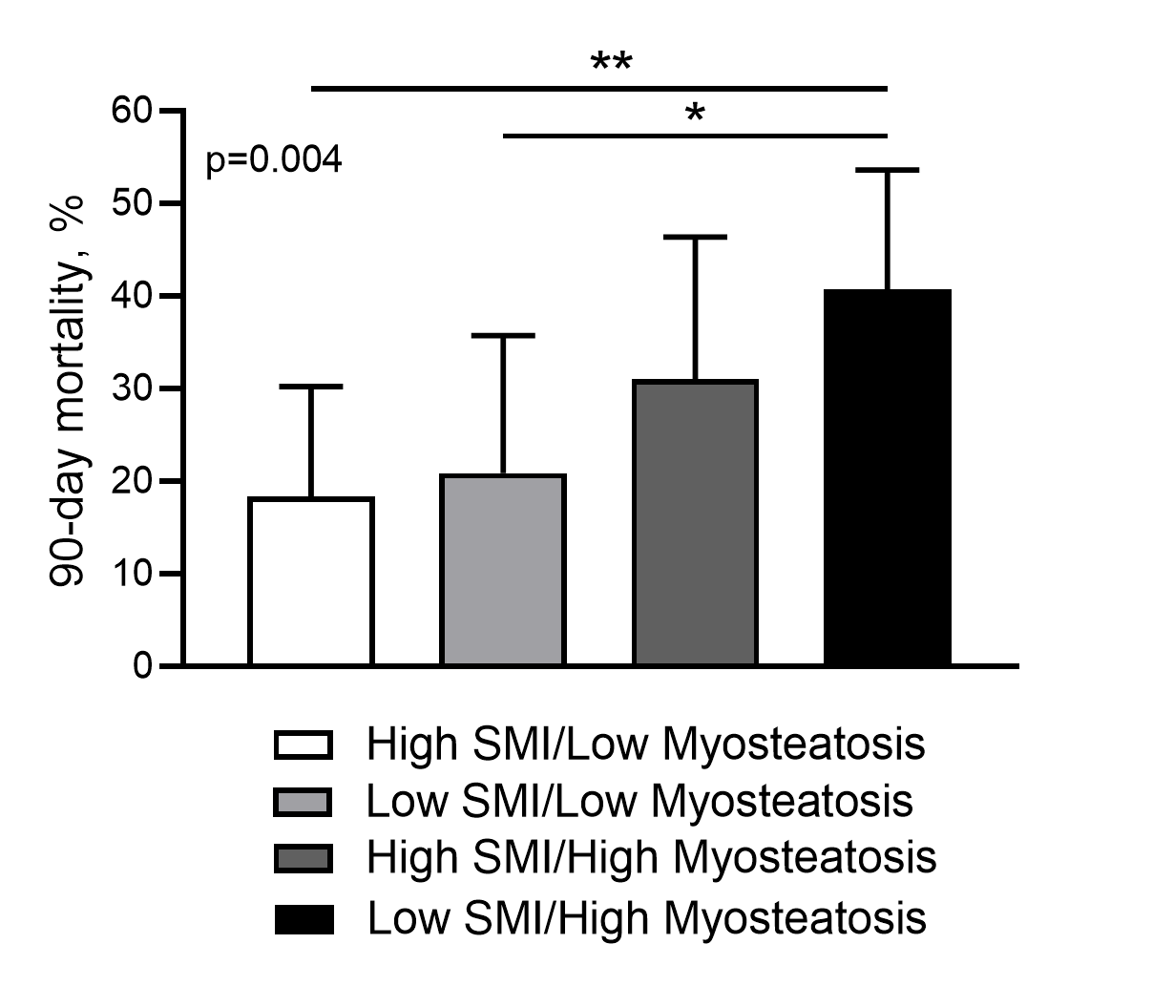

eFigure 3. Impact of combination of low or high SMI (i.e. according to the 50% percentile of SMI) with low or high myosteatosis (i.e. according to the 50% percentile of myosteatosis) on 90-day survival. Estimation of survival is described by a Kaplan-Meier survival curve after dividing the population into 4 groups defined by high or low SMI associated with high or low myosteatosis.
