Fig.2C
proBDNF | mBDNF | The two images can completely coincide and prove to be the same images.
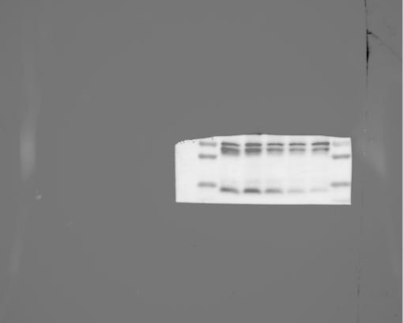 | 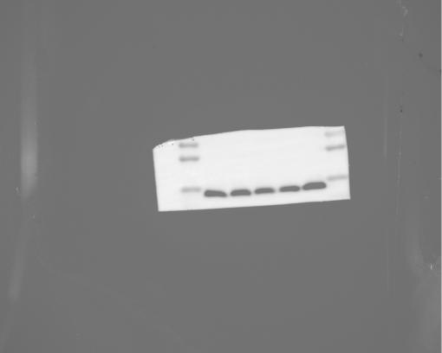

Fig.2D
proBDNF | mBDNF | The markers of the two images can completely coincide and prove to be the same image.
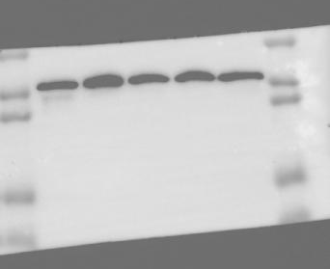 | 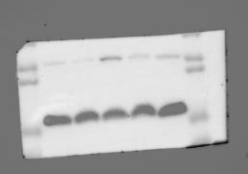

Fig.3F＆3G
p53 | β-actin | p21 | The three iamges can completely coincide and prove to be the same image.
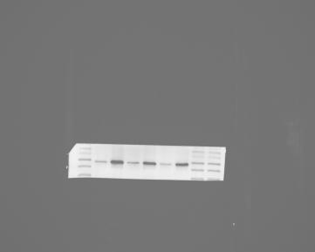 | 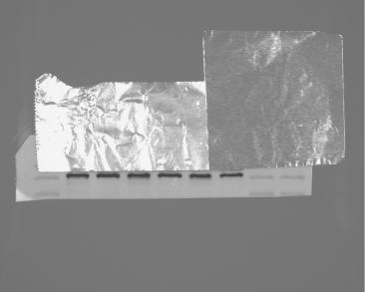 | 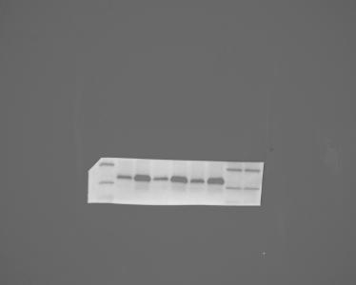

Fig.3H
bax | bcl2 | The two images can completely coincide and prove to be the same images.
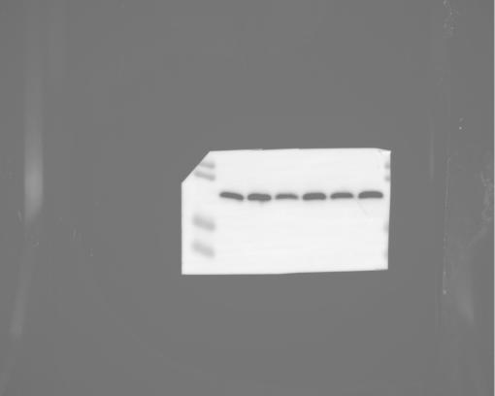 | 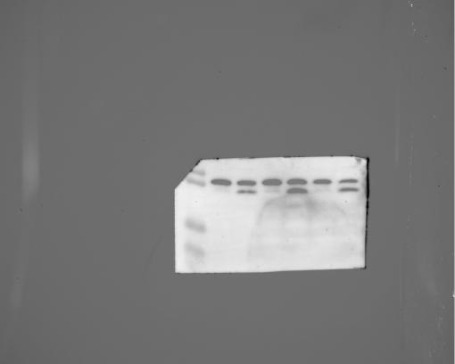

Fig.3N
proBDNF | mBDNF | The markers of the two images can completely coincide and prove to be the same image.
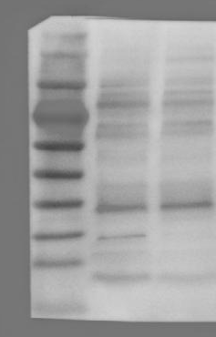 | 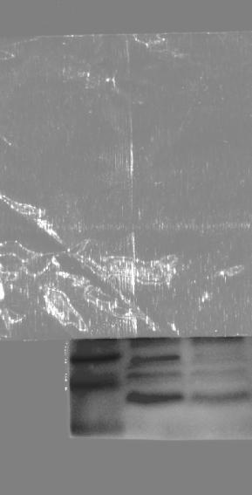

Fig.3O
TrkB | β-actin | The two images can completely coincide and prove to be the same images. | The overall image of the bright field
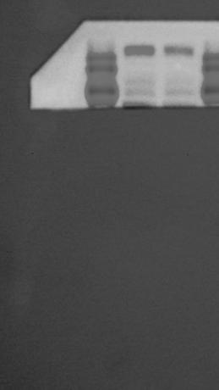 | 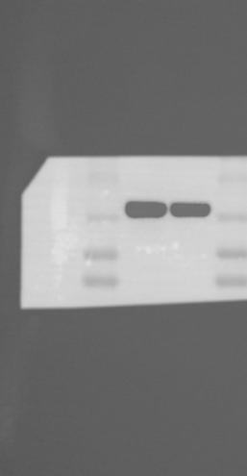 |  | 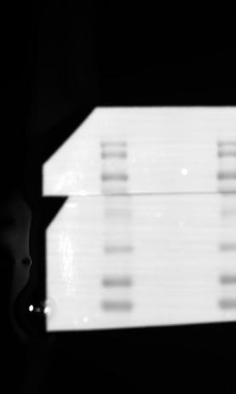

Fig.3P
p75^{NTR} | β-actin | The two images can completely coincide and prove to be the same images.
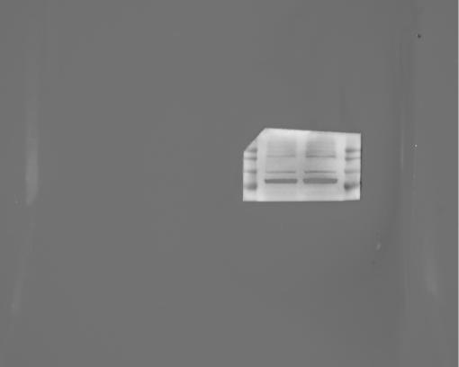 | 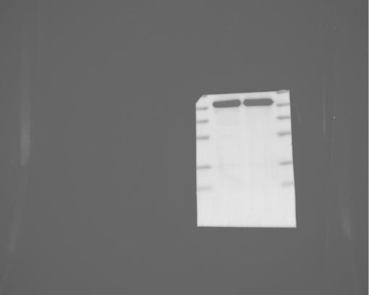

Fig.4F
proBDNF | mBDNF | The markers of the two images can completely coincide and prove to be the same image.
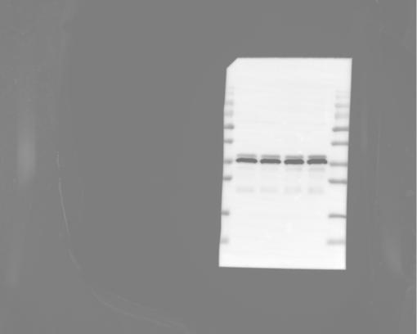 | 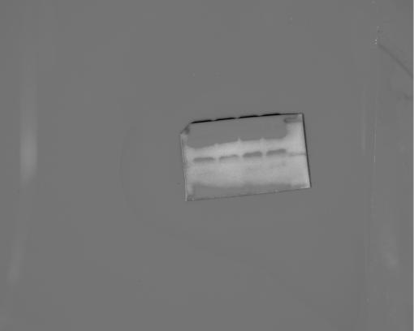

Fig.4K
p53 | β-actin | The markers of the two images can completely coincide and prove to be the same image.
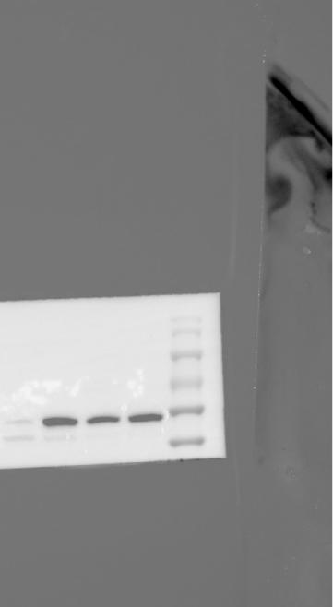 | 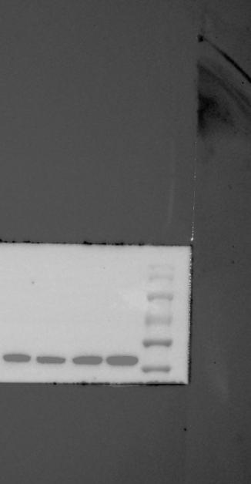

Fig.4L
p21 | β-actin | The two images can completely coincide and prove to be the same images. | The overall image of the bright field
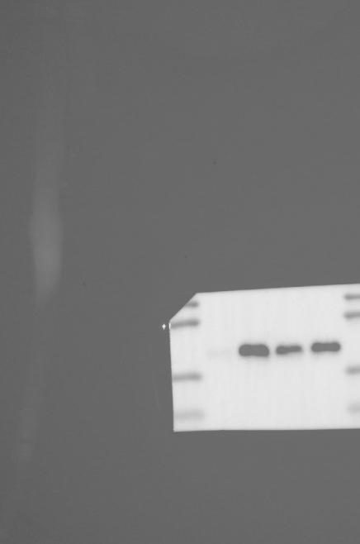 | 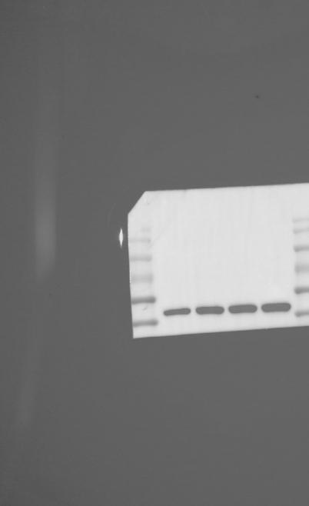 |  | 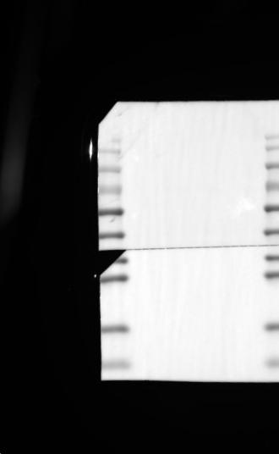

Fig.4M
bax | bcl2 | The markers of the two images can completely coincide and prove to be the same image.
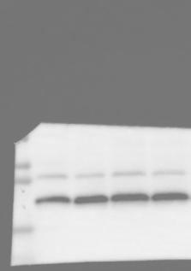 | 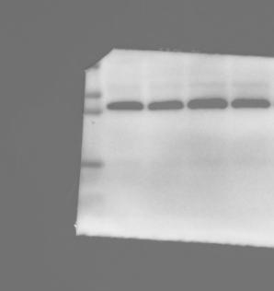

Fig.5B
Furin | β-actin | The two images can completely coincide and prove to be the same images. | The overall image of the bright field
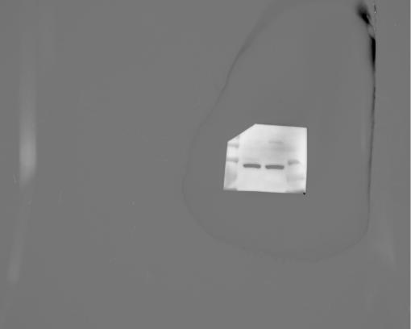 | 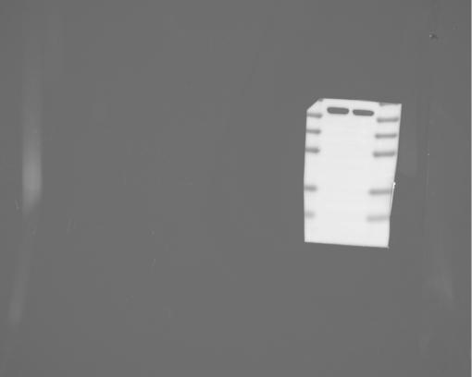 |  | 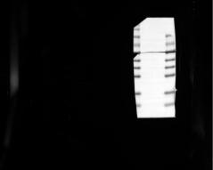

Fig.5C
tPA | β-actin | The markers of the two images can completely coincide and prove to be the same image.
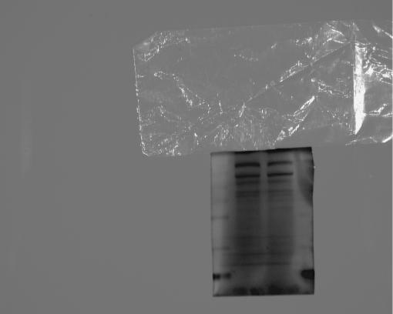 | 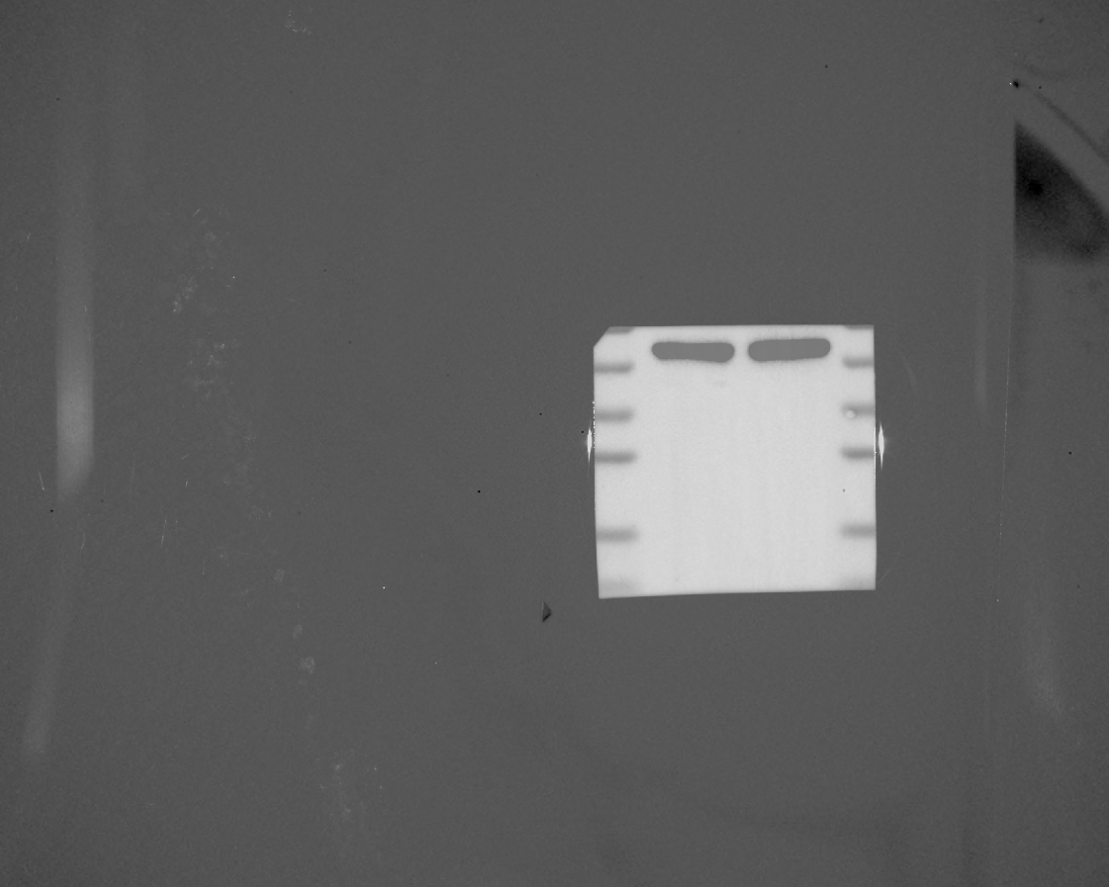

Fig.5D
MMP2 | β-actin | The two images can completely coincide and prove to be the same images. | The overall image of the bright field
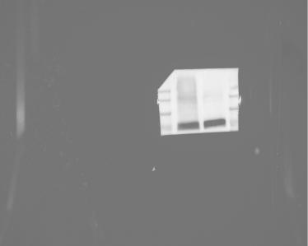 |  |  | 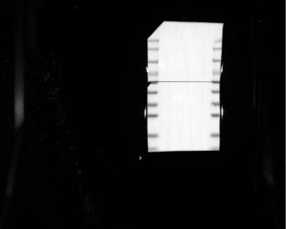

Fig.5E
MMP9 | β-actin | The two images can completely coincide and prove to be the same images.
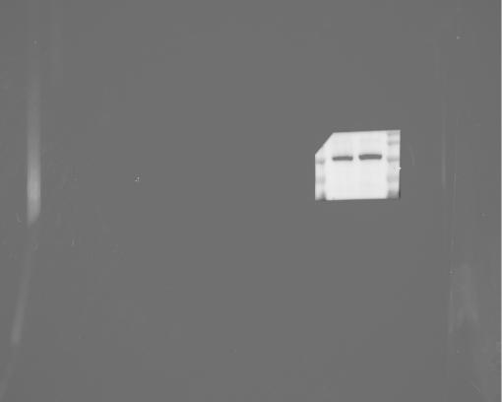 | 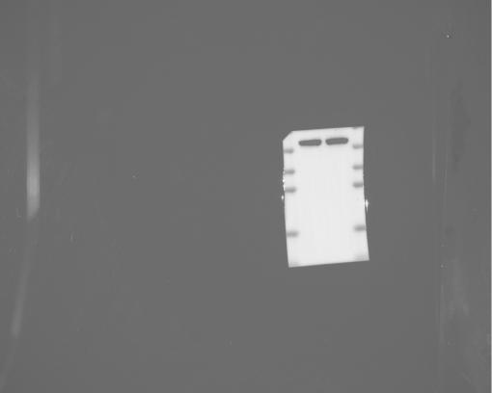

Fig.5G
PAI-1 | β-actin | The markers of the two images can completely coincide and prove to be the same image.
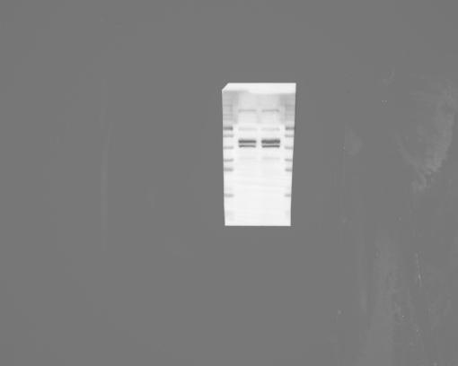 | 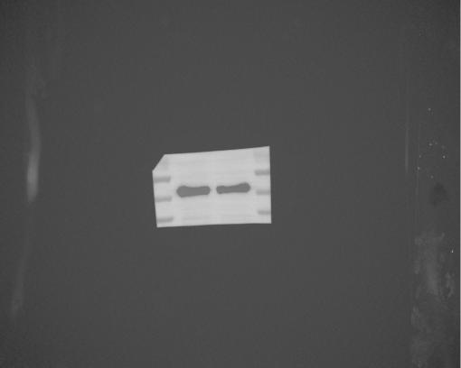

Fig.5H
tPA-PAI-1 | β-actin | The markers of the two images can completely coincide and prove to be the same image.
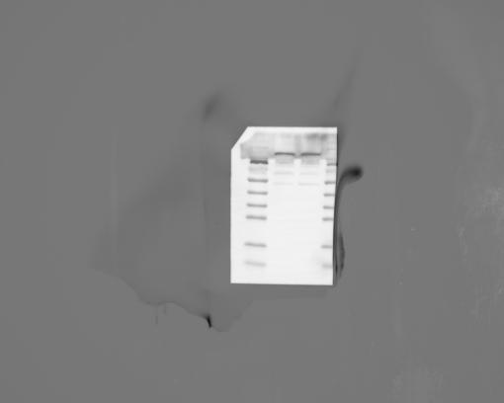 | 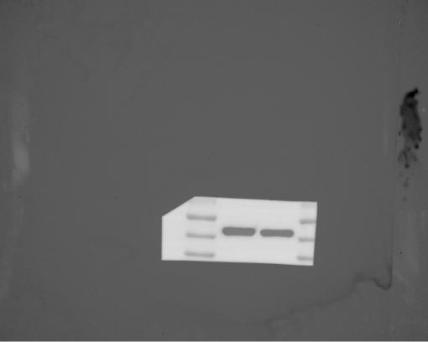

Fig.6H
p53 | β-actin | The markers of the two images can completely coincide and prove to be the same image.
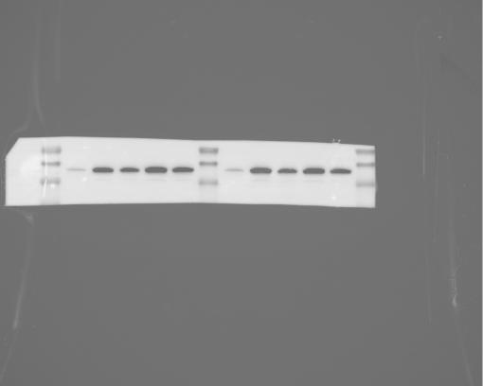 | 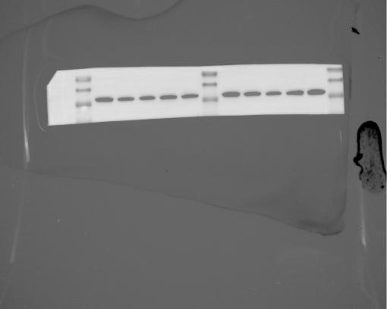

Fig.6I
p21 | β-actin | The two images can completely coincide and prove to be the same images. | The overall image of the bright field
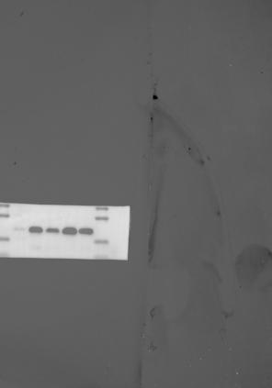 | 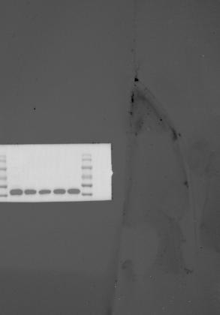 |  | 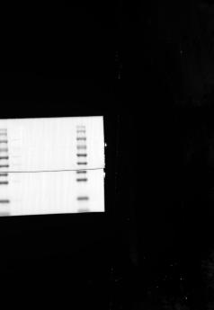

Fig.6J
bax | bcl2 | The markers of the two images can completely coincide and prove to be the same image.
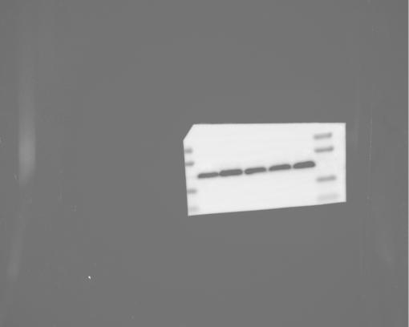 | 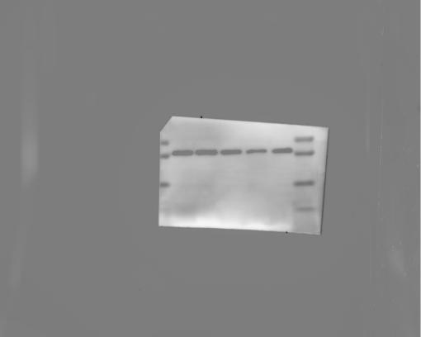

Fig.6K
proBDNF | mBDNF | The markers of the two images can completely coincide and prove to be the same image.
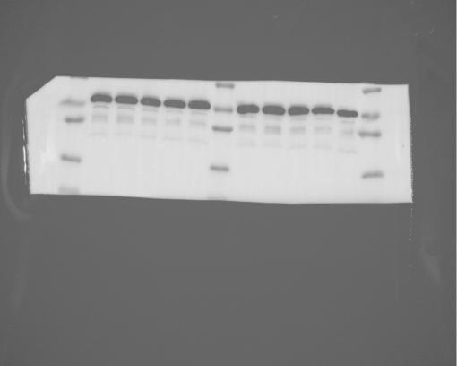 | 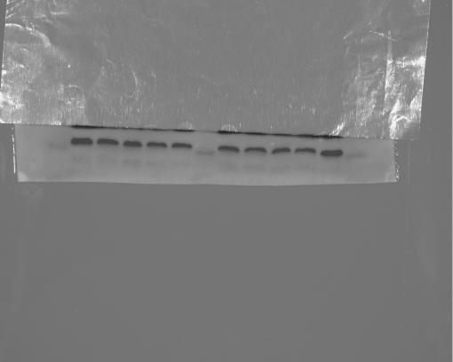

Fig.6L
tPA | β-actin | The markers of the two images can completely coincide and prove to be the same image.
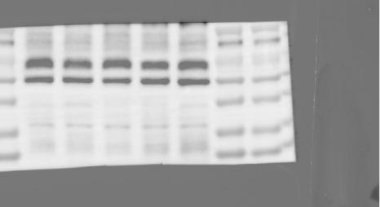 | 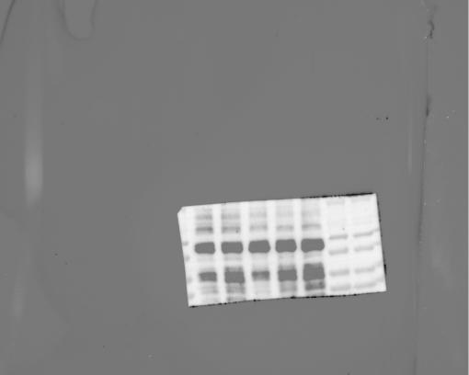

Fig.6M
PAI-1 | β-actin | The markers of the two images can completely coincide and prove to be the same image.
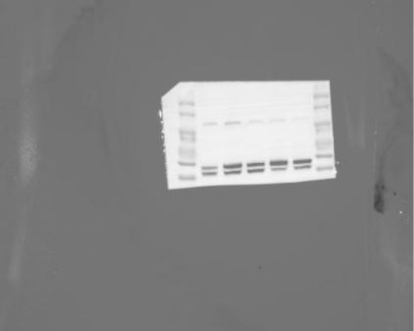 | 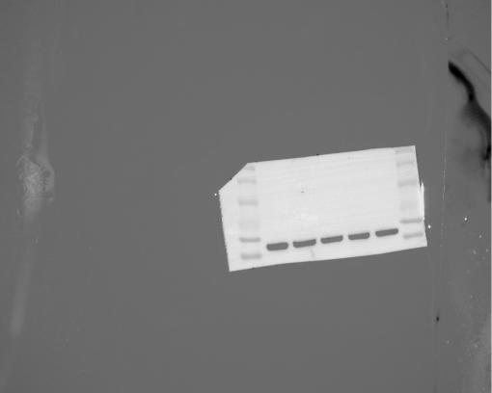

Fig.6N
tPA-PAI-1 | β-actin | The two images can completely coincide and prove to be the same images. | The overall image of the bright field
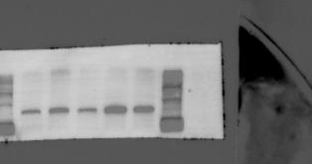 | 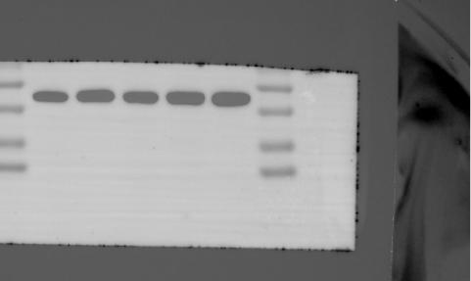 |  | 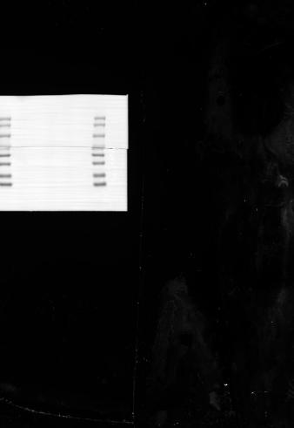

Fig.6O
tPA | β-actin | The markers of the two images can completely coincide and prove to be the same image.
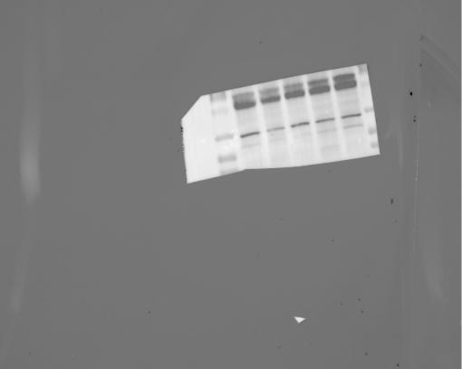 | 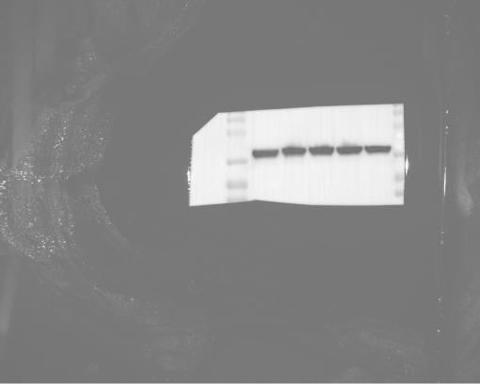

Fig.6P
PAI-1 | β-actin | The markers of the two images can completely coincide and prove to be the same image.
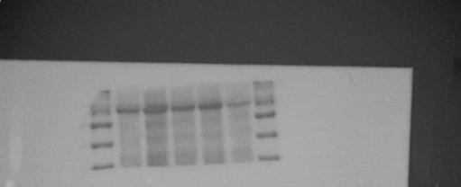 | 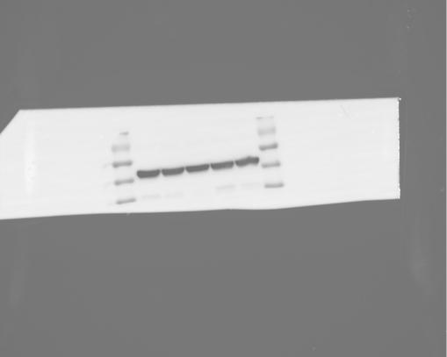

Fig.6Q
tPA-PAI-1 | β-actin | The markers of the two images can completely coincide and prove to be the same image. | The overall image of the bright field
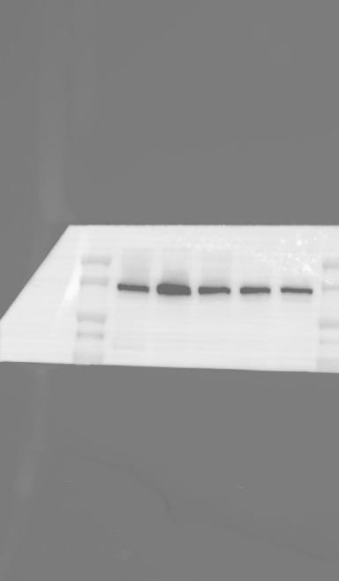 | 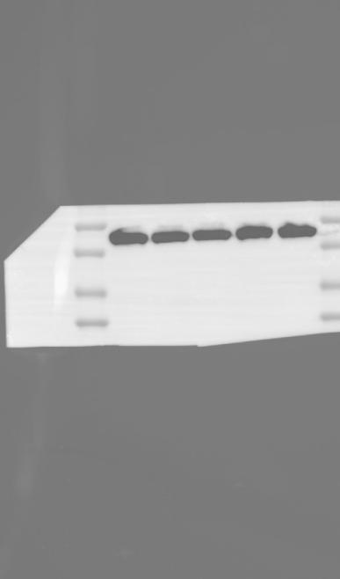 |  | 