Title
Comparing Light and Dark Chamber Measurements of CH₄ Fluxes in Drained and Rewetted Raised Bogs of Ireland.
Journal name
Wetlands Ecology and Management
Author information and affiliations
School of Architecture, Building and Environment, Technological University Dublin, Bolton Street,
Dublin 1, Ireland
Stephen Barry
Bord na Mona, Leabeg, Boora Ave, Co. Offaly, Ireland
Kenneth Crawford, Clare O’Doherty, G Heagney, Harry Kelly, Mark McCorry, Hannah Mealy, Brian Mollahan
Department of Biological Sciences & Bernal Institute, Faculty of Science and Engineering,
University of Limerick, Limerick, Ireland
Mike Clancy, Amey S. Tilak and Kenneth A. Byrne
School of Natural Sciences, Botany Discipline, Trinity College, Dublin, Ireland
Matthew Saunders
Corresponding author: Stephen Barry barry.stephen@tudublin.ie
Supplementary material 1
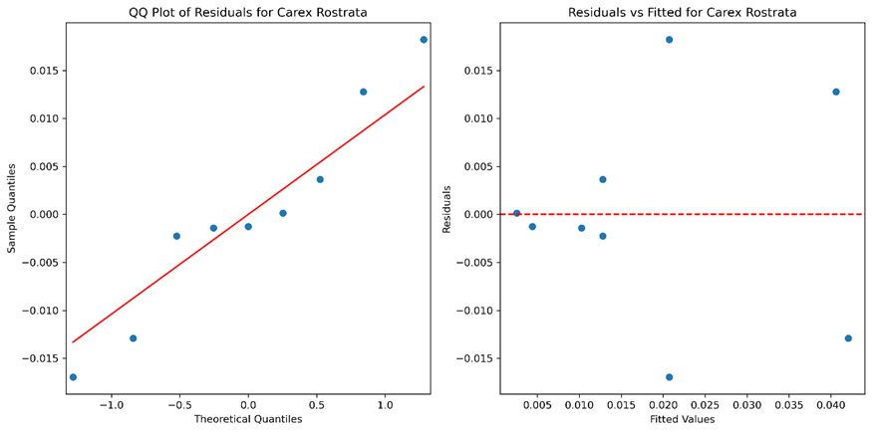

Figure S1. QQ plots and residuals vs line for Carex rostrata

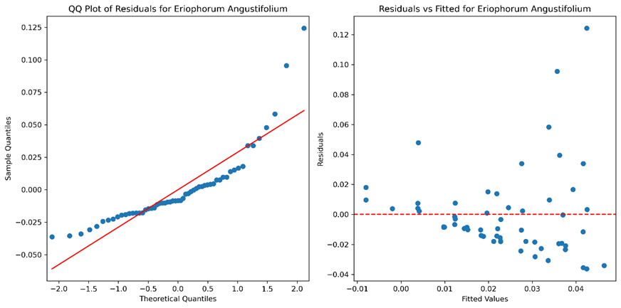
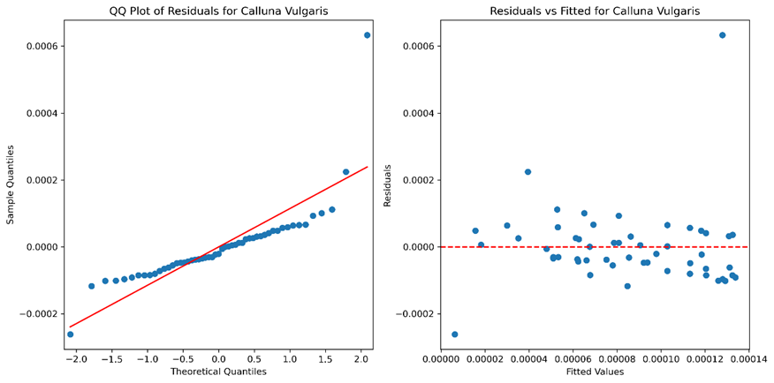
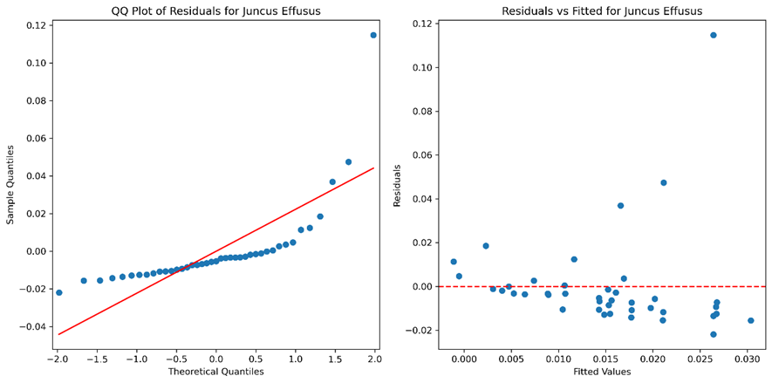
Figure S2. QQ plots and residuals vs line for Juncus effusus
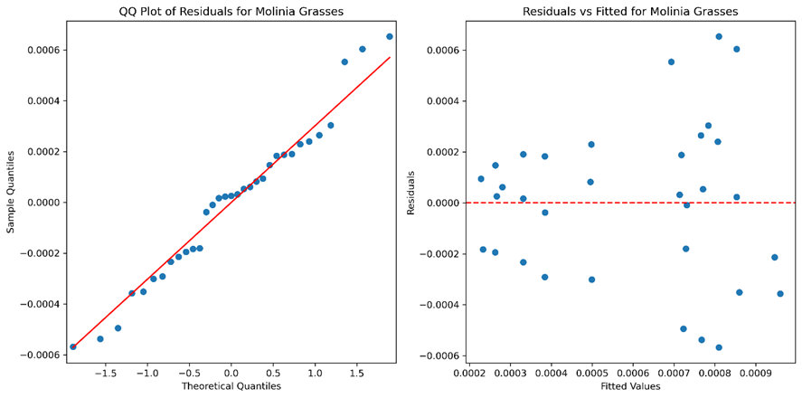
Figure S3. QQ plots and residuals vs line for Molonia caerulea

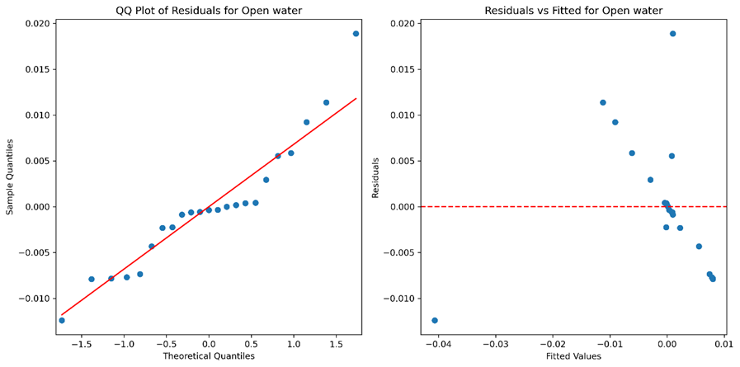
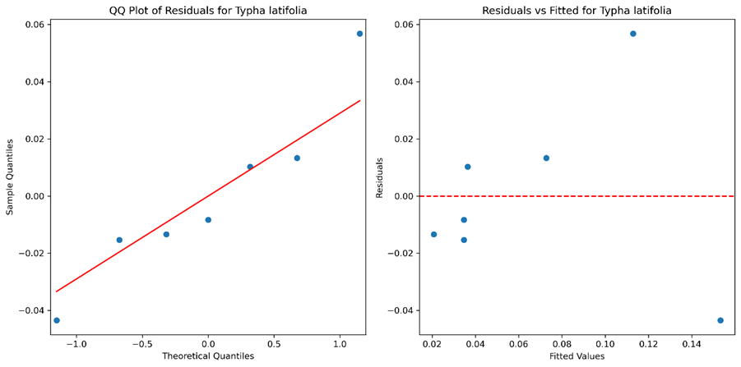
Figure S4. QQ plots and residuals vs line for Open water

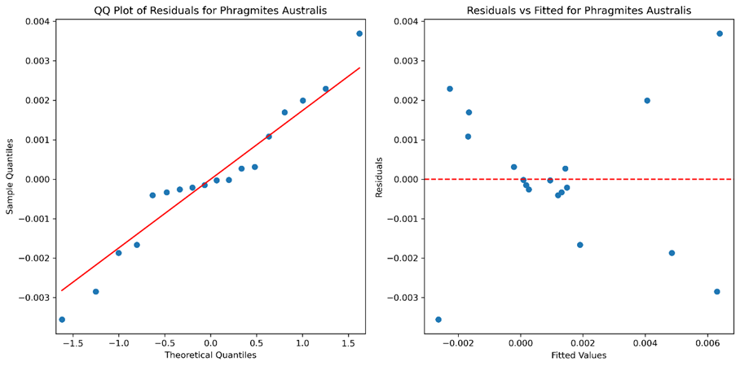
Figure S5. QQ plots and residuals vs line for Typha latifolia

Figure S6. QQ plots and residuals vs line for Phragmites australis
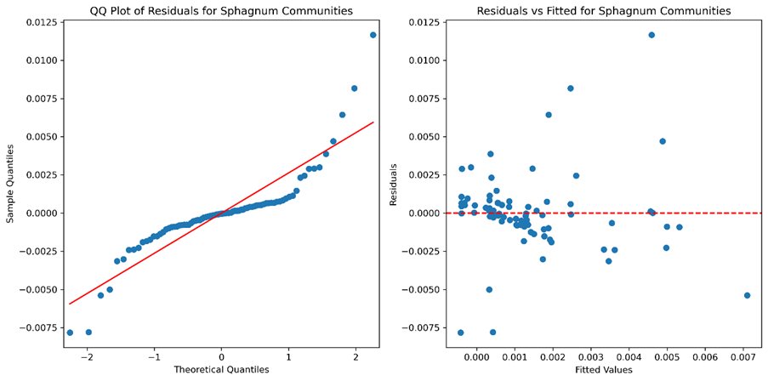

Figure S7. QQ plots and residuals vs line for Sphagnum communities

Figure S8. QQ plots and residuals vs line for Eriophorum angustifolium

Figure S9. QQ plots and residuals vs line for Calluna vulgaris
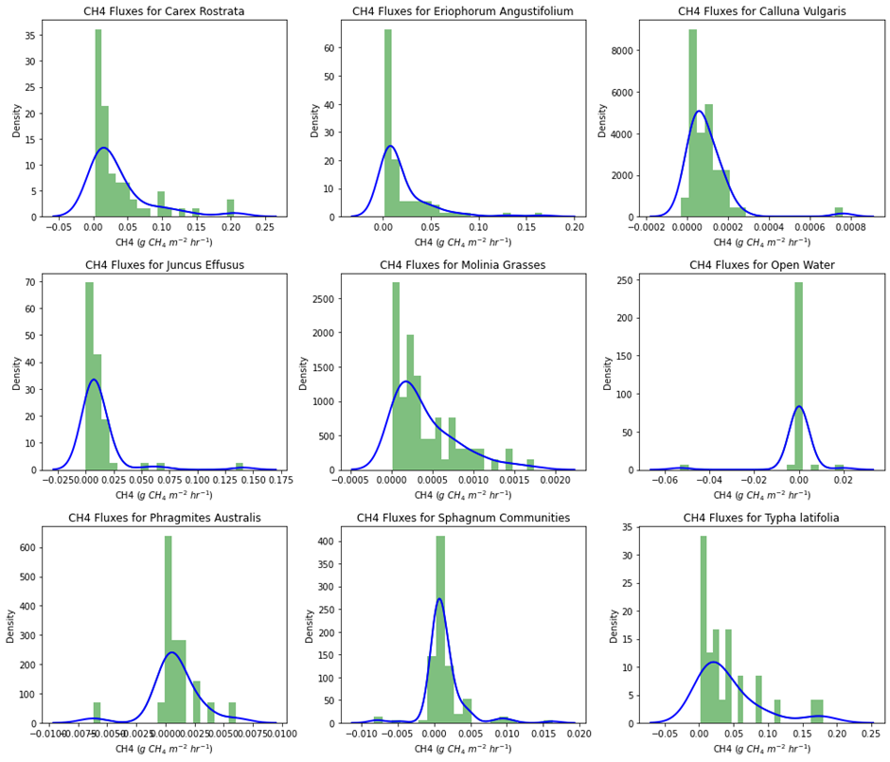

Figure S10. Histograms and Kernel Density Estimation (KDE) plots for Carex rostrata, Eriophorum angustifolium, Calluna vulgaris, Juncus effusus, Molonia caerulea, Open water, Phragmites australis, Sphagnum communities and Typha latifolia
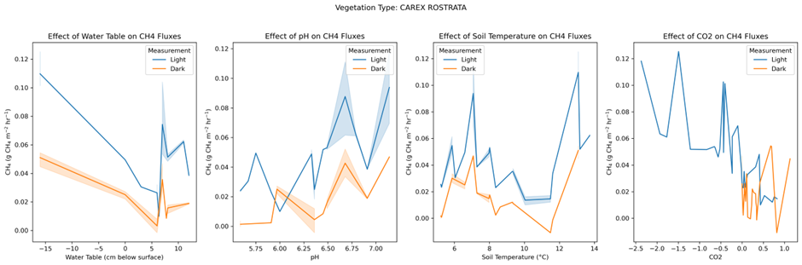

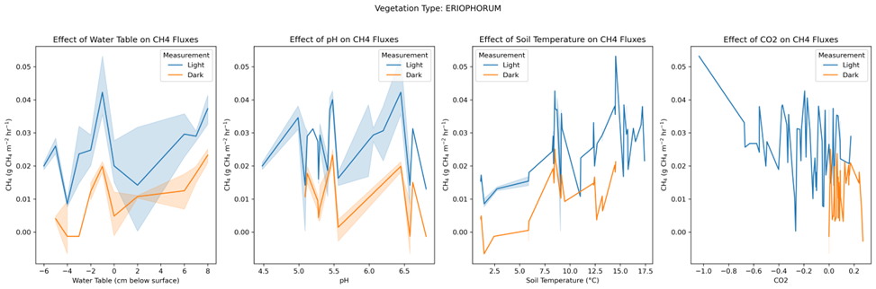
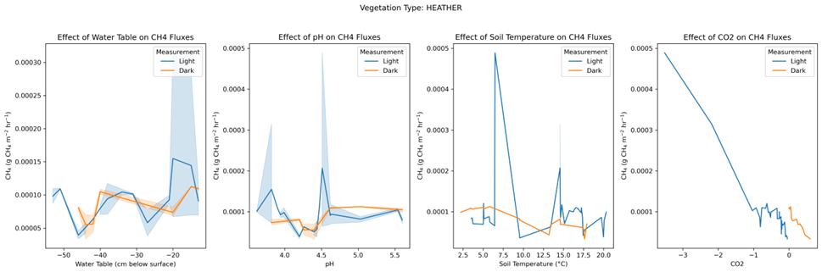

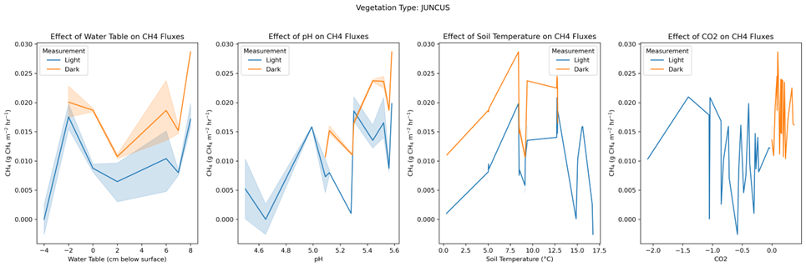

Figure S11. Comparing light and dark CH₄ fluxes for Carex rostrata, Heather, Eriophorum angustifolium and Juncus effusus vs. CO₂ flux, WTDs, pH and soil temperature

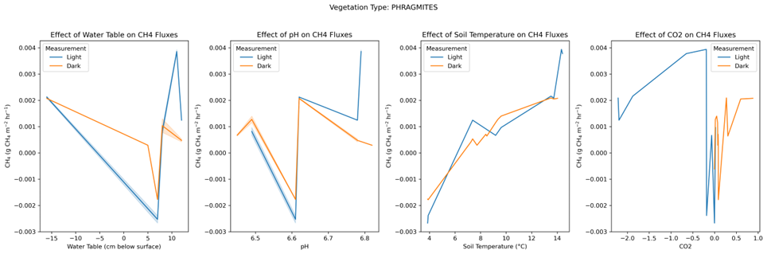
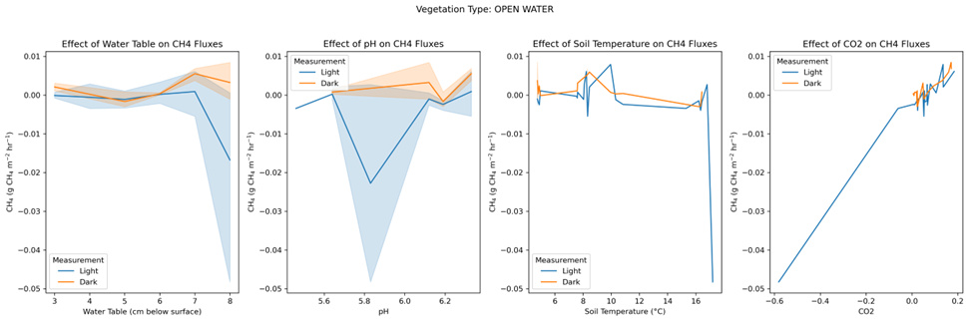

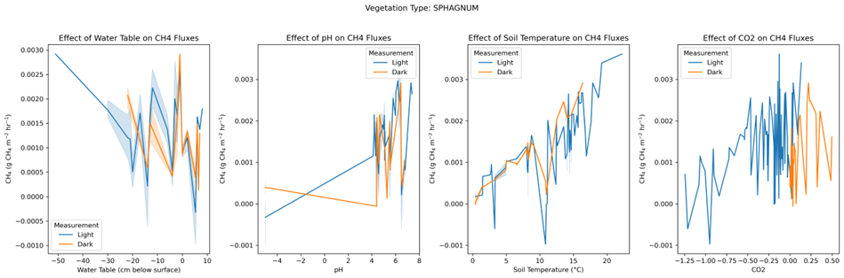
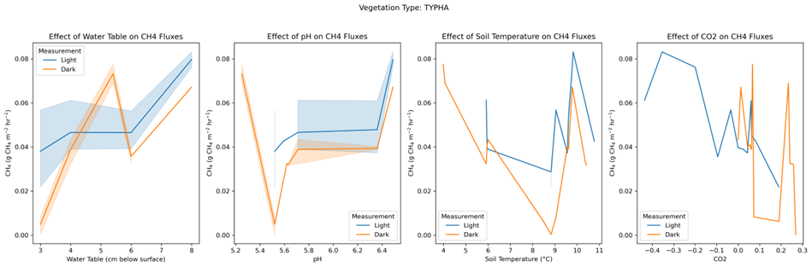

Figure S12. Comparing light and dark CH₄ fluxes for Open water, Phragmites australis, Sphagnum communities and Typha latifolia vs. CO₂ flux, WTDs, pH and soil temperature
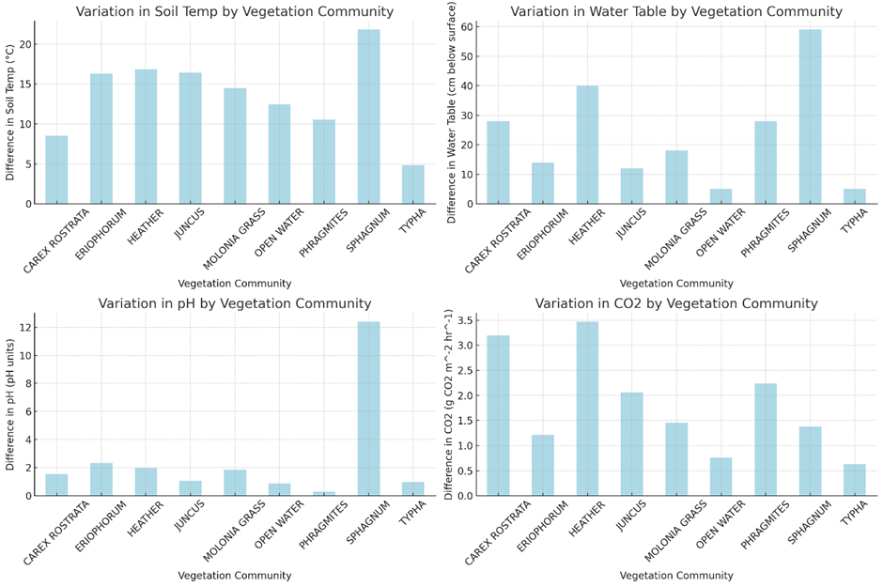
Figure S13. Measured variation in the environmental parameters for all the vegetation communities

