Supplementary tables and figures

Supplementary Table 1: High-throughput screening results
Attached separately in email
Supplementary Table 2: HIP profile
Attached separately in email
Supplementary Table 3: Strains used in this study
Strain name | Species | Strain ID | Genotype | Reference
SC5314 | C. albicans | Cat#MYA-2876 | Wild type strain, clinical Candida albicans isolate | ATCC ⁵⁹
rib1Δ/Δ | C. albicans | JN19 | SC5314 with rib1∆/∆ | ¹⁵
bioluminescent C. albicans reporter strain | C. albicans | 4222 | CIP10 NoHA + optimized firefly luciferase | ⁵³
CaSS1 | C. albicans | CaLC6106  GRACE parent strain | ura3::imm434/ura3::imm434  his3::hisG/his3::hisG  leu2::tetRGAL4ADURA/LEU2 | ^{19,21}
16ABC | S. cerevisiae | ScLC2336  Green monster | adp1Δ snq2Δ ycf1Δ pdr15Δ yor1Δ vmr1Δ pdr11Δ nft1Δ bpt1Δ ybt1Δ ynr070wΔ yol075cΔ aus1Δ pdr5Δ pdr10Δ pdr12Δ can1Δ::GMToolkit-a his3Δ1 leu2Δ0 ura3Δ0 met15Δ0 | ⁶⁰
Y14470 MATa/ MATα | S. cerevisiae | ScLC5234 | snq2Δ::Kl.LEU2/ snq2Δ::Kl.LEU2 pdr3Δ::Kl.URA3/ pdr3Δ::Kl.URA3 pdr1Δ::natMX/ pdr1Δ::natMX can1Δ::STE2prSp_his5/can1Δ::STE2prSp_his5 lyp1Δ/lyp1Δ his3Δ1/ his3Δ1 leu2Δ0/leu2Δ0 ura3Δ0/ ura3Δ0 met15Δ0/ met15Δ0 | Boone lab
CaCi-2 | C. albicans | CaLC79 | Clinical isolate | ⁶¹
CaCi-17 | C.albicans | CaLC91 | Clinical isolate | ⁶¹
CD36 | C.dubliniensis 36 | CdLC743 | Clinical isolate | ⁶²
C.tropicalis 1685 | C.tropicalis 1685 | CtLC575 | Clinical isolate | Heitman Lab
ATCC® 22019™ | C.parapsilosis | CpLC6144 | Clinical isolate | ATCC
B8441 | C. auris 0387 | CauLC5294 | Clinical isolate Clade I | ^{63,64}
C.krusei 1680 | C.krusei 1680 | CkLC571 | Clinical isolate | Heitman Lab
BG2 | C. glabrata | CgLC1002 | Clinical isolate | ⁶⁵
H99 | C. neoformans | CnLC3142 | Clinical isolate | ⁶⁶
ENO1/ENO1-GFP | C. albicans | CaLC4449 | As CaLC239, ENO1/ENO1- GFP-NAT | ⁶⁷
Human HEK 293T | Human | HEK 293T | HEK 293T | ⁶⁸
Luciferized HEK Stone et al.83 | Human | 293T U. Toronto | HEK 293T-luc Firefly luciferase, stably integrated | Cowen lab
mdr1Δ/Δ cdr1Δ/Δ cdr2Δ/Δ flu1Δ/Δ strain | C. albicans | CaLC2749 | mdr1Δ/Δ cdr1Δ/Δ cdr2Δ/Δ flu1Δ/Δ strain | ³⁴
Experimentally evolved LCB2^{G1498C} strains | C. albicans |  | mdr1Δ/Δ cdr1Δ/Δ cdr2Δ/Δ flu1Δ/Δ strain with LCB2^{G1498C} | This work
LCB2^{G1498C} (heterozygous SNP) | C. albicans | JN140;  JN141; JN142 | LCB2^{G1498C} | This work

Supplementary Table 4: plasmids
SAT1-flipper
Plasmid name | Backbone | Insert of interest | Marker | Reference
pSFS2 | / | / | Amp^{R} | ⁵⁷
pSFS2- LCB2^{G1498C} | pSFS2 | LCB2^{G1498C} | Amp^{R} | This study

Supplementary Table 5: primers
Primer name | Sequence 5’ to 3’
Haploinsufficiency profiling in C. albicans
Universal UPTAG primer | AATGATACGGCGACCACCGAGATCTACACCGAGGTCGAGAATGATGTCCACGAGGTCTCT
UPTAG indexed (with XXXXXX containing specific index nucleotides) | CAAGCAGAAGACGGCATACGAGATXXXXXXGCCATTTGTCTGTCGACCTGCAGCGTACG
Universal DOWNTAG primer | AATGATACGGCGACCACCGAGATCTACACCACATGATATGTTGAGCGGTGTCGGTCTCGTAG
DOWNNTAG indexed (with XXXXXX containing specific index nucleotides) | CAAGCAGAAGACGGCATACGAGATXXXXXXGAGTATCTGTATCTGGCCGAGCTCGAATTCATCGAT
UPTAG barcode sequencing primer | CGAGGTCGAGAATGATGTCCACGAGGTCTCT
DOWNTAG barcode sequencing primer | CACATGATATGTTGAGCGGTGTCGGTCTCGTAG
UPTAG index sequencing primer | CGTACGCTGCAGGTCGACAGACAAATGGC
DOWNTAG index sequencing primer | ATCGATGAATTCGAGCTCGGCCAGATACAGATACTC
Haploinsufficiency profiling in S. cerevisiae
HIP UP-TAG universal amplification primer | AATGATACGGCGACCACCGAGATCTACACCGAGGTCGAGAATGATGTCCACGAGGTCTCT
HIP UP-TAG index amplification primer (with NNNNNN containing specific index nucleotides) | CAAGCAGAAGACGGCATACGAGATNNNNNNGCCATTTGTCTGTCGACCTGCAGCGTACG
HIP DOWN-TAG universal amplification primer | AATGATACGGCGACCACCGAGATCTACACCACATGATATGTTGAGCGGTGTCGGTCTCGTAG
HIP DOWN-TAG index amplification primer (with NNNNNN containing specific index nucleotides) | CAAGCAGAAGACGGCATACGAGATNNNNNNGAGTATCTGTATCTGGCC GAGCTCGAATTCATCGAT
HIP UP-TAG sequencing primer | CGAGGTCGAGAATGATGTCCACGAGGTCTCT
HIP DOWN-TAG sequencing primer | CACATGATATGTTGAGCGGTGTCGGTCTCGTAG
HIP UP-TAG index sequencing primer | CGTACGCTGCAGGTCGACAGACAAATGGC
Resistant strain development and sequencing
Seq fw LCB1 1 | TGTGTGTGTGTGTGTGTACTTGG
Seq fw LCB1 2 | GCTCCTTTGGTCAATGAGG
Seq fw LCB1 3 | AGAGAACAATTGAATTTGCC
Seq rv LCB1 4 | CAGCAATGCTCACGATATCG
Seq fw LCB2 1 | CCCCACATTCGTTTACTTATCC
Seq fw LCB2 2 | TTGTGGAACCACTGATTTGC
Seq rv LCB2 3 | GATTTTCTTGAAAGTCTAGGCG
LCB2 fw upstream snp | AAGGGAACAAAAGCTGGGTACCGGGCCCCAGCAACCCCCTTGACGAGTCCACGTGCCAGATTATGTGTC
LCB2 rv upstream | TATTCTCTAGAAAGTATAGGAACTTCCTCGAGTTACATTAGTTTTGGTTTTT
LCB2 fw downstream | GAACTTCAGATCCACTAGTTCTAGAGCGGCCGCTTTCCTTTTTTATGGTTTTTTGCAC
LCB2 rv downtream | CGACTCACTATAGGGCGAATTGGAGCTCTCTACAGACTTTTCCCATAT
SNIPyes LCB2 rv | ACTGACACATAATCTGGAAG
SNIPno LCB2 rv, | ACTGACACATAATCTGGAAC
LCB2 fw | AGGAAGAGGGATTTGTGATT
LCB2 rv snp check | CAATCTTCGACATTAGTAGC

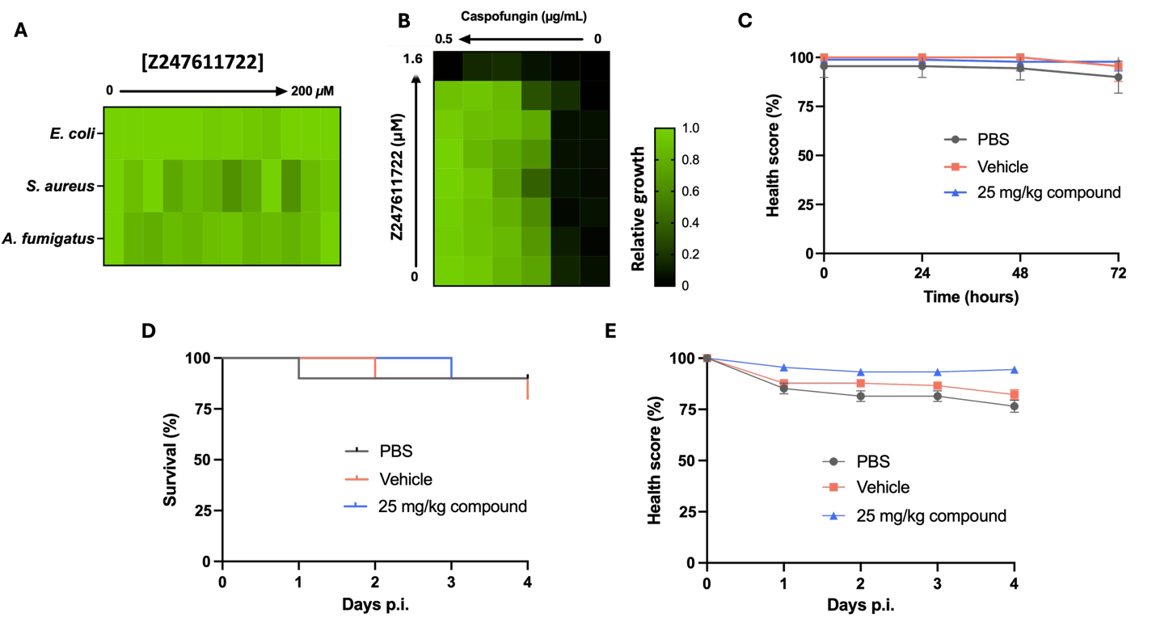

Supplementary Figure 1: (A) The antifungal activity of compound Z247611722 was tested against E.coli, S. aureus, and A. fumigatus in a two-fold BDA. The absorbance was measured after 48h. Technical repeats were averaged, and the relative growth was depicted. (B) A checkerboard assay was performed to assess the interaction between Z247611722 and caspofungin. The absorbance at 600 nm was measured after 48 h. Technical repeats were averaged, and the relative growth was depicted. The combination of the two compounds showed an FIC₈₀ of 1.016, indicating an indifferent interaction between the two compounds. (C) Health scores of G. mellonella injected with either 25 mg/kg compound, vehicle (4.88% DMSO) or PBS. The larvae were monitored for 72h. Ten 6th-instar larvae of 300 ± 50 mg were randomly selected in each group. The mean ± SEM is shown. (D) Survival of larvae injected with 5 x 10⁴ cells/larvae and monitored for up to 4 days p.i.. Larvae were either treated with compound or received the vehicle or PBS control. Ten 6th-instar larvae of 300 ± 50 mg were randomly selected in each group. (E) Health scores of G. mellonella from the same experiment shown in panel D. For larvae that died during the experiment, the final recorded values prior to death were retained in the graphical representation to minimize visual survival bias. The represents mean ± SEM.

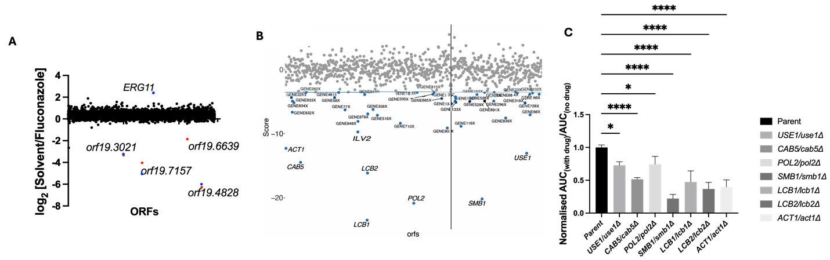
Supplementary Figure 2: (A) C. albicans HIP profile of fluconazole, quality control for C. albicans HIP. A double-barcoded heterozygous deletion mutant library was cultured in the presence and absence of 0.312 µg/mL fluconazole. Genomic DNA was extracted, and the barcodes were amplified via PCR and subsequently pooled for sequencing to evaluate the abundance of every heterozygous strain. (B) A library of heterozygous S. cerevisiae deletion strains was cultured in the presence and absence of 40 µM Z247611722 and harvested after 48h. The relative abundance of each strain was determined using high-throughput sequencing of the strain-specific PCR-amplified barcodes. Negative values are more hypersensitive. (C) Hits were validated in growth assays with the corresponding heterozygous mutants in SC medium for 24h at 30°c. The AUC was calculated, and the ratio of AUC with compound and without compound was normalized to the parental control. The mean of three technical repeats is shown, and statistical analysis was performed using one-way ANOVA with Bonferroni correction. *, p < 0.05; ****, P < 0.0001.

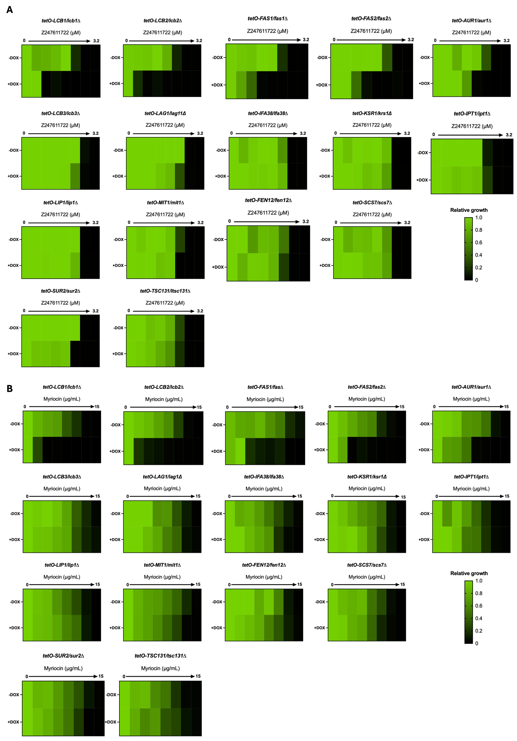
Supplementary Figure 3: Mutants from the GRACE collection involved in the sphingolipid biosynthetic pathway were tested in the presence and absence of doxycycline (DOX) in a dose-response assay with (A) compound Z247611722 and (B) myriocin.

