Health Literacy and Its Association with Non-Communicable Disease Risk Factors Among Gurkha Veterans: Insights from Western Nepal

Information about this questionnaire and how to fill it in
This questionnaire contains two parts.
In Part 1 you are asked to indicate how strongly you disagree or agree with a set of statements.
In Part 2 you are asked to indicate how difficult or easy you find a set of tasks. For each statement or task check the box that best describes you now
Please ensure that you check a box for every statement or task.

Part 1 of the questionnaire starts here
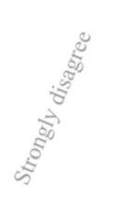
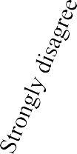

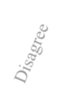



Please indicate how strongly you disagree or agree with each of the following statements. Remember to check only one box for each statement.

1 | I feel I have good information about health | □ □ □ □
2 | I have at least one healthcare provider who knows me well | □ □ □ □
3 | I can get access to several people who understand and support me | □ □ □ □
4 | I compare health information from different sources | □ □ □ □
5 | When I feel ill, the people around me really understand what  I am going through | □ □ □ □
6 | I spend quite a lot of time actively managing my health | □ □ □ □
7 | When I see new information about health, I check up on whether it is true or not | □ □ □ □

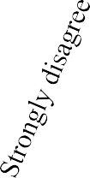

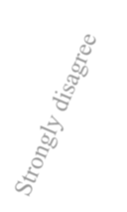

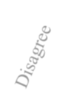
Part 1 continued

Please indicate how strongly you disagree or agree with each of the following statements. Remember to check only one box for each statement.

8 | I have at least one healthcare provider I can discuss my health problems with | □ □ □ □
9 | I make plans for what I need to do to be healthy | □ □ □ □
10 | I have enough information to help me deal with my health problems | □ □ □ □
11 | If I need help, I have plenty of people I can rely on | □ □ □ □
12 | I always compare health information from different sources and decide what is best for me | □ □ □ □
13 | Despite other things in my life, I make time to be healthy | □ □ □ □
14 | I am sure I have all the information I need to manage my health effectively | □ □ □ □
15 | I have at least one person who can come to medical appointments with me | □ □ □ □
16 | I know how to find out if the health information I receive is right or not | □ □ □ □
17 | I have the healthcare providers I need to help me work out what I need to do | □ □ □ □
18 | I set my own goals about health and fitness | □ □ □ □
19 | I have strong support from family or friends | □ □ □ □
20 | I ask healthcare providers about the quality of the health information I find | □ □ □ □
21 | There are things that I do regularly to make myself more healthy | □ □ □ □
22 | I can rely on at least one healthcare provider | □ □ □ □
23 | I have all the information I need to look after my health | □ □ □ □

Please continue to the next page.

Part 2 of the questionnaire starts here

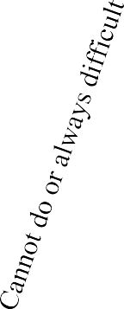


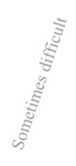
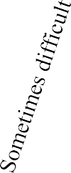

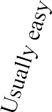
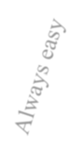
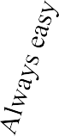
Please indicate how difficult or easy the following tasks are for you now. Remember to check only one box for each statement.

1 | Find the right health care | □ □ □ □ □
2 | Make sure that healthcare providers understand your problems properly | □ □ □ □ □
3 | Find information about health problems | □ □ □ □ □
4 | Feel able to discuss your health concerns with a healthcare provider | □ □ □ □ □
5 | Confidently fill medical forms in the correct way | □ □ □ □ □
6 | Find health information from several different places | □ □ □ □ □
7 | Have good discussions about your health with doctors | □ □ □ □ □
8 | Get to see the healthcare providers you need to | □ □ □ □ □
9 | Accurately follow instructions from healthcare providers | □ □ □ □ □
10 | Get information about health so you are up to date with the best information | □ □ □ □ □
11 | Decide which healthcare provider you need to see | □ □ □ □ □
12 | Read and understand written health information | □ □ □ □ □
13 | Make sure you find the right place to get the health care you need | □ □ □ □ □

Please continue to the next page.


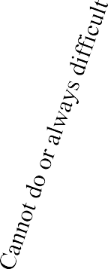



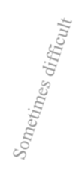
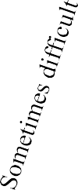

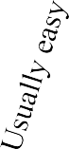
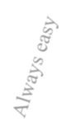
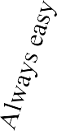
Please indicate how difficult or easy the following tasks are for you now. Remember to check only one box
for each statement.

14 | Get health information in words you understand | □ □ □ □ □
15 | Discuss things with healthcare providers until you understand all you need to | □ □ □ □ □
16 | Find out which healthcare services you are entitled to | □ □ □ □ □
17 | Read and understand all the information on medication labels | □ □ □ □ □
18 | Get health information by yourself | □ □ □ □ □
19 | Work out what the best care is for you | □ □ □ □ □
20 | Ask healthcare providers questions to get the health information you need | □ □ □ □ □
21 | Understand what healthcare providers are asking you to do | □ □ □ □ □

Thank you for completing this questionnaire.

