Supplemental Material

Neurofilament Light Chain as a Key Predictor of Cognitive Function and Mortality in Centenarians:
A Study of Plasma Neural Biomarkers in Aging

Ryo Shikimoto, Takashi Sasaki, Yukiko Abe, Kenji Tai, Nobuyoshi Hirose, Hideyuki Okano, Yasumichi Arai
Table of Contents

Supplementary Figure 1 | Association of plasma levels of amyloid-β40, amyloid-β42, the amyloid-β42/amyloid-β40 ratio, pTau181, and NfL with cognitive decline defined as a Clinical Dementia Rating (CDR) score of 0.5 or greater …………….………………………..………..………..……… | 3
Supplementary Figure 2 | Heatmap of Associations Between Blood Biomarkers and Clinical Variables ……………………………………………………………... | 4
Supplementary Figure 3 | Heatmap of Associations Between MMSE scores and Blood Biomarkers ……………………………………….…….…….…….… | 5
Supplementary Figure 4 | Kaplan-Meier Survival analysis, A. Clinical Dementia Rating score… | 6
Supplementary Figure 5 | Kaplan-Meier Survival analysis, B. Amyloid-β40……………………. | 7
Supplementary Figure 6 | Kaplan-Meier Survival analysis, C. Amyloid-β42……………………. | 8
Supplementary Figure 7 | Kaplan-Meier Survival analysis, D. Amyloid-β 42/40 ratio………….. | 9
Supplementary Figure 8 | Kaplan-Meier Survival analysis, E. pTau181………………………… | 10
Supplementary Figure 9 | Kaplan-Meier Survival analysis, F. Neurofilament Light Chain……... | 11
Supplementary Table 1 | Cox Regression Adjusted Hazard Ratios with Hemoglobin and Estimated Glomerular Filtration Rate as Covariates .………………… | 6

Supplementary Figure 1. Association of plasma levels of amyloid-β40, amyloid-β42, the amyloid-β42/amyloid-β40 ratio, pTau181, and NfL with cognitive decline defined as a Clinical Dementia Rating (CDR) score of 0.5 or greater (N=307)

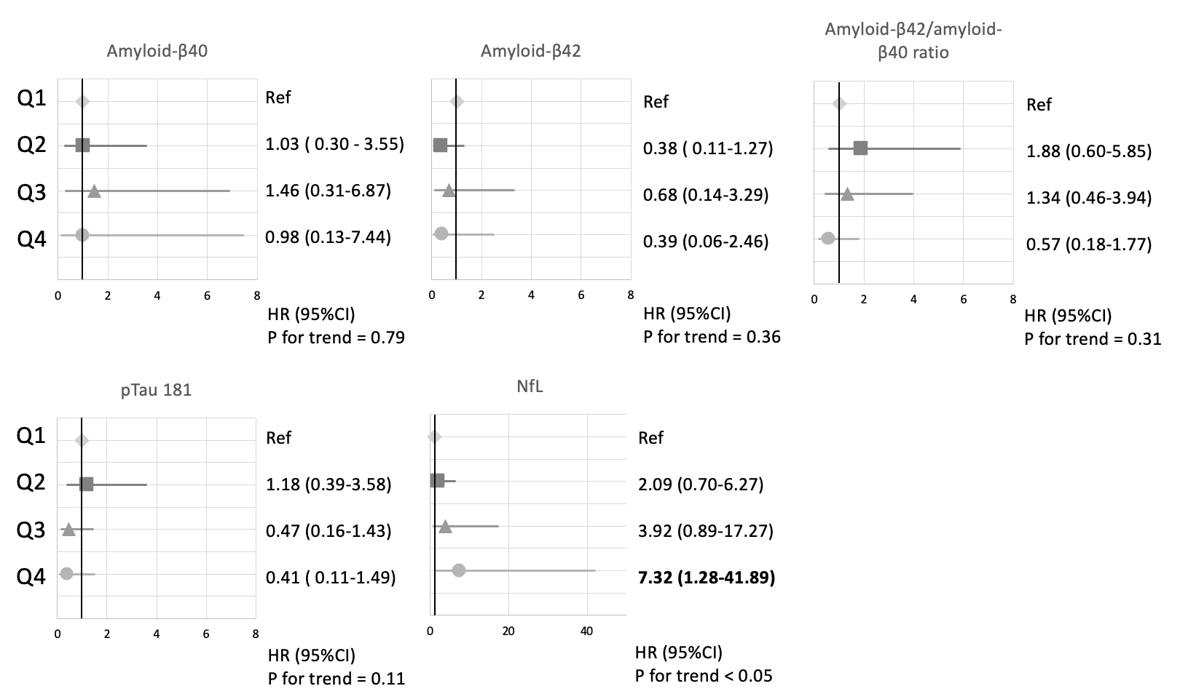
Supplementary Figure 2. Heatmap of Associations Between Blood Biomarkers and Clinical Variables
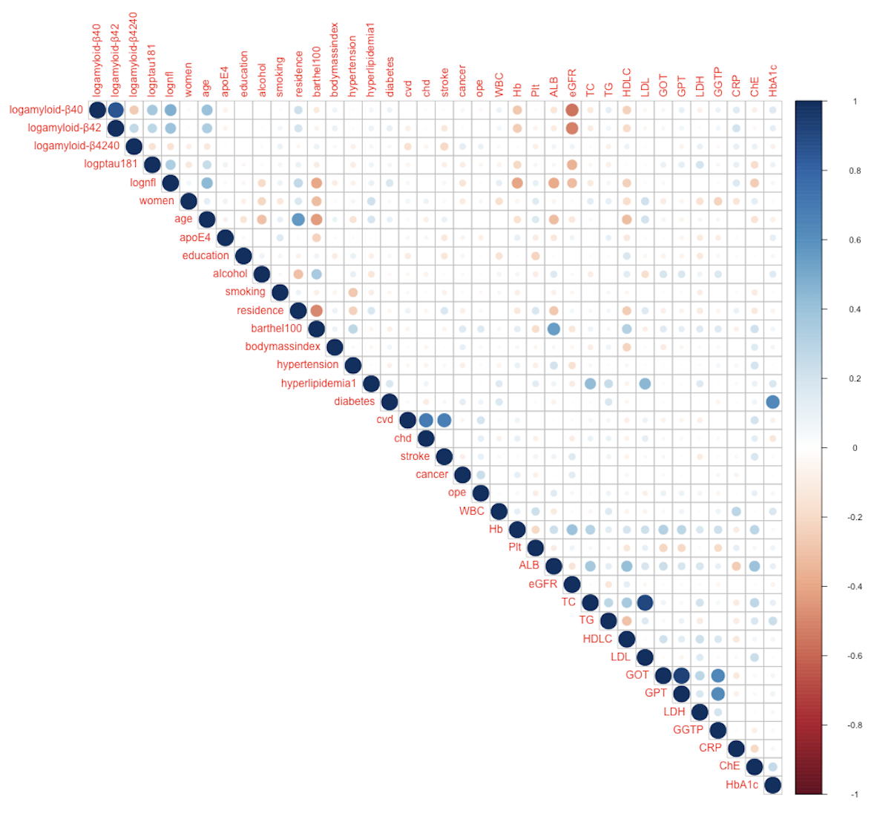
The relationships between selected clinical and biochemical variables were assessed using pairwise correlation analysis.
A heterogeneous correlation approach was applied to account for differing data types (e.g., continuous, ordinal, and categorical variables). Correlation coefficients, ranging from −1 to +1, represent the strength and direction of linear or monotonic relationships. Positive values indicate positive associations, negative values indicate inverse associations, and values near zero suggest weak or no association. The heatmap displays the correlation coefficients, with color intensity reflecting the strength of association between variable pairs.
logamyloid-β40, log-transformed amyloid-β40; logamyloid-β42, log-transformed amyloid-β42; logamyloid-β4042, log-transformed amyloid-β42/amyloid-β40 ratio; logptau181, log-transformed phosphorylated Tau 181; lognfl, log-transformed Neurofilament Light Chain; cvd, Cerebro Vascular Disease; chd, Chronic Heart Disease; WBC, white blood cells; Hb, hemoglobin; Plt, platelet; ALB, albumin; eGFR, estimated glomerular filtration rate; TC, total cholesterol; TG, triglyceride; HDLC, high-density lipoprotein cholesterol; LDL, low-density lipoprotein cholesterol; GOT, glutamate oxaloacetate transaminase; GPT, glutamate pyruvate transaminase; LDH, lactate dehydrogenase; GGTP, γ-glutamyl transpeptidase; CRP, C-reactive protein; ChE, cholinesterase, HbA1c, hemoglobin A1c.

Supplementary Figure 3. Heatmap of Associations Between MMSE scores and Blood Biomarkers
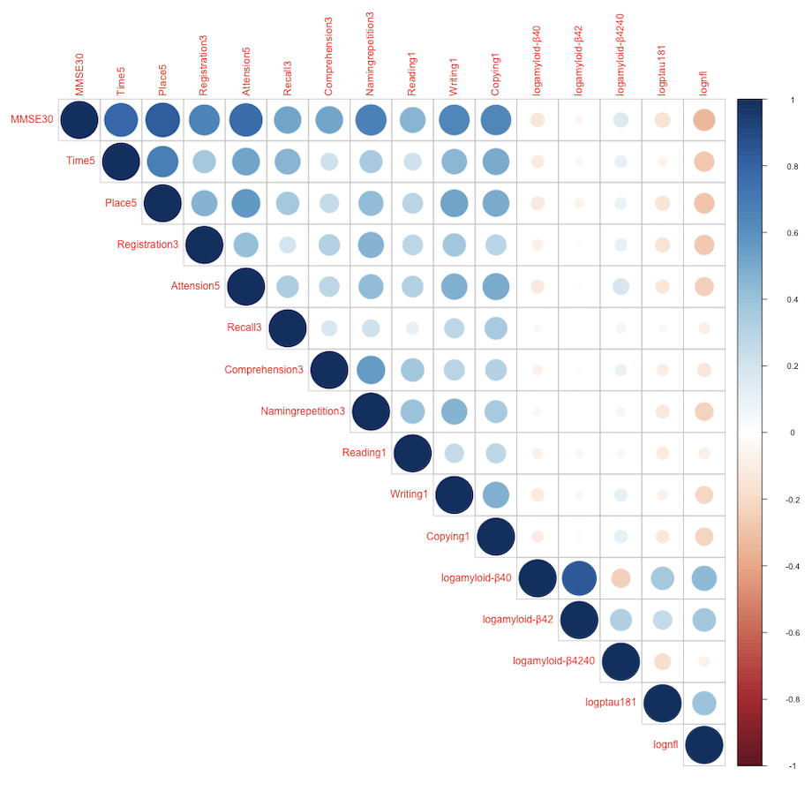
The relationships between selected clinical and biochemical variables were assessed using pairwise correlation analysis.
A heterogeneous correlation approach was applied to account for differing data types (e.g., continuous, ordinal, and categorical variables). Correlation coefficients, ranging from −1 to +1, represent the strength and direction of linear or monotonic relationships. Positive values indicate positive associations, negative values indicate inverse associations, and values near zero suggest weak or no association. The heatmap displays these correlation coefficients, with color intensity reflecting the strength of association between variable pairs. Time5, Time orientation (5-point scale); Place5, Place orientation (5-point scale); Registration3, memory encoding (3-point scale); Attention5, attention and calculation (5-point scale); Recall3, memory retrieval (3-point scale); Comprehension3, language comprehension (3-point scale); Namingrepetition3, naming and repetition(3-point scale); Reading1, reading ability(1-point scale); Writing, writing ability(1-point scale); copying, copying ability(1-point scale); logamyloid-β40, log-transformed amyloid-β40; logamyloid-β42, log-transformed amyloid-β42; logamyloid-β4042, log-transformed amyloid-β42/amyloid-β40 ratio; logptau181, log-transformed phosphorylated Tau 181; lognfl, log-transformed Neurofilament Light Chain.

Supplementary Figure 4. Kaplan-Meier Survival analysis
- Clinical Dementia Rating score (p=0.03)
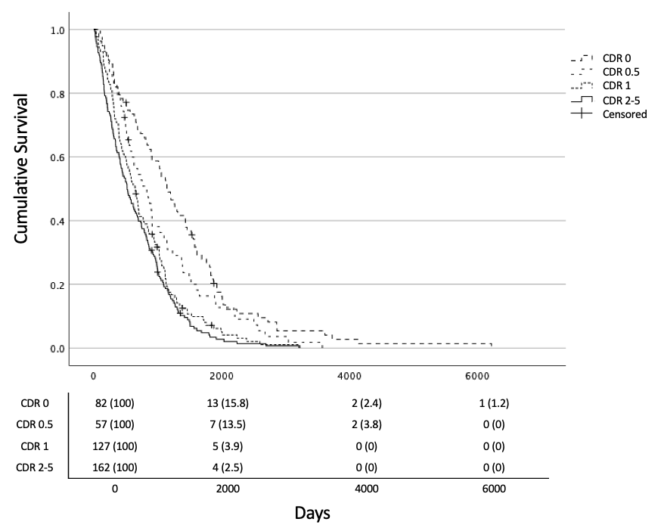
This figure shows the Kaplan-Meier survival curves for different biomarkers associated with survival in centenarians. Each panel illustrates the relationship between a specific biomarker and survival outcomes, with corresponding p-values provided for statistical significance.
* Follow-up duration ranged from 15 to 6,223 days (mean: 850.95 ± 732.63 days).
* Of the 495 centenarians, 486 completed follow-up. There were 9 missing cases: 3 with unknown survival status and follow-up duration, 4 with unknown status, and 2 with unknown duration.
* During the follow-up period, 466 participants (95.9%) died, and 20 were censored.
* The CDR score was categorized into four levels: 0, 0.5, 1, and 2-5.
* CDR, Clinical Dementia Rating

Supplementary Figure 5. Kaplan-Meier Survival analysis
B. Amyloid-β40 (p=0.64)
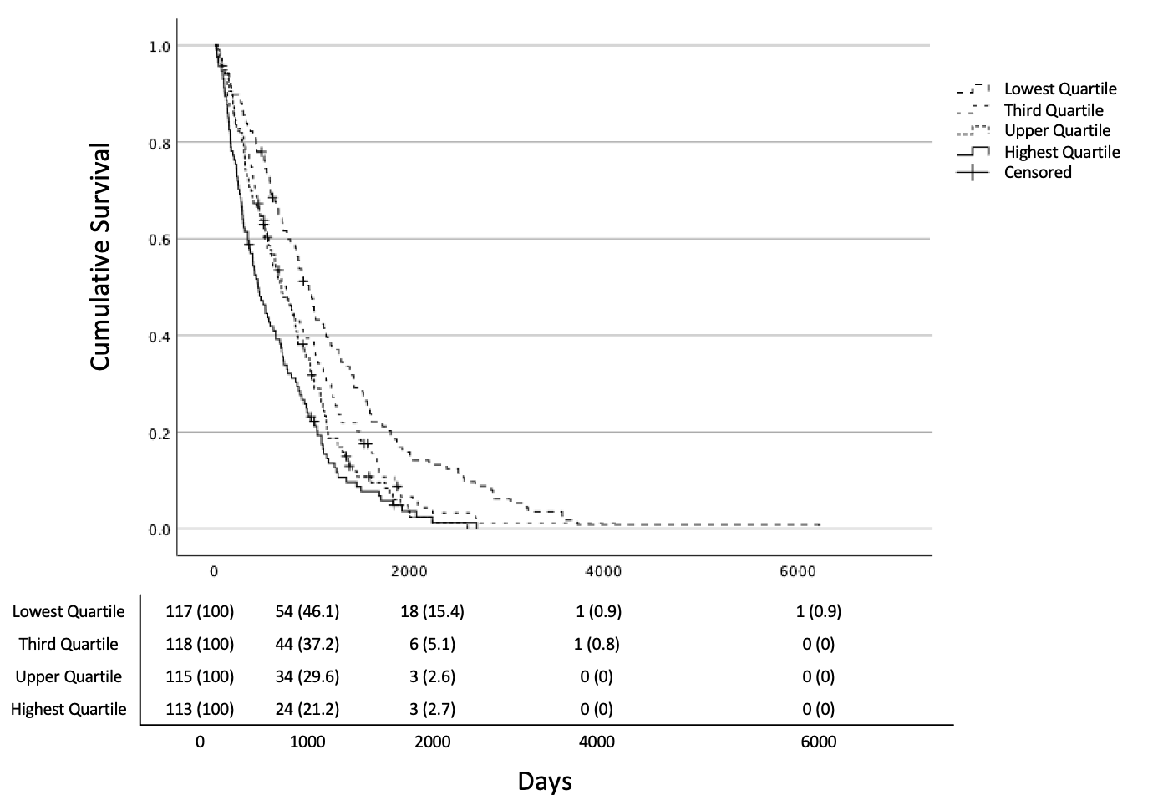
This figure shows the Kaplan-Meier survival curves for different biomarkers associated with survival in centenarians. Each panel illustrates the relationship between a specific biomarker and survival outcomes, with corresponding p-values provided for statistical significance.
* Follow-up duration ranged from 15 to 6,223 days (mean: 850.95 ± 732.63 days).
* Of the 495 centenarians, 486 completed follow-up. There were 9 missing cases: 3 with unknown survival status and follow-up duration, 4 with unknown status, and 2 with unknown duration.
* During the follow-up period, 466 participants (95.9%) died, and 20 were censored.

Supplementary Figure 6. Kaplan-Meier Survival analysis
C. Amyloid-β42 (p=0.34)
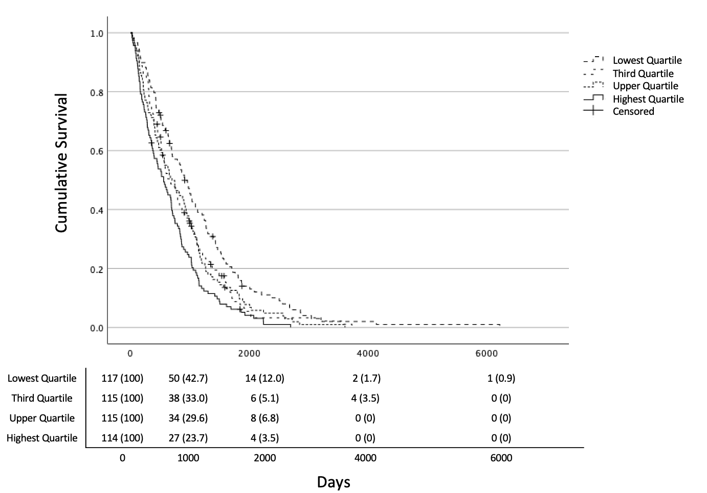
This figure shows the Kaplan-Meier survival curves for different biomarkers associated with survival in centenarians. Each panel illustrates the relationship between a specific biomarker and survival outcomes, with corresponding p-values provided for statistical significance.
* Follow-up duration ranged from 15 to 6,223 days (mean: 850.95 ± 732.63 days).
* Of the 495 centenarians, 486 completed follow-up. There were 9 missing cases: 3 with unknown survival status and follow-up duration, 4 with unknown status, and 2 with unknown duration.
* During the follow-up period, 466 participants (95.9%) died, and 20 were censored.

Supplementary Figure 7. Kaplan-Meier Survival analysis
D. Amyloid-β 42/40 ratio (p=0.22)
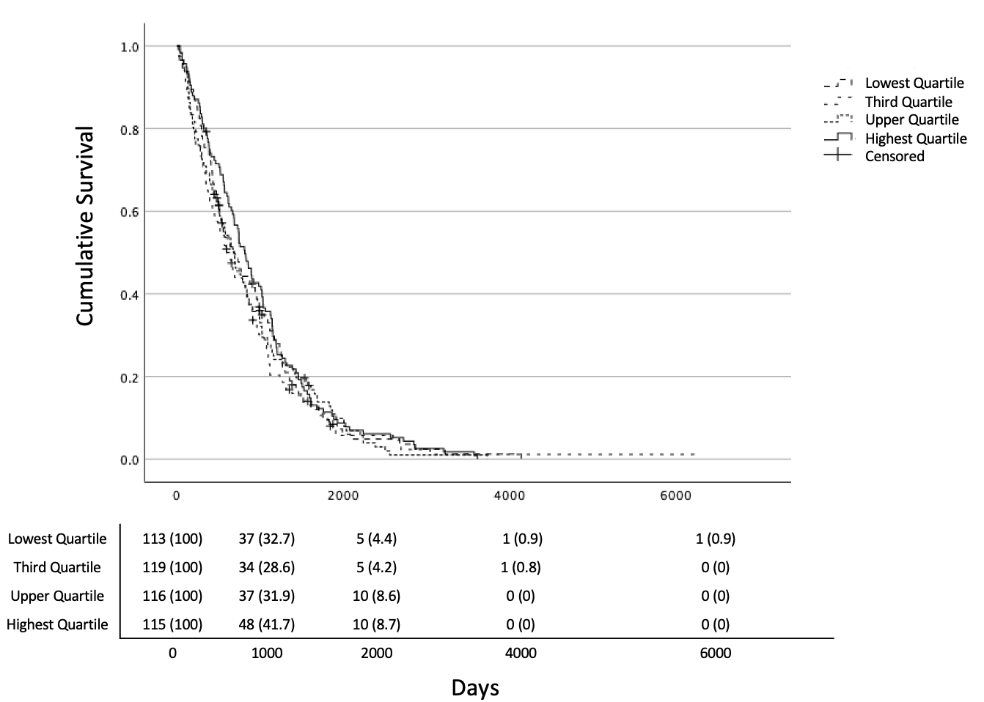
This figure shows the Kaplan-Meier survival curves for different biomarkers associated with survival in centenarians. Each panel illustrates the relationship between a specific biomarker and survival outcomes, with corresponding p-values provided for statistical significance.
* Follow-up duration ranged from 15 to 6,223 days (mean: 850.95 ± 732.63 days).
* Of the 495 centenarians, 486 completed follow-up. There were 9 missing cases: 3 with unknown survival status and follow-up duration, 4 with unknown status, and 2 with unknown duration.
* During the follow-up period, 466 participants (95.9%) died, and 20 were censored.

Supplementary Figure 8. Kaplan-Meier Survival analysis
E. pTau181 (p=0.15)
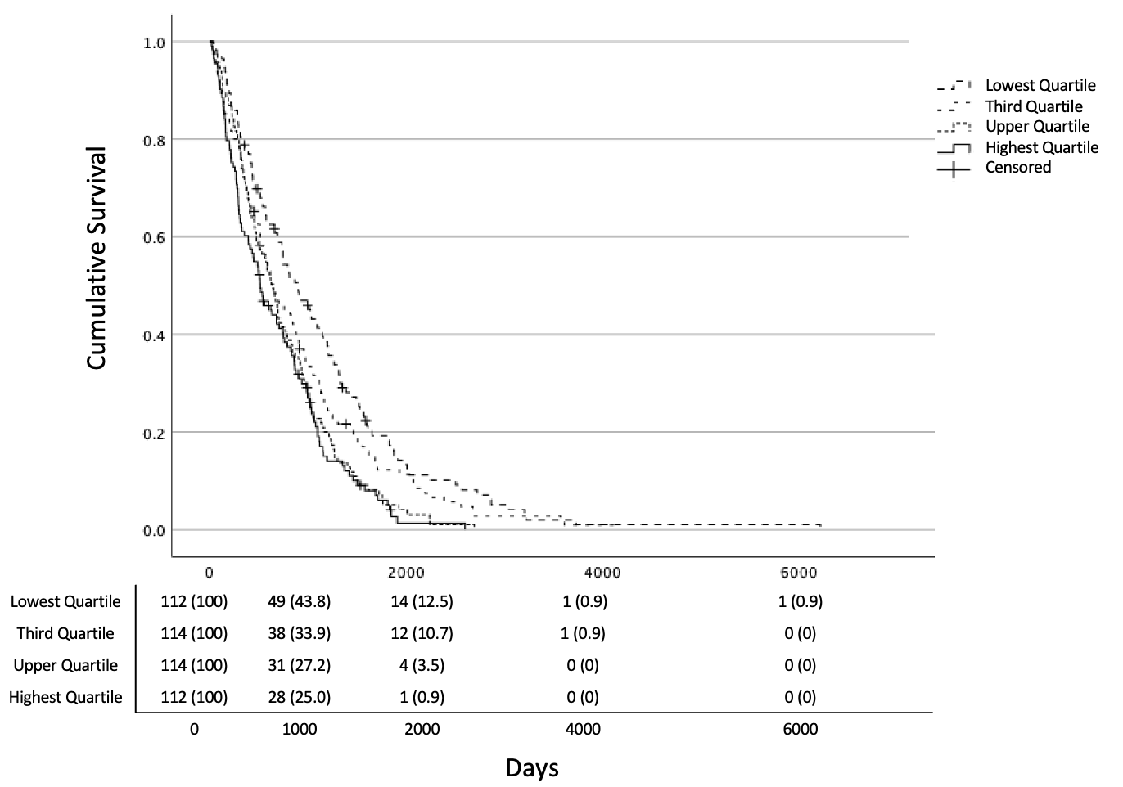
This figure shows the Kaplan-Meier survival curves for different biomarkers associated with survival in centenarians. Each panel illustrates the relationship between a specific biomarker and survival outcomes, with corresponding p-values provided for statistical significance.
* Follow-up duration ranged from 15 to 6,223 days (mean: 850.95 ± 732.63 days).
* Of the 495 centenarians, 486 completed follow-up. There were 9 missing cases: 3 with unknown survival status and follow-up duration, 4 with unknown status, and 2 with unknown duration.
* During the follow-up period, 466 participants (95.9%) died, and 20 were censored.

Supplementary Figure 9. Kaplan-Meier Survival analysis
F. Neurofilament Light Chain (p<0.001)
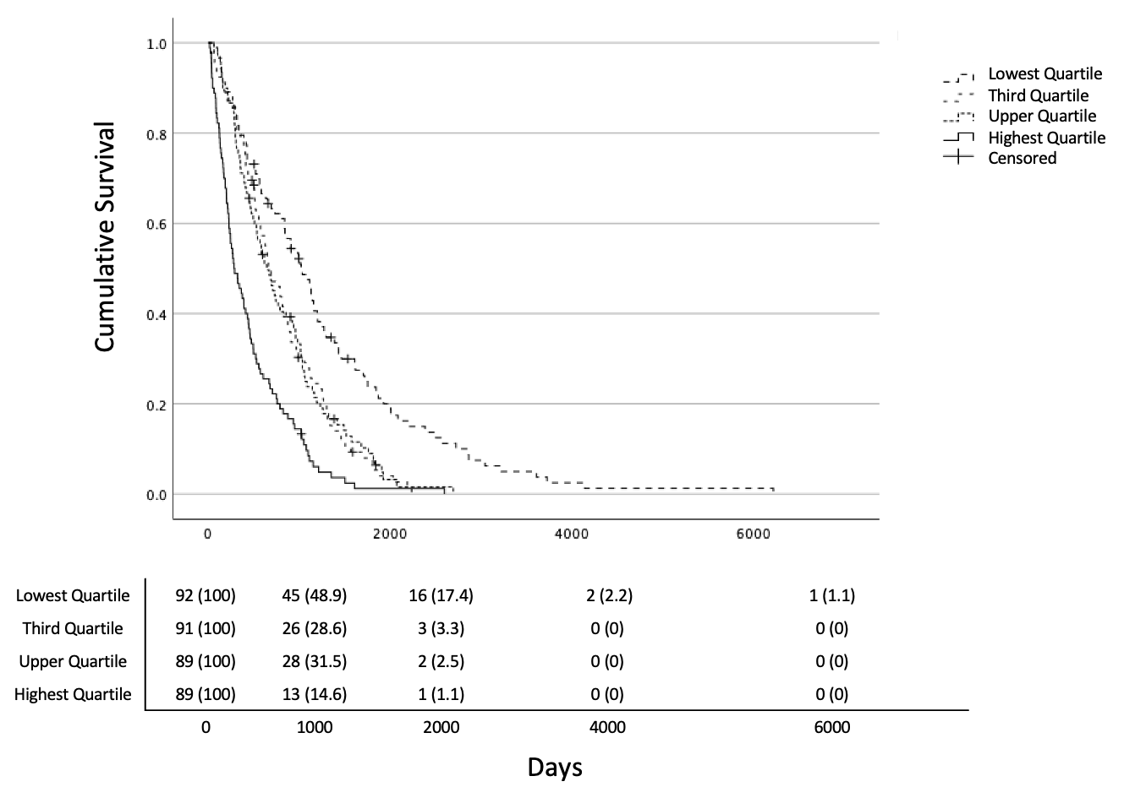

This figure shows the Kaplan-Meier survival curves for different biomarkers associated with survival in centenarians. Each panel illustrates the relationship between a specific biomarker and survival outcomes, with corresponding p-values provided for statistical significance.
* Follow-up duration ranged from 15 to 6,223 days (mean: 850.95 ± 732.63 days).
* Of the 495 centenarians, 486 completed follow-up. There were 9 missing cases: 3 with unknown survival status and follow-up duration, 4 with unknown status, and 2 with unknown duration.
* During the follow-up period, 466 participants (95.9%) died, and 20 were censored.

Supplementary Table 1. Cox Regression Adjusted Hazard Ratios with Hemoglobin and Estimated Glomerular Filtration Rate as Covariates
A. Clinical Dementia Rating score (p=0.03)
 |  | CDR
 |  | HR (95%CI) |  |  |  |  |  | p
CDR 0 |  | Ref |  |  |  |  |  | 0.04
 | 0.5 | 1.86 | ( | 1.17 | - | 2.95 | )
 | 1 | 1.64 | ( | 1.06 | - | 2.54 | )
 | 2-5 | 1.83 | ( | 1.15 | - | 2.91 | )
B. Amyloid-β 40, Amyloid-β 42, and Amyloid-β 42/40 ratio
 |  | Amyloid-β40 |  |  |  |  |  |  | Amyloid-β42 |  |  |  |  |  |  | Amyloid-β42/amyloid-β40 ratio
 |  | HR (95%CI) |  |  |  |  |  | p | HR (95%CI) |  |  |  |  |  | p | HR (95%CI) |  |  |  |  |  | p
Lowest Quartile |  | Ref |  |  |  |  |  | 0.61 | Ref |  |  |  |  |  | 0.45 | Ref |  |  |  |  |  | 0.43
Third Quartile |  | 0.95 | ( | 0.60 | - | 1.48 | ) |  | 1.29 | ( | 0.82 | - | 2.02 | ) |  | 1.07 | ( | 0.76 | - | 1.50 | )
Upper Quartile |  | 0.76 | ( | 0.46 | - | 1.26 | ) |  | 1.01 | ( | 0.62 | - | 1.65 | ) |  | 1.31 | ( | 0.94 | - | 1.83 | )
Highest Quartile |  | 0.91 | ( | 0.50 | - | 1.66 | ) |  | 1.24 | ( | 0.71 | - | 2.19 | ) |  | 1.16 | ( | 0.80 | - | 1.69 | )
C. pTau 181, and NfL
 |  | pTau181 |  |  |  |  |  |  | NfL
 |  | HR (95%CI) |  |  |  |  |  | p | HR (95%CI) |  |  |  |  |  | p
Lowest Quartile |  | Ref |  |  |  |  |  | 0.23 | Ref |  |  |  |  |  | <.001
Third Quartile |  | 1.00 | ( | 0.70 | - | 1.44 | ) |  | 1.80 | ( | 1.20 | - | 2.72 | )
Upper Quartile |  | 1.26 | ( | 0.86 | - | 1.84 | ) |  | 1.68 | ( | 1.11 | - | 2.55 | )
Highest Quartile |  | 0.87 | ( | 0.58 | - | 1.31 | ) |  | 2.82 | ( | 1.71 | - | 4.65 | )
Follow-up duration ranged from 15 to 6,223 days (mean: 850.95 ± 732.63 days). Of the 495 centenarians, 486 completed follow-up. Nine cases were missing: 3 with unknown survival status and follow-up time, 4 with unknown status, and 2 with unknown duration. During the follow-up period, 466 participants (95.9%) died, and 20 were censored. The CDR score was categorized into four levels: 0, 0.5, 1, and 2-5. Cox models were adjusted for sex, age, ApoE4 positivity, education (high school or higher), Barthel Index Score, CDR level, hemoglobin (Hb), estimated glomerular filtration rate (eGFR), and plasma levels of other biomarkers. The model for the amyloid-β42/amyloid-β40 ratio was adjusted for sex, age, ApoE4 positivity, education (high school or higher), Barthel Index Score, hemoglobin (Hb), estimated glomerular filtration rate (eGFR), and only the plasma levels of pTau181 and NfL. CDR, Clinical Dementia Rating; NfL, Neurofilament Light Chain. p <0.05 is shown in bold

