Supplementary Data
Dataset 1. Olivine major elements and trace elements
Dataset 2. Bulk-rock Fe isotopes (including olivine Mg# and bulk-rock MgO)
Dataset 3. Calculations of Fe isotopes in Fe-rich xenocrystic olivine.

Supplementary Figures
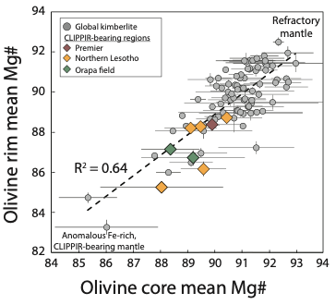
Fig S1. CLIPPIR-bearing kimberlite olivine data in comparison with global compilation of olivine data ^{14, 15} showing the relationship between mean Mg# of olivine cores and rims. Samples from CLIPPIR-diamond areas are shown as large coloured diamonds. The olivine cores are xenocrystic in origin and reflect the nature of the entrained lithospheric mantle. The rims represent the kimberlite melt composition and their Mg# is a good proxy of melt Mg# based on relatively invariant Fe/Mg at each locality⁸⁵. The correlation between the mean core Mg# and mean rim Mg# reflects the control of lithospheric mantle assimilation on kimberlite melt composition. Kimberlites traversing an anomalous, Fe-rich, CLIPPIR-bearing lithosphere entrain abundant megacrystic olivine (Mg# <89) and become significantly more enriched in Fe via melt-lithosphere interaction.

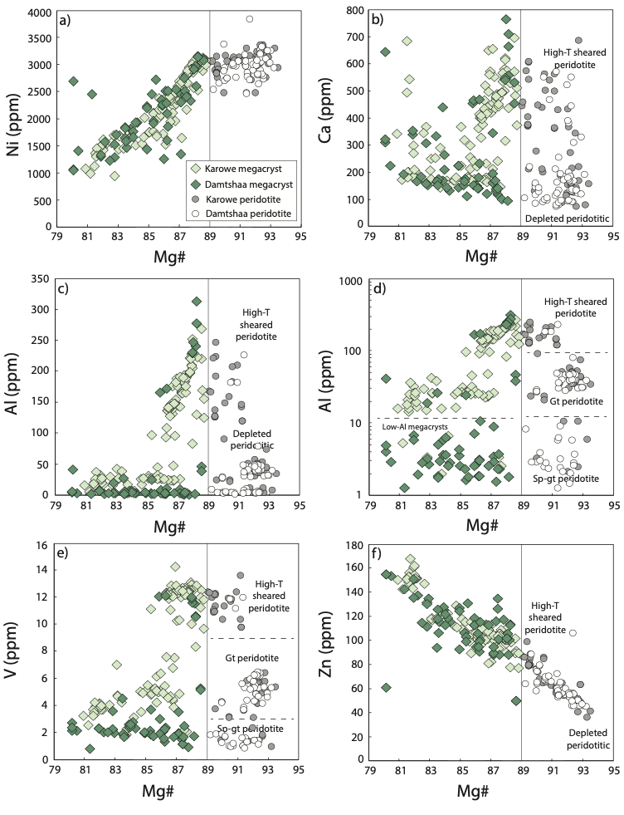
Fig S2. Covariation diagrams of Mg# vs representative trace elements in olivine cores from the Orapa field. Fe-rich olivines (Mg <89) related to metasomatised lithologies such as megacrysts are plotted using colourful diamonds, whereas Mg-rich peridotitic olivines with smaller white and grey circles.
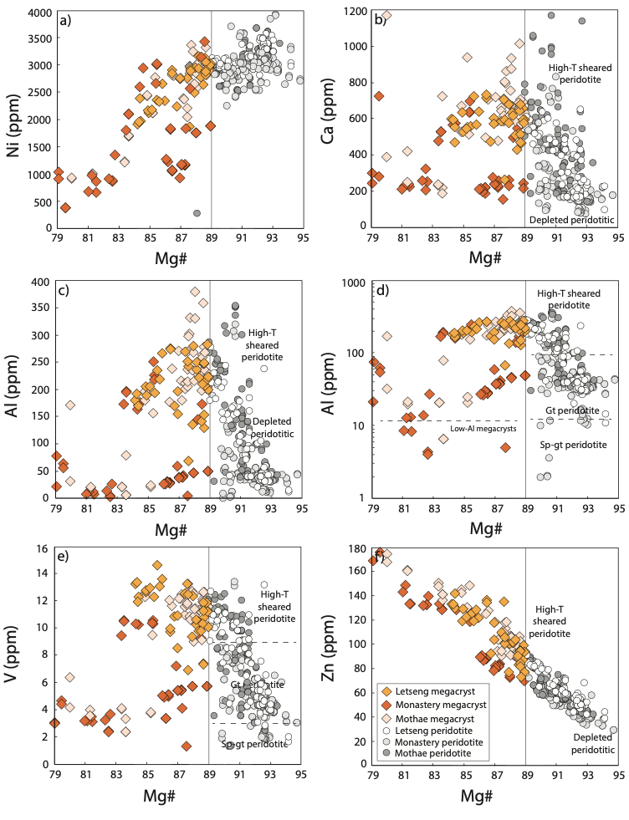
Fig S3. Covariation diagrams of Mg# vs representative trace elements in olivine cores from kimberlites in northern Lesotho. Fe-rich olivines (Mg <89) related to metasomatised lithologies such as megacrysts are plotted using colourful diamonds, whereas Mg-rich peridotitic olivines with smaller white and grey circles.

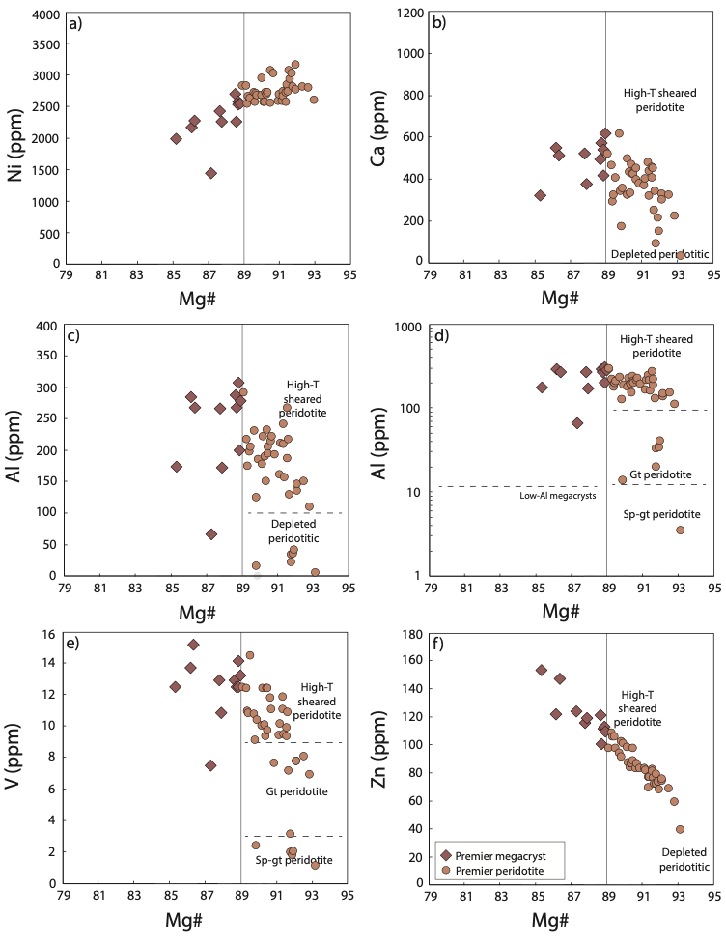
Fig S4. Covariation diagrams of Mg# vs representative trace elements in olivine cores from the Premier kimberlite.

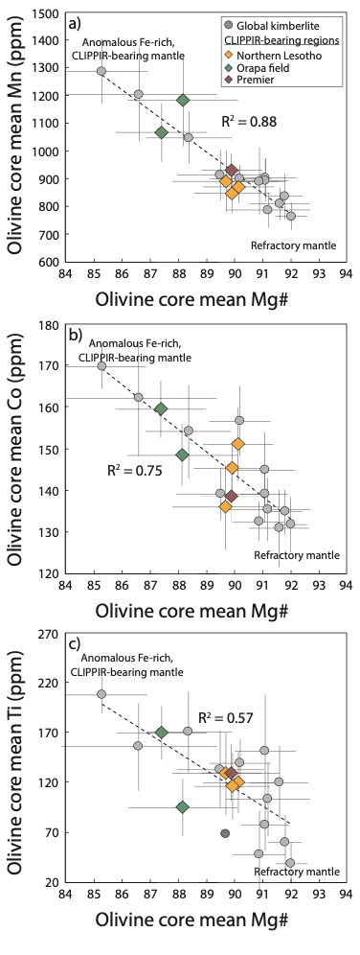
Fig S5. Correlation between average Mg# and trace element contents in olivine cores from kimberlites globally. Previous data¹⁶ are compared to those collected for CLIPPIR-diamond regions including kimberlites from the Orapa (Karowe and Damtshaa) and northern Lesotho fields (Monastery, Letseng, Mothae) in this study.

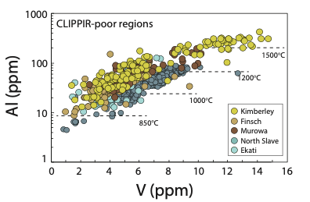
Fig S6. Relationship between the temperature-dependent concentrations of Al and V (ppm) in olivine xenocrysts from CLIPPIR-poor kimberlites. These include, Kimberley (Bultfontein, De Beers, Big Hole, Wesselton; data from Howarth et al.¹⁶), Finsch²², Northern Slave craton (Jericho, Voyageur, Muskox²¹), and Ekati (Grizzly, Koala, Leslie^{16,} ⁹⁶). The Finsch lamproite and kimberlites from Northern Slave and Ekati contain virtually no megacrystic or high-T sheared peridotite olivine, consistent with Al-in-olivine temperatures generally not exceeding 1200°C. The Kimberley kimberlites do, however, contain a population of high-Al olivine that is related to the megacryst suite and/or high-T sheared peridotites typical of these kimberlites ^{97, 98}. Thus, while CLIPPIR-poor regions are predominantly characterised by refractory mantle olivine and low abundances of megacrystic grains, megacrystic olivine are not unique to CLIPPIR-bearing locations.

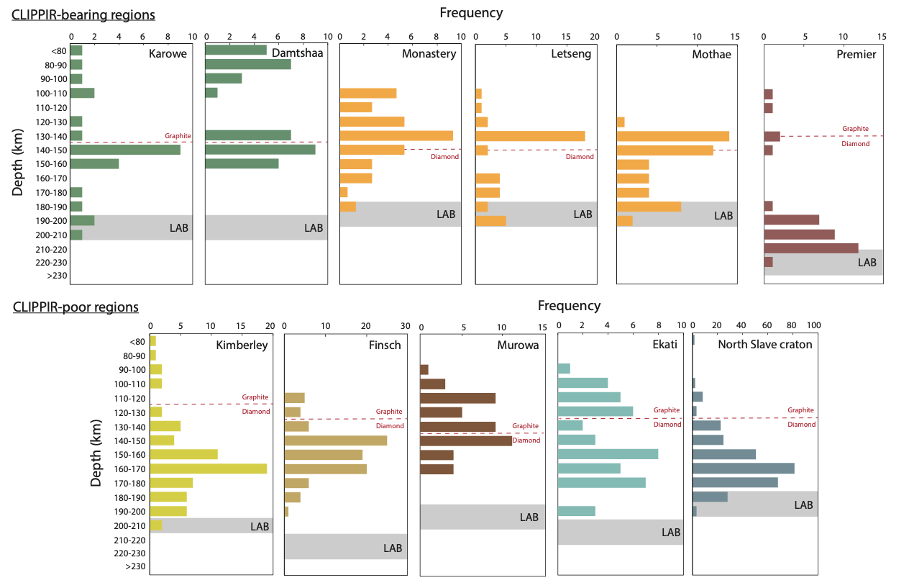
Fig S7. Histograms of olivine sampling depths. Temperatures and pressures were iteratively calculated using the Al-in-olivine thermometer and known geothermal gradients for each location (see Methods). Data for kimberlites in CLIPPIR-bearing regions including the Orapa field (Karowe and Damtshaa) and the northern Lesotho field (Monastery, Letseng, Mothae) as well as for the CLIPPIR-poor Finsch lamproite are from this study whereas the data for Kimberley, Ekati, and Northern Slave kimberlites are from previous work ^{16, 21, 95}. Lithosphere-asthenosphere boundary (LAB) and diamond-graphite depths for Karowe and Damtshaa ⁸⁸; Monastery, Letseng and Mothae ⁸⁹, Premier and Kimberley ⁹⁰, Ekati ⁹⁹, and North Slave craton (Jericho, Muskox, Voyageur)²¹ are from published resources.

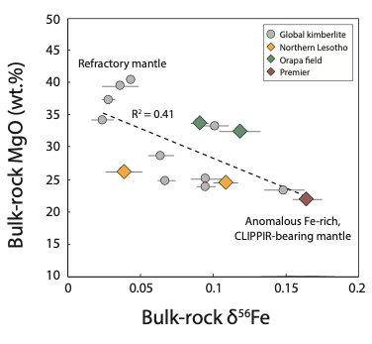
Fig S8. Linear correlation between bulk-rock Fe isotopes and MgO in representative kimberlites. The sample set includes kimberlites containing CLIPPIR diamonds (Karowe, Letseng, Premier) and others that do not (e.g., Kimberley, Ekati, Diavik) – see Dataset 2. The correlation between MgO contents and Fe isotopes is related to variable entrainment of olivine with variable but probably related Mg# contents and δ⁵⁶Fe.

