Supplementary Materials

High Temperature Excitonic Insulator and Possible Superfluid Based on Two-Dimensional Diamond
Shisheng Lin, Shaoqi Huang, Minhui Yang, Xin Chen, Hongjia Bi, Kangchen Xiong
Corresponding author: shishenglin@zju.edu.cn

Materials and Methods
Material Fabrication
2D diamond is grown by MPCVD using the CH₄ and Hydrogen as the main source, and a doped source of borane (BH₃) and Nitrogen (N₂) are added to form a mixed gas for growth under the input power of 5 kW, where the pressure of the cavity and surface temperature of the seed crystal were maintained at 100 Torr and 930 ℃. All the samples of mentioned above were grown on (100) diamond seed under different flow of BH₃ and N₂, as shown in Table S1. After growth, the single-crystal doped diamond was sequentially sonicated with acetone, isopropanol, ethanol and deionized water for 5 minutes to remove residues from the surface. And then, blow dry with a N₂ air gun.

Table S1. Different flow of BH₃ and N₂ and different thickness for sample fabrication.
Sample Number | BH₃ (sccm) | N₂ (sccm) | Thickness (nm)
20240125 | 25 | 3 | 90
20240318 | 25 | 3 | 15
20240319-2 | 5 | 3 | 15
20240409 | 25 | 3 | 30
20240411 | 25 | 3 | 5
20240423-1 | 1.5 | 9 | 9
20240423-2 | 8 | 9 | 9
20240424-2-1 | 15 | 9 | 9
20240424-2-2 | 15 | 9 | 9
20240604 | 26 | 3 | 30
20250218 | 25 | 3 | >1000

Material Characterization
The laser Raman spectrometer (inVia-Reflex) is used for Raman testing of diamonds, using a laser light source of 532nm to scan the spectrum from 100 cm⁻¹ to 2000 cm⁻¹. The samples used for diamond TEM characterization were prepared by a dual-beam focused ion beam microfabrication instrument (FEI, Quata 3D FEG) to realize the nanoscale processing of diamond samples for TEM characterization. TEM images were obtained by spherical aberration corrected transmission electron microscopy (FEI Titan G2 60-300) to observe the atomic structure arrangement of the diamond. UV-Vis Spectrophotometer (Cary 5000) is used for testing UV-Vis absorption spectrum of diamond and Infrared absorption spectrum is tested by Fourier Transform Infrared Spectrometer (INVENIO-R).

Resistivity Measurements
The ohmic contact is achieved by growth of 20nm Ti and 70 nm Au by magnetron sputtering (the spacing between the electrodes was 1.0 mm) for the measurement of low-temperature electrical properties. Resistivity properties were measured using a low-temperature physical property measurement system (QUANTUMDESIGN, Dynacool-9) with a test range from 2 K to 300 K.

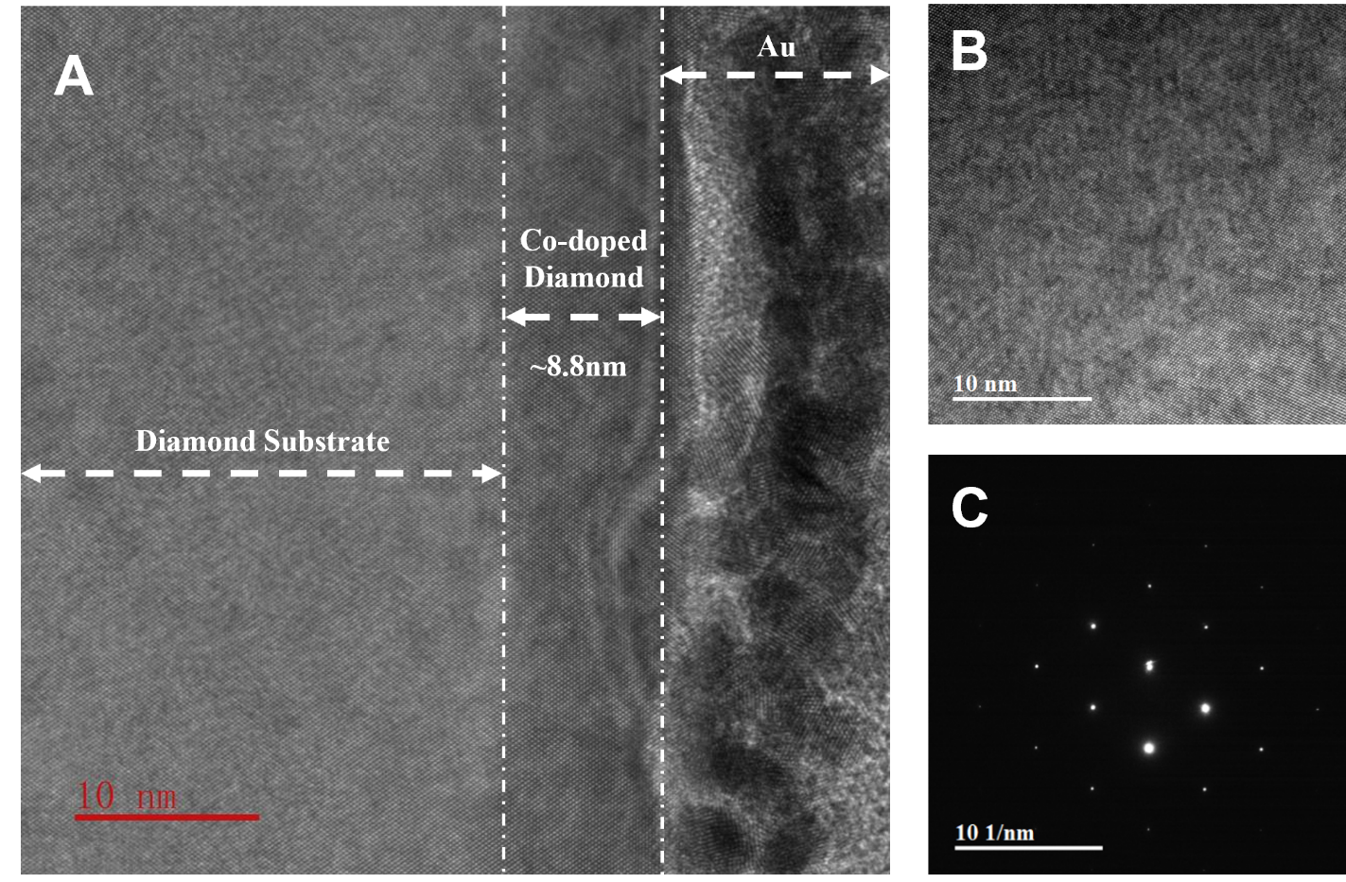

Fig. S1. Characterization of 2D diamond for another sample. (A) HRTEM image of the cross section of 2D diamond and diamond substrate, the thickness of the film is about 8.8nm, as depicted in the figure. (B) Atomic structure of diamond along <001> direction of the sample, in which long range uniformity is presented. (C) the FFT result of the sample.

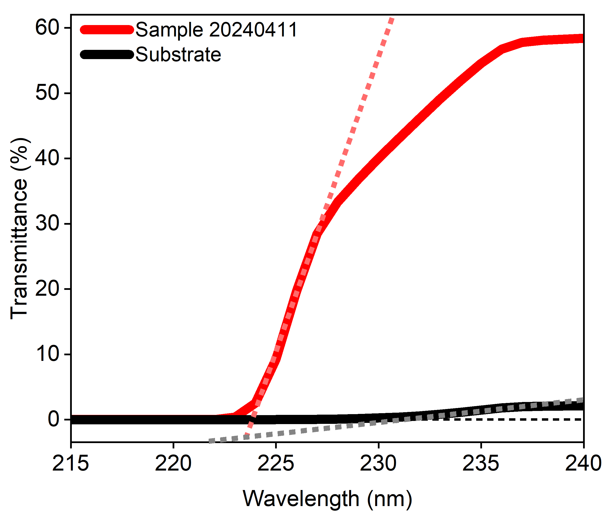

Fig. S2. Ultraviolet-visible (UV-Vis) spectroscopy of sample 20240411. By introducing dopants, the absorption edge increases from 5.39eV to 5.54eV.

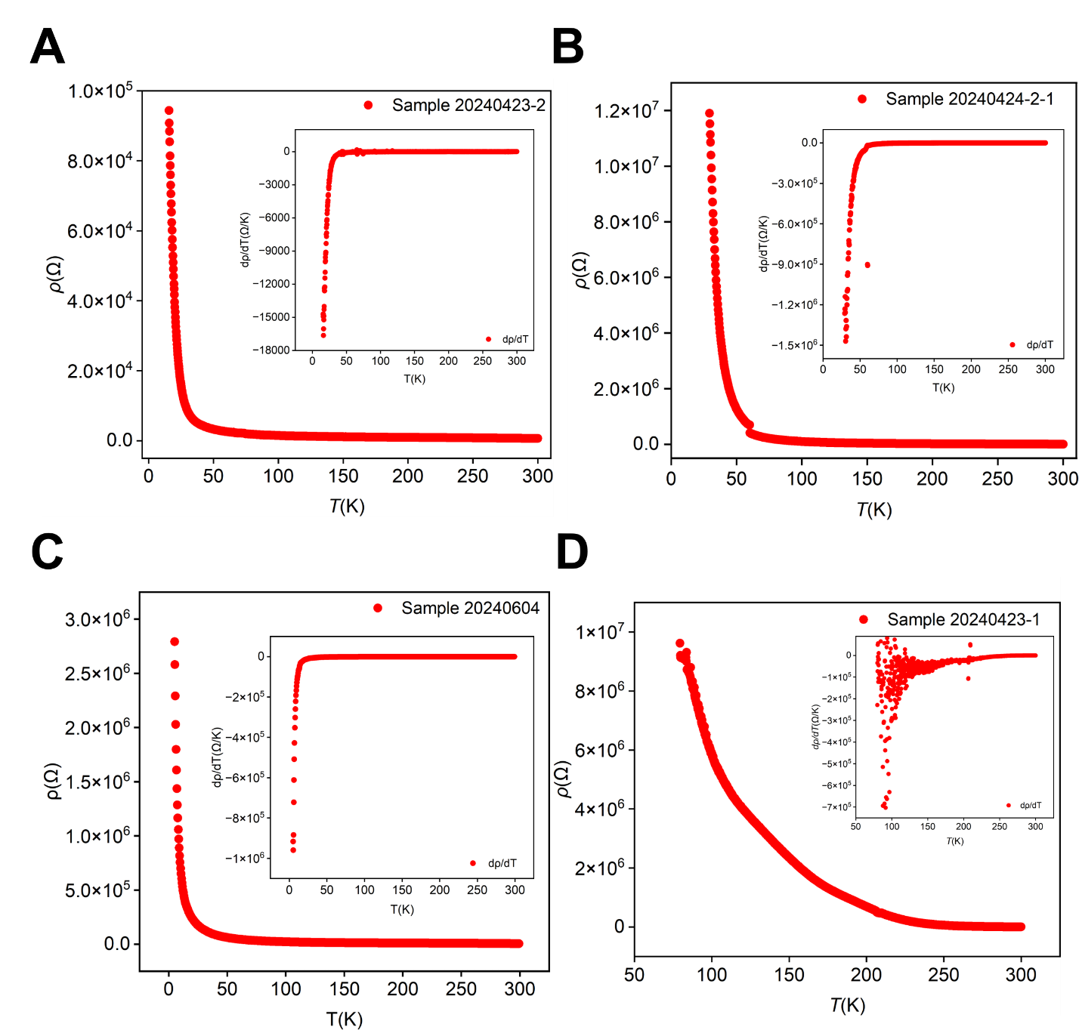

Fig. S3. Transport characteristic of excitonic insulator based on 2D diamond. Another four different samples of diamond excitonic insulator named with a thickness of 9nm, 9nm, 30nm and 9nm, sequentially, and their resistance as a function of temperature. The insets show the rate of change of resistance.

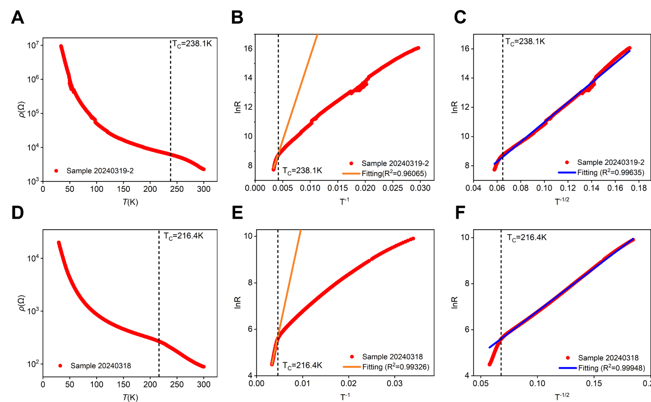

Fig. S4. Resistance model of excitonic insulator based on 2D diamond. (A) Resistance as a function of temperature in logarithmic form for sample 20240319-2. Critical temperature T_{C} = 238.1K is marked on the figure. (B) The change of resistance fits well with Arrhenius model for temperature above T_{C}. (C) The change of resistance fits well with variable range hopping model for temperature below T_{C}, where excitons condense into ground state. (D)-(F) Resistance in logarithmic form, fitting of Arrhenius model for temperature above T_{C} and fitting of variable range hopping model for temperature below T_{C} for sample 20240318, respectively. Critical temperature T_{C} = 216.4K is marked on each figure.

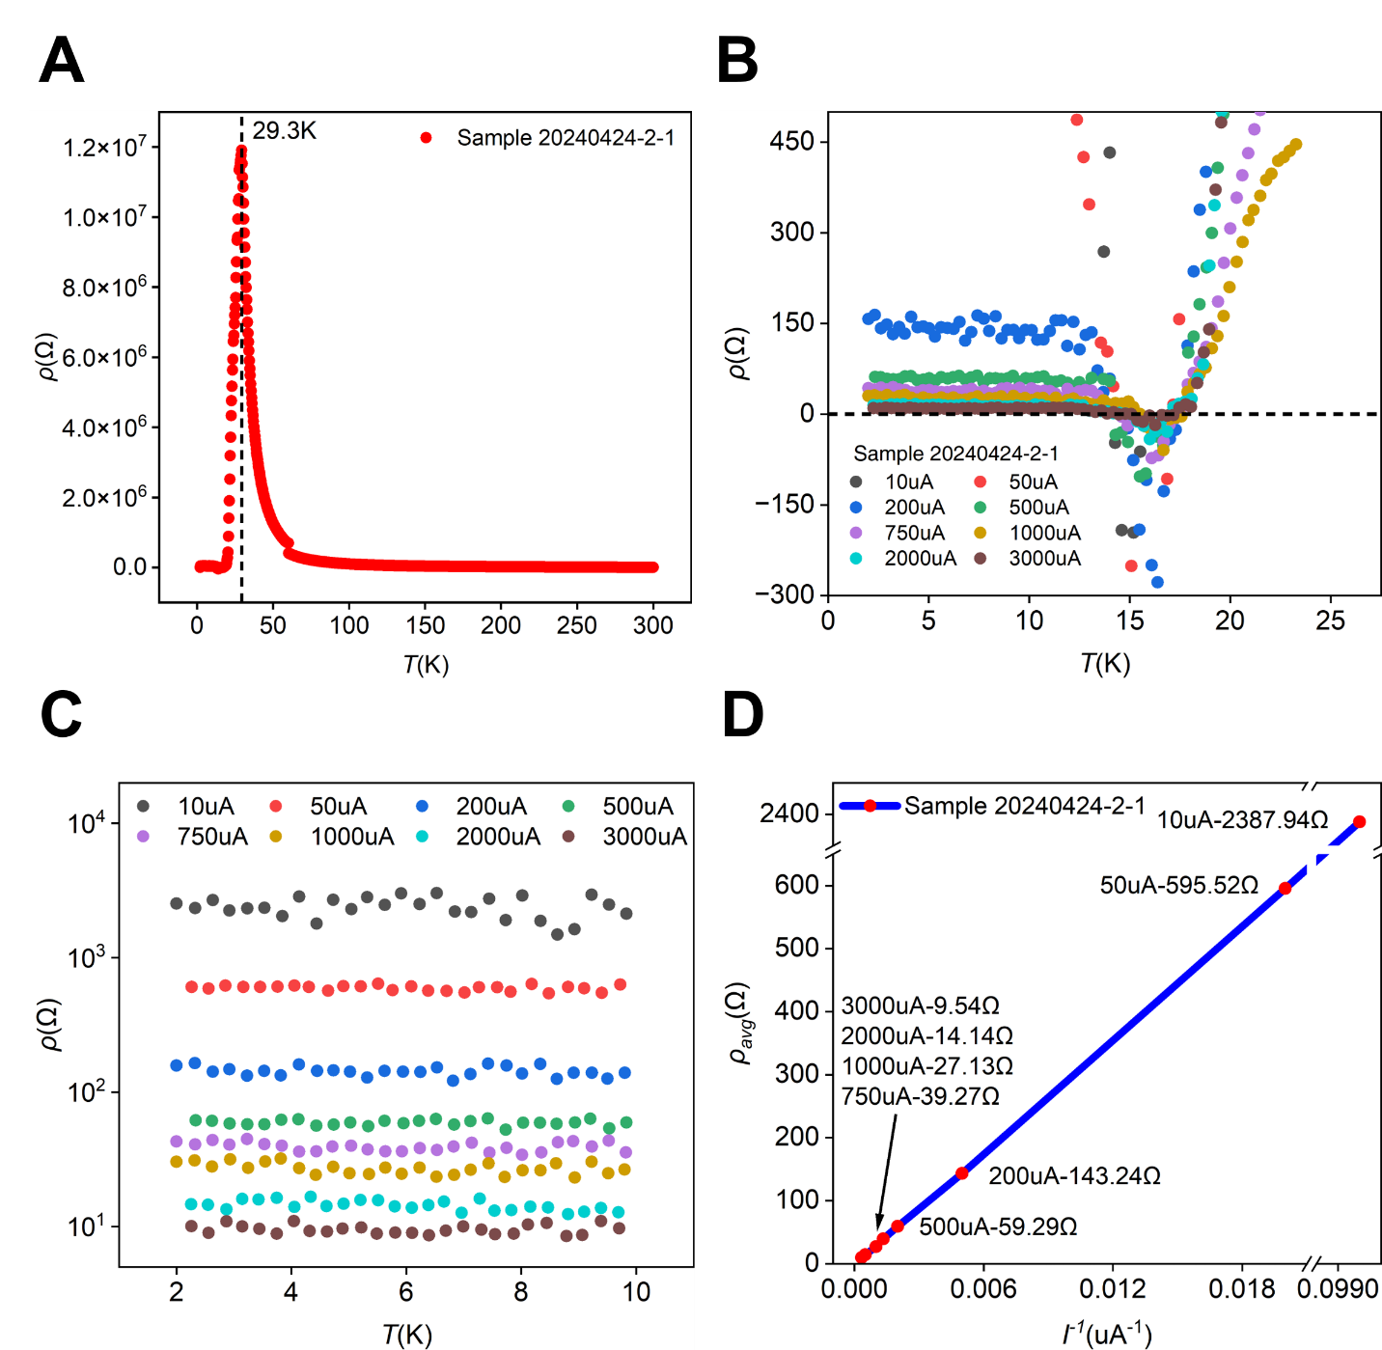

Fig. S5. Possible high temperature excitonic mediated superfluidity. (A) Sharp drop of resistance for sample 20240424-2-1 at 29.3K. (B) The resistance crosses over zero near 16 K for applied current of 10μA, 50μA, 200μA, 500μA, 750μA, 1000μA, 2000μA and 3000μA. (C) The dependence of resistance as a function of applied current below 10K, where the resistance is inverse proportion to the applied current. (D) The dependence of resistance as a reversed function of the biased current, where a linear function can be clearly clarified.

