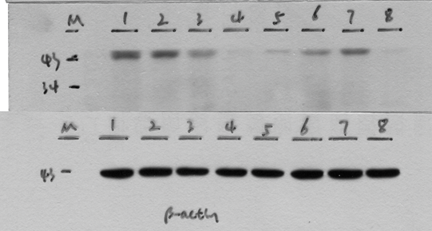
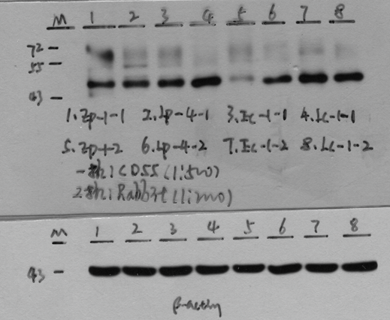
Figure 1. Western blot images of CD46 and CD55 in placentas of the EOSPE, LOSPE, E-control, and L-control groups.
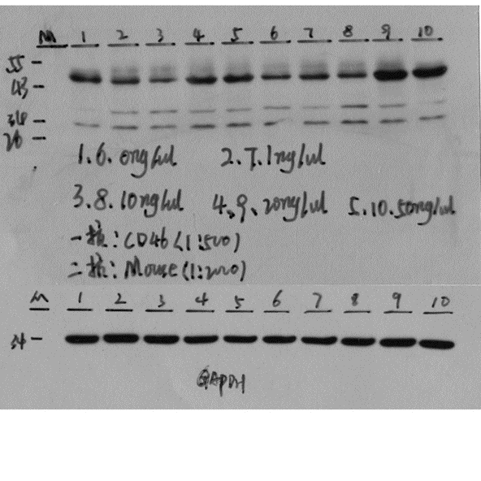

Figure 5. Expression of CD46 on HTR-8/Svneo after VEGF treatment.

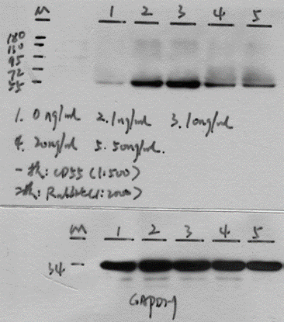
Figure 6. Expression of CD55 on HTR-8/Svneo after VEGF treatment.

