Supplementary Materials for

Non-invasive Resonance Raman Spectroscopy provides an early estimation of depth in a pig model of multi-depth burns

This file includes:

Figs. S1 to S5
Table S1

Figure S1: Images of the Raman device used to obtain the Resonance Raman Spectrum from burn wounds. The device consists of a. A box to house the laser pump, CCD array, and other optical components such as filters, b. A laser probe is used to shine the excitation laser as well as collect the emitted spectrum, connected to the box via fiber optic cable, c. A laptop to run the LabVIEW software for device operation, data collection, and Raman spectrum analysis, and d. 3D-printed adapter to attach to the probe and cover the area under investigation for a localized dark field and maintain a constant distance of 9 mm from the wound.
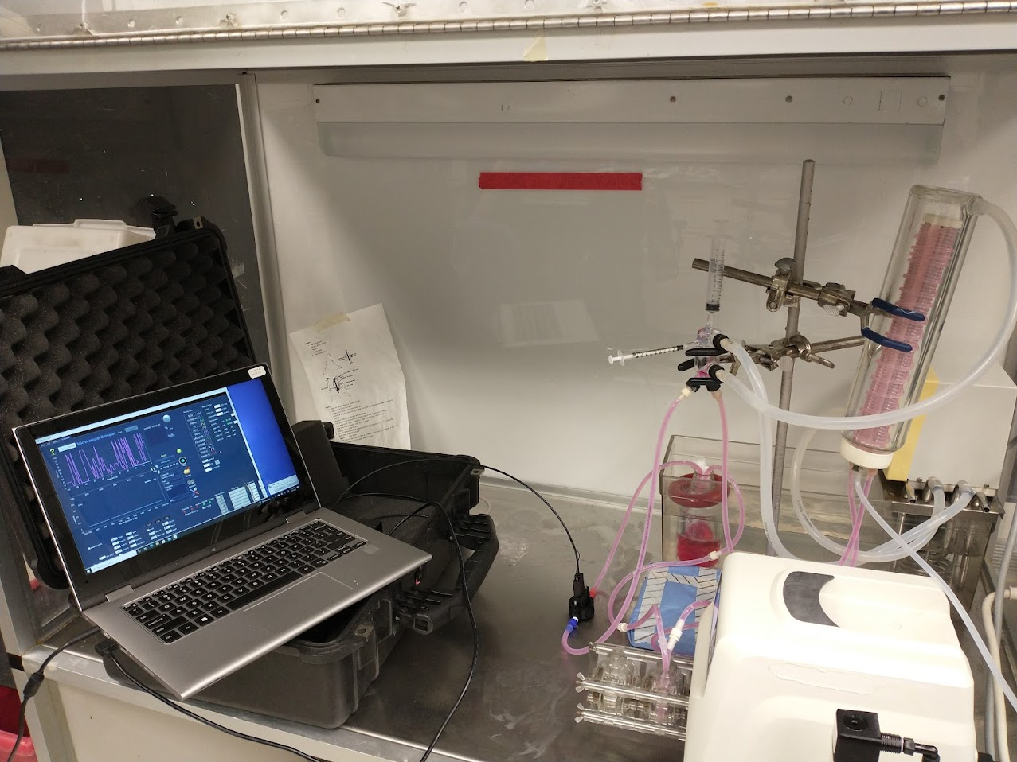
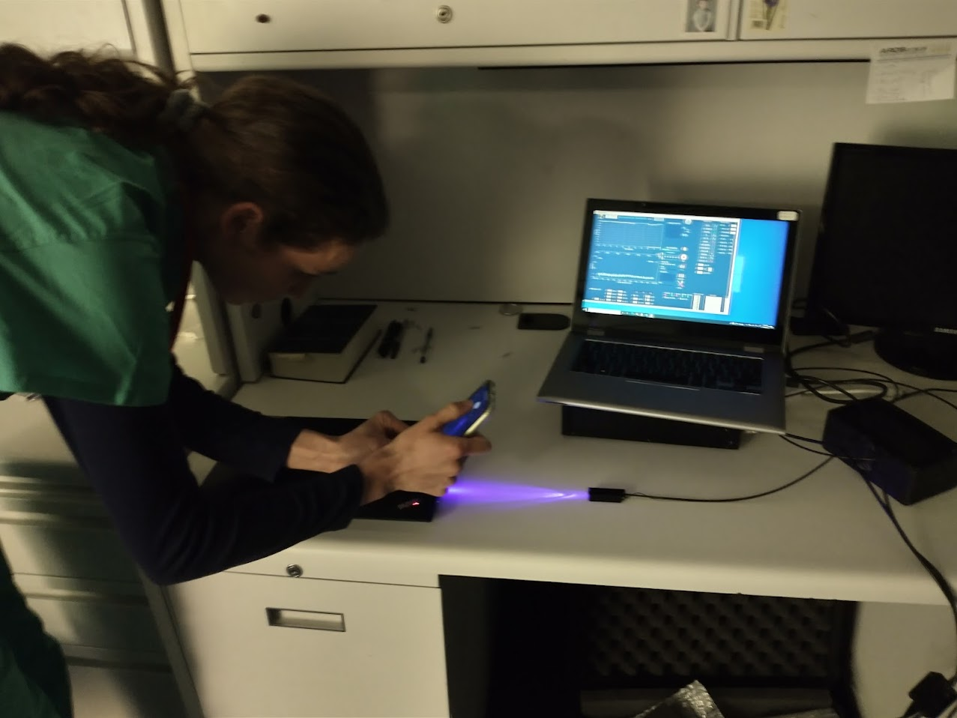
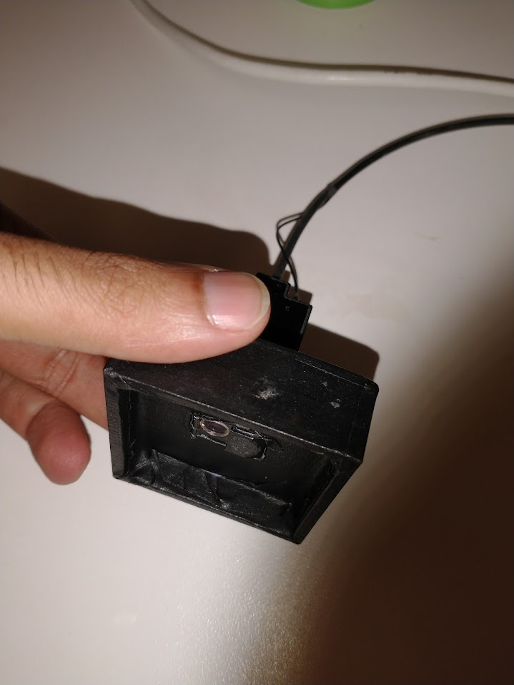
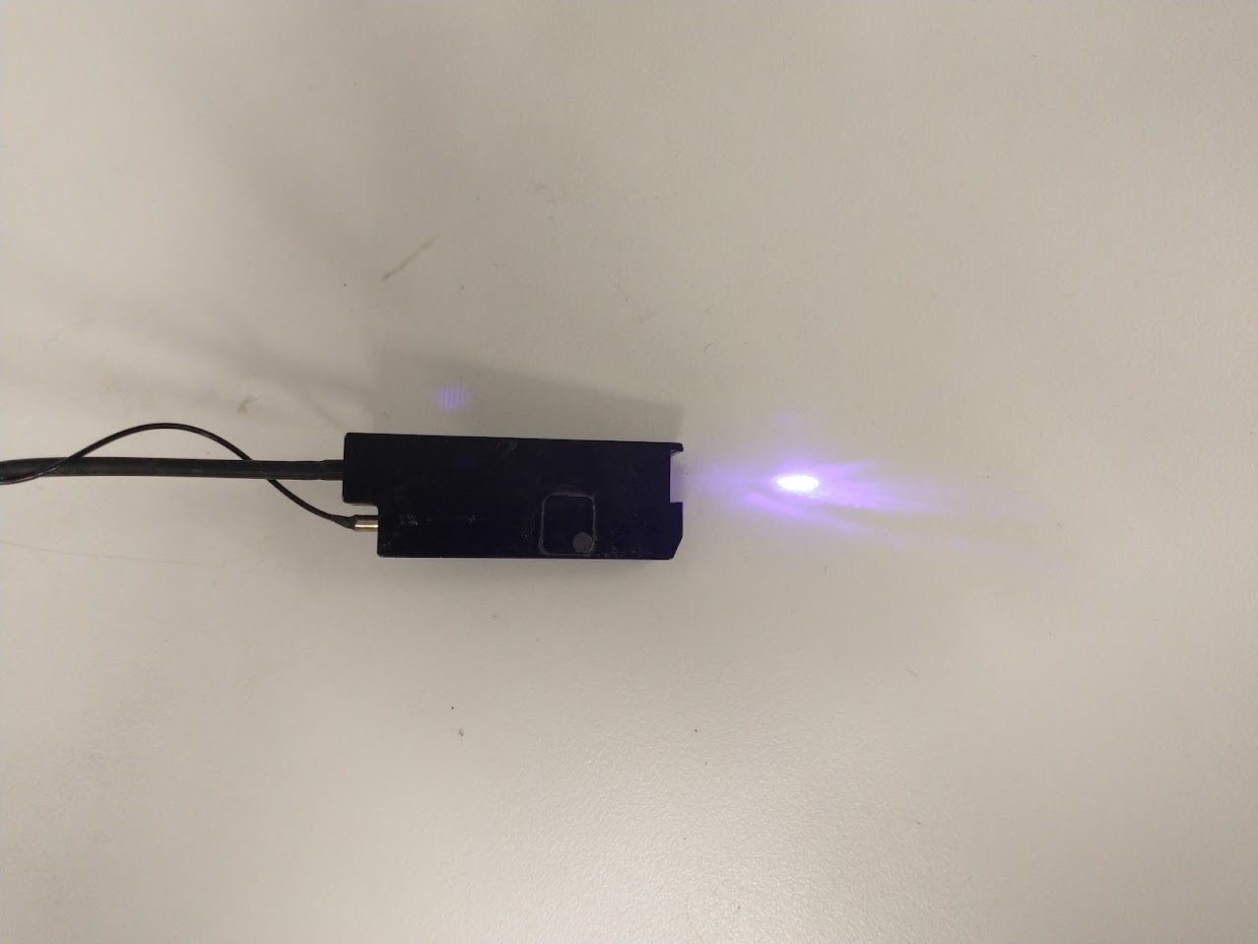
Probe Cover
Laser probe
Pelican case
for device housing
Laptop for real-time results
Black box to house laser pump & other optics
Laser probe connected to box via fiber optic cables
8 x 12 x 60 mm
60 x 60 x 10 mm
Figure S2: Representative tattoos of the wound limits on the back of each pig. Each wound was delimited by a circular tattoo of 4.5 cm diameter. Eight wounds were created in two rows, with a 7cm center-to-center distance between wounds in each row. The tape in the center was used to mark distances between adjacent wounds. Each wound was marked from one to eight using the same numbering scheme for all three pigs. This scheme was used to randomize burn categories by location and for the convenience of tracking the Raman measurements, photographs, and biopsies.

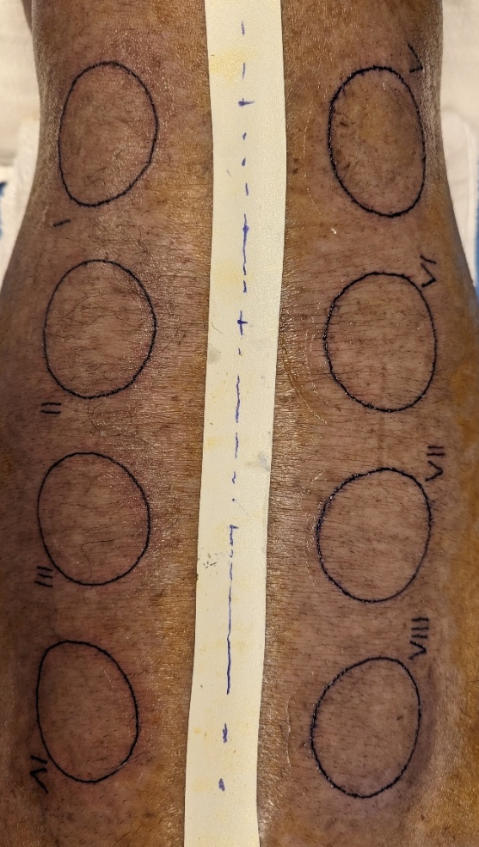
4.5 cm
7 cm
Back
Front

Figure S3: Representative micrograph shows the scoring of a trichrome-stained biopsy on POD 3 (5x magnification). Each observer measured the depth in five replicates, from the most superficial epidermal layer until the end of an obstructed vascular feature, necrosis, or damaged collagen image. These 5 replicates were averaged, followed by adding 100 µm as an additional depth to account for the lost epithelial layer of skin in wounds that required blisterectomy. The scale bar shows a length of 500 µm.

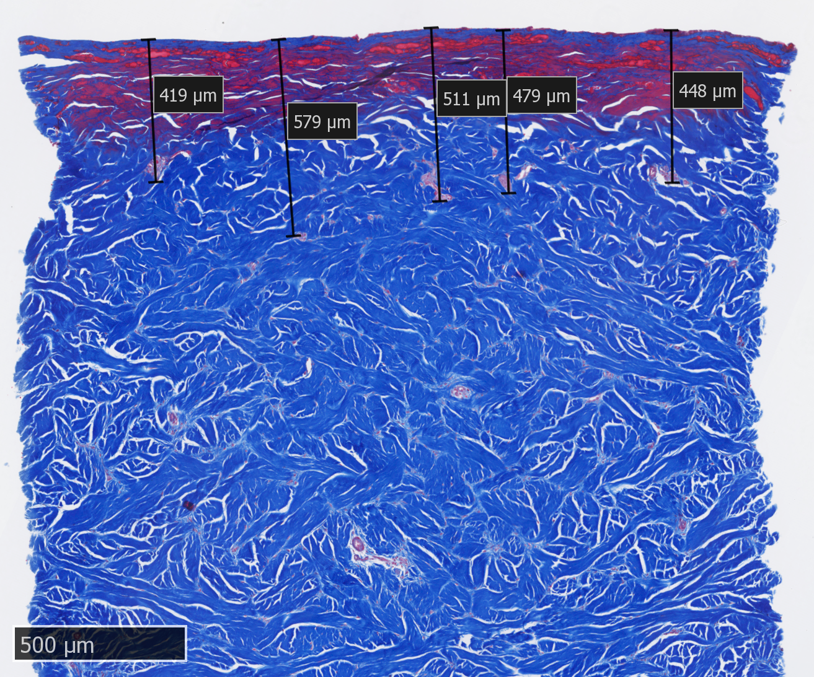

Figure S4: Correlations between Hemoglobin Index, Time to Healing, and Burn Depth. a. Time to Healing increases linearly with burn depth, achieving Pearson’s correlation coefficient of r=0.91 (p=0.0003) for completely healed wounds by the end of the study. b. Hemoglobin index on POD 3 is also highly correlated with burn depth on POD 3 (r=-0.86, p<0.0001), indicating a reduction in hemoglobin with wound depth. c. Hemoglobin index on POD 3 is also predictive of the time to healing for wounds, as observed in the high correlation coefficient (r=0.86, p=0.0003).
(b)
(a)
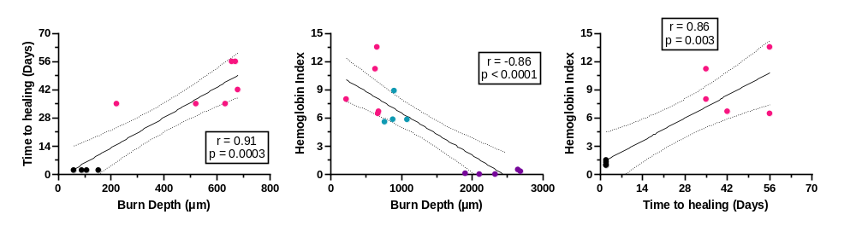
(c)

Figure S5: FI and granulation tissue as a percent of total depth on POD 64 (n=5-6).
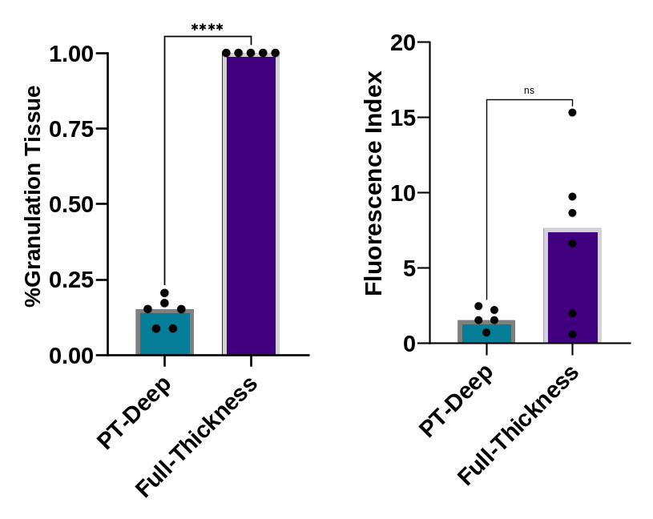

Table S1: Criteria for classification into burn depth categories based on visual and histological assessment on POD 3: Preliminary criterion for wound categorization used expected depth according to the burn-making procedure and visual evaluation of the wound on POD0 to 3. While this was sufficient for categorizing superficial, partial, and full-thickness categories, additional analysis was needed to differentiate PT-Superficial and PT-Deep wound sub-categories. Here, we used time-to-healing as a secondary criterion based on its clinical relevance. A cut-off of 56 days allowed a high degree of separation with our model in swine. Based on these criteria, n=4 wounds in the superficial category, n=6 wounds in the PT-Superficial category, n=5 wounds in the PT-Deep category, and n=6 wounds in the full-thickness category were used for subsequent HI analysis. Additionally, we have also provided the criterion for the inclusion of burn depth scores in each category from histology slides on POD 3.

 | Preliminary Criterion:  Burn temperature and visual evaluation | Confirmatory Criterion:  Time to heal | Burn Depth Quantification:  Criteria for inclusion of burn scores
Superficial Wounds | Burn making procedure- 45°C block temperature with 30s contact time  Visual evaluation- Intact epidermis with or without redness on POD 3 | Complete healing in <5 days | Minimal damage to the epidermis
Superficial Partial Thickness (PT-Superficial) Wounds | Burn making procedure- 63°C block temperature with <20s contact time  Visual evaluation- Loose/damaged epidermis or blister with significant redness on POD 3 | Complete healing judged by re-epithelialization near the end of study, i.e. POD 56 | Loose/missing epidermis, total depth of epidermal + dermal damage <680 µm total in case of scorer disagreement
Deep Partial Thickness (PT-Deep) Wounds | Burn making procedure- 96°C block temperature with >30s contact time  Visual evaluation- Loose/damaged epidermis or blister with significant redness on POD 3 | Incomplete healing judged by incomplete re-epithelialization by the end of study, i.e. POD 64 | Loose/missing epidermis, total depth of epidermal + dermal damage >680 µm total in case of scorer disagreement
Full Thickness Wounds | Visual evaluation- No blister. Damaged epidermis with white glassy appearance and firm monoblock pinching test on POD 3 | Healing by contraction, incomplete wound closure by the end of study. i.e. POD 64 | Missing epidermis, significant damage to dermal layer throughout the biopsy

