Supplementary materials

Herbal preparations traditionally used in upper respiratory tract infections: LC‒MS profile and anti-inflammatory activity in human neutrophils and PBMCs.

Małgorzata Kołtun-Jasion¹, Anna Karolina Kiss¹

¹Department of Pharmaceutical Biology, Faculty of Pharmacy, Medical University of Warsaw, ul. Banacha 1, 02-097 Warsaw, Poland

Table S1: Detailed information about the tested plant material.

No. | Species | Manufacture | Origin of the plant material | Part | Form | Batch number
1. | Andrographis paniculata (Burm.f.) Wall. ex Nees | Plantago | India | aerial part | cut raw material | 16032024
2. | Astragalus mongholicus Bunge | Plantago | China | roots | cut raw material | 28042024
3. | Cistus creticus L. | Astron | Greece | aerial part | cut raw material | 36284
4. | Cistus ladanifer L. | EcoBlik | Spain | aerial part | cut raw material | 01072019
5. | Houttuynia cordata Thunb. | Plantago | China | aerial part | cut raw material | 25052025
6. | Lonicera japonica Thunb. | Plantago | China | aerial part | cut raw material | 092023
7. | Petasites hybridus (L.) G.Gaertn., B.Mey. & Scherb. | Plantago | Romania | roots | cut raw material | 15012023
8. | Platycodon grandiflorus (Jacq.) A.DC. | Planetherbs | China | roots | cut raw material | 112024
9. | Pulmonaria officinalis L. | Plantago | China | aerial part | cut raw material | 2011202
10. | Scutellaria baicalensis Georgi | Planetherbs | China | roots | cut raw material | 112024

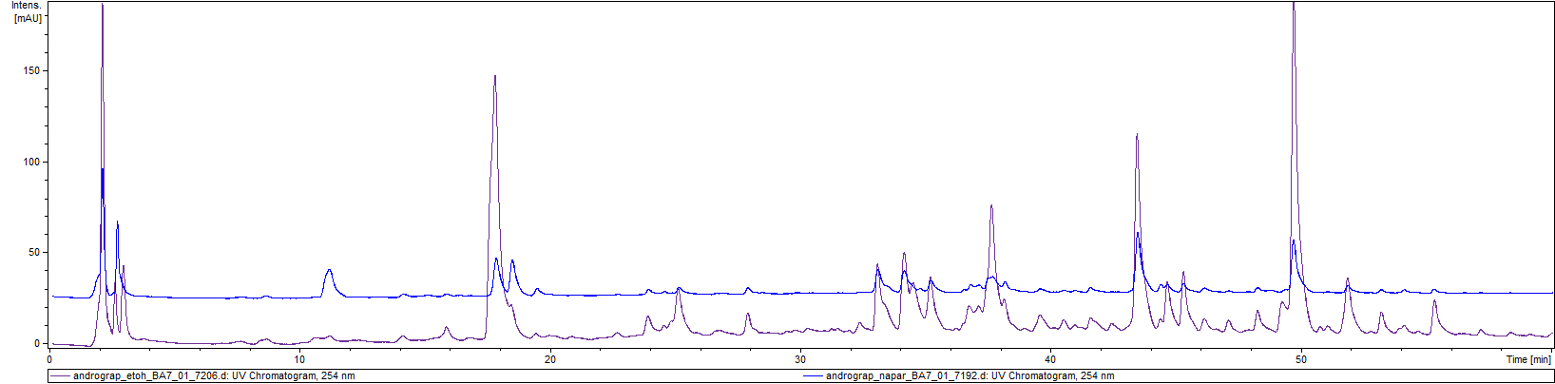
1
2
3
6
8
7
Andrographidis paniculatae herba
4
5

Fig. S1: HPLC-DAD chromatograms of the Andrographidis paniculata ethanolic extract (violet) and infusion extract (blue) recorded at 254 nm.

Tab. S2: Retention time, UV, and MS/MS data of the compounds identified in extracts of Andrographis paniculata.
No. | Compound | UV [nm] | Rt [min] | [M-H]⁻ | Product mass peaks
1. | 3-O-Caffeoylquinic acid | 216, 262, 325 | 11.3 | 353.1 | 190.7; 178.9
2. | 5-O-Caffeoylquinic acid | 216, 262, 325 | 17.8 | 353.1 | 190.7; 178.9; 172.8
3. | 3,4-Dicaffeoylquinic acid | 216, 327 | 34.2 | 515.2 | 353.1; 255.0; 299.1; 178.9; 172.9
4. | 3,5-Dicaffeoylquinic acid | 222, 326 | 35.4 | 515.2 | 353.1; 191.0; 179.1
5. | 4,5-Dicaffeoylquinic acid | 219, 326 | 37.9 | 515.2 | 351.1; 335.1; 255.0; 179.0; 172.9
6. | Andrographolide | 223 | 43.4 | 395.2* | 349.2; 331.1; 287.1
7. | Andrographidine A | 265, 315 | 49.6 | 461.3 | 298.9
8. | 14-Deoxy-11,12-didehydroandrographolide | 250 | 51.7 | 331.2 | 313.1; 286.9; 242.8

*[M+COOH]⁻

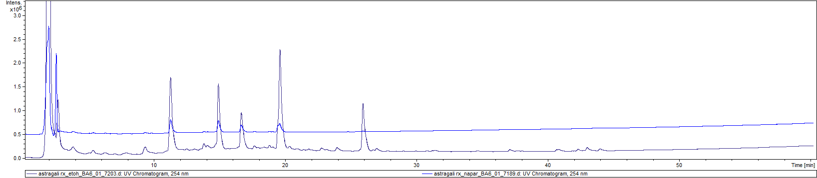
1
4
5
2
3
Astragali radix

7
Fig. S2: HPLC-DAD chromatograms of the Astragalus mongholicus ethanolic extract (violet) and infusion mixture (blue) recorded at 254 nm.

Table S3: Retention time, UV, and MS/MS data of the compounds identified in extracts of Astragalus mongholicus.

No. | Compound | UV [nm] | Rt [min] | [M-H]⁻ | Product mass peaks
1. | Calycosin-7-O-glucoside | 215, 255 sh, 287 | 11.2 | 491.2* | 445.1; 282.9
2. | Unknown | 215, 255 sh, 285 | 14.9 | 599.2 | 283.1
3. | Ononin | 215, 250 sh, 288 | 16.7 | 475.2* | 429.1; 266.9
4. | Calycosin | 216, 255 sh, 288 | 19.6 | 282.9 | 267.8
5. | Formononetin | 218, 260 sh, 290 | 25.9 | 266.9 | 251.8

*[M+COOH]⁻
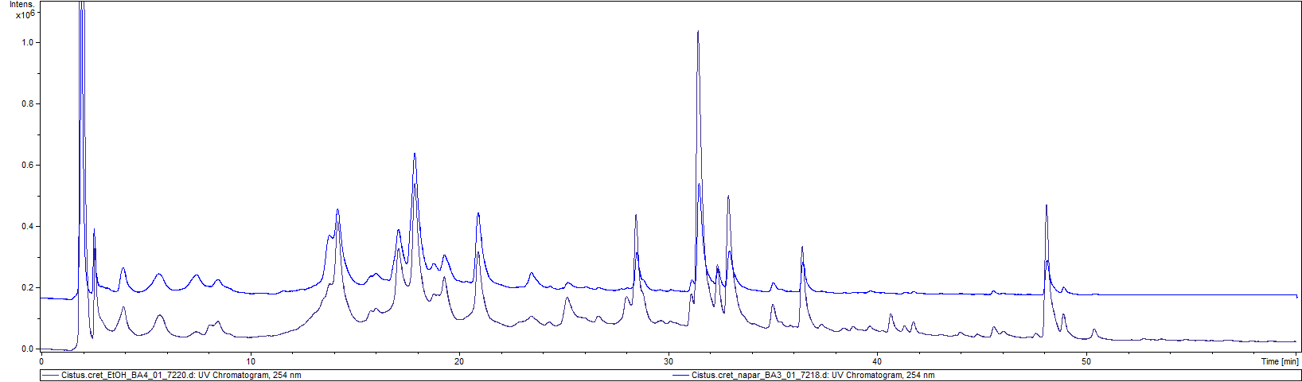
Cisti cretici herba
6
5
4
3
2
1

Fig. S3: HPLC-DAD chromatograms of the Cistus creticus ethanolic extract (violet) and infusion mixture (blue) recorded at 254 nm.

Table S4: Retention time, UV, and MS/MS data of the compounds identified in extracts of Cistus creticus.
No. | Compound | UV [nm] | Rt [min] | [M-H]⁻ | Product mass peaks
1. | Punicalin | 258 | 14.5 | 781.1 | 601.0; 541.0; 300.1
2. | Punicalagin | 258 | 18.7 | 1083.1 | 781.1; 601.0; 541.1; 301.0
3. | Myricetin-3-O-galactoside | 207, 358 | 28.7 | 479.1 | 316.9
4. | Myricetin-3-O-rhamnoside | 260, 349 | 31.6 | 463.1 | 315.9; 270.9
5. | Quercetin-3-O-galactoside | 270, 354 | 32.6 | 463.0 | 300.9
6. | Quercetin-3-O-rhamnoside | 207, 349 | 36.7 | 447.1 | 300.9
7. | Tiliroside | 207, 266, 313 | 48.3 | 593.2 | 447.0; 284.9

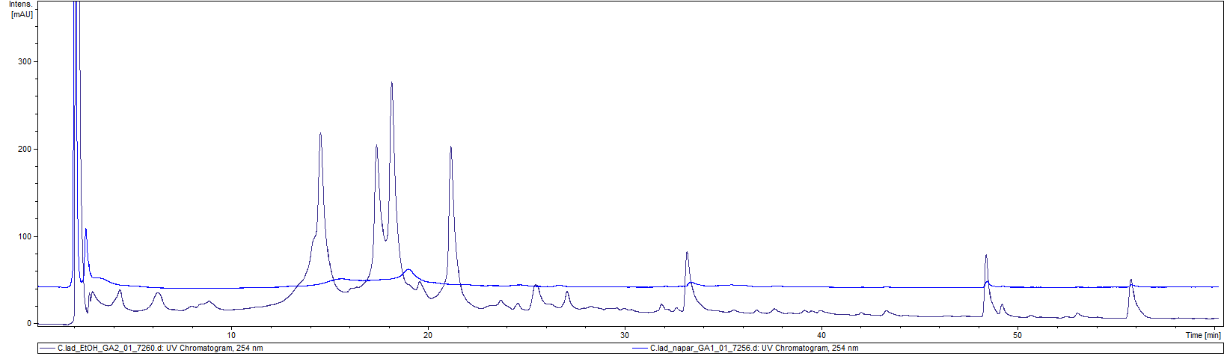
1
2
3
4
5
6
Cisti ladaniferi herba

Fig. S4: HPLC-DAD chromatograms of the Cistus ladanifer ethanolic extract (violet) and infusion mixture (blue) recorded at 254 nm.

Table S5: Retention time, UV, and MS/MS data of the compounds identified in extracts of Cistus ladanifer.
No. | Compound | UV [nm] | Rt [min] | [M-H]⁻ | Product mass peaks
1. | Punicalin | 258 | 14.5 | 781.1 | 601.0; 541.1; 300.1
2. | Punicalagin (I) | 260, 373 | 17.4 | 1083.1 | 781.1; 601.0; 541.1; 481.0; 300.9
3. | Punicalagin (II) | 258, 373 | 17.4 | 1083.1 | 781.1; 601.0; 541.1; 481.0; 300.9
4. | Strictinin | 267, 373 | 21.2 | 633.22 | 300.91
5. | Tyliroside | 266, 313 | 48.3 | 593.16 | 447.02; 284.89
6. | Kaempferol methylether | 214, 266, 351 | 55.7 | 298.98 | 283.85

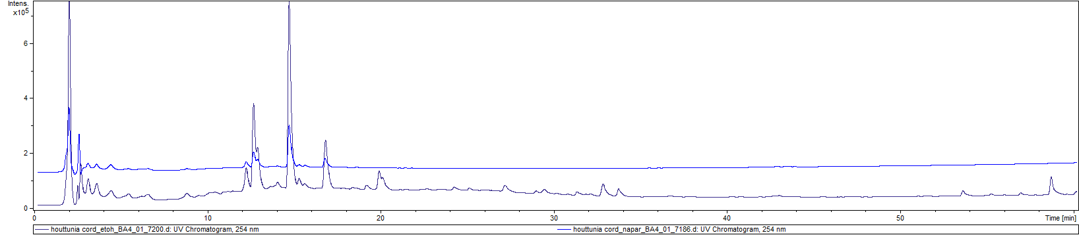
1
3
4
5
6
2
Houttuyniae herba
1

Fig. S5: HPLC-DAD chromatograms of Houttuynia cordata ethanolic extract (violet) and infusion extract (blue) recorded at 254 nm.

Tab. S6: Retention time, UV, and MS/MS data of the compounds identified in extracts of Houttuynia cordata.

No. | Compound | UV [nm] | Rt [min] | [M-H]⁻ | Product mass peaks
1. | Quercetine-3-O-glucoside (Isoquercitrin) | 258, 350 | 12.6 | 463.1 | 300.9
2. | Quercetin-3-O-galactoside  (Hyperoside) | 255, 350 | 13.0 | 463.1 | 300.9
3. | Quercetin 3-O-rhamnoside  (Quercitrin) | 255, 504 | 14.8 | 447.1 | 300.9
4. | Apigenin glucuronide | 278, 315 | 17.0 | 445.2 | 268.8
5. | Houttuynoid A/C | 220 | 32.9 | 641.3 | 521.2; 479.2; 461.2
6. | Houttuynoid A/C | 220 | 33.7 | 641.3 | 521.2;479.2; 461.5

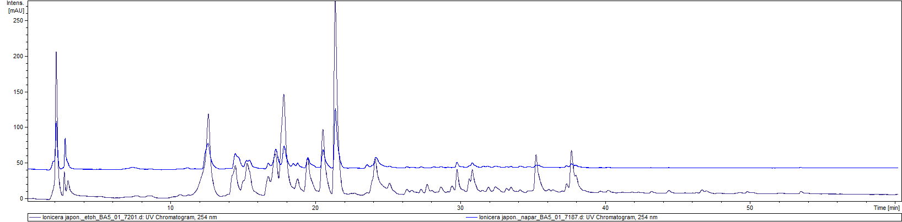
1
2
3
4
5
7
6
8
9
10
Lonicerae japonicae herba

Fig. S6: HPLC-DAD chromatograms of the Lonicera japonica ethanolic extract (violet) and infusion mixture (blue) recorded at 254 nm.
Table S7: Retention time, UV, and MS/MS data of the compounds identified in extracts of Lonicera japonica.

No. | Compound | UV [nm] | Rt [min] | [M-H]⁻ | Product mass peaks
1. | Caffeoyl-(O- glucosyl)-quinic acid | 235 sh, 310 | 12.7 | 515.1 | 353.0; 322.9; 190.8
2. | Loganic acid | 235 | 14.4 | 375.2 | 212.8; 168.8; 150.8
3. | Unknown iridoid | 235 | 15.6 | 375.2 | 194.8; 150.8
4. | Secologanoside | 230 | 16.7 | 389.1* | 345.1; 208.8; 164.8
5. | Secologanic acid | 240 | 17.3 | 373.2 | 192.7; 148.8
6. | 5-O-Caffeoylquinic acid | 216, 242 sh, 325 | 17.8 | 353.1 | 190.8
7. | Secologanoside A | 240 | 18.7 | 507.2 | 357.1; 327.0; 282.9;
8. | Caffeic acid | 238 s, 323 | 19.6 | 178.8 | 134.9
9. | Sweroside | 245 | 20.5 | 403.1* | 357.0; 194.9; 178.7
10. | Loganin | 237 | 21.4 | 435.1* | 389.1; 226.8
11. | Secoxyloganin | 235 | 24.1 | 403.2 | 371.1; 222.8;178.8
12. | 3,5-Dicaffeoylquinic acid | 214, 326 | 35.3 | 515.1 | 353.1; 190.8
13. | 4,5-Dicaffeoylquinic acid | 214, 326 | 37.9 | 515.2 | 353.1; 299.0; 254.9; 178.7; 172.8
*[M+COOH]-

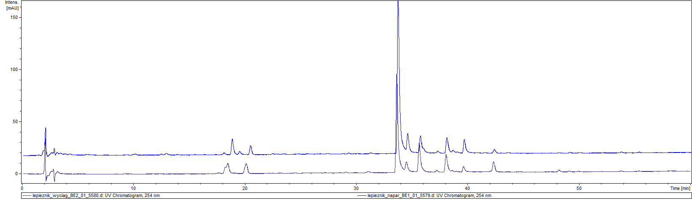
1
4
5
8
3
9
Petasitis hybridii radix
2
6
7

Fig. S7: HPLC-DAD chromatograms of the Petasites hybridus ethanolic extract (violet) and infusion mixture (blue) recorded at 254 nm.

Table S8: Retention time, UV, and MS/MS data of the compounds identified in extracts of Petasites hybridus.

No. | Compound | UV [nm] | Rt [min] | [M-H]⁻ | Product mass peaks
1. | 5-O-Caffeoylquinic acid | 219, 238 sh, 325 | 18.9 | 353.1 | 190.9
3. | Caffeic acid | 224, 238 sh, 323 | 20.5 | 179.0 | 135.1
4. | Fukinolic acid | 217, 329 | 33.5 | 433.1 | 271.0; 252,9; 235.0; 178.9
5. | 3,4-Dicaffeoylquinic acid | 222, 325 | 34.4 | 515.2 | 353.1; 299.1; 178.9; 172.9
6. | 3,5-Dicaffeoylquinic acid | 222, 326 | 35.8 | 515.2 | 353.1; 191.0; 179.1
7. | 4,5-Dicaffeoylquinic acid | 219, 329 | 38.1 | 515.2 | 351.1; 335.1; 255.0; 179.0; 172.9
8. | Petasiphenol | 218, 329 | 42.4 | 343.2 | 178.9; 134.9

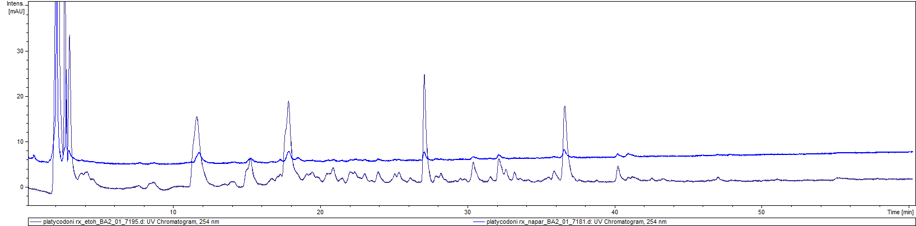
1
2
3
5
6
7
8
9
4
Platycodoni radix

Fig. S8: HPLC-DAD chromatograms of the ethanolic extract (violet) and infusion (blue) of Platycodon grandiflorus at 254 nm.

Tab. S9: Retention time, UV, and MS/MS data of the compounds identified in extracts of Platycodon grandiflorus.

No. | Compound | UV [nm] | Rt [min] | [M-H]⁻ | Product mass peaks
1. | Platycoside E | 215 | 15.3 | 1547.8 | 1458.8; 1005.8
2. | Deapioplatycodin D3 | 217 | 16.8 | 1253.7 | 1121.6; 843.5
3. | Platycodin D3 | 216 | 17.0 | 1385.8 | 1253.6; 843.6
4. | 5-O-Caffeoylquinic acid | 238 sh, 325 | 17.9 | 353.15 | 190.8
5. | Deapioplatycodin D1 | 217 | 19.1 | 1091.7 | 681.6
6. | Platycodin D | 215 | 19.6 | 1223.7 | 1133.7; 1091.7; 681.4
7. | Tianshic acid | 219 | 24.0 | 329.2 | 311.1; 228.9
8. | Platicoside M-1 | 214, 268 | 27.0 | 677.36 | 497.1; 345.0; 260.9
9. | Lobetyolin | 212, 253, 268, 283 | 36.5 | 441.2* | 395.1; 305.0; 214.8; 178.7

*[M+COOH]⁻
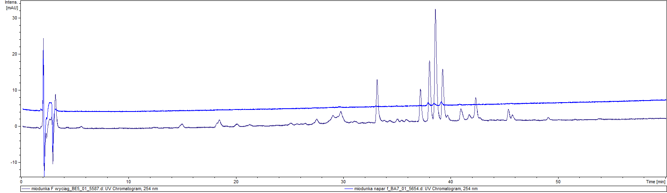
Pulmonariae herba
1
2
3
4
5
6
7
8
9
10
11

Fig. S9: HPLC-DAD chromatograms of Pulmonaria officinalis ethanolic extract (violet) and infusion extract (blue) recorded at 254 nm.

Tab. S10: Retention time, UV, and MS/MS data of the compounds identified in extracts of Pulmonaria officinalis.

No. | Compound | UV [nm] | Rt [min] | [M-H]⁻ | Product mass peaks
1. | Globoidnan B | 213, 275, 310 | 29.5 | 537.2 | 493.1; 339.1; 295.1
2. | Yunnaneic acid E | 214, 268 | 33.1 | 571.1 | 527.2; 285.0; 241.0
3. | Shimobashiric acid C | 216 | 35.8 | 719.2 | 539.1; 359.1
4. | Yunnaneic acid E-1 | 217,268 | 37.1 | 555.2* | 509.2; 491.1; 311.0; 267.0
5. | Rosmarinic acid | 216, 328 | 38.0 | 359.1* | 196.9
6. | Monardic acid A/Lithospermic acid A | 200, 309 | 38.5 | 537.2 | 493.2; 295.0
7. | Monardic acid A/Lithospermic acid A | 216, 310 | 39.2 | 537.2 | 493.2; 295.0
8. | Salvianolic acid H | 217,323 | 40.9 | 537.2 | 493.2; 359.1; 295.1
9. | Unknown | 217, 278 | 42.3 | 537.3 | 493.2; 295.1
10. | Globoidnan A | 217, 265 | 45.4 | 491.19 | 311.1; 267.0
11. | Isosalvianolic acid A | 217, 320 | 45.7 | 493.2 | 471.1; 295.1; 203.0

*[M+COOH]⁻

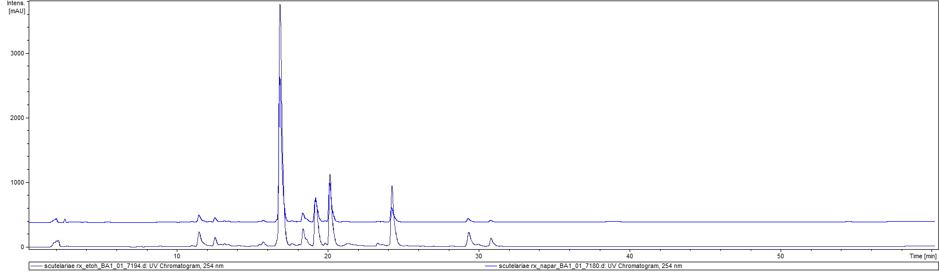
1
2
3
5
6
7
8
9
4
Scutellariae radix
10
11
12

Fig. S10: HPLC-DAD chromatograms of the ethanolic extract (violet) and infusion (blue) of Scutellaria baicalensis recorded at 254 nm.

Table S11: Retention time, UV, and MS/MS data of the compounds identified in extracts of Scutellaria baicalensis.

No. | Compound | UV [nm] | Rt [min] | [M-H]⁻ | Product mass peaks
1. | 2′,3,5,6′,7-Pentahydroxyflavanone | 199, 288 | 9.0 | 303.0 | 124.7
2. | Chrysin 6-C-glucoside 8-C-arabinoside/ Chrysin 6-C-arabinoside 8-C- glucosidearabinoside | 213, 273, 313 | 11.5 | 547.1 | 457.1; 427.1; 337.0
3. | Chrysin 6-C-glucoside 8-C-arabinoside/Chrysin 6-C-arabinoside 8-C- | 213, 273, 313 | 11.5 | 547.1 | 457.1;427.1; 337.0
4. | Baicalin | 277, 315 | 16.9 | 445.1 | 268.8; 174.7
5. | Dihydroxy-methoxy flavone-O-glucoside | 279 | 18.3 | 447.1 | 268.8
6. | Oroxylin A-O-glucuronide | 209, 271, 310 | 19.2 | 459.1 | 282.9; 268.8
7. | Wogonoside | 216, 274 | 20.2 | 459.1 | 282.9; 267.8
8. | Baicalein | 214, 275, 322 | 24.2 | 268.8 | 250.8
9. | Skullcapflavone II | 274 | 29.1 | 373.10 | 342.93
10 | Wogonin | 209, 275 | 29.3 | 283.0 | 267.9
11. | Chrysin | 218, 270 | 30.0 | 252.9 | -
12. | Oroxylin A | 216, 271, 318 | 30.8 | 282.9 | 267.8

Figure S11: Influence of infusions and ethanolic extracts at 100 μg/mL on LDH secretion by LPS-stimulated neutrophils. Data from three separate experiments performed using neutrophils isolated from independent donors assayed in duplicate are expressed as the mean ± SEM. Triton 2% was used as a positive control. Statistical significance: ***p < 0.001 vs. stimulated control (KST). The pink bars indicate the values obtained after the incubation of cells with aqueous extracts, whereas the purple bars (numbers with letters, A’) represent the results for the ethanolic extracts.

Figure S12: Influence of infusions and ethanolic extracts at 100 μg/mL on LDH secretion by LPS-stimulated PBMC monocytes/macrophages. Data from three separate experiments performed using neutrophils isolated from independent donors assayed in duplicate are expressed as the mean ± SEM. Triton 2% was used as a positive control. Statistical significance: ***p < 0.001 vs. stimulated control (KST). The pink bars indicate the values obtained after the incubation of cells with aqueous extracts, whereas the purple bars (numbers with letters, A’) represent the results for the ethanolic extracts.

