1.5 Supplement

1.5.1 Experimental groups
Animal experimental groups for subretinal injection of hCPs are shown in Table S1
Table S1. Animal experimental groups for subretinal injection of hCPs
Long Evans 2 weeks | Total number of injected rats | Total number of successful injections | Number of animals with presence of cells 2 weeks post injection
16 weeks-hCP | 11 | 10 | 10
14 weeks-hCP | 9 | 9 | 8
SHAM | 5 | N/A | N/A
RCS rats 90 days | Total number of injected rats | Total number of successful injections | Number of rats with presence of cells 90 days post injection
High dose – 150k | 8 | 7 | 6
Medium dose – 100k | 8 | 7 | 5
Low dose – 50k | 8 | 7 | 4
SHAM | 8 | N/A | N/A
Control | 8 | N/A | N/A
RD1 mice 1 week | Total number of injected mice | Total number of successful injections | Number of rats with presence of cells 1-week post injection
High dose – 100k | 4 | 4 | 3
Low dose – 50k | 4 | 3 | 2
SHAM | 4 | N/A | N/A
Control | 3 | N/A | N/A

1.5.2 Experimental design

1.5.2.1 Overview of animal experiments

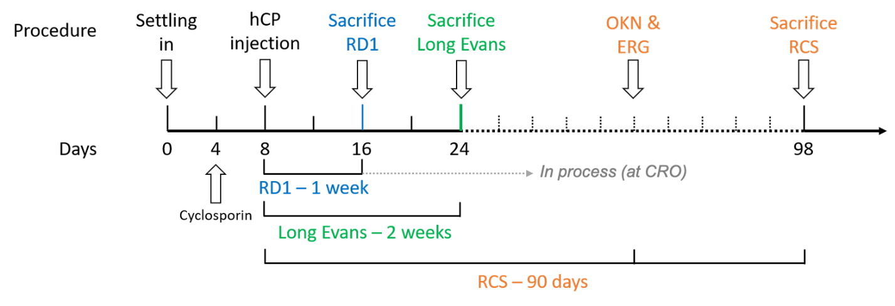
Figure S1. Experimental design of hCP injection in different animal models. Rats and mice are left to settle down for 4 days after arrival, which is followed by the start of cyclosporin treatment. hCP injection is performed at day 8 post-arrival for all groups. RD1 are sacrificed 1 week later, Long Evans 2 weeks later and RCS 90 days later. OKN and ERG are measured for RCS rats 60- and 90-days post-injection.

1.5.3 Control and measured outcomes
The control group consisted of rats/mice which had no surgery. The SHAM group consisted in rats/mice which had only a minimal surgery consisting in poking the eyeball with a 31-gauge needle without injecting anything. This is performed to replicate the trauma of needle injection itself. These rats/mice were sacrificed at the same time points as the experimental groups.
Outcomes for this study were based on direct examination, image processing and machine learning analysis of retinal sections or whole mount of injected rats/mice eyes. The measured outcomes were:
• % of cells engrafted expressing STEM121 (human)
• % of cells engrafted expressing Cone Arrestin (Cones)
• % of cells engrafted expressing DAPI (Nuclei)
• Number of nuclei in ONL (function of distance from injection location)
• Spatial frequency (OKN measurement of functional assay)
• Response to light stimulus (ERG)
• % area of IBA1 (immune cells)
• % area of CD45 (macrophages)

