Compressed higher-order structures facilitate human knowledge network learning
Xiangjuan Ren, Muzhi Wang, Tingting Qin, Fang Fang*, Aming Li*, Huan Luo*.

*Correspondence: ffang@pku.edu.cn (F.F), amingli@pku.edu.cn (A.L.), huan.luo@pku.edu.cn (H.L.)

The PDF file includes:
Supplementary Text
Figure S1 to S19
Table S1 to S2

Supplementary Text
Implementation of generalized linear mixed-effect models
The LMMs and GLMMs were implemented by R package afex, lme4 and lmerTest¹. For the estimation of marginal effects and the post hoc analysis, the emmeans package was used². LMMs for MEG analysis are implemented through python proxy for R pymer4.
GLMM1: participants’ choices (correct or wrong) on all trials in Experiment 1 are the dependent variable; fixed effects include an intercept, the main effects of the network (between-subjects designr), the trial number (the practice effect; log-transformed; trialNo), the recency effect (defined as the number of trials since the last instance of the target image on the current trial), the node-degree of the target (nodeDegree), the minimum transition distance between the cue image and the distractor image (always greater than one step; minD) and the interaction effect between the network and the trial number; random effects at the subject level include random slopes of trial numbers, recency, node-degree, minimum transition distance, and random intercept. All continuous variables, including trial numbers, recency, node-degree and minimum distance, were standardised prior to model estimation (the same below). GLMM1 is formulated as follows:
$$choices\sim 1+network+ trialNo+recency+nodeDegree+minD+network×trialNo+\left(1+trialNo+recency+nodeDegree+minD||subj\right).$$
Note that we suppress the covariance between random effects using the || operator in R. For the online data (Figure S3b bottom) and node-degree matched analysis (Figure S5), only the random slope of the trial numbers was introduced due to the singularity issue.
GLMM2.1: participants’ choices of all trials in a bin (100 trials) during the Learning II phase in Experiment 2 are the dependent variable. Fixed effects include an intercept and the path group (Random, HubToLeaf, and LeafToHub; between-subjects design). Subject-level random intercepts are kept for random effects. Similar results were obtained when the other fixed effects and their interactions were included as GLMM1.
GLMM2.2: participants’ choices of all trials during the Learning II phase in Experiment 2 are the dependent variable. Fixed effects include an intercept, the main effects of the trial number (log-transformed), recency, nodeDegree, minD, the path group, and the interaction effect between the path group and the trial number; random effects at subject level include uncorrelated random slopes (by suppressing the covariance) of all corresponding fixed effects except the path group, and random intercepts.
LMM1: neural RDMs at each time point are the dependent variable. Model RDM, path group, and their interaction are specified in the fixed effects. The subject-level random slope of model RDM was included. The linear mixed-effect model is formulated as follows:
$$N_{i,j}\sim 1+M_{i,j}+path+M_{i,j}×path+\left(1+M_{i,j}||subj\right),$$where $i$ and $j$ denotes a pair of nodes ($i<j$); subj denotes the subject index; path denotes the path group; $M$ denotes the minimal distance matrix. Correlations between random effects are removed due to singularity fits.
LMM2: elements in neural RDMs are the dependent variable. Node-degree and elements in MDM $M$ are specified as both fixed effects and subject-level random effects.
LMM3: to control the effect of node degree, we add node degree difference as both fixed and random effects to LLM1. The linear mixed-effect model is then formulated as follows:
$$N_{i,j}\sim 1+M_{i,j}+D_{i,j}+path+(M_{i,j}+D_{i,j})×path+\left(1+M_{i,j}+D_{i,j}||subj\right),$$where $i$ and $j$ denotes a pair of nodes ($i<j$); $D$ denotes the node-degree difference matrix. $D_{i,j}$ denotes the absolute node-degree difference between node $i$ and $j$. Correlations between random effects are removed due to singularity fits.
Statistics summary
Experiment 1: Pooling data from in-laboratory participants (N=80) and online participants (N=80). ANOVA from GLMM1 with likelihood ratio tests (Figure 1e), main effect of network: $χ^{2}\left(3\right)=$ 143.92, p < 0.001; trial numbers: $χ^{2}\left(1\right)=$ 26.71, p < 0.001; recency: $χ^{2}\left(1\right)=$ 44.41, p < 0.001; node-degree: $χ^{2}\left(1\right)=$ 31.93, p < 0.001, and minimal distance: $χ^{2}\left(1\right)=$ 18.66, p < 0.001; interaction effect between network and trial numbers: $χ^{2}\left(3\right)=$ 4.45, p = 0.216. Post-hoc comparisons with Bonferroni correction from GLMM1, Scale-free vs. Lattice: z = 10.63, p < 0.001; Scale-free vs. Random: z = 9.81, p < 0.001; Scale-free vs. Small-world: z = 8.68, p < 0.001; Lattice vs. Random: z = –0.79, p = 1.00; Lattice vs. Small-world: z = –1.90, p = 0.344; Random vs. Small-world: z = –1.10, p = 1.00. Correlations between the random effects were suppressed due to singularity fits.
Experiment 1: Data from in-laboratory participants (N=80). GLMM1 was applied to the data collected from the in-laboratory participants (Figure S3b, top panel). ANOVA from GLMM1 with likelihood ratio tests, main effect of network: $χ^{2}\left(3\right)=$ 52.25, p < 0.001; trial numbers: $χ^{2}\left(1\right)=$ 25.10, p < 0.001; recency: $χ^{2}\left(1\right)=$ 33.58, p < 0.001; node-degree: $χ^{2}\left(1\right)=$ 13.19, p < 0.001, and mininal distance: $χ^{2}\left(1\right)=$ 7.93, p = 0.005; interaction effect between network and trial numbers: $χ^{2}\left(3\right)=$4.75, p = 0.191. Post-hoc comparisons with Bonferroni from GLMM1, Scale-free vs. Lattice: z = 5.86, p < 0.001; Scale-free vs. Random: z = 6.72, p < 0.001; Scale-free vs. Small-world: z = 4.52, p < 0.001; Lattice vs. Random: z = 0.90, p = 1.00; Lattice vs. Small-world: z = –1.30, p = 1.00; Random vs. Small-world: z = –2.18, p = 0.18.
Experiment 1: Data from online participants (N=80). Due to the singularity problem, we applied the slightly modified version of GLMM1 to the data collected from the online participants (Figure S3b, bottom panel) and the node-degree matched analysis pooled the in-laboratory and online participants (Figure S5). The modified GLMM1, excluding all subject-evel random effects other than the random slope of the trial number and the random intercept, is formulated as follows:
$$choices\sim 1+network+ trialNo+recency+nodeDegree+minD+network×trialNo+\left(1+trialNo | subj\right)$$
ANOVA of the modified GLMM1 with likelihood ratio tests, main effect of network: $χ^{2}\left(3\right)=$ 98.87, p < 0.001; trial numbers: $χ^{2}\left(1\right)=$ 6.27, p = 0.012; recency: $χ^{2}\left(1\right)=$ 49.11, p < 0.001; node-degree: $χ^{2}\left(1\right)=$ 119.42, p < 0.001, and mininal distance: $χ^{2}\left(1\right)=$ 12.86, p < 0.001; interaction effect between network and trial numbers: $χ^{2}\left(3\right)=$ 2.01, p = 0.571. Post-hoc comparisons with Bonferroni from the modified GLMM1, Scale-free vs. Lattice: z = 9.08, p < 0.001; Scale-free vs. Random: z = 7.10, p < 0.001; Scale-free vs. Small-world: z = 7.65, p < 0.001; Lattice vs. Random: z = –1.97, p = 0.295; Lattice vs. Small-world: z = –1.43, p = 0.914; Random vs. Small-world: z = 0.54, p = 1.00.
Experiment 1: Node-degree matched analysis – node-degree of the cue matched. ANOVA of the modified GLMM1 with likelihood ratio tests, main effect of network: $χ^{2}\left(3\right)=$ 16.63, p = 0.001; trial numbers: $χ^{2}\left(1\right)=$ 19.61, p < 0.001; recency: $χ^{2}\left(1\right)=$ 123.60, p < 0.001; node-degree (of the target image): $χ^{2}\left(1\right)=$ 33.19, p < 0.001, and mininal distance: $χ^{2}\left(1\right)=$ 5.42, p = 0.020; interaction effect between network and trial numbers: $χ^{2}\left(3\right)=$ 2.94, p = 0.400. Post-hoc comparisons with Bonferroni from GLMM1, Scale-free vs. Lattice: z = 4.03, p < 0.001; Scale-free vs. Random: z = 3.02 p = 0.015; Scale-free vs. Small-world: z = 3.22, p = 0.008; Lattice vs. Random: z = –0.83, p = 1.00; Lattice vs. Small-world: z = –0.49, p = 1.00; Random vs. Small-world: z = 0.27, p = 1.00.
Experiment 1: Node-degree matched analysis – node-degree of the target matched. ANOVA from modified GLMM1 with likelihood ratio tests, main effect of network: $χ^{2}\left(3\right)=$ 0.82, p = 0.845; trial numbers: $χ^{2}\left(1\right)=$ 9.95, p = 0.002; recency: $χ^{2}\left(1\right)=$ 112.50, p < 0.001; node-degree (of the cue image): $χ^{2}\left(1\right)=$ 3.58, p = 0.058, and mininal distance: $χ^{2}\left(1\right)=$ 2.03, p = 0.154; interaction effect between network and trial numbers: $χ^{2}\left(3\right)=$ 7.42, p = 0.060.
Experiment 1: Node-degree matched analysis – both the node-degree of the cue and target matched. For this analysis, we further removed the regressor of ‘node-degree’ from the fixed effects. ANOVA of modified GLMM1 with likelihood ratio tests, main effect of network: $χ^{2}\left(3\right)=$ 1.44, p = 0.696; trial numbers: $χ^{2}\left(1\right)=$ 8.56, p = 0.003; recency: $χ^{2}\left(1\right)=$ 80.94, p < 0.001, and mininal distance: $χ^{2}\left(1\right)=$ 0.50, p = 0.481; interaction effect between network and trial numbers: $χ^{2}\left(3\right)=$ 1.47, p = 0.690.
Experiment 2: Data in each of the 8 bins of Learning II (N=238). Statistical tests with only path groups (RandomWalk, HubToLeaf, and LeafToHub) as fixed effects and random intercepts for subjects as random effects were applied to the data in each time bin (Fig. 2D, GLMM2.1):
$$choices\sim 1+path+\left(1 | subj\right)$$
ANOVA of GLMM2.1 with likelihood ratio tests for 8 bins: Bin3, $χ^{2}\left(2\right)=$ 4.66, p = 0.098; Bin4, $χ^{2}\left(3\right)=$ 9.58, p = 0.008; Bin5, $χ^{2}\left(3\right)=$ 13.21, p = 0.001; Bin6, $χ^{2}\left(3\right)=$ 3.95, p = 0.139; Bin7, $χ^{2}\left(3\right)=$ 42.67, p < 0.001; Bin8, $χ^{2}\left(3\right)=$ 18.84, p < 0.001; Bin9, $χ^{2}\left(3\right)=$ 21.06, p < 0.001; Bin10, $χ^{2}\left(3\right)=$ 27.85, p < 0.001. The following statistics in each bin represent the Bonferroni-corrected post-hoc comparisons from GLMM2.1 for HubToLeaf vs. RandomWalk, HubToLeaf vs. LeafToHub, and RandomWalk vs. LeafToHub respectively, with FDR correction across bins:
Bin3, z = 1.82, p = 0.208; z = 1.91, p = 0.191; z = 0.08, p = 1.000;
Bin4, z = 2.88, p = 0.016; z = 2.41, p = 0.064; z = –0.49, p = 1.000;
Bin5, z = 2.96, p = 0.015; z = 3.30, p = 0.008; z = 0.31, p = 1.000;
Bin6, z = 1.85, p = 0.208; z = 1.56, p = 0.360; z = –0.30, p = 1.000;
Bin7, z = 6.38, p < 0.001; z = 4.39, p < 0.001; z = –2.02, p = 0.346;
Bin8, z = 3.90, p < 0.001; z = 3.59, p = 0.004; z = –0.35, p = 1.000;
Bin9, z = 4.58, p < 0.001; z = 2.53, p = 0.055; z = –2.07, p = 0.346;
Bin10, z = 5.27, p < 0.001; z = 2.85, p = 0.026; z = –2.44, p = 0.346.
The results suggested that while all three groups showed similar performance at the beginning, HubToLeaf gradually outperformed the other two and maintained its lead thereafter.
Similar results were obtained when the other fixed effects and their interactions were included as GLMM1. Due to the singularity issue, only random slopes of the trial numbers were included:
$$choices\sim 1+path+ trialNo+recency+nodeDegree+minD+network×trialNo+\left(1+trialNo | subj\right)$$
The ANOVA with likelihood ratio tests for Bin 3, main effect of group: $χ^{2}\left(2\right)=$ 4.67, p = 0.097; main effect of trial numbers: $χ^{2}\left(1\right)=$ 0.59, p = 0.444; main effect of recency: $χ^{2}\left(1\right)=$ 44.46, p < 0.001; main effect of node-degree: $χ^{2}\left(1\right)=$ 82.23, p < 0.001; main effect of the minimal distance: $χ^{2}\left(1\right)=$ 13.93, p < 0.001; interaction effect between group and trial numbers: $χ^{2}\left(2\right)=$ 16.05, p < 0.001.
For the ANOVA results from Bin 4 to 10, the main effect of group, trial numbers, recency, node-degree, minimal distance and the interaction effect between group and trial bumbers were reported accordingly:
Bin 4: $χ^{2}\left(2\right)=$ 9.41, p = 0.009; $χ^{2}\left(1\right)=$ 0.48, p = 0.487; $χ^{2}\left(1\right)=$ 42.07, p < 0.001; $χ^{2}\left(1\right)=$ 142.27, p < 0.001; $χ^{2}\left(1\right)=$ 8.01, p = 0.005; $χ^{2}\left(2\right)=$ 1.66, p = 0.436;
Bin 5: $χ^{2}\left(2\right)=$ 13.35, p = 0.001; $χ^{2}\left(1\right)=$ 1.58, p = 0.209; $χ^{2}\left(1\right)=$ 48.63, p < 0.001; $χ^{2}\left(1\right)=$ 173.75, p < 0.001; $χ^{2}\left(1\right)=$ 7.43, p = 0.006; $χ^{2}\left(2\right)=$ 1.00, p = 0.606;
Bin 6: $χ^{2}\left(2\right)=$ 3.94, p = 0.139; $χ^{2}\left(1\right)=$ 2.40, p = 0.121; $χ^{2}\left(1\right)=$ 24.36, p < 0.001; $χ^{2}\left(1\right)=$ 191.88, p < 0.001; $χ^{2}\left(1\right)=$ 3.52, p = 0.061; $χ^{2}\left(2\right)=$ 2.23, p = 0.327;
Bin 7: $χ^{2}\left(2\right)=$ 43.37, p < 0.001; $χ^{2}\left(1\right)=$ 1.21, p = 0.272; $χ^{2}\left(1\right)=$ 18.17, p < 0.001; $χ^{2}\left(1\right)=$ 255.34, p < 0.001; $χ^{2}\left(1\right)=$ 30.37, p < 0.001; $χ^{2}\left(2\right)=$ 0.41, p = 0.813;
Bin 8: $χ^{2}\left(2\right)=$ 19.11, p < 0.001; $χ^{2}\left(1\right)=$ 0.29, p = 0.593; $χ^{2}\left(1\right)=$ 17.03, p < 0.001; $χ^{2}\left(1\right)=$ 285.83, p < 0.001; $χ^{2}\left(1\right)=$ 9.93, p = 0.002; $χ^{2}\left(2\right)=$ 1.06, p = 0.589;
Bin 9: $χ^{2}\left(2\right)=$ 21.56, p < 0.001; $χ^{2}\left(1\right)=$ 5.83, p = 0.016; $χ^{2}\left(1\right)=$ 10.05, p = 0.002; $χ^{2}\left(1\right)=$ 306.98, p < 0.001; $χ^{2}\left(1\right)=$ 14.84, p < 0.001; $χ^{2}\left(2\right)=$ 2.97, p = 0.226;
Bin 10: $χ^{2}\left(2\right)=$ 28.57, p < 0.001; $χ^{2}\left(1\right)=$ 0.34, p = 0.560; $χ^{2}\left(1\right)=$ 9.42, p = 0.002; $χ^{2}\left(1\right)=$ 391.86, p < 0.001; $χ^{2}\left(1\right)=$ 4.44, p = 0.035; $χ^{2}\left(2\right)=$ 1.68, p = 0.432.
Bonferroni-corrected post-hoc comparisons within each bin and FDR correction between bins, for HubToLeaf vs. RandomWalk, HubToLeaf vs. LeafToHub, and RandomWalk vs. LeafToHub respectively:
Bin 3: z = 1.81, p = 0.209; z = 1.92, p = 0.188; z = 0.09, p = 1.000;
Bin 4: z = 2.84, p = 0.018; z = 2.41, p = 0.063; z = –0.45, p = 1.000;
Bin 5: z = 2.98, p = 0.014; z = 3.32, p = 0.007; z = 0.31, p = 1.000;
Bin 6: z = 1.84, p = 0.209; z = 1.56, p = 0.354; z = –0.29, p = 1.000;
Bin 7: z = 6.43, p < 0.001; z = 4.41, p < 0.001; z = –2.06, p = 0.315;
Bin 8: z = 3.94, p < 0.001; z = 3.60, p = 0.004; z = –0.36, p = 1.000;
Bin 9: z = 4.63, p < 0.001; z = 2.56, p = 0.050; z = –2.10, p = 0.315;
Bin 10: z = 5.34, p < 0.001; z = 2.89, p = 0.023; z = –2.48, p = 0.315;
Experiment 2: Data from all trials of Learning II (N=238). We fitted GLMM2.2 to all data in Learning II phase, controlling recency, node-degree and other confounding factors. ANOVA with likelihood ratio tests, main effect of path group: $χ^{2}\left(2\right)=$ 124.68, p < 0.001; trial numbers: $χ^{2}\left(1\right)=$ 22.71, p < 0.001; recency: $χ^{2}\left(1\right)=$ 60.25, p < 0.001; node-degree: $χ^{2}\left(1\right)=$ 84.94, p < 0.001, and mininal distance: $χ^{2}\left(1\right)=$ 45.22, p < 0.001; interaction effect between path group and trial numbers: $χ^{2}\left(2\right)=$9.35, p = 0.009. Post-hoc comparisons with Bonferroni corrections, HubToLeaf vs. RandomWalk: z = 10.72, p < 0.001; HubToLeaf vs. LeafToHub: z = 8.03, p < 0.001; RandomWalk vs. LeafToHub: z = –2.77, p = 0.017 (Fig. 2E). Since we already matched all the other variables (i.e., trial numbers, recency, node-degree and minimum) in the experiment design of Learning II phase, we also fitted a simplified version of GLMM2.2, in which only the path group (Random, HubToLeaf, and LeafToHub), the trial numbers and their interaction were kept as the fixed effects, and the random slopes of trial numbers and the random intercept as subject-level random effects. The results still held in the simplified version of GLMM2.2.
Experiment 2: Data from all trials of Learning II in the in-laboratory experiment (N=63). We fitted GLMM2.2 and obtained ANOVA with likelihood ratio tests. Correlations between random effects were removed due to singularity fits. Main effect of path group: $χ^{2}\left(2\right)=$ 7.51, p = 0.023; trial number: $χ^{2}\left(1\right)=10.27$, p = 0.001; recency: $χ^{2}\left(1\right)=84.51$, p < 0.001; node-degree, $χ^{2}\left(1\right)=9.06$, p = 0.003; minimal distance: $χ^{2}\left(1\right)=$ 30.04, p < 0.001; interaction effect between path group and trial numbers: $χ^{2}\left(2\right)=$ 3.50, p = 0.173. Post-hoc comparison with Bonferroni corrections, HubToLeaf vs. RandomWalk: z = 2.75, p = 0.018; HubToLeaf vs. LeafToHub: z = 1.92, p = 0.164; RandomWalk vs. LeafToHub: z = -0.84, p = 1.00 (Figure S6).
Experiment 3: Data from all trials of Learning II (N=40). We fitted GLMM2.2 and obtained ANOVA with likelihood ratio tests (Figure S7). Main effect of path group: $χ^{2}\left(2\right)=$ 0.02, p = 0.884; trial number: $χ^{2}\left(1\right)=$ 22.92, p = 0.001; recency: $χ^{2}\left(1\right)=$ 30.21, p < 0.001; node-degree, $χ^{2}\left(1\right)=$ 15.67, p < 0.001; minimal distance: $χ^{2}\left(1\right)=$ 17.67, p < 0.001; interaction effect between path group and trial numbers: $χ^{2}\left(2\right)=$ 1.72, p = 0.190.
Experiment 3: RDMs at time of interest (1194 ms after cue onset; N = 40). We fitted LLM2 to neural RDMs (Figure S8) and performed Satterwhite’s t test. For HubToLeaf group, main effect of node-degree: β = –0.012, t(4760.00) = -3.27, p = 0.001; Minimal distances between nodes: β = 0.009, t(22.12) = 1.43, p = 0.168; Interaction between node-degree and minimal-distances: t(4760.00) = 1.00, p = 0.318; For LeafToHub group, main effect of node-degree: β = –0.012, t(4760.00) = -3.27, p = 0.001; Minimal distances between nodes: β = 0.009, t(22.12) = 1.43, p = 0.168; Interaction between node-degree and minimal-distances: t(4760.00) = 1.00, p = 0.318.
Experiment 3: RDMs at time of interest (1194 ms after cue onset; N = 40). To exclude that possible confounding of node degree effects in the group difference (LMM1), we observed in LLM1. We fitted LLM3 to neural RDMs at time of interest and performed Satterwhite’s t test. The inclusion of node degree as a control factor does not influence the results qualitatively. Main effect of node-degree: β = 0.00044, t(317.40) = 0.245, p = 0.807; main effect of minimal distances between nodes: β = 0.0023, t(93.54) = 0.666, p = 0.507; main effect of paths: β = -0.038, t(40.85) = -2.43, p = 0.019; Interaction between paths and minimal distances: β = 0.0085, t(40.92) = 3.07, p = 0.004; Interaction between paths and node degree: β = -0.00019, t(4667.06) = -0.212, p = 0.832.
Scale-free network generation model
Compared with the scale-free networks generated by Barabási–Albert (BA) model³, where triangle structures are rarely formed, the Holme-Kim (HK) network⁴ instead allows for tunable clustering coefficient while preserving the power-law degree distribution. The Klemm–Eguíluz (KE) network⁵ considers the memory effect in the preferential attachment mechanism and features a negative correlation between the age of a node, which refers to how early a node was added to the network, and its link attachment rate, in contrast to the BA network where nodes that were added earlier to the network have a high preferential attachment probability. Unlike the above three types of scale-free networks which are both constructed in an evolving way, the static model⁶ assumes that each node is assigned a specific variable and connections between nodes are then determined based on the values of these variables. Based on this, to ensure no isolated nodes remain, the network structure is adjusted accordingly and we obtain the Goh-Kahng-Kim (GKK) network.

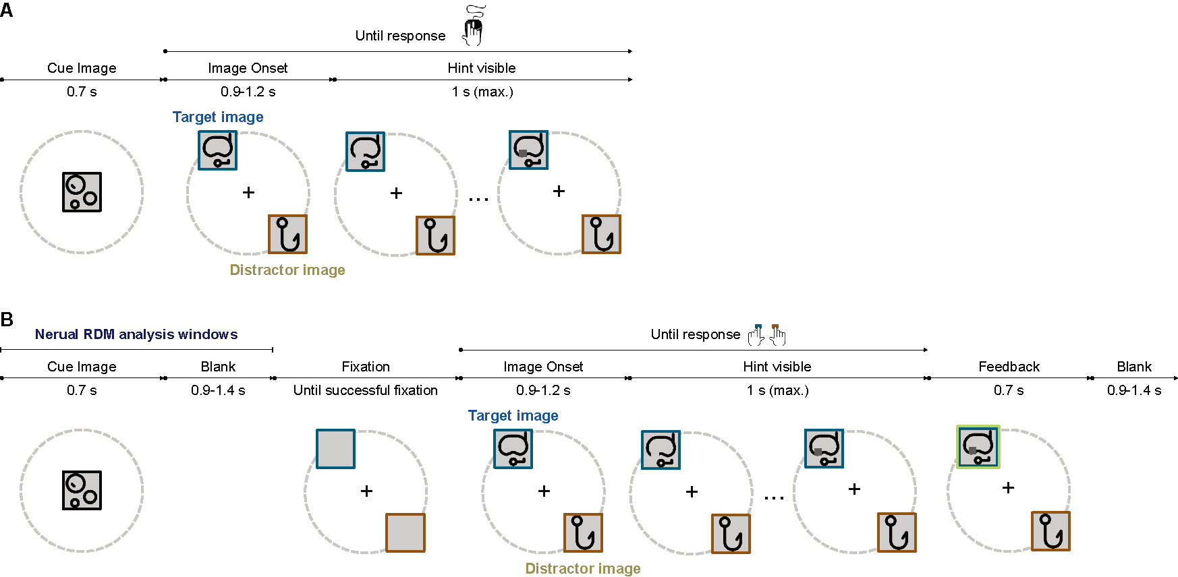
Figure S1. Task procedures.
In all experiments, subjects were encouraged to respond before the appearance of the gray hint. In Experiments 1 and 2, subjects responded by moving the mouse and clicking on the target, during which the mouse trajectory was recorded (A). In Experiment 3, to limit movement during MEG recording, we changed the mouse click to button press (B).

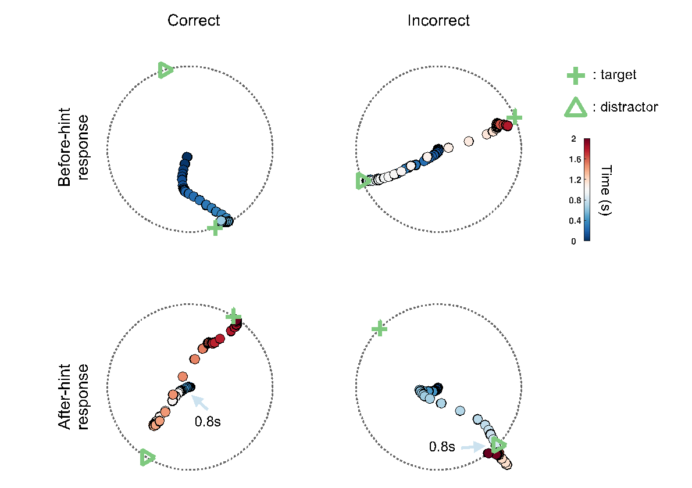
Figure S2. Binary classification of choice by mouse trajectory.
For the decision period on each trial (see Figure 1B), a target and a distractor image are shown on an invisible circle, with their positions always 180° apart. At the beginning of the “Target-distractor”, the mouse cursor is reset to the center of the screen and the pseudo-continuous trajectory, which stores the temporal dwell positions, is recorded until subjects’ final decision. Based on whether the subjects’ decisions are made before or after the hint (a gray square gradually appears on the target image), the trials can be categorised into “response-before-hint” trials (top row) and “response-after-hint” trials (bottom row). For the “response-before-hint” trials, subjects’ choice (correct vs. incorrect) is determined by the classification results at the time when the subjects click on the target or distractor image, whereas for the “response-after-hint” trials, the classification results at 0.8 s are selected, before the hint is visible. A trial is correct if the subjects choose the target image, or if their mouse cursor is closer to the target image right before the hint appears (left column). Green cross: target image. Hollow triangle: distractor image. Colour bar: temporal tracking of the mouse trajectory, with 0 indicating the onset of the target-distractor image pair.

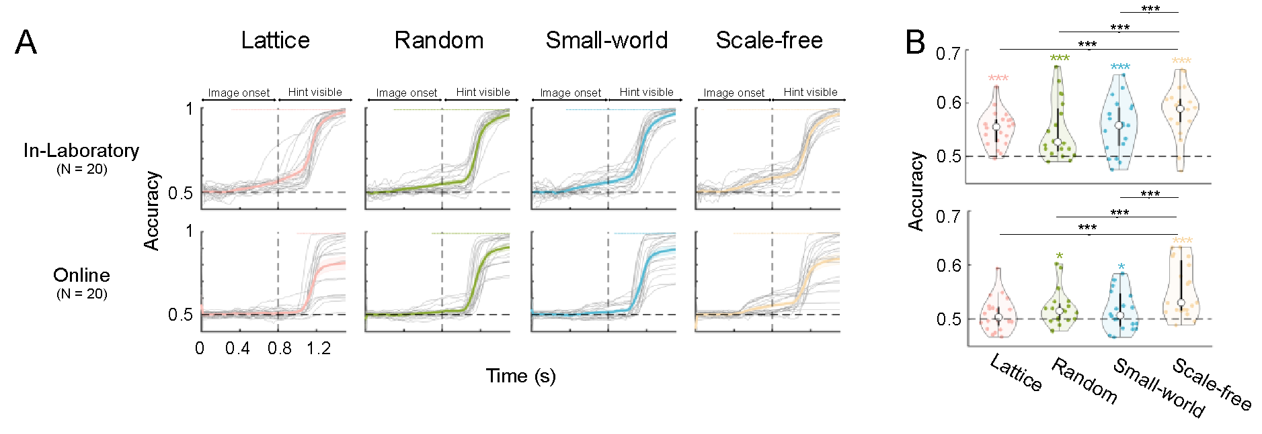
Figure S3. Predictive performance for the in-laboratory and online subjects in Experiment 1.
(A) Decision preference within a trial. Subjects’ choice preference on the target image (the accuracy) is significantly higher than the chance level (0.5) well before the hint onset for the in-laboratory subjects in all groups, while this is only true for the online subjects in the Random and Scale-free networks. Gray and colored lines denote individual subjects and grand average. The filled dots at the top indicate group level significance (p<0.05; FDR correction across time points on right-sided paired-sample t test). (B) Overall accuracy comparison of the four networks. The performance of in-laboratory subjects is significantly above the chance level in all groups (one-sample t-test with FDR correction, right-sided), whereas online subjects’ performance in the Lattice network does not differ from the chancel level. Between-group comparisons are performed using GLMM1 and post-hoc contrast, controlling for the recency (a proxy for inhomogeneity) and other confounders (In-lab subjects, main effect of network: $χ^{2}\left(3\right)=$ 52.25, p<0.001; Scale-free vs. Lattice: z = 5.86, p < 0.001; Scale-free vs. Random: z = 6.72, p < 0.001; Scale-free vs. Small-world: z = 4.52, p < 0.001. Online subjects, $χ^{2}\left(3\right)=$ 98.87, p < 0.001, Scale-free vs. Lattice: z = 9.08, p < 0.001; Scale-free vs. Random: z = 7.10, p < 0.001; Scale-free vs. Small-world: z = 7.65, p < 0.001). ***: p < 0.001; *: 0.01 ≤ p < 0.05. Top and bottom rows: in-laboratory and online subjects respectively.

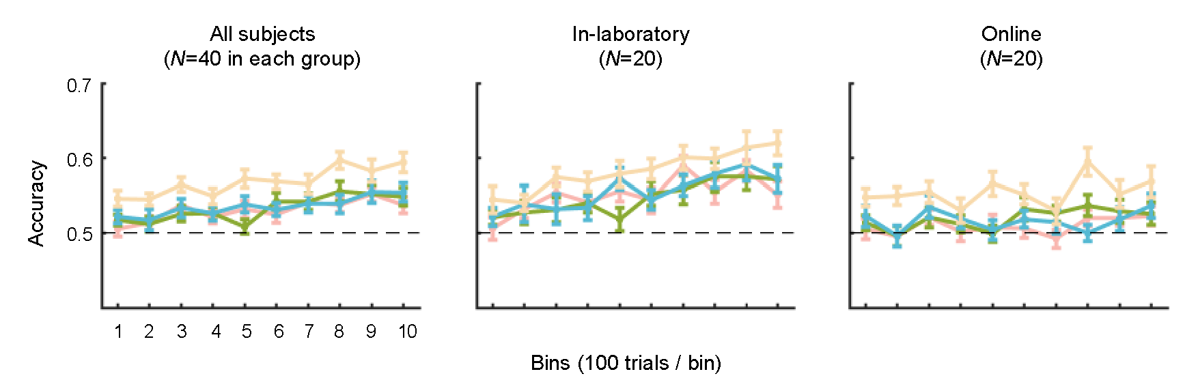
Figure S4. Learning curves for the 4 transition networks in Experiment 1.
Resting on the one-point accuracy defined on each trial, the average accuracy over 100 consecutive trials (a ‘bin’) is calculated. Left: 40 subjects for each group; middle and right: 20 in-laboratory and online subjects separately. Colors indicate different networks: Pink, Lattice; Green, Random; Blue, Small-world; Light yellow, Scale-free.

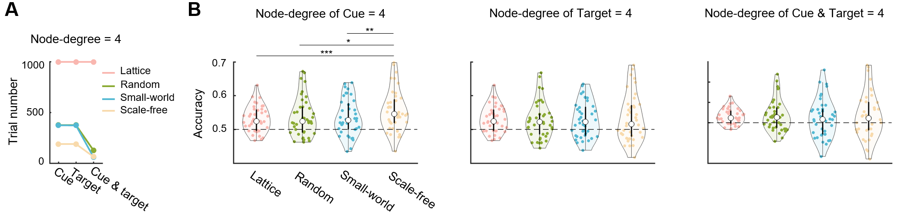
Figure S5. Learning performance in Experiment 1 with node-degree matched.
To diminish the effects of node-degree, we selected out trials with node-degree of 4, according to the cue, target, and both, respectively. (A) The numbers of trials under each node-degree matched condition. (B) Overall prediction accuracy of four networks with three types of node-degree matched conditions (left: trials with cue node-degree of 4; middle: trials with target node-degree of 4; right: trials in which the node-degrees of both cue and target are 4). The GLMM suggested that the superiority of the scale-free network was still preserved in the condition with the cue node-degree matched (main effect of network: $χ^{2}\left(3\right)=$ 16.63, p = 0.001; post-hoc comparisons with Bonferroni correction, Scale-free vs. Lattice: z = 4.03, p < 0.001; Scale-free vs. Random: z = 3.02, p = 0.015; Scale-free vs. Small-world: z = 3.22, p = 0.008), but not in the latter two conditions ($χ^{2}\left(3\right)=$ 0.82, p = 0.845; $χ^{2}\left(3\right)=$ 1.44, p = 0.696). ***: p $<$ 0.001; *: 0.01 $≤$ p $<$ 0.05.
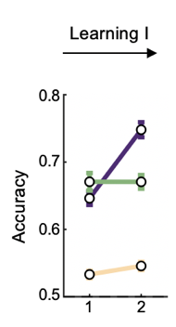
Figure S6. Learning accuracy in the blocks of Learning I. The numbers below the horizontal axis indicate the block numbers of Learning I; 100 trials in each block. Yellow line denotes RandomWalk group; Purple line denotes HubToLeaf group; Green Line denotes LeafToHub group.

Figure S7. Click-accuracy from before-hint-response trials in Experiment 1 (A) and Experiment 2 (B).

Figure S8. Overall accuracy during Learning II for pairs primed by LeafToHub and pairs primed by HubToLeaf.
Cue-target pairs are binned into four quartiles according to their presentation order in the LeafToHub pre-learning sequence (earliest to latest from left to right). Each subplot compares performance between HubToLeaf (purple) and LeafToHub (green) groups on the same set of pairs. Statistical significance: ***, p < 0.001; n.s., not significant.

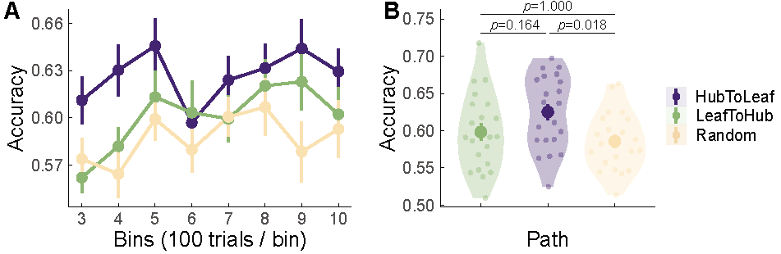
Figure S9. Behaviour results of the in-laboratory replication of Experiment 2.
We recruited another 3 groups of subjects (N = 21 for each group) in the laboratory to validate the effects of the pre-learning path found in Experiment 2. (A) Learning accuracy increases with time (GLMM2.2, main effect of the trial number; $χ^{2}\left(1\right)$ = 10.27, p = 0.001), while the accuracy differs between groups (GLMM2.2, main effect of path group, $χ^{2}\left(2\right)$ = 7.51, p=0.023; interaction between trial number and path group, $χ^{2}\left(2\right)$ = 3.50, p = 0.173). (B) Overall accuracy violin plot for the three path groups (GLMM2.2, post-hoc comparison with Bonferroni correction, two-sided; HubToLeaf vs. RandomWalk: z = 2.75, p = 0.018; HubToLeaf vs. LeafToHub: z = 1.92, p = 0.164; RandomWalk vs. LeafToHub: z = -0.84, p = 1.00).

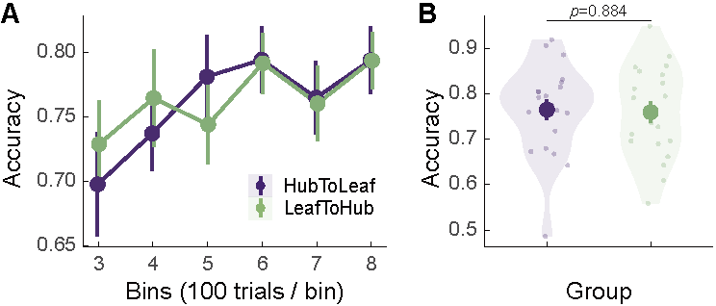
Figure S10. Accuracy in Learning II of Experiment 3 (MEG study).
Only responses before hint were counted for accuracy calculation. (A) Learning accuracy increases with time (GLMM2.2, the main effect of the trial numbers, $χ^{2}\left(1\right)$ = 27.26, p = 0.001), but the accuracy does not differentiate between groups (GLMM2.2, the main effect of path group, $χ^{2}\left(1\right)$ = 0.02, p = 0.884; interaction between the trial numbers and path group, $χ^{2}\left(2\right)=$ 1.72, p = 0.190). (B) Overall accuracy violin plot for the two path groups. Large dots with error bars denote average accuracy of each group in the Learning II phase. Each small dot denotes a subject. Note that we only recorded subjects’ final choices from button presses instead of mouse tracking in Experiment 3 due to the limitation of the MEG environment.

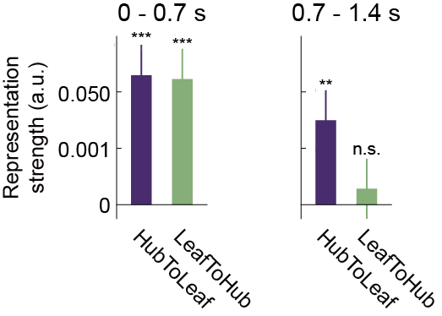
Figure S11. Two-stage mental representation of network in two pre-learning groups.
RDMs in the corresponding time windows were averaged and regressed with the minimum distance matrix (LMM1), respectively. The asterisks over the bars denote the significance of representation strength: ***, p<0.001; **, p<0.01; n.s., not significant.

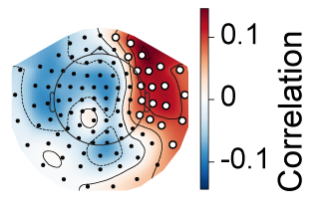
Figure S12. Topography of sensor-level response to node-degree.
At each time point and each sensor channel, MEG data were correlated with node-degree of cue image. Spatial-temporal cluster-based permutation test was performed and one single significant cluster was found on the right frontal temporal area (denoted by white hollow dots) with the time window of 412-732ms (cluster-based permutation test, p < 0.01).

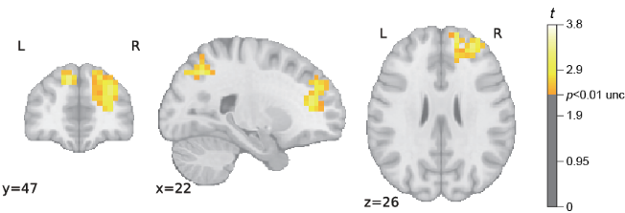
Figure S13. Whole-brain searchlight results for network representation 370 ms after cue onset.
Coloured clusters indicates the main effect of the minimal distance matrix (Whole-brain t-value map, LMM2, right-sided, p < 0.01, uncorrected). See Table S1 for the detail of clusters.

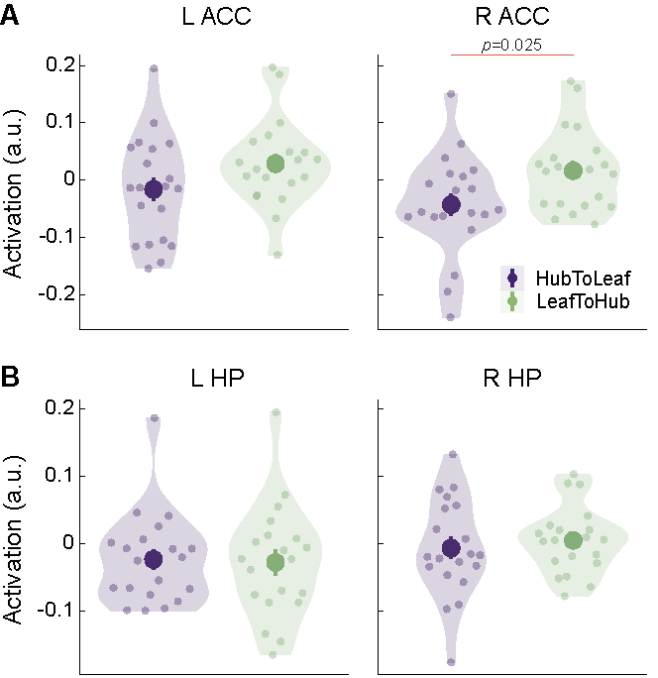
Figure S14. Neural activation of ACC (A) and hippocampus (B) at time of interest.
The facilitation of learning is not caused by enhanced ACC and hippocampus (HP) activity. HubToLeaf path weakens the activity of bilateral ACC without amplifying the activity of HP (Independent t test, two-sided; Left ACC, t(38) = –1.694, p = 0.10; Right ACC, t(38) = –2.33, p = 0.025; Left HP, t(38) = 0.19, p = 0.85; Right HP, t(38.00) = –0.58, p = 0.56).

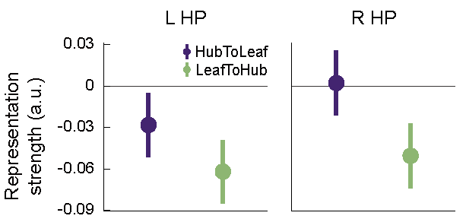
Figure S15. Representation strength of RSA in hippocampus.
The RSA at source with anatomically-defined ROIs. No significant representation advantage of HubToLeaf group was found in bilateral hippocampus (LMM1, right-sided, Left HP, β = 0.016, t(173.582) = 1.04, p = 0.15; Right HP, β = 0.026, t(130.41) = 1.61, p = 0.056).
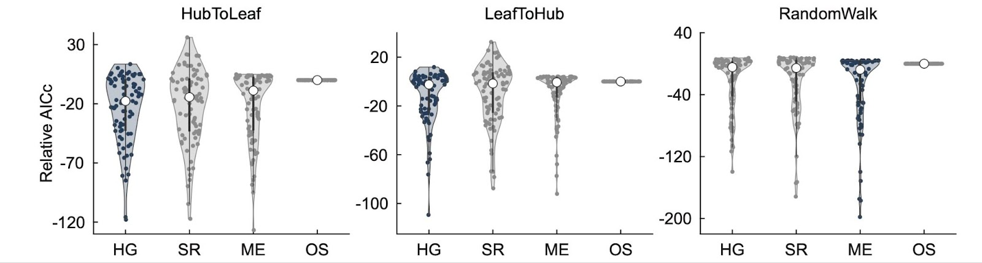
Figure S16. Model comparisons across different pre-learning conditions.
We compare the relative akaike information criterion with correction for finite sample size (AICc) among Hypergraph (HG), Successor Representation (SR), Maximum Entropy (ME), and One-step (OS) models for HubToLeaf, LeafToHub, and RandomWalk groups. Each dot in the violin plot represents one subject, and AICc values are expressed relative to the One-step model, which serves as the reference baseline. Lower values indicate better model fit.

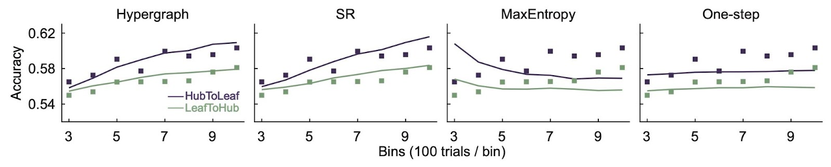
Figure S17. Model fitting of behavioral performance.
Each model was fitted to the accuracy data of both HubToLeaf and LeafToHub groups. Nodes represent the empirical accuracy observed during Learning II in Experiment 2, while the solid lines denote the corresponding model predictions.

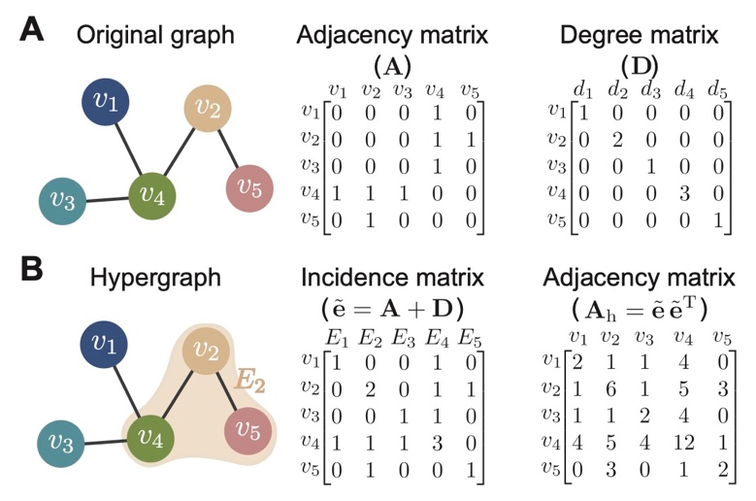
Figure S18. Illustration of higher-order relations between nodes.
(A) We present an example of a network with five nodes. The adjacency matrix $A$ for the network has $a_{ij}=1$ if $v_{i}$ and $v_{j}$ have connection and otherwise 0. The degree matrix $D$ captures the number of connections for each node. (B) The higher-order representation of the network is modelled as a hypergraph with five hyperedges, each of which is composed of a node and the node’s neighbours. The incidence matrix $\tilde{e}$ represents whether a node is in a hyperedge and its weight relative to the other nodes in the hyperedge. The adjacency matrix $A_{h}$ of the hypergraph is obtained by summing the weighted connections over all hyperedges.

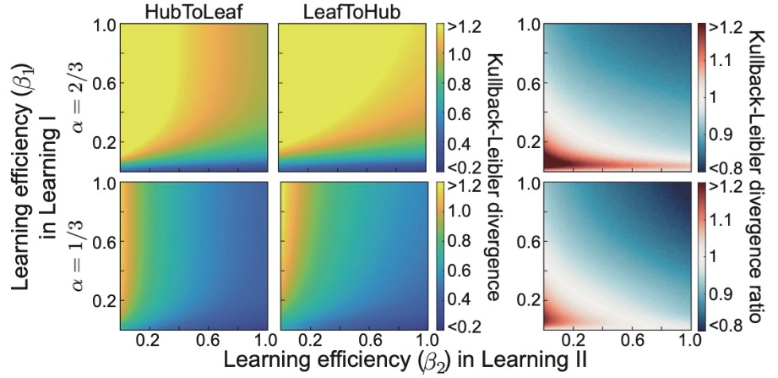
Figure S19. Comparison of the learning outcomes between HubToLeaf and LeafToHub groups.
We use Kullback-Leibler divergence to indicate the difference between true and predicted networks and show the difference values for two groups and their ratio (less than 1 indicates better performance in the HubToLeaf group) across a wide range of learning efficiency in Learning I ($β_{1}$) and that in Learning II ($β_{2}$). Here, $α$ accounts for the proportion of Learning I. The learning outcomes of two groups become better and the superiority of HubToLeaf over LeafToHub is also more pronounced when $α$ decreses.

Table S1. Source-level RSA significant cluster table.
 |  | Name | Peak MNI Location  (X, Y, Z) |  | Peak t value | size  (mm³)
Main effect (370 ms after cue onset)
 | Right superior frontal |  |  | 15, 55, 30 | 3.54 | 12625
 | Right inferior parietal |  |  | 40, -50, 50 | 3.80 | 6625
 | Left superior frontal |  |  | -10, 45, 40 | 3.31 | 3000
Group difference (1.2 s after cue onset)
 | Anterior cingulate |  |  | 0, -5, 45 | 4.96 | 92750
 | Right postcentral |  |  | 30, -30, 30 | 4.04 | 31000
 | Left dorsolateral prefrontal |  |  | -45, 35, 25 | 3.33 | 17500
 | Left cerebellum |  |  | -45, -50, -30 | 2.80 | 6750
Clusters above meet two criteria: p<0.01 uncorrected and cluster size larger than 20 voxels.

Table S2. Overview of model parameterizations.
The table reports the number of parameters for each model along with a description of their meanings.
Model | Number of parameters | Description of parameters
Hypergraph | 4 | $β_{1}$: learning efficiency in learning I  $β_{2}$: learning efficiency in learning II  $p$: nonlinearity measure  $λ$: inverse temperature
Successor  representation | 5 | $γ_{1}$: discount factor in learning I  $α_{1}$: learning rate in learning I  $γ_{2}$: discount factor in learning II  $α_{2}$: learning rate in learning II  $λ$: inverse temperature
Maximum entropy | 3 | $β_{1}$: learning efficiency in learning I  $β_{2}$: learning efficiency in learning II  $λ$: inverse temperature
One-step | 1 | $λ$: inverse temperature

References
1. Bates, D., Mächler, M., Bolker, B. & Walker, S. Fitting Linear Mixed-Effects Models Using lme4. J. Stat. Softw. 67, 1–48 (2015).
2. Lenth, R. V. emmeans: Estimated Marginal Means, aka Least-Squares Means. The R Foundation https://doi.org/10.32614/cran.package.emmeans (2017).
3. Barabasi, A. L. & Albert, R. Emergence of scaling in random networks. Science 286, 509–512 (1999).
4. Holme, P. & Kim, B. J. Growing scale-free networks with tunable clustering. Phys. Rev. E 65, 026107 (2002).
5. Klemm, K. & Eguíluz, V. M. Highly clustered scale-free networks. Phys. Rev. E 65, 036123 (2002).
6. Goh, K.-I., Kahng, B. & Kim, D. Universal Behavior of Load Distribution in Scale-Free Networks. Phys. Rev. Lett. 87, 278701 (2001).

