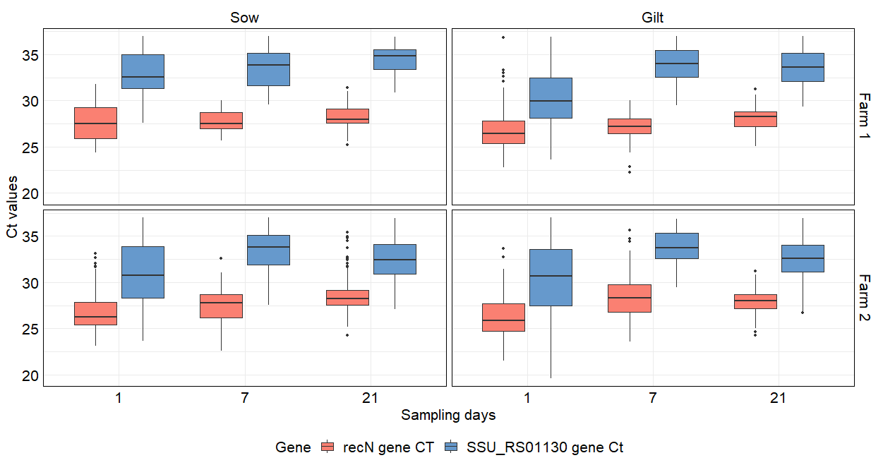
Ct values for recN and SSU_RS01130 gene-positive tonsil samples from piglets, grouped by farm and parity, at days 1, 7, and 21

