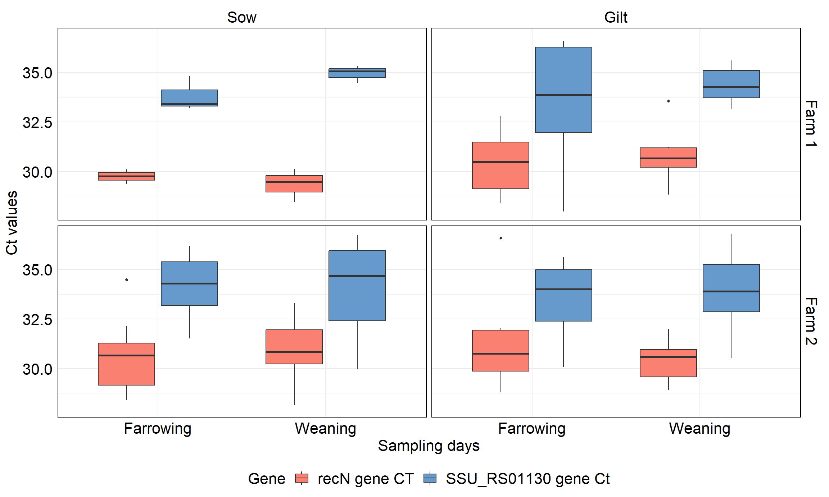
Ct values for recN and SSU_RS01130 gene-positive tonsil samples from dams, categorized by farm and parity, at farrowing and weaning

