Supplementary materials for
Nuclear import receptors and hnRNP K mediates nuclear and stress granule localization of SIRLOIN
Jialin Yao¹, Qiao Zhou¹, Hengyi Xiao², Da Jia³, and Qingxiang Sun¹*

This file contains Fig. S1-S9 and Table S1.

Fig. S1 Integrated ITC heat changes and curve fitting for titrating SIRLOIN into different MBP-tagged hnRNP K constructs. The apparent binding affinities are shown in Table 1.

Fig. S2 Integrated ITC heat changes and curve fitting for titrating CTR2 or CTR3 into different MBP-tagged hnRNP K constructs. The apparent binding affinities are shown in Table 1.

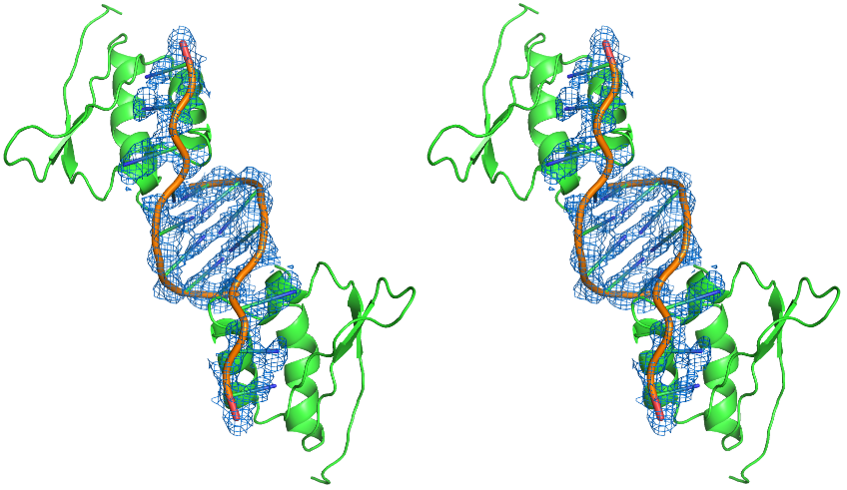
Fig. S3 Stereo view of 2Fo-Fc composite omit map around ssDNA. The map is contoured at 1 σ level. Besides interacting with KH3, some nucleotides in CTR3 formed an imperfect (containing one base pair of mismatch) double helix with an adjacent asymmetric unit CTR3 in the crystal structure.

Fig. S4 Integrated ITC heat changes and curve fitting for binding between KH3 and two tetra-nucleotides. The binding affinities are shown in Table 1.

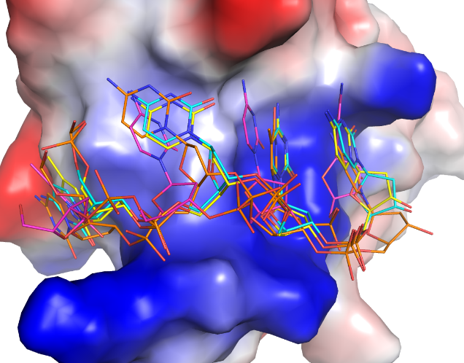
Fig. S5 Structural alignment of KH domains from 1zzi (TCCC-bound, yellow), 1j5k (TCCC-bound, magenta), 1zzj (CCCC-bound, cyan), and the CTR3-KH3 complex (CCTC-bound, orange). KH3 domain is displayed as an electrostatic surface potential map. The bound ssDNAs are displayed as sticks.

Fig. S6 Pull down of different NIRs to demonstrate that they were active. Proteins were used at 1 µM for GST-tagged proteins and 2.5 µM for target proteins, respectively.

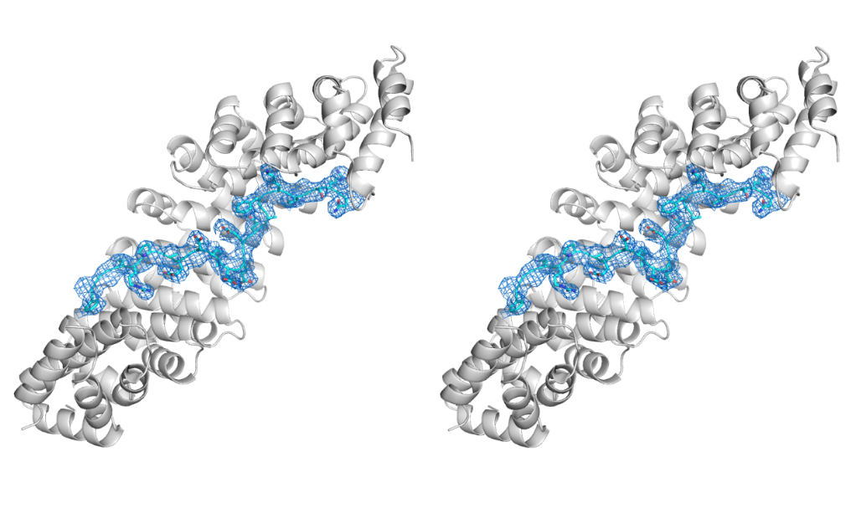
Fig. S7 Stereo view of the 2Fo-Fc composite omit map around the NLS of hnRNP K. The map is contoured at 1 σ level. Impα1 and NLS are displayed as cartoon and sticks, respectively.

Fig. S8 Increasing digitonin concentration during in vitro nuclear import promotes nuclear import of hnRNP K in Tia1-transfected cells. Arrows indicate Tia1-transfected cells.

Fig. S9 Confocal images of semi-permeabilized cells treated with the classical NIRs (1 µM), GST-hnRNP K-HA (2 µM), or mCherry-NLS^{SV40} (2 µM). The pixel intensities (white line) for the two channels are plotted in the right panels to illustrate colocalization of the import cargos with Tia1.

Table S1. Data collection and structure refinement statistics.
 | NLS:Impα1 | KH3:CTR3
Cell axial lengths (Å) | a=89.79, b=83.32, c=101.37  α= γ=90, β=98.24 | a=b=61.61, c=144.54  α= γ=90, β=120
Spacegroup | P2₁ | P6₂22
Data collection
Resolution range (Å) | 50.00-2.80 (2.85-2.80) | 50.00-3.00 (3.11-3.00)
Number of observed reflections | 120796 (5791) | 42213 (3951)
Number of unique reflections | 36276 (1755) | 3670 (356)
Completeness (%) | 98.3 (96.4) | 98.8 (100.0)
Redundancy | 3.4 (3.3) | 11.5 (11.1)
R_{pim} | 0.175 (0.888) | 0.049 (0.889)
Highest shell CC1/2 | 0.338 | 0.324
Mean I/I_{sigma} | 4.3 (0.9) | 11.5 (1.1)
Refinement
Resolution range (Å) | 46.68-2.80 (2.87-2.80) | 20.00-3.00 (3.15-3.00)
Number of working reflections | 32559 (2387) | 3239 (446)
Number of test reflections | 1850 (120) | 365 (57)
R_{work}ª (no. of reflections) | 0.213 (0.335) | 0.257 (0.410)
R_{free}^{b} (no. of reflections) | 0.240 (0.355) | 0.279 (0.398)
R.m.s. deviation bond lengths (Å) | 0.005 | 0.004
R.m.s. deviation bond angles (°) | 0.923 | 1.156
Average B-factors (Å2) (# of atoms) | 51.0 (6960) | 142.5 (717)
Ramachandran plot
Most favored regions (%) | 95.1 | 85.0
Allowed regions (%) | 4.6 | 15.0
General allowed regions (%) | 0.0 | 0.0
Disallowed regions (%) | 0.3 | 0.0

