Appendix A: Additional XCT images
Representative cross-sections obtained from the micro- and nano-CT volumes are provided in the following, highlighting the pore size and wall thickness distribution.
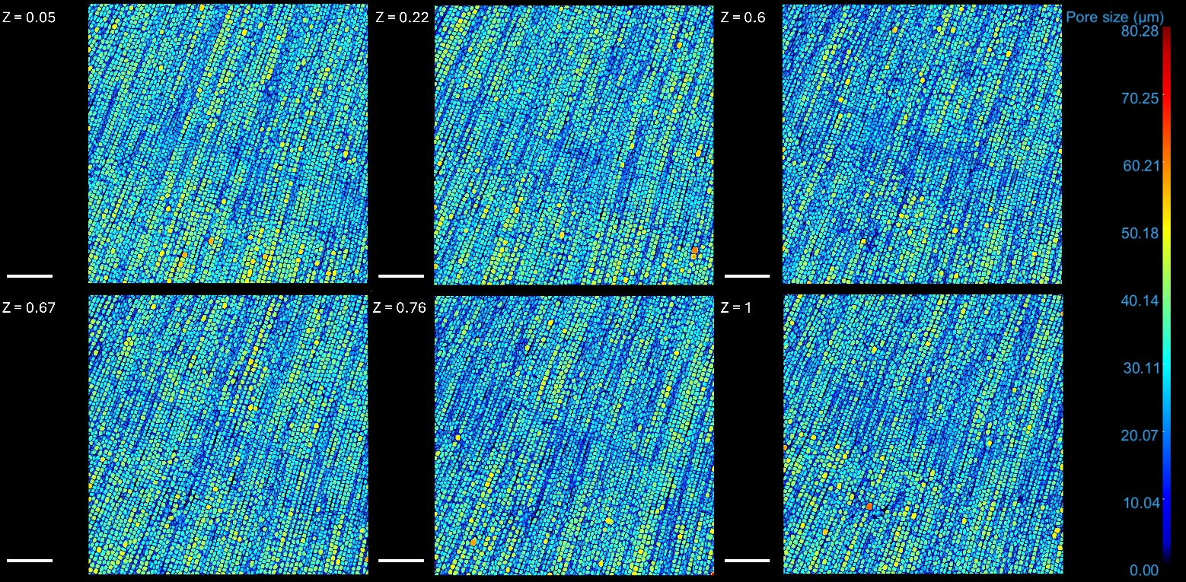
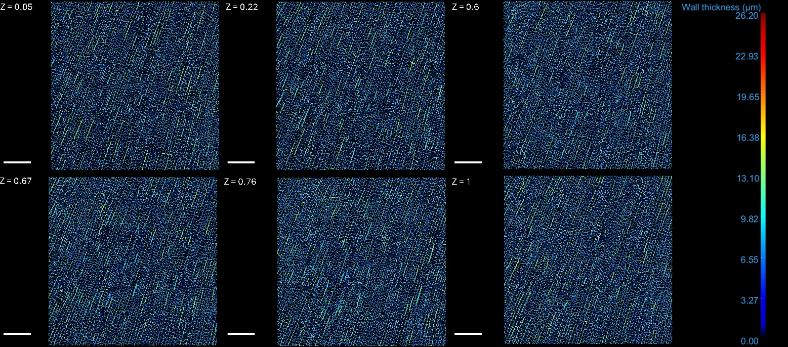
Figure A1. Micro-CT slices at different normalised volume depth (Z), highlighting the pore size distribution in the scanned volume.
Figure A2. Micro-CT slices at different normalised volume depth (Z), highlighting the wall thickness distribution in the scanned volume.

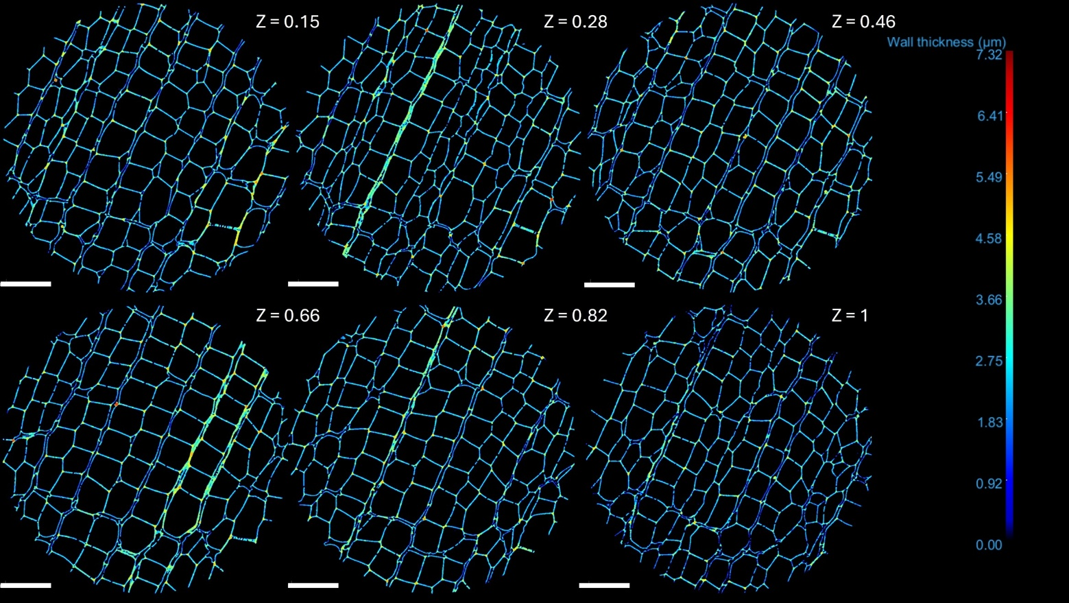
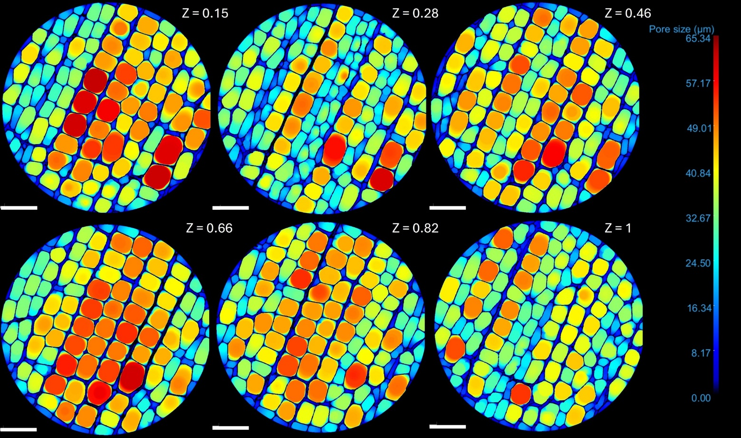
Figure A4. Nano-CT slices at different normalised volume depth (Z), highlighting the wall thickness distribution in the scanned volume.
Figure A3. Nano-CT slices at different normalised volume depth (Z), highlighting the pore size distribution in the scanned volume.

