Supplementary Data

Supplementary Table 1 The antibodies used in this study
Antibodies | Catalog# | Source
anti-Rb | sc-102 | Santa Cruz
anti-p-RB | sc-271930 | Santa Cruz
anti-Weel | sc-5285 | Santa Cruz
anti-Cyclin B1 | sc-245 | Santa Cruz
anti-Cyclin E | sc-247 | Santa Cruz
anti-CDK1 | sc-54 | Santa Cruz
anti-p21 | sc-6246 | Santa Cruz
anti-GAPDH | AP0063 | Bioworld
anti-Ki-67 | 550609 | BD Pharmingen

Supplementary Figures
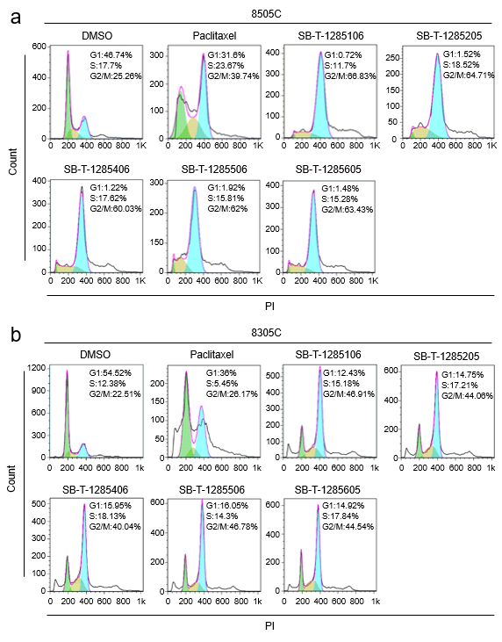

Supplementary Fig. 1 Representative flow cytometry profiles of cell cycle of each drug from three independent experiments are shown in 8505C (a) and 8305C (b) cell lines.

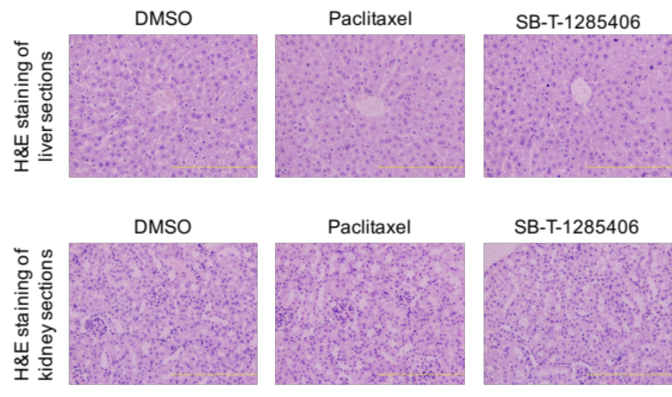

Supplementary Fig. 2 Representative H&E stained liver and kidney sections from each group.

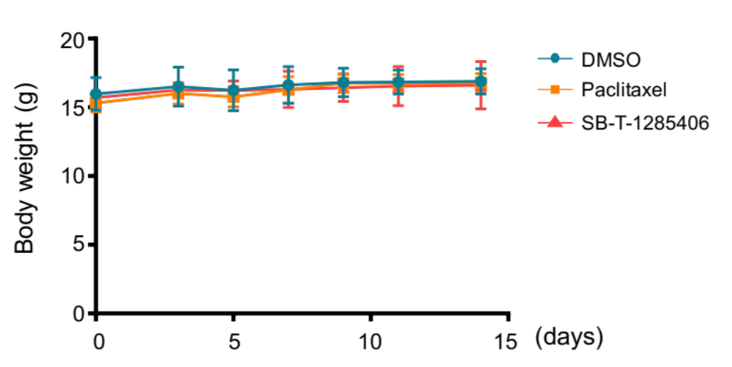

Supplementary Fig. 3 Body weight of mice during the treatments.

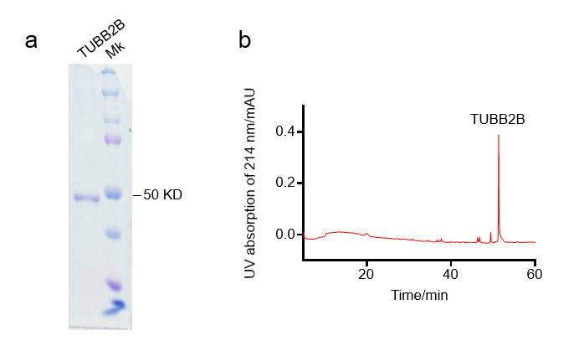
Supplementary Fig. 4 β-tubulin purity was run on a SDS PAGE system and stained with 0.1% Coomassie Blue (a) and was shown by a RP-HPLC test (b).

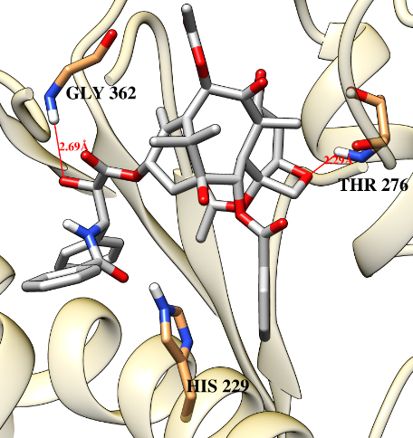 | 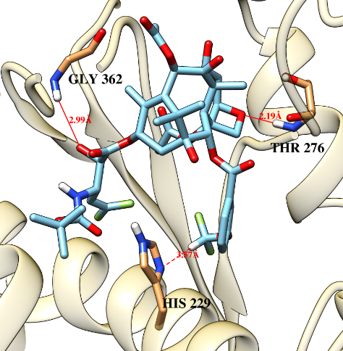 | 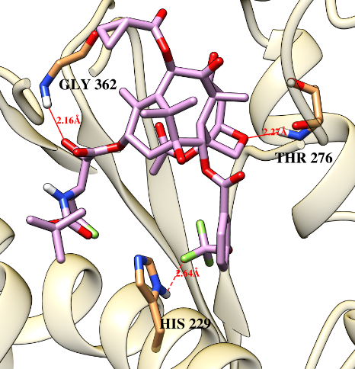
Paclitaxel | SB-T-1285106 | SB-T-1285205
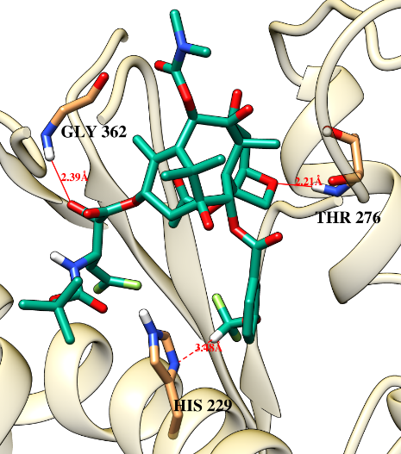 | 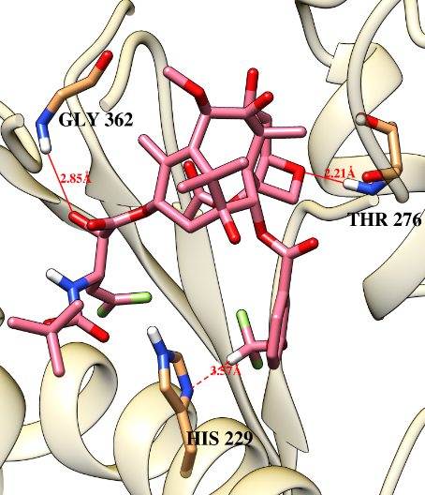 | 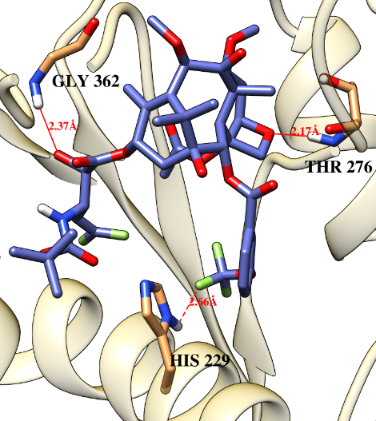
SB-T-1285406 | SB-T-1285506 | SB-T-1285605

Supplementary Fig. 5 Docked structures of paclitaxel and novel DFV-taxoids in β-tubulin.

