Supporting Information
Effect of 1-alkyl-3-methylimidazolium bromide on thermodynamic and transport properties of azeotropic mixtures of water + ethanol at 298.15 K
Forouh Malekiª, Hemayat Shekaariª*, Shima Ghasemzadehª , Mohammed Taghi Zafarani-Moattarª, Behrang Golmohammadi
ªDepartment of Physical Chemistry, Faculty of Chemistry, University of Tabriz, Tabriz, Iran, 5166616471
*Corresponding author: Tel: +98 4133393094. Fax: 98 4133340191. E-mail addresses: hemayatt@yahoo.com

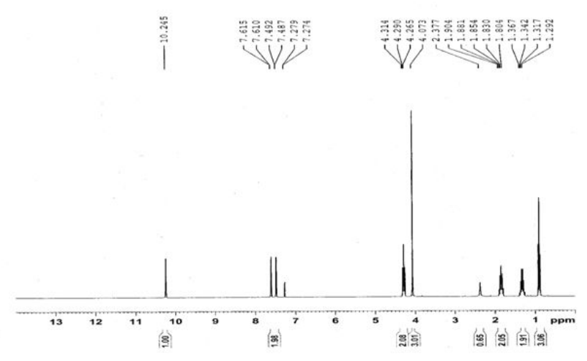

Figure S1: ¹HNMR spectrum of studied 1-butyl-3-methylimidazolium bromide [BMIm][Br].

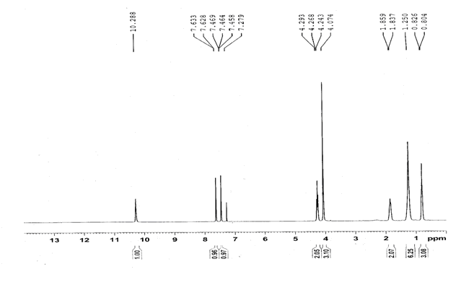
Figure S2: ¹HNMR spectrum of studied 1-hexyl-3-methylimidazolium bromide [HMIm][Br].

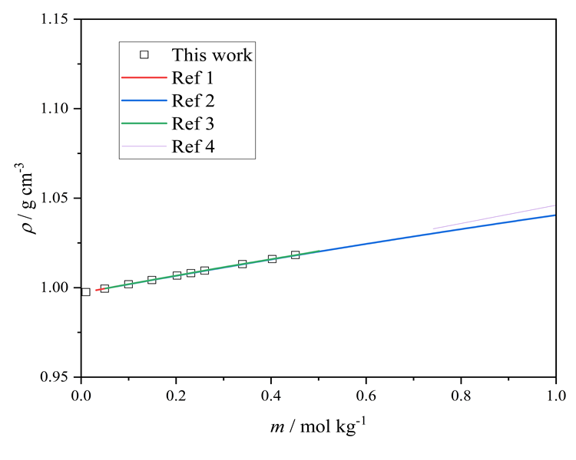
a
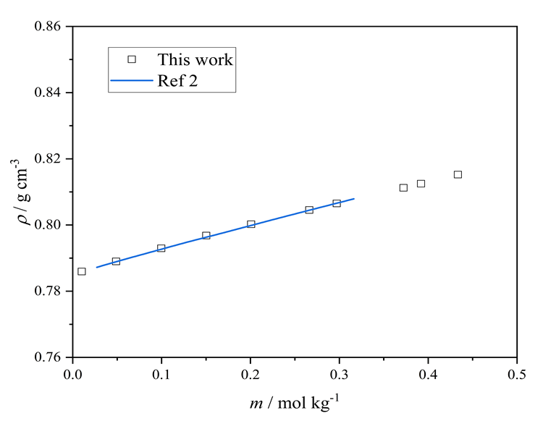
b
Figure S3. The density of a) aqueous [BMIM][Br] compared to the literature data reported Ref 1¹, Ref 2 ², Ref 3³, and Ref 4⁴. b) [BMIM][Br] in ethanol compared to the Ref 2.

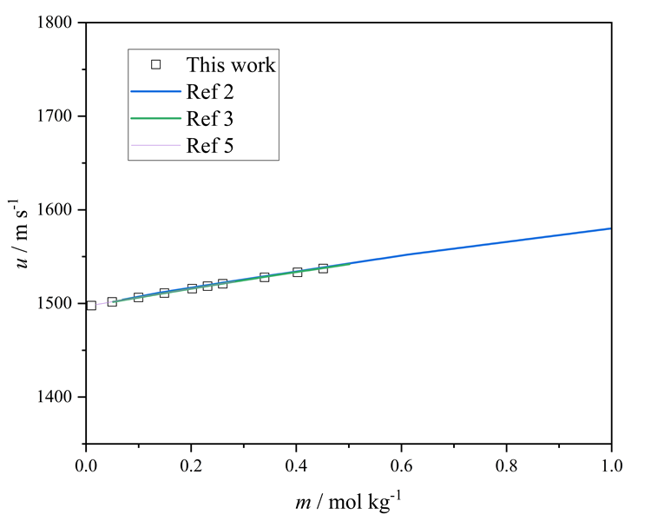
Figure S4. The speed of sound of aqueous [BMIM][Br] compared to the literature data reported Ref 2 ², Ref 3³, and Ref 5⁵.

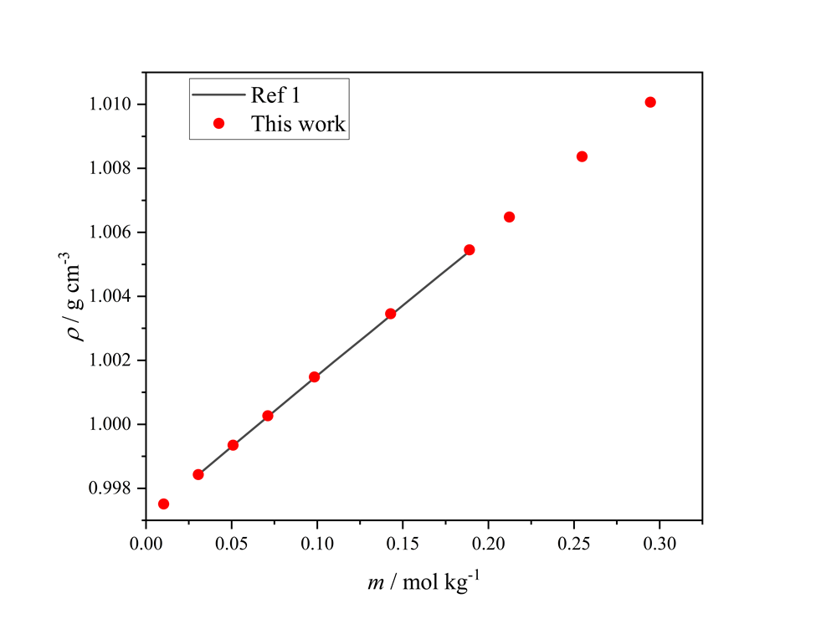

Figure S5. The density of aqueous [HMIM][Br] compared to the literature data reported Ref 1.

REFERENCES

1. Shekaari, H., Zafarani-Moattar, M. T., Kazempour, A. & Ghasedi-Khajeh, Z. Volumetric Properties of Aqueous Ionic-Liquid Solutions at Different Temperatures. J. Chem. Eng. Data 60, 1750–1755 (2015).
2. Zafarani-Moattar, M. T. & Shekaari, H. Apparent molar volume and isentropic compressibility of ionic liquid 1-butyl-3-methylimidazolium bromide in water, methanol, and ethanol at T = (298.15 to 318.15) K. The Journal of Chemical Thermodynamics 37, 1029–1035 (2005).
3. Lal, B., Sahin, M. & Ayranci, E. Volumetric studies to examine the interactions of imidazolium based ionic liquids with water by means of density and speed of sound measurements. The Journal of Chemical Thermodynamics 54, 142–147 (2012).
4. Liu, W., Cheng, L., Zhang, Y., Wang, H. & Yu, M. The physical properties of aqueous solution of room-temperature ionic liquids based on imidazolium: Database and evaluation. Journal of Molecular Liquids 140, 68–72 (2008).
5. Sadeghi, R., Golabiazar, R. & Shekaari, H. The salting-out effect and phase separation in aqueous solutions of tri-sodium citrate and 1-butyl-3-methylimidazolium bromide. The Journal of Chemical Thermodynamics 42, 441–453 (2010).

