Supplementary material

Predation on scyphozoan polyps and selective nematocyst incorporation dynamics in an alien aeolid nudibranch

Hila Dror¹, Tamar Lotan², Dror L. Angel¹*
¹The Leon Recanati Institute for Maritime Studies, University of Haifa, Mt. Carmel, Haifa 3103301, Israel
² Marine Biology Department, The Leon H. Charney School of Marine Sciences, University of Haifa, Mt. Carmel, Haifa 3103301, Israel
*Corresponding author e-mail: dangel@univ.haifa.ac.il

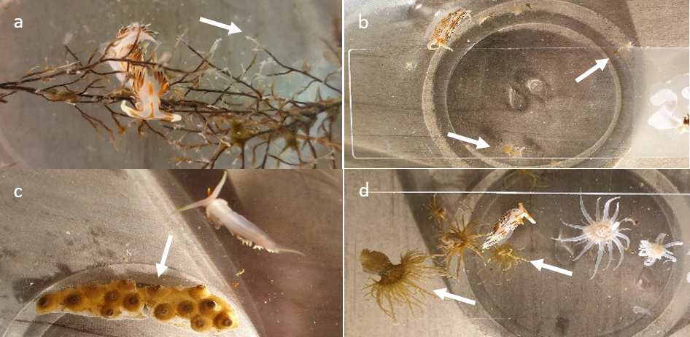
Supp. Fig. S1: Experimental glass bowls with various prey species (white arrows) and C. militaris nudibranchs. (a) P. disticha, (b) C. andromeda, (c) O. patagonica, (d) E. diaphana.

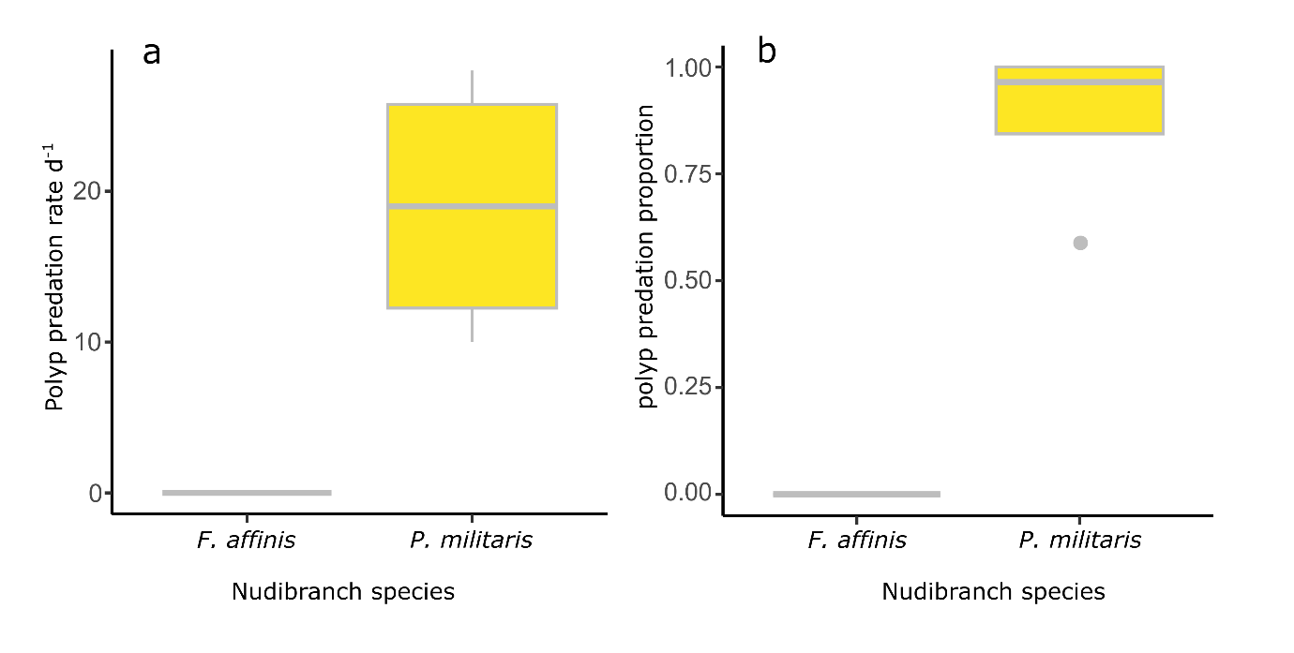
Supp. Fig. S2: R. nomadica polyps consumed by F. affinis (n = 4) and C. militaris (n = 4) nudibranchs during the 24 h feeding experiment. (a) predation rate presented as polyps day⁻¹ (b) predation proportion (number polyps consumed / number polyps provided).
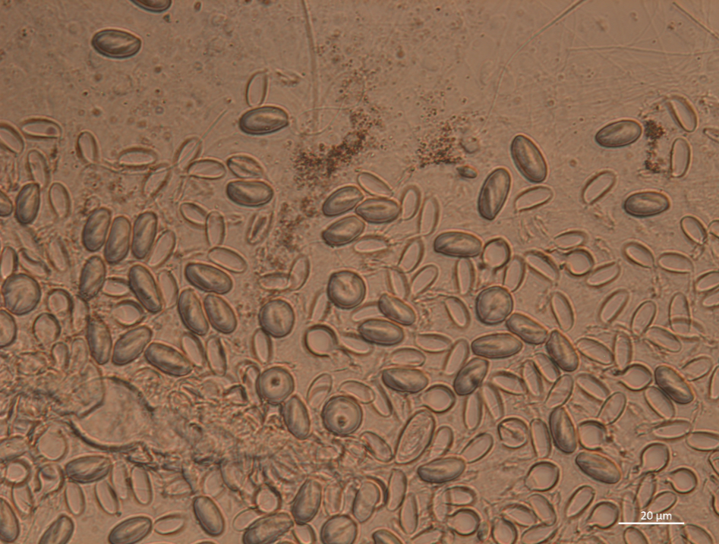
Supp. Fig S3: Nematocysts ejected from a squash preparation of a ceras of a naturally feeding C. militaris nudibranch showing many discharged and undischarged microbasic euryteles.

Supp. Table S1: Cerata samples taken from C. militaris nudibranchs during the 12-day experiment to identify nematocysts in the cerata. Cerata from naturally feeding (Nat) nudibranchs were sampled, then nudibranchs were treated with 5% KCl, and fed Scyphozoa and Hydrozoa polyps (Cas: C. andromeda, Au: Aurelia sp., Nom: R. nomadica, Ap: A. pluma, Pd: P. Disticha). Nudibranch individuals were CM102 to CM114. Each sample consisted of between 2 and 4 cerata (+ indicates cerata samples) excised from each nudibranch.

Supp. Table S2: Prey species and predation rate (polyps d⁻¹) of C. militaris nudibranchs during the 12 d feeding experiment (Methods, section 2.6.3). C. militaris individuals are identified as CM with a number. Predation rates presented as mean ± SD (n = 12).

Supp. Table S3: Summary of the long-term experiment to examine the predatory capacity of C. militaris nudibranchs on four species of scyphozoan polyps (Aurelia sp., C. andromeda, P. punctata, and R. nomadica). Polyps were provided as prey at four doses, from low to very high (≤20, ≤50, ≤80, and >80 polyps d⁻¹, respectively) and replenished twice weekly. Individual C. militaris nudibranchs are identified as “CM” with a number. *One replicate sample.

Supp. Table S4: Summary of the long-term feeding experiment to examine: a) the predatory capacity of C. militaris nudibranchs on four species of scyphozoan polyps (Aurelia sp., C. andromeda, P. punctata and R. nomadica) and b) nudibranch survival on these diets. Individual C. militaris nudibranchs are identified as “CM” with a number. Number of feeding events is the number of times the indicated prey species was provided. Scyphozoan polyps were replenished twice weekly.

15 mm
15 mm
15 mm
15 mm

Supp. Video S1: Video capture of C. militaris feeding on polyps of R. nomadica.
Supp. Video S2: Video capture of C. militaris feeding on polyps of C. andromeda.
Supp. Video S3: Video capture of C. militaris feeding on polyps of Aurelia sp.

