The catalytic mechanism of intercalated chlorine anions as active basic sites in MgAl-layered double hydroxide for COS hydrolysis
Changming Li^{1,2,3}, Shuying Zhao^{1,2,3}, Xiaolong Yao^{1,2,3}, Li He^{1,2,3}, Simin Xu⁴, Xianbao Shen^{1,2,3}, Zhiliang Yao^{1,2,3,}*
¹ State Environmental Protection Key Laboratory of Food Chain Pollution Control, School of Ecology and Environment, Beijing Technology and Business University, Beijing 100048, China.
² Key Laboratory of Cleaner Production and Integrated Resource Utilization of China National Light Industry, Beijing Technology and Business University, Beijing 100048, China.
³ School of Ecology and Environment, Beijing Technology and Business University, Beijing 100048, China.
⁴ College of Chemistry, Beijing University of Chemical Technology, Beijing 100029, China.
* Corresponding Authors:
Zhiliang Yao (E-mails: yaozhl@th.btbu.edu.cn)

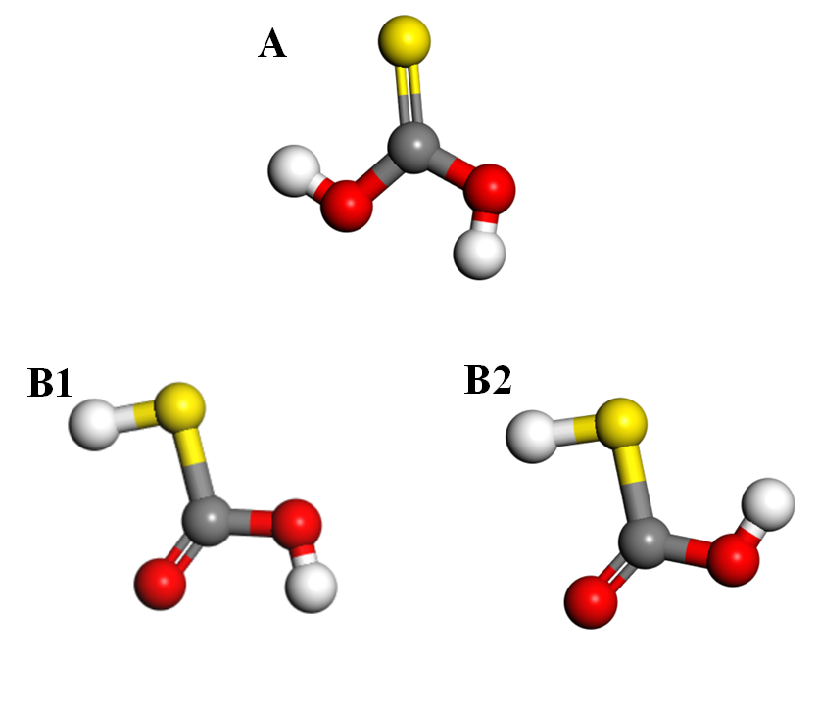
Fig. S1 The geometrically optimized trans- (A) mono-thiocarbonic acid (MTA), the cis- (B1) and trans- (B2) hydrogen thiocarbonic acid (HTA). (Atomic legend: -Cl, -C, -S, -H, -O.)

Table S1 Optimized unit cell parameters for Mg₂Al-Cl-LDH.
Model | a (Å) | b (Å) | c (Å) | α (º) | β (º) | γ (º) | V (Å³)
Mg₂Al-Cl-LDH | 5.395 | 5.396 | 14.681 | 90.00 | 89.97 | 120.40 | 368.7

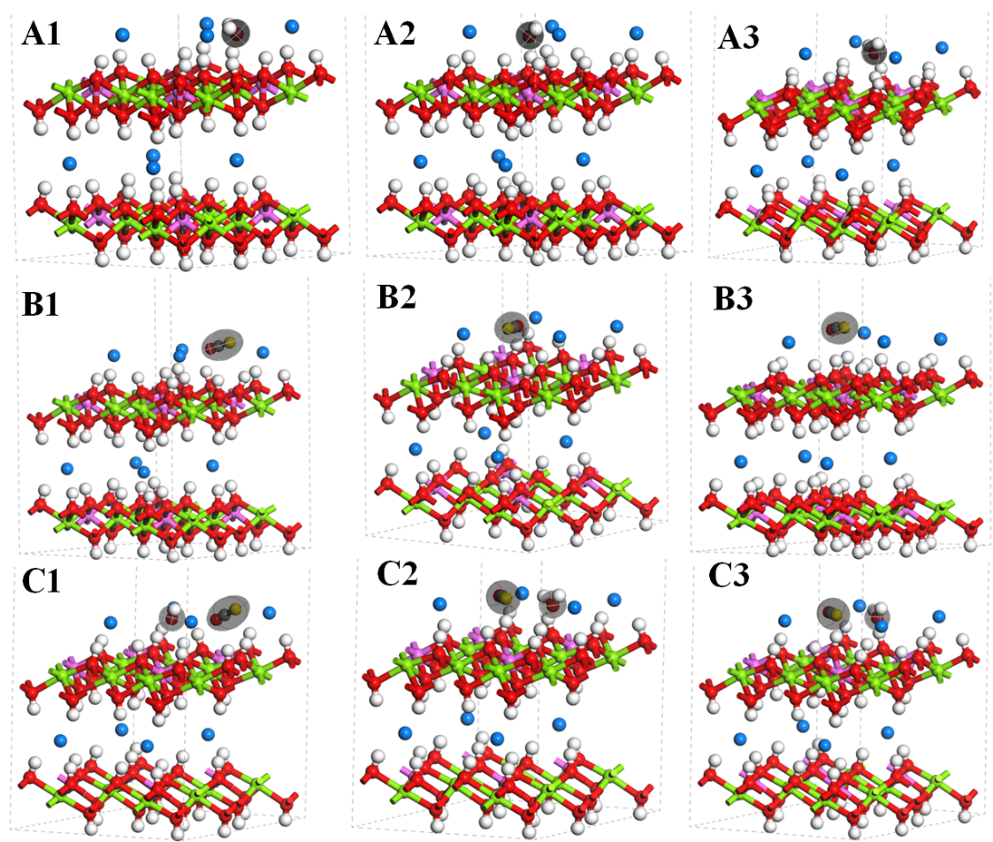
Fig. S2 The geometrically optimized configurations of H₂O (A1-A3), COS (B1-B3) and H₂O/COS (C1-C3) adsorbed at the different sites on the (0 0 3) face of Mg₂Al-Cl-LDHs from side view. (Atomic legend: -Cl, -C, -S, -H, -O, -Al, -Mg.)
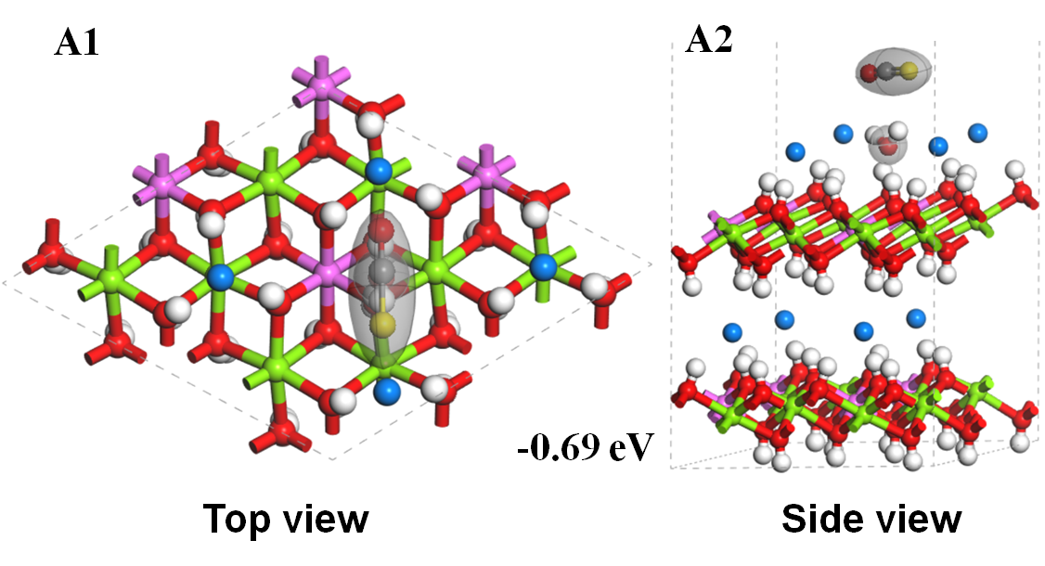
Fig. S3 The top view (A) and the side view (B) for the adsorption of COS upon the adsorbed H₂O at the Mg-Al bridge site on the (0 0 3) face of Mg₂Al-Cl-LDH. (Atomic legend: -Cl, -C, -S, -H, -O, -Al, -Mg.)
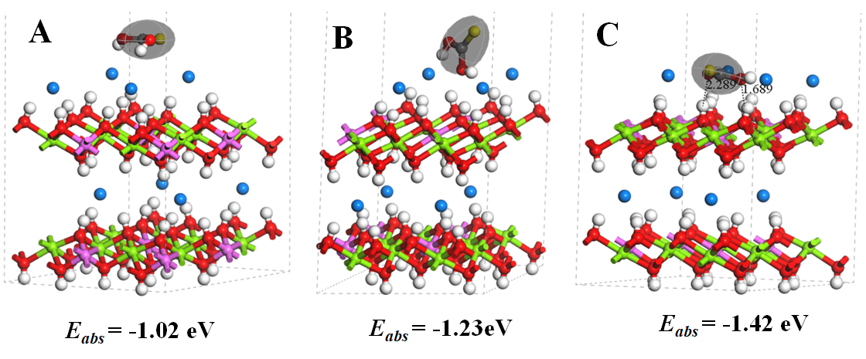
Fig. S4 The different geometrical configurations of MTA and their adsorption energies on the (0 0 3) face of Mg₂Al-LDHs-Cl from side view. A) the parallel configuration up the (0 0 3) face of LDH, B) the vertical configuration with (0 0 3) face, and C) the parallel configuration in the same plane with the chloride ions. (Atomic legend: -Cl, -C, -S, -H, -O, -Al, -Mg.)

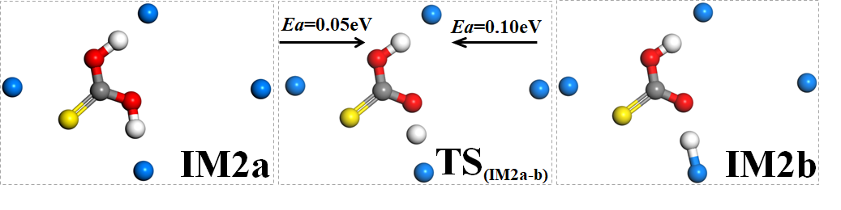
Fig. S5 The transient state and activation energies of the hydrogen transfer between MTA and MT ~ HCl over the (0 0 3) face of Mg₂Al-Cl-LDHs. (Atomic legend: -Cl, -C, -S, -H, -O. The elements in layer of LDH are not shown.)

Table S2 Imaginary frequencies of the transition states for COS hydrolysis on the (0 0 3) face of Mg₂Al- Cl-LDHs.
Transition states | Imaginary frequencies | Transition states | Imaginary frequencies | Transition states | Imaginary frequencies
TS_{2a-b} | 103.6 cm⁻¹ | TS1 | 971.3 cm⁻¹ | S-TS | 1267.4 cm⁻¹
TS_{3a-b} | 567.1 cm⁻¹ | TS2 | 110.2 cm⁻¹ | TS2a | 1478.3 cm⁻¹
TS_{4a-b} | 423.5 cm⁻¹ | TS3b | 771.9 cm⁻¹ | TS3a | 994.5 cm⁻¹
TS_{4a-c} | 133.7 cm⁻¹ | TS4b | 841.6 cm⁻¹ | TS4a | 1687.6 cm⁻¹

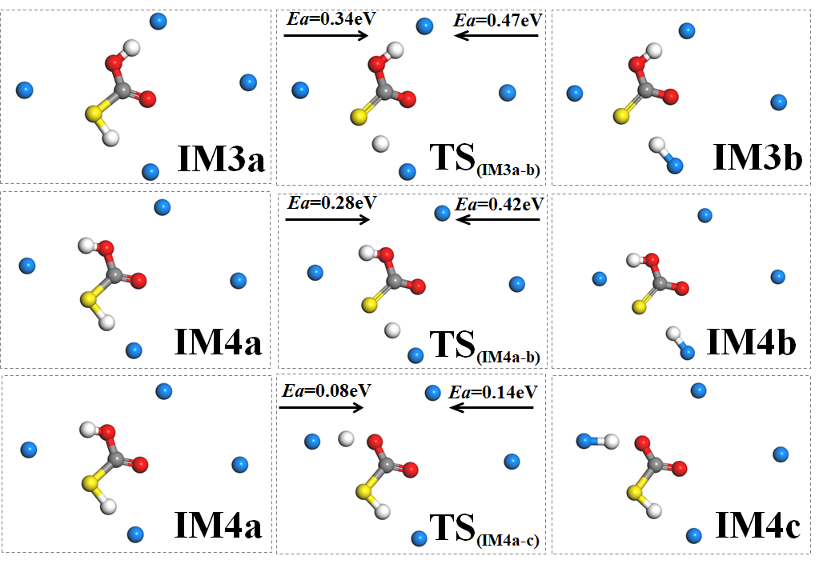
Fig. S6 The transient states and activation energies of the hydrogen transfer between HTA and HT ~ HCl over the (0 0 3) face of Mg₂Al-Cl-LDHs. (Atomic legend: -Cl, -C, -S, -H, -O. The elements in layer of LDH are not shown.)
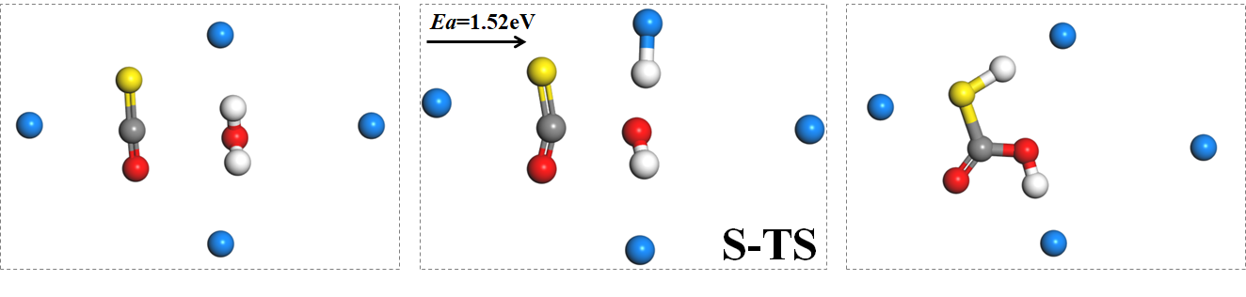
Fig. S7 The transient state and activation energy for the nucleophilic addition of C=S in COS by H₂O. (Atomic legend: -Cl, -C, -S, -H, -O. The elements in layer of LDH are not shown.)

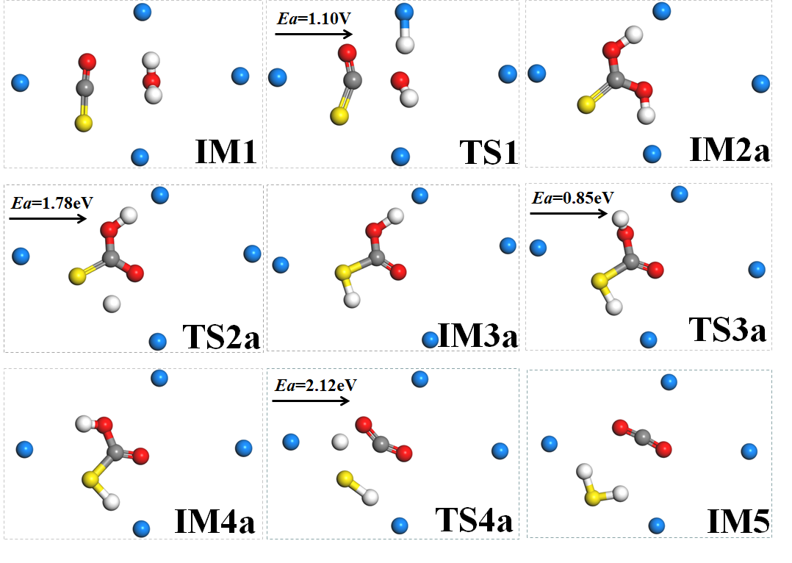
Fig. S8 The transient states and activation energies of the reaction channel through the undissociated MTA and HTA for COS hydrolysis over the (0 0 3) face of Mg₂Al- Cl-LDHs. (Atomic legend: -Cl, -C, -S, -H, -O. The elements in layer of LDH are not shown.)

