Appendix: Supplementary material (Original protein bands scans of membranes used for Western blot analysis and identification of the tails of genetically knockout mice)
Figure 1. SDC-1 was overexpressed in PC and correlated with the poor prognosis of patients with PC. (A) SDC-1 was overexpressed in the PC tissue data from TIMER database. (B) SDC-1 was overexpressed in the PC tissue data from GEPIA database. (C) SDC-1 was overexpressed in the PC tissue data from UALCAN database. (D) SDC-1 expression levels and survival curves in cancer patients in GEPIA database. (E) SDC-1 expression levels and survival curves in cancer patients in TISIDB database. (F)Kaplan–Meier survival analysis of overall survival (OS). (G) Kaplan–Meier survival analysis of progression-free survival (PFS). (H) Immunohistochemical staining results of normal pancreatic tissue and cancer tissue. (I) Immunohistochemical staining scores of pancreatic tissues in 114 cases. (J) Correlation of SDC-1 with patient survival in pancreatic cancer tissues. (K) Basic mRNA expression of SDC-1 in pancreatic cancer cells. (L) Basic expression of SDC-1 protein in pancreatic cancer cells.

Original protein bands scans of membranes used for Western blot analysis (Figure 1L)
Figure 1. SDC1 (From left to right protein bands including: HPNE, PANC-1, CFPAC-1, BXPC-3, SW1990)

Figure 2. GAPDH (From left to right protein bands including: HPNE, PANC-1, CFPAC-1, BXPC-3, SW1990)
Figure 2. Effect of SDC-1 on pancreatic cancer cell function. (A) Overexpression of SDC-1 in PANC-1 was confirmed by RT-qPCR. (B) Overexpression of SDC-1 in PANC-1 was confirmed by Western blotting. (C) SDC-1 knock down in BXPC-3 was confirmed by RT-qPCR. (D) SDC-1 knock down in BXPC-3 was confirmed by western blotting. (E, F) CCK8, colony formation and statistical analysis detected the impact of SDC-1 overexpression on the proliferation ability of PANC-1 cell line. (G) Cell scratch migration assay and statistical analysis detected the impact of SDC-1 overexpression on the migration ability of PANC-1 cell line. (H) Transwell invasion assay and statistical analysis detected the impact of SDC-1 overexpression on the invasion ability of PANC-1 cell line. (I, J) CCK8, colony formation and statistical analysis detected the impact of SDC-1 knock down on the proliferation ability of BXPC-3 cell line. (K) Cell scratch migration assay and statistical analysis detected the impact of SDC-1 knock down on the migration ability of BXPC-3 cell line. (L) Transwell invasion assay and statistical analysis detected the impact of SDC-1 knock down on the invasion ability of BXPC-3 cell line.

Original protein bands scans of membranes used for Western blot analysis (Figure 2B and 2D)
Figure 2B. SDC1 (From left to right protein bands including: NC, OE)

Figure 2B. GAPDH (From left to right protein bands including: NC, OE)

Figure 2D. SDC1 (From left to right protein bands including: NC, SIRNA02, SIRNA03)

Figure 2D. GAPDH (From left to right protein bands including: NC, SIRNA02, SIRNA03)

Results of mouse genotype identification
In this study, three mice each with the SDC-1 genotype of wild-type (WT), heterozygous (SDC-1^{+/-}), and homozygous (SDC-1^{-/-}) were selected, and the tail DNA of the mice was extracted for PCR identification. The results showed that PCR in WT mice was the first pair of primers P1 and P2, and a single fragment was obtained at 909bp. The second pair of primers P3 and P4 also obtained a single fragment at 546bp. The PCR results of SDC-1^{+/-} mice showed that the first pair of primers obtained one fragment at 909bp and two fragments each at 660bp. The second pair of primers obtained a single fragment at 546bp. The PCR results of SDC-1^{-/-} mice showed that the first pair of primers obtained a single fragment at 660bp; The second pair of primers have no bands.
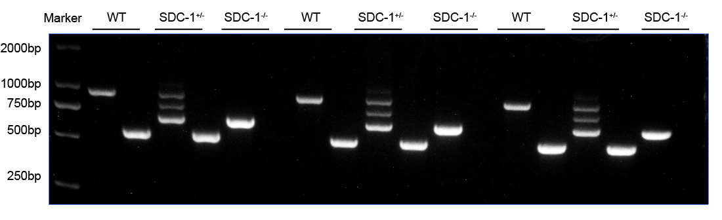
Genotype identification results of SDC1 knockout mice
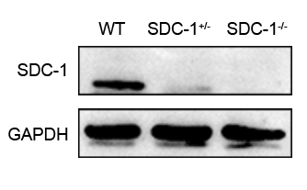
WB detection results for genotype identification of SDC1 knockout mice

