Supplementary Materials for

Rapid Discovery of Low-Threshold Organic Laser Materials via AI-Driven Closed-Loop Screening and Generative Design

Authors: Yun-Tao Ding¹†, Guojiang Zhao⁴†, Meng-Han Feng¹, Jin-Ling Qing¹, Hui-Qin Zhou¹, Yan-Ting Zhang¹, Xiao Chen², Wen-Jie Zhang², Zhang-Yue Yin⁷, Xue Jia¹, Ya-Ting Wang¹, Wen-Jing Sun¹, Bing Sun¹, Ya-Min Zhang¹, Guolin Ke⁴, Linfeng Zhang^{4,5}, Weinan E^{4,5,6}, Chun-Lin Sun¹*, Qi Ou⁸*, Zhifeng Gao^{4,5}*, Zhigang Shuai^{2,3}* and Hao-Li Zhang¹*
*Corresponding author. Email: haoli.zhang@lzu.edu.cn, shuaizhigang@cuhk.edu.cn, gaozf@dp.tech, ouqi.ripp@sinopec.com, suncl@lzu.edu.cn, lbw@lzu.edu.cn

The PDF file includes:

Materials and Methods
Supplementary Text
Figs. S1 to S58
Tables S1 to S6
References

Other Supplementary Materials for this manuscript include the following:

Data S1 to S4

Data S1: Final result of 801801 molecules.
Data S2: Final result of 2nd generated molecules.
Data S3: Molecules with optical pumping potential.
Data S4: Molecules with electrical pumping potential.

Contents
Contents 2
Materials and Methods 4
1. General Instrumentation 4
1.1 Basic Characterization: 4
1.2 Amplified Spontaneous Emission (ASE): 4
1.3 Theoretical Calculations: 4
Supplementary Text 4
2. Detail of theoretical Calculation 4
2.1 Experiment Data Collection 4
2.2 Method of Theoretical Calculation 6
2.3 Detail of AIE Properties 7
3. Construction of Initial Structures 8
3.1 Five Frameworks and 39 Core Structures 8
3.2 20559 Substitutes 9
3.3 Initial Structures Dataset 10
3.4 Properties of Core Structure 11
4. Construction of Training Set 12
4.1 Molecule selection 12
4.2 Correction of Excited State Structure 12
5. Detail of Model training 13
5.1 Fine-tuning of Uni-mol 13
5.2 Geo2Seq-VAE 14
6. Synthesis of Molecules 16
Our target Molecules: 16
6.1 General Synthesis Method 16
6.2 Synthesis of M1 (4,4'-bis((E)-4-(9H-carbazol-9-yl)-2-methylstyryl)-1,1'-biphenyl) 17
6.3 Synthesis of M2 (4,4'-bis((E)-2-(6-(9H-carbazol-9-yl)-5-methylpyridin-3-yl)vinyl)-1,1'-biphenyl) 18
6.4 Synthesis of M3 (4,4'-bis((E)-4-(9H-carbazol-9-yl)-2-methoxystyryl)-1,1'-biphenyl) 19
6.5 Synthesis of M4 (4,4'-bis((E)-4-(9H-carbazol-9-yl)-2,6-dimethoxystyryl)-1,1'-biphenyl) 19
6.7 Synthesis of M6 (4,4'-bis((E)-4-(9H-carbazol-9-yl)styryl)-1,1'-biphenyl) 20
6.8 Synthesis of M7 (2,7-bis((E)-4-(9H-carbazol-9-yl)styryl)-9,9'-spirobi[fluorene]) 21
6.9 Synthesis of M8 (2,6-bis((E)-4-(9H-carbazol-9-yl)styryl)naphthalene) 21
7. Basic photophysical properties. 23
7.1 UV-Vis and FL of Molecules in THF (c = 1.0 × 10⁻⁵ mol/L) 23
7.2 UV-Vis and FL of Molecules in Doped Film 24
7.3 Lifetime of Molecules in THF (c = 1.0 × 10⁻⁵ mol/L) 25
7.4 Lifetime of Molecules in Doped Films 26
8. Preparation and Characterization of Thin-Film Devices 28
8.1 Preparation of Thin-Film 28
8.2 ASE Performance of BSB000c00701 28
8.3 ASE Performance of BSB000c0n701 29
8.4 ASE Performance of BSB000c00702 30
8.5 ASE Performance of BSB000c20702 31
8.6 ASE Performance of DSN000c02250 32
8.7 ASE Performance of BSB000c00700 33
8.8 ASE Performance of DSF000c00700 34
8.9 ASE Performance of DSN000c00700 35
8.10 ASE Result summary of target molecules 36
9. Laser Device 38
9.1 Stability of CW laser in DFB cavity 38
9.2 CW laser in SPP structure cavity 38
10. NMR of Materials 39
c00701-CHO 39
BSB000c00701 (M1) 39
c0n701-Br 40
c0n701-CHO 41
BSB000c0n701 (M2) 41
c00702-CHO 42
BSB000c00702 (M3) 43
c20702-CHO 44
BSB000c20702 (M4) 44
c02250-CHO 45
DSN000c02250 (M5) 46
BSB000c00700 (M6, BSBCz) 47
DSF000c00700 (M7, Sp-SBCz) 47
DSN000c00700 (M8) 48
Reference and Notes 49

Materials and Methods
- General Instrumentation
  - Basic Characterization:
All reagents were used as received without further purification. Starting chemical substrates and reagents were used as commercially provided unless stated otherwise. Thin-layer chromatography (TLC) was performed on silica gel, and the chromatograms were visualized under UV light (λ = 254 or 365 nm). Flash column chromatography was carried out using silica gel (200–300 mesh). 1H and 13C NMR spectra were recorded in CDCl3 solution at 25 ºC, unless otherwise specified. Chemical shifts are reported in parts per million (δ scale). NMR spectroscopy was performed on a Bruker Avance III 400 or Bruker Neo 600. UV spectra were recorded using a Hitachi U-3900, and fluorescence (FL) spectra were obtained using a Hitachi F-7000.

  - Amplified Spontaneous Emission (ASE):
A Coherent Chameleon oscillator seeded a Ti:sapphire regenerative amplifier (Coherent Legend Elite), producing pulses with a duration of approximately 100 fs at a repetition rate of 1 kHz, with a central wavelength of 800 nm. The 400 nm pump pulse was generated by a Light Conversion OPerA-Solo optical parametric amplifier (285–2600 nm). Emission was detected using a USB4000 Fiber Optic Spectrometer (Ocean Optics, Inc.).

1.3 Theoretical Calculations:
All density functional theory (DFT) calculations were performed using the Gaussian 16-A03-AVX2 program. Time-dependent vibrational frequency calculations (TVCF) were carried out using the MOMAP-2022B version. Structure preprocessing was performed using the XTB program.

Supplementary Text
- Detail of theoretical Calculation
The theoretical calculation section includes data collection, establishment of calculation methods, treatment of AIE molecules, and comparison of various core properties.

2.1 Experiment Data Collection
From the CSD database and some experimental data previously collected in our lab, we gathered data on the absorption and emission lifetimes, quantum yields, and other properties of 27 styrene-based molecules to establish the theoretical calculation methods.

Fig. S1. Experimental Molecules we collected in this work.

Table S1. Basic Data of Experimental Molecules
Structure | $Energy_{L}$(eV) | $Energy_{s}$(eV) | D1 _{exp} | D2 _{exp} | Life  (ns) | PLQY (liquid) | PLQY (solid) | Ref.
BSB000c00002 | 3.04 | / | 8.15 | 2.21 | 1.03 | 0.79 | / | 48
BSB000c00700 | 2.96 | 2.71 | 5.54 | 10.99 | 0.66 | 0.91 | 0.76 | 49
BSB010c00200 | 2.80 | 2.66 | 3.75 | 7.75 | 1.60 | / | 0.22 | /
BSB010c00700 | 2.66 | 2.32 | 1.48 | 7.81 | 0.92 | 0.59 | 0.72 | 49
BSB100c00200 | 2.86 | 2.54 | 18.17 | 13.31 | 2.81 | / | 0.40 | /
DSB000c00000 | 3.12 | 2.60 | 6.35 | 6.44 | 1.12 | 0.83 | 0.85 | 50
DSB000c00001 | 3.10 | 2.69 | 25.88 | 2.32 | 1.11 | 0.88 | 0.88 | 51
DSB000c00100 | 3.10 | 2.69 | 10.10 | 9.31 | 1.28 | 0.95 | 0.89 | 51
DSB000c00110 | 2.82 | / | 9.48 | 13.09 | / | / | / | 52
DSB000c55555 | 3.09 | / | 3.21 | 2.24 | 0.30 | 0.08 | 0.08 | 53
DSB001c00000 | 2.91 | 2.75 | 9.45 | 16.11 | 1.54 | 0.91 | 0.45 | 54
DSB001c00101 | 2.97 | 2.64 | 25.69 | 25.91 | 1.41 | 0.85 | 0.99 | 55
DSB002c00000 | 2.81 | 2.36 | 4.61 | 17.90 | 1.74 | 0.93 | 0.51 | 56
DSB002c00300 | 2.69 | 2.48 | 3.96 | 12.29 | 1.21 | 0.95 | 0.43 | 57
DSB002c00500 | 2.83 | 2.79 | 11.59 | 7.07 | 1.78 | 0.77 | 0.12 | 56
DSB002c00600 | 2.62 | 2.53 | 0.41 | 17.09 | 1.78 | 0.81 | 0.45 | 58
DSB002c10101 | 2.81 | 2.73 | 54.43 | 23.89 | 1.63 | 0.84 | 0.45 | 59
DSB003c00000 | 2.65 | 2.53 | 13.30 | 31.30 | / | / | / | /
DSB005c00000 | 2.89 | 2.43 | 10.57 | 0.23 | 1.70 | 0.55 | 0.64 | 53
DSB010c00000 | 2.91 | 2.61 | 12.84 | 27.45 | / | /(AIE) | 0.55 | 60
DSB012c10101 | 2.64 | 2.62 | 76.55 | 42.06 | / | 0.84 | 0.26 | 61
DSB100c00000 | 2.91 | 2.60 | 30.30 | 21.88 | / | /(AIE) | 0.65 | 62
DSF000c00700 | 2.88 | 2.71 | / | / | 0.85 | 0.98 | 0.42 | 63

2.2 Method of Theoretical Calculation
We selected the M062X/6-31G* and B3LYP/6-31G* functionals for optimization and emission energy calculations. The appropriate computational method was determined by evaluating the error relative to the experimental emission peaks. The results indicate that B3LYP/6-31G* provides a good performance for calculating the emission energies of these molecules in the solid state, which is consistent with the findings of previous work.
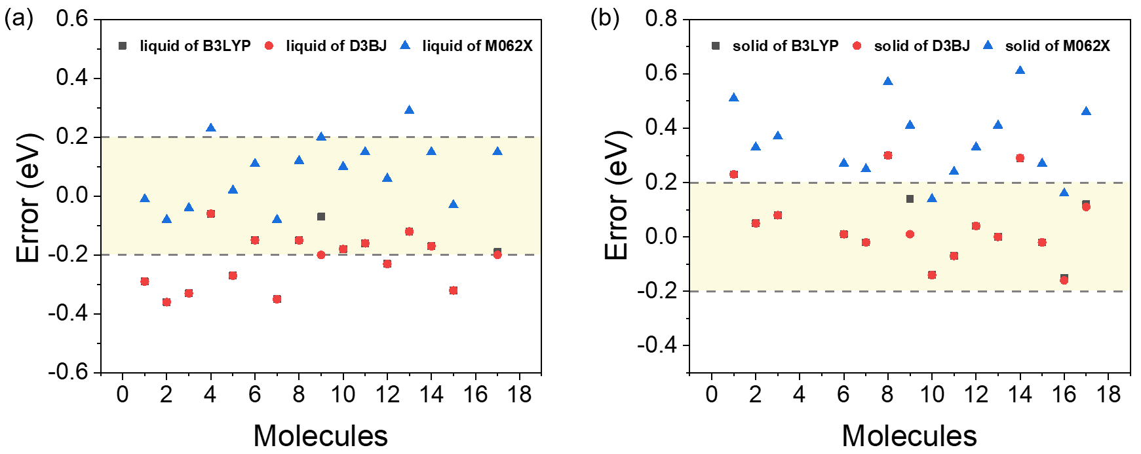
Fig. S2. Error of different molecules calculated using the M062X/6-31G* and B3LYP/6-31G* methods. Under our solid-state conditions, the B3LYP/6-31G* method shows a smaller error compared to the experimental data.

The calculation of the lifetime of S1 exciton and quantum yield was carried out using the TVCF method developed by Shuai's group. The results are shown in the table below:

Table S2. Calculation Photophysic Data of Experimental Molecules
Name | $k_{r}$ (10⁸ s⁻¹) | $k_{ic}$ (10⁸ s⁻¹) | $k_{isc}$ (s⁻¹) | $$ϕ_{exp}$$ | $$ϕ_{cal}$$
BSB000c00700 | 7.4 | 1.01 | 3.12E+05 | 0.88 | 0.76
BSB010c00200 | 5.27 | 2.02 | 0 | 0.72 | 0.22
BSB100c00200 | 4.58 | 4.94 | 0 | 0.48 | 0.4
DSB000c00000 | 6.49 | 0.34 | 1.03E+02 | 0.95 | 0.85
DSB000c00001 | 5.42 | 0.47 | 5.58E+01 | 0.92 | 0.88
DSB000c00100 | 6.86 | 0.49 | 5.92E+01 | 0.93 | 0.89
DSB000c55555 | 6.56 | 0.73 | 5.36E+01 | 0.90 | 0.08
DSB001c00000 | 5.44 | 0.56 | 4.84E+01 | 0.91 | 0.45
DSB001c00101 | 4.05 | 1.4 | 0 | 0.74 | 0.99
DSB002c00000 | 4.63 | 2.59 | 0 | 0.64 | 0.51
DSB002c00300 | 5.52 | 2.03 | 0 | 0.73 | 0.43
DSB002c00500 | 4.68 | 2.54 | 0 | 0.65 | 0.12
DSB002c10101 | 4.69 | 2.56 | 6.88E+02 | 0.65 | 0.45
DSB003c00000 | 1.58 | 4.6 | 0 | 0.26 | 0.19
DSB005c00000 | 3.9 | 2.46 | 0 | 0.61 | 0.64
DSB010c00000 | 4.49 | 0.96 | 1.44E+04 | 0.82 | 0.55
DSB100c00000 | 4.28 | 0.59 | 0 | 0.88 | 0.65
DSF000c00700 | 7.18 | 0.99 | 0 | 0.88 | 0.42

From the data, it can be observed that for molecules with high quantum yields, the calculated values are relatively accurate. However, for molecules with low quantum yields, the theoretical calculations tend to slightly overestimate the quantum yield. The reasons for this discrepancy are complex, with the most typical explanation being that some of these molecules exhibit good planarity and form H-aggregates in the solid state, which is often accompanied by excimer phenomena—manifested as the disappearance of fine structures in the fluorescence spectrum, a red shift, and a decrease in quantum yield. Another contributing factor is the anharmonicity of the potential energy surface of the molecules themselves. In practical organic lasers, the former issue can be mitigated by doping the thin films, while the latter is less significant since organic laser molecules generally exhibit high vibrational intensities, and thus anharmonic effects are not pronounced.

2.3 Detail of AIE Properties
The data we have collected include molecules exhibiting Aggregation-Induced Emission (AIE) characteristics, primarily comprising two types of cyano-substituted compounds. From a mechanistic perspective, both AIE mechanisms are realized via Restricted Intramolecular Rotation (RIR) mechanisms. In the solid state, conformational rotation is restricted. Using the FC approximation-based Time-Dependent Variational Coupled-Cluster (TVCF) method, we can effectively predict the quantum yield of these structures in the solid state, a result that has been confirmed in previous studies.
We selected molecules from the experimental dataset representing the two aforementioned types, and the experimental quantum yields are in good agreement with the predicted quantum yields.
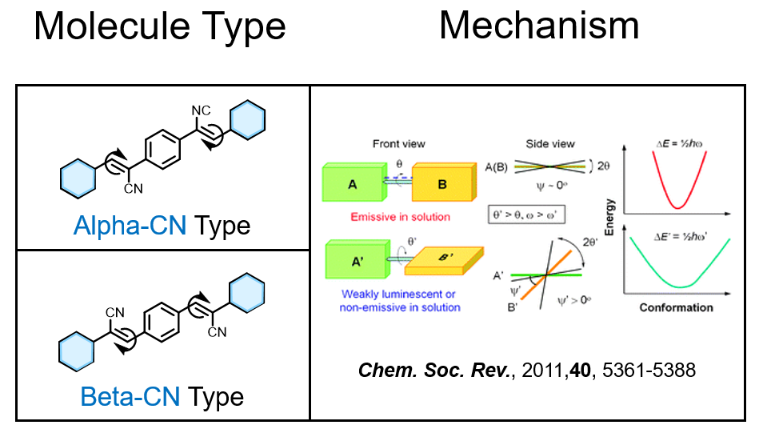
Fig. S3. Two types of AIE frameworks and their corresponding AIE mechanisms.

Table S3. Calculation Photophysic Data of AIE Molecules
Structure | $k_{ic}$ ($×10^{8}$ s⁻¹) | $k_{isc}$ (s⁻¹) | $k_{r}$ ($×10^{8}$ s⁻¹) | $$ϕ_{exp}$$ | $$ϕ_{cal}$$
BSB010c00200 | 2.022 | 0 | 5.275 | 0.22 | 0.72
BSB100c00200 | 4.942 | 0 | 4.581 | 0.40 | 0.48
DSB010c00000 | 0.961 | 1.44E+04 | 4.488 | 0.69 | 0.82
DSB012c10101 | 6.498 | 1.59E+04 | 2.175 | / | 0.25
DSB100c00000 | 0.589 | 0 | 4.277 | 0.90 | 0.88

- Construction of Initial Structures
  - Five Frameworks and 39 Core Structures
From the above structures, we identified five frameworks. By introducing six common substituents and substituting the double bond with a cyano group, while excluding those that are difficult to synthesize, we generated 39 core structures in Fig. S4.
Fig. S4. 39 core structures with 5 frameworks.

3.2 20559 Substitutes
Using SMILES encoding and the combination of substituents, we generated SMILES code texts for different substituents. In these, the carbon atoms connected to the double bond are represented by phosphorus atoms (P), which facilitates subsequent structure generation and assembly. By generating molecular structures with RDKit program, we obtained 20,559 unique structures. The filenames consist of six-character strings, with the first character representing the linking atom (C), and the subsequent characters indicating the types of substituents. The mapping is as follows: 0: H, 1: -CH₃, 2: -OCH₃, 3: -SCH₃, 4: -N(CH₃)₂, 5: -F, 6: -CN, 7: -Cz. The character "n" represents the nitrogen atom (N). Additionally, the -Cz group is introduced by first placing the iodine (I) atom on the ring, and then attaching the carbazole group to it after generating the structure.

Table S4. SMILES code of some substitutes.
Name | SMILES
c00000 | c1ccccc1
c0n020 | c1cncc(OC)c1
$$⋮$$ | $$⋮$$
c11n21 | c1c(C)c(C)nc(OC)c1(C)
c3n326 | c1c(SC)nc(SC)c(OC)c1(C#N)
$$⋮$$ | $$⋮$$
c56344 | c1c(F)c(C#N)c(SC)c(N(C)C)c1(N(C)C)
c0n226 | c1cnc(OC)c(OC)c1(C#N)
$$⋮$$ | $$⋮$$
cn0660 | c1ncc(C#N)c(C#N)c1
c60606 | c1c(C#N)cc(C#N)cc1(C#N)
c6n546 | c1c(C#N)nc(F)c(N(C)C)c1(C#N)
$$⋮$$ | $$⋮$$

3.3 Initial Structures Dataset
We employed coordinate-based assembly rather than directly converting the SMILES encoding using RDKit. Because the structures generated by RDKit are not necessarily in their stable conformations. Based on previous studies, we required trans configurations of the double bonds. The directly assembly approach saving considerable time on dynamic sampling and optimization. During the assembly process, because the substituted benzene rings do not typically exhibit symmetry. Therefore, we applied two operations during the assembly: rotating the structure by 0° and 180° along the axis. These two conformations were then optimized and their energies were calculated using GFN2-XTB. As a result, we obtained the stable conformations of 801,801 molecules.
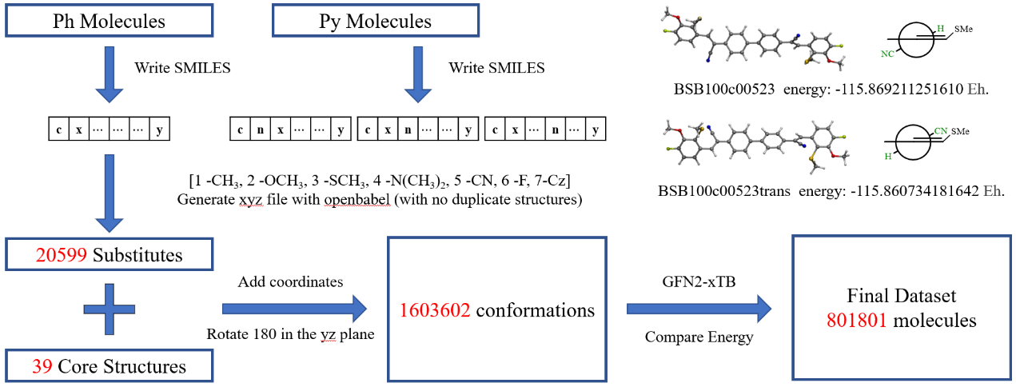
Fig. S5. Process of generate Initial Structures

3.4 Properties of Core Structure
We first estimated the oscillator strengths (f) for different cores, which are directly related to the emission cross-section. The calculations were performed for a molecule with the substituent configuration c00000, representing a benzene ring. The results are shown in Fig. S6. We categorized the molecules into three types: weak emitters (f < 0.5), moderate emitters (0.5 < f < 1.5), and strong emitters (f > 1.5). As can be seen, emitters with good performance are primarily molecules with no substituents or only methyl groups on the core. Additionally, the introduction of a cyano group onto the double bond, results in poorer laser performance compared to molecules with no cyano group. Although it may induce AIE phenomena and expand the selection of molecules, This observation is also corroborated by previous experimental data.
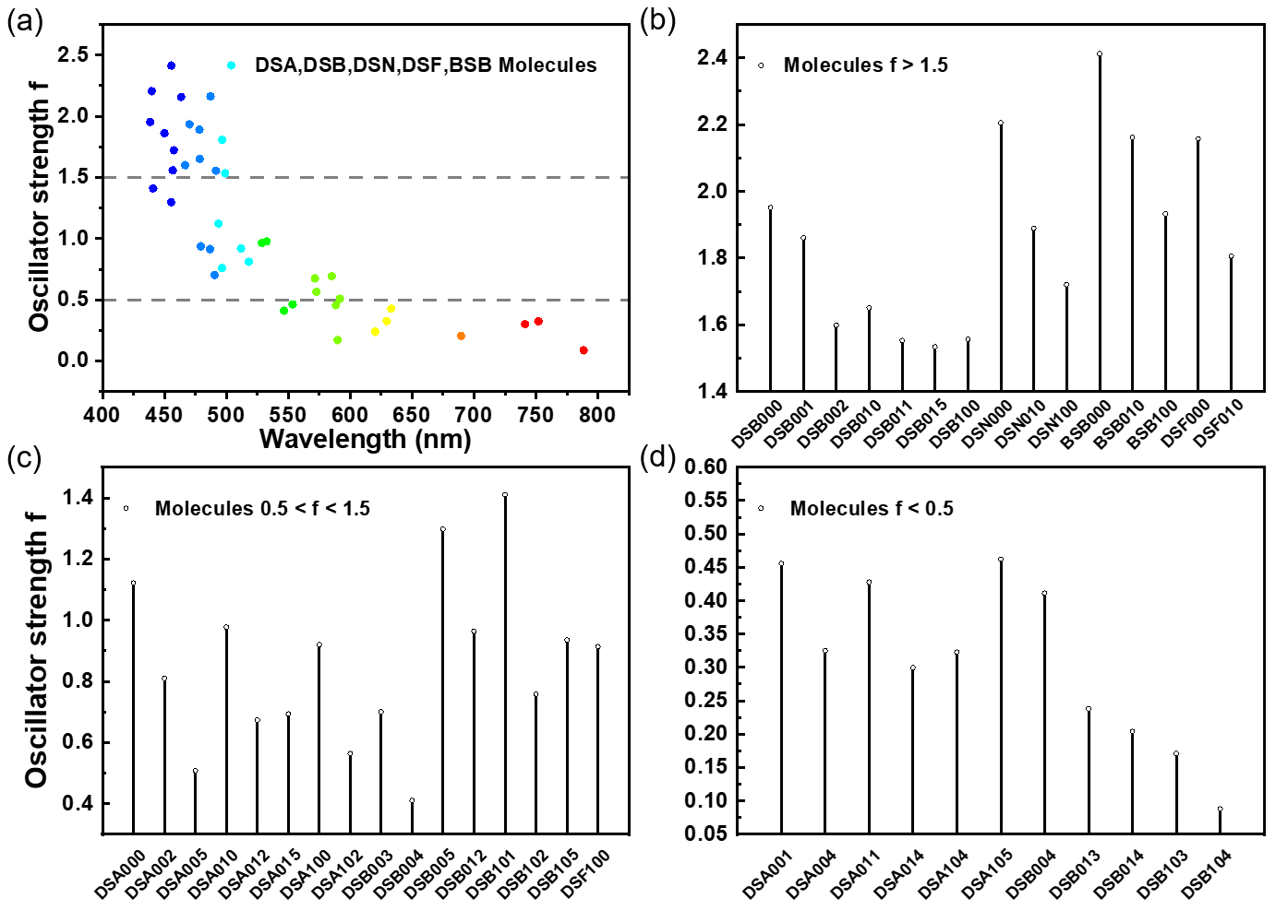
Fig. S6. The oscillator strength (luminescent performance) of different cores.

- Construction of Training Set

4.1 Molecule selection
A classification-based sampling method was employed to select 1,365 molecules for quantum chemistry calculations.
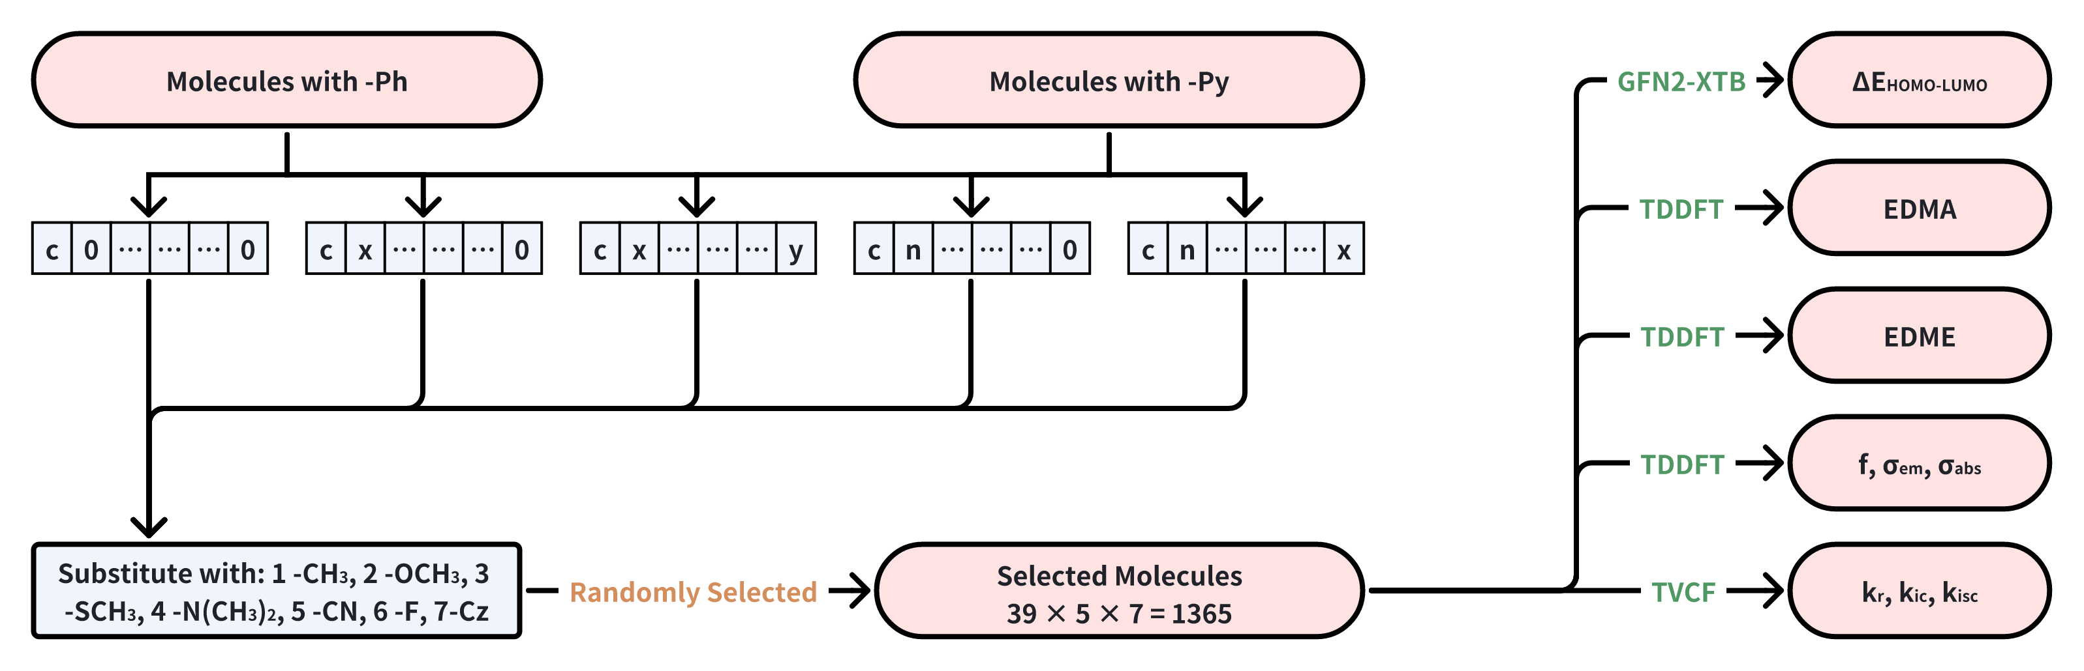
Fig. S7. Dataset selection and computational workflow.

4.2 Correction of Excited State Structure
During the calculation process, we found that for some molecules with charge-transfer (CT) characteristics, the B3LYP functional led to potential energy surface crossings during the optimization of the excited-state structures. Additionally, for molecules with strong CT features, the electronic structure obtained using B3LYP was inaccurate. To correct this, we employed two methods: comparing the similarity of the ground and excited-state NTOs (Natural Transition Orbitals) and calculating the electron-hole overlap index. For the selected molecules, we used the LC-PBE functional and optimized the w parameter for each molecule. This approach has been considered feasible in many previous studies.
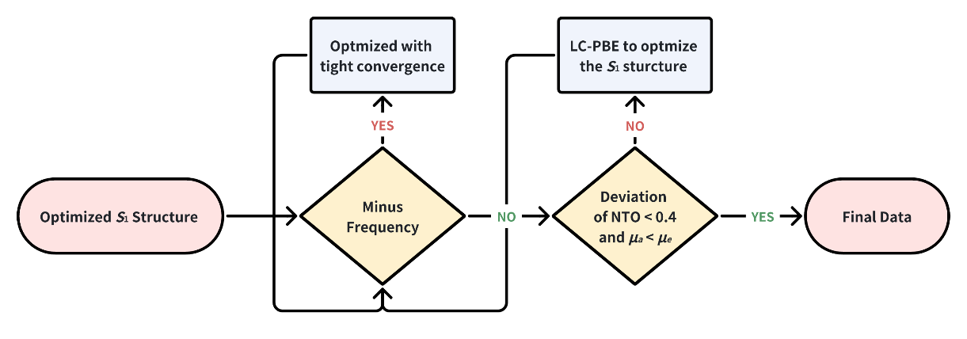
Fig. S8. Debug of excited state one (S₁).

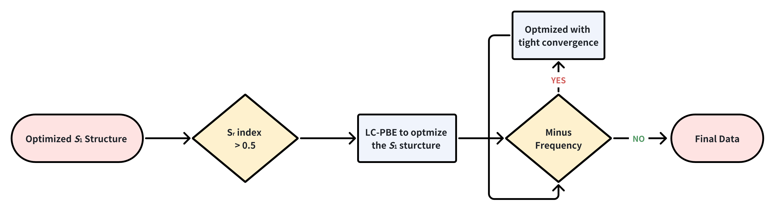
Fig. S9. Debug of CT state.

In the self-absorption calculations, we observed that sometimes the number of states calculated was insufficient. To address this, we employed an iterative strategy, gradually increasing the number of calculated states until the entire emission cross-section range was fully covered.
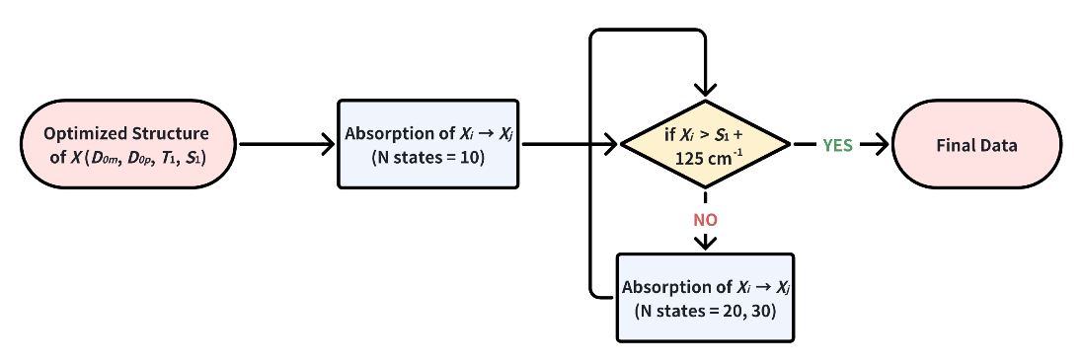
Fig. S10. Debug of self-absorption.

Ultimately, we obtained the laser properties for 1,259 molecules, including 1,021 localized excitation (LE) molecules and 238 charge-transfer (CT) molecules. The dataset was then divided into a training set of 880 molecules and a test set of 379 molecules.
- Detail of Model training

5.1 Fine-tuning of Uni-mol
In order to capture the relationship between molecular structure and properties, we employ the molecular 3D pre-training model Uni-Mol. Uni-Mol is pre-trained on a large-scale molecular dataset with two core tasks: 3D position recovery and masked atom prediction. These tasks enable the model to deeply extract the structural features of molecules. In the 3D position recovery task, the model learns the geometric configuration of molecules by correcting perturbed atom coordinates, while in the masked atom prediction task, it is required to identify randomly masked atom types. This facilitates the learning of both local environments and global interactions within the molecule, thereby gaining a profound understanding of its unique structural characteristics.
The input data for Uni-Mol consist of atom types and atom coordinates, which are processed via an embedding layer and spatial positional encoding, respectively. The atom representations are initialized from the atom types, whereas the pair representations are initialized using the Euclidean distances computed from the atom coordinates. This design ensures invariance to global rotations and translations (i.e., SE(3)-invariance). Internally, these representations interact through the self-attention mechanism of the Transformer, enabling the model to effectively capture both local and global information, and thus construct an efficient 3D representation. During downstream fine-tuning, similar to practices in NLP and CV, Uni-Mol directly uses the representation of the [CLS] token as the whole molecular representation, which is then fine-tuned with a linear head for various tasks.
For downstream fine-tuning, we employ two separate models. The first model is used to fine-tune four properties: emission energy (S₁), optical pumping emission cross-section ($σ_{opt}$), electrical pumping emission cross-section ($σ_{ele}$) and radiative constants ($k_{r}$). The second model is dedicated solely to fine-tuning the quantum yields ($φ$) property. Initially, we attempted to $k_{r}$ and non-radiative transition constants ($k_{ic}$) to compute lifetime of first excited state ($τ_{S1}$), but the results were unsatisfactory. Subsequently, we found that directly predicting quantum yields ($φ$) yields better performance. Therefore, our final approach is to have the first model predict the first four parameters and the second model predict quantum yields ($φ$).
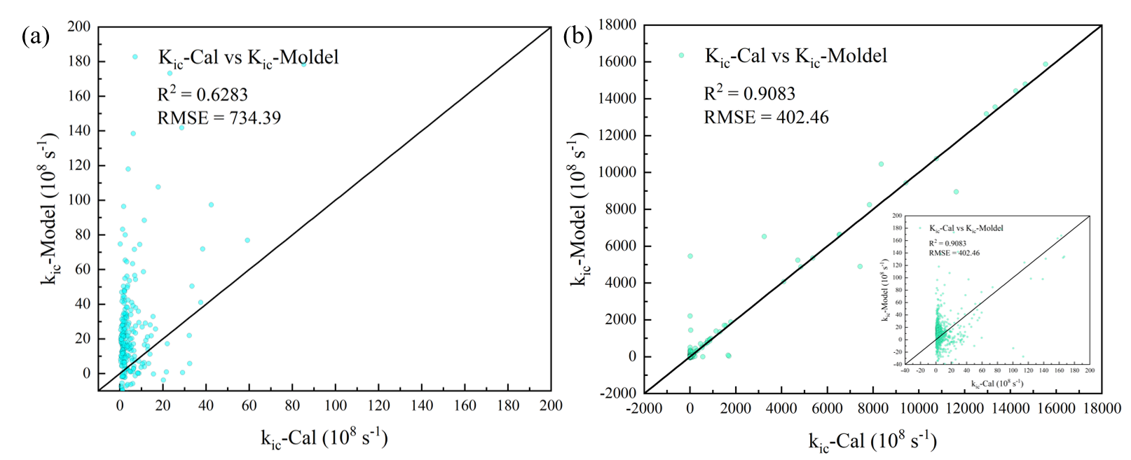
Fig. S11. a) The difference between the predicted KIC and the calculated value shows a huge RMSE, indicating poor learning performance. b) The difference between the KIC learned from the training set and the calculated value shows that, although the R^2 reaches 0.9, the RMSE is still as high as 402, indicating overfitting.
The molecular conformation is used as the input, and the corresponding computed properties serve as the labels. We optimize the models using the smooth $L_{1}$ loss function:
$$S{mooth}_{L1}\left(\hat{z},z\right)=\left\{\begin{matrix}0.5{\left(\hat{z}-z\right)}^{2}, if \left|\hat{z}-z\right|<1 \\ \left|\hat{z}-z\right|-0.5, otherwise\end{matrix}\right.$$
The overall loss is computed as the sum of the smooth $L_{1}$ loss for all predictions:
$$Loss=\sum_{i=1}^{N}{S{mooth}_{L1}\left(\hat{z},z\right)}$$
where $\hat{z}$ (or ${\hat{z}}_{i}$) denotes the model predictions and $z$ (or $z_{i}$) denotes the ground-truth values.
For the first model, we use the Adam optimizer with a learning rate of $1×{10}^{-5}$, a batch size of 32, and an 11-layer network on a single NVIDIA GeForce RTX 4090 D GPU, training for 5000 epochs. For the second model, we also use the Adam optimizer but with a learning rate of $1×{10}^{-4}$, a batch size of 32, and a 12-layer network on the same hardware, also training for 5000 epochs.

5.2 Geo2Seq-VAE
We propose a novel Geo2Seq-VAE (Geometry-to-Sequence Variational Autoencoder), a framework designed to leverage three-dimensional molecular representations for molecule generation. By integrating a 3D pretraining molecular representation encoder with the probabilistic latent space modeling capabilities of a variational autoencoder (VAE)64, our approach ensures structural accuracy and diversity in the generated molecules.
The Geo2Seq-VAE framework is built on a three-dimensional pretraining molecular encoder, Uni-Mol, which effectively captures both global and local geometric features of molecules. The encoder processes the molecule’s 3D structure, including atomic coordinates, atomic types, and distance matrices, and maps it to a high-dimensional embedding representation. To create the latent space, this molecular embedding is passed through a pair of fully connected layers, generating a mean vector ($μ$) and a log variance vector ($\log{σ^{2}}$).
To ensure smooth optimization and maintain the necessary randomness for molecule generation, the model employs a reparameterization trick. Specifically, the latent vector $z$ is computed as:
$$z=μ+ϵ\exp\left(0.5∙\log{σ^{2}}\right)$$
where$ϵ\sim N(0,I)$ introduces stochasticity while ensuring the latent space is differentiable for gradient-based optimization. This approach enables the latent representation to encapsulate the molecule’s structural and chemical characteristics, providing a robust foundation for generating a wide variety of molecular structures.
For decoding, the latent vector $z$ is mapped to a molecular sequence representation using a Transformer-based decoder.65,66 The decoder is trained to reconstruct the molecular sequence (e.g., SMILES tokens) corresponding to the input molecule. By incorporating teacher forcing during training, the model learns to effectively map high-dimensional latent vectors to molecular sequences, ensuring accurate reconstruction and generation.
The training objective of the Geo2Seq-VAE is formulated as a combination of two components: the reconstruction loss and the Kullback-Leibler (KL) divergence loss. The reconstruction loss, based on cross-entropy, measures the discrepancy between the predicted molecular sequence $\hat{x}$ and the ground truth sequence $x$:
$$L_{reconstruction}=-\sum_{i}{x_{i}}\log{{\hat{x}}_{i}}$$
where the summation is applied over all tokens in the sequence. To handle padding tokens, a mask is applied during the computation.
The KL divergence loss regularizes the latent space by aligning the posterior distribution of the latent vector $q\left(z | x\right)$ with a standard Gaussian prior$p\left(z\right)$:
$$L_{KL}=-\frac{1}{2}\sum{\left(1+\log{σ^{2}}-μ^{2}-σ^{2}\right)}$$
where the summation is applied element-wise across the latent dimensions. This term encourages smoothness and continuity in the latent space, aiding in the generation of diverse and realistic molecules.
The total loss is defined as:
$$L_{total}=L_{reconstruction}+βL_{KL}$$
where $β$ is a weighting factor that balances the trade-off between reconstruction accuracy and latent space regularization. This loss function ensures that the Geo2Seq-VAE learns both accurate reconstructions and a well-organized latent space conducive to molecular diversity. During the inference process in Geo2Seq-VAE, the generation begins by constructing the high-dimensional latent vector $\left(z\right)$ through a reparameterization process, which introduces stochasticity and ensures the model retains diversity while maintaining structural coherence. The latent vector $\left(z\right)$ is then fed into the Transformer-based decoder, which is initialized with a start-of-sequence token. The decoder generates the molecular sequence tokens, in an autoregressive manner. At each step, the decoder predicts the next token in the sequence, selecting the token with the highest probability (greedy decoding). This predicted token is appended to the partially generated sequence and iteratively fed back into the decoder to continue the generation process.
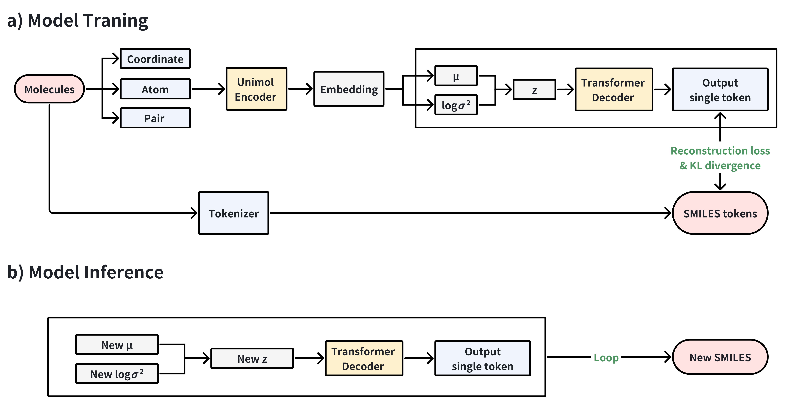
Fig. S12. Workflow of Geo2Seq-VAE.

- Synthesis of Molecules

Our target Molecules:
Fig. S13. Target Molecules

6.1 General Synthesis Method
We used Horner-Wadsworth-Emmons (HWE) reaction to synthesis all the target molecules.
Add the obtained core and side groups with a ratio about 1:2 to a 50 mL single-neck round-bottom flask, then add 5 equivalents of sodium tert-butoxide and 20 mL of tetrahydrofuran (THF). The reaction mixture was stirred at 60°C for 12 hours. Upon cooling, THF was removed via rotary evaporation, and the crude product was recrystallized from a solvent mixture of acetone and water (1:2 v/v). The final product was isolated by vacuum filtration after further cooling.

Basic Core:
The core groups were obtained by purchase.

6.2 Synthesis of M1 (4,4'-bis((E)-4-(9H-carbazol-9-yl)-2-methylstyryl)-1,1'-biphenyl)
Synthesis route:
4-(9H-carbazol-9-yl)-2-methylbenzaldehyde (c00701-CHO): Palladium acetate (224 mg, 0.1 eq), tri-tert-butylphosphine (3.5 mL, 10% in toluene), and 10 mL toluene were added to a 50 mL round-bottom flask. The mixture was stirred under nitrogen for 30 minutes. Then, 4-fluoro-2-methylbenzaldehyde (1.99 g, 10 mmol), carbazole (2.0 g, 12 mmol), and potassium carbonate (4.14 g, 30 mmol) were added, followed by an additional 10 mL of toluene. The reaction was heated at 110°C for 24 hours. After cooling, water was added to dilute the reaction mixture, and the product was extracted with ethyl acetate. The organic phase was collected and evaporated under reduced pressure. The product was separated by silica gel column chromatography, using a mobile phase of PE : DCM = 4 : 1. The product was obtained as white crystals (2.33 g, yield = 82%).
¹H NMR (400 MHz, CDCl₃) δ 10.36 (s, 1H), 8.15 (d, J = 7.7 Hz, 2H), 8.06 (d, J = 8.2 Hz, 1H), 7.62 (dd, J = 8.1, 2.1 Hz, 1H), 7.56 – 7.48 (m, 3H), 7.44 (ddd, J = 8.3, 6.9, 1.2 Hz, 2H), 7.38 – 7.29 (m, 2H), 2.80 (s, 3H).
4,4'-bis((E)-4-(9H-carbazol-9-yl)-2-methylstyryl)-1,1'-biphenyl (M1): Used general synthesis method. 0.78 g of core 1 and 1.08 g of c00701 were reacted to yield a yellow solid. The product was recrystallized from a dichloromethane-methanol mixture, followed by vacuum filtration, resulting in a pale-yellow powder (1.14 g, yield = 93%).
¹H NMR (600 MHz, CDCl₃) δ 8.16 (d, J = 7.8 Hz, 4H), 7.86 (d, J = 8.1 Hz, 2H), 7.73 – 7.66 (m, 8H), 7.50 – 7.40 (m, 14H), 7.33 – 7.27 (m, 4H), 7.18 (d, J = 16.1 Hz, 2H), 2.57 (s, 6H).
¹³C NMR (151 MHz, CDCl₃) δ 140.8, 140.0, 137.6, 136.8, 136.7, 135.6, 130.2, 128.7, 127.2, 127.2, 126.7, 125.9, 125.7, 124.8, 123.4, 120.3, 119.9, 109.9, 77.2, 77.0, 76.8, 20.1.
HRMS calculated for C54H40N2 [M+H]⁺ : 717.3271 Found: 717.3251.

6.3 Synthesis of M2 (4,4'-bis((E)-2-(6-(9H-carbazol-9-yl)-5-methylpyridin-3-yl)vinyl)-1,1'-biphenyl)
Synthesis route:
9-(5-bromo-3-methylpyridin-2-yl)-9H-carbazole (c0n701-Br): 5-Bromo-2-fluoro-3-methylpyridine (3.80 g, 20 mmol), carbazole (3.67 g, 22 mmol), and potassium carbonate (8.28 g, 60 mmol) were added to a 100 mL round-bottom flask. 50 mL of DMSO was then added. The reaction mixture was heated at 150°C for 24 hours. After cooling, DMSO was removed under reduced pressure. Water was added to dissolve the residue, and the product was extracted with ethyl acetate. The organic phase was collected and evaporated under reduced pressure. The product was purified by silica gel column chromatography, using a mobile phase of PE : DCM = 4 : 1. The product was obtained as white crystals (6.11 g, yield = 91%).
¹H NMR (600 MHz, CDCl₃) δ 8.74 (s, 1H), 8.11 (d, J = 7.7 Hz, 2H), 7.79 (d, J = 8.3 Hz, 2H), 7.54 (s, 1H), 7.48 – 7.38 (m, 2H), 7.33 (td, J = 7.5, 0.9 Hz, 2H), 2.53 (s, 3H).
6-(9H-carbazol-9-yl)-5-methylnicotinaldehyde (c0n701-CHO): c0n701-Br (1.69 g, 5 mmol) was placed in a 50 mL two-neck flask, and 20 mL of tetrahydrofuran (THF) was added under nitrogen protection. The mixture was cooled to -78°C, and n-butyllithium (2.08 mL, 2.5 M in n-hexane) was introduced. After stirring for 30 minutes, DMF (0.77 mL, 10 mmol) was added, and the reaction was allowed to proceed for 3 hours. Upon completion, the reaction was quenched with 0.5 M citric acid, and the mixture was stirred for 15 minutes. Water was then added for extraction, and the organic phase was collected and evaporated under reduced pressure. The product was purified by silica gel column chromatography using a mobile phase of PE : DCM = 1 : 4. The final product was obtained as white crystals (0.83 g, yield = 58%).
¹H NMR (600 MHz, DMSO) δ 10.32 (s, 1H), 9.08 (s, 1H), 8.26 (d, J = 7.6 Hz, 1H), 8.01 (d, J = 8.3 Hz, 2H), 7.82 (s, 1H), 7.51 (ddd, J = 8.3, 7.1, 1.3 Hz, 2H), 7.42 – 7.35 (m, 2H), 2.78 (s, 3H).
4,4'-bis((E)-2-(6-(9H-carbazol-9-yl)-5-methylpyridin-3-yl)vinyl)-1,1'-biphenyl (M2): Used general synthesis method. 1.18 g of core 1 and 1.50 g of c0n701-CHO were reacted to yield a yellow solid. The product was recrystallized from a dichloromethane-methanol mixture, followed by vacuum filtration, resulting in a pale-yellow powder (1.28 g, yield = 72 %).
¹H NMR (600 MHz, CDCl₃) δ 8.92 (s, 2H), 8.13 (d, J = 7.7 Hz, 4H), 7.86 (d, J = 8.2 Hz, 4H), 7.71 (q, J = 8.2 Hz, 8H), 7.48 (dd, J = 15.1, 6.9 Hz, 6H), 7.37 – 7.30 (m, 6H), 7.23 (d, J = 16.3 Hz, 2H), 2.59 (s, 6H).
¹³C NMR (151 MHz, CDCl₃) δ 150.2, 147.5, 146.1, 140.3, 139.6, 136.2, 131.5, 130.9, 127.4, 127.3, 126.2, 124.3, 122.5, 121.0, 120.2, 120.0, 111.2, 77.2, 77.0, 76.8, 20.0.
HRMS calculated for C52H38N4 [M+H]⁺ : 719.3104 Found: 719.3166.

6.4 Synthesis of M3 (4,4'-bis((E)-4-(9H-carbazol-9-yl)-2-methoxystyryl)-1,1'-biphenyl)
Synthesis route:
4-(9H-carbazol-9-yl)-2-methoxybenzaldehyde (c00702-CHO): 4-fluoro-2-methoxybenzaldehyde (1.54 g, 10 mmol), carbazole (2.00 g, 12 mmol), and potassium carbonate (4.14 g, 30 mmol) were added to a 100 mL round-bottom flask. 20 mL of DMF was then added. The reaction mixture was heated at 110°C for 48 hours. After cooling, the product was extracted with ethyl acetate. The organic phase was collected and evaporated under reduced pressure. The product was purified by silica gel column chromatography, using a mobile phase of PE : DCM = 2 : 1. The product was obtained as white crystals (1.51 g, yield = 51%). ¹H NMR (600 MHz, CDCl₃) δ 10.53 (s, 1H), 8.15 (dd, J = 7.7, 1.2 Hz, 2H), 8.08 (d, J = 8.2 Hz, 1H), 7.53 (d, J = 8.2 Hz, 2H), 7.44 (ddd, J = 8.2, 7.2, 1.2 Hz, 2H), 7.36 – 7.27 (m, 3H), 7.24 (d, J = 1.8 Hz, 1H), 3.97 (s, 3H).
4,4'-bis((E)-4-(9H-carbazol-9-yl)-2-methoxystyryl)-1,1'-biphenyl (M3): Used general synthesis method. 0.91 g of core 1 and 1.35 g of c00702-CHO were reacted to yield a yellow solid. The product was recrystallized from a dichloromethane-methanol mixture, followed by vacuum filtration, resulting in a pale-yellow powder (1.47 g, yield = 98 %).
¹H NMR (600 MHz, CDCl₃) δ 8.16 (d, J = 7.8 Hz, 4H), 7.84 (d, J = 8.1 Hz, 2H), 7.69 (s, 8H), 7.61 (d, J = 16.5 Hz, 2H), 7.51 – 7.49 (m, 4H), 7.47 – 7.41 (m, 4H), 7.34 – 7.28 (m, 6H), 7.21 (dd, J = 8.0, 2.0 Hz, 2H), 7.12 (d, J = 1.9 Hz, 2H), 3.93 (s, 6H).
¹³C NMR (151 MHz, CDCl₃) δ 157.8, 140.8, 137.9, 136.9, 129.3, 127.4, 127.2, 127.1, 126.0, 125.8, 123.4, 122.8, 120.4, 120.0, 119.3, 109.9, 109.8, 77.2, 77.0, 76.8, 55.9.
HRMS calculated for C54H40N2O2 [M+H]⁺ : 749.3170 Found: 749.3143.

6.5 Synthesis of M4 (4,4'-bis((E)-4-(9H-carbazol-9-yl)-2,6-dimethoxystyryl)-1,1'-biphenyl)
Synthesis route:
4-(9H-carbazol-9-yl)-2,6-dimethoxybenzaldehyde (c20702-CHO): Palladium acetate (224 mg, 0.1 eq), tri-tert-butylphosphine (3.5 mL, 10% in toluene), and 10 mL toluene were added to a 50 mL round-bottom flask. The mixture was stirred under nitrogen for 30 minutes. Then, 4-bromo-2,6-dimethoxybenzaldehyde (2.45 g, 10 mmol), carbazole (2.0 g, 12 mmol), and potassium carbonate (4.14 g, 30 mmol) were added, followed by an additional 10 mL of toluene. The reaction was heated at 110°C for 48 hours. After cooling, water was added to dilute the reaction mixture, and the product was extracted with ethyl acetate. The organic phase was collected and evaporated under reduced pressure. The product was separated by silica gel column chromatography, using a mobile phase of PE : DCM = 3 : 1. The product was obtained as white crystals (1.63 g, yield = 49.2%).
¹H NMR (600 MHz, CDCl₃) δ 10.56 (s, 1H), 8.15 (dt, J = 7.7, 1.0 Hz, 2H), 7.55 (d, J = 8.2 Hz, 2H), 7.50 – 7.42 (m, 2H), 7.37 – 7.31 (m, 2H), 6.84 (s, 2H), 3.94 (s, 6H).
(4,4'-bis((E)-4-(9H-carbazol-9-yl)-2,6-dimethoxystyryl)-1,1'-biphenyl) (M4): Used general synthesis method. 0.93 g of core 1 and 1.50 g of c20702-CHO were reacted to yield a yellow solid. The product was recrystallized from a dichloromethane-methanol mixture, followed by vacuum filtration, resulting in a pale-yellow powder (1.04 g, yield = 62.3 %).
¹H NMR (400 MHz, CDCl₃) δ 8.17 (d, J = 7.7 Hz,4H), 7.73 (d, J = 16.6 Hz, 2H), 7.68 (s, 8H), 7.59 (d, J = 16.6 Hz, 2H), 7.52 (dt, J = 8.3, 1.0 Hz,4H), 7.45 (ddd, J = 8.2, 7.0, 1.2 Hz, 4H), 7.31 (ddd, J = 7.9, 7.0, 1.1 Hz, 4H), 6.82 (s, 4H), 3.94 (s, 12H).
¹³C NMR (151 MHz, CDCl₃) δ 159.4, 140.8, 139.5, 138.2, 137.4, 132.4, 127.0, 126.1, 123.4, 120.4, 120.0, 119.3, 114.2, 110.0, 103.2, 77.2, 77.0, 76.8, 56.1.
HRMS calculated for C56H44N2O4 [M+H]⁺ : 809.3309 Found: 809.3354.

6.6 Synthesis of M5 (2,6-bis((E)-3-fluoro-4,5-dimethoxystyryl)naphthalene)
Synthesis route:
3-fluoro-4,5-dimethoxybenzaldehyde (c02350-CHO): 3-fluoro-4-hydroxy-5-methoxybenzaldehyde (1 g, 5.87 mmol) was added to a 100 mL round-bottom flask. 40 mL of THF was then added. Add sodium hydride (0.26 g, 0.6 wt.% in oil, 6.45 mmol) to the mixture and stirred 10 min. Then added methyl iodide (1.67g, 0.75 mL, 12 mmol). The reaction mixture was stirred at 30 °C for 12 hours. After cooling, the product was extracted with ethyl acetate. The organic phase was collected and evaporated under reduced pressure. The product was purified by silica gel column chromatography, using a mobile phase of PE : EA = 3 : 1. The product was obtained as white crystals (0.83 g, yield = 92%). ¹H NMR (600 MHz, CDCl₃) δ 9.84 (d, J = 1.2 Hz, 1H), 7.28 – 7.23 (m, 2H), 4.06 (d, J = 2.1 Hz, 3H), 3.95 (s, 3H).
2,6-bis((E)-3-fluoro-4,5-dimethoxystyryl)naphthalene (M5): Used general synthesis method. 0.86 g of core 2 and 0.81 g of c00702-CHO were reacted to yield a yellow solid. The product was recrystallized from a dichloromethane-methanol mixture, followed by vacuum filtration, resulting in a pale-yellow powder (0.92 g, yield = 95%).
¹H NMR (600 MHz, CDCl₃) δ 8.16 (d, J = 7.8 Hz, 4H), 7.86 (d, J = 8.1 Hz, 2H), 7.77 – 7.61 (m, 8H), 7.54 – 7.38 (m, 14H), 7.36 – 7.28 (m, 4H), 7.18 (d, J = 16.1 Hz, 2H), 2.57 (s, 6H).
¹³C NMR (151 MHz, CDCl₃) δ 156.9, 155.3, 153.7, 136.84, 136.76, 134.6, 133.3, 132.94, 132.88, 129.0, 128.5, 127.9, 126.5, 124.0, 107.2, 107.0, 105.9, 77.2, 77.0, 76.8, 61.6, 56.3.
HRMS calculated for C30H26F2O4 [M+H]⁺ : 489.1869 Found: 489.1866.

6.7 Synthesis of M6 (4,4'-bis((E)-4-(9H-carbazol-9-yl)styryl)-1,1'-biphenyl)
Synthesis route:
4,4'-bis((E)-4-(9H-carbazol-9-yl)styryl)-1,1'-biphenyl (M6): Used general synthesis method. 0.91 g of core 1 and 1.20 g of 4-(9H-carbazol-9-yl)benzaldehyde were reacted to yield a yellow solid. The product was recrystallized from a dichloromethane-methanol mixture, followed by vacuum filtration, resulting in a pale-yellow powder (1.05 g, yield = 78%).
¹H NMR (600 MHz, CDCl3) δ 8.16 (d, J = 7.8 Hz, 4H), 7.78 (d, J = 8.1 Hz, 4H), 7.69 (q, J = 8.1 Hz, 8H), 7.59 (d, J = 8.1 Hz, 4H), 7.51 – 7.39 (m, 8H), 7.31 (t, J = 7.3 Hz, 4H), 7.28 (d, J = 2.4 Hz, 4H).
HRMS calculated for C52H36N2 [M+H]⁺ : 689.2958 Found: 689.2975.

6.8 Synthesis of M7 (2,7-bis((E)-4-(9H-carbazol-9-yl)styryl)-9,9'-spirobi[fluorene])
Synthesis route:
2,7-bis((E)-4-(9H-carbazol-9-yl)styryl)-9,9'-spirobi[fluorene] (M7): Used general synthesis method. 1.23 g of core 3 and 1.2 g of 4-(9H-carbazol-9-yl)benzaldehyde were reacted to yield a yellow solid. The product was recrystallized from a dichloromethane-methanol mixture, followed by vacuum filtration, resulting in a pale-yellow powder (0.87 g, yield = 51%).
¹H NMR (600 MHz, CDCl₃) δ 8.13 (d, J = 7.8 Hz, 4H), 7.95 (d, J = 7.7 Hz, 2H), 7.88 (d, J = 7.9 Hz, 2H), 7.63 – 7.58 (m, 6H), 7.49 (d, J = 8.4 Hz, 4H), 7.45 (t, J = 7.8 Hz, 2H), 7.40 (dd, J = 6.2, 1.4 Hz, 8H), 7.30 – 7.27 (m, 4H), 7.21 – 7.18 (t, 2H), 7.09 – 7.00 (m 4H), 6.94 (s, 2H), 6.87 (d, J = 7.6 Hz, 2H).
¹³C NMR (151 MHz, CDCl₃) δ 148.6, 140.8, 137.1, 129.4, 127.7, 127.4, 127.1, 126.9, 125.9, 124.3, 123.4, 121.9, 120.3, 120.0, 109.8, 77.2, 77.0, 76.8.
HRMS calculated for C52H36N2 [M+H]⁺ : 851.3428 Found: 851.3962.

6.9 Synthesis of M8 (2,6-bis((E)-4-(9H-carbazol-9-yl)styryl)naphthalene)
Synthesis route:
2,6-bis((E)-4-(9H-carbazol-9-yl)styryl)naphthalene (M8): Used general synthesis method. 0.93 g of core 2 and 1.2 g of 4-(9H-carbazol-9-yl)benzaldehyde were reacted to yield a yellow solid. The product was recrystallized from a dichloromethane-methanol mixture, followed by vacuum filtration, resulting in a pale-yellow powder (1.04 g, yield = 76%).
¹H NMR (600 MHz, CDCl₃) δ 8.16 (d, J = 7.8 Hz, 4H), 7.95 – 7.87 (m, 4H), 7.81 (t, J = 8.2 Hz, 6H), 7.61 (d, J = 8.1 Hz, 4H), 7.48 (d, J = 8.1 Hz, 4H), 7.44 (t, J = 7.5 Hz, 4H), 7.38 (d, J = 3.8 Hz, 4H), 7.31 (t, J = 7.3 Hz, 4H).
¹³C NMR (151 MHz, CDCl₃) δ 140.82, 129.56, 127.87, 127.29, 126.68, 125.99, 124.16, 123.48, 120.35, 120.03, 109.85.
HRMS calculated for C50H34N2 [M+H]⁺ : 663.2802 Found: 663.4520.

- Basic photophysical properties.
We tested the basic photophysical properties of all target molecules in tetrahydrofuran (THF) solution and doped thin films, including UV-Vis absorption, fluorescence, lifetime, and quantum yield. The results are as follows:

7.1 UV-Vis and FL of Molecules in THF (c = 1.0 × 10⁻⁵ mol/L)
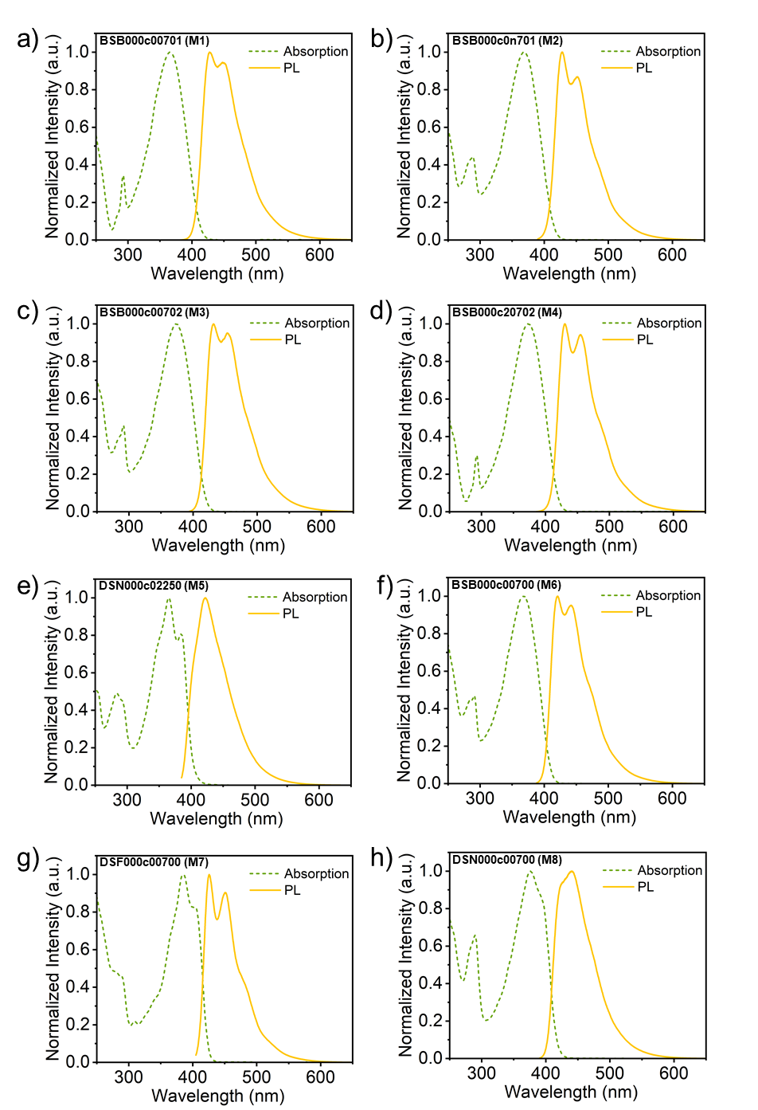
Fig. S14. UV-Vis absorption and PL spectra of M1-M8 (a-h) in THF.

7.2 UV-Vis and FL of Molecules in Doped Film
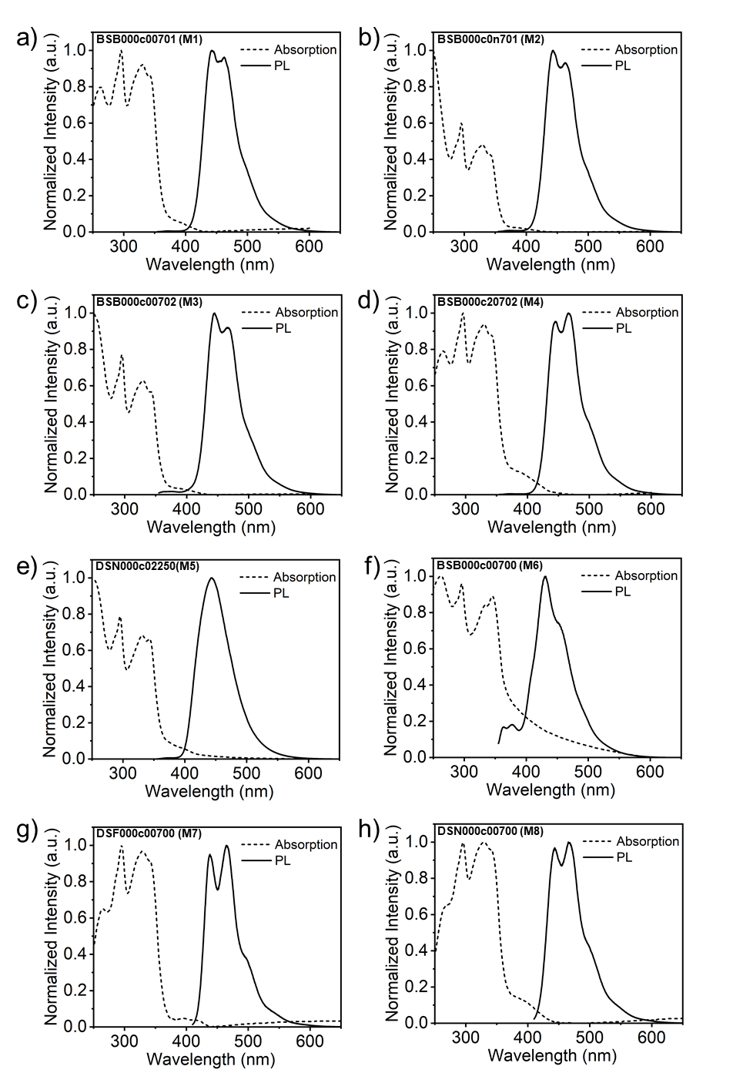
Fig. S15. UV-Vis absorption and PL spectra of M1-M8 (a-h) in doped CBP films.

7.3 Lifetime of Molecules in THF (c = 1.0 × 10⁻⁵ mol/L)
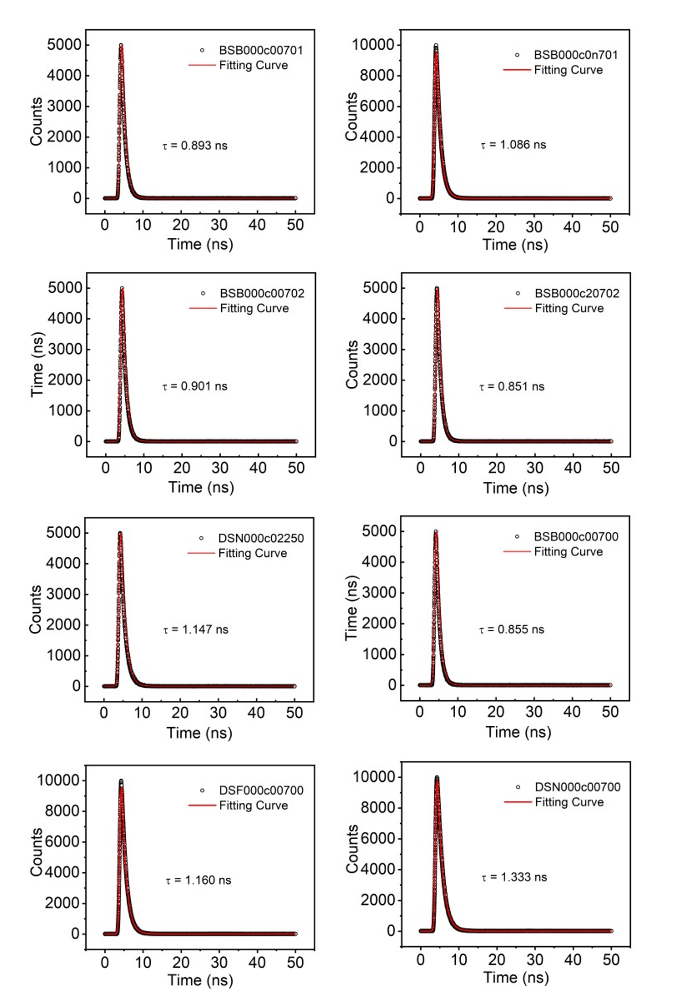
Fig. S16. Transient PL decay spectra of M1-M8 (a-h) in THF.

7.4 Lifetime of Molecules in Doped Films
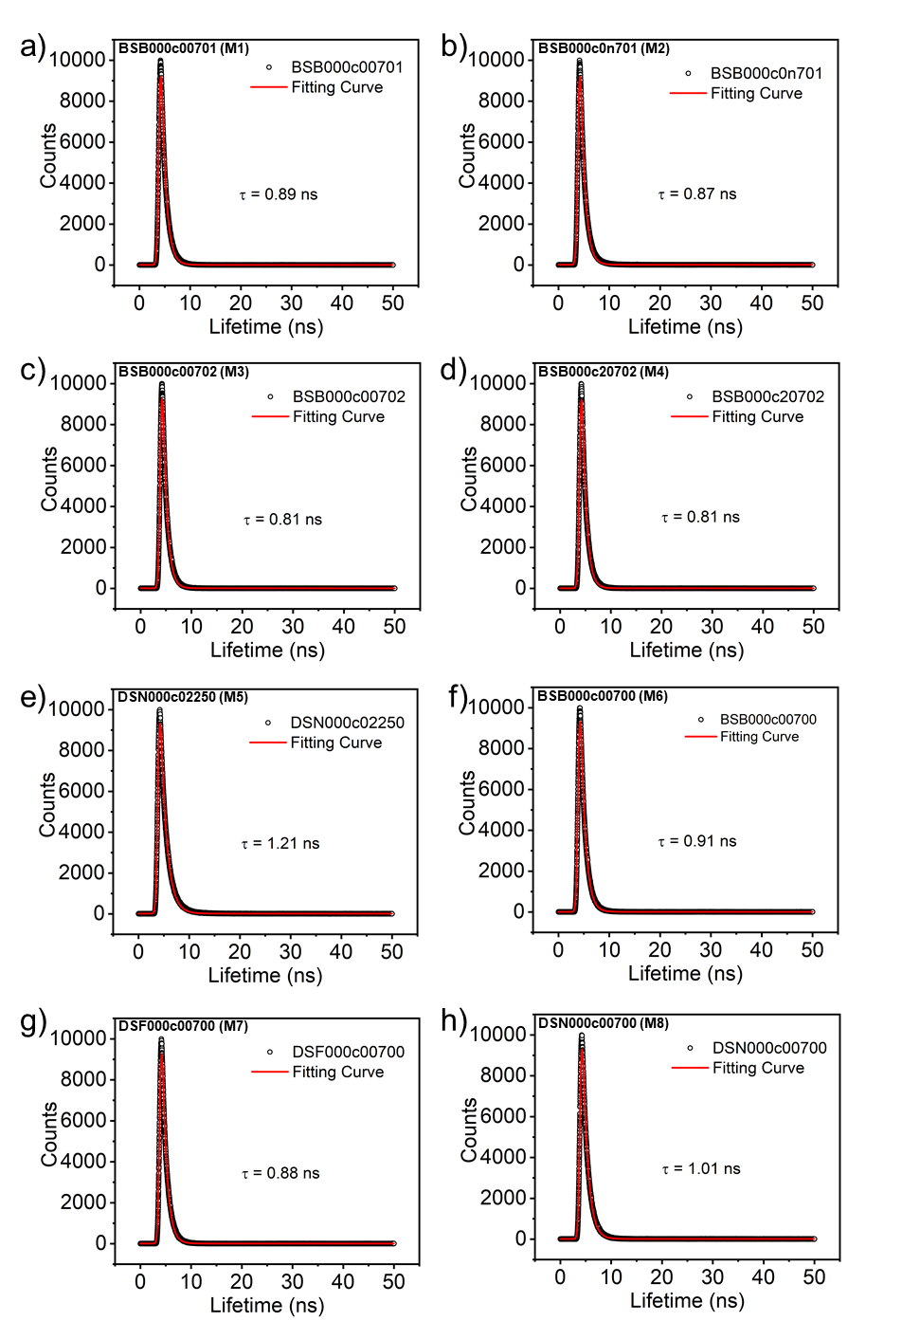
Fig. S17. Transient PL decay spectra of M1-M8 (a-h) in doped CBP films.

Table S5. Photophysical Properties
Molecule | $$λ_{PL}$$  (nm)ª | $$τ$$  (ns)ª | PLQYª | $$λ_{PL}$$  (nm)^{b} | $$τ$$  (ns)^{b} | $$k_{r}$$  (10⁸ s⁻¹) | $$k_{nr}$$  (10⁸ s⁻¹)
M1 | 427 | 0.89 | 0.95 | 442 | 0.89 | 10.7 | 0.562
M2 | 428 | 1.08 | 0.98 | 443 | 0.87 | 9.07 | 0.185
M3 | 432 | 0.90 | 0.95 | 445 | 0.81 | 10.6 | 0.556
M4 | 430 | 0.85 | 0.96 | 466 | 0.81 | 11.3 | 0.471
M5 | 422 | 1.15 | 0.98 | 443 | 1.21 | 8.52 | 0.174
M6 | 420 | 0.86 | 0.95 | 431 | 0.91 | 11.1 | 0.581
M7 | 426 | 1.16 | 0.99 | 465 | 0.88 | 8.53 | 0.086
M8 | 440 | 1.33 | 0.95 | 465 | 1.01 | 7.14 | 0.374
a Test in THF solvent (c = 10⁻⁵ mol/L)
b Test in doped film (3 wt.% in CBP)

- Preparation and Characterization of Thin-Film Devices
Amplified Spontaneous Emission (ASE) is a phenomenon that occurs when spontaneous emission in a material is amplified through stimulated emission. ASE testing is commonly used to evaluate the gain performance of laser materials. During ASE testing, a pump source excites the material, which then undergoes amplification of the spontaneous emission. The intensity and spectral characteristics of the emitted light are analyzed to assess the gain and efficiency of the material.
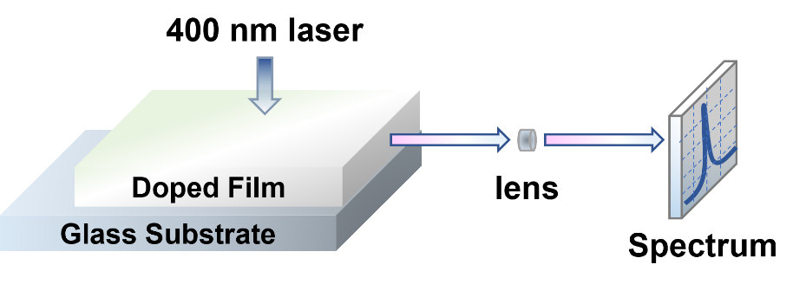
Fig. S18. Measurement of ASE

8.1 Preparation of Thin-Film
Thin-film devices were fabricated by spin-coating the target materials onto non-fluorescent glass substrates (BLP 10×10×2 mm). The glass substrates were cleaned sequentially with piranha solution, deionized water, and acetone, each for 10 minutes, followed by UV-ozone treatment for 15 minutes. For the 100 nm-thick films, a 4,4’-Bis(N-carbazolyl)-1,1’-biphenyl (CBP) solution (3 wt% emitter) was spin-coated from a chloroform solution (20 mg/mL) at 3000 rpm for 15 s. Similarly, for the 200 nm-thick films, a CBP solution (3 wt% emitter) was spin-coated from a chloroform solution (30 mg/mL) at 3000 rpm for 15 s. The thickness of the prepared films was measured using a KLA-Tencor Alpha-Step® D-300 profilometer.

8.2 ASE Performance of BSB000c00701
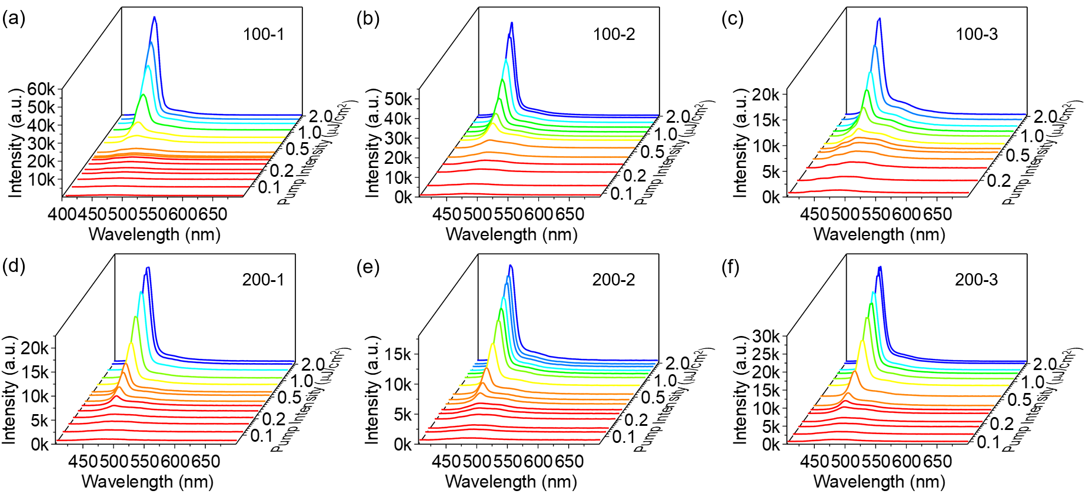
Fig. S19. a-f) Spectral progression of BSB000c00701 (M1) from spontaneous emission to amplified spontaneous emission regime with increasing pump excitation intensity, including tests for 100 nm and 200 nm film thicknesses, with three parallel experimental sets.
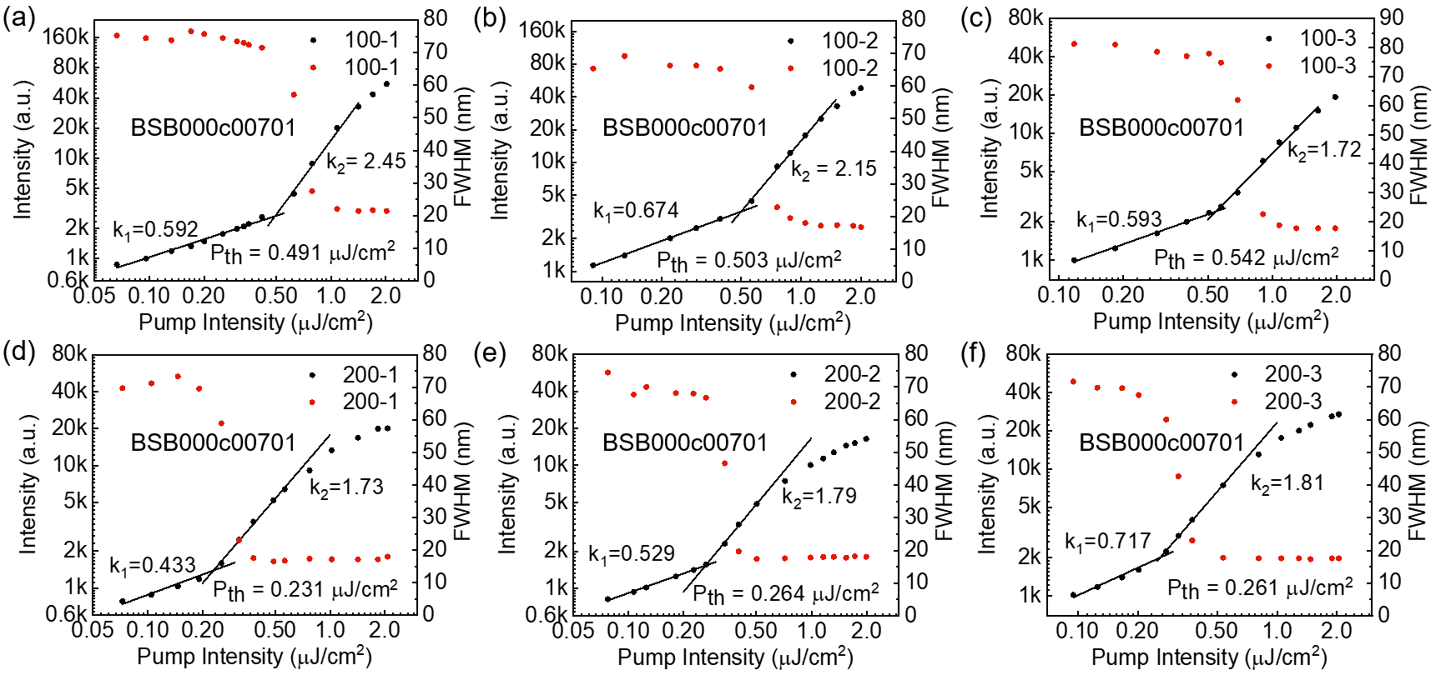
Fig. S20. Determination of the amplified spontaneous emission threshold for BSB000c00701 (M1). Input-output intensity characteristic plots of emission intensity and emission line width as a function of excitation intensity, including tests for 100 nm and 200 nm film thicknesses, with three parallel experimental sets.

8.3 ASE Performance of BSB000c0n701
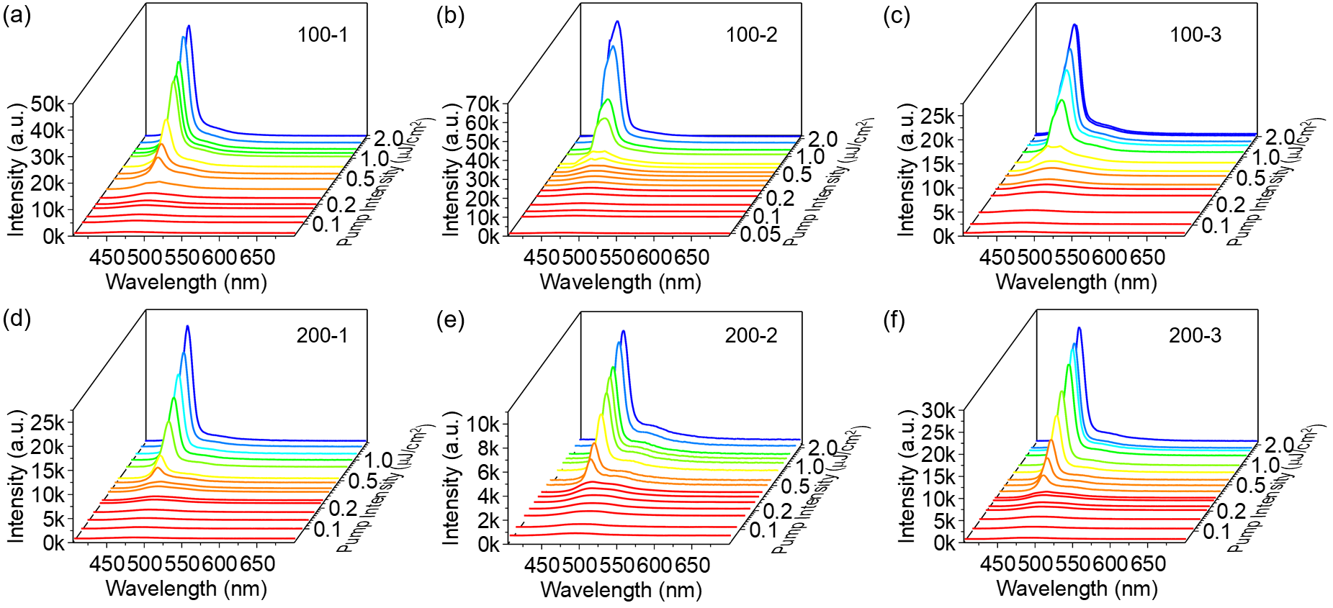
Fig. S21. a-f) Spectral progression of BSB000c0n701 (M2) from spontaneous emission to amplified spontaneous emission regime with increasing pump excitation intensity, including tests for 100 nm and 200 nm film thicknesses, with three parallel experimental sets.

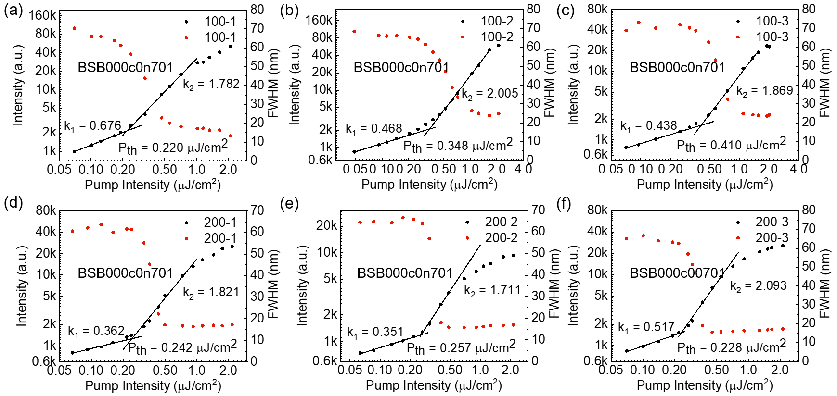
Fig. S22. Determination of the amplified spontaneous emission threshold for BSB000c0n701 (M2). Input-output intensity characteristic plots of emission intensity and emission line width as a function of excitation intensity, including tests for 100 nm and 200 nm film thicknesses, with three parallel experimental sets.

8.4 ASE Performance of BSB000c00702
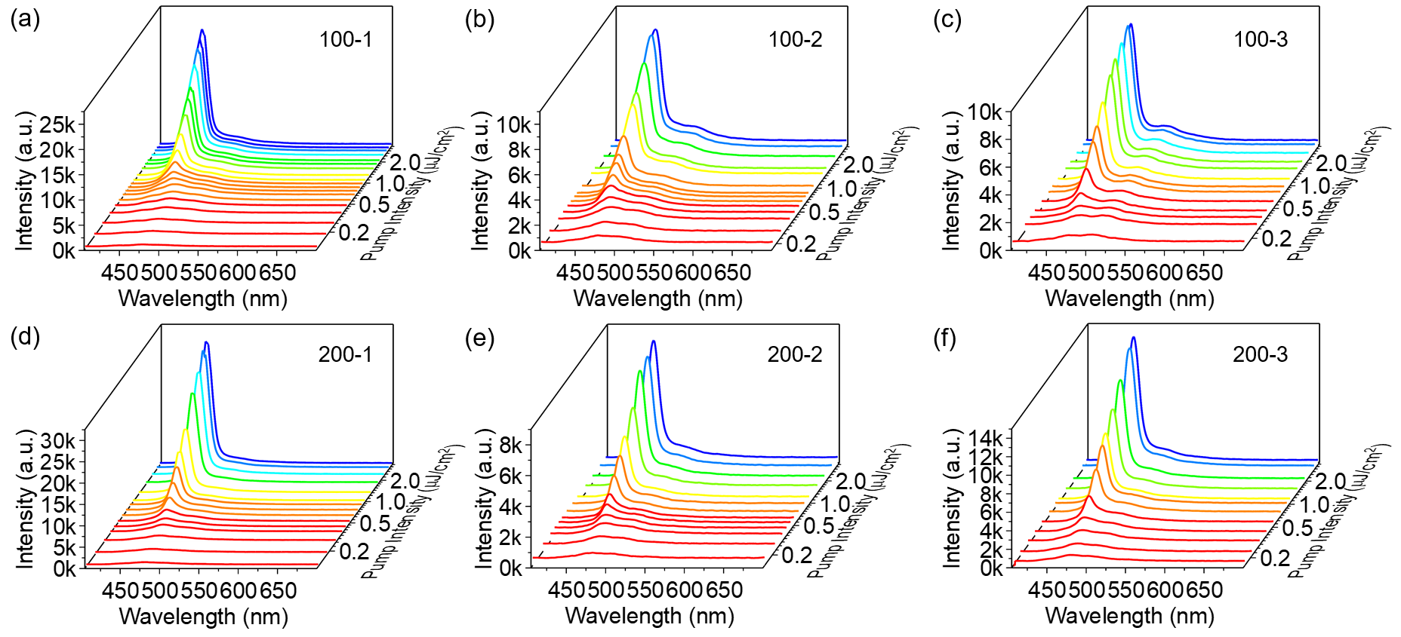
Fig. S23. Spectral progression of BSB000c00702 (M3) from spontaneous emission to amplified spontaneous emission regime with increasing pump excitation intensity, including tests for 100 nm and 200 nm film thicknesses, with three parallel experimental sets.

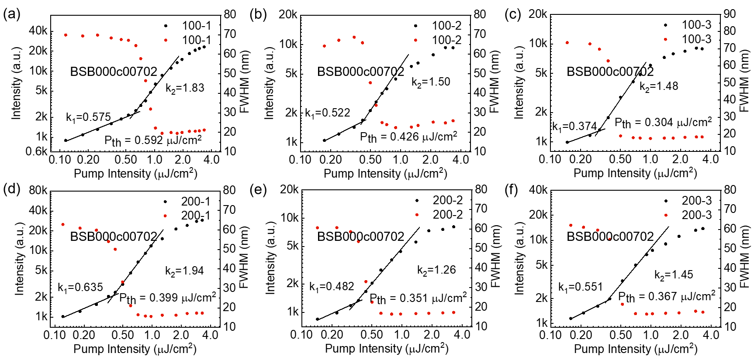
Fig. S24. Determination of the amplified spontaneous emission threshold for BSB000c00702 (M3) Input-output intensity characteristic plots of emission intensity and emission line width as a function of excitation intensity, including tests for 100 nm and 200 nm film thicknesses, with three parallel experimental sets.

8.5 ASE Performance of BSB000c20702
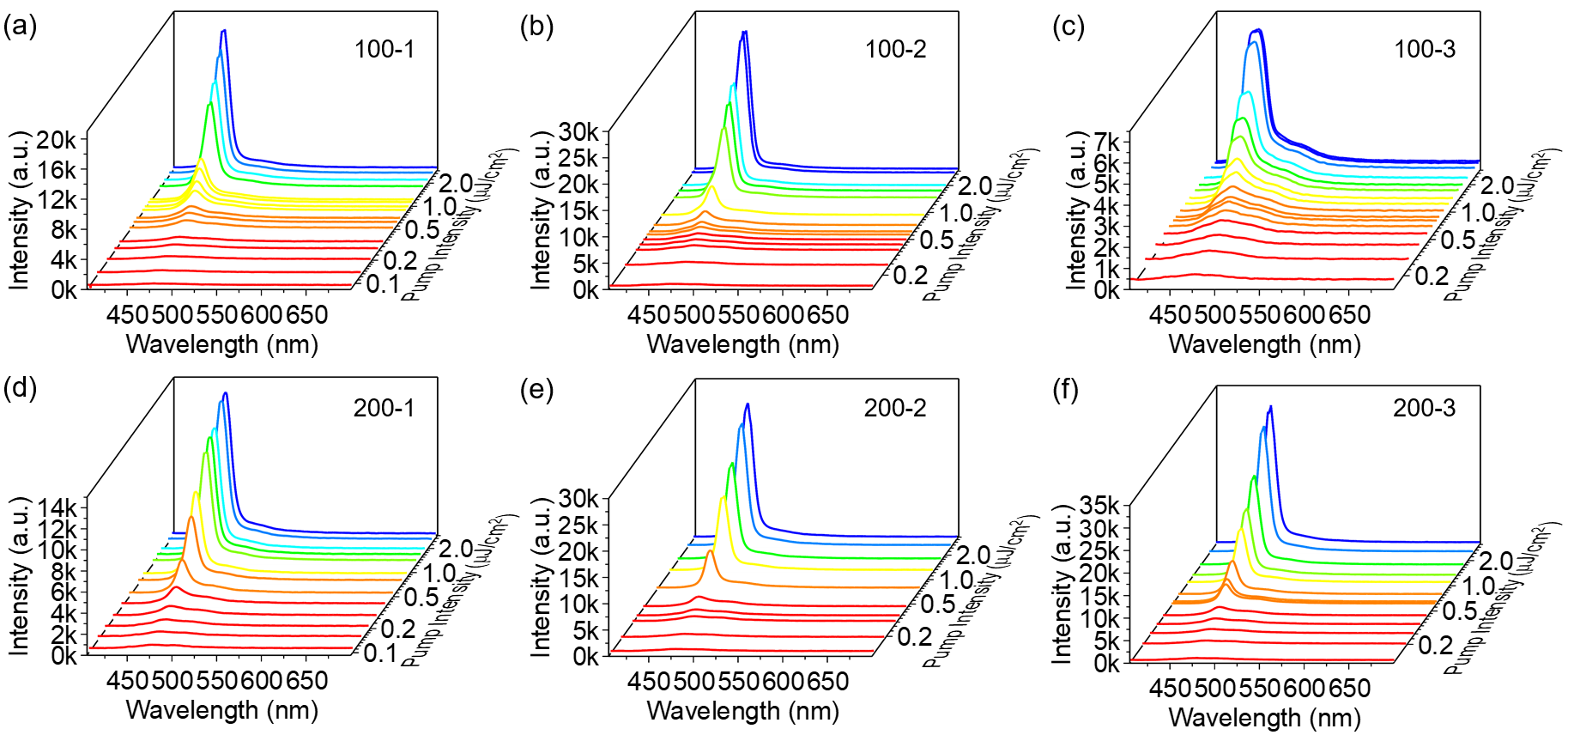
Fig. S25. Spectral progression of BSB000c20702 (M4) from spontaneous emission to amplified spontaneous emission regime with increasing pump excitation intensity, including tests for 100 nm and 200 nm film thicknesses, with three parallel experimental sets.

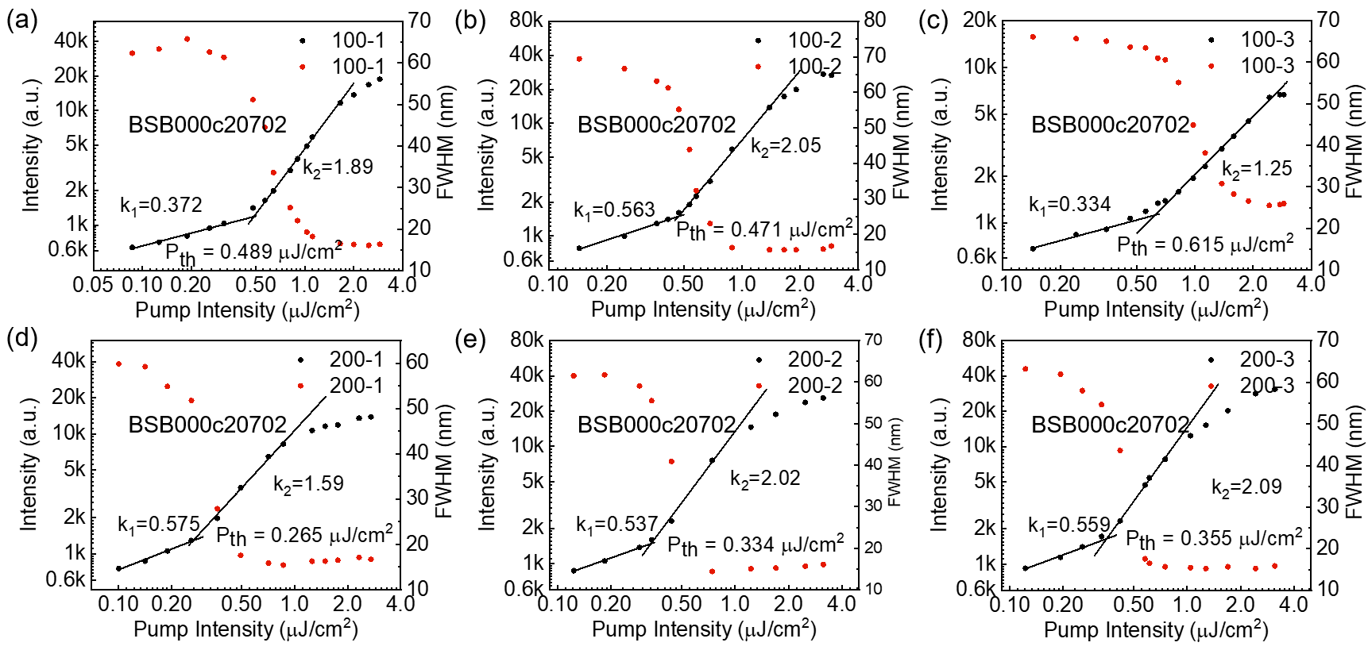
Fig. S26. Determination of the amplified spontaneous emission threshold for BSB000c20702 (M4) Input-output intensity characteristic plots of emission intensity and emission line width as a function of excitation intensity, including tests for 100 nm and 200 nm film thicknesses, with three parallel experimental sets.

8.6 ASE Performance of DSN000c02250
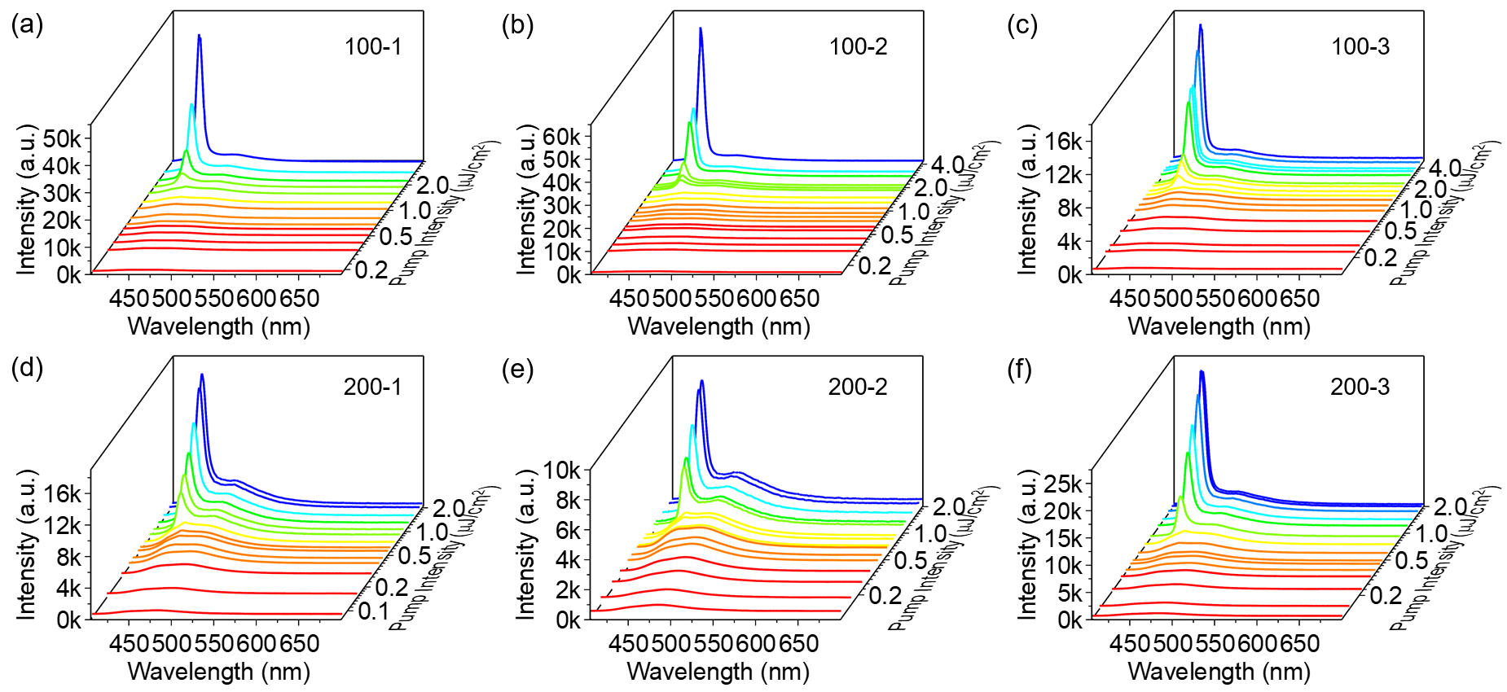
Fig. S27. Spectral progression of DSN000c02250 (M5) from spontaneous emission to amplified spontaneous emission regime with increasing pump excitation intensity, including tests for 100 nm and 200 nm film thicknesses, with three parallel experimental sets.

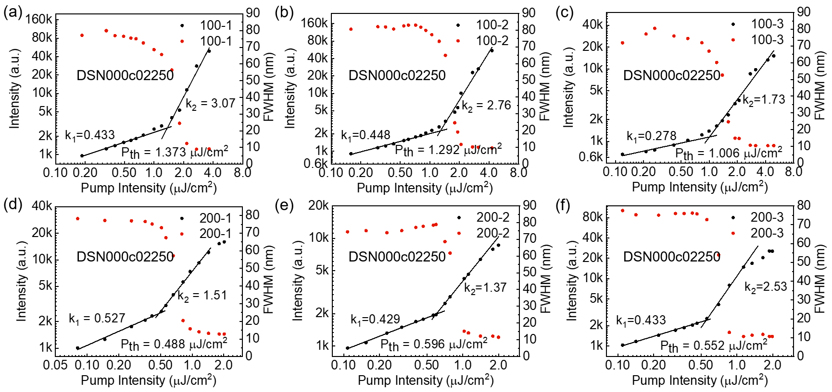
Fig. S28. Determination of the amplified spontaneous emission threshold for DSN000c02250 (M5) Input-output intensity characteristic plots of emission intensity and emission line width as a function of excitation intensity, including tests for 100 nm and 200 nm film thicknesses, with three parallel experimental sets.

8.7 ASE Performance of BSB000c00700
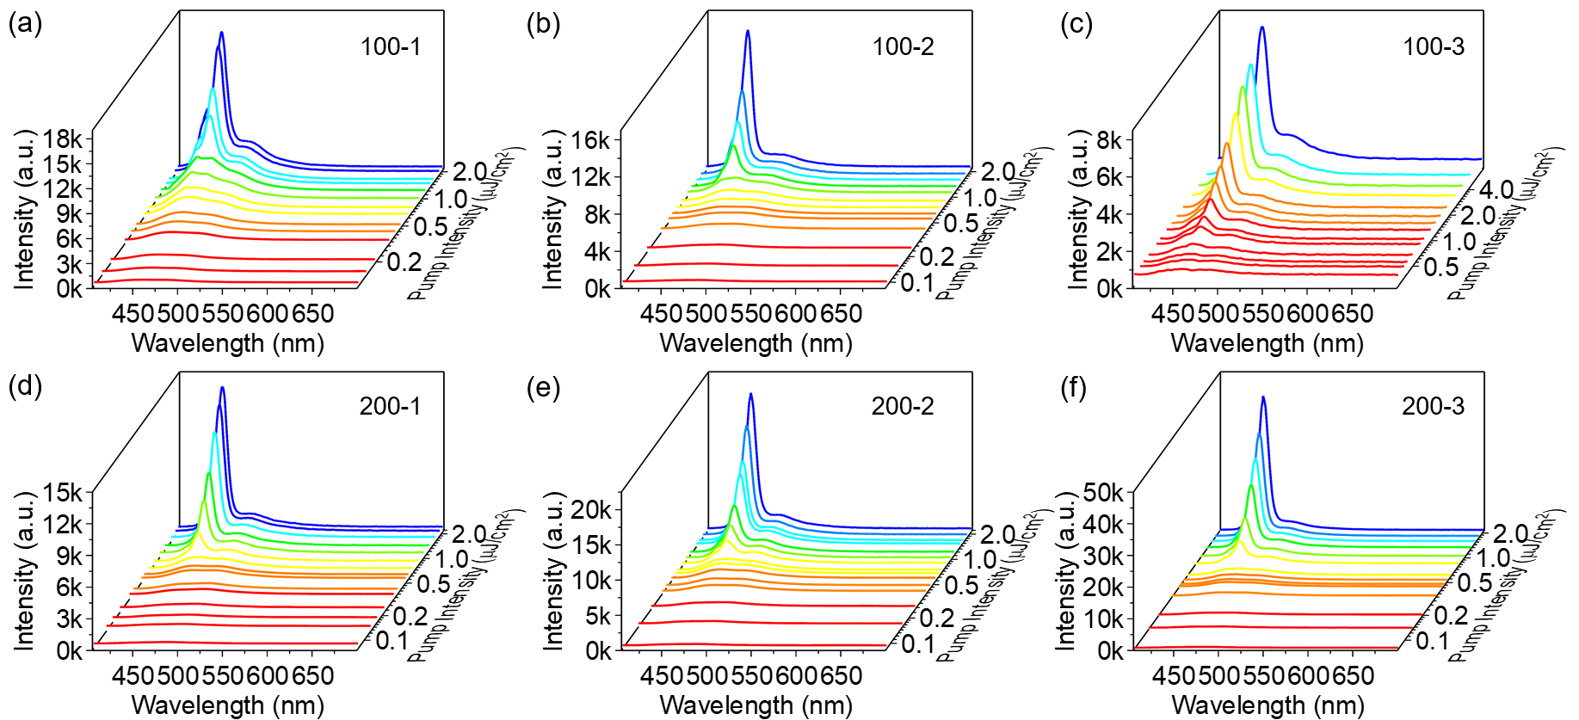
Fig. S29. Spectral progression of BSB000c00700 (M6) from spontaneous emission to amplified spontaneous emission regime with increasing pump excitation intensity, including tests for 100 nm and 200 nm film thicknesses, with three parallel experimental sets.

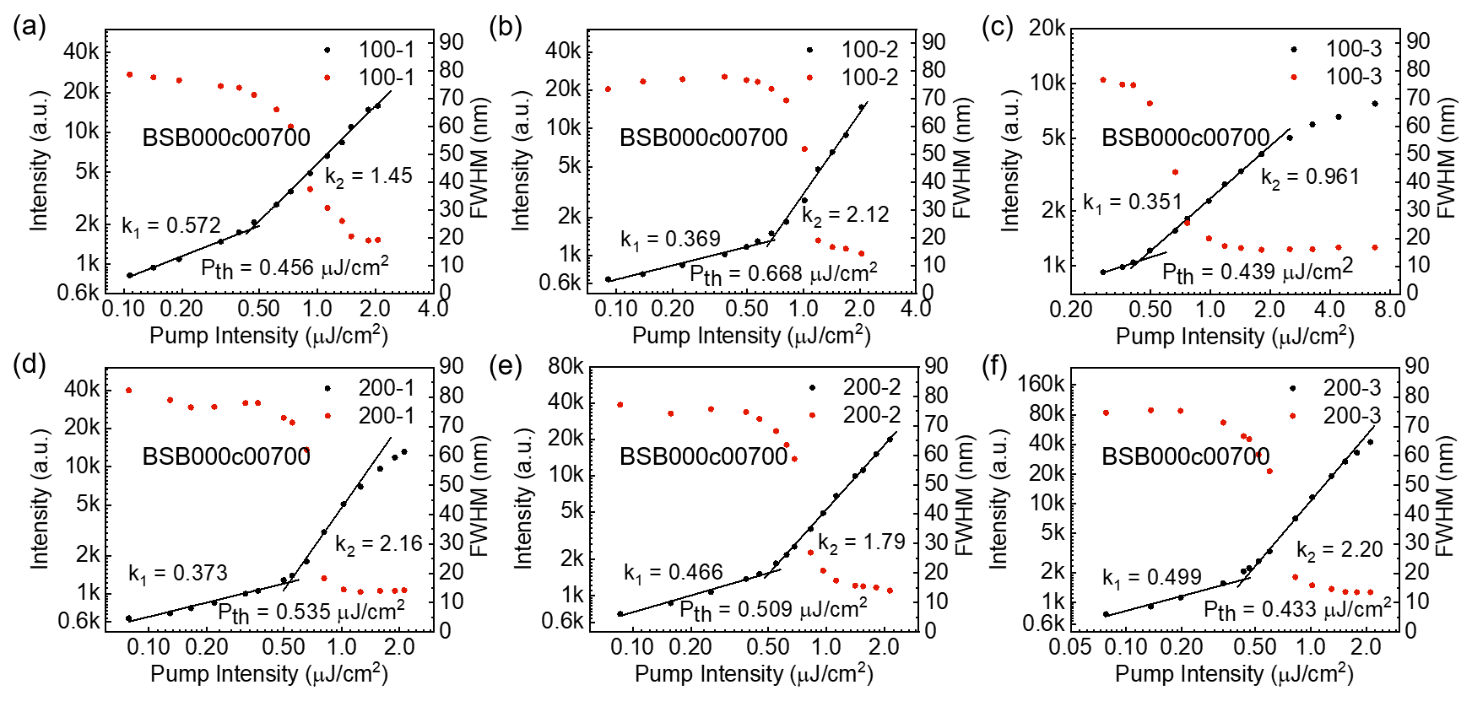
Fig. S30. Determination of the amplified spontaneous emission threshold for BSB000c00700 (M6) Input-output intensity characteristic plots of emission intensity and emission line width as a function of excitation intensity, including tests for 100 nm and 200 nm film thicknesses, with three parallel experimental sets.

8.8 ASE Performance of DSF000c00700
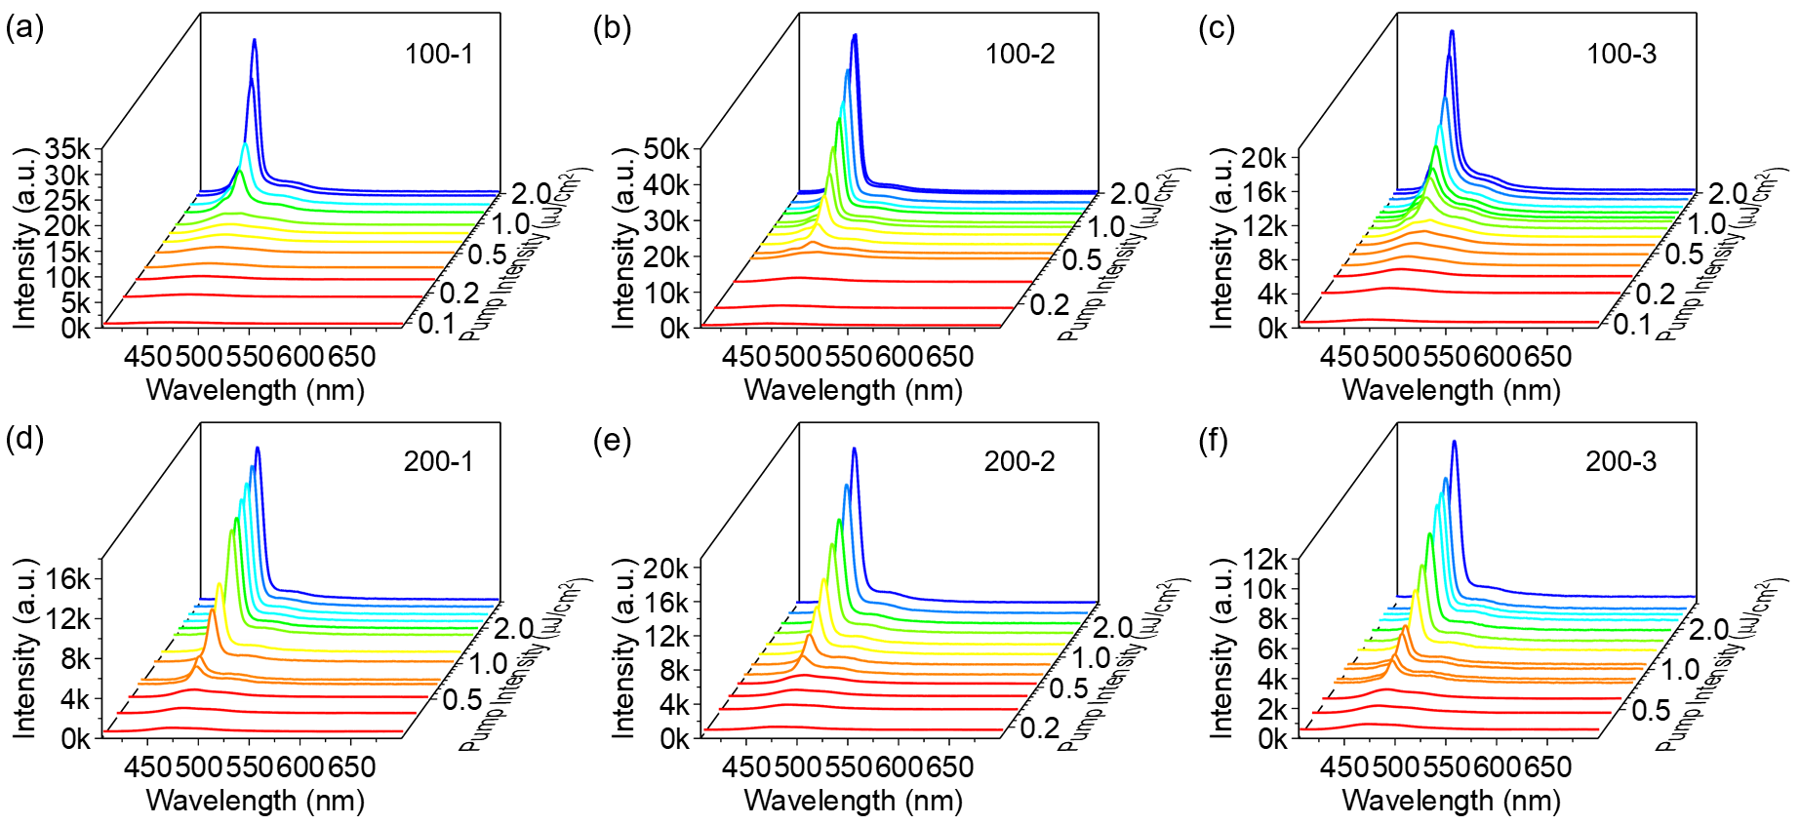
Fig. S31. Spectral progression of DSF000c00700 (M7) from spontaneous emission to amplified spontaneous emission regime with increasing pump excitation intensity, including tests for 100 nm and 200 nm film thicknesses, with three parallel experimental sets.

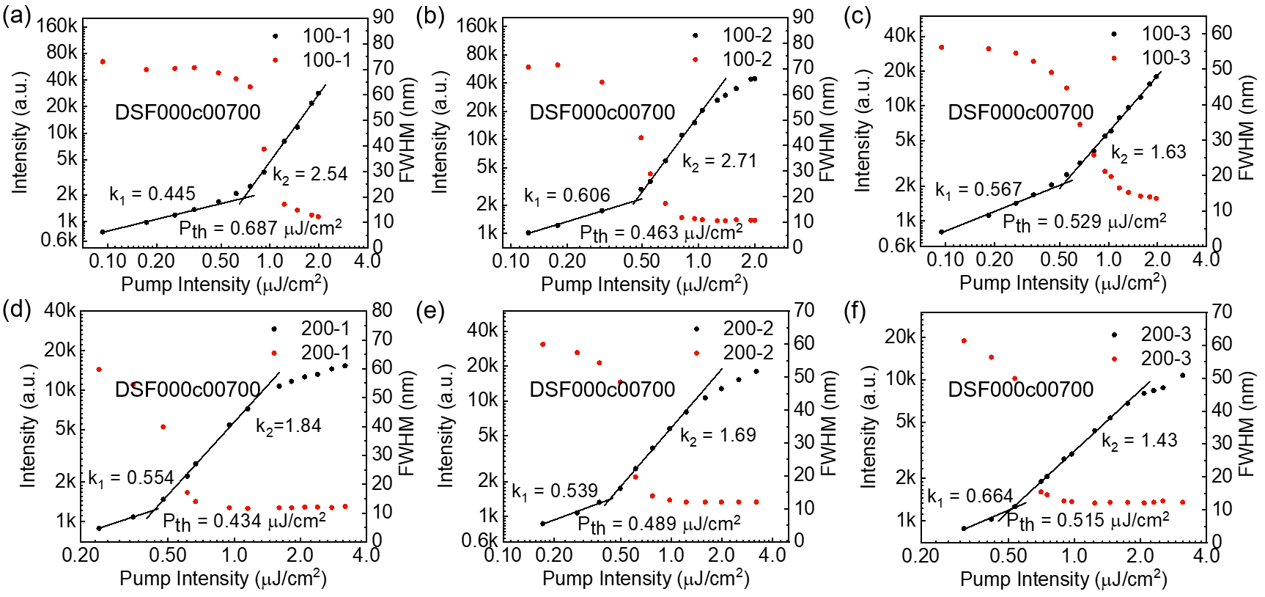
Fig. S32. Determination of the amplified spontaneous emission threshold for DSF000c00700 (M7) Input-output intensity characteristic plots of emission intensity and emission line width as a function of excitation intensity, including tests for 100 nm and 200 nm film thicknesses, with three parallel experimental sets.

8.9 ASE Performance of DSN000c00700
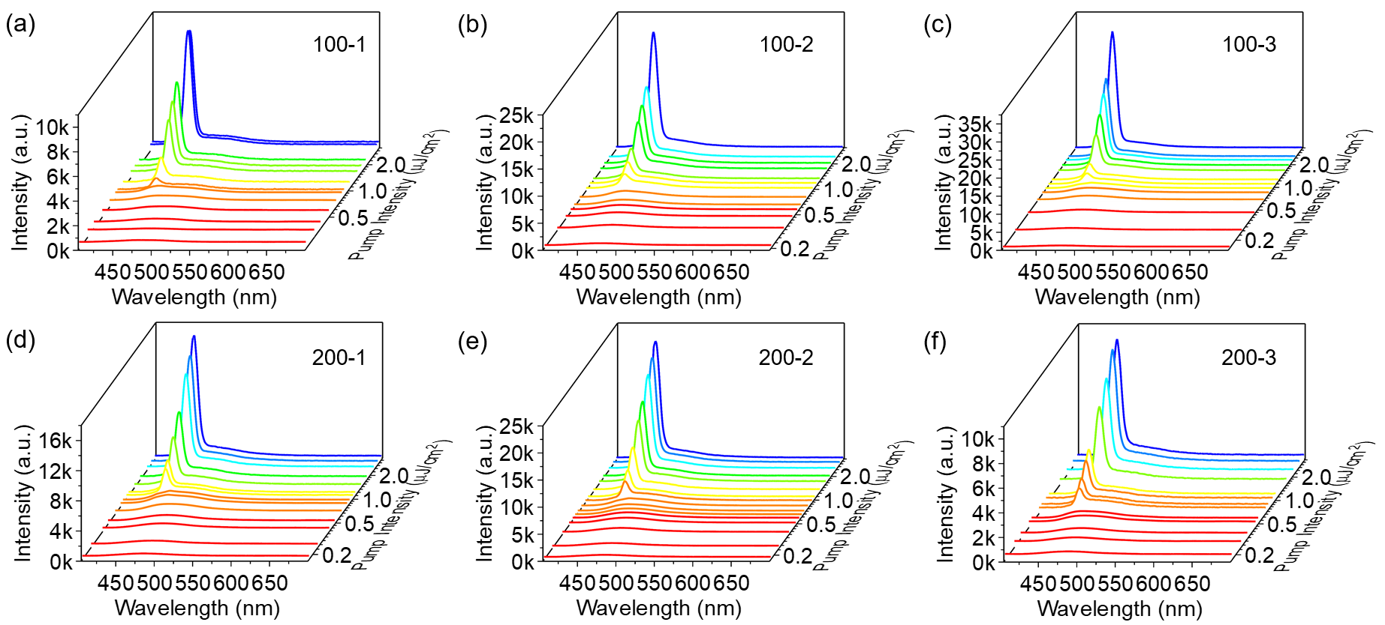
Fig. S33. Spectral progression of DSN000c00700 (M8) from spontaneous emission to amplified spontaneous emission regime with increasing pump excitation intensity, including tests for 100 nm and 200 nm film thicknesses, with three parallel experimental sets.

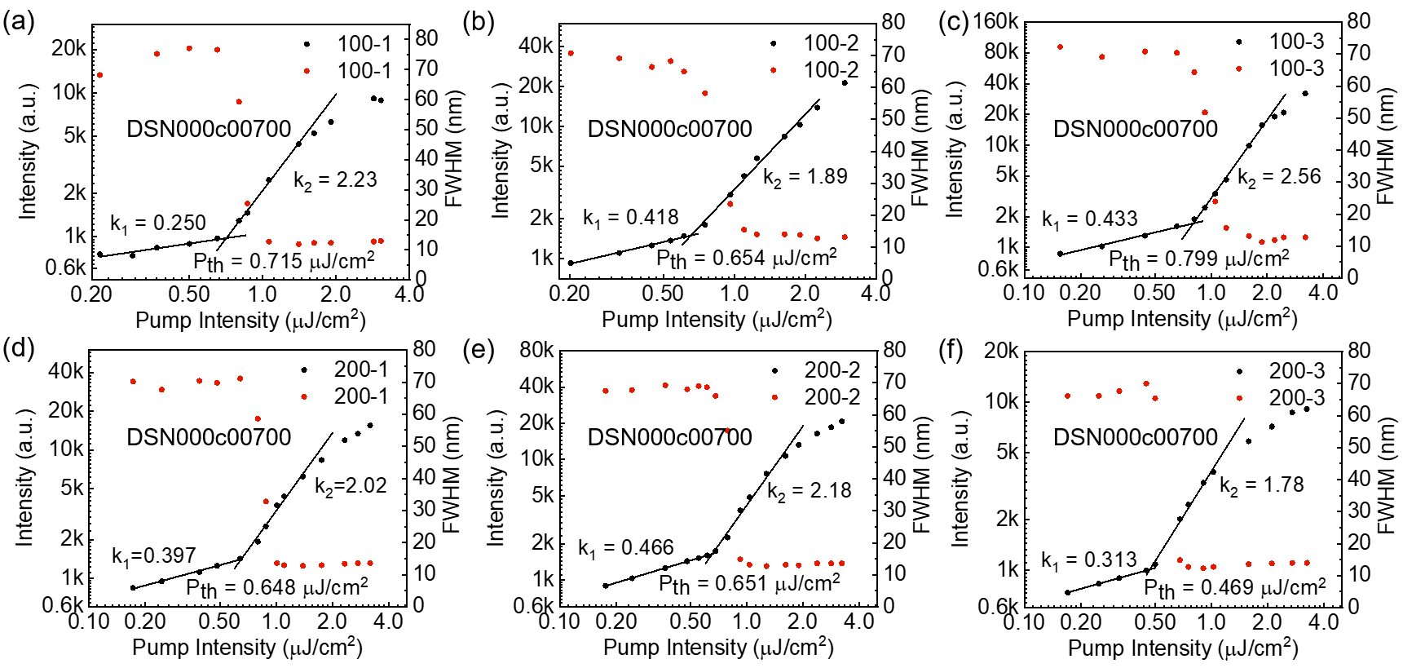
Fig. S34. Determination of the amplified spontaneous emission threshold for DSN000c00700 (M8) Input-output intensity characteristic plots of emission intensity and emission line width as a function of excitation intensity, including tests for 100 nm and 200 nm film thicknesses, with three parallel experimental sets.

8.10 ASE Result summary of target molecules
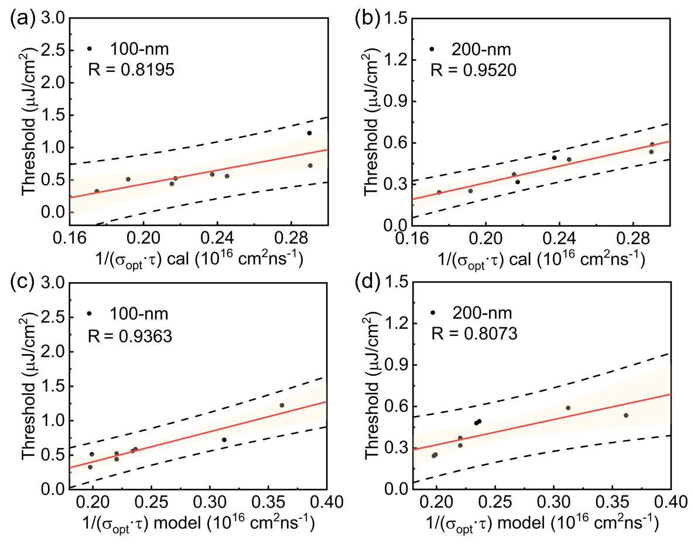
Fig. S35. a-b) The calculation value of $1/\left[σ_{opt}\left(v\right)×τ_{S1}\right]$ vs experiment threshold, c-d) The model predict value of $1/\left[σ_{opt}\left(v\right)×τ_{S1}\right]$ vs experiment threshold.
Table S6. Result summary
 | 100 nm |  |  | 200 nm |  |  | 100-bar | 200-bar
Name | P1 | P2 | P3 | P1 | P2 | P3 | 100-bar | 200-bar
BSBCz | 0.456 | 0.668 | 0.439 | 0.535 | 0.509 | 0.433 | 0.521 | 0.492
BSB000c00701 | 0.491 | 0.503 | 0.542 | 0.231 | 0.264 | 0.261 | 0.512 | 0.252
DSN000c02250 | 1.373 | 1.292 | 1.006 | 0.488 | 0.596 | 0.522 | 1.224 | 0.535
BSB000c0n701 | 0.220 | 0.348 | 0.410 | 0.242 | 0.257 | 0.228 | 0.326 | 0.242
DSF000c00700 | 0.687 | 0.463 | 0.529 | 0.434 | 0.489 | 0.515 | 0.560 | 0.479
BSB000c20702 | 0.489 | 0.471 | 0.615 | 0.265 | 0.334 | 0.355 | 0.525 | 0.318
BSB000c00702 | 0.593 | 0.426 | 0.304 | 0.399 | 0.351 | 0.367 | 0.441 | 0.372
DSN000c00700 | 0.715 | 0.654 | 0.799 | 0.648 | 0.651 | 0.469 | 0.723 | 0.589

- Laser Device
To validate the potential of our AI-designed materials for continuous-wave lasers, we selected two representative types of resonant cavities for continuous-wave laser testing.

9.1 Stability of CW laser in DFB cavity

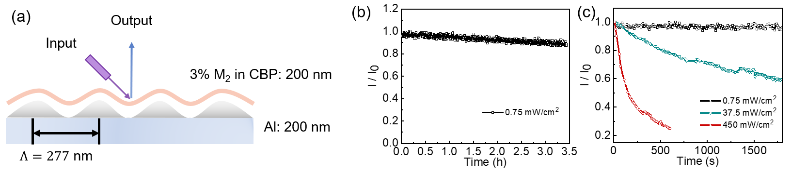
Fig.S36. a) Structure of CW laser device, b) Laser output intensity as a function of time under continuous-wave pumping at 0.75 mW/cm² ($≈3P_{th}$), c) Laser output intensity as a function of time at different excitation energy levels.

9.2 CW laser in SPP structure cavity

Fig. S37. a) Structure of nano CW laser device, b) Incident angle (θ)-dependent reflectance spectra, c) CW Laser performance, threshold is about 5.85 mW/cm², d) Polarization under threshold (Red) and above threshold (Green) in nanocavity, e) Output of laser.

- NMR of Materials

c00701-CHO
Fig. S38. ¹H NMR (400 MHz, CDCl₃) of c00701-CHO.

BSB000c00701 (M1)
Fig. S39. ¹H NMR (600 MHz, CDCl₃) of BSB000c00701
Fig. S40. ¹³C NMR (151 MHz, CDCl₃) of BSB000c00701

c0n701-Br
Fig. S41. ¹H NMR (600 MHz, CDCl₃) of c0n701-Br

c0n701-CHO
Fig. S42. ¹H NMR (600 MHz, CDCl₃) of c0n701-CHO

BSB000c0n701 (M2)
Fig. S43. ¹H NMR (600 MHz, CDCl₃) of BSB000c0n701
Fig. S44. ¹³C NMR (151 MHz, CDCl₃) of BSB000c0n701

c00702-CHO
Fig. S45. ¹H NMR (600 MHz, CDCl₃) of c00702-CHO

BSB000c00702 (M3)
Fig. S46. ¹H NMR (600 MHz, CDCl₃) of BSB000c00702

Fig. S47. ¹³C NMR (151 MHz, CDCl₃) of BSB000c00702

c20702-CHO
Fig. S48. ¹H NMR (600 MHz, CDCl₃) of c20702-CHO

BSB000c20702 (M4)
Fig. S49. ¹H NMR (600 MHz, CDCl₃) of BSB000c20702
Fig. S50. ¹³C NMR (151 MHz, CDCl₃) of BSB000c20702

c02250-CHO
Fig. S51. ¹H NMR (600 MHz, CDCl₃) of c02250-CHO

DSN000c02250 (M5)
Fig. S52. ¹H NMR (600 MHz, CDCl₃) of DSN000c02250

Fig. S53. ¹³C NMR (151 MHz, CDCl₃) of DSN000c02250

BSB000c00700 (M6, BSBCz)
Fig. S54. ¹H NMR (600 MHz, CDCl₃) of BSB000c00700 (BSBCz)

DSF000c00700 (M7, Sp-SBCz)
Fig. S55. ¹H NMR (600 MHz, CDCl₃) of DSF000c00700 (Sp-SBCz)

Fig. S56. ¹³C NMR (151 MHz, CDCl₃) of DSF000c00700

DSN000c00700 (M8)
Fig. S57. ¹H NMR (600 MHz, CDCl₃) of DSN000c00700
Fig. S58. ¹³C NMR (151 MHz, CDCl₃) of DSN000c00700

Reference and Notes
48 Xia, L., Chen, X., Xiao, X. & Li, G. Magnetic-covalent organic polymer solid-phase extraction coupled with high-performance liquid chromatography for the sensitive determination of fluorescent whitening agents in cosmetics. 41, 3733-3741, doi:https://doi.org/10.1002/jssc.201800632 (2018).
49 Mamada, M., Fukunaga, T., Bencheikh, F., Sandanayaka, A. S. D. & Adachi, C. Low Amplified Spontaneous Emission Threshold from Organic Dyes Based on Bis‐stilbene. Advanced Functional Materials 28, doi:10.1002/adfm.201802130 (2018).
50 Gierschner, J., Lüer, L., Milián-Medina, B., Oelkrug, D. & Egelhaaf, H.-J. Highly Emissive H-Aggregates or Aggregation-Induced Emission Quenching? The Photophysics of All-Trans para-Distyrylbenzene. The Journal of Physical Chemistry Letters 4, 2686-2697, doi:10.1021/jz400985t (2013).
51 Kabe, R., Nakanotani, H., Sakanoue, T., Yahiro, M. & Adachi, C. Effect of Molecular Morphology on Amplified Spontaneous Emission of Bis‐Styrylbenzene Derivatives. Advanced Materials 21, 4034-4038, doi:10.1002/adma.200803588 (2009).
52 Heller, A. Organic Liquid Scintillators. VI. Substituted Distyrylbenzenes: Scintillation Properties and Spectra of Absorption and Fluorescence. The Journal of Chemical Physics 40, 2839-2851, doi:10.1063/1.1724914 (1964).
53 Coates, G. W. et al. Phenyl−Perfluorophenyl Stacking Interactions: Topochemical [2+2] Photodimerization and Photopolymerization of Olefinic Compounds. Journal of the American Chemical Society 120, 3641-3649, doi:10.1021/ja974072a (1998).
54 Yang, Z. & Geise, H. J. Electrical conductivity of iodine-doped poly(para-phenylene vinylene) model compounds blended with polystyrene. Synthetic Metals 47, 95-104, doi:https://doi.org/10.1016/0379-6779(92)90335-G (1992).
55 Liang, Q. et al. Circularly Polarized Lasing from a Microcavity Filled with Achiral Single-Crystalline Microribbons. 62, e202213229, doi:https://doi.org/10.1002/anie.202213229 (2023).
56 Sun, C. L. et al. Understanding the Unconventional Effects of Halogenation on the Luminescent Properties of Oligo(Phenylene Vinylene) Molecules. Chemistry – An Asian Journal 8, 3091-3100, doi:10.1002/asia.201300732 (2013).
57 Gao, F. et al. Strong Two‐Photon Excited Fluorescence and Stimulated Emission from an Organic Single Crystal of an Oligo(Phenylene Vinylene). Angewandte Chemie International Edition 49, 732-735, doi:10.1002/anie.200905428 (2010).
58 Xu, Z. et al. Water-miscible organic J-aggregate nanoparticles as efficient two-photon fluorescent nano-probes for bio-imaging. Journal of Materials Chemistry 22, doi:10.1039/c2jm33081d (2012).
59 Sun, C.-L. et al. Lasing from an Organic Micro-Helix. 59, 11080-11086, doi:https://doi.org/10.1002/anie.202002797 (2020).
60 Grozema, F. C., Telesca, R., Snijders, J. G. & Siebbeles, L. D. A. Tuning of the excited state properties of phenylenevinylene oligomers: A time-dependent density functional theory study. The Journal of Chemical Physics 118, 9441-9446, doi:10.1063/1.1568079 (2003).
61 Hino, Y. & Hayashi, S. Mesityl-Appended 1,4-Bis(β-acrylonitrile)-2,5-dimethoxybenzene: Blue and Green Fluorescent Crystals from a Soluble Donor–Acceptor Molecular System. 7, e202201489, doi:https://doi.org/10.1002/slct.202201489 (2022).
62 Shi, J. et al. Solid State Luminescence Enhancement in π-Conjugated Materials: Unraveling the Mechanism beyond the Framework of AIE/AIEE. The Journal of Physical Chemistry C 121, 23166-23183, doi:10.1021/acs.jpcc.7b08060 (2017).
63 Nakanotani, H. et al. Extremely Low‐Threshold Amplified Spontaneous Emission of 9,9′‐Spirobifluorene Derivatives and Electroluminescence from Field‐Effect Transistor Structure. Advanced Functional Materials 17, 2328-2335, doi:10.1002/adfm.200700069 (2007).
64 Kingma, D. P. & Welling, M. J. a. e.-p. Auto-Encoding Variational Bayes. arXiv:1312.6114 (2013). <https://ui.adsabs.harvard.edu/abs/2013arXiv1312.6114K>.
65 Vaswani, A. et al. Attention Is All You Need. arXiv:1706.03762 (2017). <https://ui.adsabs.harvard.edu/abs/2017arXiv170603762V>.
66 Zhou, G. et al. in International Conference on Learning Representations.

