Supporting Information
Ultra-Strong and Highly-Robust Elastomers with Synergistic Multiple Weak Interactions
Xinshu Sun¹, Yuchen Hu², Zhiqi Wang¹, Baohua Guo¹, Jiaxin Shi^{* 1}, Jun Xu^{* 1}

1 Advanced Materials Laboratory of Ministry of Education (MOE), Department of Chemical Engineering, Tsinghua University, Beijing, 100084, China
2 Intelligent Systems and Robotics Lab, Institute for Interdisciplinary Information Sciences, Tsinghua University, Beijing, 100084, China

Table of Content
1. Experimental Methods 2
1.1. Materials 2
1.2. Synthesis of HZPU series 2
1.3. 1D and 2D Infrared Spectroscopy (IR) Measurements 2
1.4. 1D and 2D Small-angle X-ray Scattering (SAXS) Measurements 3
1.5. Dynamic Mechanical Analysis (DMA) Measurements 3
1.6. Ab Initio Calculations 3
1.7. Linear Stretching and Cyclic Stretching Measurements 4
1.8. Relaxation Ability Measurements 5
1.9. Split-Hopkinson Pressure Bar (SHPB) Measurements 6
2. Supplementary Figures 7
References 25

1. Experimental Methods
1.1. Materials
Polytetramethylene ether glycols (PTMEG) with M_{n}=250/650/850/1000/2000, as well as hexamethylene diisocyanate (HDI) and isophorone diisocyanate (IPDI), were purchased from Aladdin (Shanghai, China). Terephthalic dihydrazide (p-PDHZ) and isophthalic dihydrazide (m-PDHZ) were purchased from J&K Scientific (Beijing, China). Anhydrous N, N-dimethylacetamide (DMAc) (containing molecular sieves) and dibutyltin dilaurate (DBTDL) were purchased from Meryer (Shanghai, China) Biochemical Technology Co., Ltd. All materials were used as received without further purification.
1.2. Synthesis of HZPU series
The typical synthesis procedure for the HZPU elastomer materials is as follows: In a thoroughly dried three-neck round-bottom flask, 5 mmol of PTMEG (10 g for PTMEG with M_{n}=1000) is added and heated under vacuum at 110 °C for 3 hours to ensure complete removal of moisture. Then, a mixed solution contains 10 mmol of diisocyanate (1.68 g for HDI; 2.22 g for IPDI), 0.03 g of DBTDL, and 10 mL DMAc is added, and the mixture is stirred at 80 °C under a nitrogen atmosphere for 3 hours to form the prepolymer. Once the system cools to 40 °C, 5 mmol of PDHZ (para-substituted or meta-substituted) dissolved in 60 mL of DMAc is added as a chain extender, and the mixture is stirred at 40°C for 18 hours to allow complete reaction. After completion, the obtained solution is poured into a PTFE mold using a micropipette (purchased from Bioland (China)), degassed under vacuum, and dried at 80 °C for 20 hours. The sample is then further dried in a vacuum oven at 80 °C for 40 hours to remove all solvents, yielding the desired target HZPU material.
1.3. 1D and 2D Infrared Spectroscopy (IR) Measurements
The one-dimensional and two-dimensional infrared spectroscopy tests were performed using a Shimadzu IRTracer-100 (Japan) Fourier-transform infrared spectrometer. For the 1D IR tests, a Specac Quest (UK) diamond crystal ATR accessory was additionally installed. Four different samples (HDI-pAr₁₀₀₀/HDI-mAr₁₀₀₀/IPDI-pAr₁₀₀₀/IPDI-mAr₁₀₀₀) were cut into thin sheets of 10*10*0.5 mm and tested within a scan range of 400-4000 cm⁻¹, with peak deconvolution performed on the 1600-1750 cm⁻¹ region of the resulting spectra. For the 2D IR tests, the four different samples were dissolved in DMF to a concentration of 10 g/L and dropped onto potassium chloride salt plates, then air-dried. The resulting films were tested sequentially at temperatures of 70/80/90/100/110/120/130/140/150 °C. The 1600-1750 cm⁻¹ region of the results was then combined to generate both synchronous and asynchronous two-dimensional infrared spectra.
1.4. 1D and 2D Small-angle X-ray Scattering (SAXS) Measurements
The small-angle X-ray scattering experiments under different conditions were performed using a Xenocs Xeuss (France) 2.0 platform. X-rays with a wavelength of 1.5419 Å (generated by a copper target at a tube power of 30 W) were used, and the detector employed was a Pilatus 3R 300K with a single pixel size of 172 microns. The sample-to-detector distance (SDD) was set at 1200 mm, and the exposure time for the X-ray was 300 seconds. 1D SAXS curves and 2D images for four samples (HDI-pAr₁₀₀₀, HDI-mAr₁₀₀₀, IPDI-pAr₁₀₀₀, and IPDI-mAr₁₀₀₀) were obtained in their normal state as well as when stretched to 100%, 200%, and 500% of their original length. Additionally, one-dimensional SAXS results for HDI-pAr1000 at different temperatures (25/50/75/100/125 ℃) were acquired to further provide supplementary reference for the changes in its internal structure with temperature variations.
1.5. Dynamic Mechanical Analysis (DMA) Measurements
The dynamic mechanical analysis (DMA) experiments were conducted using a Waters TA DMA850 (USA) platform. During testing, the absolute strain amplitude was set to 0.1%, with a constant frequency of 1 Hz and a preloaded stress of 0.1 N. The variations in storage modulus and loss tangent for four different samples were measured over a temperature range of -100 °C to 200 °C, with a constant heating rate of 3 °C per minute.
1.6. Ab Initio Calculations
All hard segment molecular simulations were carried out using xtb software (Version 6.4.1) ^{[1]} and Gaussian 16 (Version A.03) ^{[2]}. First, the geometry of each hard segment molecule was optimized using B3LYP functional and 6-311G (2d, p) basis set in Gaussian. Then, single-point energy calculations of the optimized molecules (E_{s}) were performed using M06-2X functional and def2-TZVPP basis set. Assisted by Molclus software package ^{[3]}, 1,200 randomly generated dimer configurations with different conformations and interaction modes were created for each hard segment molecule (the large number of dimers ensures that no optimal molecular binding modes are missed). Subsequently, GFN1-xTB ^{[4, 5]} semi-empirical DFT method in xtb software was employed to perform a broad search for dimer conformations and energy sorting to find the lowest energy dimer configurations.
Next, for each of the five different hard segment molecules, the ten lowest energy dimer configurations were selected from the 1,200 generated and optimized geometrically and vibrationally using Gaussian (with B3LYP functional 6-311G (2d, p) basis set) to obtain the thermodynamic correction energies and ensure that no imaginary frequencies existed. The ten optimized structures were then resorted by energy, and the single lowest energy dimer configuration was selected for each of the five molecules, representing the optimal structure formed by the interaction of two hard segment molecules. Single-point energies for these structures (E_{d}) were calculated using M06-2X functional and def2-TZVPP basis set. In this study, the energy reduction caused by the dimerization of the hard segment molecules, i.e., the interaction energy (∆E_{int}), is defined as follows. Note that the influence of all thermodynamic transitions on molecular energy is neglected in this study.
$$\begin{aligned}{∆E}_{int}=E_{d}-{2E}_{s}\#S1-1\end{aligned}$$
Along with determining the optimal dimer configuration, the key hydrogen bond positions and bond lengths in the HDI-pAr dimer were also identified. The criteria for hydrogen bond formation were defined as follows: The distance between the hydrogen bond donor polar atom (the atom covalently bonded to hydrogen, denoted as A) and the hydrogen bond acceptor polar atom (the adjacent atom forming the hydrogen bond, denoted as B) is ≤3.5 Å, and the A-H-B bond angle, including the hydrogen atom, is greater than 140°.
Using the IGMH method in Multiwfn software package ^{[6]}, atomic electron densities were partitioned based on the Hirshfeld atomic space division approach, derived from the actual electron density of the system ^{[7]}. The specific energy decomposition formula was implemented using the sobEDA software package ^{[8]}. Energy decomposition was performed for all single-point energies to determine the relative contributions of different weak interactions. Additionally, two-dimensional visualizations of the interaction isosurfaces within various dimers were obtained by plotting the eigenvalues of the electron density Hessian matrix. In these visualizations, blue isosurfaces indicate strong electrostatic interactions (such as hydrogen bonding and ionic interactions), green represents significant van der Waals interactions, and red signifies strong repulsive interactions. Detailed information can be found in Figure S14.
The dispersion energy of the dimers was decomposed using Multiwfn with DFT-D3(BJ) correction based on the B3LYP functional to quantify the contribution of each atom to the overall dispersion energy. The results were visualized using the VMD program ^{[9]}. In these visualizations, atoms with a stronger contribution to dispersion energy appear more red-shifted, with detailed information provided in Figure S10. The results indicate that, compared to the other dimers, the HDI-pAr dimer exhibits significantly higher dispersion energy contributions from the atoms forming the benzene rings, confirming the presence of strong π-π stacking interactions.
1.7. Linear Stretching and Cyclic Stretching Measurements
All tensile (i.e., linear stretching) and cyclic stretching experiments were conducted using an INSTRON 5967 calibration lab (USA) universal testing machine. In the tensile experiments, all samples were cut into dumbbell-shaped strips with a gauge length of 10 mm and a width of 1.4 mm. The samples were stretched at a constant rate of 50 mm/min until spontaneous fracture, with three parallel strips prepared and tested for each sample. For the cyclic stretching experiments, all strips (with the same dimensions as in the tensile tests) were stretched at a constant rate of 50 mm/min to a strain of 500% of their original length and then returned to the initial state at the same rate. For HDI-pAr₁₀₀₀ strips, different relaxation conditions were applied to the stretched samples before secondary stretching to evaluate recovery behavior: the samples were left at room temperature for 30 minutes/180 minutes, or placed in a 70°C oven for 5 minutes. The same tensile parameters were then used to obtain cyclic stretching curves. For the other samples, only the 5-minute recovery condition at 70°C was applied before secondary stretching, allowing for a direct comparison of recovery performance with HDI-pAr₁₀₀₀. Let σ represent the engineering stress, ε the engineering strain, L₀ the original gauge length, and L the stretched length. In this study, the true stress (σₜ) was calculated using the following equation ^{[10]}:
$$\begin{aligned}σ_{t}=σ\frac{L}{L_{0}}=σ\left(1+ε\right)\#S1-2\end{aligned}$$
The tensile toughness (τ) of the samples in this study was defined as the definite integral of the tensile curve, where the engineering stress (σ) is the dependent variable and the engineering strain (ε) is the independent variable. It can be calculated using the following equation:
$$\begin{aligned}τ=\int_{0}^{ε_{max}}{σdε}\#S1-3\end{aligned}$$
In the tensile tests, in addition to obtaining the tensile curves for each specimen, the stretching deformation recovery rate of four different samples was also measured. The specific method involved marking a 15 mm-long region in the middle of each dumbbell-shaped strips to facilitate visualization and measurement. Subsequently, this marked region was uniformly stretched to a length of 75 mm using the universal testing machine. Afterward, the strip was removed and left to rest overnight under natural conditions to allow maximum recovery. The recovered length of the marked region, denoted as L', was then measured. Given that the original length (L₀) was 15 mm, the stretching deformation recovery rate (r) was calculated using the following equation:
$$\begin{aligned}r=\frac{75-\left(L^{'}-L_{0}\right)}{75}=\frac{90-L^{'}}{75}\#S1-4\end{aligned}$$
1.8. Relaxation Ability Measurements
In the tensile tests, in addition to obtaining the tensile curves for each specimen, the stretching deformation recovery rate of four different samples was also measured. The specific method involved marking a 15 mm-long region in the middle of each dumbbell-shaped strips to facilitate visualization and measurement. Subsequently, this marked region was uniformly stretched to a length of 75 mm using the universal testing machine. Afterward, the strip was removed and left to rest overnight under natural conditions to allow maximum recovery. The recovered length of the marked region, denoted as L', was then measured. Given that the original length (L₀) was 15 mm, the stretching deformation recovery rate (r) was calculated using the following equation:
The relaxation ability tests under different conditions were conducted using a Waters TA DMA850 (USA) platform. In these experiments, a preload stress of 0.005 N was applied, with a peak tensile strain set at 5% of the original specimen length, and a soak time of 5 minutes. For all samples, the relaxation time (t) at a given temperature was defined as the time required for the stress within the strip to decrease to 1/e of its initial value. In this study, a modified form of the Arrhenius equation was employed to calculate the relaxation activation energy of the material:
$$\begin{aligned}\ln{t}=\ln{A+\frac{E_{a}}{RT}}\#S1-5\end{aligned}$$
Where A is the pre-exponential factor, also representing the characteristic relaxation time at infinite temperature; E_{a} is the relaxation activation energy; R is the universal gas constant (with a value of 8.314 J/(mol·K)); and T is the test temperature corresponding to the specific relaxation time (t).
1.9. Split-Hopkinson Pressure Bar (SHPB) Measurements
The Split-Hopkinson Pressure Bar (SHPB) experiment was conducted using a Hopkinson impact bar system, which consists of an impact head, an incident module, a force transfer module, and an absorption module. The HDI-pAr₁₀₀₀ samples were fabricated into uniform cylindrical shapes with a diameter of 14 mm and a thickness of 5 mm and were positioned between the incident module and the force transfer module to facilitate impact strength testing at various impact velocities. Each impact velocity test was performed three times.

2. Supplementary Figures
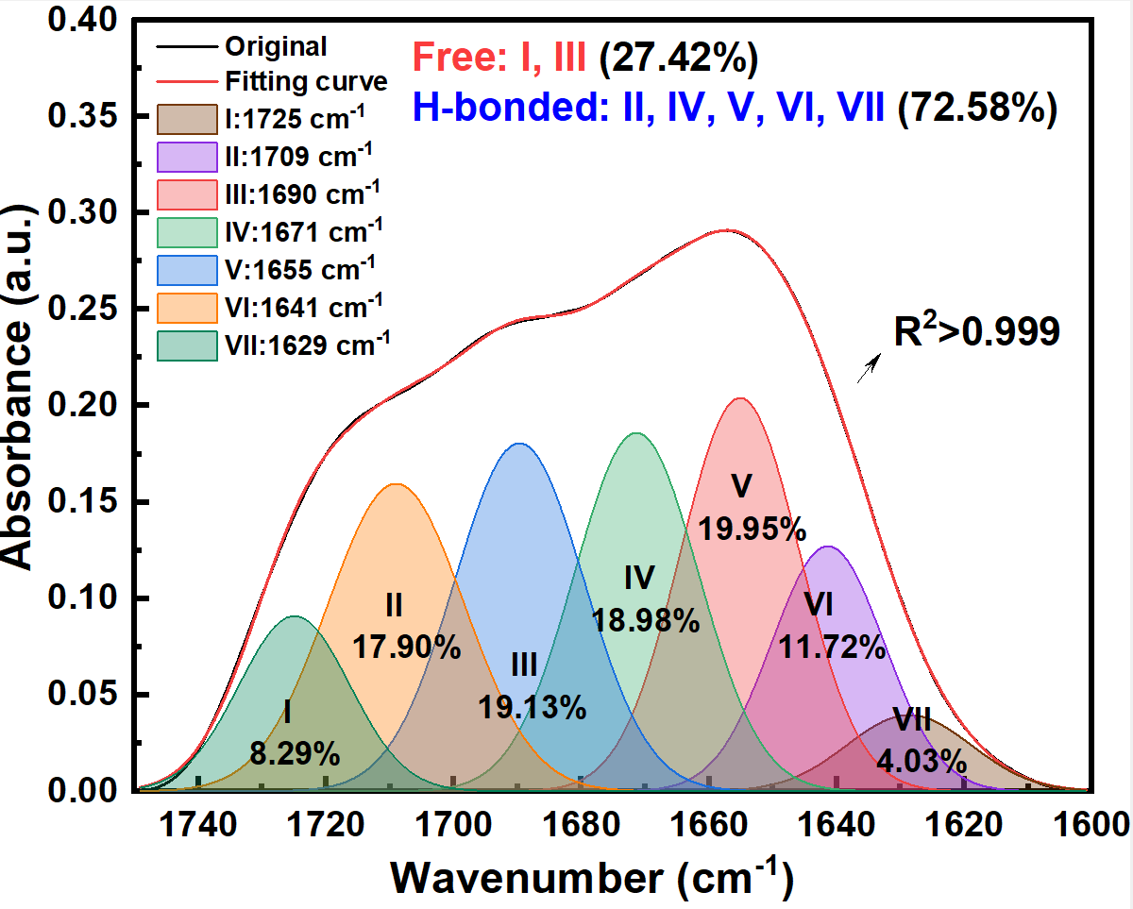
Figure S1. FTIR spectra between 1600-1750 cm⁻¹ of HDI-mAr₁₀₀₀.
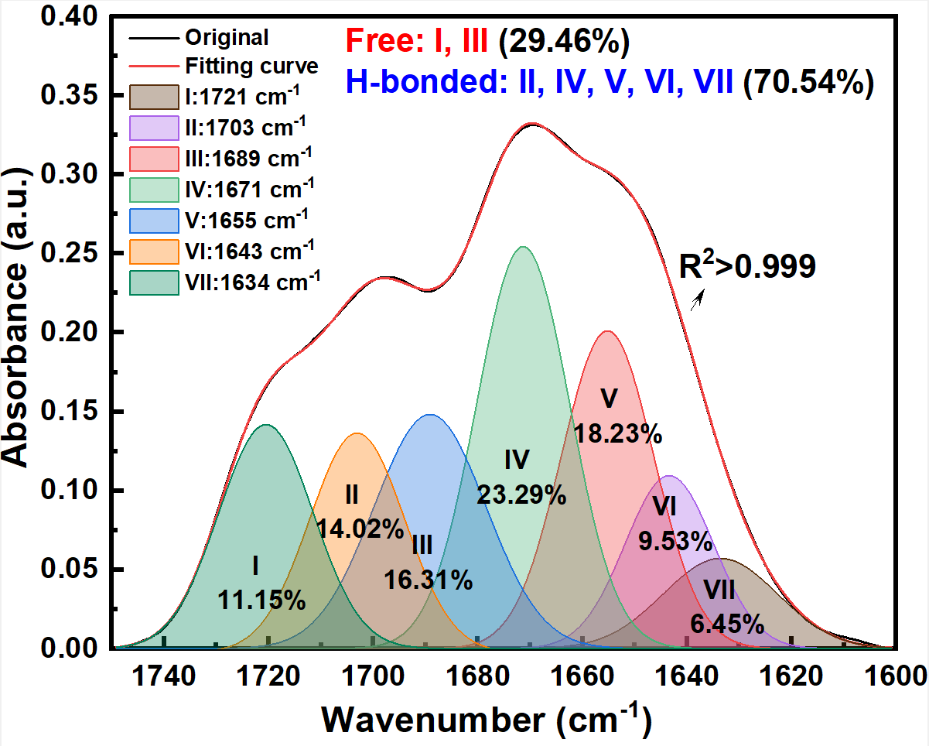
Figure S2. FTIR spectra between 1600-1750 cm⁻¹ of IPDI-mAr₁₀₀₀.
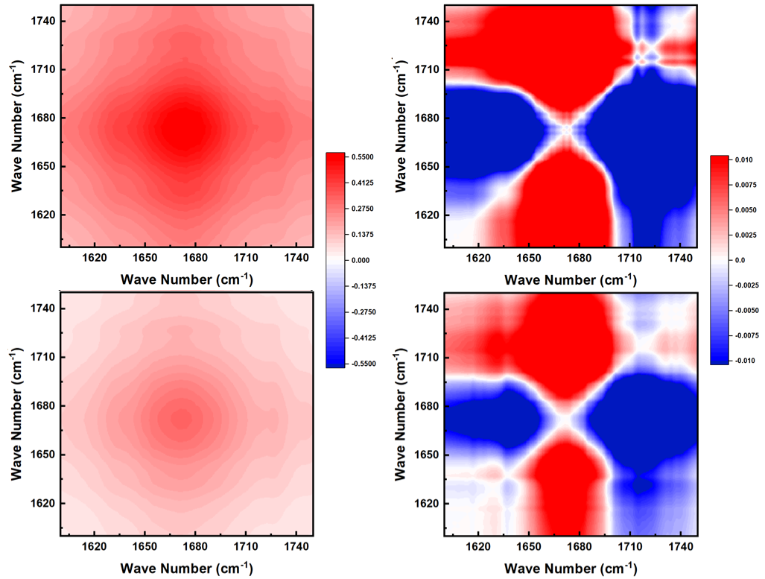
Figure S3. 2D synchronous (all left) and asynchronous (all right) FTIR patterns between 1600-1750 cm⁻¹ of HDI-mAr₁₀₀₀ (all above) and IPDI-mAr₁₀₀₀ (all below).
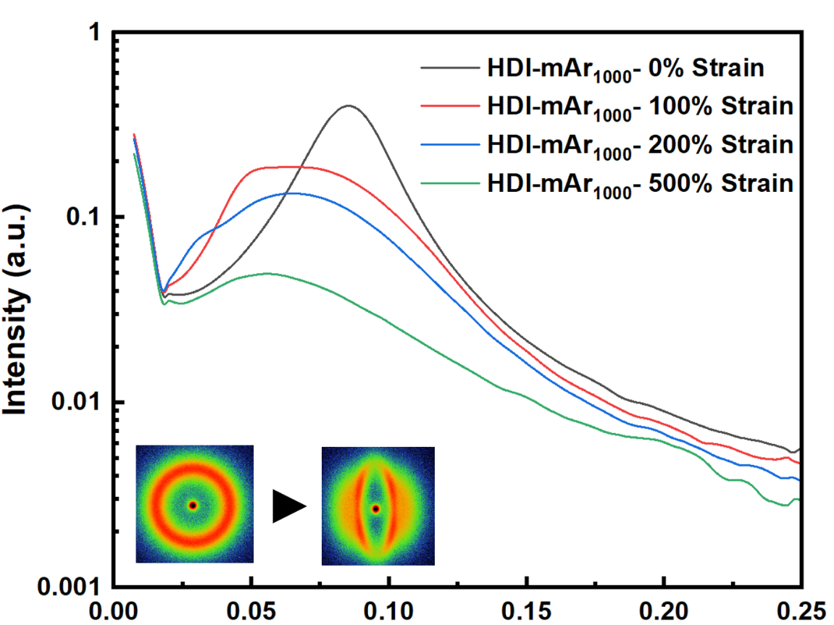
Figure S4. 1D SAXS curves during stretching and 2D SAXS patterns (inner photos) from original samples to stretching samples of HDI-mAr₁₀₀₀.
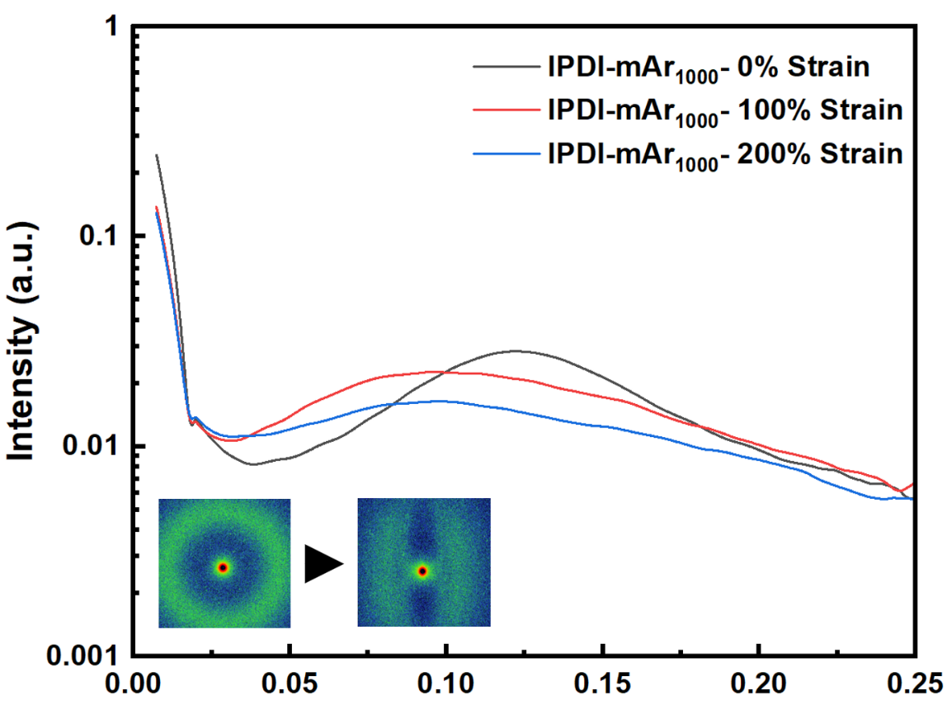
Figure S5. 1D SAXS curves during stretching and 2D SAXS patterns (inner photos) from original samples to stretching samples of IPDI-mAr₁₀₀₀.
The weak hard segment stacking ability of IPDI-mAr₁₀₀₀ results in insufficient toughness, preventing it from being successfully stretched to a 500% strain state in the stretching SAXS experiment (as it fractured before reaching this strain level). Consequently, its 1D SAXS curve does not include data for the 500% strain condition.
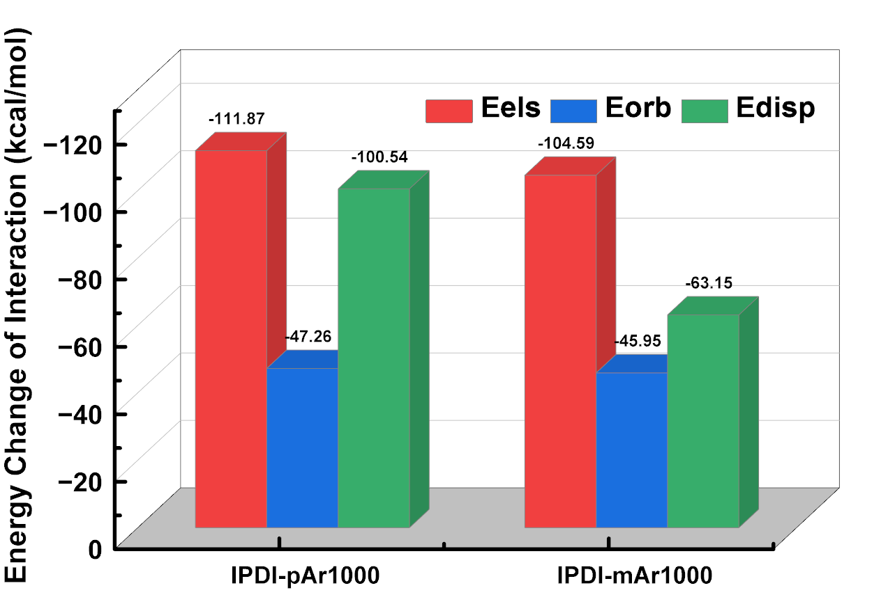
Figure S6. The energy changes after the formation of dimers for the hard segment molecules containing IPDI-related structures. Only the energy values that contribute positively to the formation of the dimers are presented.
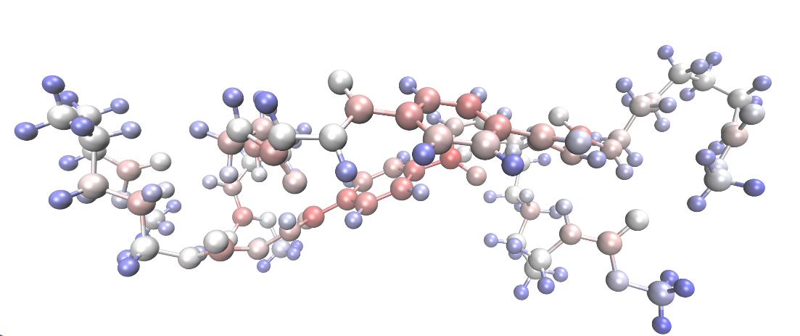
Figure S7. Schematic representation of the dispersion energy contributions from each atom within the dimers of HDI-pAr (trans).
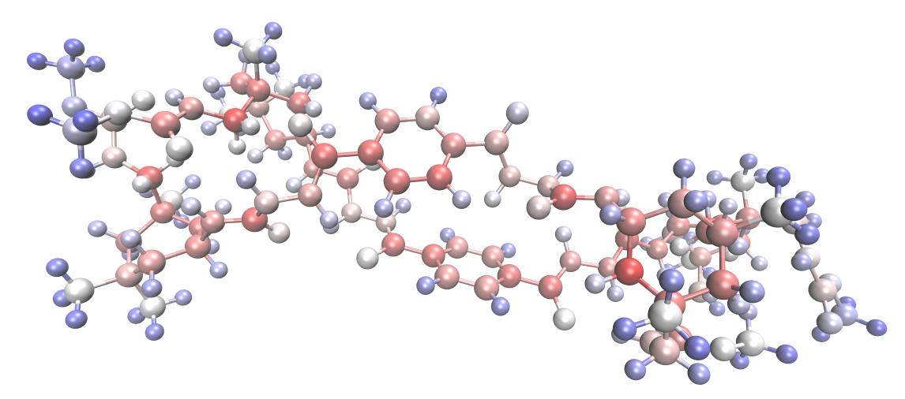
Figure S8. Schematic representation of the dispersion energy contributions from each atom within the dimers of IPDI-pAr.
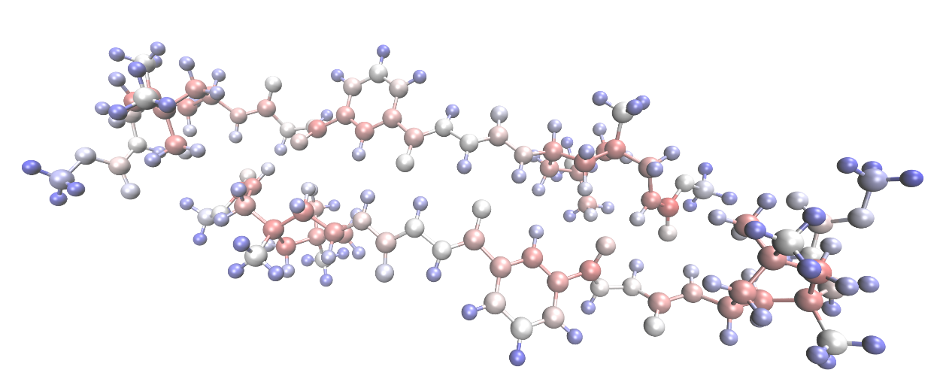
Figure S9. Schematic representation of the dispersion energy contributions from each atom within the dimers of IPDI-mAr.
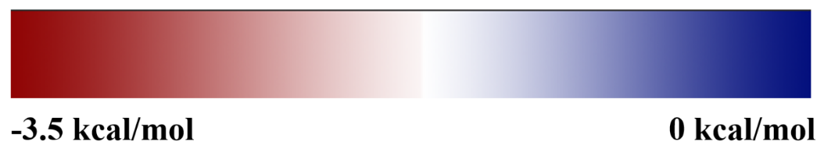
Figure S10. Legend of the dispersion energy contributions, which is also shown in the main text.
Among the five dimers, the atoms forming the benzene rings in HDI-pAr (cis) show the most prominent red color (with the highest value of -3.42 kcal/mol, as indicated in the legend, which is significantly higher than the peak values of the individual atomic dispersion energy contributions in the other four dimers), strongly illustrating the presence of π-π stacking interactions within its structure.
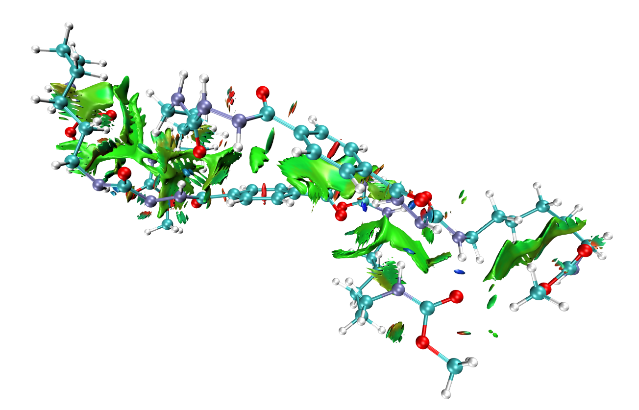
Figure S11. Schematic representation of the weak interactions within the dimers of HDI-pAr (trans).

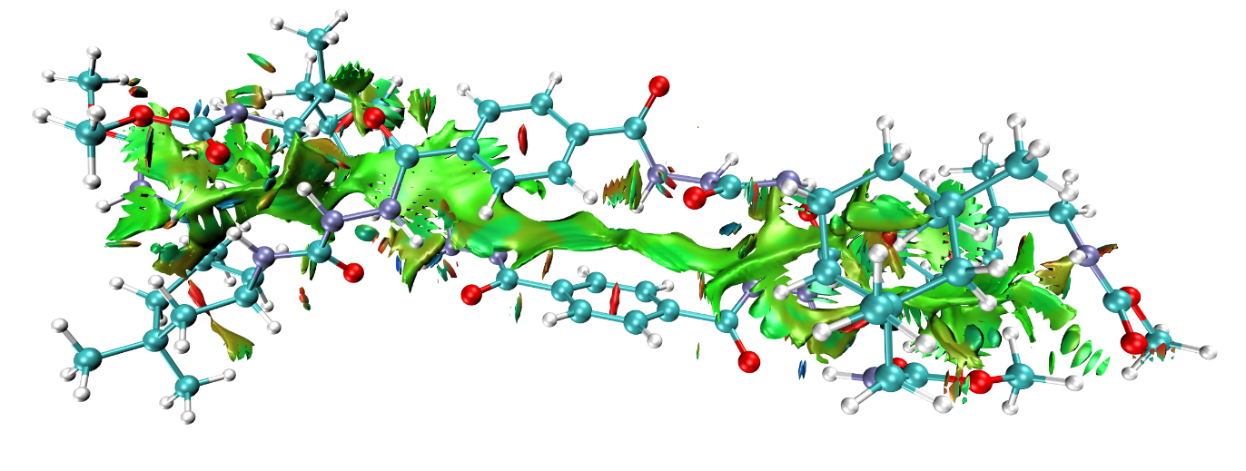
Figure S12. Schematic representation of the weak interactions within the dimers of IPDI-pAr.
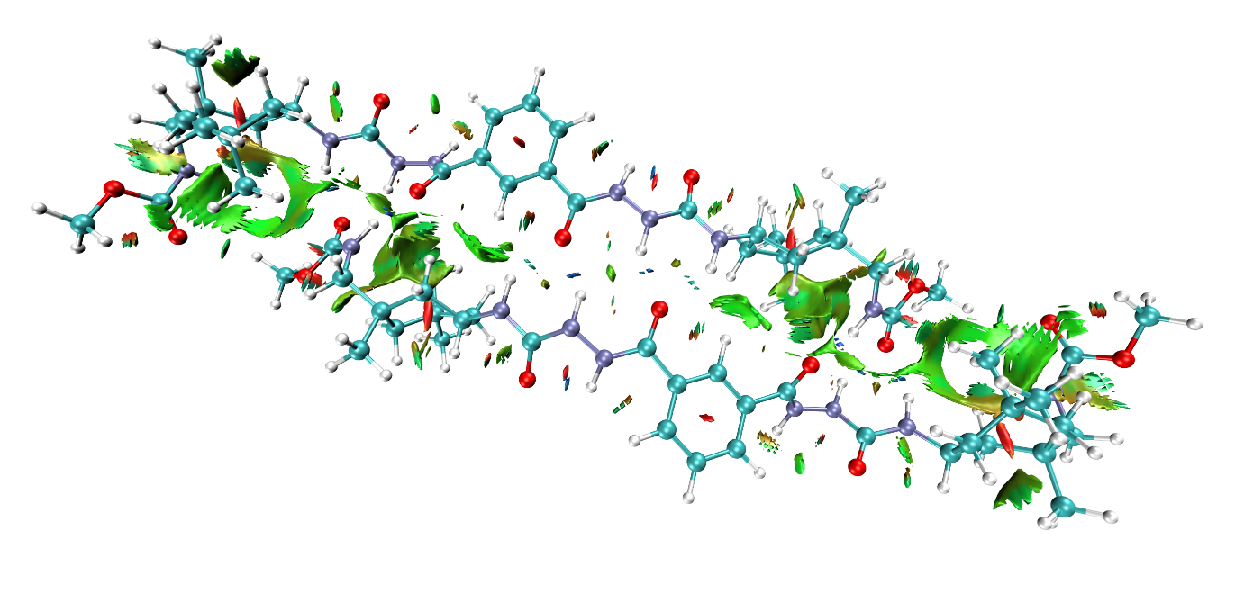
Figure S13. Schematic representation of the weak interactions within the dimers of IPDI-mAr.
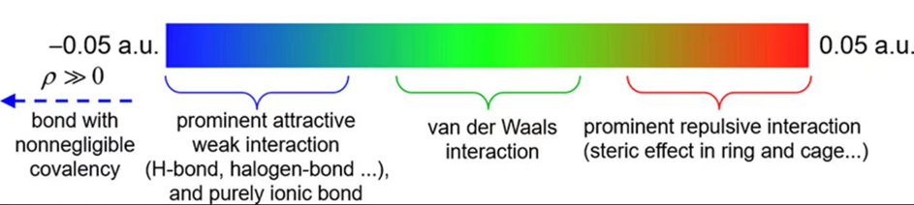
Figure S14. Legend of the weak interactions (derived from article ^{[6]}), which is also shown in the main text.
As shown in the results, van der Waals interactions dominate the weak interactions between all the dimers. Blue regions between the atoms forming hydrogen bonds indicate strong electrostatic attraction in these areas. The green bands within the HDI-pAr (cis) dimer are the clearest, most uniform, and largest in area, revealing a widespread strong van der Waals interaction primarily driven by π-π stacking. It is noteworthy that the IPDI-pAr dimer also exhibits strong van der Waals interactions, but these are mainly concentrated around the six-membered ring of the molecular structure, indicating that the van der Waals interactions in this dimer are primarily generated by the close proximity of the bulky carbon rings rather than being dominated by π-π stacking interactions.
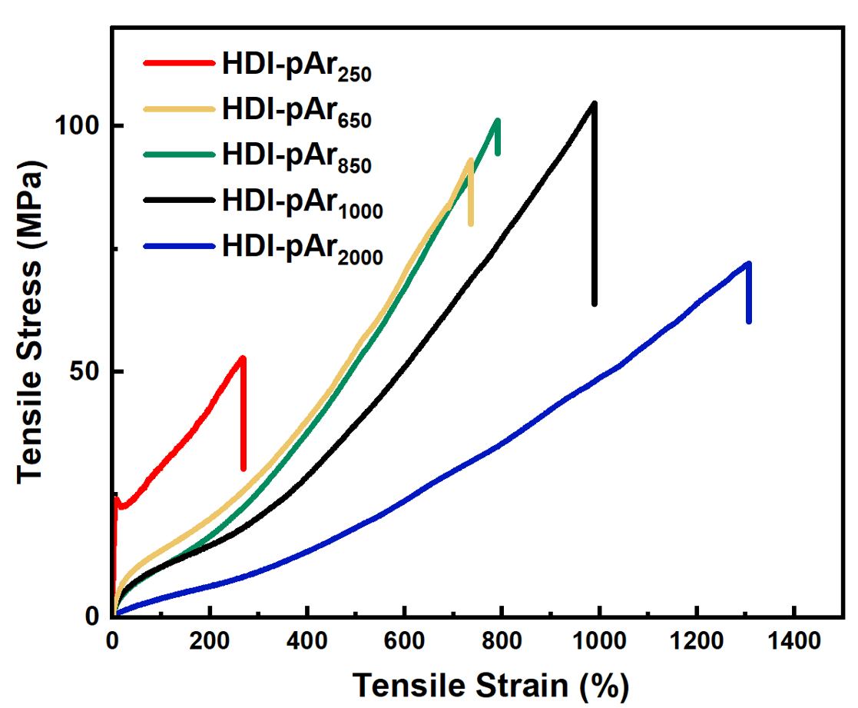
Figure S15. Engineering stress-strain curves of HDI-pAr_{n} series with different types of PTMEG (M_{n} = 250/650/850/1,000/2,000), measured at the stretching speed of 50 mm/min.
In this study, in addition to modifying the hard segment composition of HZPU, samples with different soft segment molecular weights but a fixed HDI-pAr hard segment were synthesized to evaluate the influence of the soft segment on the overall performance of HZPU series and to identify the optimal soft segment molecular weight. PTMEG with M_{n} = 250/650/850/1,000/2,000 was selected as the raw material to construct soft segments of varying lengths. Tensile tests were conducted on all synthesized HDI-pAr series samples, and the resulting tensile curves revealed that HDI-pAr₆₅₀, HDI-pAr₈₅₀, and HDI-pAr₁₀₀₀ exhibited similar tensile behavior, with comparable maximum tensile stress values. This suggests that the hard segments in the HDI-pAr series, prepared using the methods employed in this study, had already reached their maximum stress-bearing capacity. Meanwhile, the gradual increase in soft segment length provided greater molecular chain mobility and deformation capacity, leading to an increase in the material’s apparent maximum tensile strain. For HDI-pAr₂₀₀₀, although the ultra-long soft segment allowed for greater tensile strain, it significantly reduced the proportion of hard segments in the material, resulting in a noticeable decrease in maximum tensile stress. Conversely, for HDI-pAr₂₅₀, the excessively short soft segment restricted the material’s overall stress dissipation capability, causing rapid necking and fracture in the early stages of stretching. Overall, HDI-pAr₁₀₀₀, synthesized using PTMEG with M_{n} = 1000, exhibited the most optimal mechanical tensile performance. Therefore, this formulation was primarily chosen for the preparation and characterization of all HZPU series materials in this study.
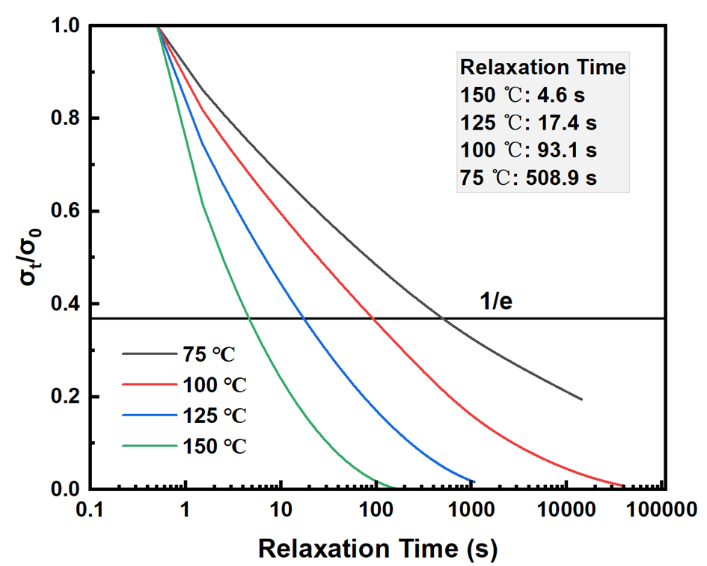
Figure S16. The normalized stress-relaxation curves of HDI-mAr₁₀₀₀ at different temperatures.
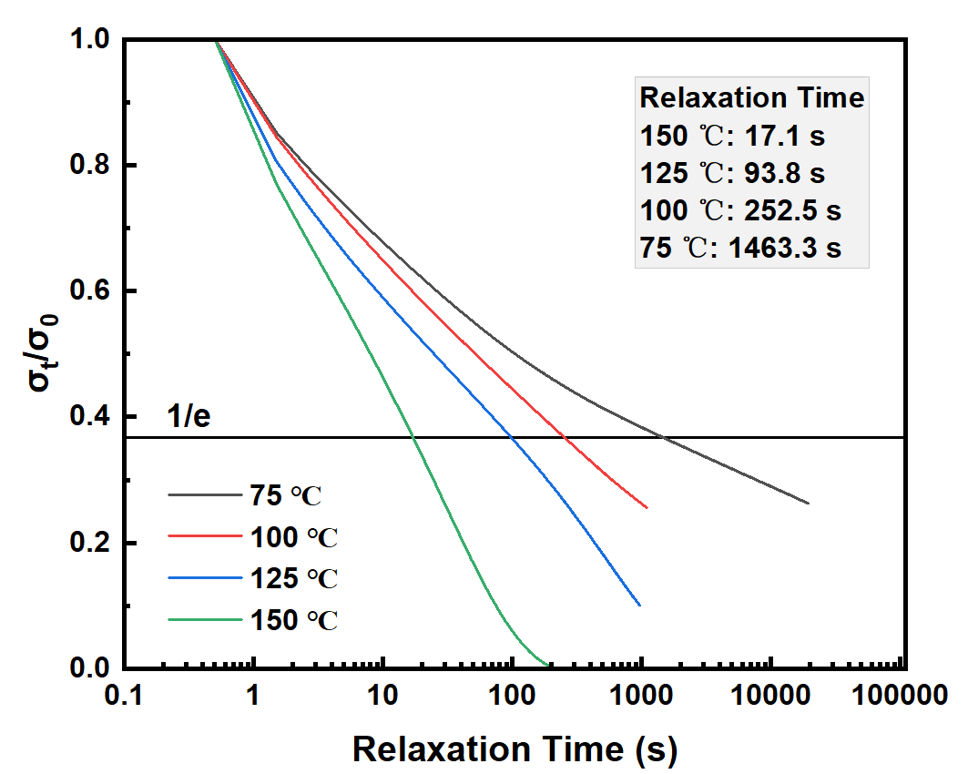
Figure S17. The normalized stress-relaxation curves of IPDI-pAr₁₀₀₀ at different temperatures.
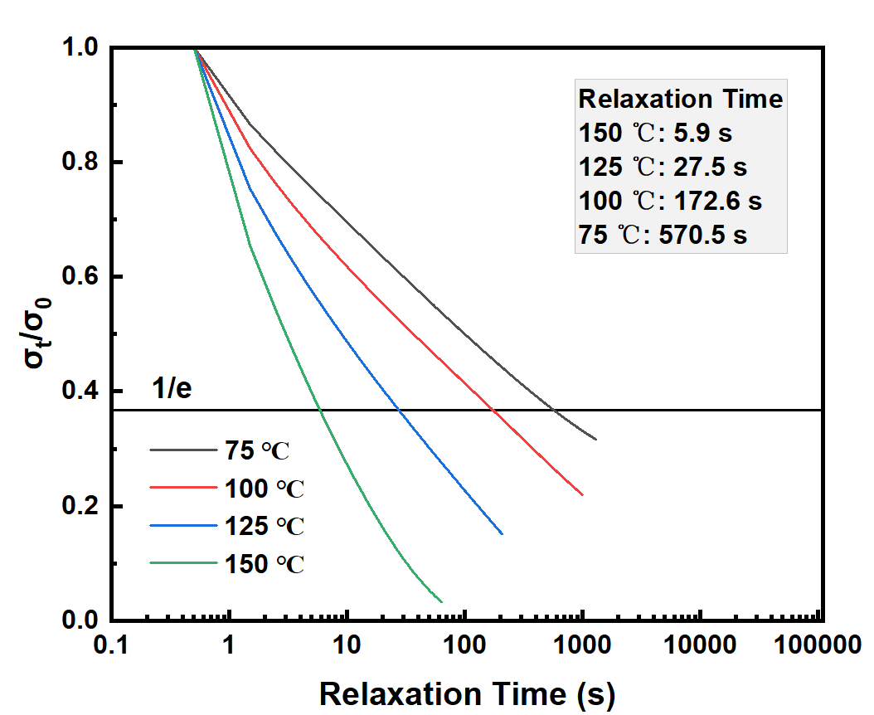
Figure S18. The normalized stress-relaxation curves of IPDI-mAr₁₀₀₀ at different temperatures.
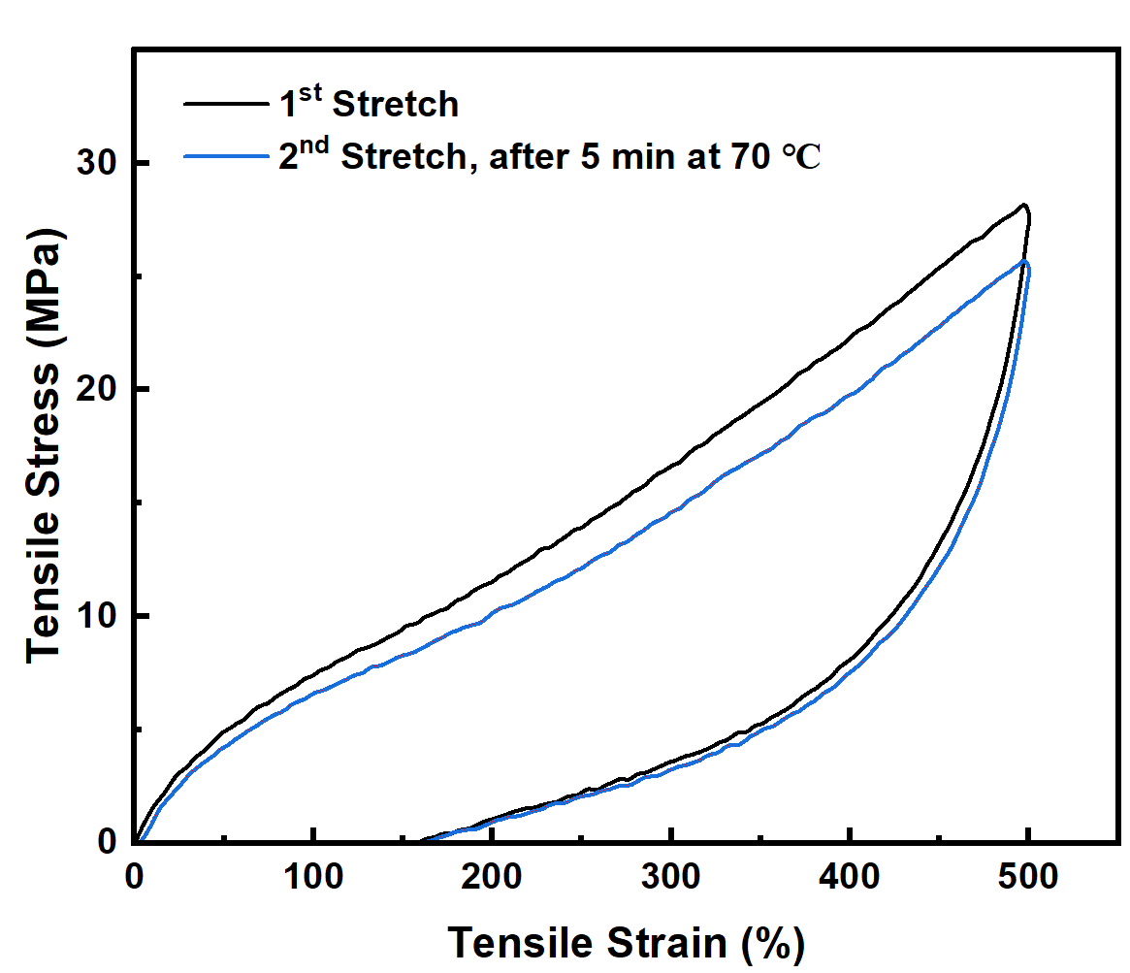
Figure S19. Cyclic loading-unloading tensile curves at 500% strain with different recovery conditions of HDI-mAr₁₀₀₀.
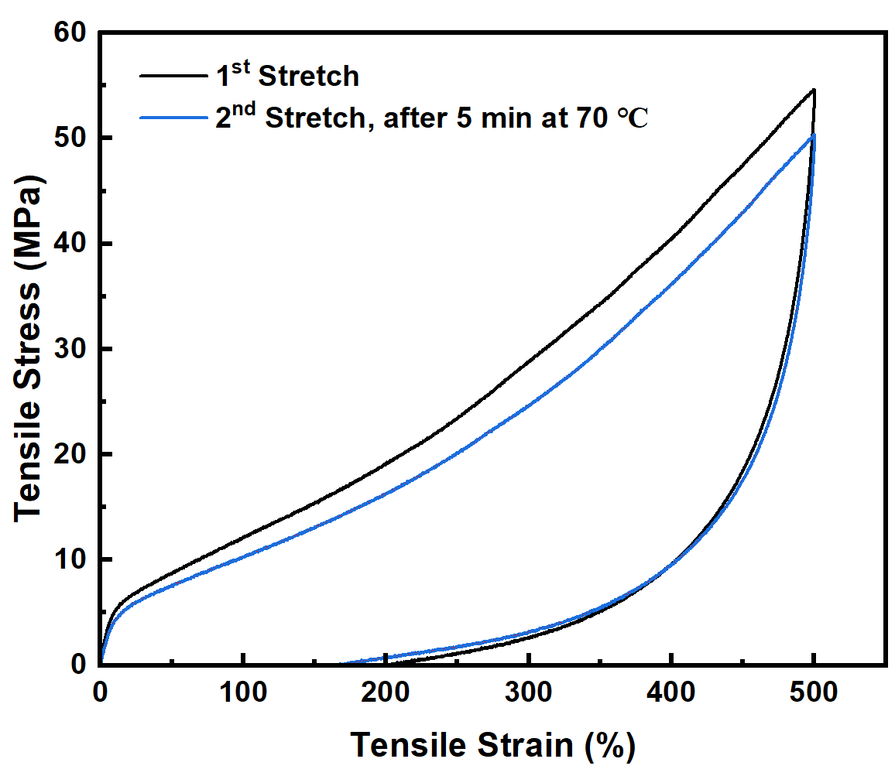
Figure S20. Cyclic loading-unloading tensile curves at 500% strain with different recovery conditions of IPDI-pAr₁₀₀₀.
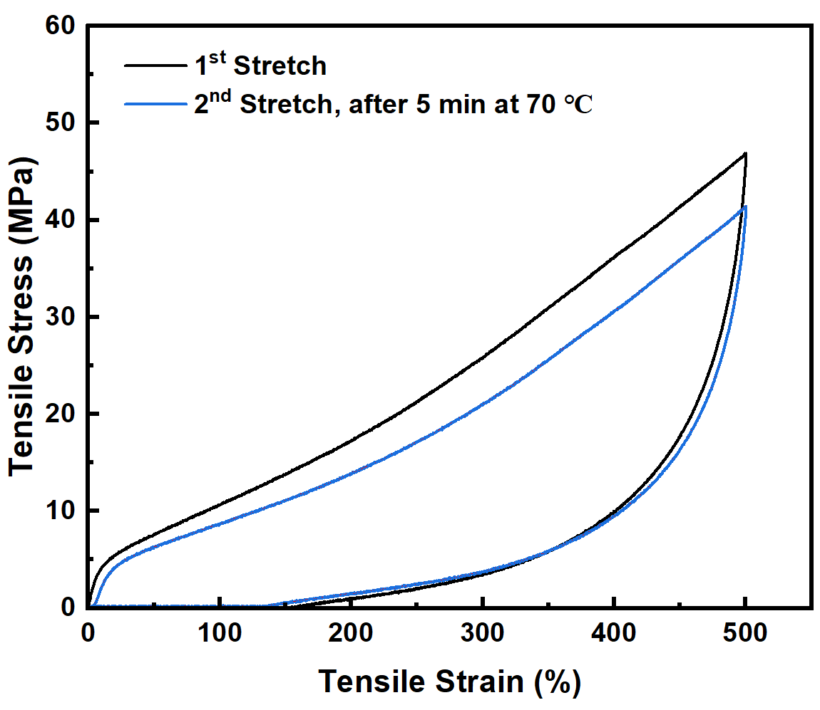
Figure S21. Cyclic loading-unloading tensile curves at 500% strain with different recovery conditions of IPDI-mAr₁₀₀₀.
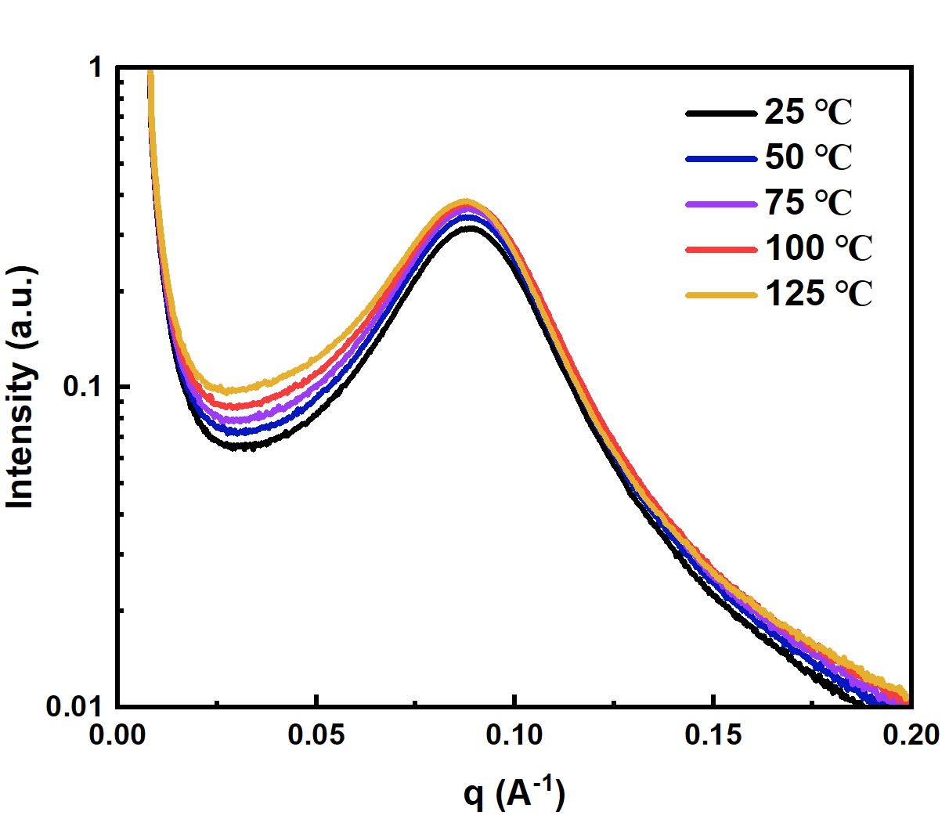
Figure S22. 1D SAXS curves of HDI-pAr₁₀₀₀ at different temperatures.
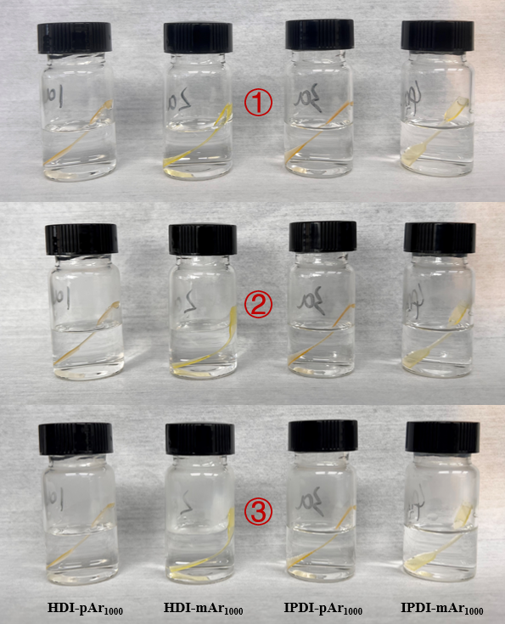
Figure S23. Photographs showing the distinct performances of HZPU series after soaking in 1 mol/L HCl for ①an instant/②3 hours/③9 hours.
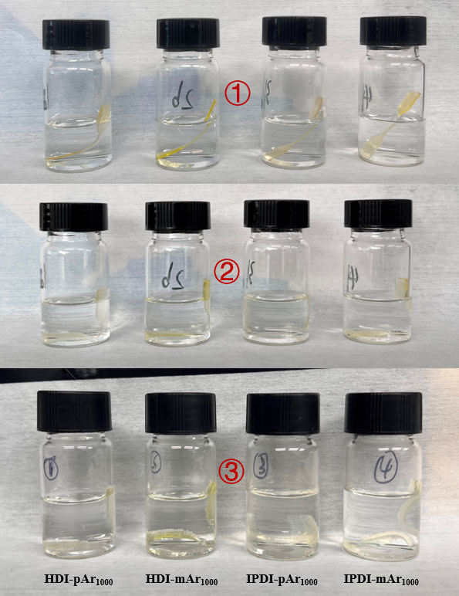
Figure S24. Photographs showing the distinct performances of HZPU series after soaking in 1 mol/L NaOH for ①an instant/②3 hours/③9 hours.
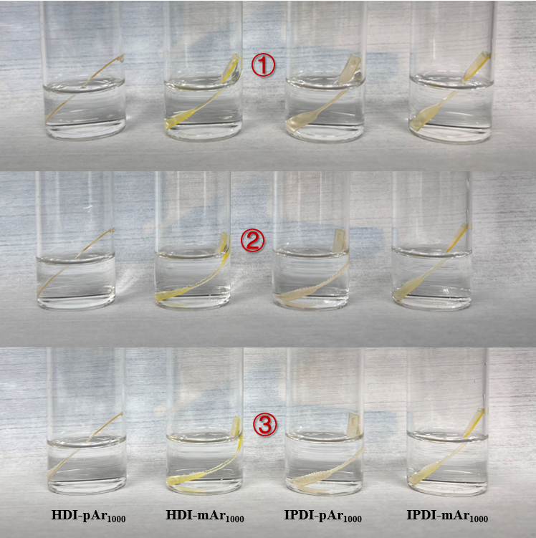
Figure S25. Photographs showing the distinct performances of HZPU series after soaking in 2 mol/L NaCl for ①an instant/②3 hours/③9 hours.
In the experiment, dumbbell-shaped strips of the four samples were immersed in 1 mol/L HCl, 1 mol/L NaOH, and 2 mol/L NaCl solutions for varying durations to evaluate their acid resistance, base resistance, and salt tolerance, respectively. Compared to alkaline conditions, all of the HZPU series exhibit better stability in acidic and saline environments, with HDI-pAr₁₀₀₀ demonstrating the highest resistance. After 9 hours of immersion, HDI-pAr₁₀₀₀ showed almost no bending or collapse, with contrast to the other samples. In alkaline conditions, all strips exhibit significant deformation, which can be attributed to hydroxide ions acting as effective catalysts for the hydrolysis of amide groups. However, compared to the other samples, HDI-pAr₁₀₀₀ displayed the least deformation under the same immersion duration and was able to maintain its overall shape, whereas the other samples exhibited varying degrees of pronounced bending or swelling after 9 hours of exposure.
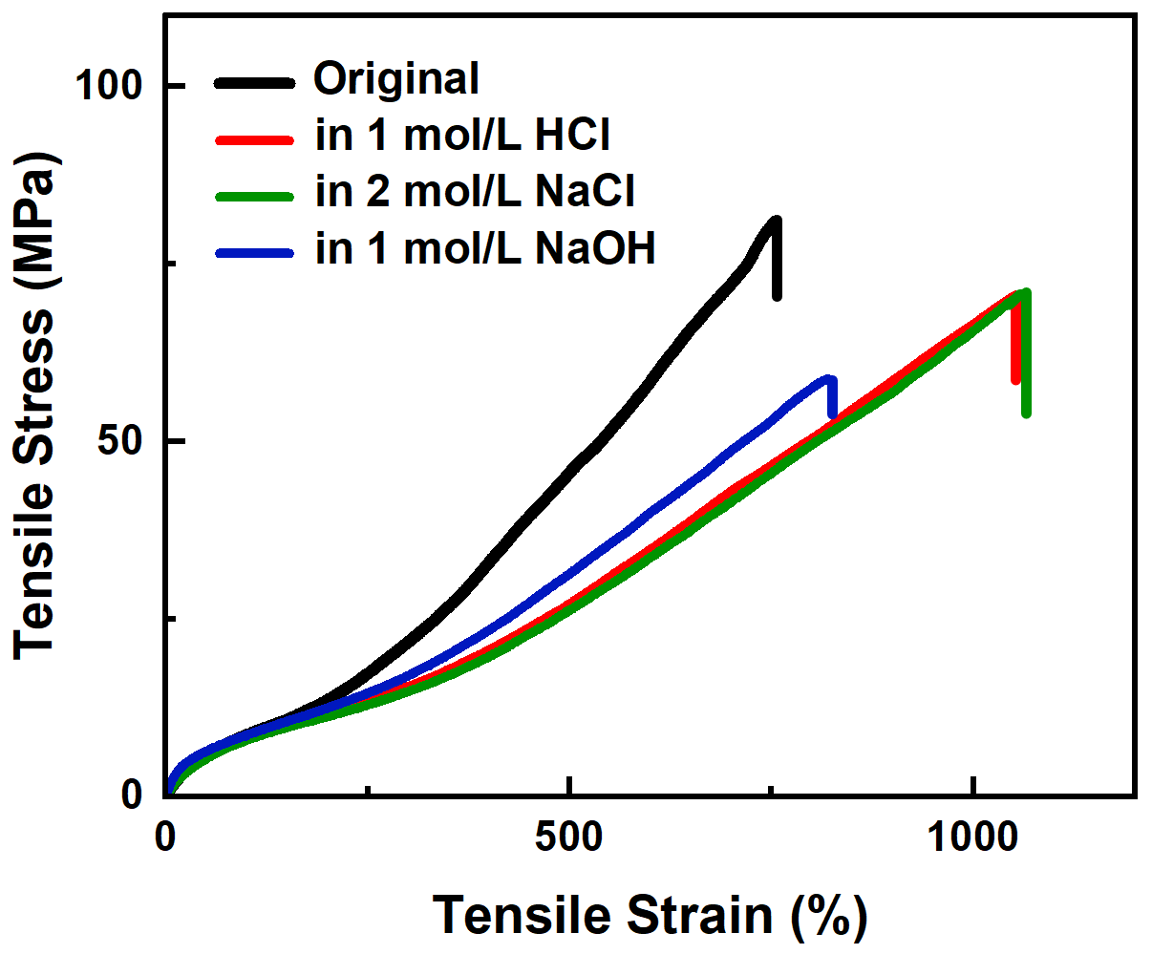
Figure S26. Engineering stress-strain curves of HDI-mAr₁₀₀₀ under different chemical situations for 9 hours, respectively.
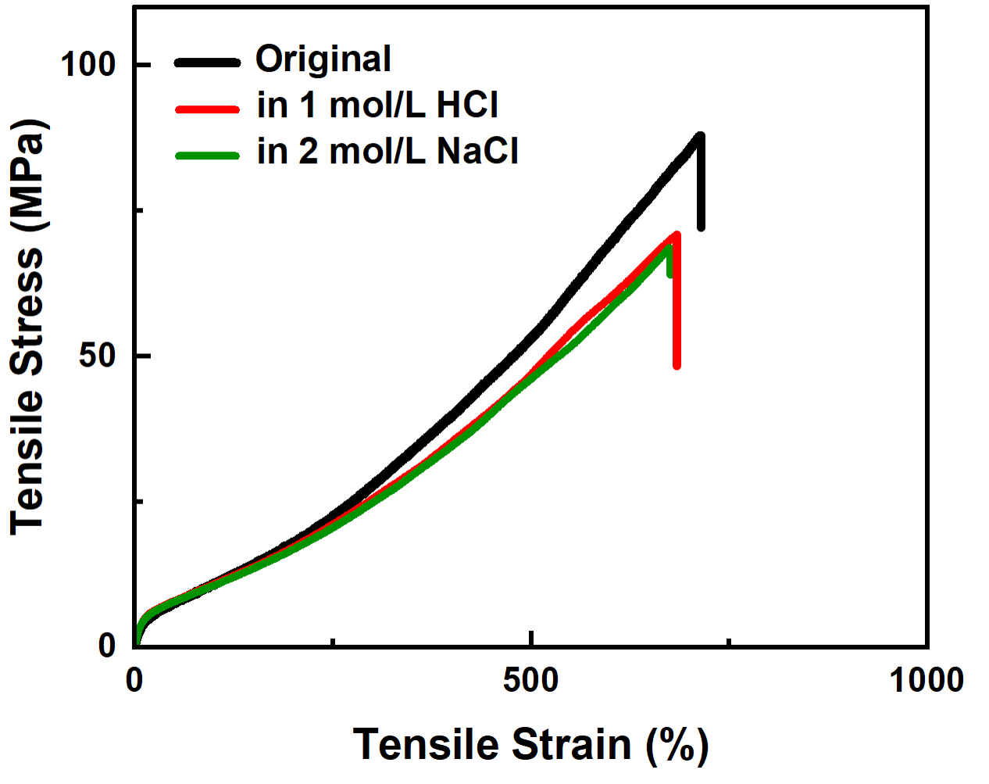
Figure S27. Engineering stress-strain curves of IPDI-pAr₁₀₀₀ under different chemical situations for 9 hours, respectively.
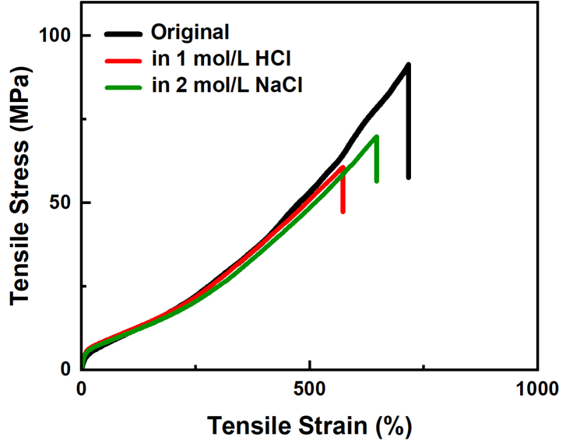
Figure S28. Engineering stress-strain curves of IPDI-mAr₁₀₀₀ under different chemical situations for 9 hours, respectively.
After 9 hours of immersion in chemical solutions, all strips of HZPU series were removed, thoroughly dried, and subjected to tensile testing. The testing methods and parameters were identical to those described earlier for tensile tests. The results for HDI-pAr₁₀₀₀ are already shown in Figure 6c of the main text. The findings indicate that, in contrast to HDI-pAr1000, all other samples exhibit varying degrees of significant deterioration in tensile performance after immersion. Notably, IPDI-pAr₁₀₀₀ and IPDI-mAr₁₀₀₀, after being immersed in alkaline solution for 9 hours and subsequently dried, suffered severe degradation and fragmentation, making them unsuitable for tensile testing; thus, no corresponding experimental curves were obtained. These results collectively highlight the exceptional chemical resistance and structural stability of HDI-pAr₁₀₀₀.
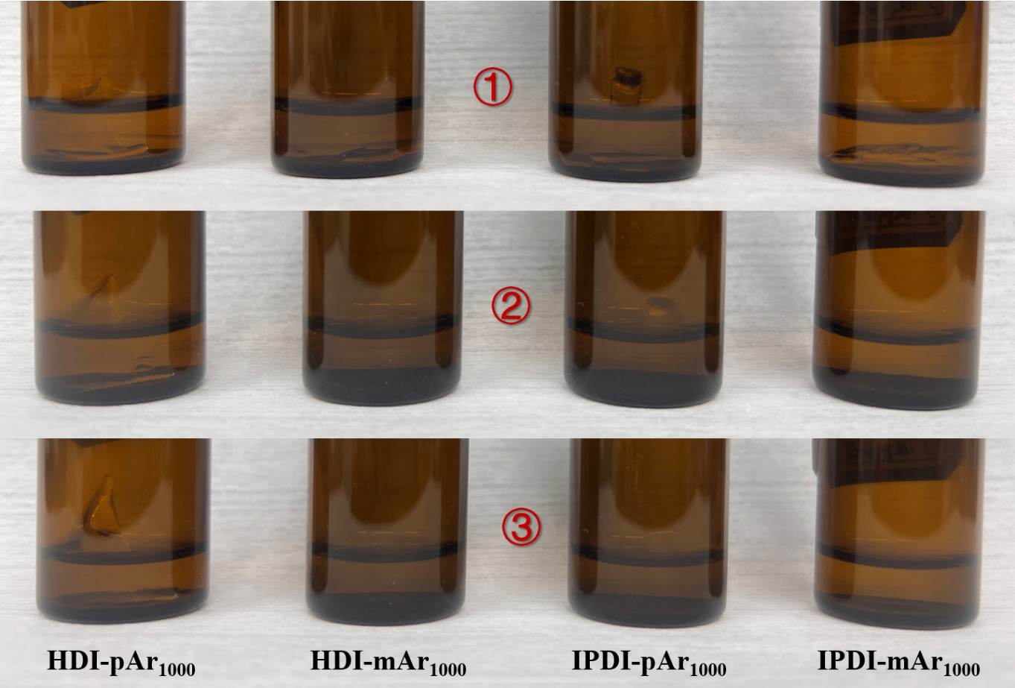
Figure S29. Photographs showing the distinct performances of HZPU series after soaking in DMF for ①an instant/②3 hours/③3 days.
In the experiment, fragments of different HZPU series samples were immersed in DMF, which is known for its strong ability to dissolve conventional polyurethane-based polymers, to assess their solvent resistance. All samples, except for HDI-pAr₁₀₀₀, were almost completely dissolved within 3 hours. In contrast, HDI-pAr₁₀₀₀ retained its shape even after 3 days of immersion in DMF, exhibiting only slight swelling.

References
[1] C. Bannwarth, E. Caldeweyher, S. Ehlert, A. Hansen, P. Pracht, J. Seibert, S. Spicher, S. Grimme, WIREs Comput. Mol. Sci. 2020, 11, e01493.
[2] Gaussian 16, Revision A.03, M. J. Frisch, G. W. Trucks, H. B. Schlegel, G. E. Scuseria, M. A. Robb, J. R. Cheeseman, G. Scalmani, V. Barone, G. A. Petersson, H. Nakatsuji, X. Li, et al., Gaussian, Inc., Wallingford CT, 2016.
[3] T. Lu, Molclus program, Version 1.12, http://www.keinsci.com/research/molclus.html
[4] S. Grimme, C. Bannwarth, P. Shushkov, J. Chem. Theory Comput. 2017, 13, 1989-2009.
[5] C. Bannwarth, S. Ehlert, S. Grimme, J. Chem. Theory Comput. 2019, 15, 1652-1671.
[6] T. Lu, F. Chen, J. Comput. Chem. 2012, 33, 580-592.
[7] T. Lu, Q. Chen, J. Comput. Chem. 2022, 43, 539-555.
[8] T. Lu, Q. Chen, J. Phys. Chem. A 2023, 127, 7023.
[9] W. Humphrey, A. Dalke, K. Schulten, J. Mol. Graph. 1996, 14, 33-38.
[10] X. Li, N. Mignard, M. Taha, F. Prochazka, J. Chen, S. Zhang, F. Becquart, Macromolecules 2019, 52, 6585-6599.

