Supplementary Methods

Chemicals and reagents
4-(2-hydroxyetheyl)-1-piperazineethanesulfonic acid (HEPES), NaCl, and NaHCO₃ were purchased from Sigma Aldrich (St. Louis, Missouri, USA). K₂HPO₄, MgSO₄, glucose, and CaCl₂ were bought from Merck (Søborg, Denmark). ETN was purchased from Amigen-Wyeth (Enbrel, Thousand Oaks, CA, USA), and XPro1595 was provided by INmmune Bio (Boca Raton, FL, USA). The PSS used for the protocol con- tained 115 mM NaCl, 25 mM NaHCO₃, 2.5 mM K₂HPO₄, 1.2 mM MgSO₄, 5.5 mM glucose, 10 mM HEPES, and 1.3 mM CaCl₂. All solutions were heated to 37 °C and bubbled with 5% CO₂ for at least 20 minutes before use. The PSS was made every week.

Pressure myography
This experimental protocol was performed on male and female C57BL/6J mice (male: n=11; female: n=6) and C57BL/6J male mice subjected to continuous ANGII and XPro1595 treatment (n=6–8).
Mice were humanely euthanized through cervical dislocation, and second-order mesenteric arteries were isolated from the intestines at 4 °C in a PSS solution. Immediately after dissection, pressure perfusion experiments were initiated. Additionally, certain arterioles were promptly snap-frozen and preserved at – 80 °C for subsequent PCR analyses. Pressure microperfusion was performed following the established procedure outlined in the work of Schjorring et al. [1]. In summary, a pressure myograph (model 110P, Danish MyoTechnology, Aarhus, Denmark) was filled with PSS maintained at 37 °C and set to a baseline pressure of 0 mmHg. Glass pipettes with outer tip diameters of 80–200 μm were accurately crafted from soda-lime glass tubing under a microscope, utilizing a rotating system equipped with heating filaments. Glass pipettes were inserted into the outflow and inflow tubing.
Isolated second-order mesenteric arteries were positioned within the pressure myograph chamber. The proximal end of each artery was cannulated with the inflow pipette and securely fastened with Ethilon 11- 0 sutures (Ethicon, Norderstedt, Germany). The distal end, approximately 1.5–3 mm in length, was similarly cannulated on the outflow pipette without any stretching and secured with Ethilon 11-0 sutures.
Subsequently, the perfusion pressure was gradually increased to 20 mmHg, and meticulous longitudinal stretching of the vessel was performed to detect and rectify any potential leaks. The chamber was carefully supplied with an air mixture comprising 95% oxygen and 5% carbon dioxide, and its temperature was maintained at 37 °C. Perfusion was consistently sustained at 60 mmHg at the inlet and 55 mmHg at the outlet, leading to a flow rate of 1–2 μl per minute. To assess vessel viability, 6 μl of phenylephrine (10-5 mol/L) and 6 μl of acetylcholine (10-5 mol/L) were applied. Only vessels exhibiting more than 50% baseline tone in both contraction and relaxation were subjected to further evaluation.

Series I: Myogenic tone of healthy mesenteric arteries of both sexes incubated with XPro1595 and ETN
The experimental arteries of 11 male mice and 6 females underwent a 30-minute acclimatization phase at 20 mmHg in PSS, followed by successive increases in transmural pressure, ranging from 20 to 160 mmHg in 20 mmHg increments, with each step lasting 3 minutes.
In the subsequent phase, the artery was exposed to ETN at a concentration of 300 µg/mL or XPro1595 of 300 µg/mL at a pressure of 20 mmHg for 30 minutes prior to the pressure increase. In the third phase, a thorough washing procedure in PSS (30 minutes at 20 mmHg) was carried out. Subsequently, in the fourth phase, the opposite of Phase 1 either ETN (300 µg/mL) or XPro1595 (300 µg/mL) was introduced (Figure S1).
The experiment culminated with a final incremental pressure step-up protocol performed in a Ca²⁺ -free PSS buffer, to measure passive artery diameter at the same increments in pressure 20 mmHg-160 mmHg.
Series II: Myogenic tone of mesenteric arteries from male mice incubated with varying doses of exogenous TNF
Second order mesenteric arteries from healthy male C57BL/6J mice (n=3-7 per condition) underwent a 30-minute acclimatization phase at 20 mmHg in PSS, followed by successive increases in transmural pressure, ranging from 20 to 160 mmHg in 20 mmHg increments, with each step lasting 3 minutes. In the subsequent four phases, the same artery representing one animal was incubated in varying doses of exogenous TNF (1, 50, 100, and 500 pg/mL). One phase represents one round of a 30-minute incubation phase at 20 mmHg at one dose (e.g. 1 pg/mL TNF), followed by successive increases in transmural pressure ranging from 20 to 160 mmHg in 20 mmHg increments, with each step lasting 3 minutes. The experiment ended with a final incremental pressure step-up protocol performed in a Ca²⁺ -free PSS environment, facilitating the measurement of passive artery diameter.

Series II: Myogenic tone of mesenteric arteries from male mice treated with continuous ANGII with and without the co-infusion of XPro1595.
The second order mesenteric arteries of 8 male C57BL/6J mice treated with a continuous infusion of ANGII for 7 days (60 ng/kg/min, Calbiochem, San Diego, CA, USA) followed by with or without co-infusion with XPro1595 (20 mg/kg/day) for 4 days were harvested immediately after sacrifice. The experimental arteries underwent a 30-minute acclimatization phase at 20 mmHg in PSS, followed by successive increases in transmural pressure, ranging from 20 to 160 mmHg in 20 mmHg increments, with each step lasting 3 minutes. In the next phase, the artery was incubated in exogenous TNF (50 pg/mL) and a pressure of 20 mmHg for 30 minutes before the pressure increment steps. Passive artery diameter was measured with a final incremental pressure step-up protocol performed in a Ca²⁺ -free PSS environment.

Catheterization of mice and arterial blood pressure measurement
After a 1-week acclimatization period, 9-week-old C57BL/6J male mice underwent anesthesia and were prepared for the surgical implantation of chronic indwelling catheters in both the femoral artery and vein. Following our previously established methods, this procedure allowed for measuring arterial blood pressure and venous infusions [2, 3].These catheters comprised a micro-renathane tip with an outer diameter ranging from 0.340 to 0.380 mm, connected to polyethylene tubing. They were routed through a tunnel to the back of the neck. To maintain catheter patency, they were continuously filled with heparin at a concentration of 100 U/mL in an isotonic glucose solution, infused at a rate of 10 μL/hr. The exterior portion of the catheters was subcutaneous attached to a swivel, allowing the mice to move freely without interference. The arterial line was linked to a pressure transducer (Föhr Medical Instruments, Hessen, Germany) for continuous MAP and HR measurements, while the vein line was connected to a pump for uninterrupted drug infusion. For post-surgical analgesia, mice received an initial subcutaneous bolus injection of 0.1 mg/kg of Temgesic, followed by a continuous infusion of 3.75 mg/kg/day of Temgesic for 1 day. Subsequently, the mice were allowed a recovery period of 4 days following surgery. Data were acquired using LabView software (National Instruments, Austin, TX, USA). Once the recovery period had elapsed, continuous blood pressure and HR measurements were initiated, with readings taken every 5 minutes. Initial baseline measurements were carried out over 4 days, followed by subsequent measurements following the experimental protocol (see Figure S2). MAP and HR measurements are presented following circadian rhythm as an average 12-hour (day(D)/night(N)) cycle.

Experimental series
In vivo effects of step-up administration of XPro1595 at baseline and to ANGII-induced hypertensive mice on arterial blood pressure
After catheter indwelling surgery[2, 3], the mice (vehicle: n=6; XPro1595: n=5) were allowed to recover for 4
days, followed by 4 days of baseline mean MAP and HR measurements prior to Xpro1595 testing. Then, a bolus (0.5 mg/kg) of the selective solTNF inhibitor XPro1595 (INmmune Bio, Boca Raton, FL, USA) was given intravenously, followed by a continuous infusion of XPro1595 at a rate of 0.5 mg/kg/day for 2 days, after which the infusion dose was increased to 1 mg/kg/day for an additional 2 days before the highest dose of 2 mg/kg/day of XPro1595 was given for 2 days. Then, hypertension was induced by the intravenous co-infusion of ANGII (60 ng/kg/min) for 4 days. In parallel, a corresponding control group was subjected to continuous infusions of a heparin-glucose solution (in a volume-to-time interval fashion). Before the termination of the mice at the end of the protocol, 200 µl arterial blood was collected in EDTA-coated tubes for plasma isolation, and samples were stored at -80 °C. At the end of the protocol, mice were weighed, and euthanized, and the kidney, heart, aorta, and spleen were harvested and weighed. Organ weight was calculated using a body weight-to-organ ratio.

In vivo effect of administration of a high dose of XPro1595 to established hypertensive mice on blood pressure
Following 4 days of recovery and 4 days of baseline measurements of mean MAP and HR, a 200 µl blood sample was noninvasively collected from each mouse (Base line, vehicle: n=8; XPro1595: n=6) through arterial catheters in EDTA-coated tubes. Subsequently, ANGII (60 ng/kg/min) was continuously infused for 4 days to induce hypertension. Then, XPro1595 (20 mg/kg/day) or heparin-glucose (for control animals) was co-infused continuously for 4 days. Before administering XPro1595 or heparin-glucose. At the end of the experimental period, an additional 200 µl of undisturbed arterial blood was collected in the same manner (ANGII). At the end of the protocol, mice were weighed and euthanized, and the kidney, heart, aorta, and spleen were harvested and weighed. Organ weight was calculated by a body weight-to-organ ratio.

References

1. Schjorring, O.L., R. Carlsson, and U. Simonsen, Pressure Myography to Study the Function and Structure of Isolated Small Arteries. Methods Mol Biol, 2015. 1339: p. 277-95.
2. Thuesen, A.D., et al., Deficiency of T-type Ca(2+) channels Ca(v)3.1 and Ca(v)3.2 has no effect on angiotensin II-induced hypertension but differential effect on plasma aldosterone in mice. Am J Physiol Renal Physiol, 2019. 317(2): p. F254-F263.
3. Andersen, H., et al., Plasminogen Deficiency and Amiloride Mitigate Angiotensin II-Induced Hypertension in Type 1 Diabetic Mice Suggesting Effects Through the Epithelial Sodium Channel. J Am Heart Assoc, 2020. 9(23): p. e016387.

Supplemental Figures:

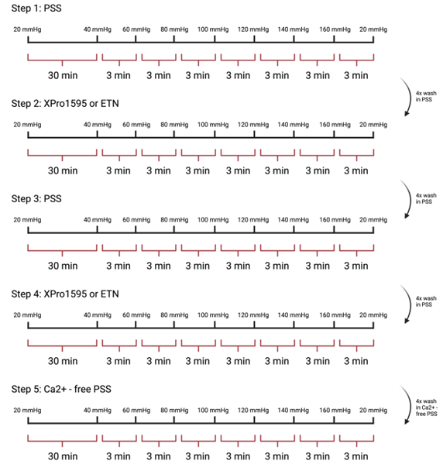
Figure S1: Experimental setup for the pressure myograph protocol
The transmural pressure on the mesenteric artery was increased step-wise (20–160 mmHg) for five steps. Experimental arteries underwent a 30-minute acclimatization at 20 mmHg, followed by pressure increases from 20 to 160 mmHg in 20 mmHg steps, each lasting 3 minutes. ETN (300 µg/mL) or XPro1595 (300 µg/mL) was applied at 20 mmHg for 30 minutes before pressure incrementation. A thorough washing in PSS preceded ETN or XPro1595 administration. Finally, vessels were subjected to pressure step-up in calcium-free PSS to measure the passive diameter. Made in Biorender.

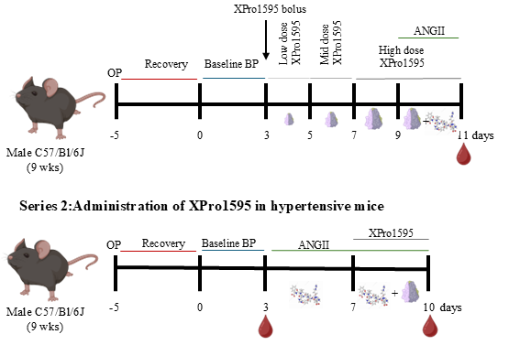
Figure S2: Study overview of blood pressure measurements in mice
Series 1: The mice were allowed to recover for 5 days prior to baseline blood pressure recordings for 3 days with no intervention. On day 3 a bolus of 0.05 mg/kg XPro1595 was provided before continuous infusion of three different concentrations of XPro1595 (0.5, 1, and 2 mg/kg/min) in 2 days step-up manner. Days 9–11: Hypertension was induced by the continuous infusion of ANGII (60 ng/kg/min). A blood drop symbol indicates the collection of blood samples. Vehicle: n=6; XPro1595: n=5.
Series 2: followed 5-day surgical recovery, baseline blood pressure was measured for 3 days, followed by induction of hypertension by the continuous infusion of ANGII (60 ng/kg/min) from day 3-7. Days 7–10: Mice were administered a high dose of XPro1595 (20 mg/kg/min) or vehicle co-infused with ANGII. A blood drop symbol indicates the collection of blood samples. Vehicle: n=8; XPro1595: n=5. Made in Biorender.

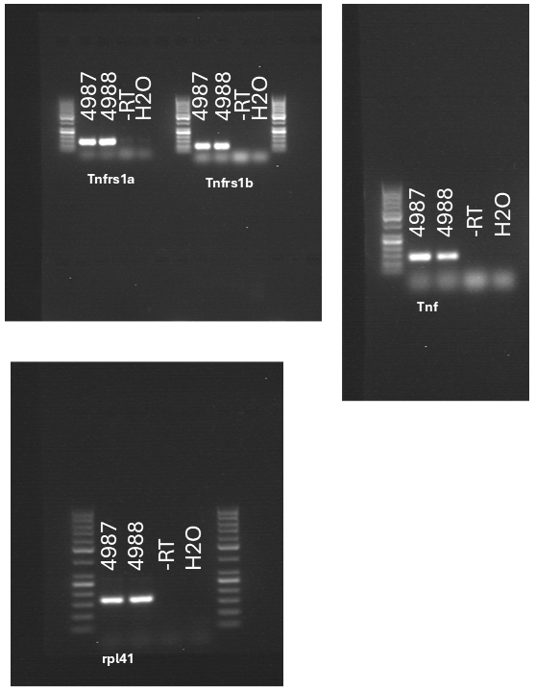

Figure S3: Full frame agarose gel pictures of RT-PCR product ofTnfrs1a, Tnfrs1b, Tnf and Rpl41
Full agarose gel pictures of the PCR-products Tnfrs1a, Tnfrs1b, Tnf and Rpl41 amplified for 36 cycles and separated on an 2% agarose gel. The numbers indicate mouse ID of isolated RNA from mesenteric arteries. The negative controls include RNA samples (-RT) to ensure no genomic DNA is amplified, and H2O where water is used instead of 50 pmol cDNA.

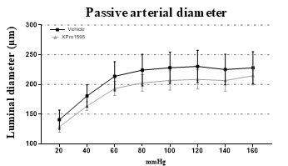
Figure S4: Passive arterial diameter of mesenteric arteries
The graph shows passive luminal diameter measurements of the mesenteric arteries of vehicle- and AN- GII+XPro1595-treated male mice (n=5–6). The mesenteric arteries were preincubated in Ca²⁺-free PSS for 30 minutes and subsequently subjected to incremental pressure (step-up). A two-way ANOVA with Bonferroni’s multiple comparisons test assessed murine vessel diameter differences between the two test groups. Data are presented as mean ± SD.

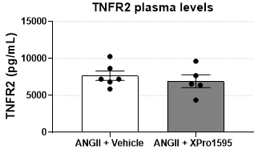
Figure S5: Plasma TNFR2 levels
Plasma TNFR2 levels were measured in plasma samples from mice from Experimental Series 2 (n=5– 6). No significant differences were observed. Data were compared using unpaired t-tests and reported as mean ± SD.

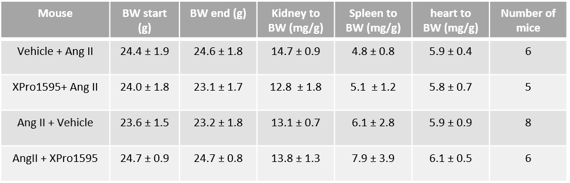
Table S1: Body and organ weights for blood pressure mice
Values are presented as mean ± SD, no significant differences were observed by Student’s t-test

