SUPPLEMENTARY MATERIAL
Structural characterization of atrial natriuretic peptide amyloid fibrils from patients with atrial fibrillation

Luca Broggini^{1,2}, Marco Piccoli^{1,3}, Antonio Chaves-Sanjuan², Diane Marie Valérie Bonnet⁴, Federica Cirillo¹, Cristina Visentin², Federica Sonzini², Paola Signorelli⁵, Ivana Lavota¹, Melissa Milazzo², Simona Nonnis⁶, Lorenzo Menicanti⁷, Giuseppe Ciconte^{1,3,8}, Carlo Pappone^{1,3,8}, Luigi Anastasia^{1,3}, Stefano Ricagno^{1,2 *}

¹Institute for Molecular and Translational Cardiology (IMTC), IRCCS Policlinico San Donato, Piazza Malan, 2, 20097 San Donato Milanese, Milan, Italy.
² Department of Biosciences, University of Milan, Via Celoria 26, 20133, Milan, Italy.
³ School of Medicine, University Vita-Salute San Raffaele, Via Olgettina, 58, 20132 Milan, Italy.
⁴Unitech NOLIMITS, Imaging facility, Università degli Studi di Milano, Milan, Italy
⁵“Aldo Ravelli” Center for Neurotechnology and Experimental Brain Therapeutics, Department of Health Sciences, University of Milan, Via Antonio di Rudinì 8, 20142, Milan, Italy.
⁶Department of Veterinary Medicine and Animal Science (DIVAS), University of Milan, Via dell’Università 6, 26900, Lodi, Italy
⁷ Department of Cardiac Surgery, Istituto di Ricovero e Cura a Carattere Scientifico Policlinico San Donato, Milan, Italy.
⁸Arrhythmology Department, IRCCS Policlinico San Donato, Piazza Malan, 2, 20097, San Donato Milanese, Milan, Italy.
* corresponding to: stefano.ricagno@unimi.it

Supplementary table 1. Patients’ clinical information.
Variable
 | Patient 1 | Patient 2 | Patient 3
Age, years | 82 | 78 | 72
Gender | M | F | M
Diagnosis | AF | AF | AF
Congo red reactivity | Positive | Positive | Positive
Anti-ANP reactivity | Positive | Positive | Positive

Supplementary table 2. List of cardiac-derived ANP peptides identified by nLC–MS/MS in fibrils extracted from Pt1 and Pt2. The sequences were obtained from mass spectrometry analysis of water-soluble fractions. Numbering refers to the ANP sequence (UniProt P01160). Lowercase “c” denotes carbamidomethylated cysteine residues.
Sequence | Patient 1 | Patient 2
100GPWDSSDR107 | x | -
138IGAQSGLGcNSFRY151 | x | x
138IGAQSGLGcNSFR150 | x | -
138IGAQSGLGcNSF149 | x | -
135MDRIGAQSGLGcNSFRY151 | - | x
127RSScFGGR134 | - | x
138IGAQSGLGcN147 | - | x
138IGAQSGLGcNS148 | x | x
128SScFGGRMDR137 | - | x
128SScFGGR134 | x | x

Supplementary table 3. Cryo-EM data acquisition and processing.
 | Patient 1 | Patient 2 | Patient 3
Data collection and image processing
Microscope (Company) | TALOS Arctica (Thermo Fischer Scientific) | Titan Krios (Thermo Fischer Scientific) | TALOS Arctica (Thermo Fischer Scientific)
Voltage (kV) | 200 | 300 | 200
Camera | Falcon 3EC | Gatan K3 | Falcon 3EC
Magnification | 120000 | 105000 | 76000
Total electron dose (e-/Å2) | 40 | 41 | 40
Defocus range (µm) | -0.8 to -2.6 | -0.8 to -2.2 | -0.8 to -2.0
Pixel size (Å) | 0.889 | 0.839 | 1.43
Micrographs (n.) | 1818 | 16251 | 191

 | PolA | PolB
Data processing and reconstruction
Helical reconstruction
Imposed symmetry | pseudo-2₁ | pseudo-2₁
Twist | 178.9 ° | 179.5 °
Rise | 2.35 Å | 2.36 Å
Initial segments (n.) | 285254 | 93973
Final segments | 67547 | 31545
B-factor (Å²) | 73.85 | 62.89
Map/model statistics
Model refinement
r.m.s. deviations
Bond lengths (Å) (# > 4σ) | 0.004 (0) | 0.003 (0)
Bond angles (°) (# > 4σ) | 0.524 (3) | 0.529 (18)
Ramachandran plot
Favored (%) | 95.91 | 91.16
Allowed (%) | 4.09 | 8.84
Outliers (%) | 0 | 0
Validation
Molprobity score | 1.74 | 2.78
Clashscore | 6.30 | 16.88
Poor rotamers (%) | 1.39 | 5.06
CC mask/box/peaks/volume | 0.79/0.41/0.21/0.78 | 0.69/0.41/0.17/0.63
Deposition codes
PDB | 9RBD | 9RBW
EMDB | EMD-53891 | EMD-53910
EMPIAR | 12800 | 12800
Supplementary table 4. Cryo-EM data overview.

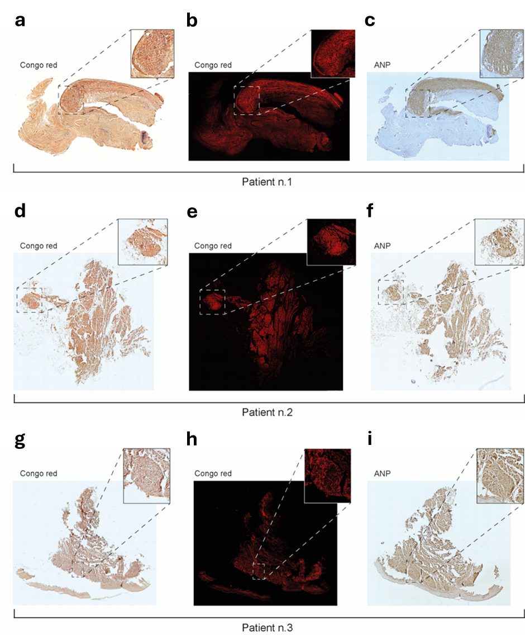Supplementary figure 1. Congo red and immunostaining of ANP deposits of atrial appendages. Congo red staining: brightfield light (a, Pt1; d, Pt2; g, Pt3); fluorescence light (b, Pt1; e, Pt2; h, Pt3) showed massive deposits of amyloid in the heart. The amyloid deposits were immunoreactive for ANP (c, Pt1; f, Pt2; i, Pt3).

Supplementary figure 2. Peptide mapping of the cardiac-derived ANP fibrils identified by nLC–MS/MS.
Schematic representation of the human ANP sequence (UniProt P01160), showing protein region covered by peptides identified in fibrils from Pt1 (green) and Pt2 (orange). Peptides mapped to the mature ANP region (blue) and, exclusively in Pt1, to upstream sequences within the pro-ANP peptide (gray), indicating the presence of both mature and uncleaved ANP in cardiac amyloid deposits.

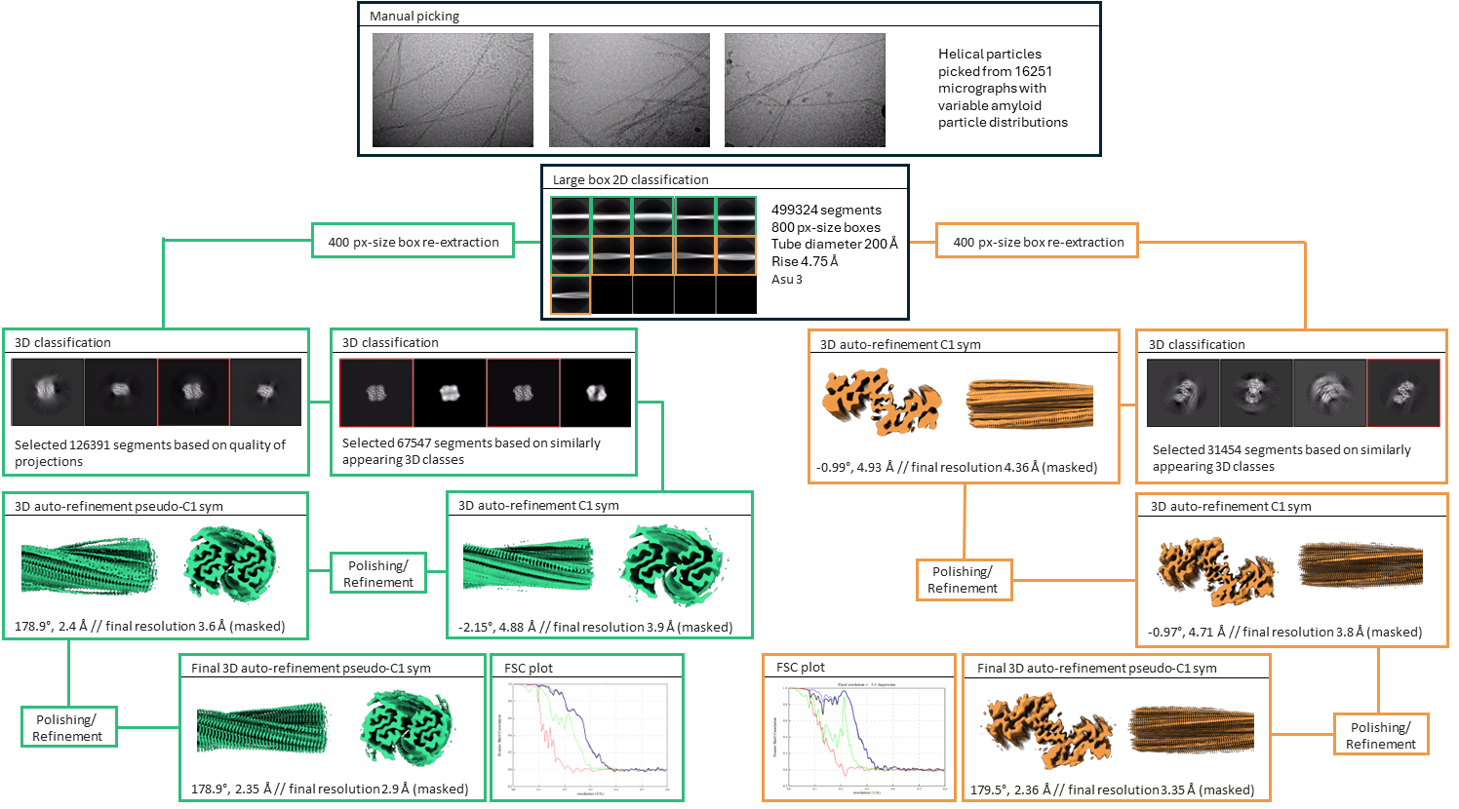Supplementary figure 3. Cryo-EM data processing workflow, Fourier shell correlation curves and residue-level map-model cross-correlation plots. The workflow is described in the methods section. Reference free 2D and 3D class averages are shown as obtained from Relion 3.1. For the 2D classes, the number of segments, inter-box distances and helical search parameters (tube diameter, rise, asymmetric unit (asu)) are listed. In 2D class selection, class averages highlighted in green belonged to PolA and were processed independently from the ones highlighted in orange, belonging to PolB. In 3D class sub-selection, class averages highlighted in green or orange were selected for further processing. To visualize the improvement in map quality, green or orange maps are shown in front and side views, along with listed values for the estimated resolution as well as helical twist and rise parameters. Bayesian Polishing and per-particle CTF refinement steps were added at indicated steps during the workflow.

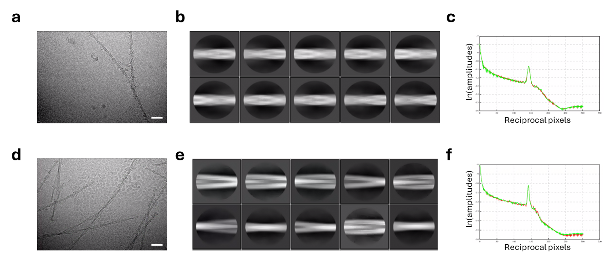
Supplementary figure 4. 2D classification of coated and naked ANP fibrils. a Representative Cryo-EM image of ANP coated fibrils. Disordered material wraps up the fibrils, hiding the classical features of amyloids. b Reference-free 2D classification of PolA ANP fibrils. c Representative helical layer line profile of selected PolA reference-free 2D class showing a positive peak representative of β-strand separation. d Representative Cryo-EM image of ANP non-coated fibrils. e Reference-free 2D classification of PolB ANP fibrils. f Representative helical layer line profile of selected PolB reference-free 2D class showing a positive peak representative of β-strand separation.

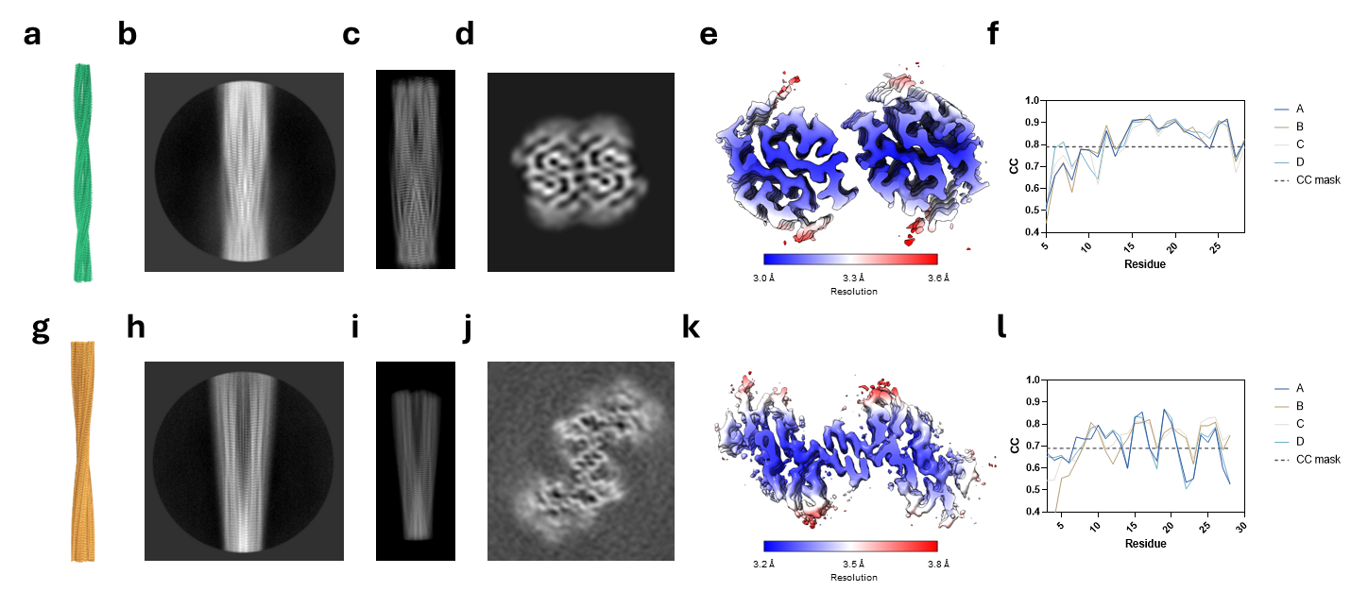
Supplementary figure 5. Cryo-EM structures of ANP fibrils. a PolA model composed of two protofilaments. b PolA 2D class average corresponding to the orientation of the projection reported in panel C. c PolA 2D projection of the reconstructed map. d Cross section view of PolA reconstructed map. e PolA map is colored on a blue, white and red color gradient corresponding to local resolution estimates of 3, 3.3 and 3.6 Å, respectively. f PolA residue-level map-model cross-correlation plot reveals map support for all residues. g PolB model composed of two protofilaments. h PolB 2D class average corresponding to the orientation of the projection reported in panel I. i PolB 2D projection of the reconstructed map. j Cross section view of PolB reconstructed map. k PolB map is colored on a blue, white and red color gradient corresponding to local resolution estimates of 3.2, 3.5 and 3.8 Å, respectively. l PolB residue-level map-model cross-correlation plot reveals map support for all residues.

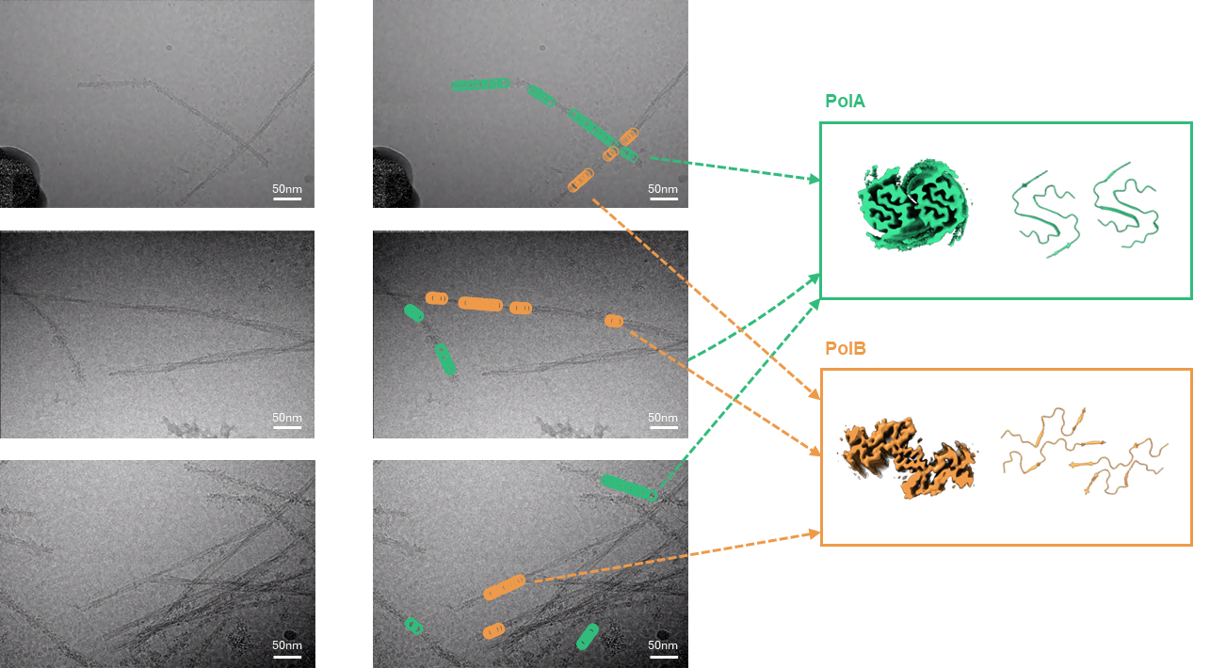
Supplementary figure 6. PolA and PolB do not coexist in the same fibrils. Representative figures from three micrograph showing the location of PolA (green) and PolB (orange) on ANP fibrils. PolA is localized exclusively on coated fibrils, while PolB is found solely in naked fibrils.

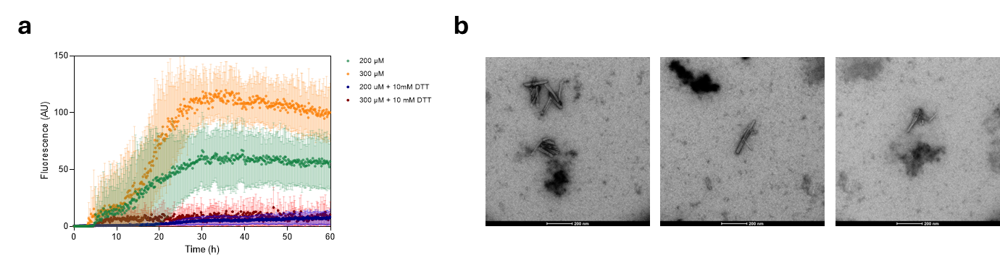
Supplementary figure 7. ANP aggregation in vitro. a Aggregation kinetics of the ANP peptide at 200 and 300 µM, in presence and in absence of reducing agent. b TEM images of fibrillar material from the 300 µM ANP solution at the end of the aggregation experiment.

