Appendix
Figure – 1 Flow diagram
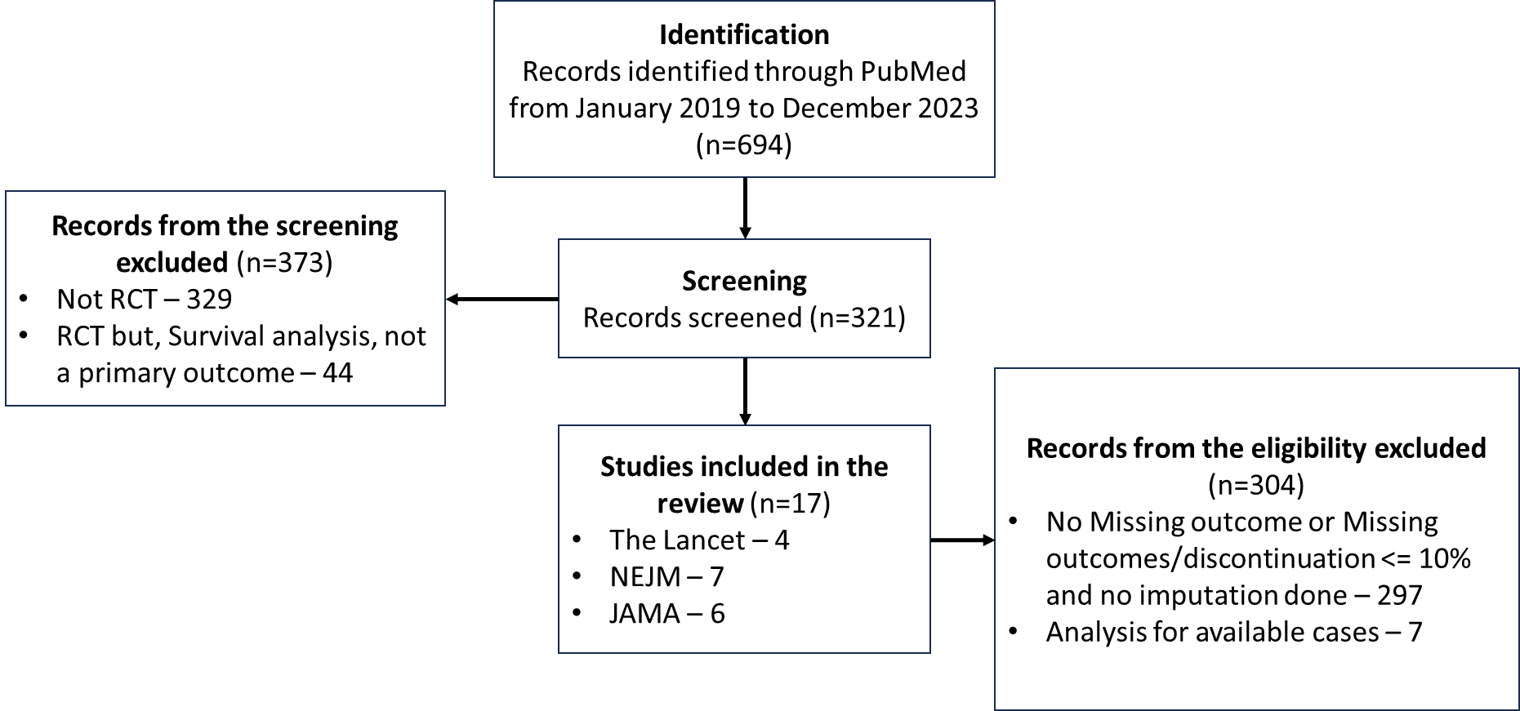
Table – 1 Key Characteristics of Included RCTs
Research articles characteristics | N = 17 | %
Journals
The Lancet | 7 | 51.7
JAMA | 6 | 37.2
NEJM | 7 | 11.1
Year of Publication
2019 | 3 | 17.6
2020 | 5 | 29.4
2021 | 5 | 29.4
2022 | 0 | 0.0
2023 | 4 | 23.5
Study based on
Cardiovascular Diseases | 5 | 29.4
Cancer | 3 | 17.6
Infectious Diseases | 2 | 11.8
Pediatric Conditions | 2 | 11.8
Other Conditions | 5 | 29.4
Type of Intervention
Drug | 14 | 82.4
Health Service Strategies | 3 | 17.6
Primary Outcomes
Mortality | 4 | 23.5
Cardiovascular Outcomes | 4 | 23.5
Efficacy Endpoints | 3 | 17.6
Safety and Clinical Outcomes | 6 | 35.3
Table – 2 Handling of Missing Data
Research articles with missing data handling | N = 17 | %
Number of Participants for each arm
< 100 | 2 | 11.8
100 to 499 | 7 | 41.2
500 to 999 | 2 | 11.8
1000 to 4999 | 3 | 17.6
> 5000 | 2 | 11.8
Proportion of Missing Primary Outcome Data
< 10% | 10 | 58.8
10 to 19% | 1 | 5.9
≥ 20% | 6 | 35.3
Method of Handling missing data in primary analysis
Multiple Imputation based methods | 10 | 58.8
Worst-case Best-case scenario | 6 | 35.3
Inverse Probability Weighting | 1 | 5.9

Table – 3: MI reporting guidelines suggested by Sterne et al.²⁴ and their adherence across studies
Study* | Fully describe the method and model(s) | Specify all the variables in the imputation model | Report the number of imputations | Report the software package and procedures/commands used | Report method of pooling results | Provide pooled estimate, CI, and p-value
S1
S2
S3
S4
S5
S6
S7 | - | - |  | -
S8 | - | - | - | - | - | -
S9 | - | - | - | - | - | -
S10
*S1–S10 are described in detail in the annexure.

