Supplements for Redox dysregulation, inflammation and mental health in adults with high risk of childhood maltreatment

Clara von Wendorff ^{1,7 #}, Maria Meier ^{2, 3, #}, Daniella Dwir ⁴, Paul Klauser ⁴, Gizem Demirkiran ⁴, Patricia Schneider ⁴, Mickaël Das Neves ⁴, David Bürgin ^{2, 5}, Cyril Boonmann ^{2, 6}, Jörg Fegert ^{1,7}, Marc Schmid ²,Vera Clemens ^{1,7}
1 Department for Child and Adolescent Psychiatry/Psychotherapy, University of Ulm, Ulm, Germany
2 Child and Adolescent Psychiatric Research Department, University Psychiatric Clinics Basel (UPK), University of Basel, Switzerland
3 Department of Psychology, University of Konstanz, Konstanz, Germany
4 Center for Psychiatric Neuroscience, Department of Psychiatry, Centre Hospitalier Universitaire Vaudois and University of Lausanne (CHUV-UNIL), Prilly-Lausanne, Switzerland
5 Jacobs Center for Productive Youth Development, University of Zurich, Zurich, Switzerland
6 Department of Child and Adolescent Psychiatry, Leiden University Medical Center (LUMC) Curium, The Netherlands
7 German Center for Mental Health (DZPG), partner site Ulm
# shared first authorship
ORCIDs:
Clara von Wendorff: 0009-0001-4122-4356
Maria Meier: 0000-0002-1655-5479
Daniella Dwir: 0000-0003-4931-9007
Paul Klauser: ​​0000-0003-0284-4947
David Bürgin: 0000-0002-0856-1342
Cyril Boonman: 0000-0002-2862-884X
Marc Schmid: 0000-0002-6634-4442
Vera Clemens: 0000-0001-5485-4691
Corresponding author: Clara von Wendorff (clara.vonwendorff@uniklinik-ulm.de), Maria Meier (maria.meier@unibas.ch)

Figure S1: Flow Chart of Study Participants through the study baseline (MAZ. study), follow-up study (JAEL & JAELred study) with final sample sizes included in the current data analysis.
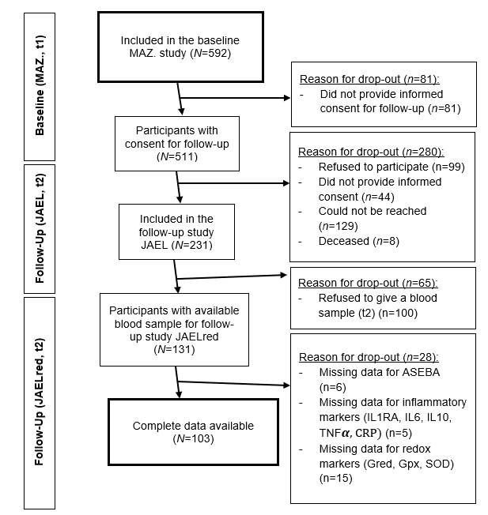

Table S1: Pearson’s correlations between mental health, CM, OS markers, and inflammatory markers
Biomarkers | Childhood maltreatment (CTQ) | Mental Health Problems (ASEBA)
SOD | .07 | .11
GPx/GRed(log) | .19* | .05
GRed(log) | -.13 | .01
GPx | .11 | .06
CRP(log) | .04 | -.03
TNF𝞪 | .06 | .17
IL1RA(log) | .03 | .13
IL6(log) | -.05 | .07
IL10(log) | .03 | .08
Note. no Bonferroni correction was used because of the exploratory aspect. ** p < .01; * p < .05; Between n = 97 and n = 130

Table S2: Pearson’s correlation coefficients between the biomarkers, CTQ, ASEBA and potential covariates.
 | age | sex | smoking | fasting | BMI | time difference
SOD | -.08 | -.04 | .09 | .07 | .11 | .04
GPx | -.20* | .21* | -.08 | .17 | -.09 | -.03
GRed(log) | .04 | -.04 | -.30** | .05 | .12 | -.09
GPx/GRed (log) | -.15 | .15 | .22* | .03 | -.14 | .07
CRP(log) | .23** | -.09 | .17 | -.05 | .37*** | -.01
TNF𝞪 | -.04 | -.11 | -.01 | .01 | -.01 | .16
IL6(log) | .27** | -.11 | .17 | -.10 | .26** | -.06
IL10(log) | -.04 | .01 | .09 | .03 | .03 | .06
IL1RA(log) | .05 | .05 | .17 | .10 | .41*** | .22*
ASEBA total | -.17 | .25** | .21* | .19* | .06 | .17
CTQ total | -.10 | .36*** | .12 | -.11 | .01 | .22*
Note. *** p < .001; ** p <.01; * p < .05. Between n = 86 and n = 131.

Table S3: Results of the regression model in which we predicted mental health problems (ASEBA total score) by CM (CTQ total score).
Predictor | ß | p
Intercept | -0.70 | <.001***
CTQ total score | 0.39 | <.001***
sex | 0.15 | .47
smoking  (1 = yes; 0 = no) | 0.55 | .09
Note. *** p < .001; n = 96
Table S4: Results of the regression model in which we predicted GPx/GRed (log) by CM (CTQ total score).
Predictor | ß | p
Intercept | -0.65 | .07
CTQ total | 0.20 | .03*
smoking  (1 = yes; 0 = no) | 0.67 | .07
Note. * p < .05; n = 87.
Table S5: Results of the regression model in which we predicted SOD by CM (CTQ total score).
Predictor | ß | p
Intercept | 0 | .99
CTQ total | 0.07 | .43
Note. n = 114
Table S6: Results of the regression model in which we predicted GPx/GRed (log) by emotional abuse (CTQ subscale).
Predictor | ß | p
Intercept | -0.68 | .05
CTQ emotional abuse | 0.24 | .01*
smoking  (1 = yes; 0 = no) | 0.70 | .05
Note. * p < .05; n = 87
Table S7: Results of the regression model in which we predicted IL1RA(log) by CM (CTQ total score).
Predictor | ß | p
Intercept | -0.05 | .59
CTQ total | 0.02 | .74
BMI | 0.40 | <.001***
time difference | 0.03 | .73
Note. *** p < .001; n = 96

Table S8: Results of the regression model in which we predicted IL-6(log) by CM (CTQ total score)
Predictor | ß | p
Intercept | -0.12 | .17
CTQ total | -0.01 | .92
age | 0.17 | .06
BMI | 0.21 | .02*
Note. * p < .05; n = 96
Table S9: Results of the regression model in which we predicted IL-10(log) by CM (CTQ total score)
Predictor | ß | p
Intercept | -0.01 | .94
CTQ total | 0.03 | .77
Note. n = 124
Table S10: Results of the regression model in which we predicted CRP(log) by CM (CTQ total score).
Predictor | ß | p
Intercept | -0.03 | .76
CTQ total | 0.07 | .40
age | 0.15 | .10
BMI | 0.35 | <.001***
Note. *** p < .001; n = 99
Table S11: Results of the regression model in which we predicted TNF𝞪 by CM (CTQ total score).
Predictor | ß | p
Intercept | 0.01 | .95
CTQ total | 0.06 | .49
Note. n = 124

Table S12: Results of the regression model in which we predicted mental health problems (ASEBA total score) by TNF𝞪.
Predictor | ß | p
Intercept | -1.31 | <.002**
TNF𝞪 | 0.21 | .03*
sex | 0.56 | .01**
smoking  (0 = no; 1 = yes) | 0.65 | .06
Note. * p < .05; ** p <.01; n = 94
Table S13: Results of the regression model in which we predicted mental health problems (ASEBA total score) by SOD.
Predictor | ß | p
Intercept | -1.42 | <.002**
SOD | 0.07 | .55
sex | 0.59 | .01**
smoking  (0 = no; 1 = yes) | 0.76 | .05*
Note. * p < .05; ** p <.01; n = 87
TableS14: Results of the regression model in which we predicted mental health problems (ASEBA total score) by GPx/GRed (log).
Predictor | ß | p
Intercept | -1.49 | <.002**
GPx/GRed(log) | -0.60 | .60
sex | 0.60 | .01**
smoking (0 = no; 1 = yes) | 0.83 | .04*
Note. * p < .05; ** p <.01; n = 87
Table S15: Results of the regression model in which we predicted mental health problems (ASEBA total score) by IL1RA(log).
Predictor | ß | p
Intercept | -2.95 | .01**
IL1RA(log) | 0.32 | .08
sex | 0.55 | .01**
smoking  (0 = no; 1 = yes) | 0.54 | .13
Note. ** p <.01; n = 94

Table S16: Results of the regression model in which we predicted mental health problems (ASEBA total score) by IL-6(log).
Predictor | ß | p
Intercept | 1.28 | .002**
IL6(log) | 0.09 | .41
sex | 0.57 | .01**
smoking  (0 = no; 1 = yes) | 0.60 | .11
Note. ** p <.01; n = 94
Table S17: Results of the regression model in which we predicted mental health problems (ASEBA total score) by IL-10(log).
Predictor | ß | p
Intercept | -1.26 | .003**
IL10(log) | 0.10 | .30
sex | 0.55 | .01*
smoking  (0 = no; 1 = yes) | 0.61 | .09
Note. * p < .05; ** p <.01; n = 94
Table S18: Results of the regression model in which we predicted mental health problems (ASEBA total score) by CRP(log).
Predictor | ß | p
Intercept | -1.24 | .004**
CRP(log) | -0.05 | .59
sex | 0.48 | .03*
smoking  (0 = no; 1 = yes) | 0.70 | .06
Note. * p < .05; ** p <.01; n = 96

Table S19: Pearson’s correlations between biomarkers and subtypes of CM (CTQ subscales) and mental health problems (ASEBA subscales)

Biomarkers | Emotional abuse (CTQ) | Physical abuse (CTQ) | Physical neglect (CTQ) | Emotional neglect (CTQ) | Sexual abuse (CTQ) | Internalizing mental health problems (ASEBA) | Externalizing mental health problems (ASEBA)
SOD | .09 | .03 | -.02 | -.01 | .14 | .09 | .03
GPx/GRed  (log) | .19* | .11 | .02 | .14 | .14 | .10 | -.06
GRed(log) | -.17 | -.02 | 0 | -.06 | -.09 | -.03 | .10
GPx | .08 | .02 | -.01 | .14 | .10 | .16 | .04
CRP(log) | -.02 | .11 | .05 | .06 | -.08 | -.14 | -.07
TNF𝞪 | .01 | -.01 | .04 | .11 | .07 | .13 | .11
IL1RA(log) | .10 | -.02 | -.01 | 0 | .10 | .09 | .08
IL6(log) | -.06 | -.02 | .05 | -.07 | -.06 | -.01 | -.01
IL10(log) | .07 | -.02 | -.13 | .04 | .08 | .03 | -.03
Note. * p<.05. n = between 115 and 130.

Table S20: Differences in OS and inflammation status between participants with and without any psychiatric diagnosis (HITOP).
 | Without psychiatric diagnosis |  | With any psychiatric diagnosis
 | M | SD | M | SD | df |  | t |  | p |  | Cohen’s d
SOD | 0.34 | 1.03 | -0.07 | 1 | 106 |  | 1.49 |  | .14 |  | .41
GPx/GRed(log) | -0.24 | 1.02 | -0.03 | 0.98 | 106 |  | -0.71 |  | .48 |  | .20
IL1-R | -0.21 | 0.97 | -.01 | 0.98 | 116 |  | -0.82 |  | .42 |  | .20
IL6 | -0.43 | 0.7 | 0.09 | 1.02 | 116 |  | -2.13 |  | .04* |  | .53
IL10 | 0.05 | 0.93 | -0.05 | 1.03 | 116 |  | 0.37 |  | .71 |  | .09
CRP | -0.12 | 1.06 | 0.04 | 0.95 | 121 |  | -0.66 |  | .51 |  | .16
TNF | -0.07 | 0.96 | -0.06 | 0.96 | 116 |  | -0.05 |  | .96 |  | .01
Note. All biomarkers were z-standardized.

