Supporting information for

Hydrophilic polymeric fluorescent probes based on benzothiadiazole constructed for real-time monitoring of lipid droplet levels in cells
Jin-Hua Jiang, ª Wei-Long Cui, ^{b} Yun-Hao Yang, ^{b} Jian-Yong Wang ^{b} *
ª School of Aeronautics, Shandong Jiaotong University, Jinan, Shandong, 250357, P. R., China
^{b} Faculty of Light Industry, State Key Laboratory of Green Papermaking and Resource Recycling, Key Laboratory of Pulp and Paper Science & Technology of Ministry of Education, Qi Lu University of Technology (Shandong Academy of Sciences), Jinan, 250353, P. R., China. No.3501,Daxue Road, Changqing District, Jinan, 250353, Shandong Province, PR China
E-mail: wjy@qlu.edu.cn

*Correspondence to: Jian-Yong Wang, Faculty of Light Industry, State Key Laboratory of Biobased Material and Green Papermaking, Key Laboratory of Pulp and Paper Science & Technology of Ministry of Education, Qi Lu University of Technology (Shandong Academy of Sciences), Jinan, 250353, P. R., China. No.3501,Daxue Road, Changqing District, Jinan, 250353, Shandong Province, PR China. E-mail: wjy@qlu.edu.cn

Table of contents

Materials and instruments S3
Synthesis of fluorescent monomers of benzothiadiazole (MBMA) S3
Scheme S1 S4
General information for spectroscopic studies. S4
Cell culture and cytotoxicity assays S4
Imaging of cells and co-localization experiments S5
Table S1 S5
Figure S1 S6
Figure S2 S6
Figure S3 S7
Figure S4 S7
Figure S5 S8
Figure S6 S8
Figure S7 S9
Figure S8 S9
Figure S9 S10
References S10

1. Materials and instruments
NMR spectra were examined from AVANCE II 400 MHz Digital NMR Spectrometer with TMS as an internal standard; Electronic absorption spectra were recorded on a LabTech UV Power spectrometer; Fluorescence spectra were obtained with a HITACHI F4600 fluorescence spectrophotometer; The fluorescent images of the cells were obtained with Leica SP8 inverted fluorescence confocal microscope. The number average molecular weight (Mn) and PDI were determined by Waters 2695 gel permeation chromatography (GPC) at 25°C with THF as eluent (1.0 mL/min). The pH measurements were implemented on a Mettler-Toledo Delta 320 pH meter; analysis was exhibited on silica gel plates and column chromatography was carried out over silica gel (mesh 200-300). Both TLC and silica gel were purchased from the Qingdao Ocean Chemicals.

2. Synthesis of fluorescent monomers of benzothiadiazole (MBMA)
The synthesis design route of NBMA was shown in Scheme S1, and the specific synthesis method was as follows. The synthesis and characterization of compound 1 was expressed in the previous work.[1]
Synthesis of compound 2
Compound 1 (4-bromo-7-nitro-benzo[1,2,5] thiadiazole) (0.5 mmol, 130.05 mg) and ethanolamine (0.6 mmol, 36.8 mg) were dissolved in 62 mL of ethanol (Ethyl Alcohol) under N₂ at reflux for 4.5 h. The reaction product was purified by column chromatography The product was purified by column chromatography with eluent (petroleum ether: ethyl acetate, V: V=10:1) to give pure compound 2 (2-((7-nitrobenzo[c][1,2,5]oxadiazol-4-yl)amino)ethanol), which showed yellow fluorescence under a 365 nm UV lamp. ¹H NMR (400 MHz, DMSO-d6) δ 8.62 (d, J = 9.1 Hz, 1H), 8.56 (s, 1H), 6.64 (d, J = 9.1 Hz, 1H), 4.95 (t, J = 5.6 Hz, 1H), 3.69 (q, J = 5.7 Hz, 2H), 3.56 (s, 2H).
Synthesis of compound NBMA
Compound 2 (2-((7-nitrobenzo[c][1,2,5]oxadiazol-4-yl)amino)ethanol) (0.5 mmol, 120 mg) was dissolved in dichloromethane (CH₂Cl₂) (6 mL), triethylamine (TEA) (150 μL) was added and methacryloyl chloride (1.5 mmol, 150 μL) was added to the reaction system under N₂ environment and ice water bath at 0 ℃. The reaction product was extracted with distilled water and CH₂Cl₂ (dichloromethane), dried with anhydrous sodium sulfate and then spun dry on a rotary evaporator, and purified by column chromatography with eluent (petroleum ether:ethyl acetate) = 10:1. The pure compound NBMA ( 2-[(7-nitro-2,1,3-benzoxadiazol-4-yl)amino]ethyl 2-methyl-2-propenoate ) was obtained, which showed yellow fluorescence under 365 nm UV lamp. ¹H NMR (400 MHz, DMSO-d6) δ 8.79 (t, J = 5.8 Hz, 1H), 8.63 (d, J = 9.0 Hz, 1H), 6.72 (d, J = 9.1 Hz, 1H), 6.01 (s, 1H), 5.66 (s, 1H), 4.37 (t, J = 5.3 Hz, 2H), 3.88 – 3.78 (m, 2H), 1.83 (s, 3H). 13C NMR (101 MHz, DMSO-d6) δ 167.03, 148.52, 147.92, 146.73, 136.07, 134.50, 126.99, 126.67, 100.26, 63.12, 42.16, 18.43.

Scheme S1 Synthesis route of benzothiadiazole fluorescent monomer (NBMA).

3. General information for spectroscopic studies
A certain amount of probe NBMA-co-PEGMA₄₀₀ was dissolved in dimethyl sulfoxide (DMSO) to obtain the stock solution (1 mg/mL). The 30 μg/mL probe was used in all spectroscopic experiments, prepared by adding 60 μL of the probe stock solution to the cuvette after dilution to 2 mL with different solvents. Solutions of various interfering substances (10 mM) were prepared in ultrapure water. The PBS buffer solutions with different pH from 1-14 were measured and prepared with a pH meter. The excitation wavelength was 460 nm; Vol. 600 V; both of the excitation and emission slit widths are 5 nm.

4. Cell culture and cytotoxicity assays
Cells were provided by Jiangsu Kaiji Biotechnology Co., Ltd. The living HeLa cells were cultured in the Dulbecco’s modified Eagle’s medium (DMEM) supplemented with fetal bovine serum (10% FBS) under the atmosphere containing 5% CO₂ and 95% air at 37 °C. The cytotoxic effects of the probe (NBMA-co-PEGMA₄₀₀) were tested by the MTT assay. The living cells line were treated in DMEM (Dulbecco’s Modified Eagle Medium) supplied with fetal bovine serum (10%, FBS), penicillin (100 U/mL) and streptomycin (100 μg/mL) under the atmosphere of CO₂ (5%) and air (95%) at 37 °C. The HeLa cells were then seeded into 96-well plates, and 0, 2, 5, 10, 20, 30 μM (final concentration) of the probe NBMA-co-PEGMA₄₀₀ (99.9% DMEM and 0.1% DMSO) were added respectively. Subsequently, the cells were cultured at 37 °C in an atmosphere of CO₂ (5%) and air (95%) for 24 hours. Then the HeLa cells were washed with PBS buffer, and DMEM medium (500 μL) was added. Next, MTT (50 μL, 5 mg/mL) was injected to every well and incubated for 4 h. Violet formazan was treated with sodium dodecyl sulfate solution (500 μL) in the H₂O-DMF mixture. Absorbance of the solution was measured at 570 nm by the way of a microplate reader. The cell viability was determined by assuming 100% cell viability for cells without NBMA-co-PEGMA₄₀₀.

5. Imaging of cells and co-localization experiments
The concentration of the probe in the cell imaging experiments was 30 μg/mL and the concentration of Nile Red was 5 μM. Both were added to the cells and co-incubated at 37℃ and 5% CO₂ for 30 minutes. To remove the residual probe, the cells were rinsed three times with PBS buffer solution before imaging. Finally, the cells were imaged with a Leica SP8 inverted fluorescence confocal microscope with excitation wavelength of 405 nm and emission wavelengths of 510-570 nm (green channel) and 570-630 nm (red channel).
Table S1. Molecular weight distribution data of the polymer probe NBMA-co-PEGMA₄₀₀
Sample | Mn | Mw | PDI
NBMA-co-PEGMA₄₀₀ | 5100 | 7800 | 1.53

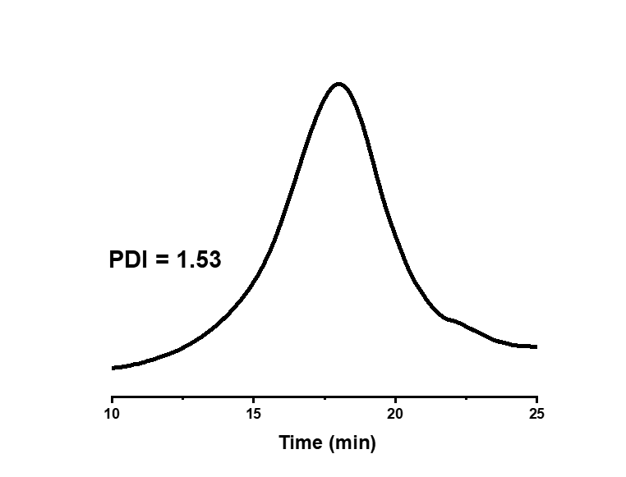
Fig. S1. Polymer probe NBMA-co-PEGMA₄₀₀ GPC trace using THF as eluent (refractive index response).

Fig. S2. Fluorescence emission spectra of polymeric probe NBMA-co-PEGMA₄₀₀ (30 µg/mL) and fluorescent monomer CMMA (5 µM) in DMSO. λ_{ex}=460 nm, Vol.=600 V, Slit =5 nm.

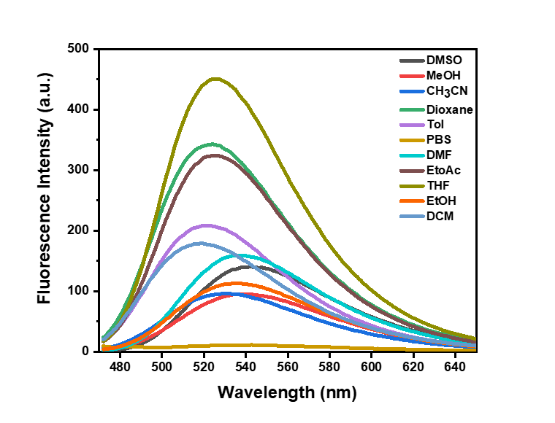
Fig. S3. Fluorescence emission spectra of probe NBMA-co-PEGMA₄₀₀ (30 μg/mL) in different solvents.

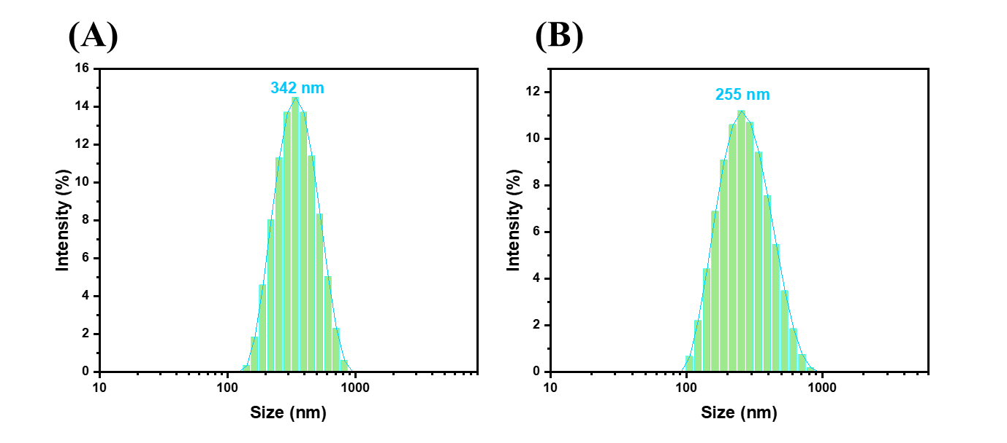
Fig. S4. (A)Particle size distribution of polymeric probe NBMA-co-PEGMA₄₀₀ (10 µg/mL) in PBS.(B) Particle size distribution of polymeric probe NBMA-co-PEGMA₄₀₀ (30 µg/mL) in PBS.

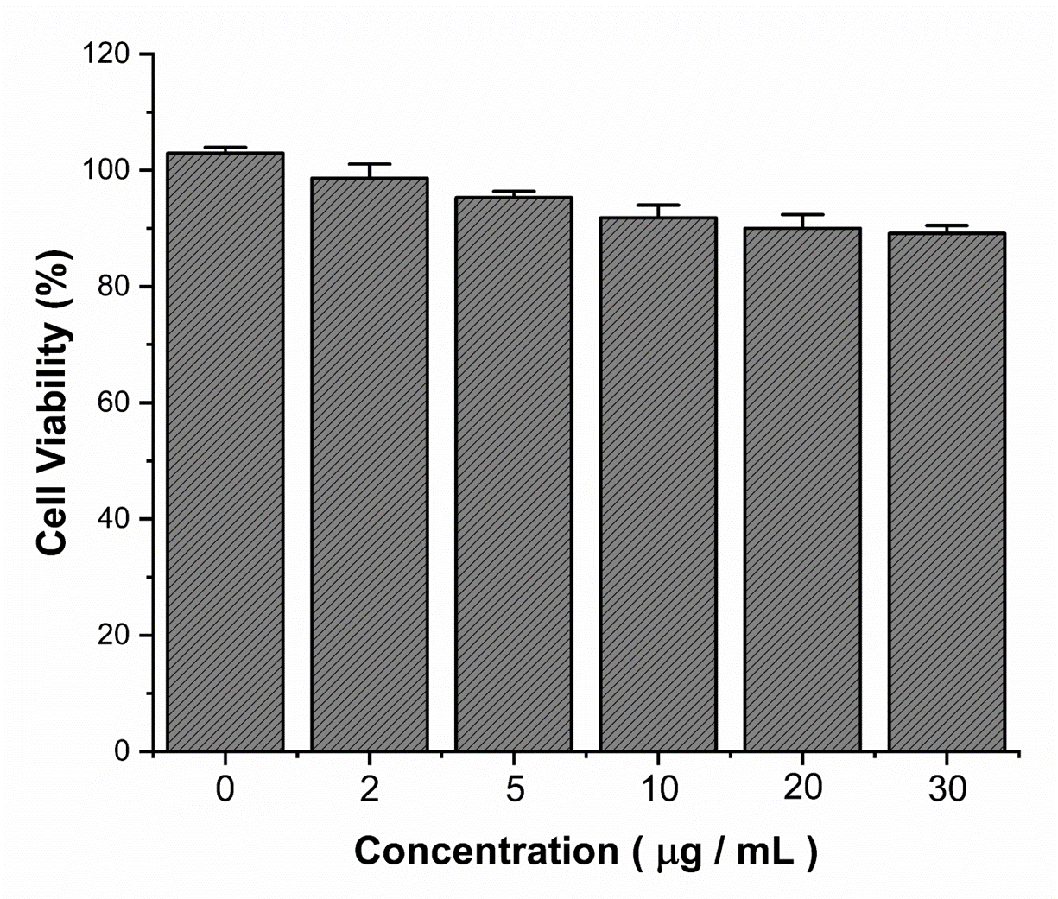
Fig. S5. Cytotoxicity assay of different concentrations of the probe NBMA-co-PEGMA₄₀₀ (0-30 μg/mL).

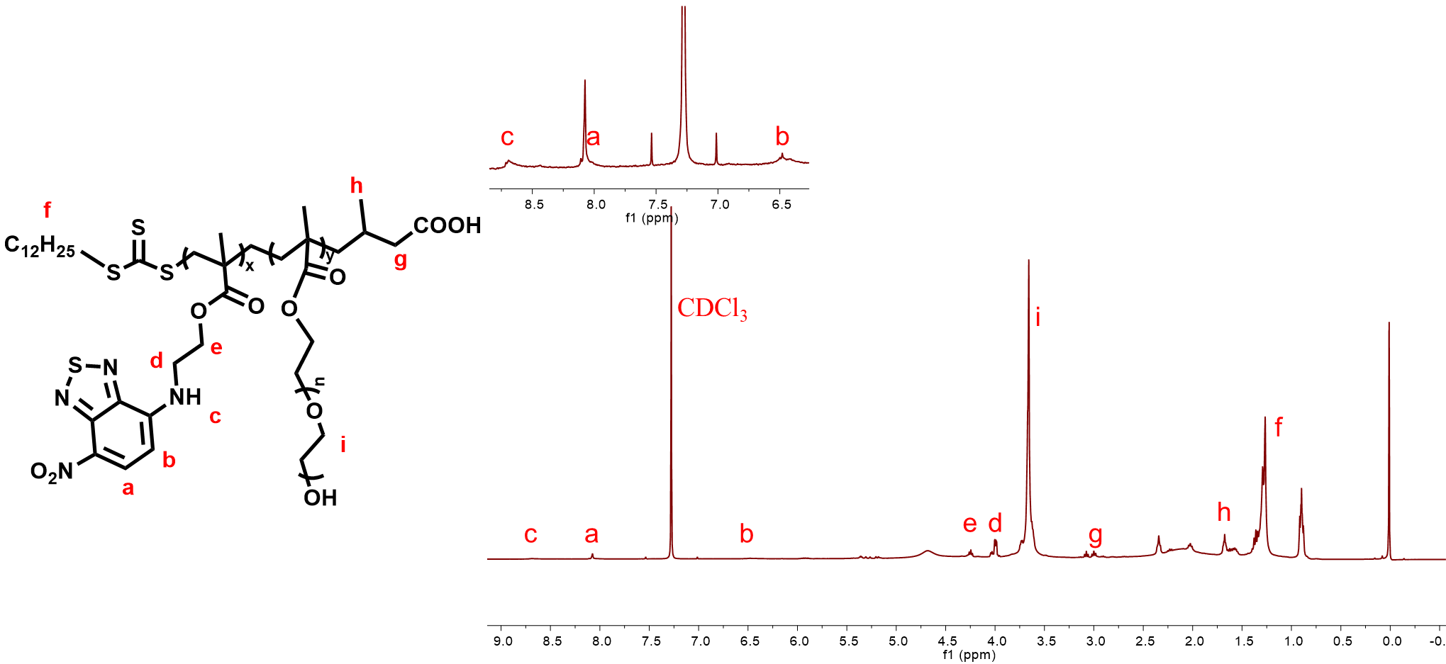
Fig. S6. ¹H NMR spectrum of polymeric probe NBMA-co-PEGMA₄₀₀ in CDCl₃.
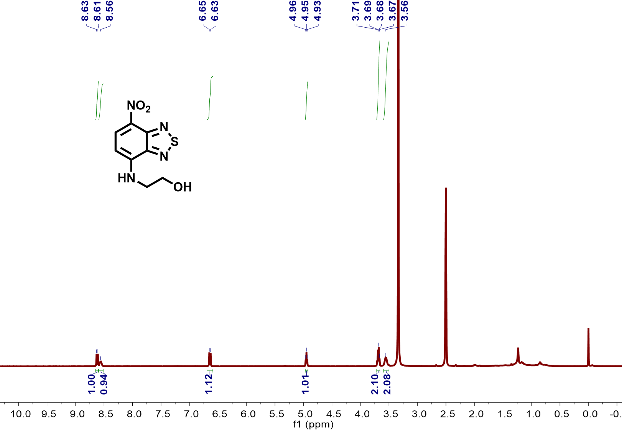
Fig. S7. ¹H NMR spectrum of compound 2 in CDCl₃.

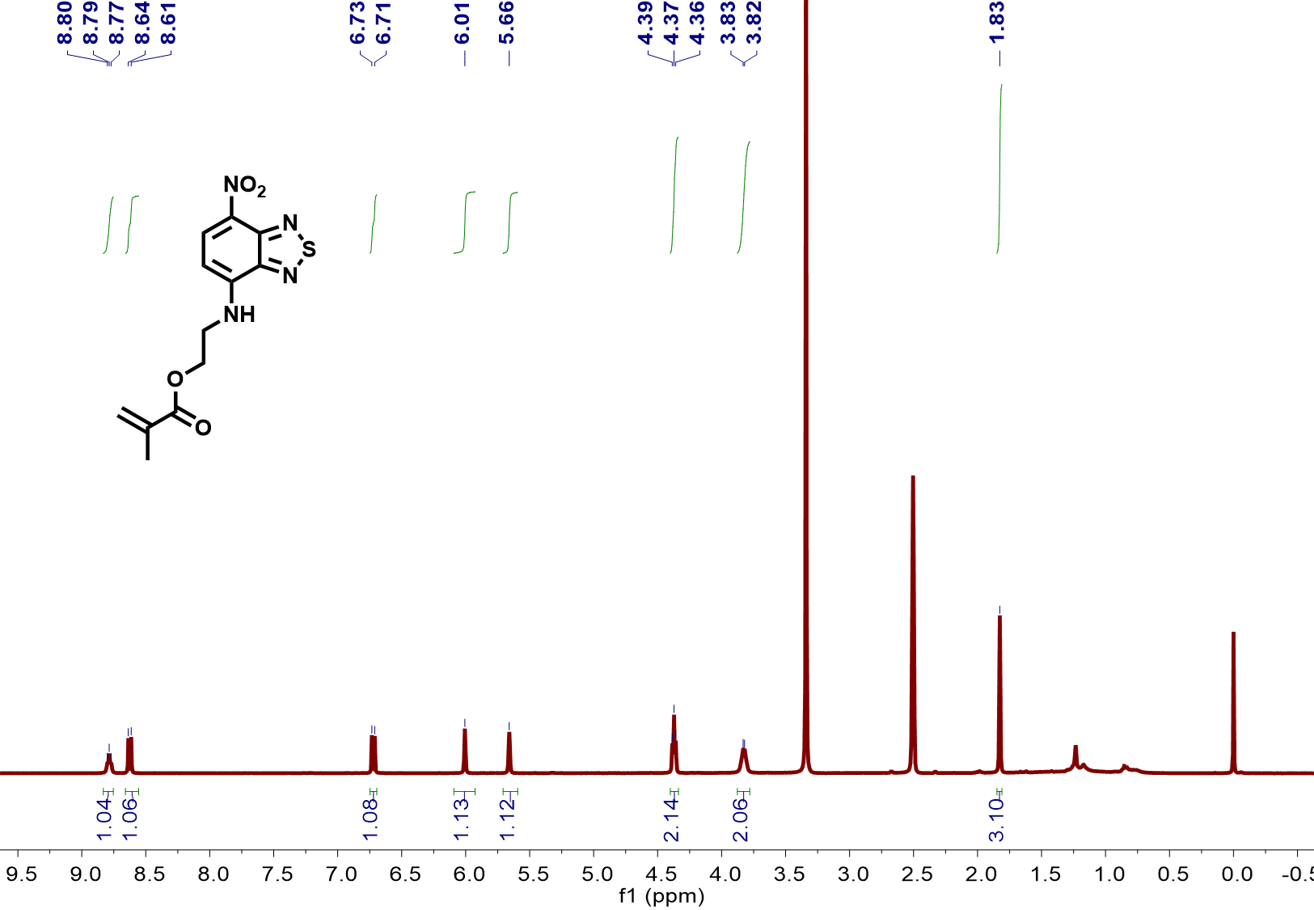
Fig. S8. ¹H NMR spectrum of compound NBMA in CDCl₃.
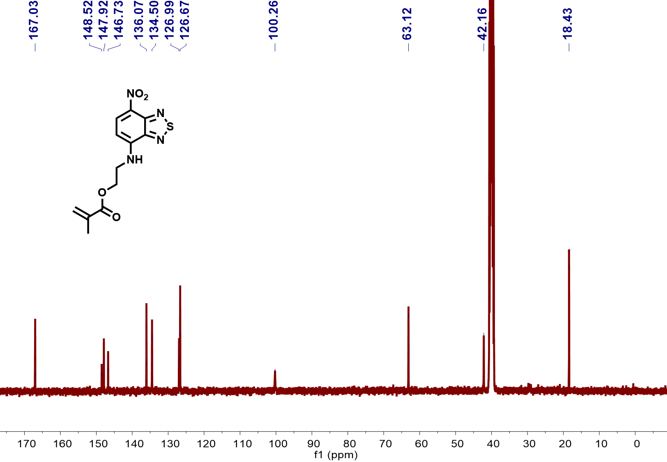
Fig. S9. ¹³C NMR spectrum of compound NBMA in DMSO-d6.

References
[1] Z. H. Zhang, C. C. Li, W. L. Cui, J. Qu, H. Zhang, K. Liu, X. Z. Zhu and J. Y. Wang, Eur. Polym. J. 166 (2022) 111030.

