SUPPLEMENTARY APPENDIX
 | Title
Figures
Figure S1 | Data Flow Diagram for the eLIXIR-BiSL data linkage
Figure S2 | Direct acyclic graph for virtual care and birth outcomes
Figure S3 | Trajectories for models 1-3
Figure S4 | Individual trajectories
Tables
Table S1 | The RESILIENT Study Group
Table S2 | Members of The Early Life Cross Linkage in Research, Born in South London (eLIXIR-BiSL) Partnership
Table S3 | Key pregnancy and birth indicators
Table S4 | Guidelines for Reporting on Latent Trajectory Studies (GRoLT) checklist
Table S5 | Trajectory criteria statistics for 1 to 5 trajectories
Table S6 | Registration characteristics from those included (n=34,114) vs those not included in the analysis (n=18,593)
Table S7 | Delivery characteristics from those included (n=34,114) vs those not included in the analysis (n=7,842)
Table S8 | Registration characteristics from those included (n=34,114) vs those without antenatal data but with delivery data (n=2,147)
Table S9 | Delivery characteristics from those included (n=34,114) vs those without antenatal data but with registration data (n=2,147)
Table S10 | Sensitivity analyses showing adjusted associations between the trajectories and birth outcomes in women and their children from the eLIXIR-BiSL

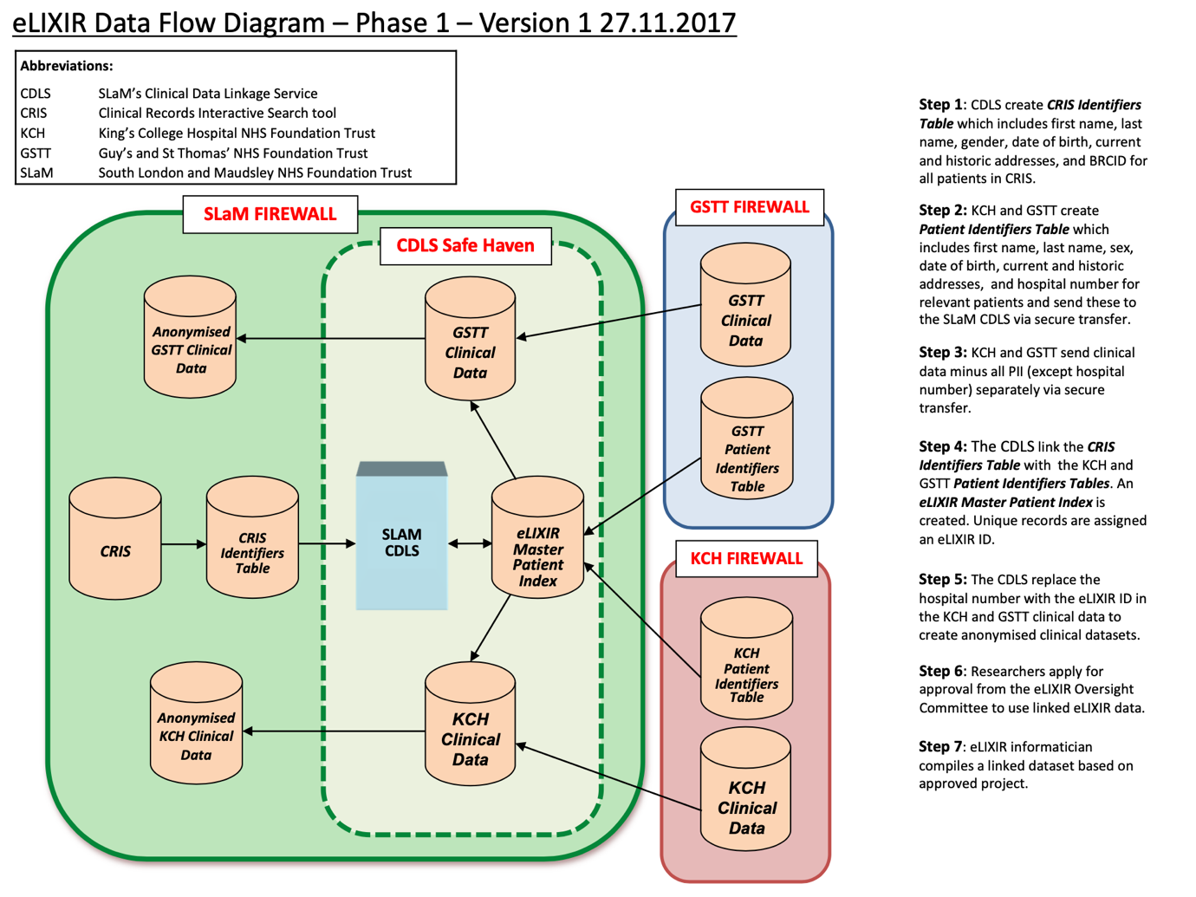
Figure S1: Data Flow Diagram for the eLIXIR-BiSL data linkage
BiSL (Born in South London), CDLS (Clinical Data-Linkage Service), eLIXIR (Early Life Cross-linkage In Research), SlaM (South London and Maudsley National Health Service Foundation Trust)
Data Linkage
This linkage of maternity, neonatal and maternal mental health records was created in 2018, generating a repository of real-time, pseudonymised, structured data derived from the electronic health record systems of National Health Service (NHS) providers in South London, UK including two acute (Guy’s and St Thomas’ Hospital NHS Foundation Trust [GSTT] and King’s College Hospital NHS Foundation Trust [KCH]), and one mental health (South London and Maudsley NHS Foundation Trust [SLaM]) provider, together with primary care data (Lambeth DataNet [LDN] for women registered in the London borough of Lambeth). These data include pregnancy records from antenatal registration appointments and assessments to birth and birth outcomes, blood test results, mental health records from secondary and community care, and postnatal information for mothers and babies up to six weeks after birth.

eLIXIR Data
Clinical data from maternity and neonatal service datasets at the two sites GSTT and KCH (Badgernet System C.com), are extracted by NHS information and communication technology staff. Following secure transfer to the SLaM Clinical Data Linkage Service (CDLS), antenatal data are linked in the CDLS Trusted Research Environment (TRE), using common identifiers, with mental health data (as relevant) from the SLaM Clinical Record Interactive Service system, and with primary care records. Match quality is 98.5% for infants with their mothers’ records. Results from all linkages (current and prior) are stored within the CDLS TRE, as are the identifier fields (used to create a ‘master patient index’) required for data linkage. This process is summarised in Figure S1.
NHS patients in the UK have the opportunity to opt out of all research by advising their general practitioner, and their data is automatically excluded from research downloads at source. Opt-out information and details of the project are also given to each patient entering maternity and neonatal services providing the option of opting out of the programme at any time, based on Section 251 approval under the NHS Act 2006 granted by the Health Research Authority Confidentiality Advisory Group (HRA CAG) to the eLIXIR team for all the standard linkages. Data are available in an identifiable format to only a small number of data-processing staff, in accordance with data sharing contracts between the data provider institutions (HRA CAG Ref: 18/CAG/0040). Ethical approval for use of clinical data was obtained from the South Central - Oxford C Research Ethics Committee (18/SC/0086, 2018-23; renewal 23/SC/0116, 2023-8).

Table S1: The RESILIENT Study Group

Chief Investigator
Prof. Laura A. Magee | Professor of Women’s Health, King's College London
Co-investigators
Prof. Debra Bick | Professor of Clinical Trials in Maternal Health, University of Warwick
Dr. Harriet Boulding | Research Fellow, The Policy Institute, King's College London
Prof. Peter von Dadelszen | Professor of Global Women's Health, King's College London
Dr. Kathryn Dalrymple | Lecturer in Nutritional Sciences, King's College London
Ms. Tisha Dasgupta | Research Associate and PhD Candidate, King's College London
Prof. Emma L Duncan | Professor of Clinical Endocrinology, King's College London
Dr. Abigail Easter | Reader in Perinatal Mental Health, King's College London
Prof. Julia Fox-Rushby | Professor of Health Economics, King's College London
Ms. Gillian Horgan | Operations Assistant, King's College London
Prof. Asma Khalil | Professor of Obstetrics and Maternal Fetal Medicine, St George's University Hospitals NHS Foundation Trust and Director of Fetal Medicine at Liverpool Women’s Hospital NHS Foundation Trust.
Ms. Alice McGreevy | Research Assistant in Health Economics, King's College London
Dr. Hiten D. Mistry | Senior Research Fellow, King's College London
Prof. Eugene C. Nelson | Professor of Community and Family Medicine, Dartmouth College, USA
Prof. Lucilla Poston | Professor of Maternal & Fetal Health, King's College London
Mr. Paul Seed | Reader in Medical Statistics, King's College London
Mr. Sergio A. Silverio | Research Fellow in Social Science of Women’s Health, King's College London and Lecturer in Medical Psychology & Lifecourse Health, University of Liverpool
Dr. Marina Soley-Bori | Lecturer in Health Economics, King's College London
Dr. Florence Tydeman | Research Associate in Medical Statistics, King's College London
Ms. Aricca Van Citters | Senior Research Scientist, Dartmouth College, USA
Dr. Sara White | Senior Clinical Lecturer in Women’s Health & Diabetes, King's College London
Prof. Ingrid Wolfe | Professor of Paediatrics and Child Population Health, King's College London
Prof. Wang Yangzhong | Professor of Statistics in Population Health, King's College London

Table S2: Members of The Early Life Cross Linkage in Research, Born in South London (eLIXIR-BiSL) Partnership
Professor Lucilla Poston | eLIXIR-BiSL Principal Investigator, and Professor of Maternal & Fetal Health, Department of Women and Children’s Health, School of Life Course and Population Sciences, King’s College London
Professor Laura A Magee | eLIXIR-BiSL Co-Investigator, Professor of Women’s Health, Department of Women and Children’s Health, School of Life Course and Population Sciences, King’s College London
Professor Robert Stewart | eLIXIR-BiSL Co-Investigator Professor of Psychiatric Epidemiology & Clinical Informatics, Department of Psychological Medicine, Institute of Psychiatry, Psychology and Neuroscience, King’s College London and NIHR Maudsley Biomedical Research Centre, South London and Maudsley NHS Foundation Trust, London. Consultant Psychiatrist at South London and Maudsley NHS Foundation Trust, London
Professor David Edwards | Chair in Paediatrics & Neonatal Medicine, Department of Perinatal Imaging and Health, King’s College London. Neonatal Consultant at Guy’s and St. Thomas’ NHS Foundation Trust
Professor Mark Ashworth | Professor of Primary Care, Department of Population Health Sciences, School of Life Course and Population Sciences, King’s College London
Professor Jane Sandall | Professor of Social Science & Women’s Health, Department of Women and Children’s Health, School of Life Course and Population Sciences, King’s College London
Dr Ingrid Wolfe | Professor of Paediatrics and Child Population Health, Department of Women and Children’s Health, School of Life Course and Population Sciences, King’s College London and Consultant in Children's Public Health Medicine and Director of the Evelina London Children’s Healthcare
Dr Cheryl Gillett | Head of Tissue Banking, Department of Comprehensive Cancer Centre, School of Cancer & Pharmaceutical Sciences, King’s College London
Dr Michael Absoud | Paediatric Consultant at Evelina London Children’s Healthcare
Dr Lucy Pickard | Consultant Paediatrician, King’s College Hospital NHS Foundation Trust
Ms Amanda Grey | Lay member of the eLIXIR Oversight Committee
Ms Sarah Spring | Lay member of the eLIXIR Oversight Committee
Ms Toyin Kazeem | Information Governance Operations Lead, South London and Maudsley NHS Foundation Trust, London
Ms Amelia Jewell | Clinical Data Linkage Service Lead, NIHR Maudsley Biomedical Research Centre, South London and Maudsley NHS Foundation Trust
Mr Matthew Broadbent | CRIS Clinical Informatics Lead, NIHR Maudsley Biomedical Research Centre, South London and Maudsley NHS Foundation Trust, London
Ms Finola Higgins | Research Informatics Programme Manager, Guy’s and St Thomas’ NHS Foundation Trust
Mr Leonardo de Jongh | Data Warehouse Manager, Guy’s and St. Thomas’s Hospital NHS Foundation Trust
Ms Tisha Dasgupta | Research Associate and eLIXIR Coordinator, Department of Women & Children’s Health, School of Life Course and Population Sciences, King’s College London
Dr Carolyn Gill | School Bioresource Manager, School of Life Course and Population Sciences, King’s College London.
Figure S2: Direct acyclic graph for virtual care and birth outcomes (co-morbidities are chronic hypertension and pre-gestational diabetes)
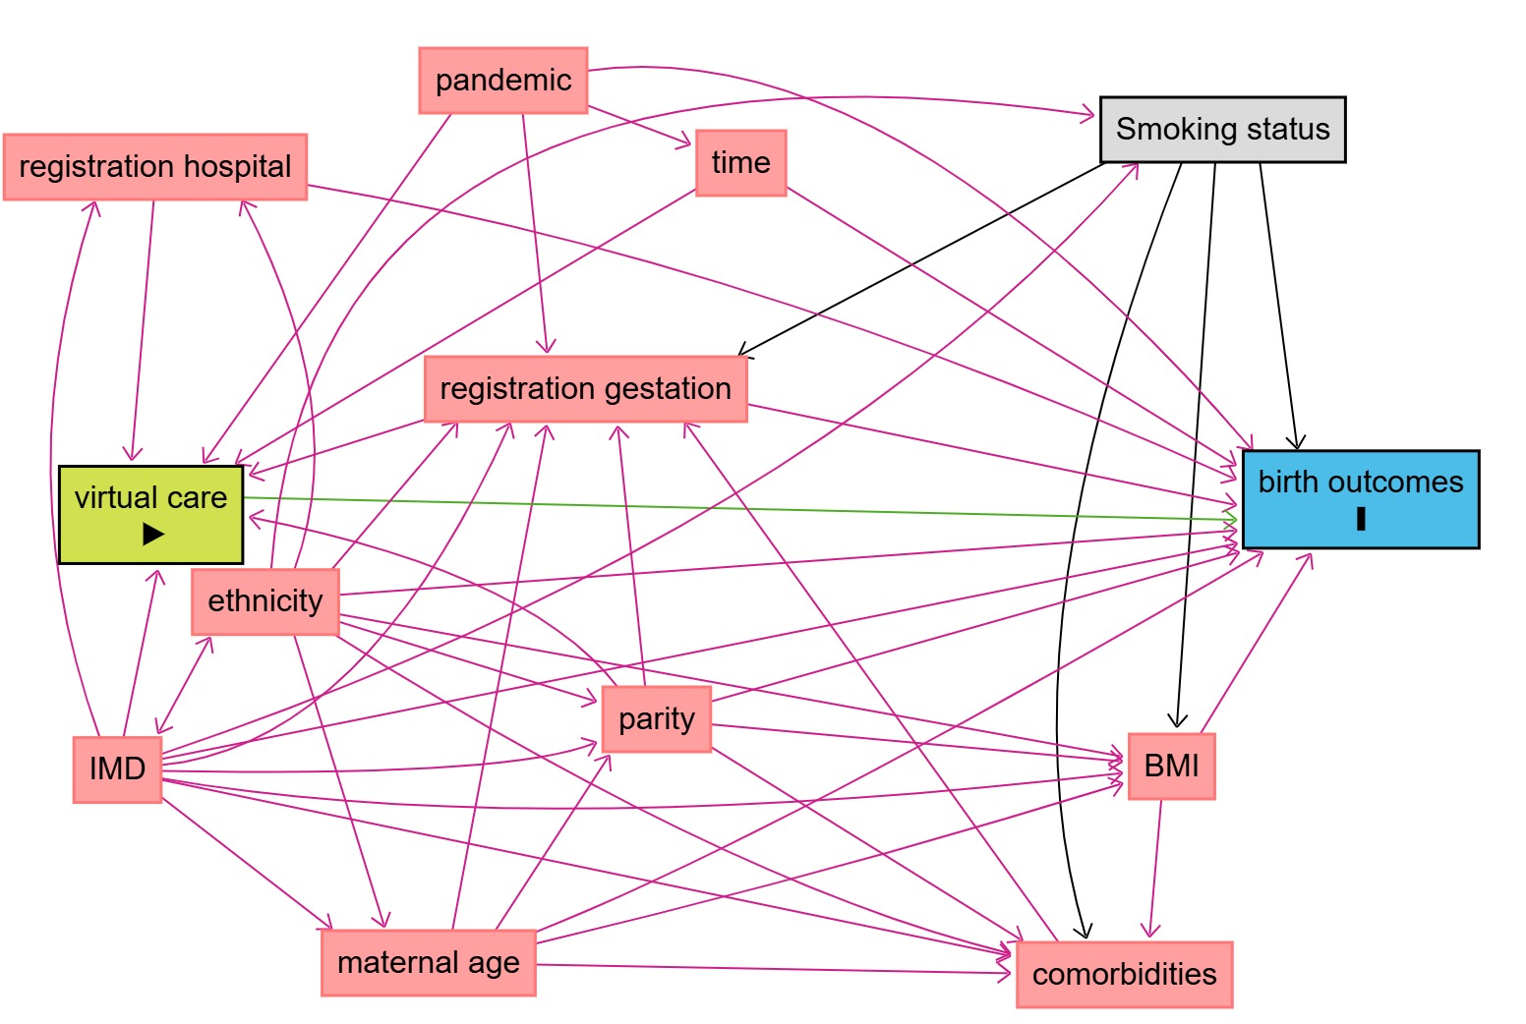

Adjustment: IMD, registration gestation, registration hospital, parity, pandemic time and smoking status

dag {
bb="0,0,1,1"
"Smoking status" [adjusted,pos="0.769,0.169"]
"birth outcomes" [outcome,pos="0.892,0.472"]
"maternal age" [pos="0.240,0.906"]
"registration gestation" [pos="0.474,0.405"]
"registration hospital" [pos="0.075,0.202"]
"virtual care" [exposure,pos="0.099,0.487"]
BMI [pos="0.780,0.611"]
IMD [pos="0.077,0.752"]
comorbidities [pos="0.700,0.818"]
ethnicity [pos="0.174,0.588"]
pandemic [pos="0.273,0.083"]
parity [pos="0.510,0.638"]
time [pos="0.500,0.213"]
"Smoking status" -> "birth outcomes"
"Smoking status" -> "registration gestation"
"Smoking status" -> BMI
"Smoking status" -> comorbidities [pos="0.653,0.623"]
"maternal age" -> "birth outcomes"
"maternal age" -> "registration gestation"
"maternal age" -> BMI
"maternal age" -> comorbidities
"maternal age" -> parity
"registration gestation" -> "birth outcomes"
"registration gestation" -> "virtual care"
"registration hospital" -> "birth outcomes" [pos="0.487,0.251"]
"registration hospital" -> "virtual care"
"virtual care" -> "birth outcomes"
BMI -> "birth outcomes"
BMI -> comorbidities
IMD -> "Smoking status" [pos="0.532,0.521"]
IMD -> "birth outcomes"
IMD -> "maternal age"
IMD -> "registration gestation"
IMD -> "registration hospital" [pos="0.003,0.465"]
IMD -> "virtual care"
IMD -> BMI
IMD -> comorbidities
IMD -> parity [pos="0.334,0.759"]
IMD <-> ethnicity
comorbidities -> "registration gestation"
ethnicity -> "Smoking status" [pos="0.490,0.259"]
ethnicity -> "birth outcomes"
ethnicity -> "maternal age"
ethnicity -> "registration gestation"
ethnicity -> "registration hospital" [pos="0.231,0.402"]
ethnicity -> BMI
ethnicity -> comorbidities
ethnicity -> parity
pandemic -> "birth outcomes" [pos="0.583,0.028"]
pandemic -> "registration gestation"
pandemic -> "virtual care"
pandemic -> time
parity -> "birth outcomes"
parity -> "registration gestation"
parity -> "virtual care" [pos="0.347,0.559"]
parity -> BMI
parity -> comorbidities
time -> "birth outcomes"
time -> "virtual care"
}

Table S3: key pregnancy and birth indicators
- Organisation Performance Indicators, | measured at antenatal registration (i.e., maternal age and N<20 years; ethnicity; index of multiple deprivation; complex social factors [e.g., difficulty understanding English, or drug use currently, ever, or previously in the last 12 months], body mass index, prior Caesarean, prior stillbirth, and gestational age at registration (including late registration >16 weeks) or at birth (interventional birth [defined below], and skin-to-skin contact within one hour).
- Clinical Quality Improvement Metrics | measured at birth (i.e., smoker at delivery, gestational age at birth, preterm birth <37 weeks, mode of birth, 3rd or 4th degree vaginal tear, 5-minute Apgar <7, and first feed as breastmilk).
- National Maternity Indicators | (i.e., mode of birth, 3rd or 4th degree vaginal tear, postpartum haemorrhage (PPH, >1L), 5-minute Apgar < 7, birthweight <10th centile with birth at ≥40 weeks, and first feed as breastmilk). Additionally, we included: intrapartum risk factors (malpresentation, gestational diabetes, high blood pressure (any), proteinuria, pre-eclampsia, postpartum haemorrhage/vaginal blood loss, placenta abruption specifically, infection, meconium, suspicious or pathological fetal heart rate or pattern, low iron, uterine rupture, reduced fetal movement, issue with FHR, delayed labour, or need for labour augmentation), gestational hypertension (defined as systolic blood pressure [BP] ≥140mmHg or diastolic BP ≥90mmHg at ≥20 weeks gestation, in women without prior chronic hypertension¹), stillbirth, small-for-gestational age (SGA, <10th centile) infants², and neonatal intensive care unit admission. Interventional birth was defined as birth by Caesarean or operative vaginal delivery (which included mid-cavity forceps without rotation; rotational forceps [including Kiellands], ventouse with rotation; low forceps without rotation; forceps not otherwise specified, and Ventouse without rotation, or Ventouse not otherwise specified).

Summary of Group-Based Trajectory Modelling
Model Adequacy
Bayesian Information Criterion (BIC) is calculated for each model and is a likelihood- based statistic, a value closer to zero implies better model fit³. The average posterior probability assignment (APPA) was calculated for each participant, with the value representing the average posterior probability of belonging to a class over all individuals assigned to a class. The APPA trajectory mean should be greater than 70%⁴. The Odds of correct classification (OCC) for each trajectory should be greater than 5. The OCC is trajectory specific; it is the ratio of the odds of a correct classification into each trajectory. Each trajectory should hold a group membership of at least 5%³. However, this is dependent on sample size; the minimum sample size recommended for latent class modelling is between 300-500, but if there is a much larger sample size then group membership can be less than 5%^{5,6}. Relative entropy estimates the accuracy (convergence) of classification of individuals into the different latent classes⁷. Entropy values close to 1 indicate greater classification certainty³.

Model Selection
The objective of model selection is to summarise the distinct features of the data considering parsimony, interpretability, and model adequacy. The BIC value is commonly used to assess the appropriate number of trajectories. However, BIC values may decrease as more classes are added reflecting model overfit³. It is therefore advised that the number of trajectories chosen be based on the lowest BIC and satisfactory values for the remaining criteria.

Group-Based Trajectory Modelling
GBTM is a semi-parametric technique used to identify distinct trajectories. Each individual in the eLIXIR-BiSL cohort had a distinct pattern of vANC during their pregnancy and distinct changes in their pattern over time, GBTM allows for the distribution of individual differences within the data to be clustered. Given that the strength and direction of change can vary for each trajectory, an intercept and slope are generated for each trajectory. GBTM fixes the slope and the intercept equally across individuals within a trajectory. GBTM can handle trajectories in the same model that follow a different pattern/shape (e.g. intercept, linear, quadratic, and cubic). As there were six gestational epochs, our analysis can accommodate cubic shape trajectories (as these require a minimum of four data points). GBTM handles missing data under the ‘missing at random’ assumption as the model uses maximum likelihood estimation.

When applying GBTM to the data, the intercept, linear, quadratic and cubic functions of each trajectory can be tested. To ensure model parsimony, non-significant cubic and quadratic terms are removed. However, linear parameters can be retained irrespective of significance as long as the BIC is lower than if an intercept parameter was used. This process is repeated until there is no evidence of an improvement in model fit assessed. A summary of the model fit criteria is summarised in Table S5. Our analysis was also confirmed using latent class analysis.

Table S4: Guidelines for Reporting on Latent Trajectory Studies (GRoLT) checklist
Item 1: metric of time | Gestational age
Item 2: fixed or varying occasion | 6 fixed gestational window; 0-14⁺⁶ weeks, 15-20⁺⁶ weeks, 21-27⁺⁶ weeks, 28-32⁺⁶ weeks, 33-36⁺⁶ weeks and +37 weeks.
Item 3a: missing data mechanism | Missing at random, there was available data at the following timepoints: 0-14⁺⁶ weeks: 28967, 15-20⁺⁶ weeks: 27003, 21-27⁺⁶ weeks: 23142, 28-32⁺⁶ weeks: 30237, 33-36⁺⁶ weeks: 30,876 and +37 weeks: 27137.
Item 3b: auxiliary variables | Supplementary Tables 6 & 7: reports the demographic differences between those included in the analysis (n=34114) and those who were excluded (n=24288 due to missing registration, delivery or antenatal data)
Item 3c: how dealt with missing data | Pregnancies with registration, at least 1 antenatal appointment and delivery data from October 2018 – July 2023 were included in the analysis
Item 4: distribution | Censored normal distribution (as the dependent was scaled)
Item 5: software | Stata 18.0 'traj' command
Item 6a: LGMM versus LCGA | Our findings for the GBTM were compared with the output of a latent class analysis.
Item 6b: across-class variance-covariance matrix | Default
Item 7: functional form | Intercept, linear, quadratic, and cubic.
Item 8: covariates | Covariates were not included in the model to predict trajectory groups
Item 9: random starts | Default
Item 10: model comparison | Average Posterior Probability Assignment, Bayesian Information Criterion, odds of correct classification, entropy, percentage of participants assigned to each group
Item 11: 1-class solution | Supplementary table 5
Item 12: sample size per class | Group 1: n=27,751 (81.3%), group 2 n=832 (2.4%), group 3 n=2410 (7.1%) and group 4: n=3121 (9.2%)
Item 13: entropy | 0.915 for the final model
Item 14a: plot of final solution | Figure 2
Item 14b: plots for each model | Supplementary figure 3
Item 14c: plots of individual trajectories | Supplementary figure 4
Item 15: descriptive statistics | Table 1
Item 16: syntax | Example code: traj , var(quartile_*) indep(t_*) model(cnorm) order(2 2 2 3) min(0) max(4)

Figure S3: Trajectories for models 1-3
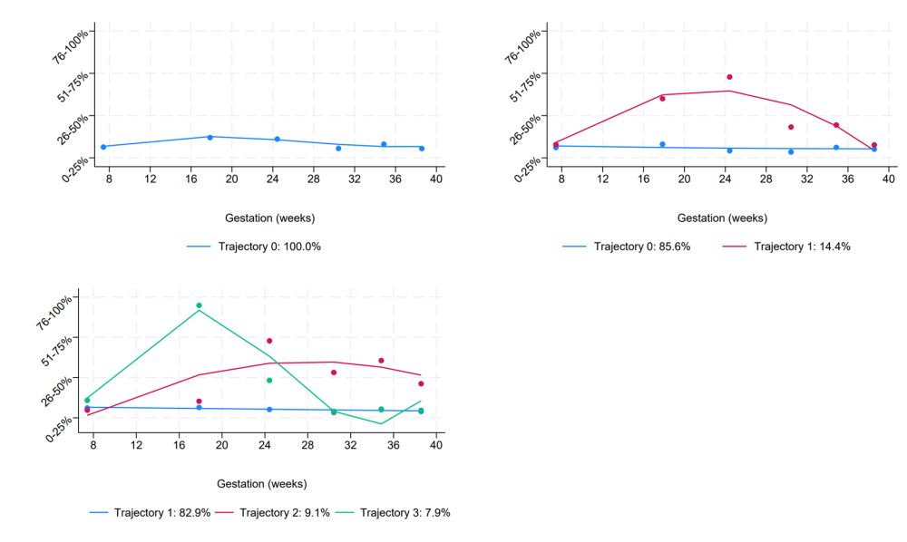

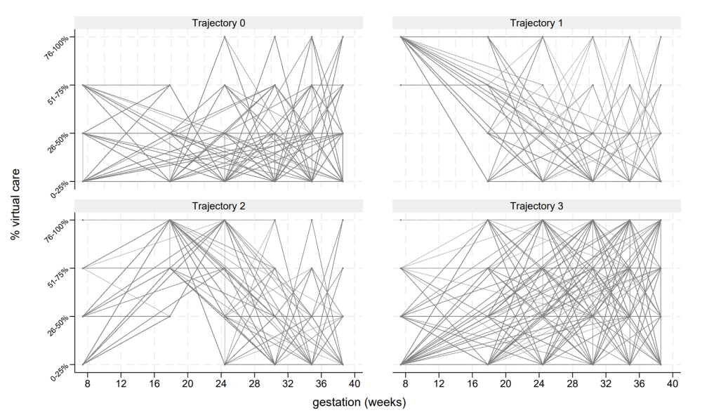
Figure S4: Individual trajectories
Table S5: Trajectory criteria statistics for 1 to 5 trajectories
 | BIC | Group membership | APPA | Entropy | OCC
1 class; order (3) | -192606 | 100%
2 classes; order (2 2) | -186826 | 87.2%  12.8% | 0.96  0.87 | 0.82 | 4.3  38.8
2 classes; order (1 3) | -184817 | 91.5%  8.5% | 0.98  0.92 | 0.91 | 6.8  127.5
2 classes; order (2 3) | -184717 | 91.9%  8.1% | 0.98  0.93 | 0.91 | 6.2  144.4
3 classes; order (1 2 3) | -178873 | 84.0%  8.7%  7.3% | 0.97  0.87  0.93 | 0.90 | 7.0  64.0  170.3
3 classes; order (2 1 3) | -179171 | 85.3%  6.7%  8.0% | 0.97  0.89  0.94 | 0.91 | 6.6  97.0  169.1
3 classes; order (2 2 3) | -179597 | 89.3%  2.4%  8.2% | 0.98  0.99  0.93 | 0.93 | 7.3  15492.2  145.8
4 classes; order (1 1 2 3) | -175030 | 7.4%  2.6%  82.3%  7.6% | 0.88  0.97  0.97  0.95 | 0.92 | 86.9  1079.2  7.5  204.5
4 classes; order (1 2 2 3) | -172981 | 7.7%  82.1%  2.4%  7.7% | 0.87  0.97  0.99  0.96 | 0.92 | 78.5  7.7  12797.1  245.2
4 classes; order (2 2 2 3) | -172617 | 2.4%  9.2%  81.3%  7.1% | 0.99  0.88  0.97  0.95 | 0.91 | 5534.1  71.0  7.6  218.6
4 classes; order (2 2 1 3) | -176703 | 10.3%  78.8%  2.7%  8.2% | 0.87  0.95  0.96  0.94 | 0.89 | 54.7  6.2  789.1  145.2
4 classes; order (2 1 2 3) | -176468 | 14.2%  79.2%  4.1%  2.5% | 0.89  0.96  0.91  0.98 | 0.90 | 45.1  7.4  215.0  1957.0
4 classes; order (2 1 3 2) | -182758 | 3.9%  0.0%  83.7%  12.4% | 0.90  -  0.96  0.86 | 0.90 | 202.7  -  5.3  42.0
5 classes; order (2 1 2 1 3) | -176573 | 1.4%  79.2%  12.1%  4.7%  2.5% | 0.77  0.96  0.86  0.87  0.98 | 0.89 | 209.8  6.7  40.0  127.6  1661.7
5 classes; order (2 2 2 2 3) | -172638 | 2.4%  0.0%  81.4%  9.2%  7.0% | 0.99  -  0.97  0.88  0.95 | 0.93 | 5534.1  -  7.6  71.0  218.6
Abbreviations: APPA: Average Posterior Probability Assignment, BIC: Bayesian Information Criteria, OCC: odds of correct classification.

Table S6: Registration characteristics from those included (n=34114) vs those not included in the analysis (n=18593)
 | All women (n=52707) | Not included n=18593 (35.3%) | Included n=34114 (64.7%) | Included vs not included
Maternal age at registration (years) | 32.9 (5.4) | 33.2 (5.5) | 32.7 (5.4) | <0.001
Age > 20 years | 618 (1.1%) | 206 (1.1%) | 412 (1.2%) | 0.309
BMI at registration (kg/m²) | 24.2 (21.6, 28.2) | 24.1 (21.5, 28.0) | 24.3 (21.7, 28.2) | <0.001
BMI missing | 3211 (6.1%) | 1709 (9.2%) | 1502 (4.4%) | <0.001
BMI category
underweight | 1274 (2.6%) | 440 (2.6%) | 834 (2.6%) | <0.001
healthy weight | 26581 (53.7%) | 9239 (54.7%) | 17342 (53.2%)
overweight | 12890 (26.0%) | 4328 (25.6%) | 8562 (26.3%)
obesity I | 5512 (11.1%) | 1872 (11.1%) | 3640 (11.2%)
obesity II | 2148 (4.3%) | 656 (3.9%) | 1492 (4.6%)
obesity III | 1091 (2.2%) | 348 (2.1%) | 741 (2.3%)
Registration Hospital (Site A) | 31628 (60.0%) | 11374 (61.2%) | 20254 (59.4%) | <0.001
Gestation at registration (weeks) | 9.7 (8.6, 12.1) | 9.6 (8.4, 12.1) | 9.7 (8.6, 12.3) | <0.001
Late registration (>16 weeks) | 7460 (14.1%) | 2856 (15.4%) | 4604 (13.5%) | <0.001
Registration timepoint
1 Oct 2018-22 Mar 2020 | 17940 (34.0%) | 5848 (31.5%) | 12092 (35.4%) | <0.001
23 Mar 2020-23 June 2020 | 3047 (5.8%) | 896 (4.8%) | 2151 (6.3%)
23 June 2020-4th Nov 2020 | 3929 (7.5%) | 1129 (6.1%) | 2800 (8.2%)
5 Nov 2020-5 Jan 2021 | 1842 (3.5%) | 521 (2.8%) | 1321 (3.9%)
6 Jan 2021-17 Jul 2021 | 6361 (12.1%) | 1723 (9.3%) | 4638 (13.6%)
18 Jul 2021 - 4 May 2023 | 19588 (37.2%) | 8476 (45.6%) | 11112 (32.6%)
IMD score
1 Most deprived | 10069 (19.1%) | 3462 (18.6%) | 6607 (19.4%) | <0.001
2 | 21343 (40.5%) | 7264 (39.1%) | 14079 (41.3%)
3 | 13022 (24.7%) | 4563 (24.5%) | 8459 (24.8%)
4 | 5141 (9.8%) | 1995 (10.7%) | 3146 (9.2%)
5 Least deprived | 2221 (4.2%) | 948 (5.1%) | 1273 (3.7%)
missing | 911 (1.7%) | 361 (1.9%) | 550 (1.6%)
Mother's ethnicity
White | 26892 (51.1%) | 9546 (51.3%) | 17346 (50.8%) | <0.001
Asian or Asian British | 5103 (9.7%) | 1736 (9.3%) | 3367 (19.9%)
Black, Black British, Caribbean or African | 10148 (19.3%) | 3066 (16.5%) | 7082 (20.8%)
Mixed or multiple ethnic groups | 2690 (5.1%) | 868 (4.7%) | 1822 (5.3%)
Other ethnic group | 3479 (6.6%) | 1165 (6.3%) | 2314 (6.8%)
missing | 4395 (8.3%) | 2212 (11.9%) | 2183 (6.4%)
Difficulty understanding English | 3575 (6.8%) | 1175 (6.3%) | 2400 (7.0%) | 0.002
Drug use in the previous 12 months | 621 (1.2%) | 169 (0.9%) | 452 (1.3%) | <0.001
Current drug use | 204 (0.4%) | 64 (0.3%) | 140 (0.4%) | 0.242
Drug use ever | 3474 (6.6%) | 1247 (6.7%) | 2227 (6.5%) | 0.429
Nulliparous | 28836 (54.7%) | 10685 (57.5%) | 18151 (53.2%) | <0.001
Multiparous women only (n=23871)
Previous c-section | 7554 (31.6%) | 2470 (31.2%) | 5084 (31.8%) | 0.337
Previous PPH | 2058 (8.6%) | 658 (8.3%) | 1400 (8.8%) | 0.244
Previous preterm birth | 1848 (7.7%) | 637 (8.1%) | 1211 (7.6%) | 0.205
Previous still birth | 425 (1.8%) | 134 (1.7%) | 291 (1.8%) | 0.480
Abbreviations: BMI: Body mass index, IMD: index of multiple deprivation, PPH: postpartum haemorrhage

Table S7: Delivery characteristics from those included (n=34114) vs those not included in the analysis (n=7842)
 | All women (n=41956) | Not included  n=7842 (18.7%) | Included  n=34114 (81.3%) | Included vs not included
Smoker at delivery | 1153 (3.8%) | 296 (3.8%) | 857 (3.5%) | <0.001
Intrapartum risk factors | 8609 (20.5%) | 1512 (19.3%) | 7097 (20.8%) | 0.003
Delivery timepoint
1 Oct 2018-22 Mar 2020 | 14352 (34.2%) | 6582 (83.9%) | 7770 (22.8%) | <0.001
23 Mar 2020-23 June 2020 | 2151 (5.1%) | 93 (1.2%) | 2058 (6.0%)
23 June 2020-4th Nov 2020 | 3132 (7.5%) | 68 (0.9%) | 3064 (9.0%)
5 Nov 2020-5 Jan 2021 | 1305 (3.1%) | 53 (0.7%) | 1252 (3.7%)
6 Jan 2021-17 Jul 2021 | 4614 (11.0%) | 210 (2.7%) | 4404 (12.9%)
18 Jul 2021 - 8 July 2023 | 16402 (39.1%) | 836 (10.7%) | 15566 (45.9%)
Age < 20 years | 522 (1.2%) | 112 (1.4%) | 410 (1.2%) | 0.103
Age at delivery | 33.0 (30.0, 36.0) | 33.0 (29.0, 36.0) | 33.0 (30.0, 36.0) | 0.001
gestation
≤24 weeks | 83 (0.2%) | 41 (0.5%) | 42 (0.1%) | <0.001
24⁺⁰-27⁺⁶ weeks | 302 (0.7%) | 149 (1.9%) | 153 (0.4%)
28⁺⁰-33⁺⁶ weeks | 673 (1.6%) | 218 (2.8%) | 455 (1.3%)
34⁺⁰-36⁺⁶ weeks | 1749 (4.2%) | 405 (5.2%) | 1344 (3.9%)
≥37 weeks | 39149 (93.3%) | 7029 (89.6%) | 32120 (94.2%)
mode of delivery
vaginal unassisted | 19893 (47.4%) | 3912 (49.9%) | 15981 (46.8%) | <0.001
assisted vaginal | 6229 (14.8%) | 1178 (15.0%) | 5051 (14.8%)
elective CS | 6719 (16.0%) | 1172 (14.9%) | 5547 (16.3%)
emergency CS | 9115 (21.7%) | 1580 (20.1%) | 7535 (22.1%)
First feed: breastmilk | 35259 (84.0%) | 6281 (80.1%) | 28978 (84.9%) | <0.001
Apgar<7 at 5minutes | 687 (1.6%) | 193 (2.5%) | 494 (1.5%) | <0.001
Induction | 8845 (21.1%) | 1355 (17.3%) | 7490 (22.0%) | <0.001
3rd or 4th degree tear | 683 (1.6%) | 158 (2.0%) | 525 (1.5%) | <0.001
Skin to skin | 36319 (87.3%) | 6405 (83.1%) | 29914 (88.3%) | <0.001
NICU | 2708 (6.5%) | 779 (9.9%) | 1929 (5.7%) | <0.001
PPH greater than 1000ml | 4,148 (9.9%) | 772 (9.2%) | 3,426 (10.0%) | 0.220
Birth outcome
livebirth | 41542 (99.0%) | 7653 (97.6%) | 33889 (99.3%) | <0.001
stillbirth | 239 (0.6%) | 101 (1.3%) | 138 (0.4%)
Neonatal death | 163 (0.4%) | 84 (1.1%) | 79 (0.2%)
Infant death | 12 (0.1%) | 4 (0.1%) | 8 (0.1%)
Sex (Male) | 21489 (51.2%) | 4051 (51.7%) | 17438 (51.1%) | 0.356
SGA <10th | 2962 (7.1%) | 612 (7.8%) | 2350 (6.9%) | <0.001
Abbreviations: CS: caesarean section, NICU: Neonatal intensive care unit, PPH: postpartum haemorrhage, SGA: Small for gestational age

Table S8: Registration of antenatal care characteristics from those included (n=34114) vs those without antenatal data but with delivery data (n=2147)
 | No antenatal data n=2147 (5.9%) | Included in analysis  n=34114 (94.1%) | Included vs not included
Registration appointment virtual | 529 (25.7%) | 857 (2.5%) | <0.001
Maternal age at registration (years) | 32.3 (5.8) | 32.7 (5.4) | <0.001
Age > 20 years | 40 (2%) | 412 (1%) | 0.008
BMI at registration (kg/m²) | 25.3 (22.3 29.5) | 24.3 (21.7 28.2) | <0.001
BMI missing | 401 (18.7%) | 1502 (4.4%) | <0.001
BMI category
underweight | 37 (2.1%) | 834 (2.6%) | <0.001
healthy weight | 803 (46.0%) | 17342 (53.2%)
overweight | 505 (28.9%) | 8562 (26.3%)
obesity I | 260 (14.9%) | 3640 (11.2%)
obesity II | 102 (5.8%) | 1492 (4.6%)
obesity III | 39 (2.2%) | 741 (2.3%)
Registration Hospital (Site A) | 1813 (84.4%) | 20254 (59.4%) | <0.001
Gestation at registration | 23.7 (10.6, 33.9) | 9.7 (8.6 12.3) | <0.001
late registration (>16 weeks) | 1213 (56.5%) | 4604 (16.5%) | <0.001
Registration timepoint
1 Oct 2018-22 Mar 2020 | 1458 (67.8%) | 12092 (35.4%) | <0.001
23 Mar 2020-23 June 2020 | 42 (2.0%) | 2151 (6.3%)
23 June 2020-4th Nov 2020 | 70 (3.3%) | 2800 (8.2%)
5 Nov 2020-5 Jan 2021 | 21 (1.0%) | 1321 (3.9%)
6 Jan 2021-17 Jul 2021 | 117 (5.4%) | 4638 (13.6%)
18 Jul 2021 - 4 May 2023 | 439 (20.4%) | 11112 (32.6%)
IMD score
1 Most deprived | 451 (21.0%) | 6607 (19.4%) | <0.001
2 | 784 (36.5%) | 14079 (41.3%)
3 | 457 (21.3%) | 8459 (24.8%)
4 | 225 (10.5%) | 3146 (9.2%)
5 Least deprived | 142 (6.6%) | 1273 (3.7%)
missing | 88 (4.1%) | 550 (1.6%)
Mother's ethnicity
White | 846 (39.4%) | 17346 (50.8%) | <0.001
Asian or Asian British | 155 (7.2%) | 3367 (9.9%)
Black, Black British, Caribbean or African | 341 (15.9%) | 7082 (20.8%)
Mixed or multiple ethnic groups | 73 (3.4%) | 1822 (5.3%)
Other ethnic group | 187 (8.7%) | 2314 (6.8%)
missing | 545 (25.4%) | 2183 (6.4%)
Difficulty understanding English | 151 (7.0%) | 2400 (7.0%) | 0.997
Current drug use | 4 (0.2%) | 140 (0.4%) | 0.109
Drug use in the previous 12 months | 13 (0.6%) | 452 (1.3%) | 0.004
Drug use ever | 56 (2.6%) | 2227 (6.5%) | <0.001
Nulliparous | 1037 (48.3%) | 18151 (53.2%) | <0.001
Inpatient antenatal care | 915 (42.6%) | 857 (2.5%) | <0.001
Multiparous women only (n=17073)
Previous c-section | 296 (26.7%) | 5084 (31.8%) | <0.001
Previous PPH | 74 (6.7%) | 1400 (8.8%) | 0.016
Previous preterm birth | 80 (7.2%) | 1211 (7.6%) | 0.623
Previous still birth | 19 (1.7%) | 291 (1.8%) | 0.788
Abbreviations: BMI: Body mass index, IMD: index of multiple deprivation, PPH: postpartum haemorrhage

Table S9: Delivery characteristics from those included (n=34114) vs those without antenatal data but with registration data (n=2147)
 | No antenatal data n=2147 (5.9%) | Included n=34114 (94.1%) | Included vs not included
Smoker at delivery | 104 (4.8%) | 857 (2.5%) | <0.001
Intrapartum risk factors | 449 (20.9%) | 7097 (20.8%) | 0.904
Delivery timepoint
1 Oct 2018-22 Mar 2020 | 1444 (67.3%) | 7770 (22.8%) | <0.001
23 Mar 2020-23 June 2020 | 48 (2.2%) | 2058 (6.0%)
23 June 2020-4th Nov 2020 | 68 (3.2%) | 3064 (9.0%)
5 Nov 2020-5 Jan 2021 | 27 (1.3%) | 1252 (3.7%)
6 Jan 2021-17 Jul 2021 | 112 (5.2%) | 4404 (12.9%)
18 Jul 2021 - 8 July 2023 | 448 (20.9%) | 15566 (45.6%)
Age < 20 years | 49 (2.3%) | 410 (1.2%) | <0.001
Age at delivery | 33.0 (28.0, 36.0) | 33.0 (30.0, 36.0) | <0.001
gestation
≤24 weeks | 29 (1.4%) | 42 (0.1%) | <0.001
24⁺⁰-27⁺⁶ weeks | 108 (5.0%) | 153 (0.4%)
28⁺⁰-33⁺⁶ weeks | 135 (6.3%) | 455 (1.3%)
34⁺⁰-36⁺⁶ weeks | 171 (8.0%) | 1344 (3.9%)
≥37 weeks | 1704 (79.4%) | 32120 (94.2%)
mode of delivery
vaginal unassisted | 1068 (49.7%) | 15981 (46.8%) | 0.020
assisted vaginal | 284 (13.2%) | 5051 (14.8%)
elective CS | 317 (14.8%) | 5547 (16.3%)
emergency CS | 478 (22.3%) | 7535 (22.1%)
First feed: breastmilk | 1517 (70.7%) | 28978 (84.9%) | <0.001
Apgar<7 at 5minutes | 103 (4.8%) | 494 (1.4%) | <0.001
induction | 332 (15.5%) | 7490 (22.0%) | <0.001
3rd or 4th degree tear | 47 (2.2%) | 525 (1.5%) | <0.001
Skin to skin | 1454 (70.6%) | 29914 (88.3%) | <0.001
NICU | 438 (20.4%) | 1929 (5.7%) | <0.001
PPH greater than 1000 | 213 (9.9%) | 3,426 (10.0%) | 0.931
Birth outcome
livebirth | 2003 (93.3%) | 33889 (99.3%) | <0.001
stillbirth | 75 (3.5%) | 138 (0.4%)
Neonatal death | 65 (3.0%) | 79 (0.2%)
Infant death | 4 (0.2%) | 8 (0.1%)
Sex (male) | 1107 (51.6%) | 17438 (51.1%) | 0.661
SGA <10th | 207 (9.6%) | 2350 (6.9%) | <0.001
Abbreviations: CS: caesarean section, NICU: Neonatal intensive care unit, PPH: postpartum haemorrhage, SGA: Small for gestational age

Summary of those included in the analysis, vs those excluded: Compared to those women included in the analysis, women excluded (n=18,593) with registration of antenatal care data were more likely to be younger, have a higher BMI, less likely to register at Site A, be register their pregnancy late or be nulliparous (Table S6). Women excluded (n=7,842) with delivery data were more likely to be a smoker, have an unassisted vaginal delivery or have a 3rd or 4th degree vaginal tear; less likely to be induced or have a Caesarean section and the infant was less likely to be offered breastmilk or have skin-to-skin after birth, more likely to be admitted to NICU, be stillborn or suffer a neonatal death (Table S7).

Table S10: Sensitivity analyses showing adjusted associations between the trajectories and birth outcomes in women and their children from the eLIXIR-BiSL
Birth outcomes |  | Traj 0 (n=23,364)  Stable | Traj 1 (n=751)  High 1st trimester | Traj 2 (n=2,359)  High 2nd trimester | Traj 3 (n=2,960)  High 3rd trimester
 |  |  | Relative risk ratio (95% confidence interval)
Truncated analysis† (n=29,434)
Smoker at deliveryª |  | Ref | 1.37 (0.87, 2.16) | 1.19 (0.91, 1.56) | 1.17 (0.92, 1.50)
Gestational hypertension |  |  | 1.09 (0.89, 1.33) | 0.86 (0.75, 0.98)* | 0.86 (0.75, 0.99)*
Preterm <37 weeks |  |  | 1.04 (0.77, 1.42) | 1.21 (1.02, 1.44)* | 1.38 (1.17, 1.62)***
Gestation at delivery | Before 24⁺⁰ weeks  24⁺⁰-27⁺⁶ weeks  28⁺⁰-33⁺⁶ weeks  34⁺⁰-36⁺⁶ weeks  >=37 weeks | Ref | -  1.28 (0.51, 3.20)  0.87 (0.44, 1.71)  1.12 (0.78, 1.62)  Ref | -  1.76 (1.08, 2.89)**  1.17 (0.82, 1.69)  1.14 (0.92, 1.41)  Ref | -  0.98 (0.52, 1.86)  1.75 (1.27, 2.41)***  1.38 (1.14, 1.68)***  Ref
Induced |  | Ref | 1.02 (0.86, 1.21) | 1.13 (1.02, 1.25)** | 1.06 (0.96, 1.17)
Breech |  |  | - | 1.89 (1.00, 3.57)* | 1.19 (0.54, 2.59)
Mode of delivery | vaginal unassisted  assisted vaginal  elective CS  emergency CS | Ref | Ref  0.85 (0.67, 1.10)  0.96 (0.78, 1.18)  0.93 (0.77, 1.13) | Ref  0.88 (0.76, 1.01)  1.07 (0.95, 1.21)  1.01 (0.90, 1.13) | Ref  0.94 (0.83, 1.07)  1.57 (1.40, 1.75)***  1.20 (1.08, 1.34)***
Third/fourth degree |  | Ref | 1.15 (0.65, 2.05) | 0.84 (0.58, 1.23) | 0.63 (0.43, 0.93)*
PPH |  | Ref | 0.98 (0.78, 1.24) | 1.14 (1.00, 1.30)** | 1.04 (0.90, 1.20)
5-min Apgar <7 |  | Ref | 0.73 (0.37, 1.43) | 1.03 (0.73, 1.50) | 0.93 (0.65, 1.34)
Birth outcome | Live birth  Stillbirth  Neonatal death | Ref | Ref  0.95 (0.30, 3.06)  1.39 (0.42, 4.54) | Ref  1.22 (0.66, 2.27)  1.10 (0.49, 2.45) | Ref  1.09 (0.59, 2.04)  0.15 (0.02, 1.10)
Sex (female) |  | Ref | 0.98 (0.84, 1.13) | 0.92 (0.85, 1.00) | 1.00 (0.92, 1.09)
SGA <10th percentile |  | Ref | 1.06 (0.80, 1.41) | 0.97 (0.82, 1.15) | 1.07 (0.91, 1.25)
Skin-to-skin (Yes) |  | Ref | 0.89 (0.71, 1.12) | 0.90 (0.78, 1.02) | 0.80 (0.71, 0.91)***
NICU admission |  | Ref | 1.14 (0.85, 1.53) | 1.04 (0.86, 1.25) | 1.32 (1.12, 1.57)**
Breastfeeding |  | Ref | 1.04 (0.82, 1.33) | 0.94 (0.83, 1.06) | 0.88 (0.79, 0.98)*
Analysis stratified by parity^{c}
Nulliparous women (n=18,151) |  | Traj 0 (n=14,711)  Stable | Traj 1 (n=425)  High 1st trimester | Traj 2 (n=1,270)  High 2nd trimester | Traj 3 (n=1,745)  High 3rd trimester
Smoker at delivery^{b} |  | Ref | 2.02 (1.13, 3.62)* | 1.30 (0.85, 1.98) | 1.23 (0.84, 1.80)
Gestational hypertension |  | Ref | 1.17 (0.91, 1.49) | 0.76 (0.64, 0.90)** | 0.81 (0.68, 0.96)*
Preterm <37 weeks |  |  | 0.98 (0.64, 1.50) | 1.30 (1.03, 1.63)* | 1.29 (1.04, 1.60)*
Gestation at delivery | <24+0 weeks  24+0-27+6 weeks  28+0-33+6 weeks  34+0-36+6 weeks  ≥37 weeks | Ref | -  1.42 (0.43, 4.64)  1.04 (0.45, 2.38)  0.94 (0.56, 1.60)  Ref | -  1.78 (0.92, 3.46)  1.37 (0.86, 2.18)  1.23 (0.93, 1.62)  Ref | -  0.96 (0.44, 2.13)  1.82 (1.21, 2.73)**  1.23 (0.95, 1.60)  Ref
Induced |  | Ref | 1.13 (0.91, 1.40) | 1.09 (0.96, 1.25) | 0.97 (0.86, 1.10)
Breech presentation |  |  | - | 3.21 (1.49, 6.96)** | 1.09 (0.32, 3.74)
Mode of delivery | vaginal unassisted  assisted vaginal  elective CS  emergency CS | Ref | Ref  0.87 (0.66, 1.14)  1.05 (0.76, 1.44)  1.06 (0.83, 1.34) | Ref  0.90 (0.76, 1.05)  0.97 (0.80, 1.18)  1.05 (0.91, 1.21) | Ref  0.92 (0.80, 1.07)  1.60 (1.34, 1.90)***  1.17 (1.03, 1.35)*
3rd/4th degree vaginal tear |  | Ref | 1.29 (0.72, 2.29) | 0.84 (0.56, 1.27) | 0.65 (0.44, 0.97)*
PPH |  | Ref | 1.03 (0.78, 1.37) | 1.15 (0.97, 1.36) | 1.13 (0.95, 1.34)
5-min Apgar <7 |  | Ref | 0.74 (0.30, 1.82) | 1.00 (0.64, 1.60) | 0.90 (0.57, 1.40)
Birth outcome | Live birth  Stillbirth  Neonatal death | Ref | Ref  0.52 (0.07, 3.81)  - | Ref  0.84 (0.33, 2.12)  0.34 (0.05, 2.50) | Ref  1.12 (0.53, 2.38)  0.23 (0.03, 1.76)
Sex (female) |  | Ref | 1.01 (0.83, 1.23) | 0.92 (0.82, 1.03) | 0.98 (0.88, 1.09)
SGA <10th percentile |  | Ref | 1.14 (0.82, 1.60) | 1.00 (0.81, 1.24) | 1.03 (0.85, 1.25)
Early skin-to-skin contact |  | Ref | 0.74 (0.55, 0.99)* | 0.85 (0.71, 1.02) | 0.77 (0.65, 0.90)**
NICU admission |  | Ref | 1.26 (0.87, 1.82) | 1.13 (0.90, 1.42) | 1.25 (1.01, 1.54)*
Breastfeeding |  | Ref | 1.25 (0.87, 1.82) | 0.94 (0.78, 1.12) | 0.95 (0.82, 1.09)
Multiparous women (n=15,963) |  | Traj 0 (n=13,040)  Stable | Traj 1 (n=407)  High 1st trimester | Traj 2 (n=1,140)  High 2nd trimester | Traj 3 (n=1,376)  High 3rd trimester
Smoker at delivery^{b} |  | Ref | 0.91 (0.48, 1.74) | 1.11 (0.79, 1.58) | 1.20 (0.89, 1.63)
Gestational hypertension |  | Ref | 1.00 (0.73, 1.37) | 1.00 (0.82, 1.23) | 0.86 (0.69, 1.08)
Preterm <37 weeks |  |  | 1.07 (0.70, 1.62) | 1.11 (0.86, 1.44) | 1.41 (1.13, 1.77)**
Gestation at delivery | <24+0 weeks  24+0-27+6 weeks  28+0-33+6 weeks  34+0-36+6 weeks  ≥37 weeks | Ref | -  1.05 (0.25, 4.45)  0.73 (0.27, 2.01)  1.23 (0.76, 1.98)  Ref | -  1.81 (0.87, 3.79)  0.90 (0.50, 1.61)  1.05 (0.76, 1.44)  Ref | -  0.83 (0.29, 2.37)  1.36 (0.85, 2.20)  1.54 (1.18, 2.00)***  Ref
Induced |  | Ref | 0.96 (0.74, 1.25) | 1.18 (1.01, 1.38)* | 1.12 (0.96, 1.30)
Breech presentation |  |  | - | 0.84 (0.25, 2.78) | 1.22 (0.46, 3.24)
Mode of delivery | vaginal unassisted  assisted vaginal  elective CS  emergency CS | Ref | Ref  0.90 (0.55, 1.47)  0.96 (0.74, 1.23)  0.87 (0.64, 1.17) | Ref  0.78 (0.57, 1.06)  1.11 (0.96, 1.29)  0.89 (0.74, 1.08) | Ref  1.05 (0.81, 1.36)  1.50 (1.30, 1.73)***  1.24 (1.05, 1.47)*
3rd/4th degree vaginal tear |  | Ref | 0.76 (0.18, 3.15) | 0.81 (0.34, 1.89) | 0.77 (0.32, 1.81)
PPH |  | Ref | 0.95 (0.67, 1.34) | 1.14 (0.93, 1.41) | 0.95 (0.75, 1.19)
5-min Apgar <7 |  | Ref | 0.95 (0.41, 2.18) | 1.09 (0.66, 1.81) | 0.77 (0.42, 1.42)
Birth outcome | Live birth  Stillbirth  Neonatal death | Ref | Ref  1.32 (0.31, 5.64)  2.61 (0.75, 9.09) | Ref  1.69 (0.74, 3.90)  1.85 (0.74, 4.66) | Ref  1.09 (0.42, 2.86)  -
Sex (female) |  | Ref | 0.94 (0.77, 1.15) | 0.92 (0.81, 1.04) | 1.06 (0.94, 1.18)
SGA <10th percentile |  | Ref | 0.80 (0.49, 1.31) | 0.91 (0.68, 1.22) | 1.12 (0.87, 1.43)
Early skin-to-skin contact |  | Ref | 1.15 (0.83, 1.60) | 0.99 (0.81, 1.20) | 0.91 (0.76, 1.08)
NICU admission |  | Ref | 0.98 (0.62, 1.54) | 0.94 (0.70, 1.27) | 1.29 (1.00, 1.65)*
Breastfeeding |  | Ref | 0.98 (0.73, 1.31) | 0.96 (0.81, 1.14) | 0.89 (0.77, 1.03)
Abbreviations: CS: Caesarean section, eLIXIR-BiSL: early Life Cross Linkage in Research, Born-in-South London; NICU: neonatal intensive care unit, PPH: postpartum haemorrhage, SGA: Small-for-Gestational-Age.
***p < 0.001; **p < 0.01; *p < 0.05. Multinominal logistic was used to assess the relationship between the four trajectories and the birth outcomes, the reference group is the stable trajectory (group 0). Models were adjusted for: parity, registration hospital, registration gestation, pandemic timepoint, smoking status at registration and an interaction between index of multiple deprivation and ethnicity.
ª modelled using negative binominal regression, adjusted for parity, gestation at registration and antenatal care type.
^{b} Not adjusted for smoking status.
^{C} Not adjusted for parity.
† Truncated analysis excluding those outside the timeframe of 1 April 2019, to 1 May 2023, to avoid potential bias by including those with short registration to birth intervals, because of late registration for antenatal care or preterm birth.

References
1 Magee LA, Brown MA, Hall DR, et al. The 2021 International Society for the Study of Hypertension in Pregnancy classification, diagnosis & management recommendations for international practice. Pregnancy Hypertens 2022; 27: 148–69.
2 Villar J, Ismail LC, Victora CG, et al. International standards for newborn weight, length, and head circumference by gestational age and sex: the Newborn Cross-Sectional Study of the INTERGROWTH-21st Project. The Lancet 2014; 384: 857–68.
3 Lennon H, Kelly S, Sperrin M, et al. Framework to construct and interpret latent class trajectory modelling. BMJ Open 2018; 8: e020683.
4 Nagin DS. Group-Based Trajectory Modeling: An Overview. ANM 2014; 65: 205–10.
5 Nagin D. Group-Base Modeling of Development. London, England: Havard University Press, 2005.
6 Andruff H, Carraro N, Thompson A, Gaudreau P, Louvet B. Latent class growth modelling: a tutorial. Tutorials in Quantitative Methods for Psychology 2009; 5: 11–24.
7 van de Schoot R, Sijbrandij M, Winter SD, Depaoli S, Vermunt JK. The GRoLTS-Checklist: Guidelines for Reporting on Latent Trajectory Studies. Structural Equation Modeling: A Multidisciplinary Journal 2017; 24: 451–67.

