Table 4. L*, a*, b*, C*ab, h, K/S values of each printing and dyeing.
Sample | Dye Shade | L* | a* | b* | C*_{ab} |  | h | K/S (410 nm)
A | 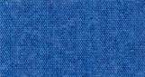 | 40.66 | 6.19 | -37.95 | 38.45 |  | 279.26 | 0.73
B | 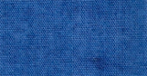 | 37.62 | 7.27 | -37.47 | 38.17 |  | 280.98 | 0.89
C | 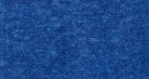 | 35.71 | 7.81 | -36.86 | 37.68 |  | 281.97 | 1.07
D | 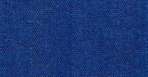 | 31.88 | 9.26 | -34.73 | 35.94 |  | 284.93 | 1.46
1 | 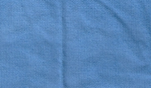 | 53.29 | -1.47 | -32.86 | 32.90 |  | 267.44 | 0.31
2 | 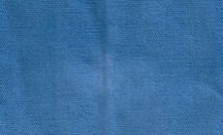 | 46.41 | 0.76 | -35.14 | 35.14 |  | 271.24 | 0.48
3 | 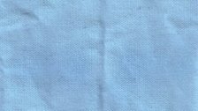 | 70.29 | -6.30 | -16.97 | 18.10 |  | 249.62 | 0.17
4 | 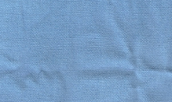 | 60.99 | -4.06 | -23.27 | 23.62 |  | 260.11 | 0.27
5 | 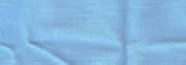 | 69.05 | -6.24 | -22.16 | 23.03 |  | 254.29 | 0.13
6 | 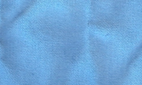 | 65.66 | -6.04 | -25.67 | 26.37 | 256.76 |  |  | 0.15
7 | 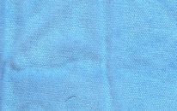 | 67.92 | -6.92 | -22.62 | 23.65 | 253.00 |  |  | 0.14
8 | 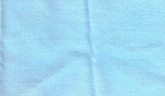 | 75.90 | -5.31 | -12.21 | 13.31 | 246.51 |  |  | 0.12
9 | 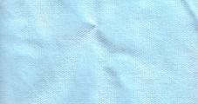 | 78.62 | -4.58 | -8.48 | 9.64 | 241.63 |  |  | 0.11
10 | 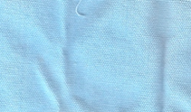 | 75.36 | -5.77 | -13.17 | 14.38 | 246.51 |  |  | 0.12

