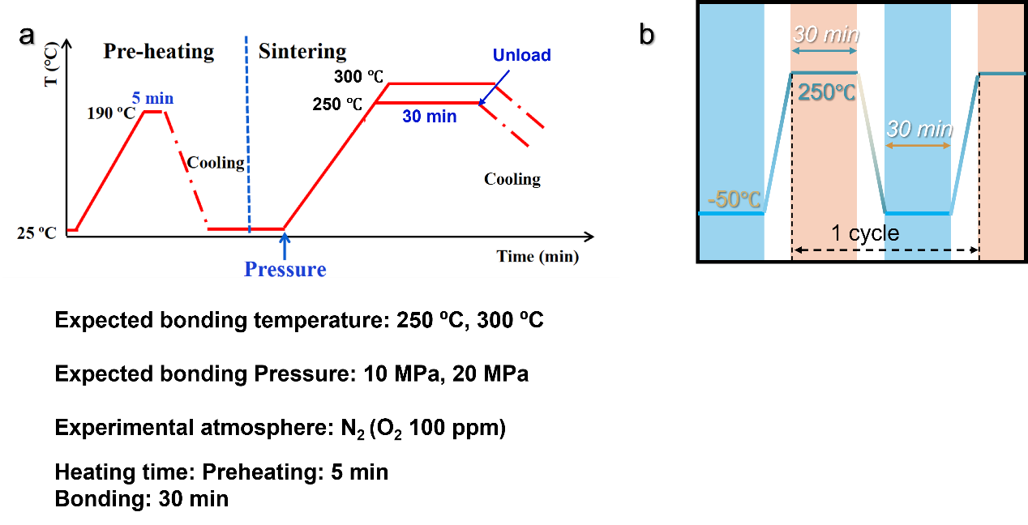
Fig. S1. a) sintering process profile to prepare bonding samples, and b) thermal cycle profile for aftertreatment.

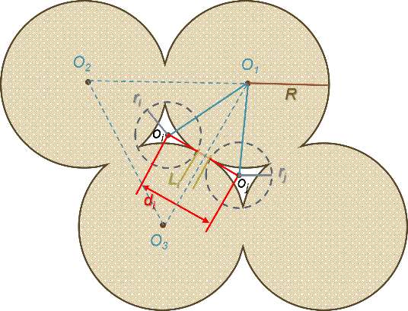
Fig. S2 Two-dimensional sintering model of four particles illustrating the method for calculating neck length and average particle dispersion.
The identification and calculation strategies for dispersion and neck length mentioned in the manuscript are introduced as follows:
Dispersion (d): starting from the center of the minimum enclosing circle of a given pore, the distances to the centers of all other pores’ minimum enclosing circles are calculated, (as shown in the figure above, denoted as d_{i}). These distances are sorted in ascending order, and the four smallest values are averaged to represent the dispersion of that pore. The average dispersion ($\overline{d}$) for the entire image is then calculated as the mean of individual dispersion values across all pores.
Neck Length (L_{i}): As illustrated above, based on the Two-dimensional sintering model of four particles shown in above image, the neck length between two adjacent particles can be calculated by:
$$\begin{aligned}L_{ij}=d_{i}-r_{i}-r_{j}\#\end{aligned}$$
While neck length is theoretically defined between pairs of adjacent pores, the algorithm assigns a neck length value to each individual pore according to closest pore pairs centered on the given pore, where pairs with calculated $L_{ij}<0$ are excluded (typically occurring in cases of highly irregular pore shapes). The neck length L_{i} of the given pore is calculated from an average of four smallest valid L_{ij} value. The average neck length ($\overline{L}$) is then calculated as the mean of all L_{i} values in the image.
Un-sintered $d_{i}$: in the case of four completely un-sintered particles arranged in a close-packed hexagonal model, the neck length L_{ij} therefore equals 0, and the center-to-center distance$O_{1}O_{3}=2R$. Assuming the particles are equal or nearly equal in size, the centers of the three particles forming an equilateral triangle. The distance from the triangle’s centroid to any vertex $O_{1}o_{j}=\frac{2\sqrt{3}}{3}R$, yielding a theoretical $d_{i}=\frac{\sqrt{2}}{3}R$ in un-sintered circumstance.
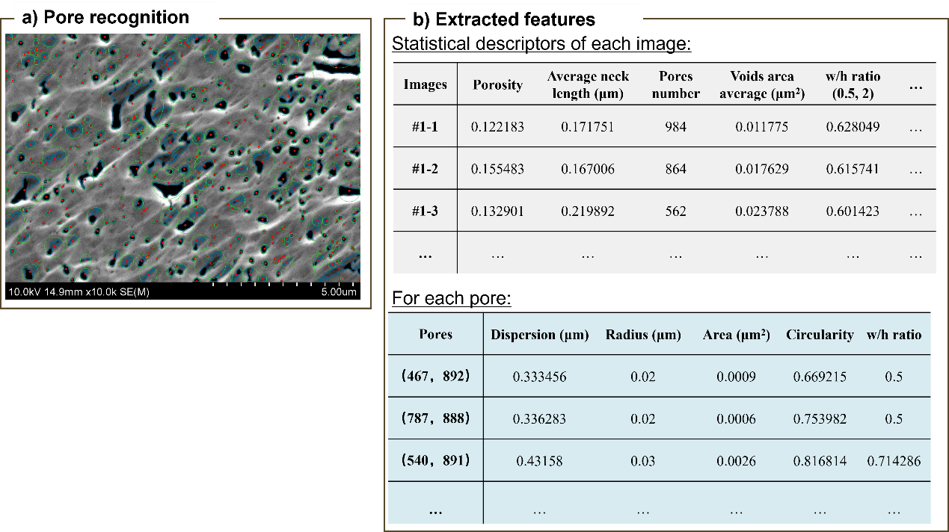
Fig. S3 Construction of the training dataset: (a) example of pore recognition and feature extraction from a cross-sectional SEM image, and b) extracted pore features and statistical descriptors for each image.

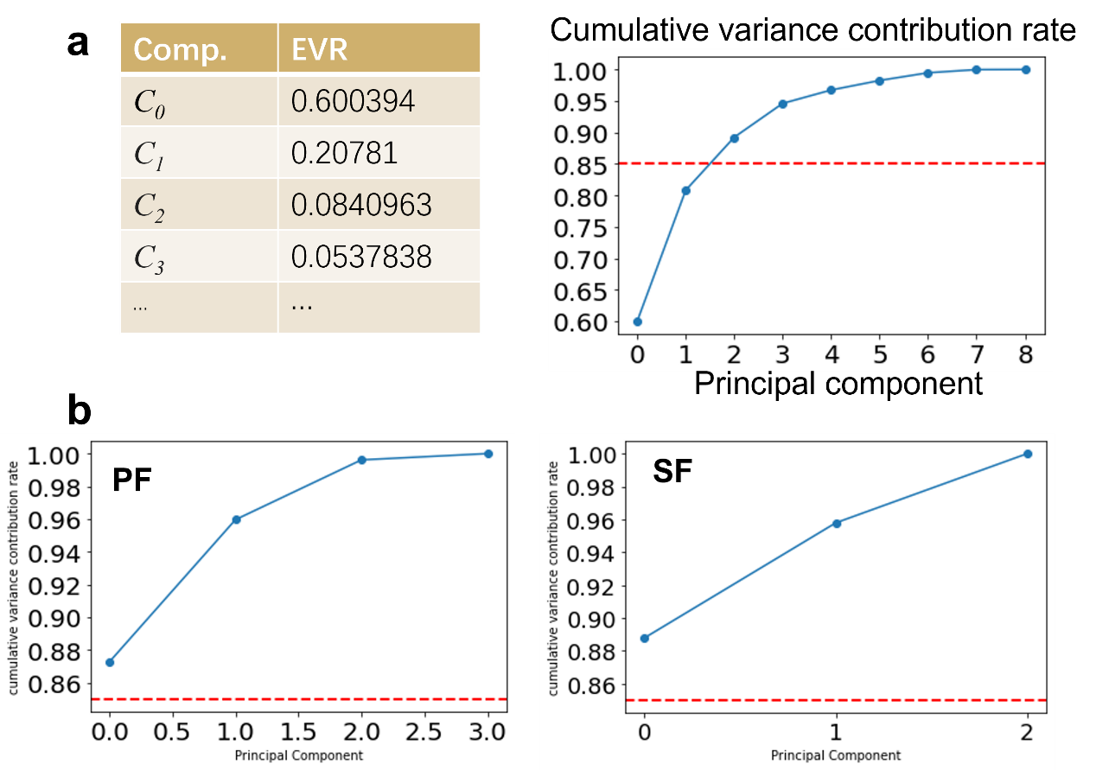

Fig. S4 a) explained variance ratio (EVR) for each principal component and cumulative variance contribution after applying PCA to all features, b) cumulative variance contribution after separately applying PCA to the porosity-related group and the shape-related group.

