Table 3. Site conditions for analysis
Site 1 | Site 2 | Site 3 | Site 4
Area for each event
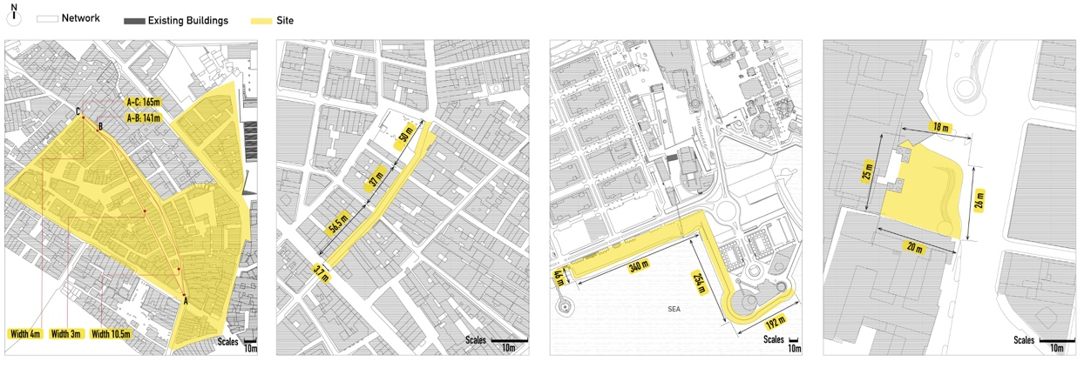
Pedestrian route, spatial nodes and lighting locations
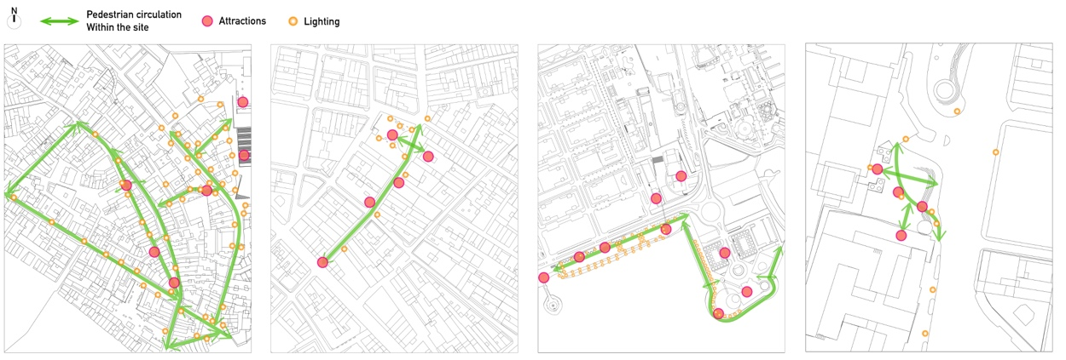
Lighting conditions of each event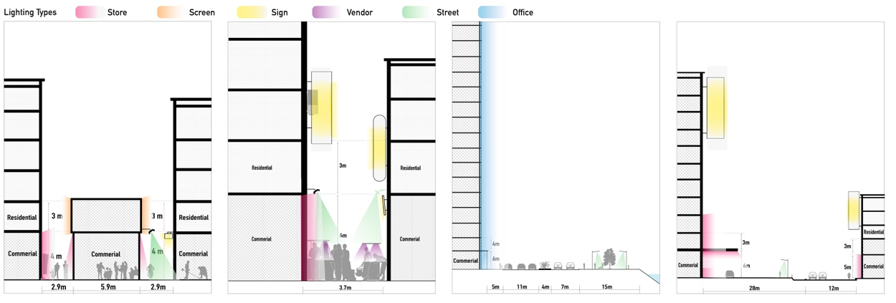
Auditory sources from each urban events
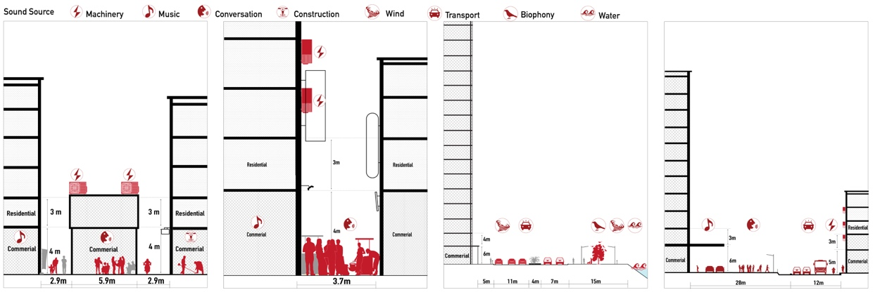
Site conditions and visual sources
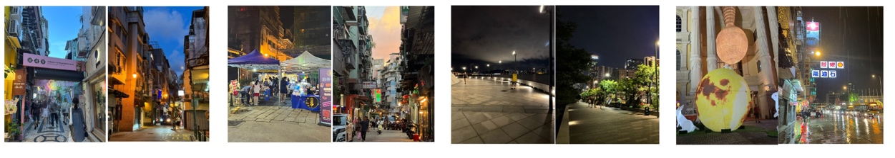

Table 8. Structural model results.
 | Model I |  |  |  |  |  | Model II |  |  |  |  |  | Model III |  |  |  |  |  | Model Ⅳ
 | β |  | f² |  | t |  | β |  | f² |  | t |  | β |  | f² |  | t |  | β |  | f² |  | t
LQ->PC |  | 0.405*** |  | 0.150 |  | 9.233 |  | 0.532*** |  | 0.323 |  | 11.643 |  | 0.309*** |  | 0.063 |  | 3.682 |  | 0.333** |  | 0.090 |  | 2.171
LQ->PR |  | 0.288*** |  | 0.135 |  | 7.286 |  | 0.244*** |  | 0.083 |  | 6.041 |  | 0.493*** |  | 0.551 |  | 9.156 |  | 0.440*** |  | 0.506 |  | 8.438
PC->PR |  | 0.594*** |  | 0.574 |  | 16.173 |  | 0.642*** |  | 0.574 |  | 17.766 |  | 0.481*** |  | 0.525 |  | 8.573 |  | 0.534*** |  | 0.744 |  | 8.916
VAP->LQ |  | 0.748*** |  | 1.273 |  | 34.118 |  | 0.770*** |  | 1.452 |  | 34.708 |  | 0.922*** |  | 5.635 |  | 105.653 |  | 0.827*** |  | 2.161 |  | 26.578
VAP->PC |  | 0.363*** |  | 0.120 |  | 8.923 |  | 0.317*** |  | 0.115 |  | 6.843 |  | 0.586*** |  | 0.227 |  | 7.175 |  | 0.485*** |  | 0.192 |  | 3.608
Note: *0.05≤p≤0.10;**0.01≤p≤0.05;***p≤0.01

Table 10. Results of multigroup analysis.
 | Model I vs. II |  | Model I vs. III |  | Model I vs. IV |  |  | Model II vs. III |  | Model II vs. IV |  | Model III vs. IV
 | Δβ | Δt | Δβ | Δt | Δβ | Δt |  | Δβ | Δt | Δβ | Δt | Δβ | Δt
VAP LQ | -0.021 | 1.990 | -0.173*** | 6.401*** | -0.078* | 1.421* |  | -0.152*** | 5.405*** | -0.057 | 0.997 | 0.095*** | 4.049***
VAP PC | 0.046 | 0.736 | -0.223** | 2.653** | -0.122 | 1.074 |  | -0.268*** | 3.067*** | -0.168* | 1.302* | 0.101 | 0.558
LQ PC | -0.126** | 1.990** | 0.096 | 1.093 | 0.073 | 0.586 |  | 0.222** | 2.514** | 0.199* | 1.527* | -0.023 | 0.123
LQ PR | 0.044 | 0.778 | -0.205*** | 3.136*** | -0.152* | 1.530* |  | -0.249*** | 3.757*** | -0.196** | 1.876** | 0.053 | 0.463
PC PR | -0.048 | 0.930 | 0.113** | 1.753** | 0.060 | 0.644 |  | 0.160** | 2.522** | 0.108 | 1.142 | -0.053 | 0.411
Note: *0.05≤p≤0.10;**0.01≤p≤0.05;***p≤0.01 |  |  |  |  |  |  | 