Supplementary Information
Effect of geometric structures on initial filtration and dust loading performance of bimodal coarse fibrous filter media: a numerical study
Yu Song *, Min Du, Yuhai Yan, Jiawei Liu, and Rongwu Wang
Engineering Research Center of Technical Textiles, Ministry of Education, College of Textiles, Donghua University, Shanghai 201620, China

*Corresponding author.
E-mail address: songyu@dhu.edu.cn (Y. Song)

This supplementary information includes:
Fig. S1 to S9, and Table S1 to S5.

Table S1 Collision model parameters.
Parameter | Values
Boltzmann constant, k_{B} (J/K) | 1.38×10⁻²³
Temperature, T (K) | 300
Relative permittivity, Ɛ | 3.8 (A2), 2.3 (PET), 3.8 (Nylon), 1.0 (Air)
Plank's constant, h (J*s) | 6.63×10⁻³⁴
Main electronic absorption frequency, v_{e} (s⁻¹) | 3.00×10¹⁵
Refractive index, n | 1.45 (A2), 1.6 (PET), 1.54 (Nylon), 1.0 (Air)
Hamaker constant, H (×10⁻²⁰) | 7.55 (PET-A2), 6.96 (Nylon-A2), 7.26 (Fiber-A2), 5.97 (A2-A2)

Table S2 Simulation parameters.
Parameter | Values
Face velocity, u (cm/s) | 20
Particle concentration, c (mg/m³) | 150
Particle density, ρ (kg/m³) | 1808
Air density, ρ_{air} (kg/m³) | 1.204
Air dynamic viscosity, μ (kg/ms) | 1.834×10⁻⁵
Simulation time per batch, t (s) | 45
Number of particles per batch | 108970

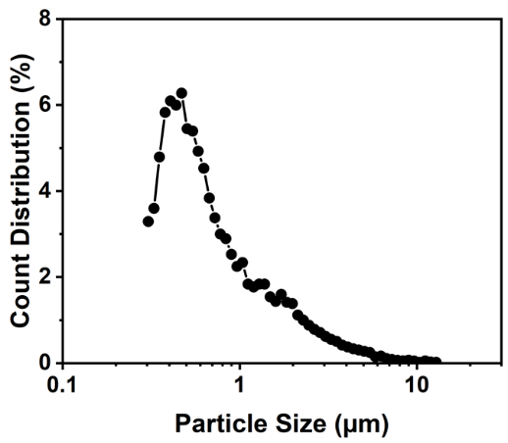
Fig. S1. Particle size distribution [1].

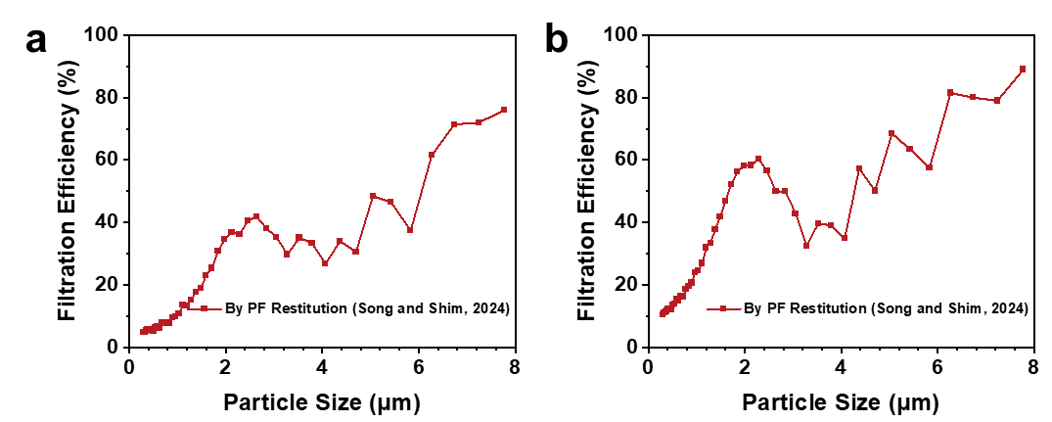
Fig. S2. Simulated fractional efficiency using the restitution coefficient from our previous work [1] based on the generated 3D structure in (a) Fig. S5a-8.5μm and (b) Fig. S5a-6μm.

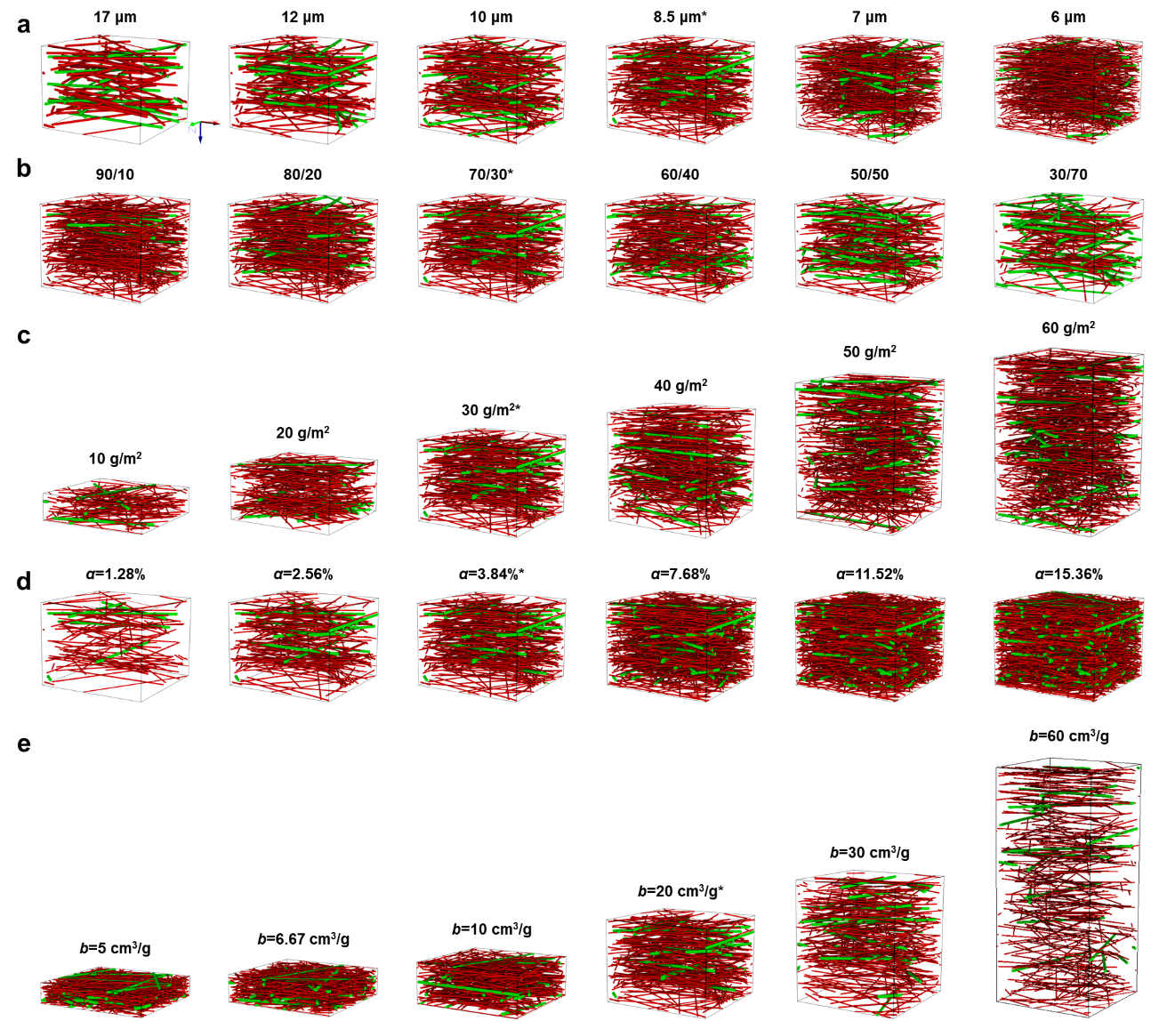
Fig. S3. Virtual 3D structures of filter media with various geometric parameters. (a) Fine fiber diameter, (b) mass blend ratio, (c) filter basis weight, (d) filter solidity, and (e) filter bulkiness. (* Indicates the same filter structure in Fig. 1a without inflow/outflow region.)
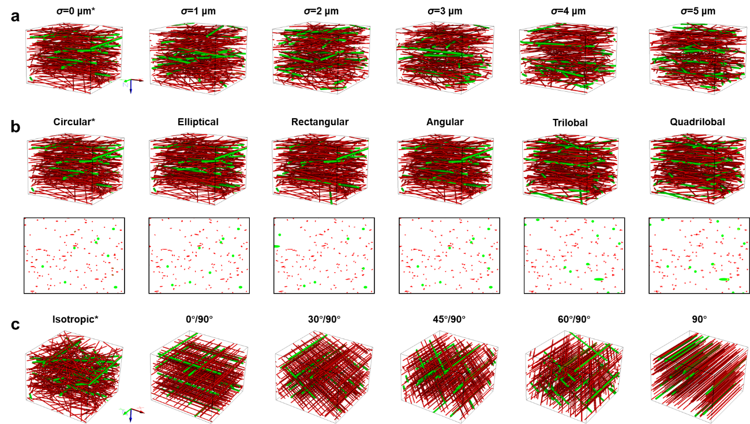
Fig. S4. Virtual 3D filter media structures with various geometric parameters (continued). (a) Fine fiber diameter distribution, (b) fine fiber cross-section shape, (c) in-plane fiber orientation. (* Indicates the same filter structure in Fig. 1a without inflow/outflow region.)

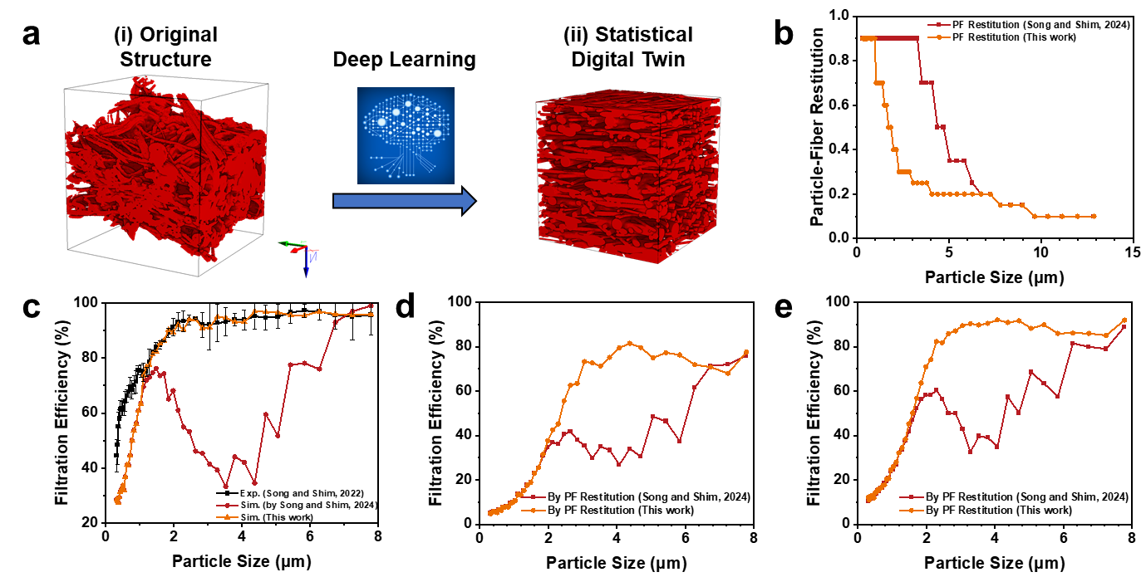
Fig. S5. (a) Creating a statistical digital twin from a non-uniform 3D filter structure [2] assisted by deep learning. (b) Comparison of PF restitution coefficients in our previous work [1] and this work. Initial fractional efficiency based on (c) the statistical digital twin, (d) the generated 3D structure in Fig. S5a-8.5μm, and (e) Fig. S5a-6μm. (The involved experimental results in Fig. S3c were conducted and reported in the previous work [2]; dimensions, Fig. S5a-(i): 660*660*723 μm³, Fig. S5a-(ii): 600*600*619 μm³; slices with filter solidity <1% were ignored in digital twin generation, leaving a thickness of 619 μm)

Table S3 Key structural characteristics of virtual filters with various fiber diameter distributions of the fine fibers.
Case | d_{fine}, μm | d_{coarse}, μm | D₅₀, μm | Specific surface area, m²/m³
S1-1* | 8.5 ± 0 | 20 | 68.61 | 8849
S1-2 | 8.5 ± 1 | 20 | 67.94 | 8728
S1-3 | 8.5 ± 2 | 20 | 70.53 | 8467
S1-4 | 8.5 ± 3 | 20 | 72.14 | 8072
S1-5 | 8.5 ± 4 | 20 | 72.73 | 7680
S1-6 | 8.5 ± 5 | 20 | 72.86 | 7687
* Indicates the case of the filter structure in Fig. 1a/Fig. S3a-8.5μm.

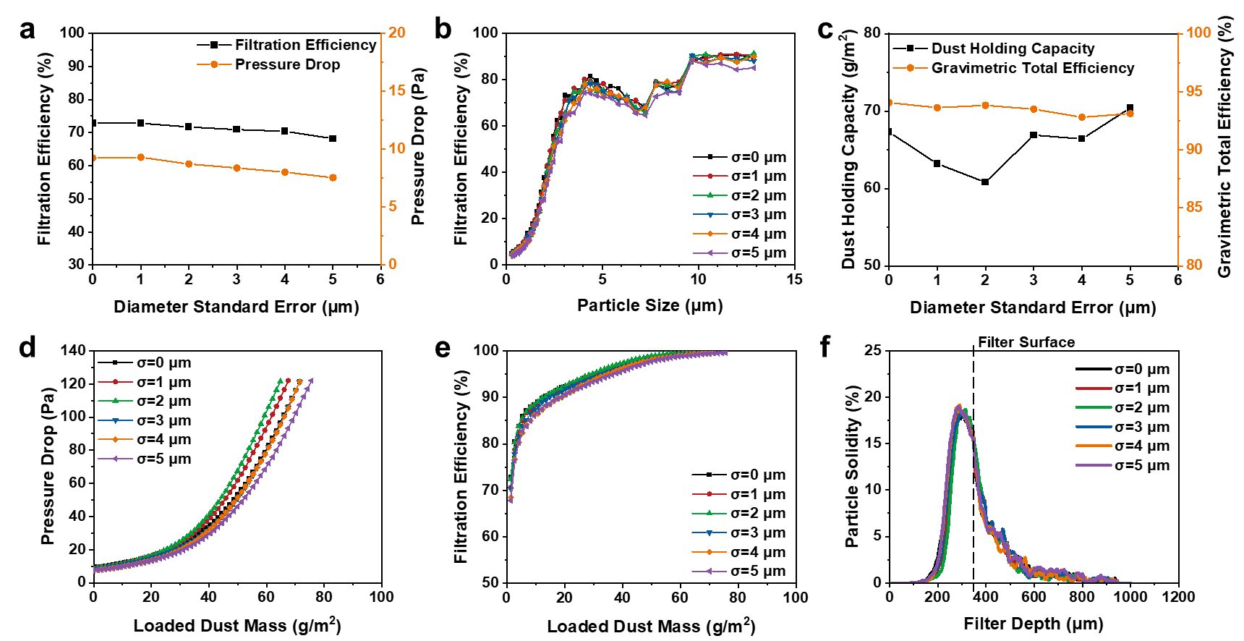
Fig. S6. Effect of fine fiber diameter distribution. (a) Initial filtration efficiency and pressure drop, (b) initial fractional efficiency. (c) Dust holding capacity and gravimetric total efficiency at 120 Pa, (d) pressure drop evolution, and (e) filtration efficiency evolution during dust loading, and (f) particle deposition profile across filter depth.
Table S4 Key structural characteristics of virtual filters with various cross-section shapes of fine fibers.
Case | Fine fiber  cross-section shape | Coarse fiber  cross-section shape | D₅₀, μm | Specific surface area, m²/m³
S2-1* | Circular | Circular | 68.61 | 8849
S2-2 | Elliptical | Circular | 67.94 | 9550
S2-3 | Rectangular | Circular | 70.53 | 9959
S2-4 | Angular | Circular | 72.14 | 10462
S2-5 | Trilobal | Circular | 72.73 | 10810
S2-6 | Quadrilobal | Circular | 72.86 | 12196
* Indicates the case of the filter structure in Fig. 1a/Fig. S3a-8.5μm.

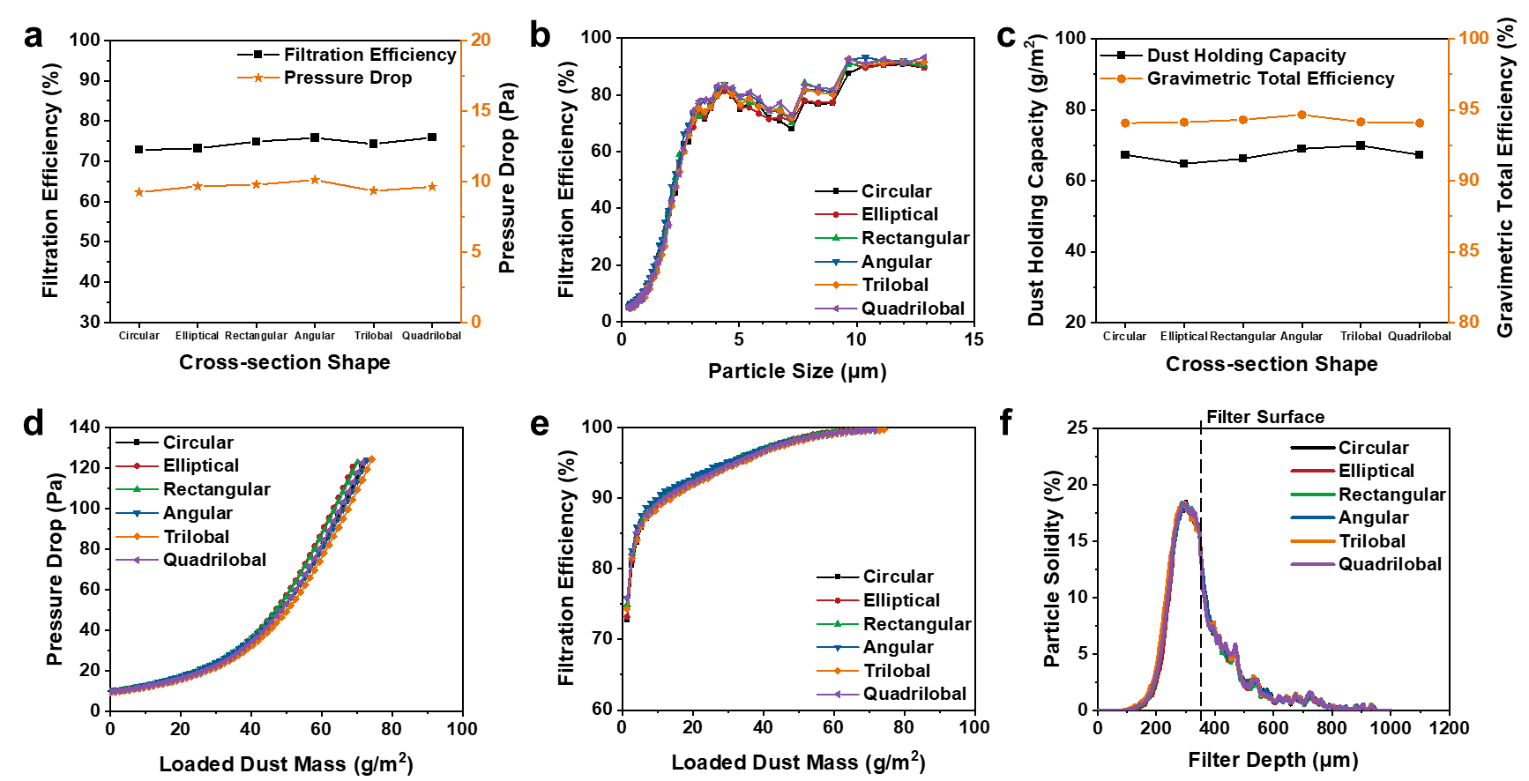
Fig. S7. Effect of fine fiber cross-section shape. (a) Initial filtration efficiency and pressure drop, (b) initial fractional efficiency. (c) Dust holding capacity and gravimetric total efficiency at 120 Pa, (d) pressure drop evolution, and (e) filtration efficiency evolution during dust loading, and (f) particle deposition profile across filter depth.
Table S5 Key structural characteristics of virtual filters with various in-plane fiber orientations of the fine fibers.
Case | Fiber Orientation | Fraction | D₅₀, μm
S3-1* | Isotropic | 100% | 68.61
S3-2 | 0°/90° | 50%/50% | 63.97
S3-3 | 30°/90° | 50%/50% | 54.31
S3-4 | 45°/90° | 50%/50% | 62.08
S3-5 | 60°/90° | 50%/50% | 54.13
S3-6 | 90° | 100% | 42.86
* Indicates the case of the filter structure in Fig. 1a/Fig. S3a-8.5μm.

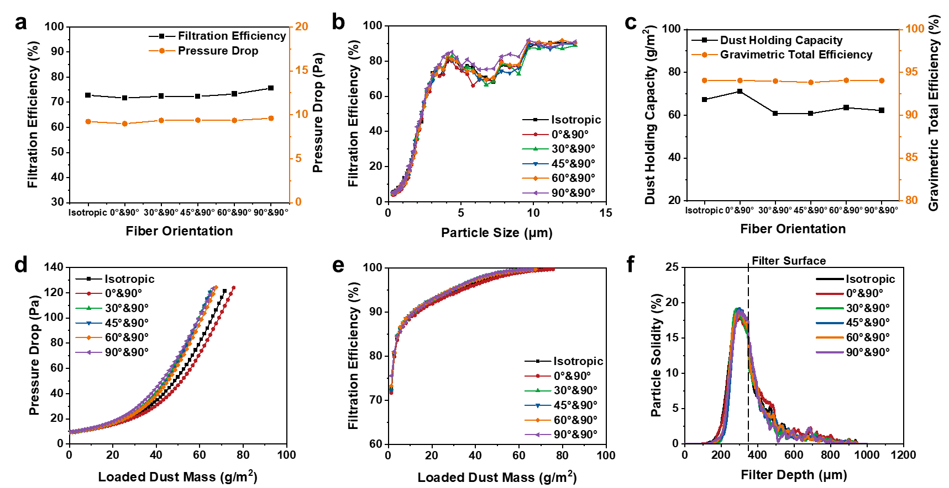
Fig. S8. Effect of in-plane fiber orientation. (a) Initial filtration efficiency and pressure drop, (b) initial fractional efficiency. (c) Dust holding capacity and gravimetric total efficiency at 120 Pa, (d) pressure drop evolution, and (e) filtration efficiency evolution during dust loading, and (f) particle deposition profile across filter depth.
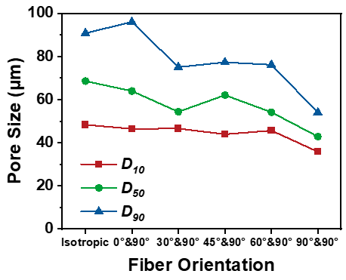
Fig. S9. D₁₀, D₅₀, and D₉₀ of filter structures with various fiber orientations.

References
[1] Y. Song, E. Shim, High-fidelity 3D simulation of dust-loading behavior and clogging process of coarse nonwoven filter media considering collision effect, Sep. Purif. Technol. 344 (2024) 127046. https://doi.org/10.1016/j.seppur.2024.127046.
[2] Y. Song, E. Shim, 3D X-ray tomographic microstructure analysis of dust-clogging inside nonwoven fibrous filter media, J. Memb. Sci. 664 (2022) 121067. https://doi.org/10.1016/j.memsci.2022.121067.

