Extended Data Figures
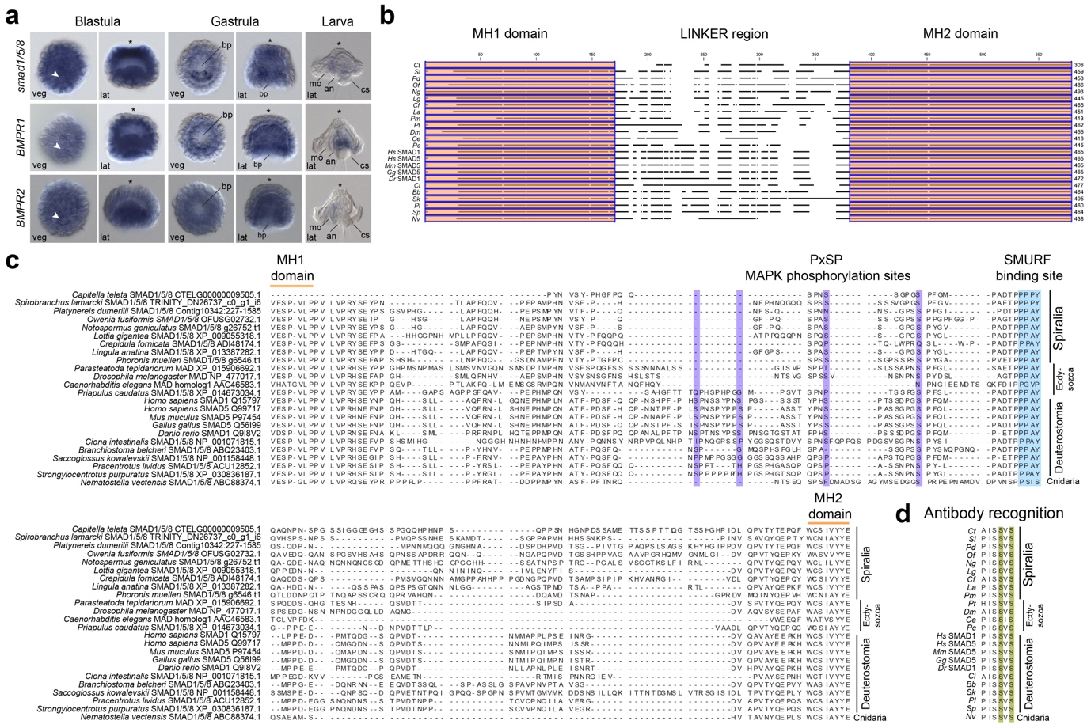
Extended Data Fig. 1 | The BMP pathway and conservation of Smad1/5/8 in O. fusiformis. (a) Whole mount in situ hybridisation of the secondary messenger smad1/5/8 and receptors bmpr1 and bmpr2 of the BMP pathway at the blastula (6 hpf), gastrula (9 hpf) and larval (24 hpf) stages in O. fusiformis. (b) Schematic diagram of a multiple protein alignment of the MH domains and linker region of SMAD1/5/8 across bilaterian and cnidarians highlighting the high conservation of the MH domains. (c) Multiple protein alignment in the linker region of SMAD1/5/8 showing the presumptive MAPK phosphorylation sites (highlighted in violet). Only Deuterostomes have all sites conserved. (d) Multiple protein alignment of the C-terminus of SMAD1/5/8 proteins showing the conserved residues recognised by the pSMAD1/5/8 antibody used in this study. In (a), the arrowheads point to the 4d organiser, and the asterisks mark the animal/apical pole. Scale bars are 50 µm. an anus, ao apical organ, bp blastopore, ch chaetae, cs chaetal sac, fg foregut, lat lateral, mo mouth, pt prototroch, veg vegetal.

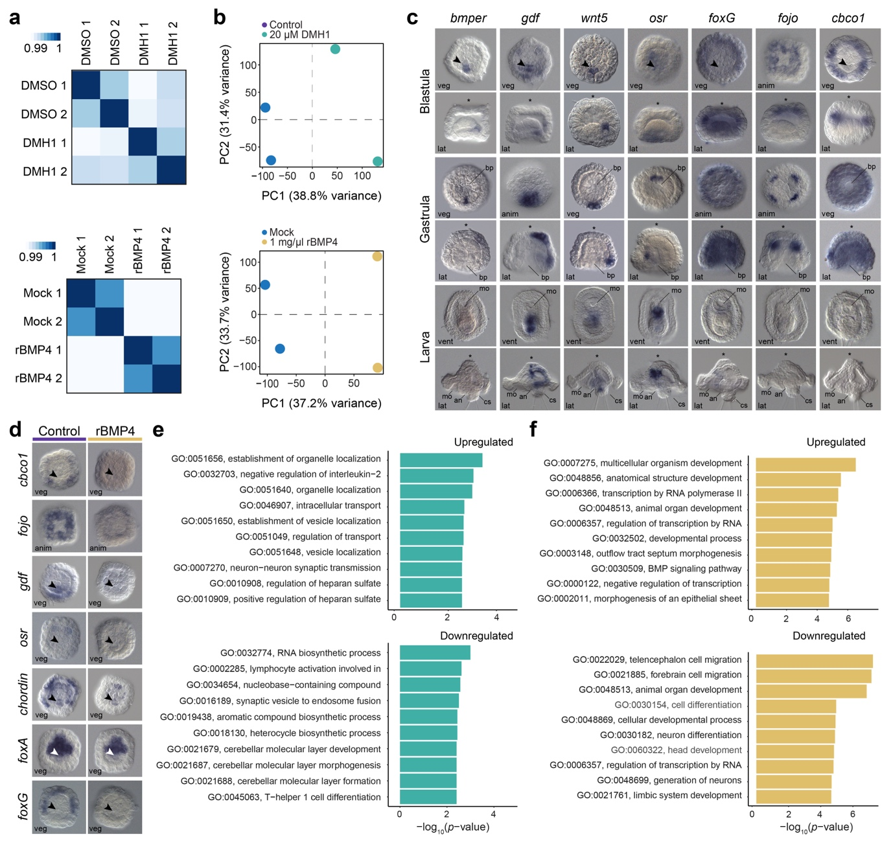
Extended Data Fig. 2 | Differential gene expression analyses in DMH1 and rBMP4-treated O. fusiformis embryos. (a) Hierarchically clustered pairwise correlation matrix between DMH1 (top) and rBMP4 (bottom) treated and control samples. The scale shows the relative difference in Euclidean distance. (b) Principal component (PC) analysis plots for DMH1 (top) and rBMP4 (bottom) transcriptomic analyses indicate that the main source of transcriptional variability between samples is the treatment condition (PC1). (c) Whole mount in situ hybridisation of selected candidate, differentially expressed genes in the rBMP4-treated condition, at the blastula, gastrula, and larval stages. (d) Whole mount in situ hybridisation validates the downregulation of candidate genes at the blastula stage (6 hpf) after rBMP4 treatment. (e, f) Bar plots showing the top ten enriched Gene Ontology terms in differentially expressed genes after DMH1 (e) and rBMP4 treatment (f). In (c, d), the arrowheads point to the 4d organiser, and the asterisks mark the animal/apical pole. Scale bars are 50 µm. an anus, anim animal, ao apical organ, bp blastopore, ch chaetae, cs chaetal sac, fg foregut, lat lateral, mo mouth, pt prototroch, veg vegetal.

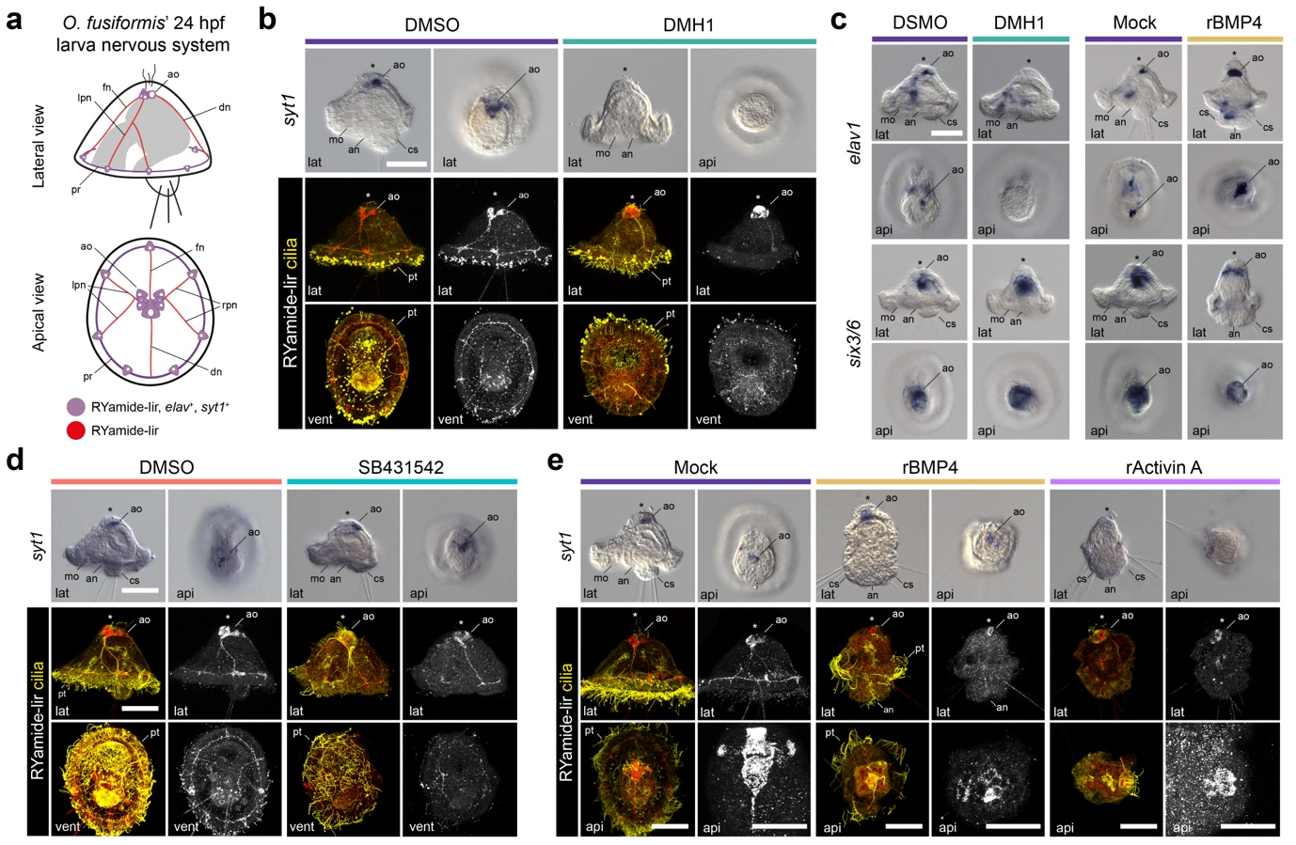
Extended Data Fig. 3 | The role of BMP and Activin/Nodal in neural specification in O. fusiformis. (a) Schematic diagram of the larval nervous system at 24 hpf in O. fusiformis. (b) Whole mount in situ hybridisation of the neuronal marker syt1 (top) and z-stack projections of RYamide immunoreactivity in control and treated larvae developed from embryos treated from 4 to 6 hpf with DMH1. (c) Whole mount in situ hybridisation of the neural markers elav1 and six3/6 in control and treated larvae developed from embryos treated from 4 to 6 hpf with DMH1 and rBMP4. (d–e) Whole mount in situ hybridisation of the neuronal marker syt1 (top) and z-stack projections of RYamide immunoreactivity in control and treated larvae developed from embryos treated from 4 to 6 hpf with the Activin/Nodal inhibitor SB431542 (d) and overactivated with rBMP4 and rActivin A (e). In all panels, the asterisks mark the apical pole. Scale bars are 50 µm. an anus, ao apical organ, api apical, at apical tuft, ch chatae, cs chaetal sac, dn dorsal nerve, fn frontal nerve, lat lateral, lpn left peripheral nerve, mg midgut, mo mouth, pr prototrochal ring, pt prototroch, rpn right peripheral nerve, vent ventral. Drawings are not to scale.

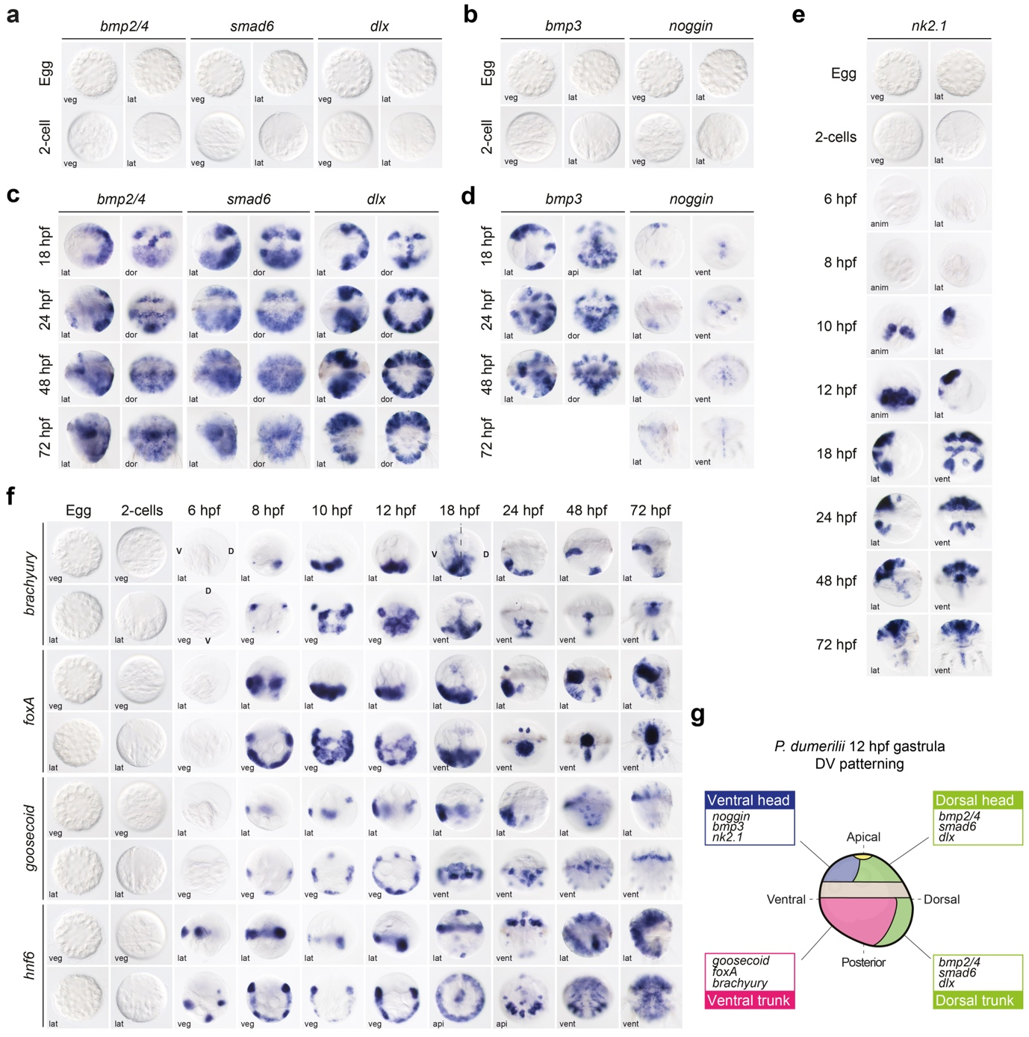
Extended Data Fig 4. | Expression of dorsoventral marker genes in P. dumerilii. (a–e) Whole mount in situ hybridisation of dorsoventral markers at selected embryonic and larval stages. (f) Whole mount in situ hybridisation of brachyury, foxA, goosecoid, and hnf6 at selected embryonic and larval stages. (g) Diagram of dorsoventral marker genes, and goosecoid, foxA, and brachyury expression domains in a 12 hpf gastrula stage. A ciliary ring (the prototroch; grey) separates the anterior head and the posterior trunk. anim animal, veg vegetal, vent ventral, lat lateral. Drawing is not to scale.

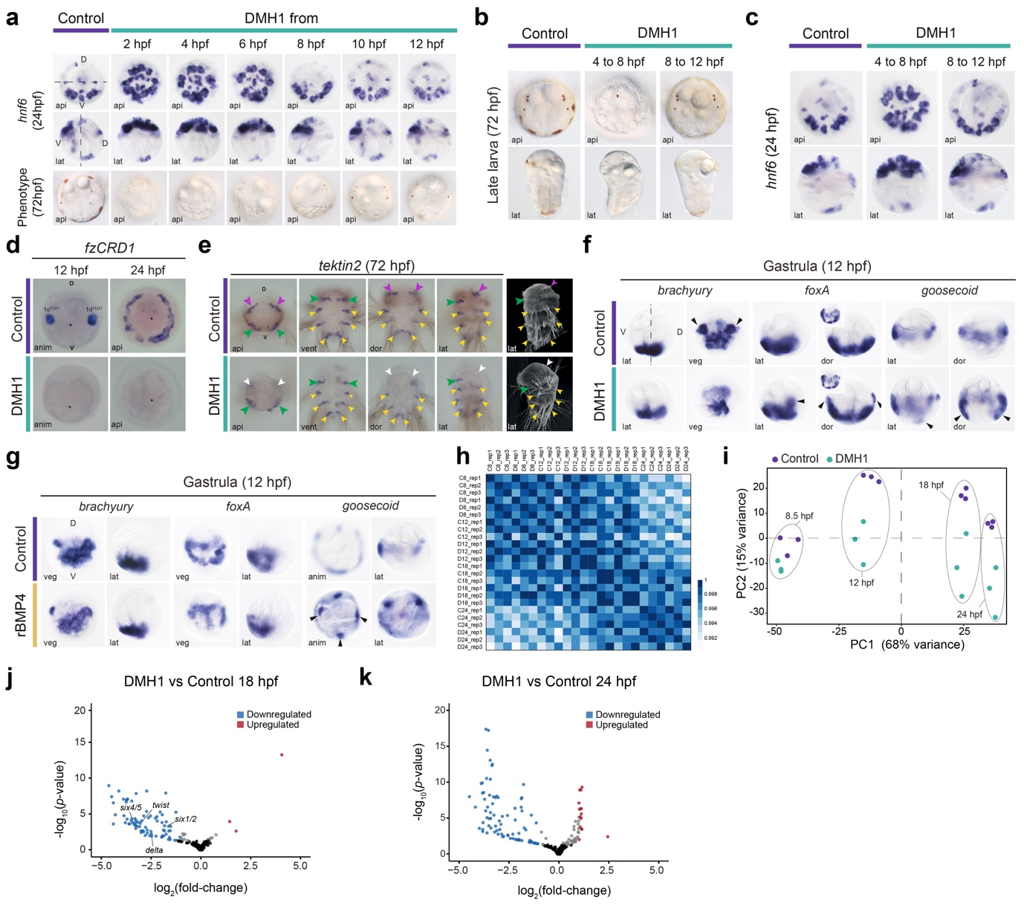
Extended Data Fig. 5 | The role of BMP in dorsoventral axis specification in Platynereis. (a) Whole mount in situ hybridisation of hnf6 at 24 hpf (two top row) and Differential Interference Contrast (DIC) images at 72 hpf (bottom row) in controls (first column) and different windows of treatments with DMH1. (b–c) DIC images (b) and whole mount in situ hybridisation (c) of hnf6 in control and DMH1-treated in windows that result in an abnormal dorsoventral axis (4 to 8 hpf treatment) and wild-type phenotype (8 to 12 hpf treatment). (d) Whole mount in situ hybridisation of nephroblast (1c¹¹²²¹& 1d¹¹²²¹)/headkidney marker fzCRD1 in control and DMH1-treated 12 and 24 hpf larvae. (e) Whole mount in situ hybridisation of the ciliary marker tektin-2 and scanning electron microscopy images of control and DMH1-treated 72 hpf larvae. Ciliary bands like the dorsoanterior akrotroch (present/red, absent/white), the metatroch (green), and the paratrochs (yellow) are indicated by arrows. (f–g) Whole mount in situ hybridisation of brachyury, foxA and goosecoid in control and DMH1 (f) and rBMP4-treated (g) gastrula. (h) Hierarchically clustered pairwise correlation matrix between DMH1-treated and control samples. The scale shows the relative difference in Euclidean distance. (i) Principal component (PC) analysis plot for DMH1-treated vs control RNA-seq analyses. (j–k) Volcano plots depicting differentially expressed genes in 18 and 24 hpf larvae after DMH1 treatment from 4 to 8 hpf. anim animal, api apical, dor dorsal, lat lateral, veg vegetal.

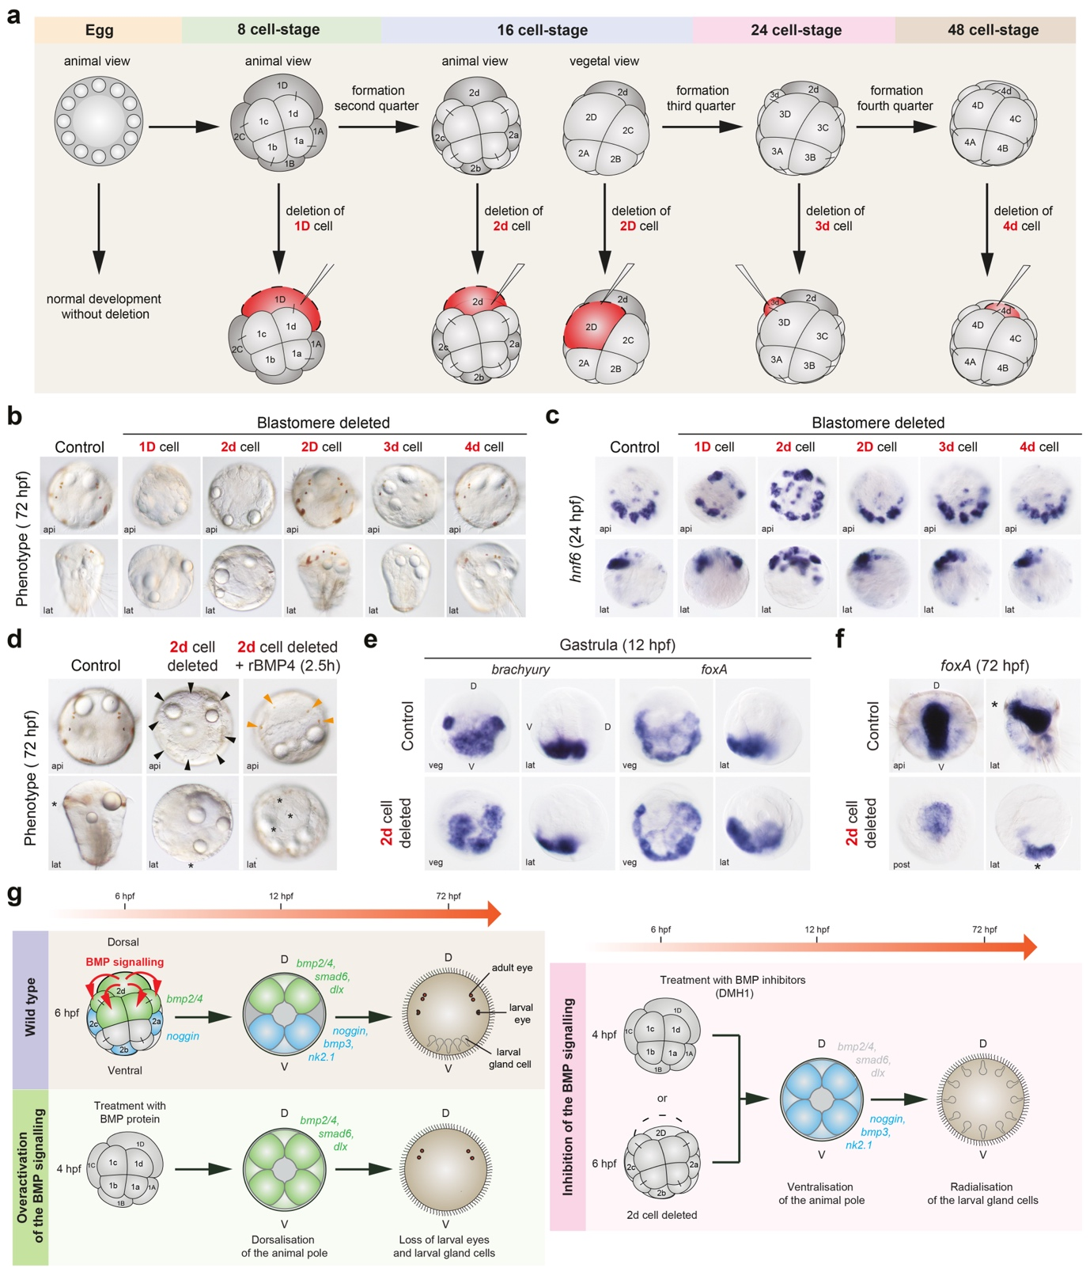
Extended Data Fig. 6 | Effect of D-lineage blastomere ablations on dorsoventral specification in Platynereis. (a) Diagram of the blastomere ablations (red) at different cleavage stages. Ablated cells (1D is the precursor cell of 2d and 2D; 2D will bud off 3d and 4d) are indicated in red. (b) Differential Interference Contrast (DIC) images of 72 hpf larvae resulting from the blastomere ablations. (c) Whole mount in situ hybridisation of hnf6 in larvae (24 hpf) after blastomere ablations. (d) DIC images of larvae rescued with rBMP4 after the 2d-cell ablation. At 72 hpf, larvae after 2d cell deletion exhibit the radialisation of gland cells (black arrowheads) and loss of eyes. Rescue with rBMP4 results in a reduction of gland cells and the retention of two pairs of adult eyes (orange arrowheads). (e) Whole mount in situ hybridisation of brachyury and foxA in gastrulae (12 hpf) after 2d ablation. (f) Whole mount in situ hybridisation of foxA in larvae (72 hpf) after 2d ablation. (g) Diagram of the role of BMP signalling in wild type, rBMP4- and DMH1-treated, and 2d cell-ablated embryos, depicting the effects on dorsoventral marker gene expression at the gastrula stage (12 hpf), and the effects on morphology at 72 hpf larva. The asterisks mark the mouth. api apical, D dorsal, lat lateral, post posterior, V ventral, veg vegetal.

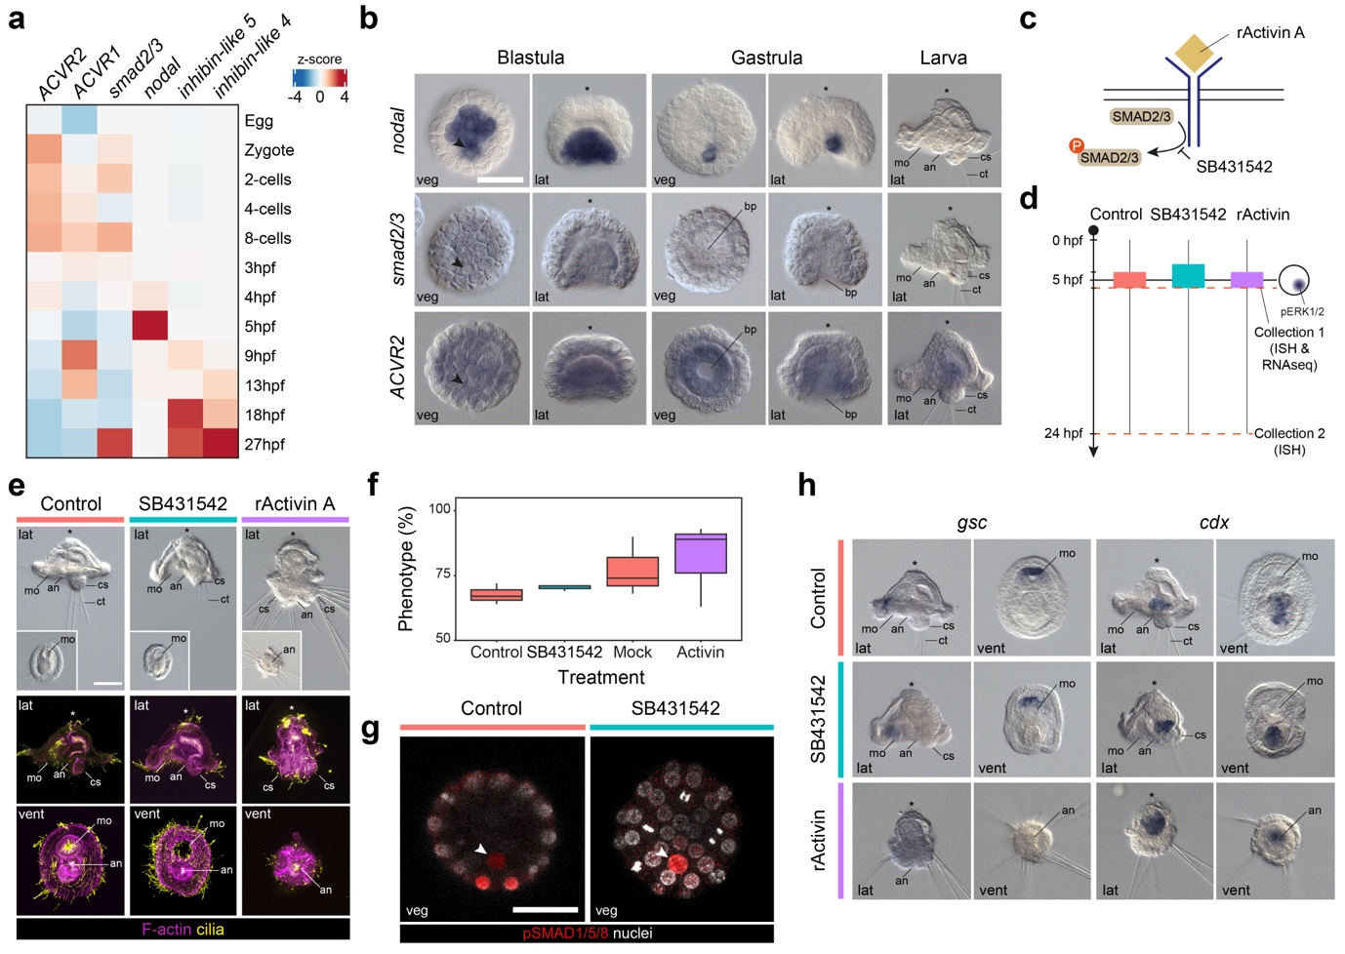
Extended Data Fig. 7 | Activin/Nodal plays a role in dorsoposterior specification in O. fusiformis independently of pSMAD1/5/8. (a) Heatmap indicating the relative expression of core components of the Activin/Nodal pathway during the development of O. fusiformis. (b) Whole mount in situ hybridisation of the ligand nodal, secondary messenger smad2/3, and the activin receptor ACVR2 in blastula (6 hpf), gastrula (9 hpf), and larval stages (24 hpf). (c) Simplified schematic of the Activin/Nodal pathway and mode of action of SB431542 and recombinant Activin A (rActivin A). (d) Schematic representation of the experimental design for the treatment windows and sample collections. (e) Differential interference contrast (top) and z-stack projections of control and treated larvae developed from embryos treated with SB431542 (3 to 6 hpf) and rActivin A (4 to 6 hpf). Insets in the first row are ventral views. Cilia (yellow) are labelled with tubulin, and F-actin (magenta) is labelled with phalloidin. (f) Box plots indicating the percentage of embryos exhibiting the described phenotypes for each treatment. DMSO and mock control larvae have a wild-type morphology. SB431542-treated larvae have a mild reduction of the dorsoposterior region, and rActivin-treated larvae have ectopic dorsoposterior tissue. (g) Z-stack projections of blastula (6 hpf) treated with control and SB431542/rActivin A stained against pSMAD1/5/8. (h) Whole mount in situ hybridisation of anterior (gsc) and posterior (cdx) marker genes in control and treated larvae developed from SB431542 and rActivin A-treated embryos. In all panels, the arrowheads point to the 4d organiser, and the asterisks mark the animal/apical pole. Scale bars are 50 µm. an anus, bp blastopore, ch chatae, cs chaetal sac, lat lateral, mo mouth, pt prototroch, veg vegetal, vent ventral.

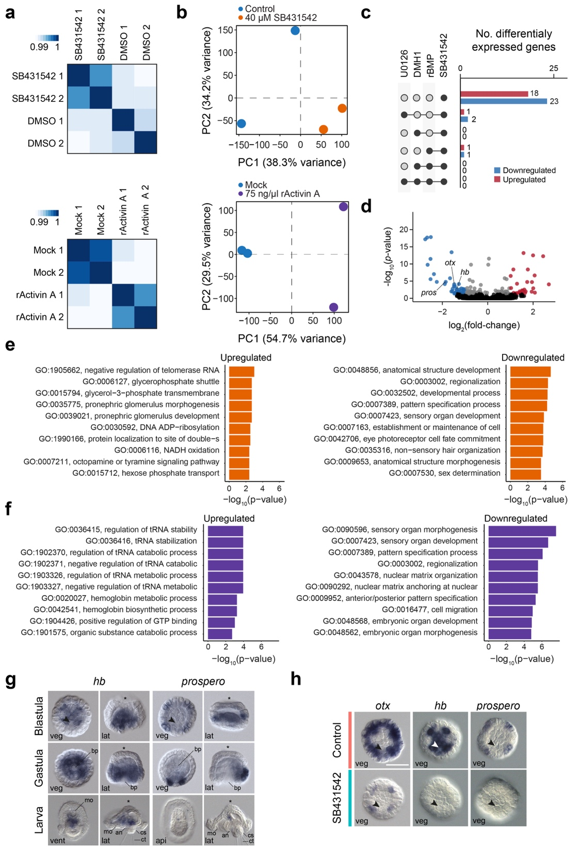
Extended Data Fig. 8 | The gene regulatory network downstream of Activin/Nodal pathway in O. fusiformis. (a) Hierarchically clustered pairwise correlation matrix between SB431542 (top) and rActivin A (down) treated and control samples. The scale shows the relative difference in Euclidean distance. (b) Principal component (PC) analysis plots for SB431542 (top) and rActivin (bottom) transcriptomic analyses indicate that the main source of transcriptional variability between samples is the treatment condition (PC1). (c) Bar plots indicating the number of differentially expressed genes in different treatments. Full circles connected with a line indicated shared differentially expressed genes. (d) Volcano plot depicting differentially expressed genes after SB431542 treatment in 6 hpf blastulae. (e, f) Bar plots showing the top ten enriched Gene Ontology terms in differentially expressed genes after SB431542 (e) and rActivin A treatment (f). (g, h) Whole mount in situ hybridisation of selected candidate differentially expressed genes in SB431542-treated embryos at the blastula, gastrula, and larval stages. In (g, h), the arrowheads point to the 4d organiser, and the asterisks mark the animal/apical pole. Scale bars are 50 µm. an anus, bp blastopore, ch chatae, cs chaetal sac, lat lateral, mo mouth, pt prototroch, veg vegetal.

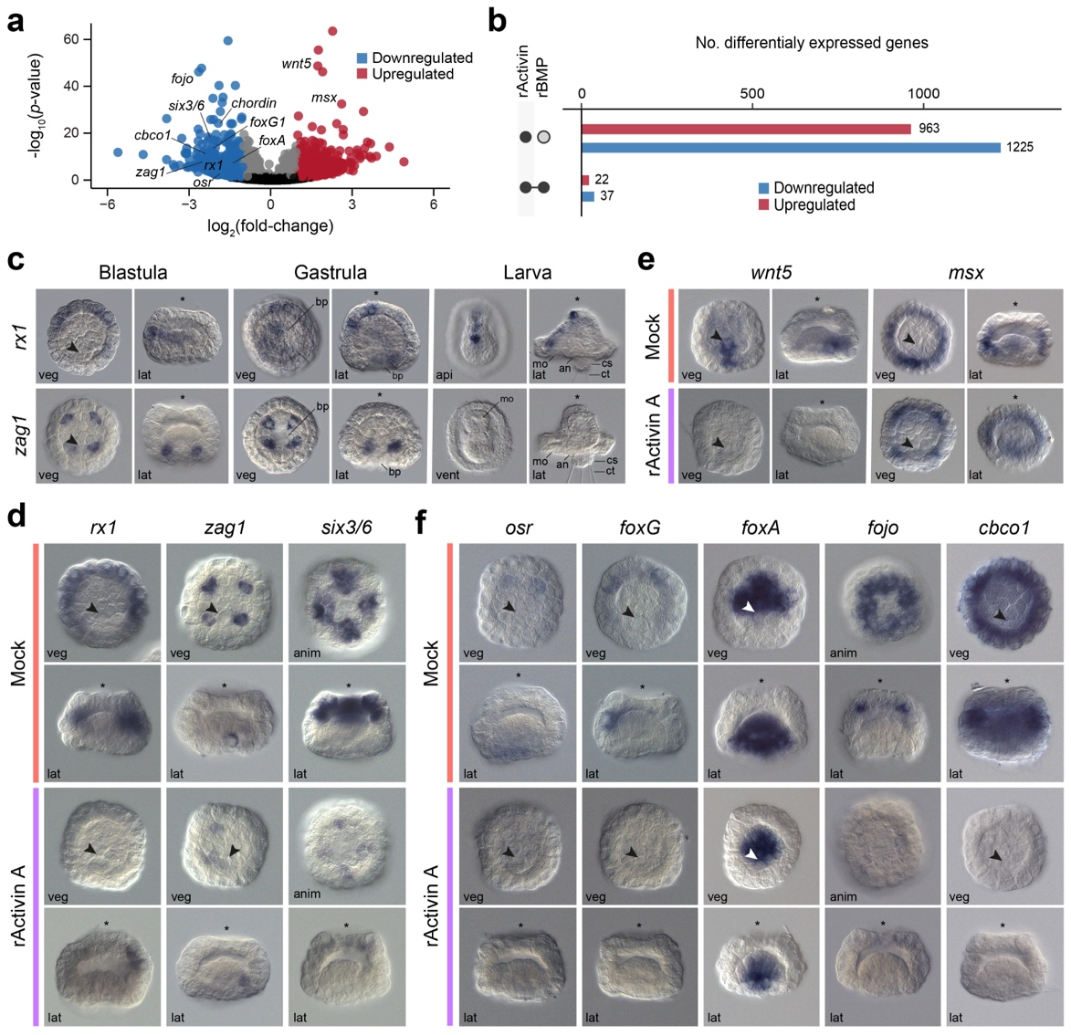
Extended Data Fig. 9 | Differential gene expression analyses in recombinant Activin A-treated O. fusiformis embryos. (a) Volcano plot depicting differentially expressed genes after rActivin A treatment in 6 hpf blastulae. (b) Bar plots indicating the number of differentially expressed genes in different treatments. Full circles connected with a line indicated shared differentially expressed genes. (c) Whole mount in situ hybridisation of selected candidate differentially expressed genes after rActivin A treatment in wild type embryos at blastula, gastrula, and larval stages. (e–f) Whole mount in situ hybridisation of candidate genes downregulated only in recombinant Activin A-treated blastula (e), upregulated in rBMP4 and rActivin A-treated blastula (f), and downregulated in rBMP4 and rActivin A-treated blastula. In (b–f), the arrowheads point to the 4d organiser, and the asterisks mark the animal/apical pole. Scale bars are 50 µm. an anus, anim animal, bp blastopore, ch chatae, cs chaetal sac, lat lateral, mo mouth, veg vegetal.

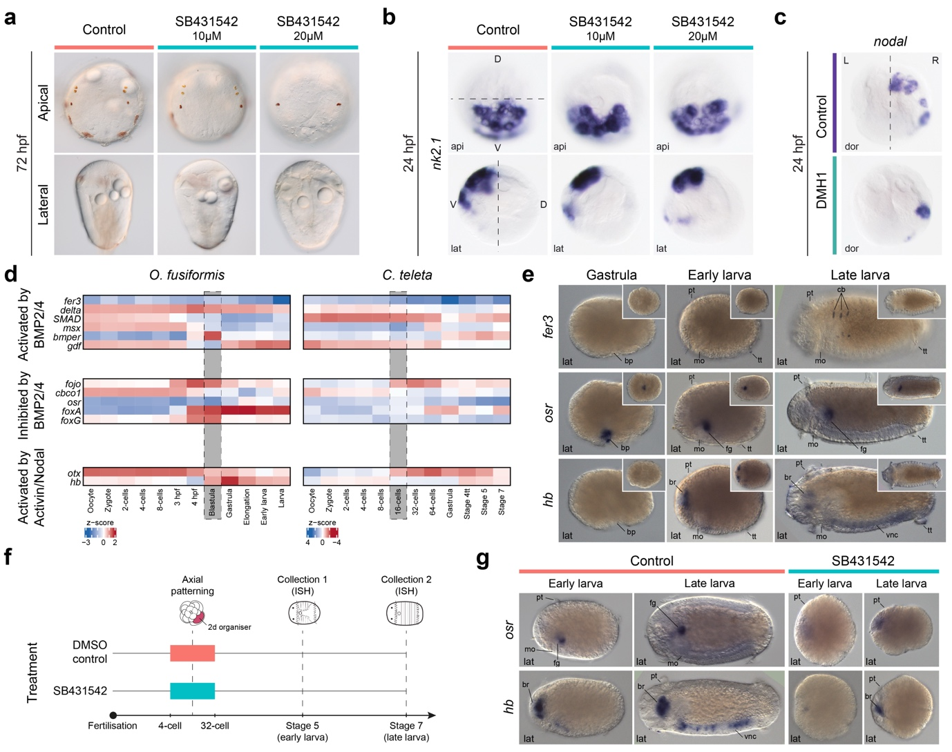
Extended Data Fig. 10 | Activin/Nodal does not control dorsoventral polarity in P. dumerilii and uses a different downstream network in C. teleta. (a) Differential interference contrast images of control and SB431542 larvae at 72 hpf in P. dumerilii. (b) Whole mount in situ hybridisation of the ventral marker nk2.1 in control and SB431542 24 hpf larvae of P. dumerilii. The dashed line marks the boundary between the dorsal (D) and ventral (V) sides. (c) Whole mount in situ hybridisation of nodal in control and DMH1-treated 24 hpf larvae in P. dumerilii. The dashed line marks the boundary between the left (L) and right (R) sides. (d) Heatmaps depicting the relative expression of differentially expressed candidate genes in O. fusiformis and their corresponding one-to-one orthologs in C. teleta during the embryogenesis of these species. (e) Whole mount in situ hybridisation of three candidate differentially expressed genes in O. fusiformis during the development of C. teleta at the gastrula, stage 5 and stage 7 larvae. Insets are ventral views. (f) Schematic diagram of the drug treatment in C. teleta. (g) Whole mount in situ hybridisation of the candidate genes osr (inhibited by the BMP pathway) and hb (activated by Activin/Nodal) in control and SB431542 stage 5 and stage 7 C. teleta larvae. Scale bars are 50 µm. an anus, api apical, bp blastopore, br brain, cb chaetoblast, dor dorsal, fg foregut, lat lateral, mo mouth, pt prototroch, tt telotroch, vnc ventral nerve cord.

