Supplemental Figure 2

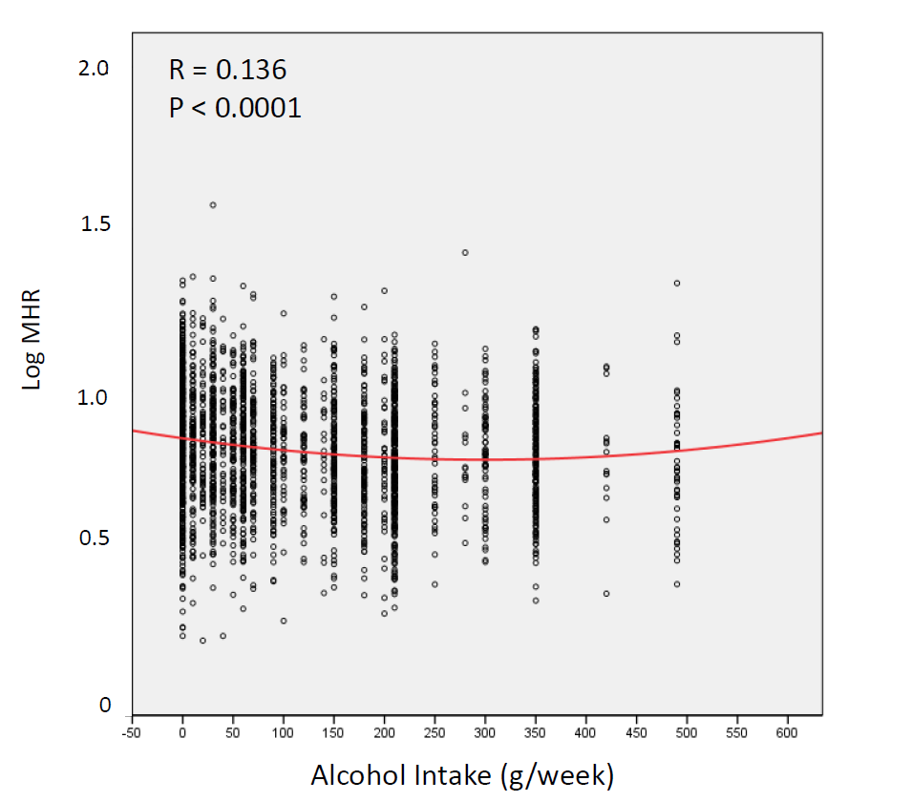

The Relationship between Log MHR and Alcohol Intake: Quadratic Curve.

MHR = monocyte/HDL-C ratio

Since the MHR does not have a normal distribution, the logarithmic conversion is performed. Since alcohol intake was a positive independent determinant of the MHR, curve-fitting regression analysis between alcohol intake and the MHR was performed to investigate the health hazard of heavy alcohol consumption. In this analysis, the MHR decreased gradually as alcohol intake increased, but the MHR increased at an alcohol intake threshold of around 300 g/week, as shown by the quadratic curve.

