Supplementary Information for “Widespread reductions in human labor capacity after 1.5°C warming”

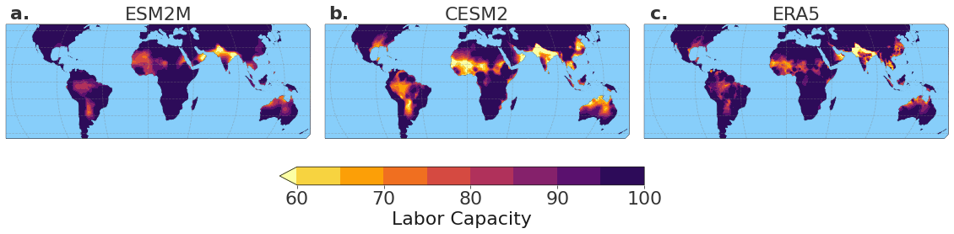
Supplementary Figure 1. Baseline summertime labor capacity for the historical period
(1980-2000) calculated using WBGT projections from a. ESM2M and b. CESM2, and verified against reanalysis data from c. ERA5.

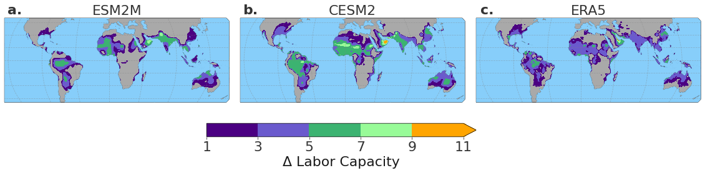
Supplementary Figure 2. Interannual standard deviation of summertime labor capacity for the
historical period (1980-2000), averaged across ensemble members for a. ESM2M and b.
CESM2, and verified against c. ERA5.
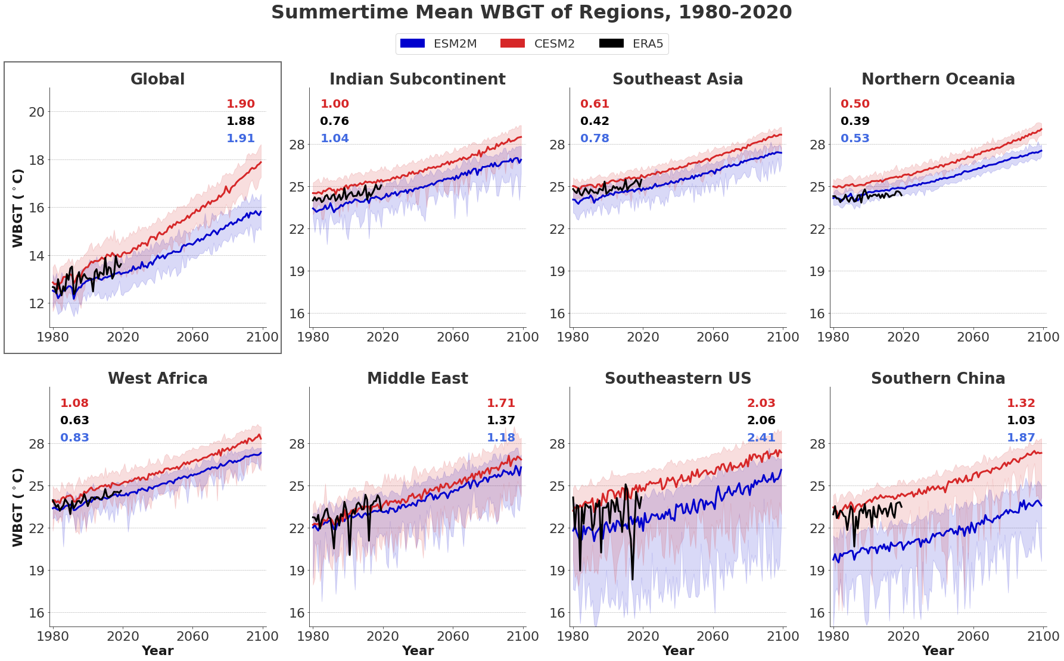
Supplementary Figure 3. Time series of summertime mean WBGT, computed as a land \
area-weighted average at the global and regional scales. Dark lines represent the ESM2M and
CESM2 ensemble means, while shading represents the ensemble range. Interannual standard
deviation of summertime mean WBGT for the period 1980-2020 is displayed for ESM2M (blue),
CESM2 (red), and ERA5 (black) in the corner of each panel. Standard deviation is computed
across the time dimension for each grid cell, land area-weighted and averaged across the grid
cells in each region, and averaged across ensemble members for ESM2M and CESM2. The variability apparent in the ERA5 product (black) should not be visually compared to the ensemble means (dark red and blue), as the ensemble mean is smoothed across 30 climate states at each point in time, whereas ERA5 is representative of a single climate realization. For this reason, the interannual statistics are presented in the corner of each panel and serve as the appropriate model validation metric.

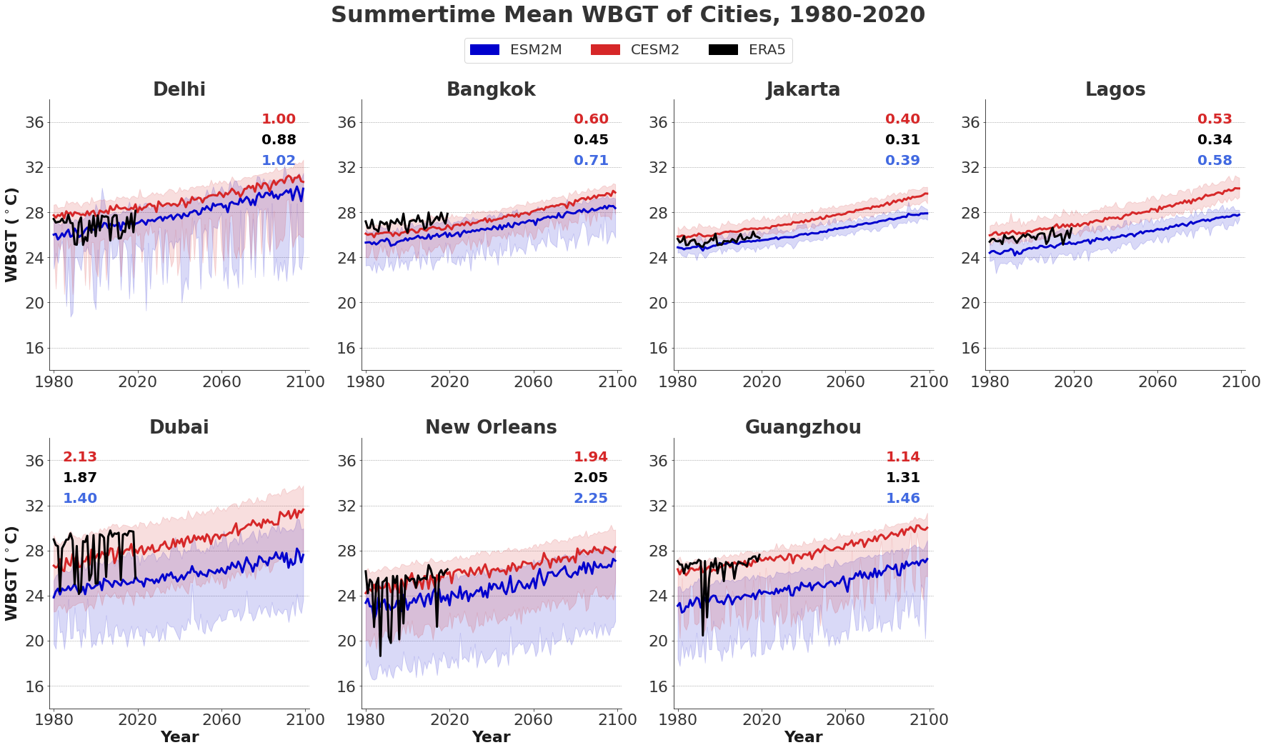
Supplementary Figure 4. Time series of summertime mean WBGT for selected cities in
vulnerable regions. Dark lines represent the ESM2M and CESM2 ensemble means, while
shading represents the ensemble range. Interannual standard deviation of summertime mean
WBGT for the period 1980-2020 is displayed for ESM2M (blue), CESM2 (red), and ERA5
(black) in the corner of each panel. Standard deviation is computed across the time dimension for
each grid cell, and averaged across ensemble members for ESM2M and CESM2. The variability apparent in the ERA5 product (black) should not be visually compared to the ensemble means (dark red and blue), as the ensemble mean is smoothed across 30 climate states at each point in time, whereas ERA5 is representative of a single climate realization. For this reason, the interannual statistics are presented in the corner of each panel and serve as the appropriate model validation metric.
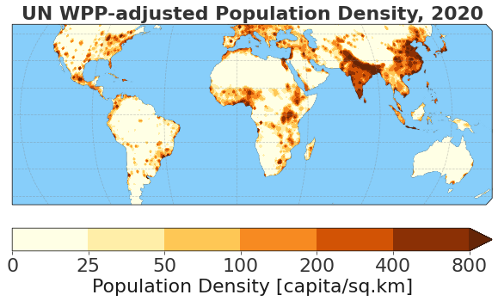
Supplementary Figure 5. Population density estimated for 2020, obtained from Columbia
University’s Socioeconomic Data and Applications Center Gridded Population of the World: UN
WPP-Adjusted Population Density dataset.

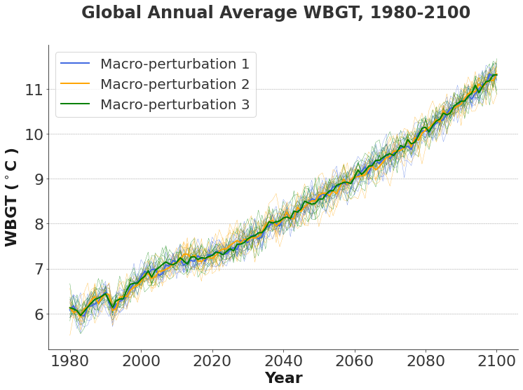
Supplementary Figure 6. Time series of annual average WBGT for 30 CESM2 ensemble
members. Members initialized from the three different macro-perturbations are distinguished by
color. Thick lines represent the mean across the 10 members from each macro-perturbation. Thin
lines represent individual members branched from each macro-perturbation using
micro-perturbations.

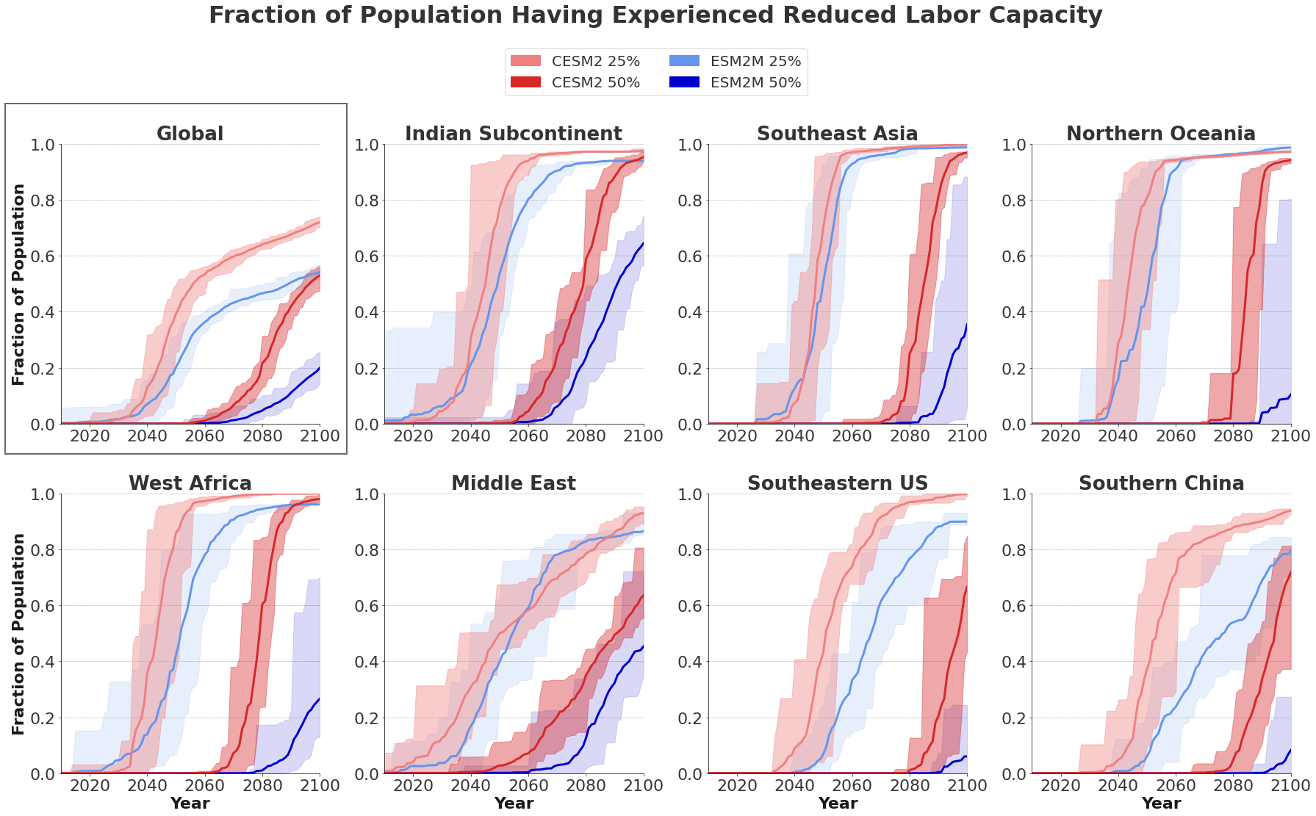
Supplementary Figure 7. Fraction of global and regional populations having experienced first occurrence of reduced summertime labor capacity. The affected fraction at each year is calculated by aggregating the population from grid cells with an earlier time of first emergence. Dark lines represent the ensemble mean of the affected fraction, while shading represents the ensemble range.

