S-Table 1. Quality assessment of the studies.
Study | 1 | 2 | 3 | 4 | 5 | 6 | 7 | 8 | 9 | 10 | 11 | 12 | 13 | 14 | 15 | 16 | 17 | 18 | 19 | 20 | Quality score
Mateos  2021 | Y | N | Y | Y | Y | Y | Y | Y | Y | Y | Y | Y | Y | Y | Y | Y | Y | Y | Y | Y | 19/20
Nakazato  2021 | Y | Y | Y | Y | Y | Y | Y | Y | Y | Y | Y | Y | Y | Y | Y | Y | Y | P | Y | Y | 19/20
Stege  2021 | Y | Y | Y | Y | Y | Y | Y | Y | Y | Y | Y | Y | Y | Y | Y | Y | Y | Y | Y | Y | 20/20
Facon  2022 | Y | Y | Y | Y | Y | Y | Y | Y | Y | Y | Y | Y | Y | Y | Y | Y | Y | Y | Y | Y | 20/20
Groen  2023 | Y | Y | Y | Y | Y | Y | Y | Y | Y | Y | Y | Y | Y | Y | Y | Y | Y | Y | Y | Y | 20/20
Zhang  2024 | Y | Y | N | Y | Y | Y | Y | Y | Y | Y | Y | Y | Y | Y | Y | Y | Y | Y | Y | Y | 19/20
Y = YES; N = NO; P = PARTIAL; U = UNCLEAR. A study with ≥ 70% of positive responses (12/18 or 14/20) was considered to be of acceptable quality.

Institute of Health Economics (IHE). Quality Appraisal of Case Series Studies Checklist. Edmonton (AB): Institute of Health Economics; 2014. Available from: http://www.ihe.ca/research-programs/rmd/cssqac/cssqac-about

References:
Moga C, Guo B, Schopflocher D, Harstall C. Development of a quality appraisal tool for case series studies using a modified Delphi technique. Edmonton: Institute of Health Economics; 2012. Available at http://www.ihe.ca/advanced-search/development-of-a-quality-appraisal-tool-for-case-series-studies- using-a-modified-delphi-technique . Accessed January 8, 2016.
Guo B, Moga C, Harstall C, Schopflocher D. A principal component analysis is conducted for case series quality appraisal checklist. Journal of Clinical Epidemiology 2016;69:199-207.

S-Table 2. Summary of Findings Table.
Certainty assessment |  |  |  |  |  |  | № of patients |  | Effect |  | Certainty | Importance
№ of studies | Study design | Risk of bias | Inconsistency | Indirectness | Imprecision | Other considerations | Non-frail | Frail | Relative  (95% CI) | Absolute  (95% CI) | Certainty | Importance
Infection risk (follow-up: mean 45 weeks; assessed with: mg)
5ª | non-randomised studies and  randomised studies^{b} | not serious^{c} | not serious^{d} | not serious | serious^{e} | all plausible residual confounding would reduce the demonstrated effect  dose response gradient^{f} | 917 | 793 | - | RR 0.77  (0.66 to  0.90) | ⨁⨁⨁⨁  High | CRITICAL

CI: confidence interval; RR: risk ratio.

Explanations

a. Stege et al. and Groen et al studies are considered a single study.
b. The meta-analysis includes randomized and non-randomized studies.
c. All included studies scored above 70% on the IHE checklist, indicating good methodological quality.
d. The I² value is 0%, indicating no heterogeneity. Moreover, the confidence interval of the results is narrow [0.66, 0.90] with a mean effect size of 0.77.
e. Most studies cross the threshold of no effect. However, the confidence intervals of the overall effect do not cross the line of no effect. With a statistically significant sample size of at least 314 participants, the meta-analysis provides robust statistical power.
f. Publication Bias: Egger's Test showed Sig=0.142, confirmed by Begg and Mazumdar’s rank correlation test with Sig=0.1 and Trimm and Fill study=0. Then, no significant publication bias has been revealed. Large Effect: the observed effect size (RR = 0.77) suggests a reduced infection risk in non-frail patients compared to frail patients. However, the effect is moderate and does not meet the threshold for a large effect. Plausible Confounding: a potential source of confounding is the unequal distribution of disease severity (ISS stage III) across frailty groups. Dose Response Gradient: a clear dose-response relationship is observed, as infection risk progressively increases from Fit to Intermediate to Frail patients.

S-Table 3. Grade 3–4 hematologic toxicities reported across the studies.
study,  year | patients at baseline, n° | neutropenia  n° | lymphopenia  n° | leukopenia  n° | thrombocytopenia  n° | anemia  n°
Mateos DVMP,  2021 | 350 | 139 | 26 | 28 | 120 | 60
Fit | 48 | 27 | 6 | 5 | 13 | 5
Intermediate | 139 | 46 | 6 | 10 | 48 | 21
Frail | 163 | 66 | 14 | 13 | 59 | 34
Mateos VMP,  2021 | 356 | 138 | 22 | 12 | 30 | 67
Fit | 74 | 35 | 2 | 4 | 31 | 14
Intermediate | 130 | 51 | 7 | 8 | 44 | 21
Frail | 152 | 52 | 13 | 18 | 59 | 32
Nakazato,  2021 | 47 | 10 | n.a. | n.a. | 4 | 14
Fit | 16 | 4 | n.a. | n.a. | 1 | 2
Frail | 31 | 6 | n.a. | n.a. | 3 | 12
Stege,  2021 | 65 | 6 | n.a. | n.a. | 15 | 2
Frail | 65 | 6 | n.a. | n.a. | 15 | 2
Facon DRd,  2022 | 368 | 186 | 56 | 40 | 29 | 49
Fit | 68 | 30 | 7 | 7 | 4 | 4
Intermediate | 128 | 59 | 18 | 11 | 8 | 17
Frail | 172 | 97 | 31 | 22 | 17 | 28
Facon Rd,  2022 | 369 | 129 | 39 | 21 | 33 | 75
Fit | 78 | 22 | 7 | 2 | 3 | 11
Intermediate | 122 | 52 | 14 | 10 | 12 | 24
Frail | 169 | 55 | 18 | 9 | 18 | 40
Groen,  2023 | 65 | 4 | n.a. | n.a. | 3 | 2
Fit-Intermediate | 65 | 4 | n.a. | n.a. | 3 | 2
Zhang,  2024 | 90 | 26 | n.a. | n.a. | 32 | 11
Fit | 33 | 9 | n.a. | n.a. | 10 | 5
Intermediate | 16 | 7 | n.a | n.a. | 8 | 2
Frail | 41 | 9 | n.a. | n.a. | 14 | 4
DRd, daratumumab/lenalidomide/dexamethasone; DVMP, daratumumab/bortezomib/melphalan/prednisone; IMWG-FI, international myeloma working group frailty index; ISS, international staging system; Ixa-Dara-dex, ixatuximab/daratumumab/dexhamethasone; MC, multicenter; P, prospective; R, retrospective; Rd, lenalidomide/ dexamethasone; SC, single center; VCD, bortezomib/cyclophosphamide/dexamethasone; VRd, bortezomib/lenalidomide/dexamethasone; VTD, bortezomib/thalidomide/dexamethasone.

S-Figure 1. Meta-analysis of prospective studies comparing non-frail versus frail patients.
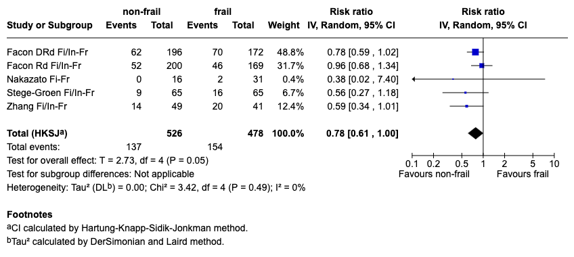

Fi, fit; Fr, frail; In, intermediate; RR, risk ratio.

S-Figure 2. Funnel plots of the subgroups analysis.
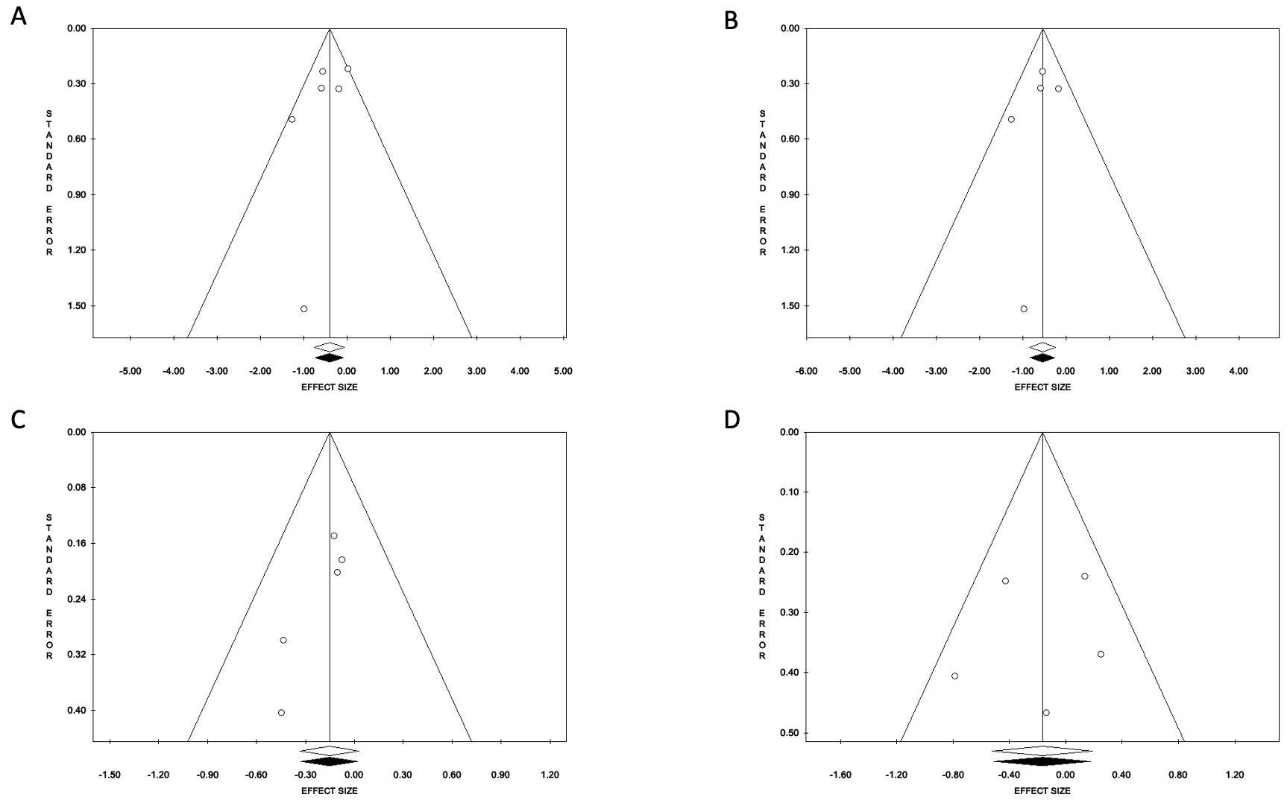

A) fit versus frail funnel plot. B) fit versus frail funnel plot without the outlier study “Facon Rd Fi-Fr”. C) intermediate versus frail funnel plot. D) fit versus intermediate funnel plot.

S-Figure 3. Subgroup analysis for fit versus frail without the outlier study: meta-analysis.
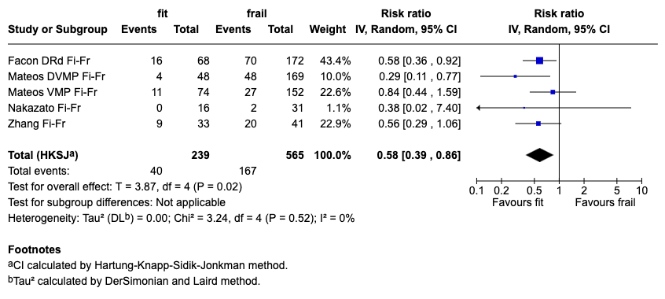

Fi, fit; Fr, frail; In, intermediate; RR, risk ratio.
Meta-analysis on fit versus frail and intermediate versus frail subgroups assessing the risk of infection, after removing the outlier comparison group “Facon Rd Fi-Fr” reported as risk RR. The overall RR for infection risk across fit versus frail studies was to 0.58 (95% CI: 0.39-0.86); heterogeneity reduced to 0% (Tau²= 0.00; Chi²=3.24, df=4, p=0.52; I²=0%).

