Zinc–Copper Imbalance and Lipid Peroxidation Mark Glycaemic Control in Type 2 Diabetes Mellitus
Promise Chineye Nwaejigh*, Tamunoibim Jessica Chima-Nwogwugwu, Michael Yusuf Odegbo, Stephen Sunday Udofia

(Questionnaire)
STUDY TITLE: ZINC–COPPER IMBALANCE AND LIPID PEROXIDATION MARK GLYCAEMIC CONTROL IN TYPE 2 DIABETES MELLITUS

SECTION B: SOCIODEMOGRAPHIC INFORMATION
Age (in years): __________________
Sex: ☐ Male ☐ Female ☐ Other
Marital status: ☐ Single ☐ Married ☐ Divorced ☐ Widowed
Educational level: ☐ No formal education ☐ Primary ☐ Secondary ☐ Tertiary ☐ Postgraduate
Occupation: __________________
Residential location: ☐ Urban ☐ Semi-urban ☐ Rural
Monthly income (optional): ☐ <₦50,000 ☐ ₦50,000–₦100,000 ☐ ₦100,001–₦200,000 ☐ >₦200,000

SECTION C: MEDICAL HISTORY AND EXCLUSION CRITERIA
Have you ever been diagnosed with Type 1 Diabetes? ☐ Yes ☐ No
Have you been diagnosed with gestational diabetes or currently pregnant? ☐ Yes ☐ No
Have you ever been diagnosed with chronic kidney disease? ☐ Yes ☐ No
Do you currently have liver dysfunction or liver disease? ☐ Yes ☐ No
Have you experienced any cardiovascular events (e.g., heart attack, stroke) in the past 6 months? ☐ Yes ☐ No
Do you currently have any infections (e.g., fever, cough, UTI, etc.)? ☐ Yes ☐ No
Have you been diagnosed with an inflammatory disorder (e.g., rheumatoid arthritis, lupus)? ☐ Yes ☐ No
Have you been diagnosed with any form of cancer? ☐ Yes ☐ No
Have you taken any vitamin or mineral supplements (especially zinc or copper) in the last 3 months? ☐ Yes ☐ No
Do you currently smoke cigarettes or use tobacco products? ☐ Yes ☐ No
Do you consume alcohol regularly or have a history of alcohol dependence? ☐ Yes ☐ No

SECTION D: DIABETES STATUS AND CLINICAL INFORMATION
When were you first diagnosed with diabetes? Year: _______
What type of diabetes were you diagnosed with? ☐ Type 2 Diabetes ☐ Others (specify): ______
Are you currently on treatment for diabetes? ☐ Yes ☐ No
Type of diabetes medication: ☐ Oral hypoglycemic agents ☐ Insulin ☐ Both ☐ Diet and exercise only
How often do you check your blood glucose? ☐ Daily ☐ Weekly ☐ Monthly ☐ Rarely
Most recent Fasting Plasma Glucose (FPG) (if known): _______ mmol/L
Most recent HbA1c result (if known): _______ %
Do you have a family history of diabetes? ☐ Yes ☐ No
Any diabetes-related complications? ☐ Neuropathy ☐ Retinopathy ☐ Nephropathy ☐ None ☐ Others: ______

SECTION E: LIFESTYLE AND DIETARY INFORMATION
How often do you consume fruits and vegetables? ☐ Daily ☐ 2–4 times/week ☐ Rarely ☐ Never
How often do you eat red meat? ☐ Daily ☐ 2–4 times/week ☐ Rarely ☐ Never
Do you consume foods high in fat/oil (e.g., fried foods, pastries)? ☐ Frequently ☐ Occasionally ☐ Rarely
How often do you consume seafood/shellfish? ☐ Frequently ☐ Occasionally ☐ Rarely ☐ Never
Do you engage in regular physical activity (≥3 times/week)? ☐ Yes ☐ No
Type of physical activity (if any): ☐ Walking ☐ Jogging ☐ Gym/Resistance training ☐ Other: _______

SECTION F: ANTHROPOMETRIC AND CLINICAL MEASUREMENTS
Weight: ______ kg
Height: ______ m
BMI (calculated): ______ kg/m²
Waist circumference: ______ cm
Systolic BP: ______ mmHg Diastolic BP: ______ mmHg

SECTION G: SAMPLE AND LABORATORY INFORMATION
Date of blood sample collection: ____ / ____ / ______
Fasting duration before sample: ______ hours
Sample ID/Code: __________________
Laboratory tests performed: ☐ FPG ☐ HbA1c ☐ Serum Zinc ☐ Serum Copper ☐ MDA ☐ 8-iso-PGF2α ☐ Lipid profile ☐ Others: _______
Supplementary Figure S1 (Questionnaire)

Supplementary Table S1: Principal Component Analysis (PCA) loadings and explained variance for trace elements and oxidative stress biomarkers.
.

Variables component loading

8-iso-Postaglandin factor 2α (pg/mL) 0.939

Malondialdehyde (µmol/L) 0.879

Copper (µmol/L) 0.932

Zinc (µmol/L) - 0.913

Zinc/Copper ratio - 0.974

Component Eigenvalue % Variance explained Cumulative %

PC1 4.307 86.13 86.13
Note: One principal component (PC1) was retained, explaining over 86.13% of the total variance. Strong positive and negative loadings reflect collinearity among oxidative stress biomarkers and trace elements, justifying dimensionality reduction.

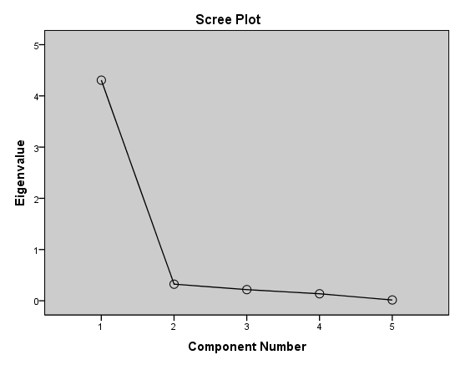
Supplementary Figure S2: Scree plot showing only one major component (PC1) extracted from Principal Component Analysis (PCA).

