APPENDIX
A map of The United Republic of Tanzania showing major water bodies that provides opportunity for fishing and agricultural activities
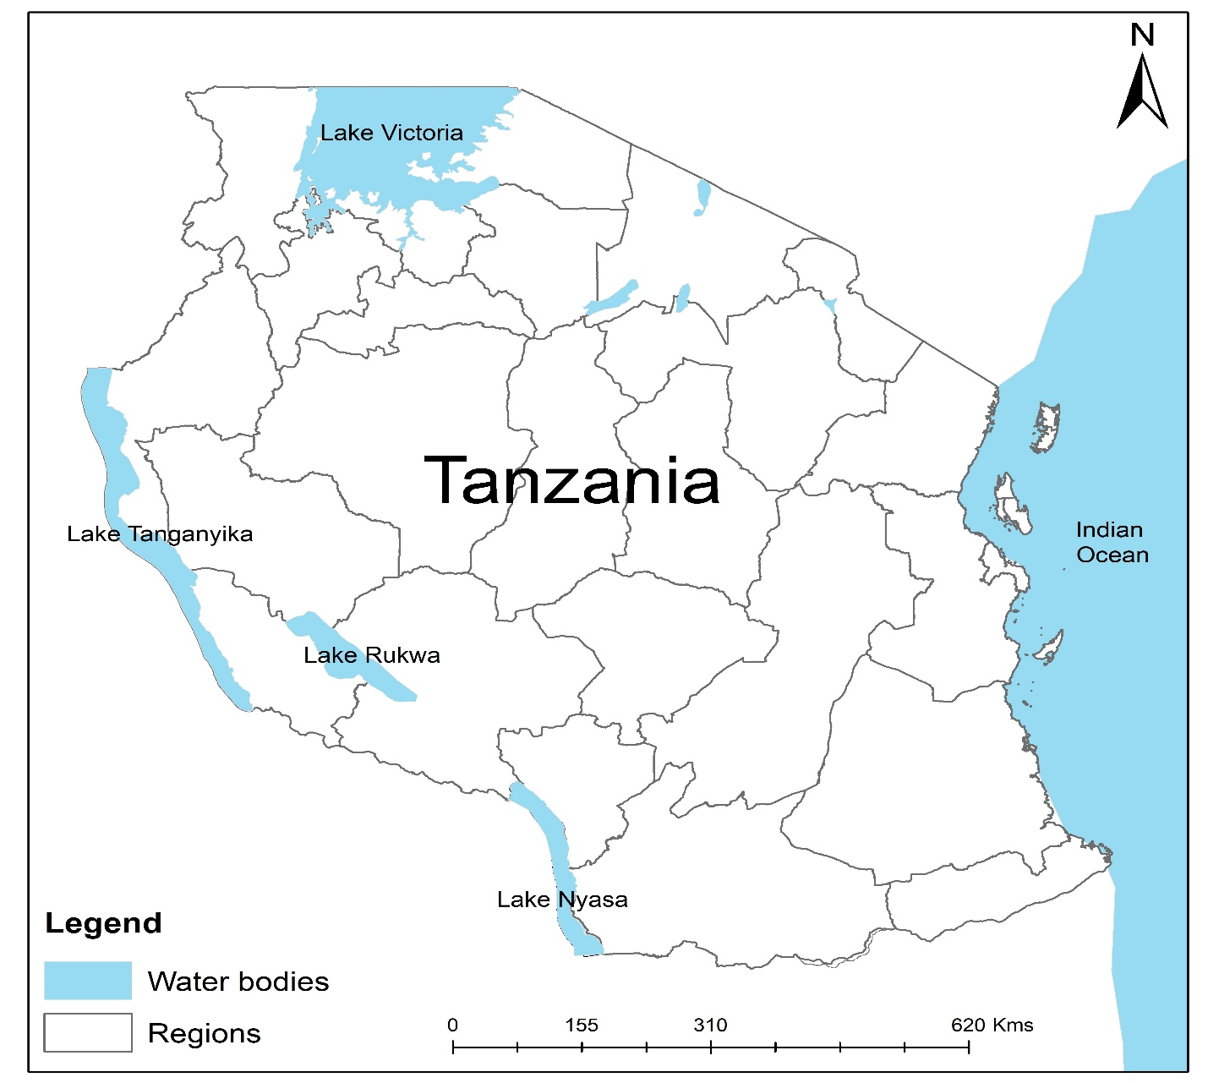
Source: Author’s drawing

