Species | Wistar albino irat
Age | 1-1.5 yrs
Gender | Male
Weight | 450-570 gm
Table 1:Animal protocol
Group’s name | No of animals | Treatment’s design
Group I | 5 | Normal Control (0.5-1.O ml CMC)
Group II | 5 | Disease Control ( NCI-H460 cell suspension120µl contains Approx. 1.146 x 10^7/ml))
Group III | 5 | Stnd Drug Methotrexate (25mg/ml)  5ml/kg, i.p.
Group IV | 5 | Extract of Berberis vulgaris 300 mg/kg
Group V | 5 | Extract of Berberis vulgaris 500 mg/kg
Group VI | 5 | MTX (20mg/ml) + Test drug (250mg/ml)
Group II | 5 | Preventive treatment group

Table 2: Arrangement of Animal group’s design

Reaction Component | 25 µl Reaction
SYBR Green mix 2x | 2.5µl
Forward Primers | 1µl each
Reverse Primers | 1µL each
H₂O | Bring final up to 25 µl volume
Total | 25 µl
Table 3: PCR Protocol

Sr. iNo. | Metabolite | Tests | Result
1 | Berberine | Picric acid reagent iTest | +
2 | Triterpenoids | Liebermann-Burchard reagent test | +
3 | Flavonoids | Ammonia Solution Test | +
4 | Phenols | Ferric chloride reagent | +
5 | Sesquiterpenes | Vanillin-sulfuric acid reagent test | +
6 | Berberine | Dandruff reagent Test | +
Table 5: Confirmatory Tests for Phytoconstituents
Concentration | Absorbance
50 µg/ml | 2.84
250 µg/ml | 3.06
350µg/ml | 3.14
450µg/ml | 3.75
550µg/ml | 3.9
Table 6: Absorbance of Plant extract in different concentration
Solvent used for the preparation of standard solution | Amount found (mg/ml.)
Water | 9.36
Table 7: Amount of the found Plant extract
Parameter | Involved Fact
Solvent | Water
Absorption maxima (nm) | 500
Slope | 0.242
Intercept | 2.51
Correlation coefficient(R2) | 0.9604
Range | 100-500µg/ml
Regression equation | y= 0.242x + 2.512
Limit of detection | 10.90
Limit of quantitation | 33.05
Table 8:Results Of UV analysis
Group | Absorbance(OD)
Normal | 0.144
Stand | 0.092
Stnd+t | 0.085
Test i(h) | 0.101
Test i(l) | 0.118
DC | 0.176
PT | 0.046
Table 9: UV Absorbance of different groups for haemoglobin assay
Groups | Hemoglobin (gm/dl)
Normal | 14.4
Standard | 9.2
Std+Test | 8.5
Test(H) | 10.1
Test(L) | 11.8
DC | 17.6
Pre treat | 4.6
Table 10: Concentration of Haemoglobin of different groups
Group | Haemoglobin conc.  ( gm/dL )
Normal control | 15.5 ± 1.48
Disease control | 16.53 i± i1.07
Standard (MTX) | 8.35 ± 0.93
Standardi+ Testi | 8.01 ±i i1.2
Test (high) | 9.26 ±i0.797
Test i(low) | 12.35 ±i0.49
Preventive treatment | 5.53 ± 1.17
Table 11: Statical chart for Haemoglobin assay
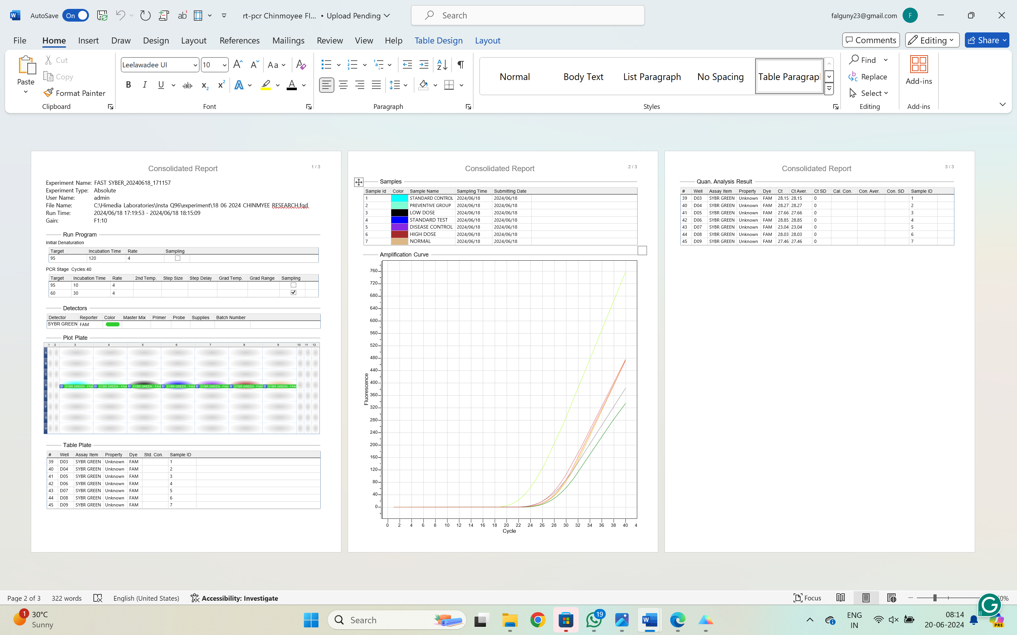
Table-12:Analysis Result of PCR

Groups | CT value(time)
Standard | 26.48 ±1.527
Preventive group | 27.54 ± 0.92
Low dose group | 27.7 ± 1.17
Standard +Test group | 28.41 ± 0.48
Disease group | 23.21 ±0.8139
high dose group | 28.35 ± 1.025
normal group | 26.74 ±1.0042
Table 13: CT value estimation

