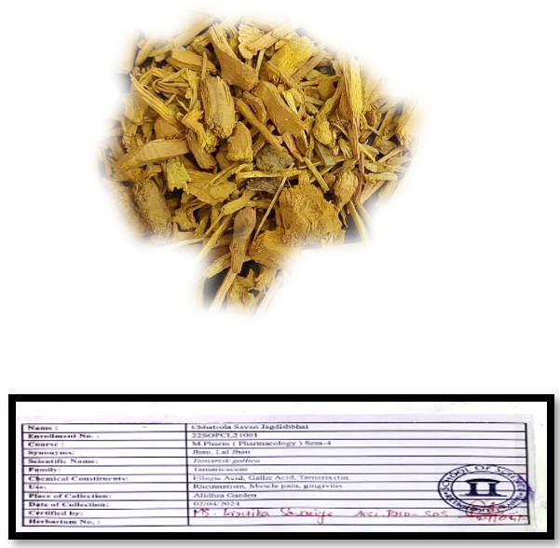
Figure 1: The root of Berberis vulgaris

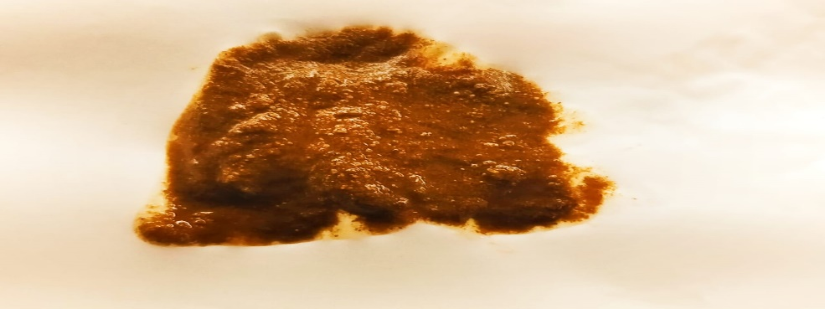
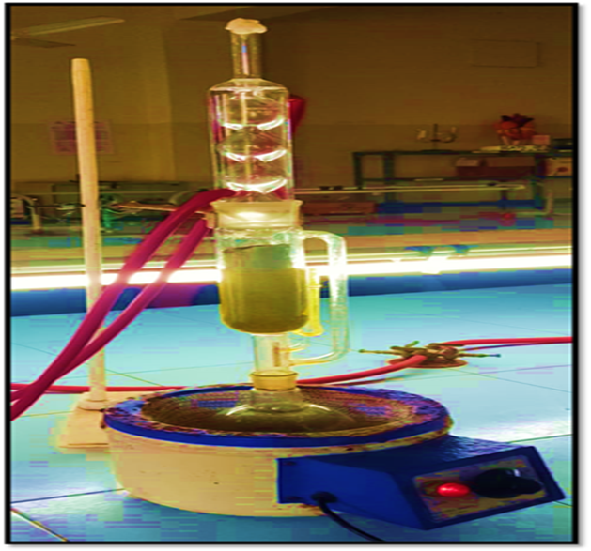
Figure 2 Soxhalation process of extraction

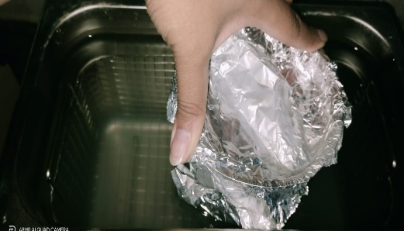
Figure 3 Ultrasonication process of extraction
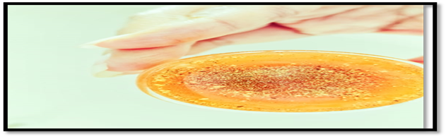
Figure 4 Confirmatory test of Berberine

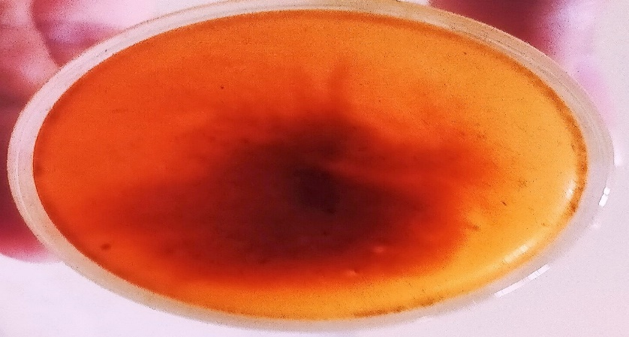
Figure 5 Confirmatory test for Berberine
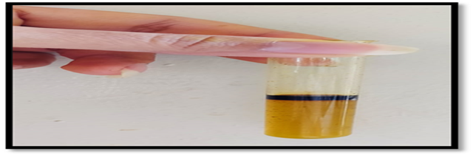
Figure 6Confirmatory test for Triterpenoids

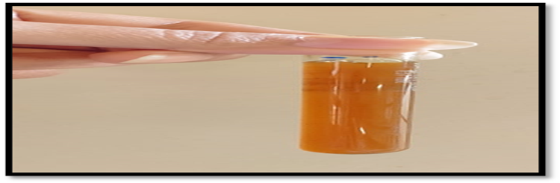
Figure 7 Confirmatory test for Flavinoids
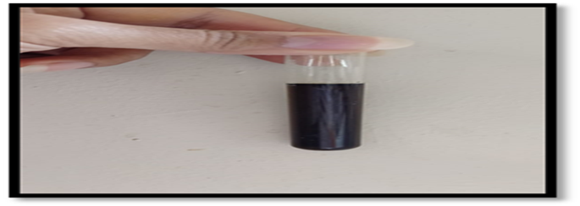
Figure 8Confirmatory test for Phenol
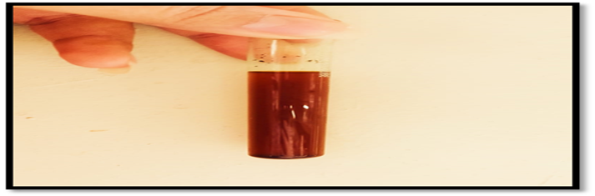
Figure 9Confirmatory test for Sesquiterpene

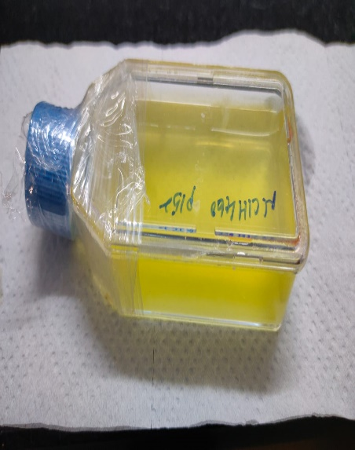
Figure 10 NCI-H460 CELL LINE

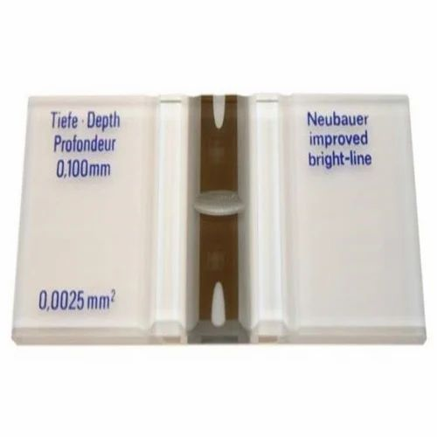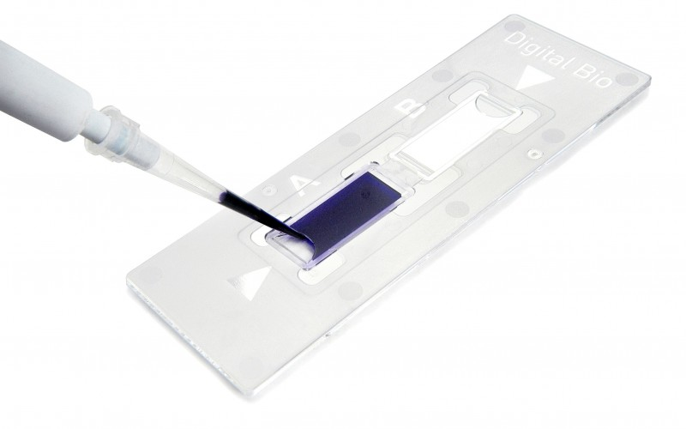
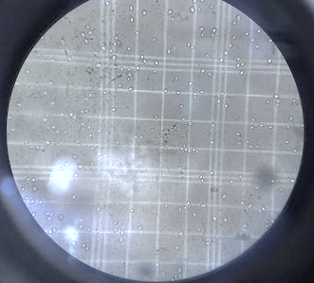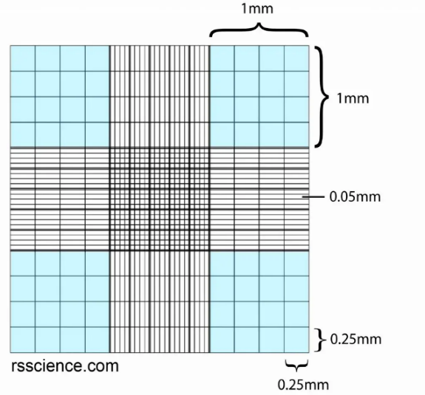

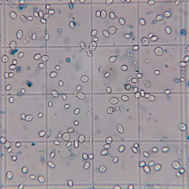
Figure 11 Process of cell counting

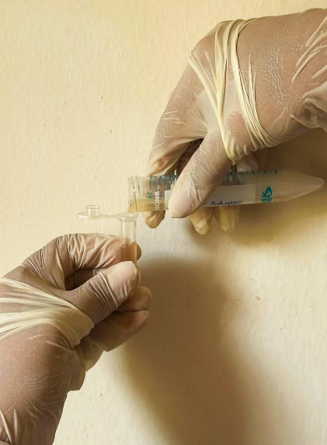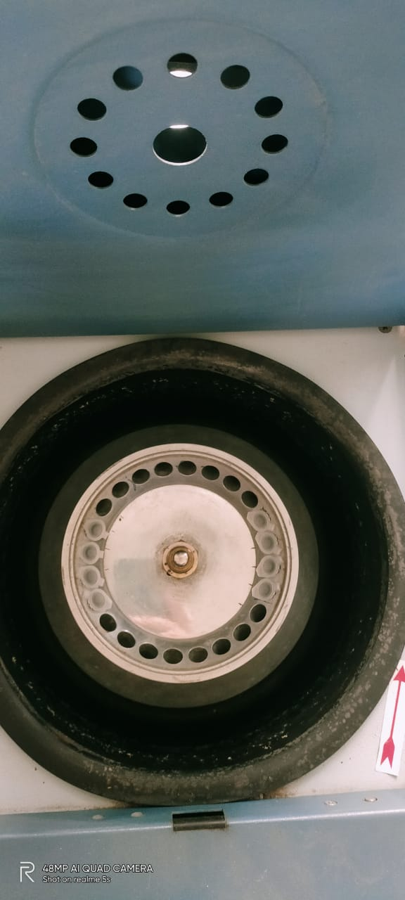

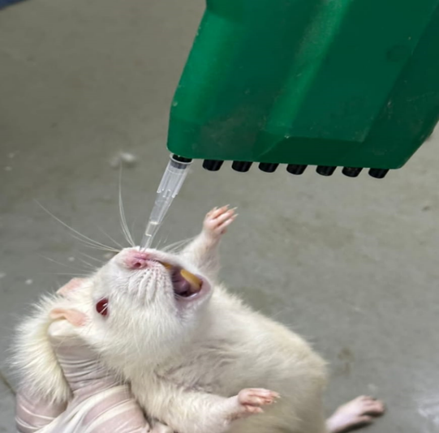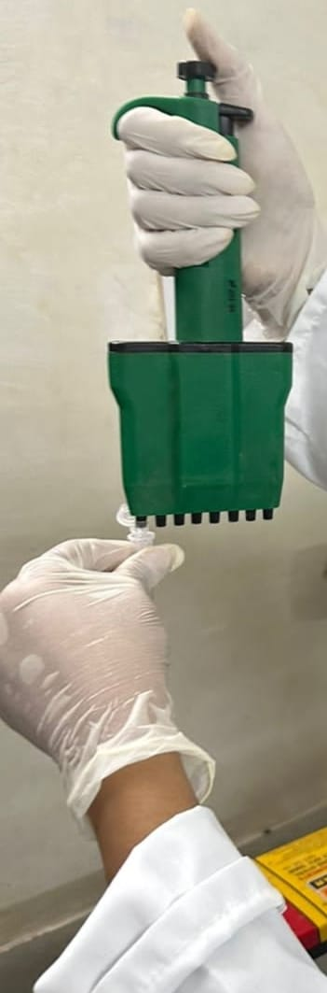
Figure 12 Process of Cell suspension induction in Rats
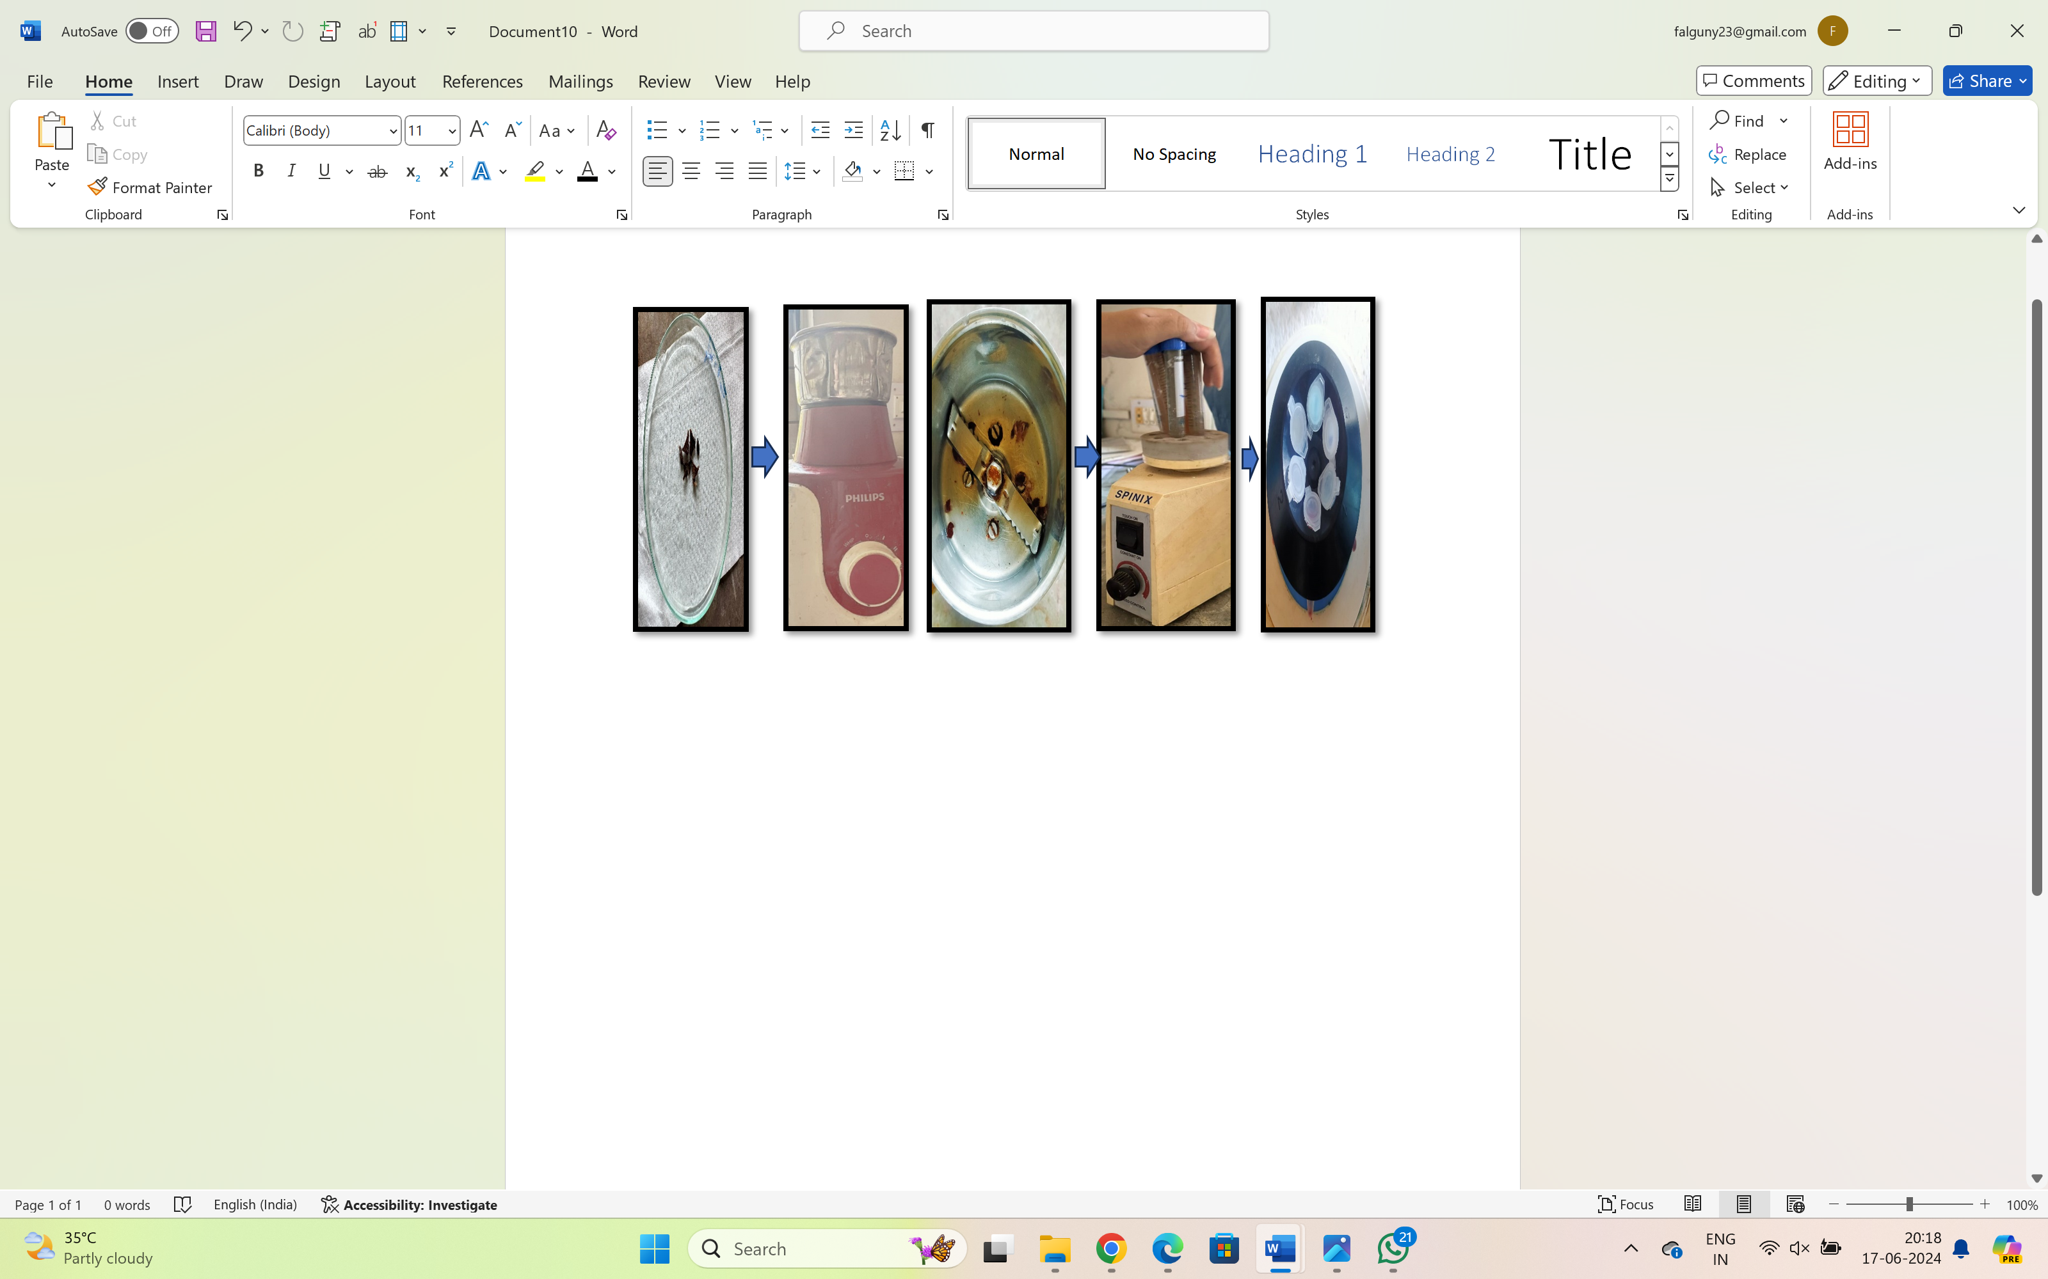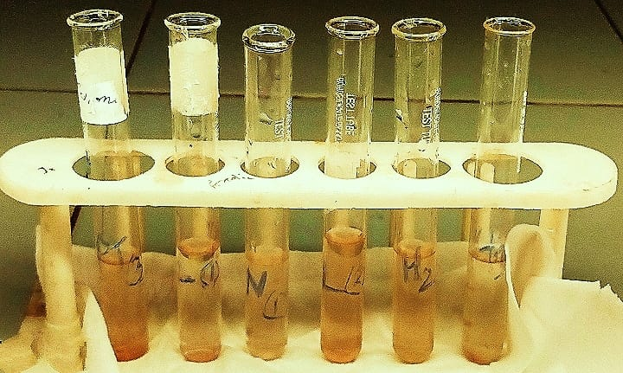
Figure 13Sample preparation assay for Haemoglobin assay

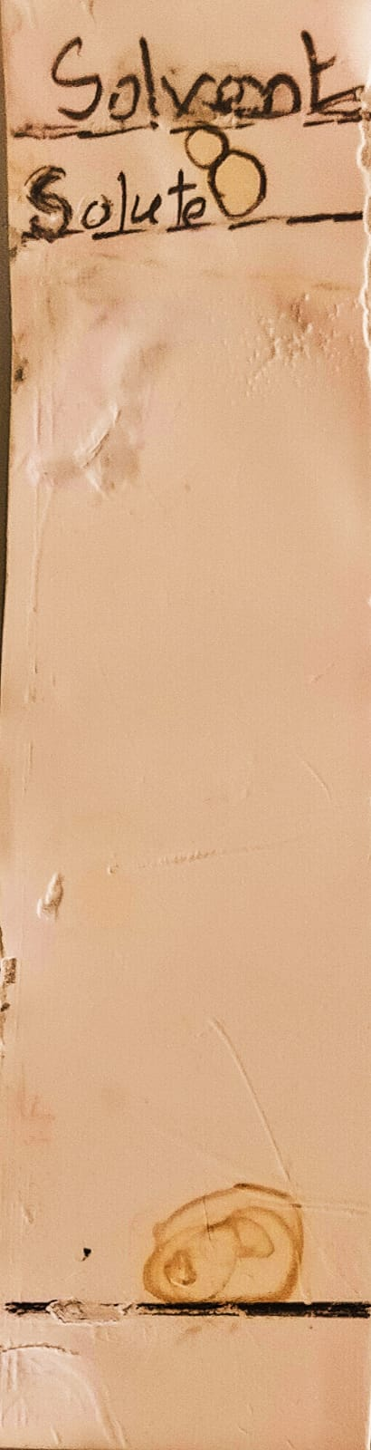
8cm
6cm
Figure 14 TLC Analysis process

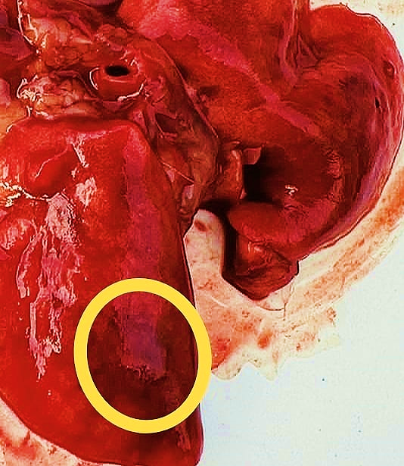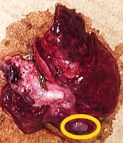
b
c
a
Figure 15 Formation of lung cancer a)1st rat on 7th day, b) 2nd rat on 13th da7, c)3rd rat on 18 th day
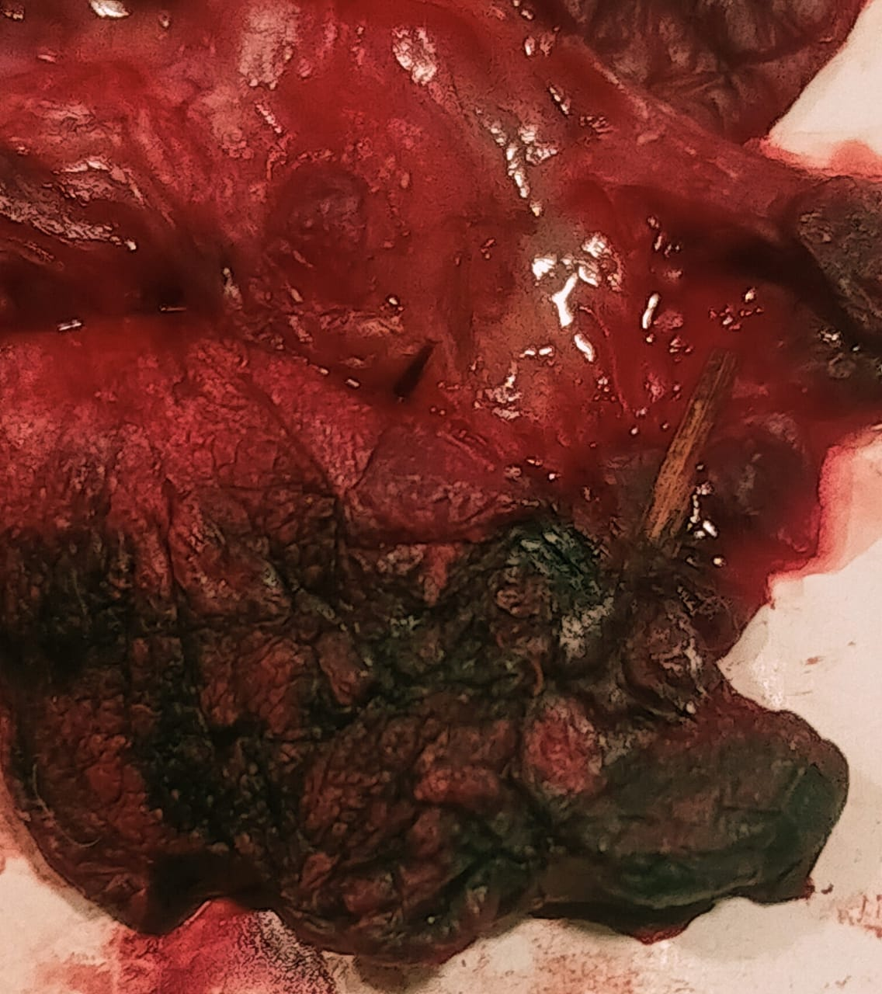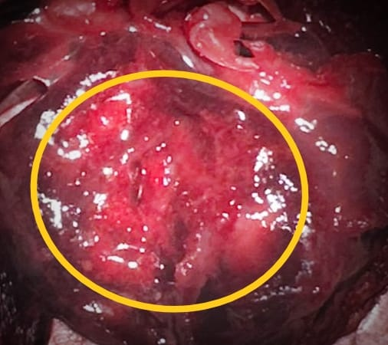
e
d
Figure 16Formation of lung cancer d) 3rd rat on 18th day, e) 4th rat on 20th day
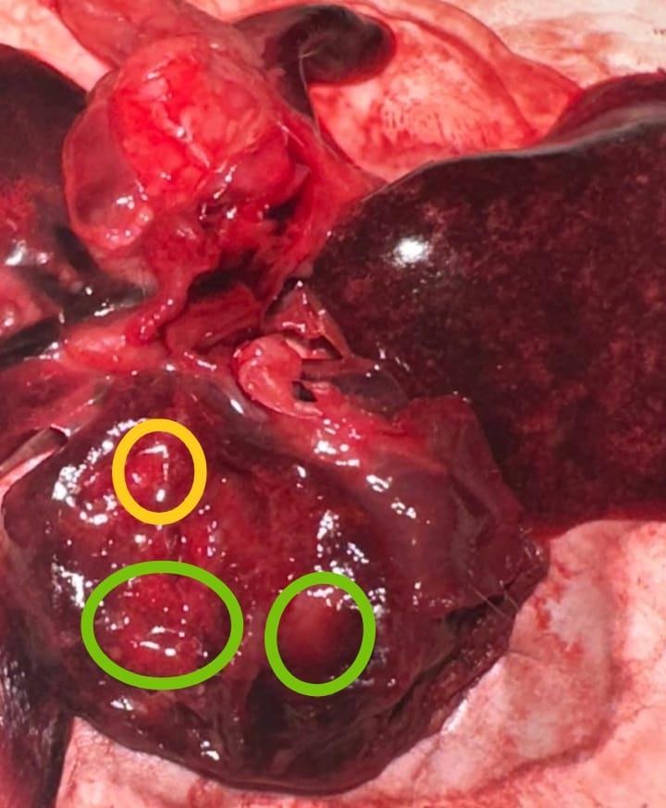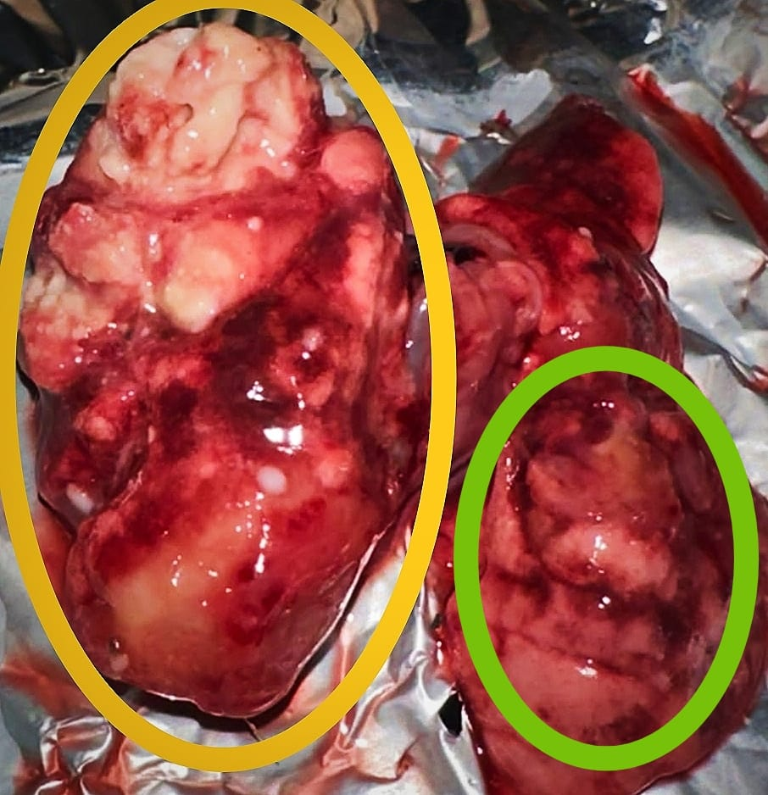
g
f
Figure 17Formation lung cancer f)4t rat on 20th day , g) 5th day on 22th day
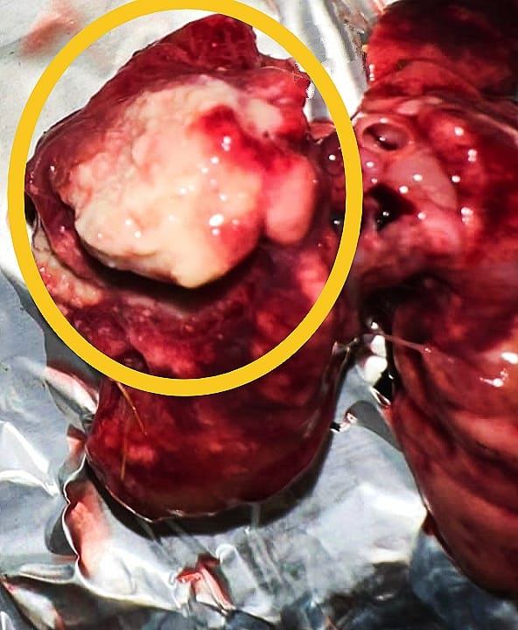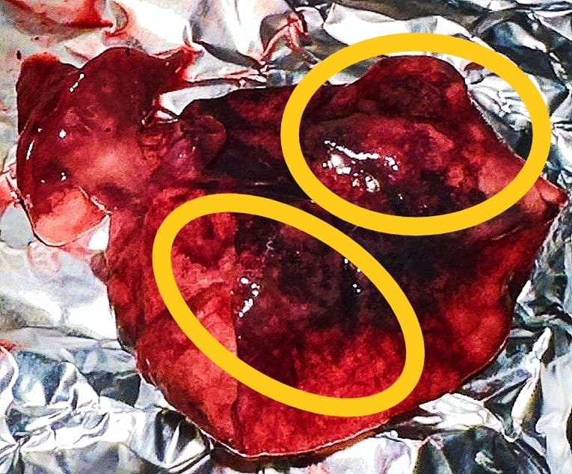
i
h
Figure 18 Formation of Lung cancer h) 5th rat on 22th day , i) 6h rat on 24th day

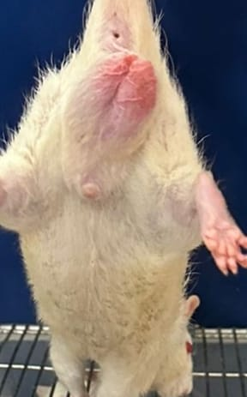
Figure 19: Redness & Inflammation in penis & scrotum part of the rat
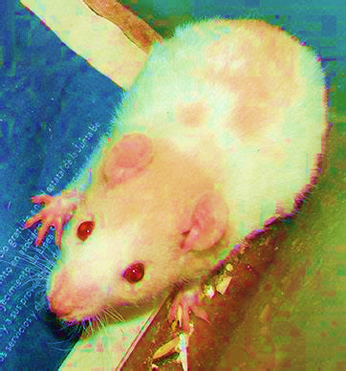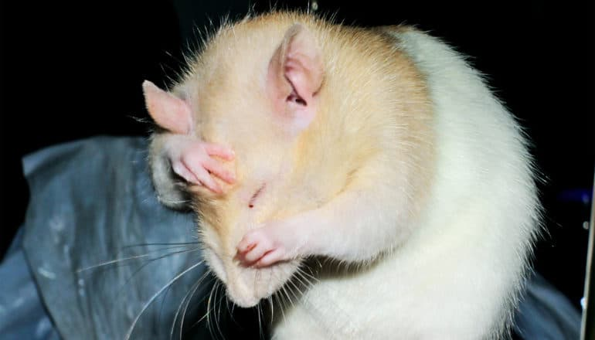
b
a
Figure 20 a) Redness of skin, b) Itchy skin

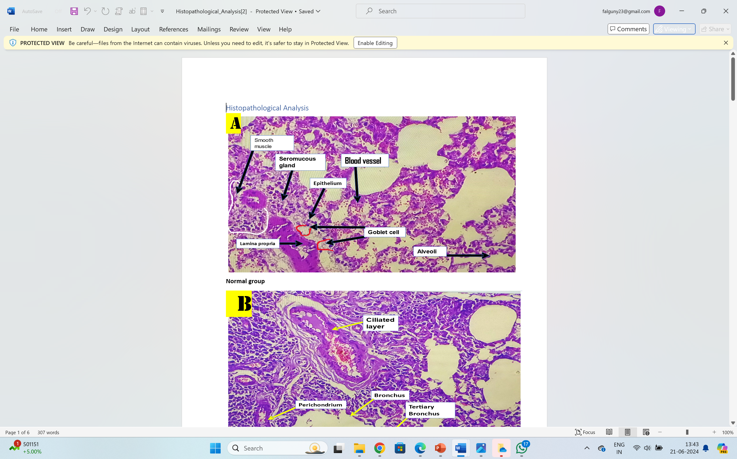
Figure 21 Histopathological Analysisi of Normal Group
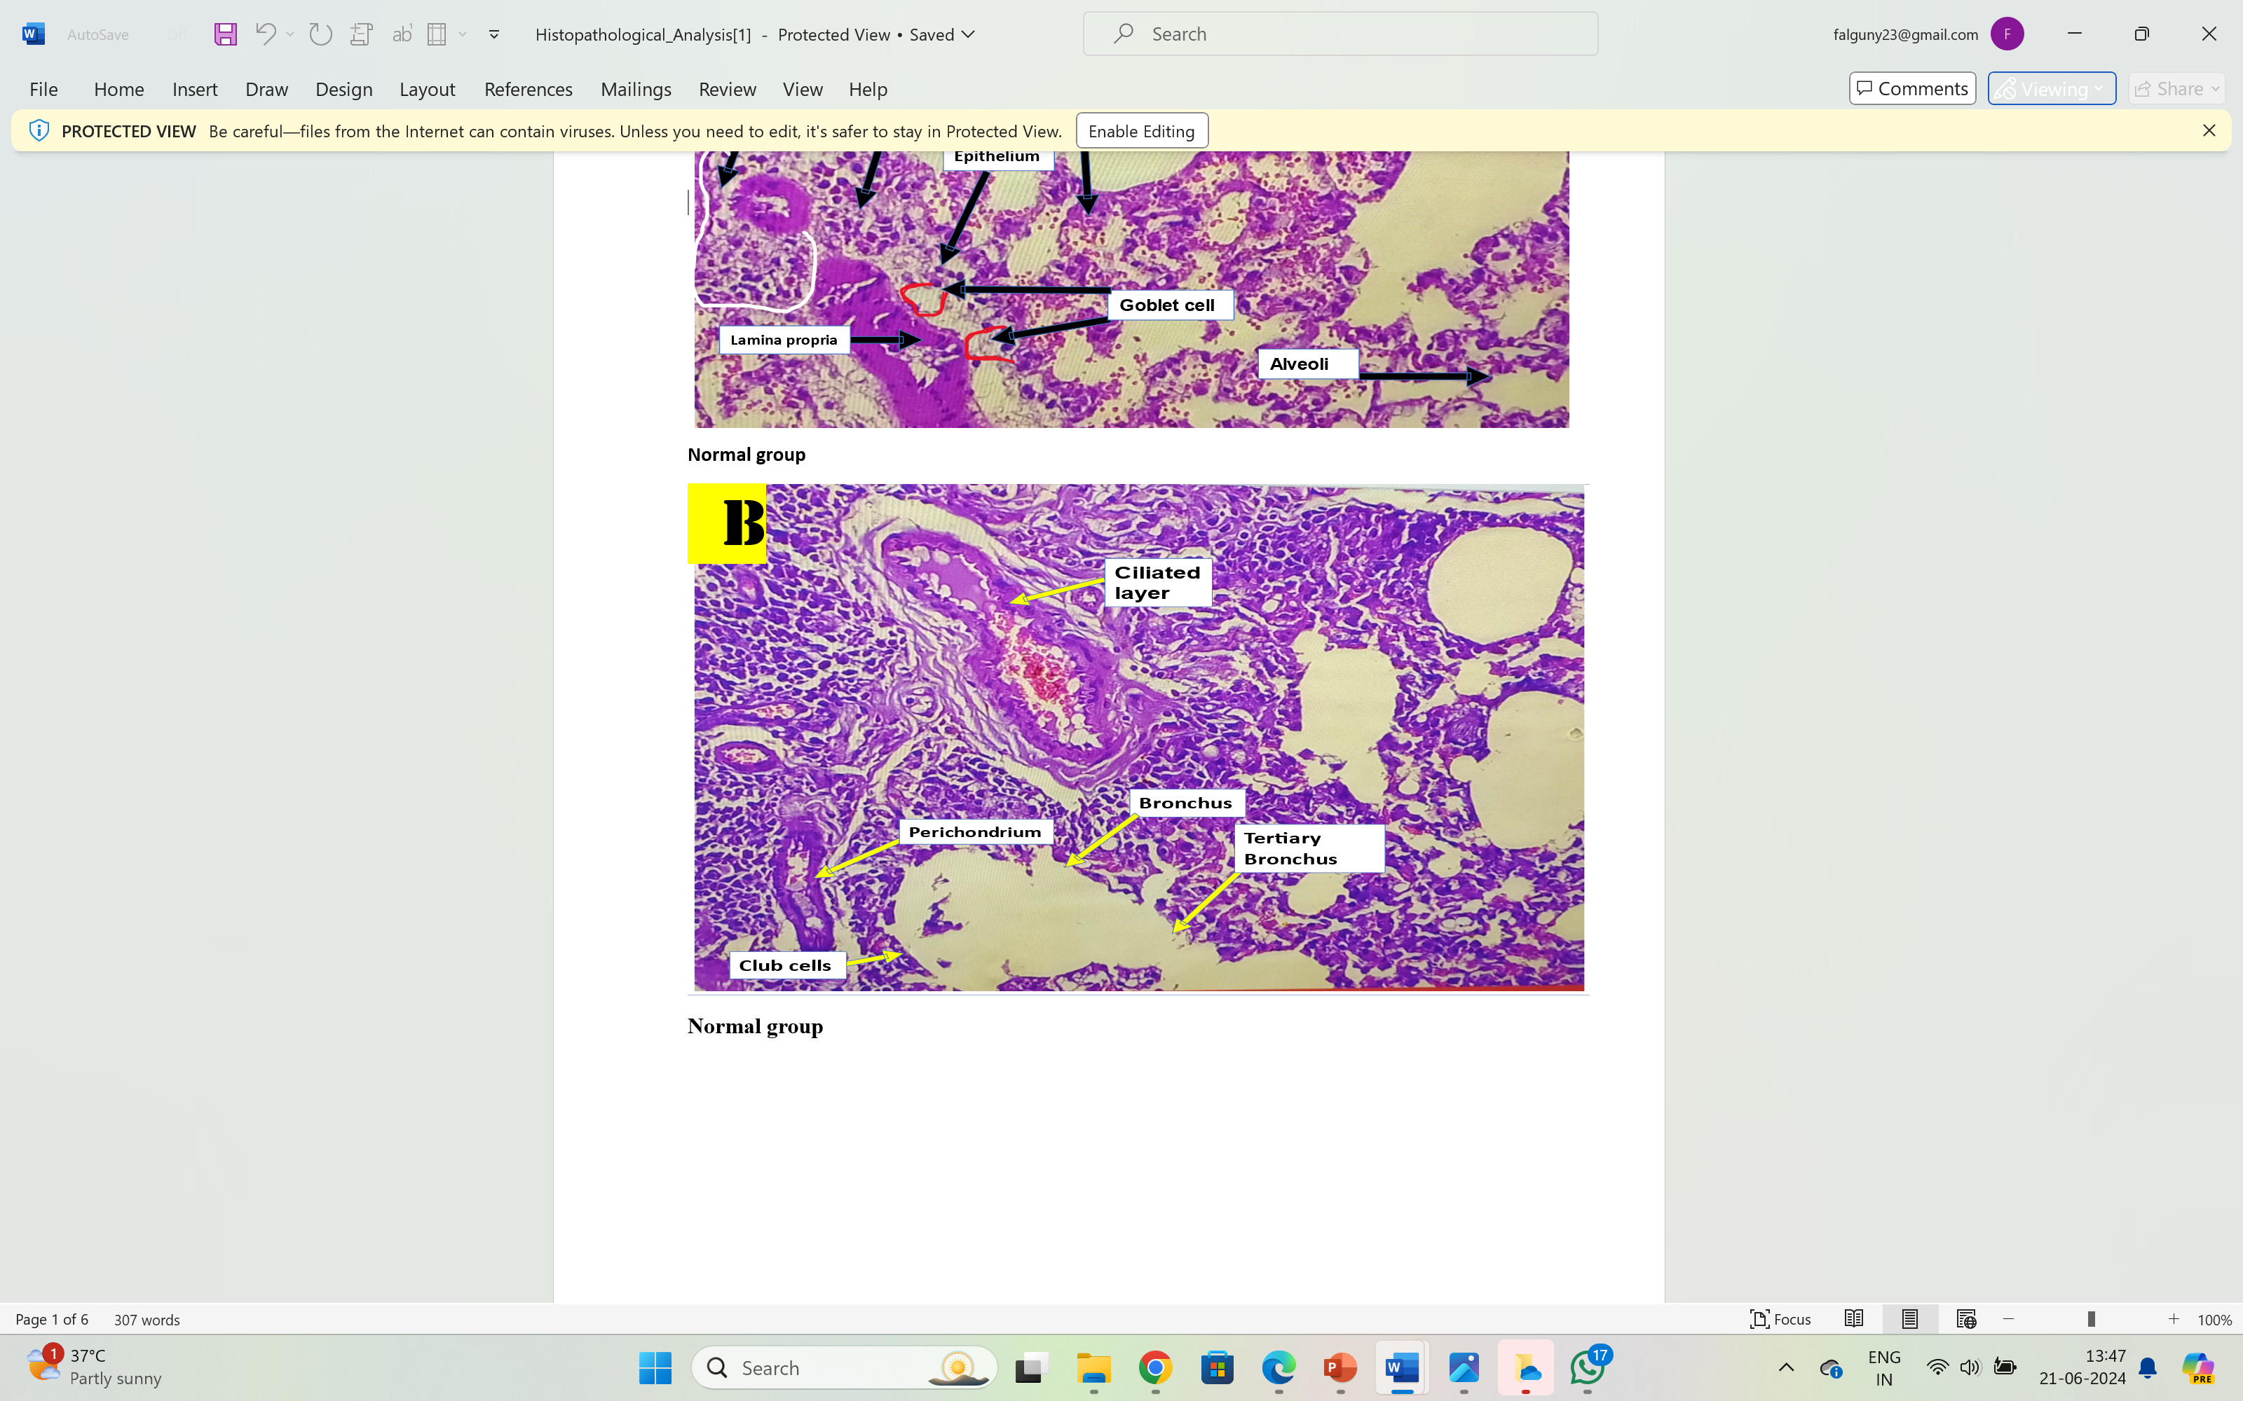
Figure 22 Histopathological Analysis of normal group

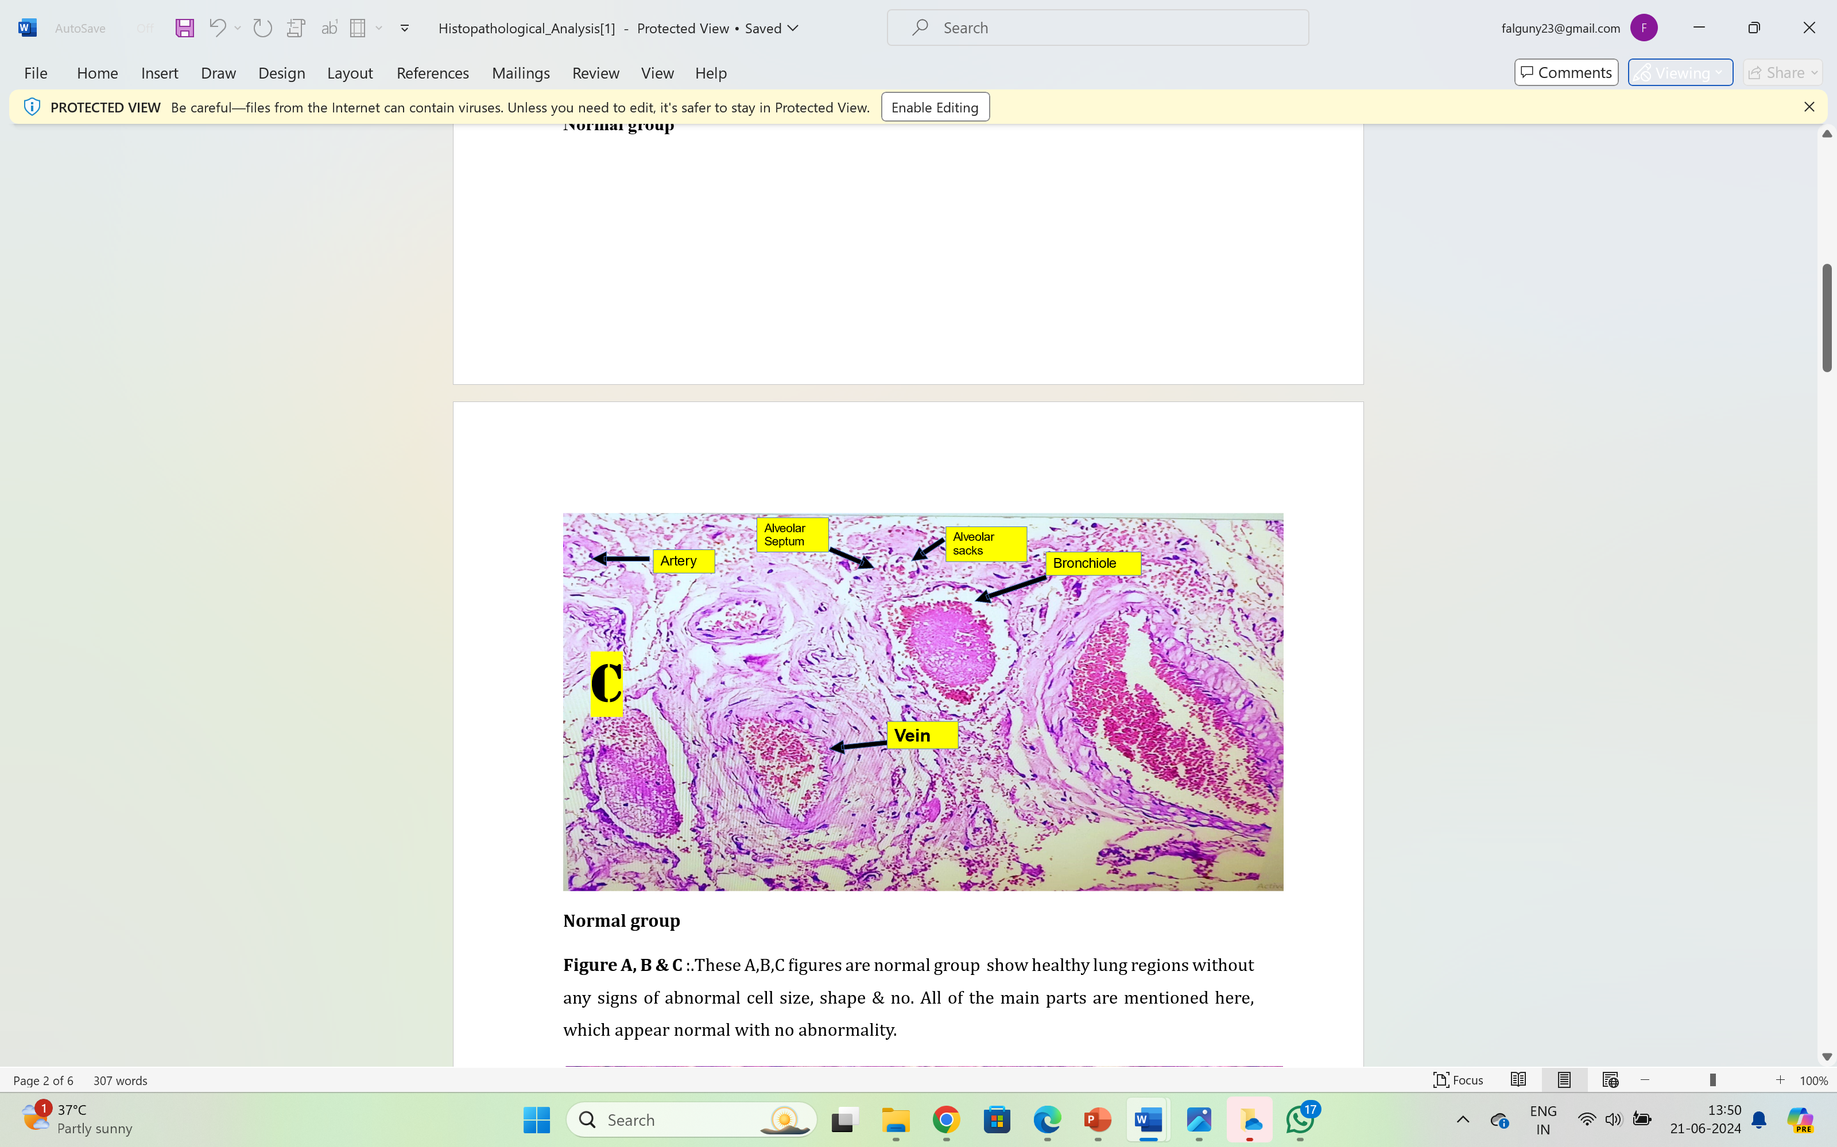
Figure 23 Histopathological Analysis of Normal group
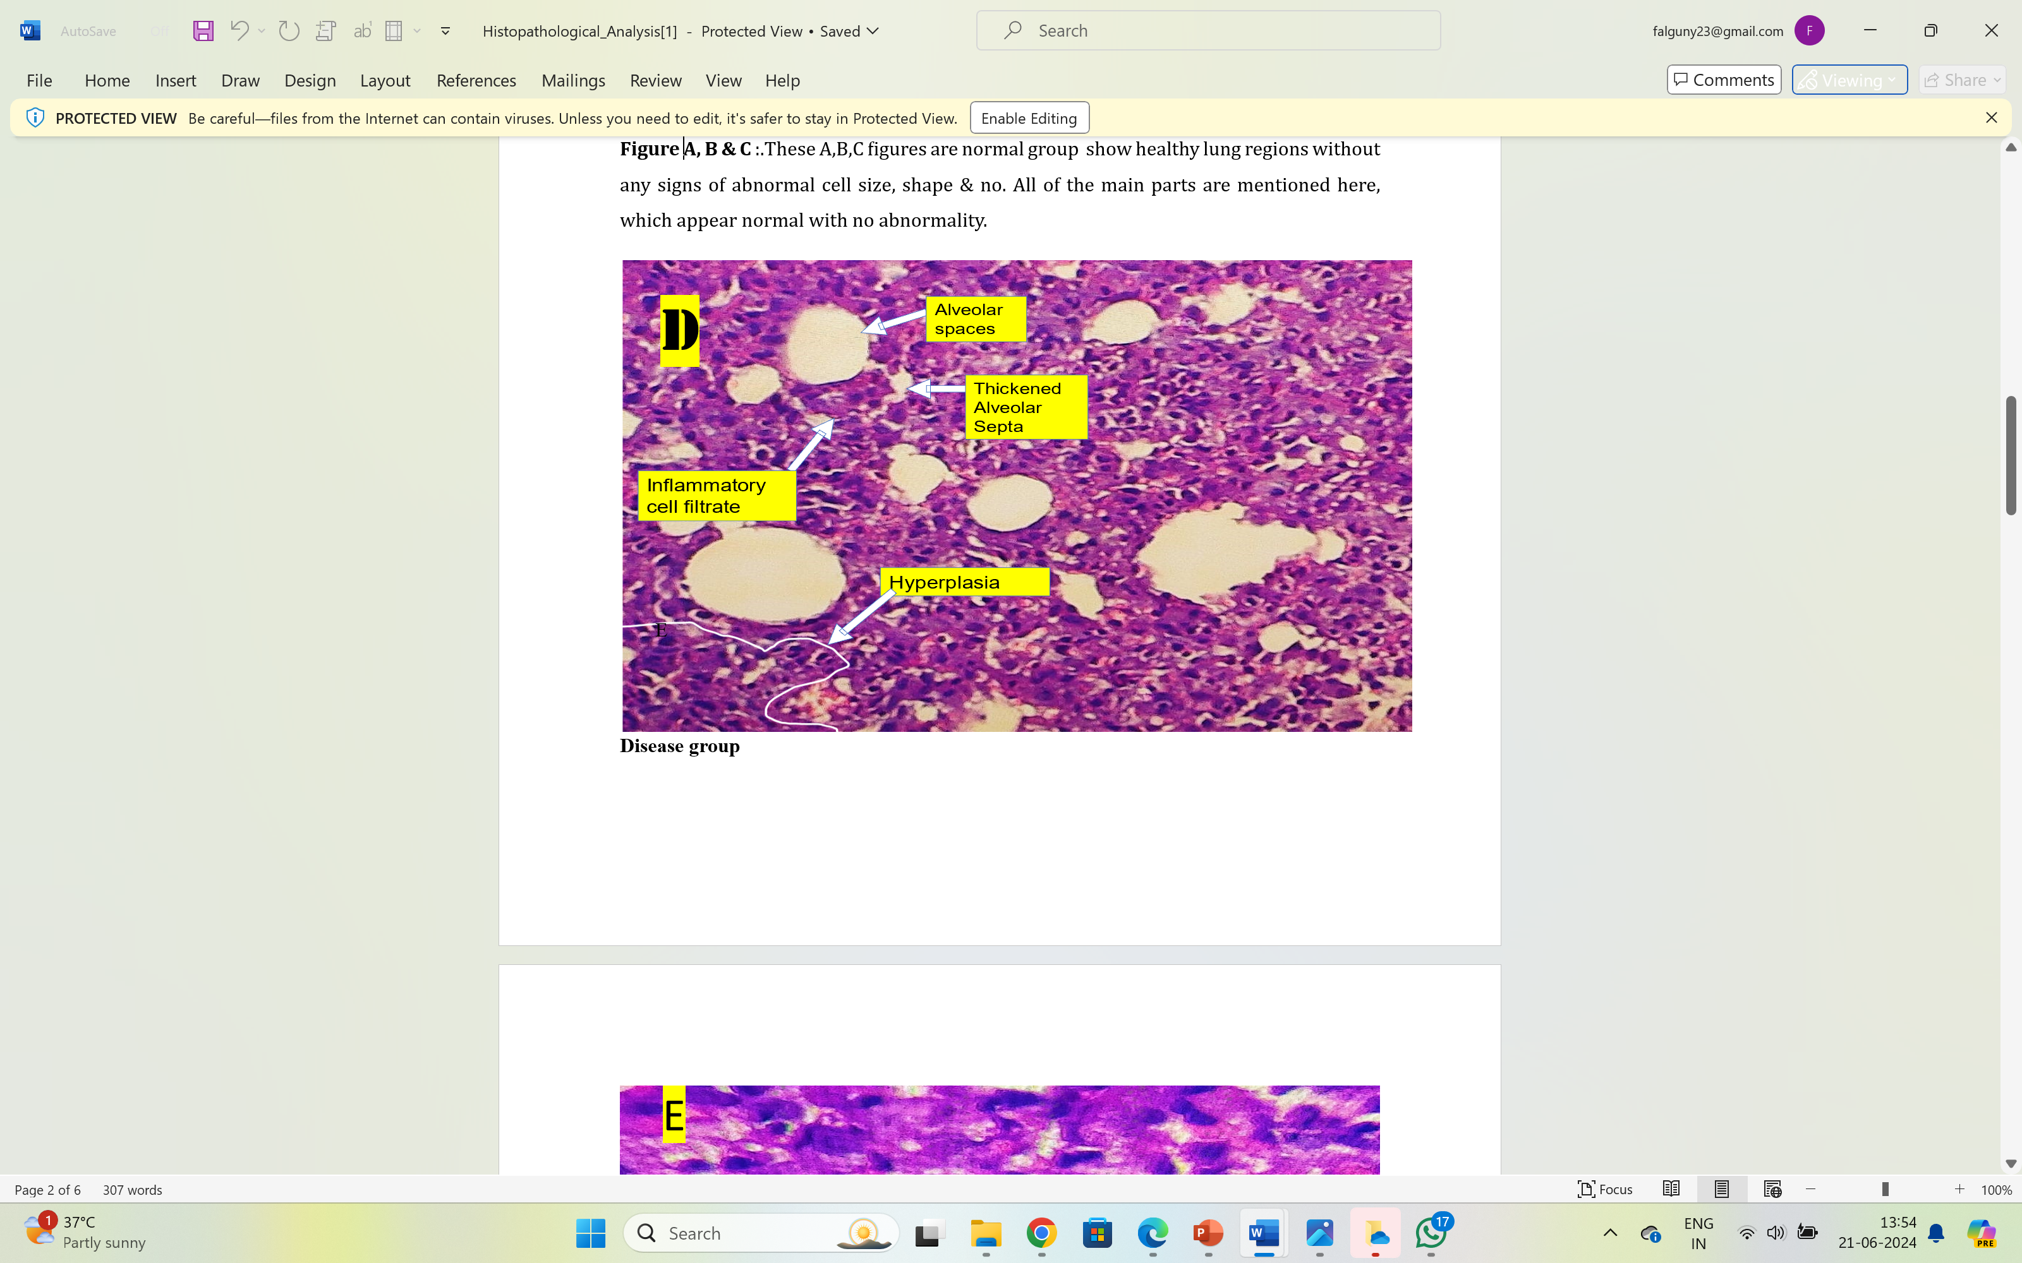
Figure 24 Histopathological Analysisi of Disease control group
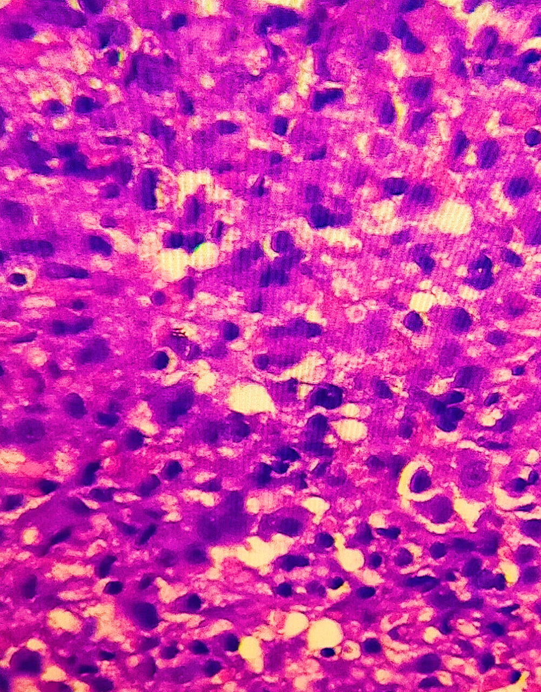
Figure 25 Histopathological Analysis of Disease conrol group
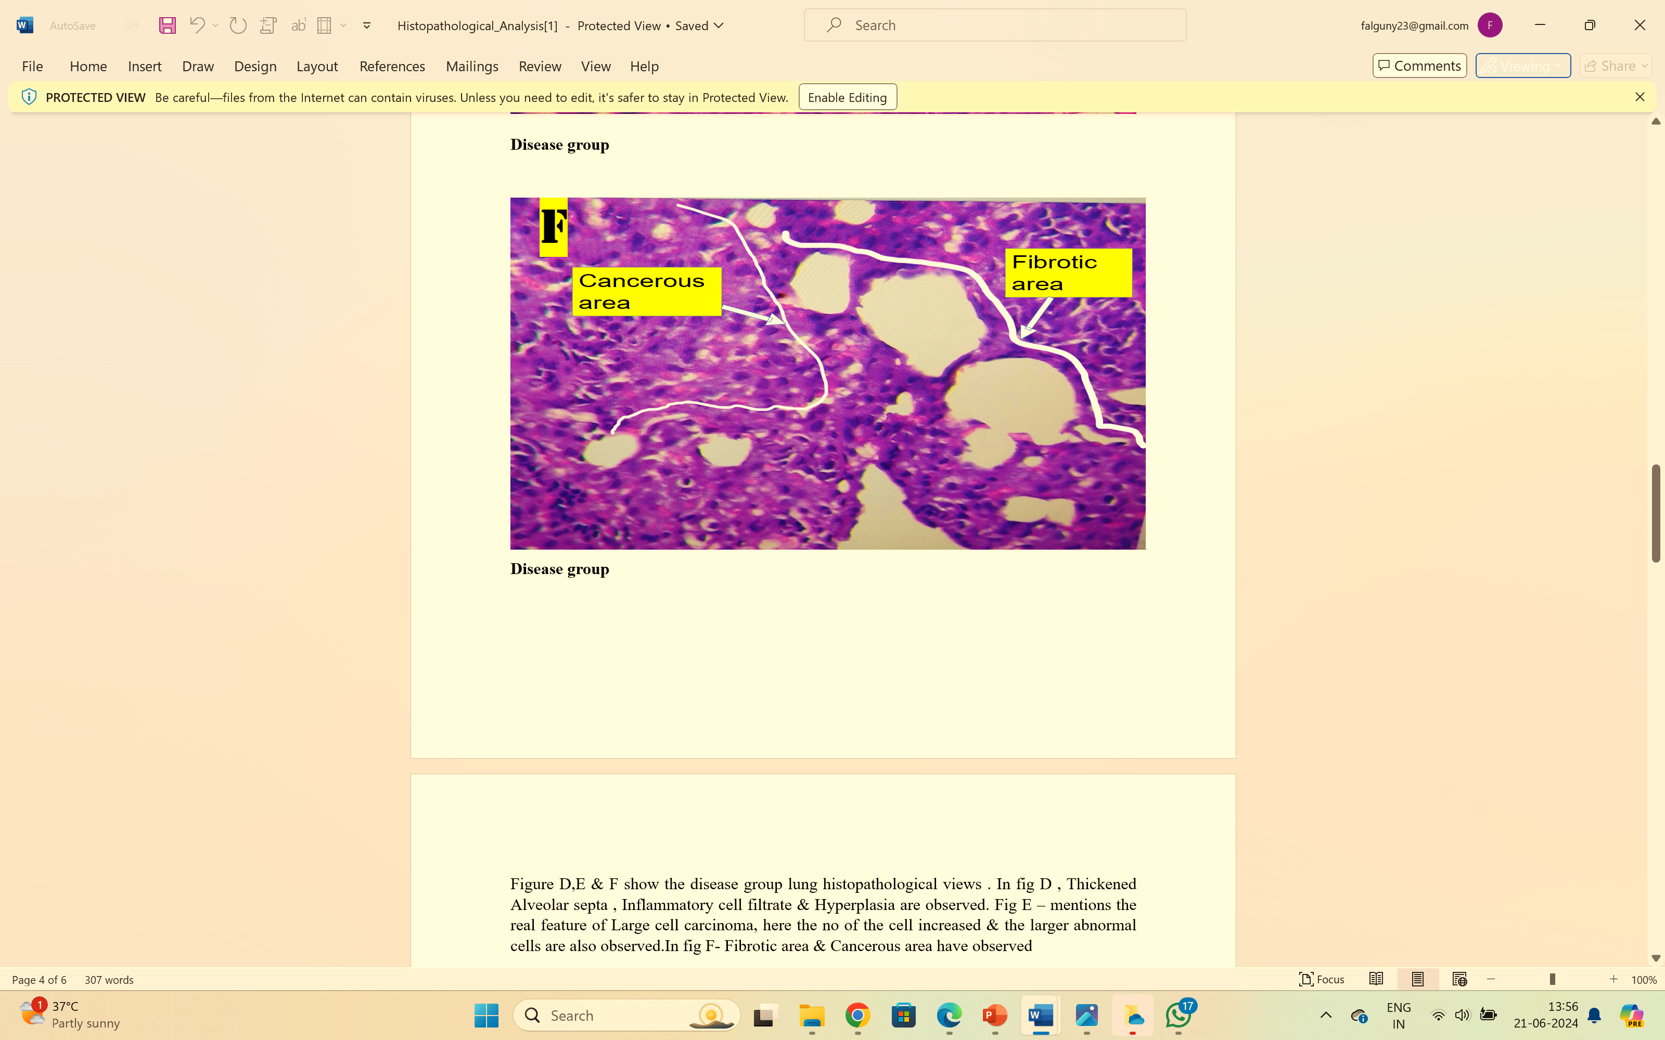
Figure 26 Histopathological Analysis of Disease control group
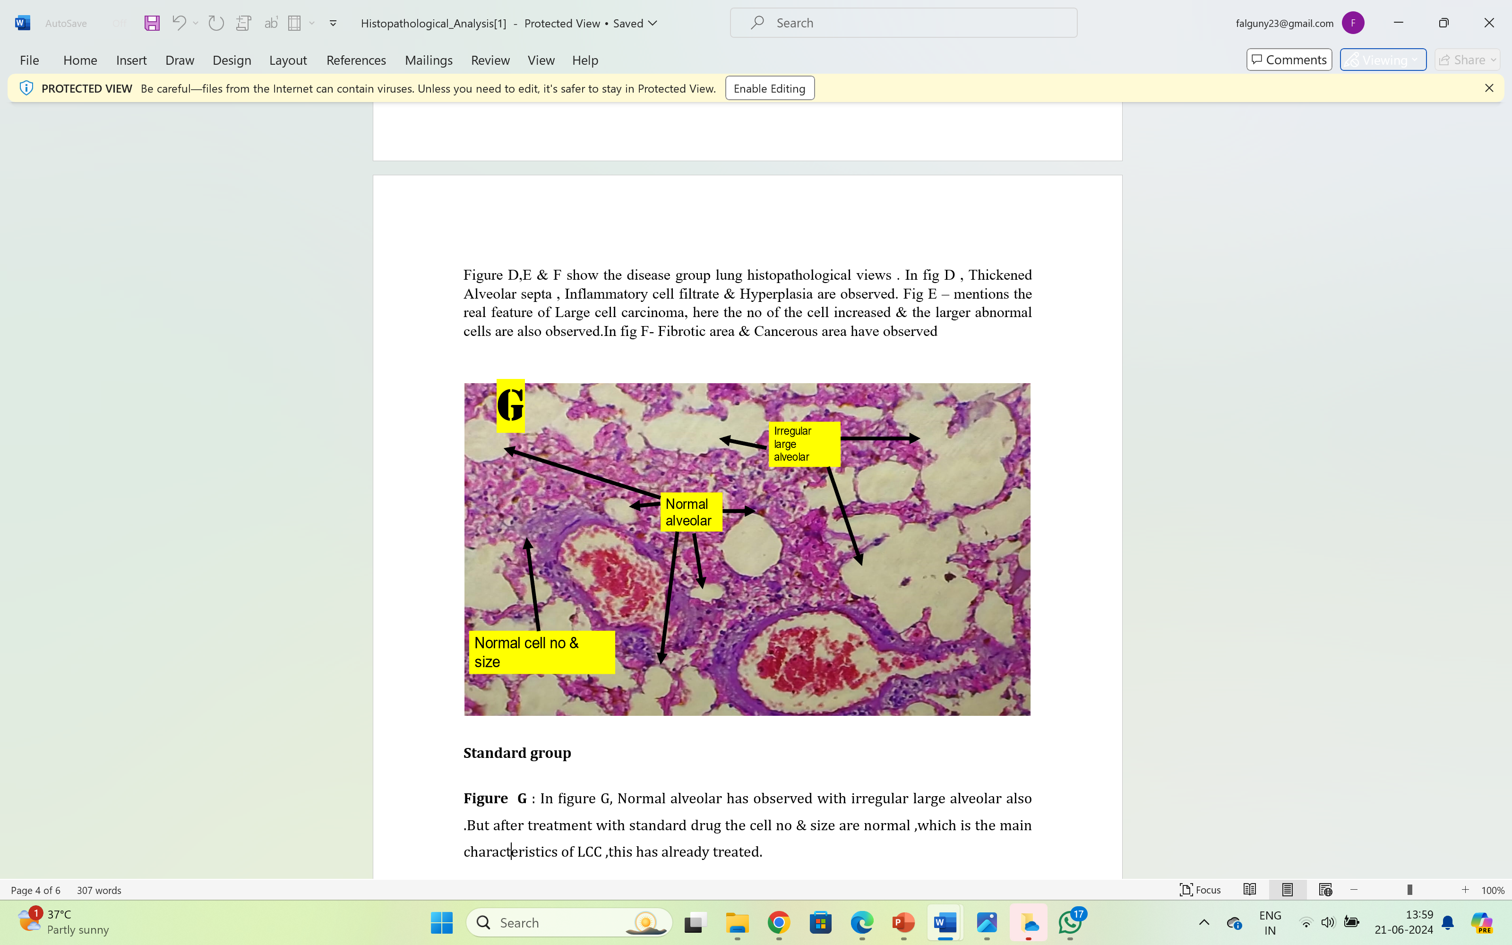
Figure 27 Histopathological Analysis of Standard group
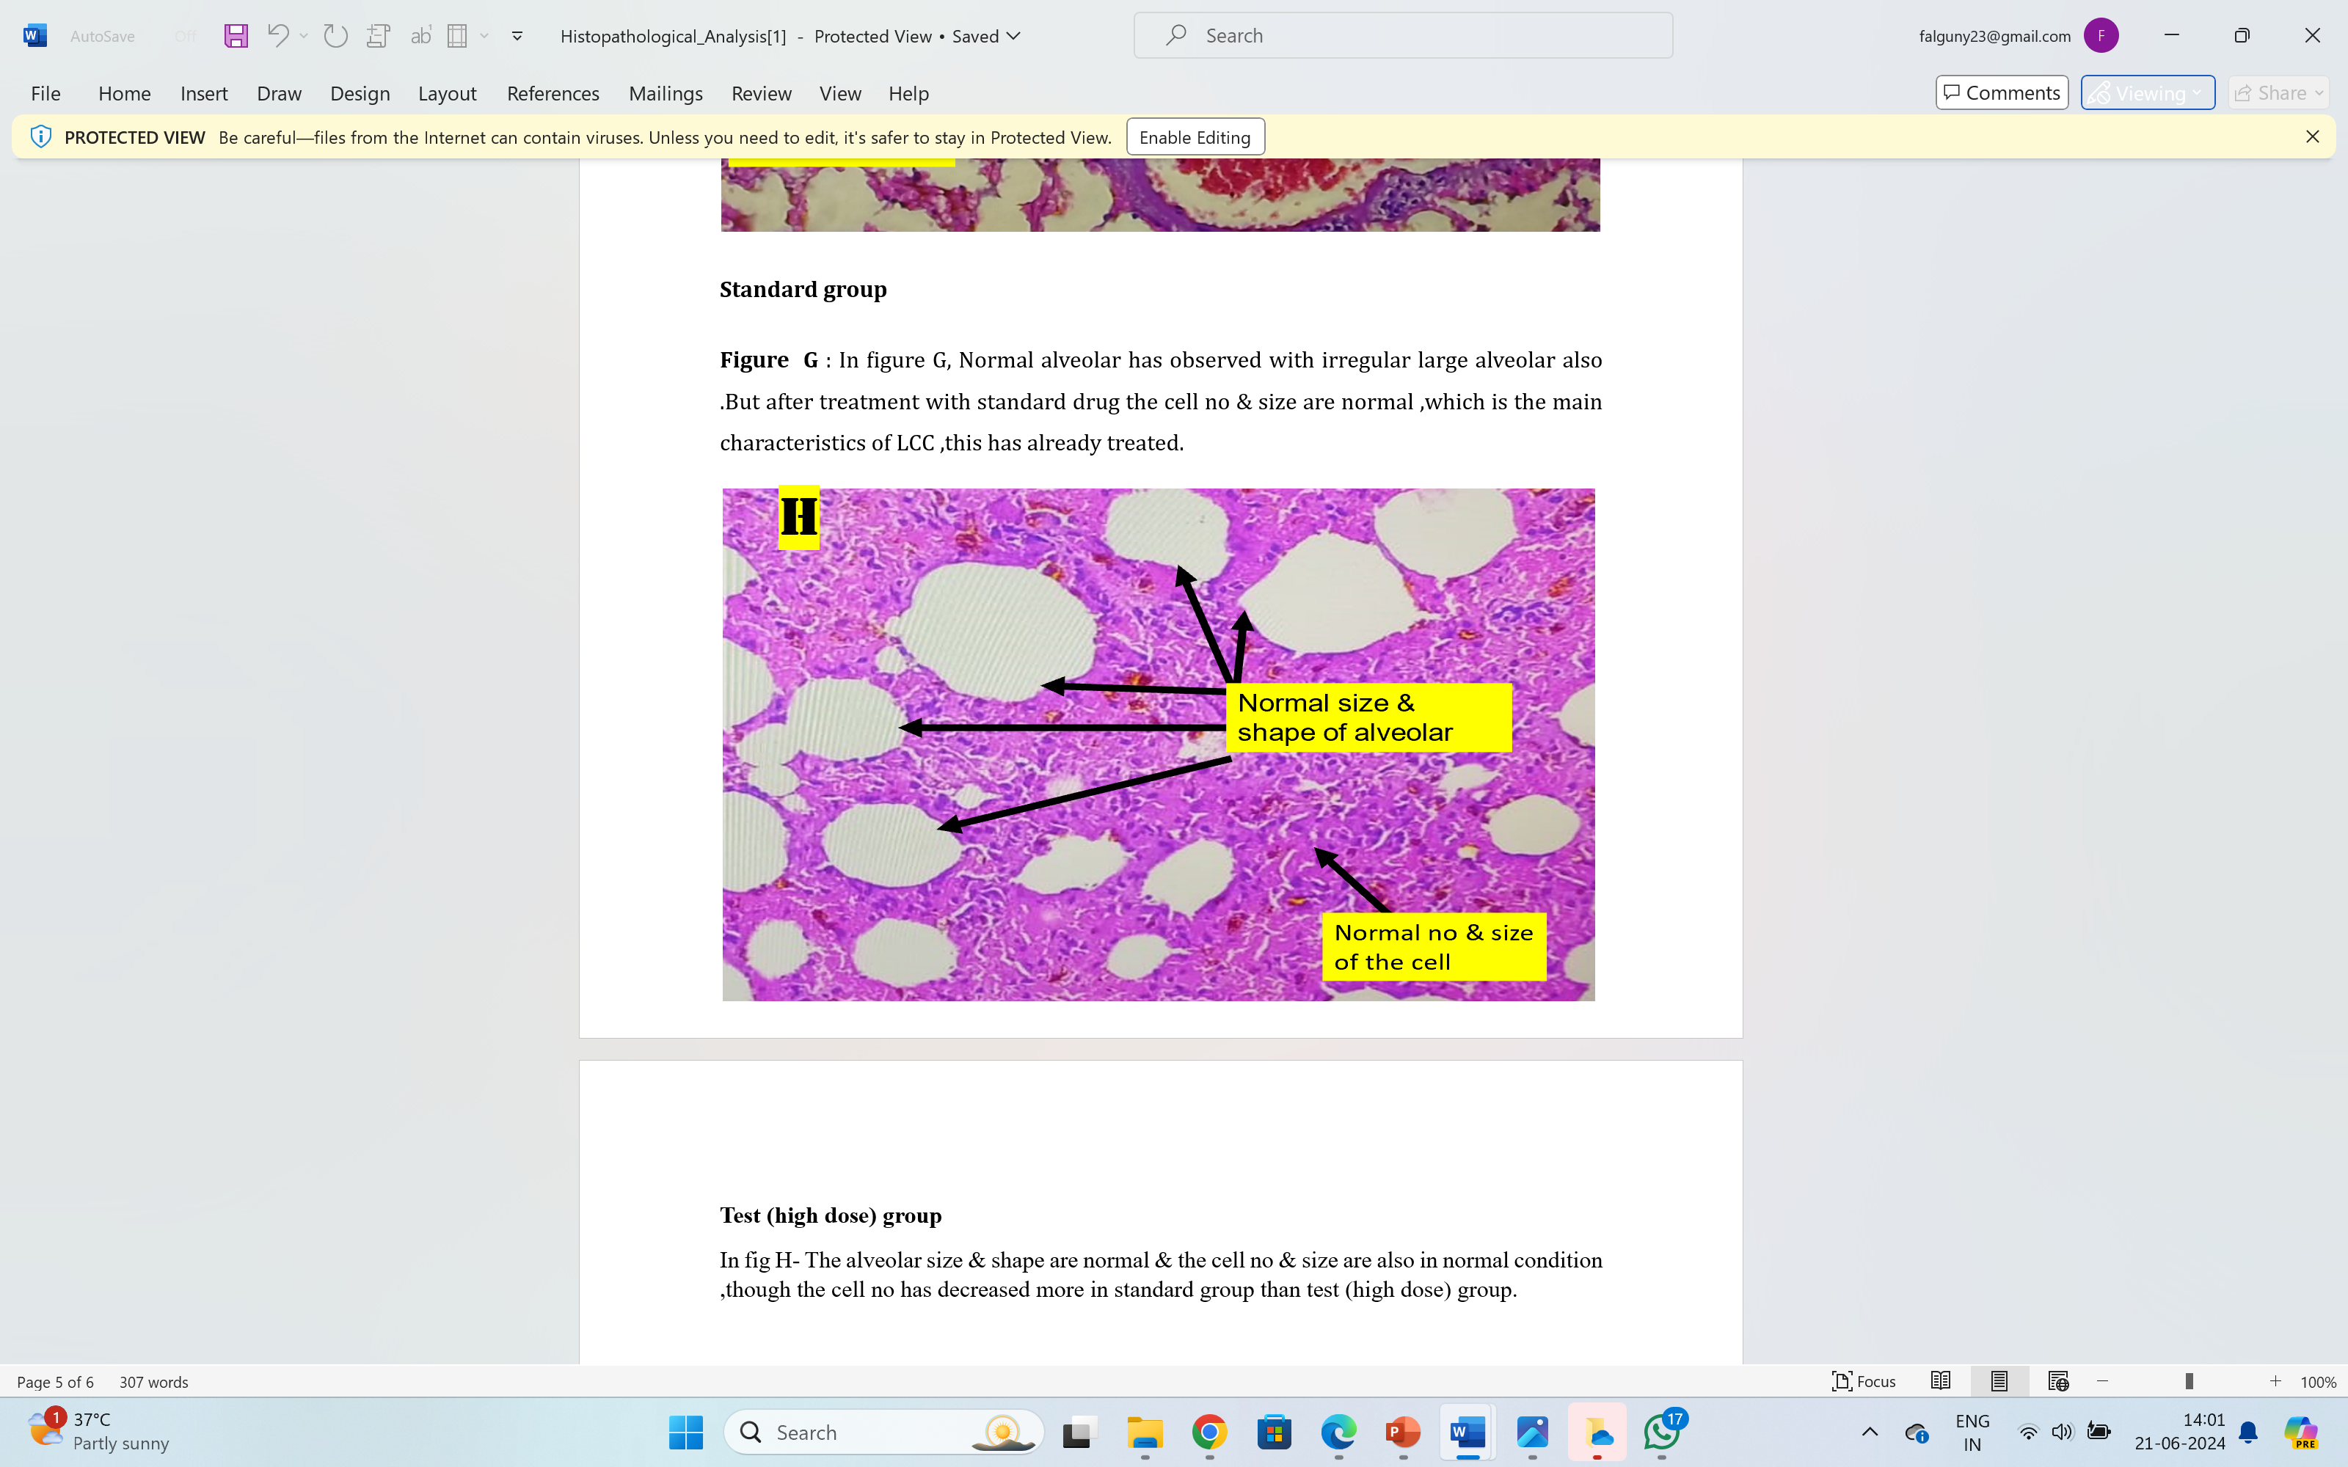
Figure 28 Histopathological analysis of Test (high dose ) group
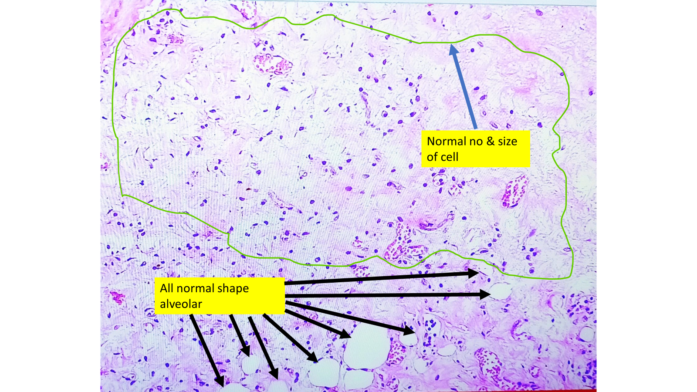
Figure 29 Histopathological Analysis of Standadrd + test group
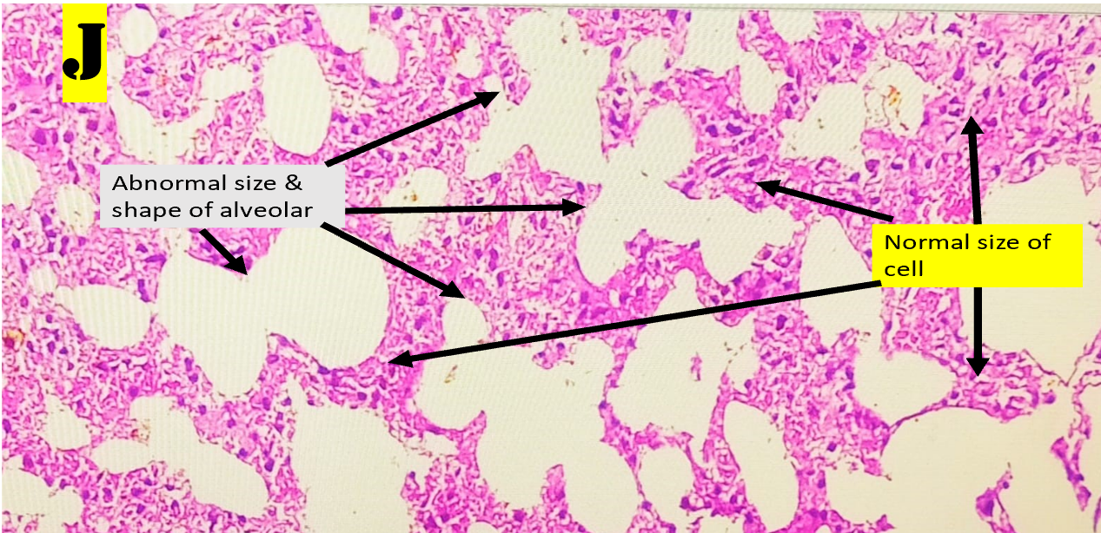
Figure 30 Histopathological analysis of test (low dose ) group
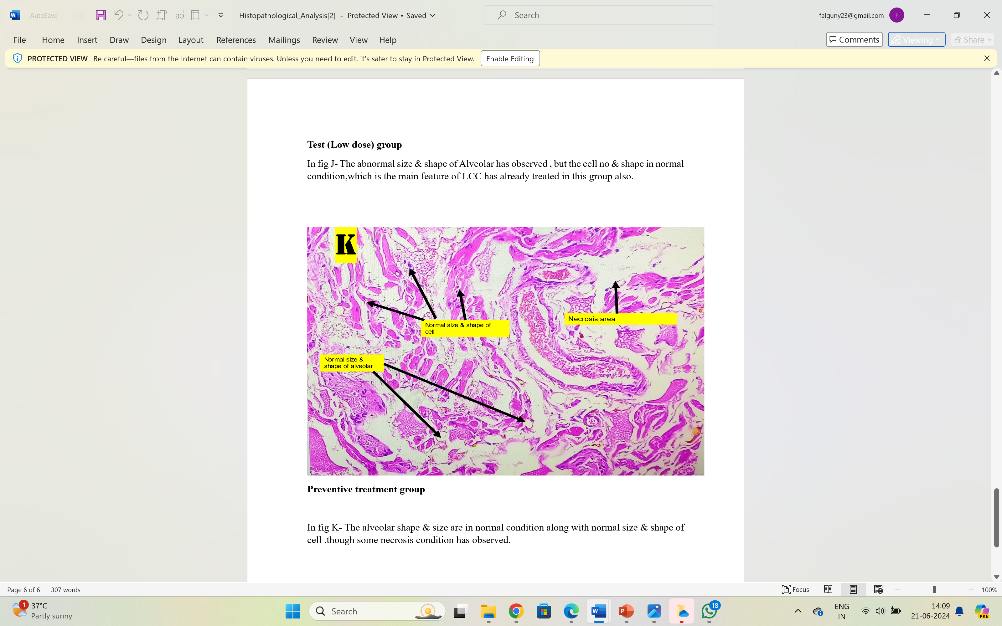
Figure 31Histopathological Analysis of Preventive treatment group

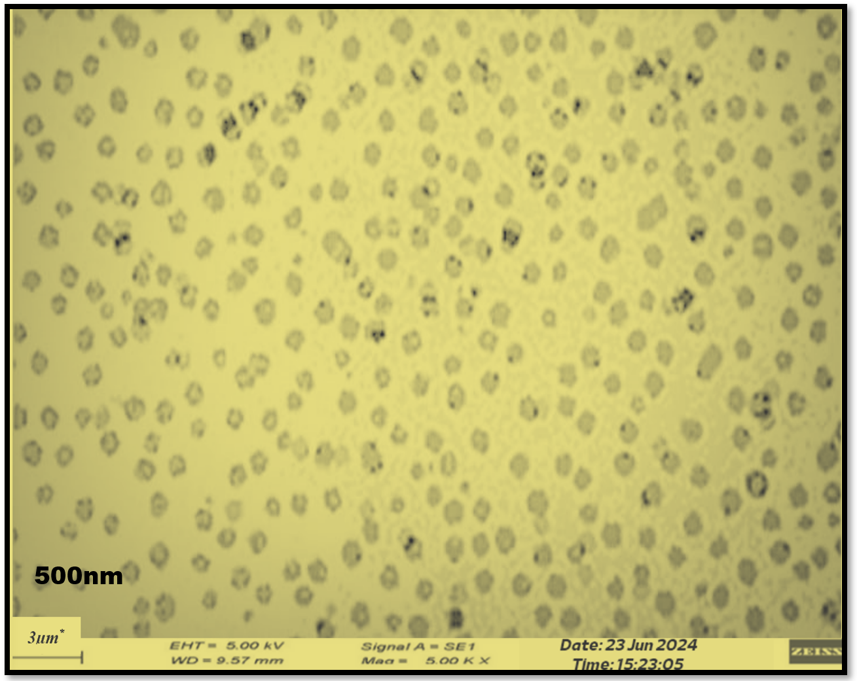
Figure-32:Scanning electron microscopic view of particle size of nano suspension

