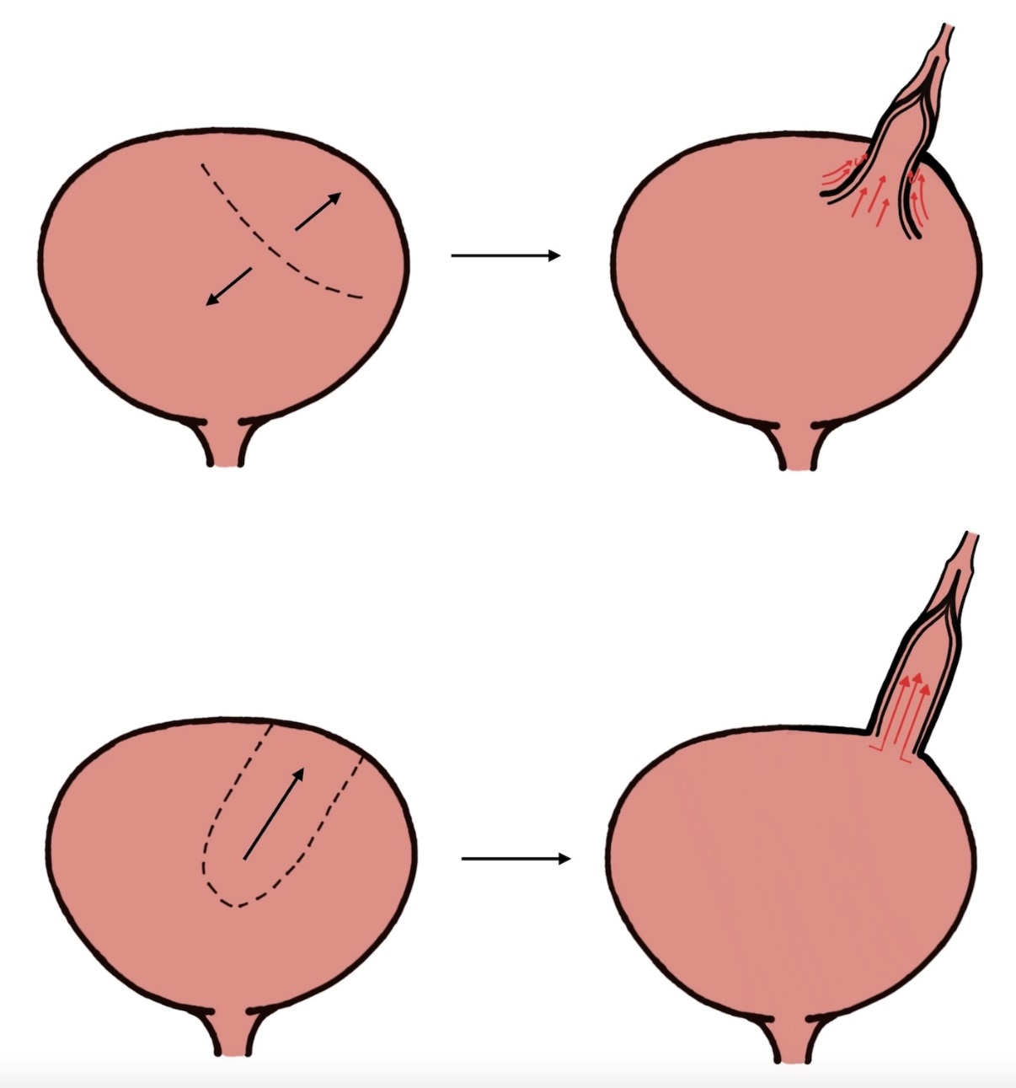
Supplementary Figure 3 – Proposed blood supply comparison, bladder elongation (top) vs Boari flap (bottom)

