Saccharomyces cerevisiae reduces vulvovaginal candidiasis severity through modulation of fungal pathogenicity and inflammatory responses

Mart Sillen^{1,2}, Dania El Abyad¹, Nina Vreys¹, Silke Baldewijns¹, Ilse Palmans¹, Odessa Van Goethem¹, Kar On Cheng³, Greetje Vande Velde⁴, Dolly E Montaño³, Mieke Gouwy⁵, Agustin R. Sharpe⁴, Axel Dietschmann³, Paul Vandecruys¹, Sarah Lebeer², Liesbeth Demuyser¹, Mark S. Gresnigt^{3,*}, Patrick Van Dijck^{1,6,*}

SUPPLEMENTARY MATERIALS

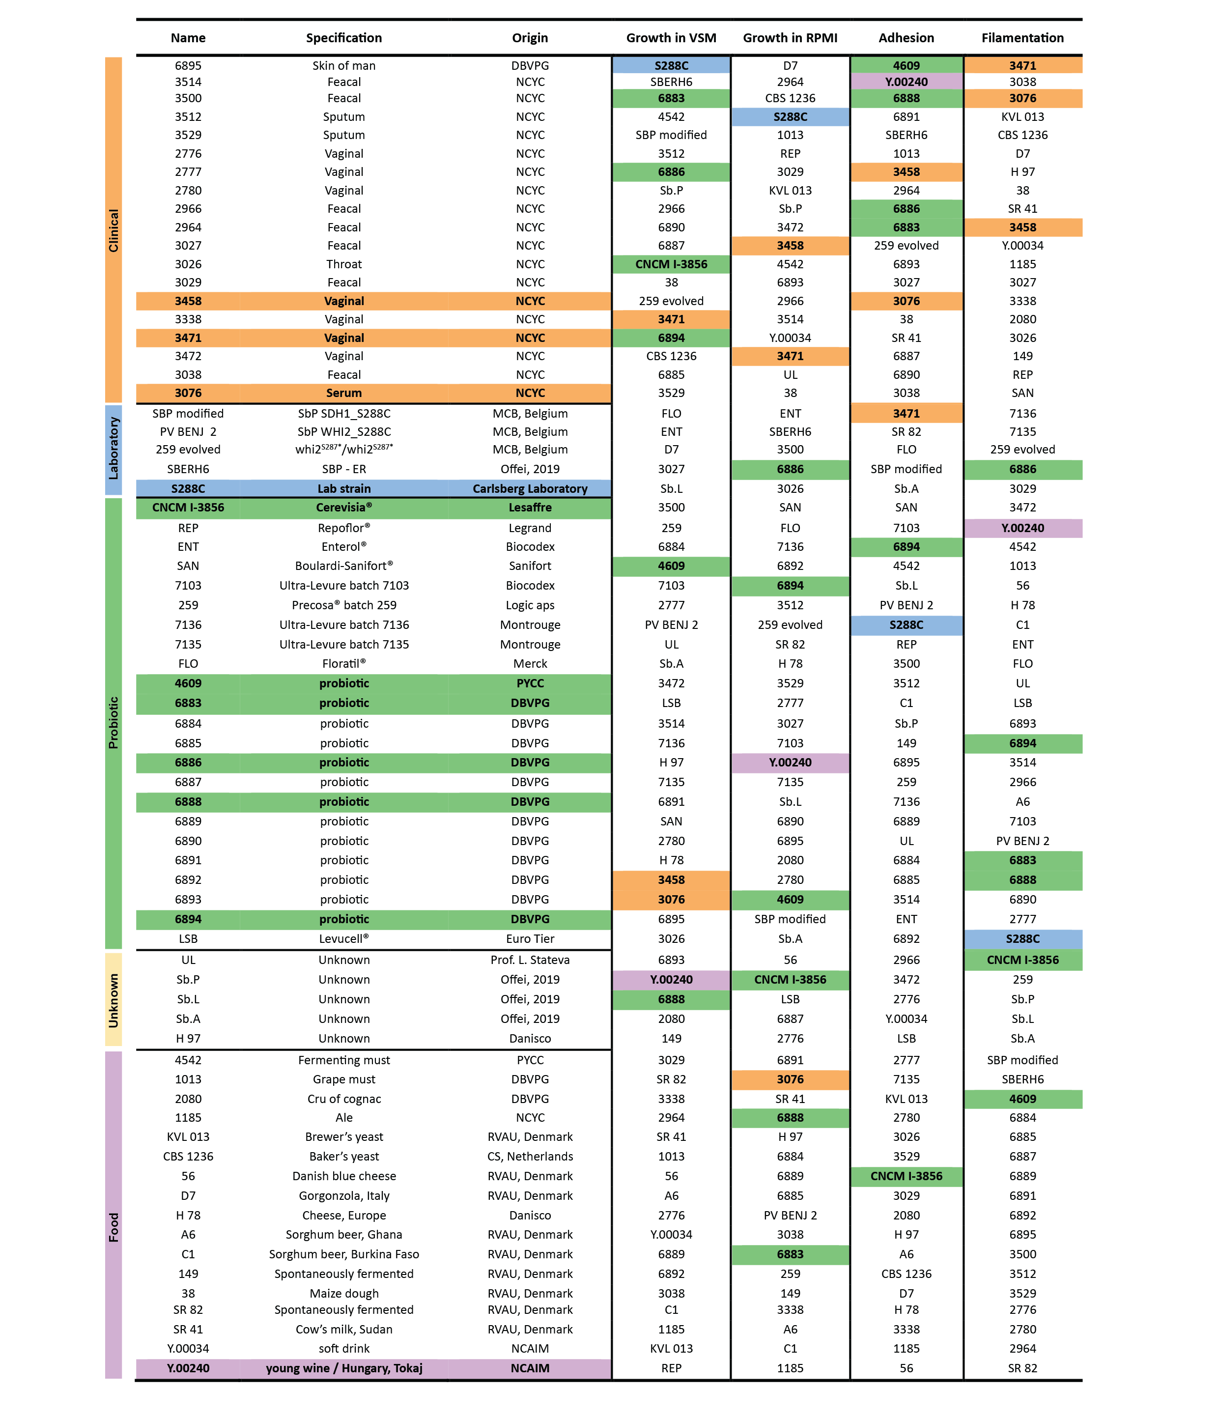
Supplementary Table 1. Overview of S. cerevisiae isolates. Detailing their background and performance in inhibiting C. albicans CA3153 pathogenicity (Growth, Adhesion, and Filamentation). The strains selected for further investigation are highlighted.
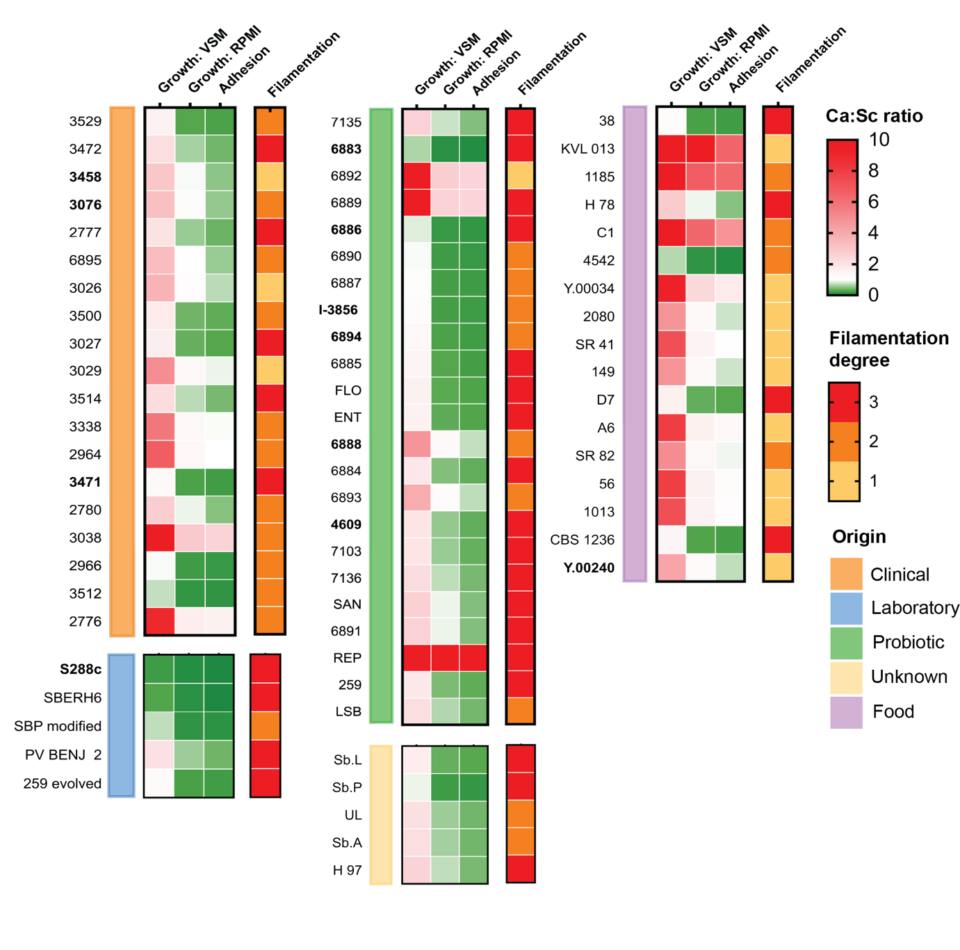
Supplementary Fig. 1: Effects of S. cerevisiae on C. albicans growth, adhesion, and filamentation by origin. The heatmaps represent three conditions: Growth on VSM, growth on RPMI, and adhesion, with color intensities indicating the Ca:Sc ratio. Green corresponds to low ratios (approaching 0), transitioning through white to red, representing high ratios (up to 10). Adjacent to these growth heatmaps, filamentation degree is depicted as a categorical variable, color-coded as follows: yellow for degree 1 (pseudohyphae), orange for degree 2 (few hyphae), and red for degree 3 (abundant hyphae). The colored bars on the left denote the origin of the S. cerevisiae strains, providing a clear visual representation of strain-specific phenotypic variability across different conditions.

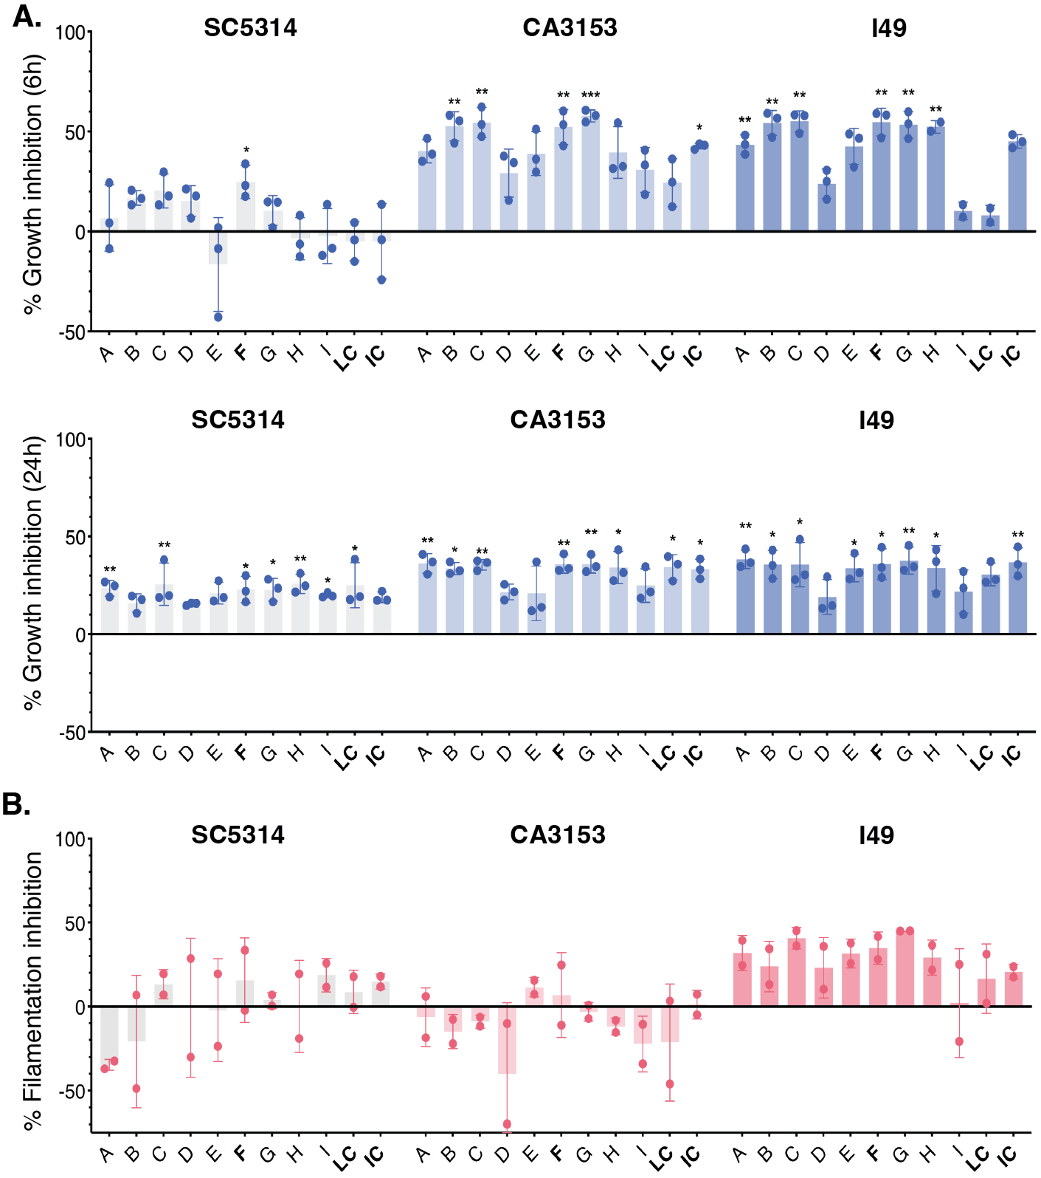
Fig. S2: Evaluation of top candidate S. cerevisiae isolates for inhibitory properties against C. albicans in RPMI. A. Inhibition of C. albicans growth by S. cerevisiae isolates (A-I, LC = lab control S288C, IC = probiotic standard CNCM I-3856) in RPMI after 6 hours (upper panel) and 24 hours (lower panel). C. Inhibition of C. albicans filamentation by S. cerevisiae in VSM after 3 hours. All values are presented as mean ± standard deviation (s.d.) from n≥2 independent experiments, with dots representing the mean of the technical replicates of the individual experiments. Data were transformed using a Box-Cox transformation to meet linear regression assumptions. Statistical significance was determined using a one-sample t-test against a theoretical mean of 0%, representing C. albicans alone. Significant differences are indicated as *p < 0.05, **p < 0.01, ***p < 0.001.

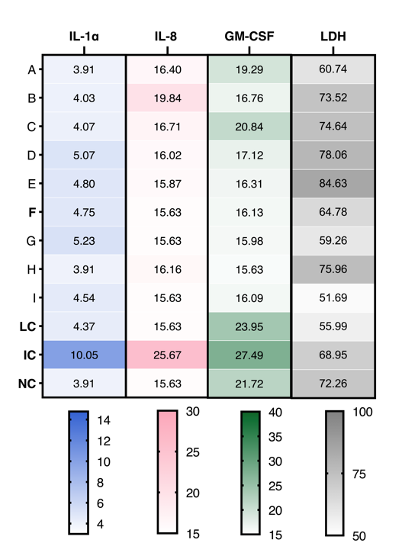
Fig. S3: S. cerevisiae modulates C. albicans-induced VECs cytokine release and LDH levels. Levels of IL-1α, IL-1Ra, IL-8, GM-CSF, and LDH measured across experimental groups (A–I) and controls (Lab Control (LC), Industrial Control (IC), and Negative Control (NC)). Conditions include treatments with varying combinations of stimuli or controls, as indicated. Data are displayed as a heatmap with color scales representing relative intensities from n ≥ 2 experiments.
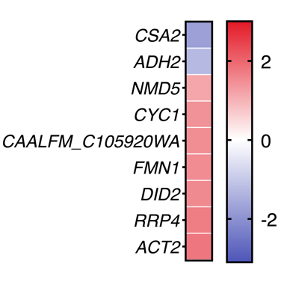
Fig. S4: S. cerevisiae induces minimal transcriptional changes in C. albicans during epithelial infection 6 hpi. Heatmap of transcriptional changes of C. albicans upon exposure Sc3458. Gene expression is shown as Log2 fold change, with significant downregulation indicated (Log2 > 1 or < −1, p < 0.05). Data represent mean ± standard deviation (s.d.) from n ≥ 3 independent experiments, with dots representing the mean of technical replicates.

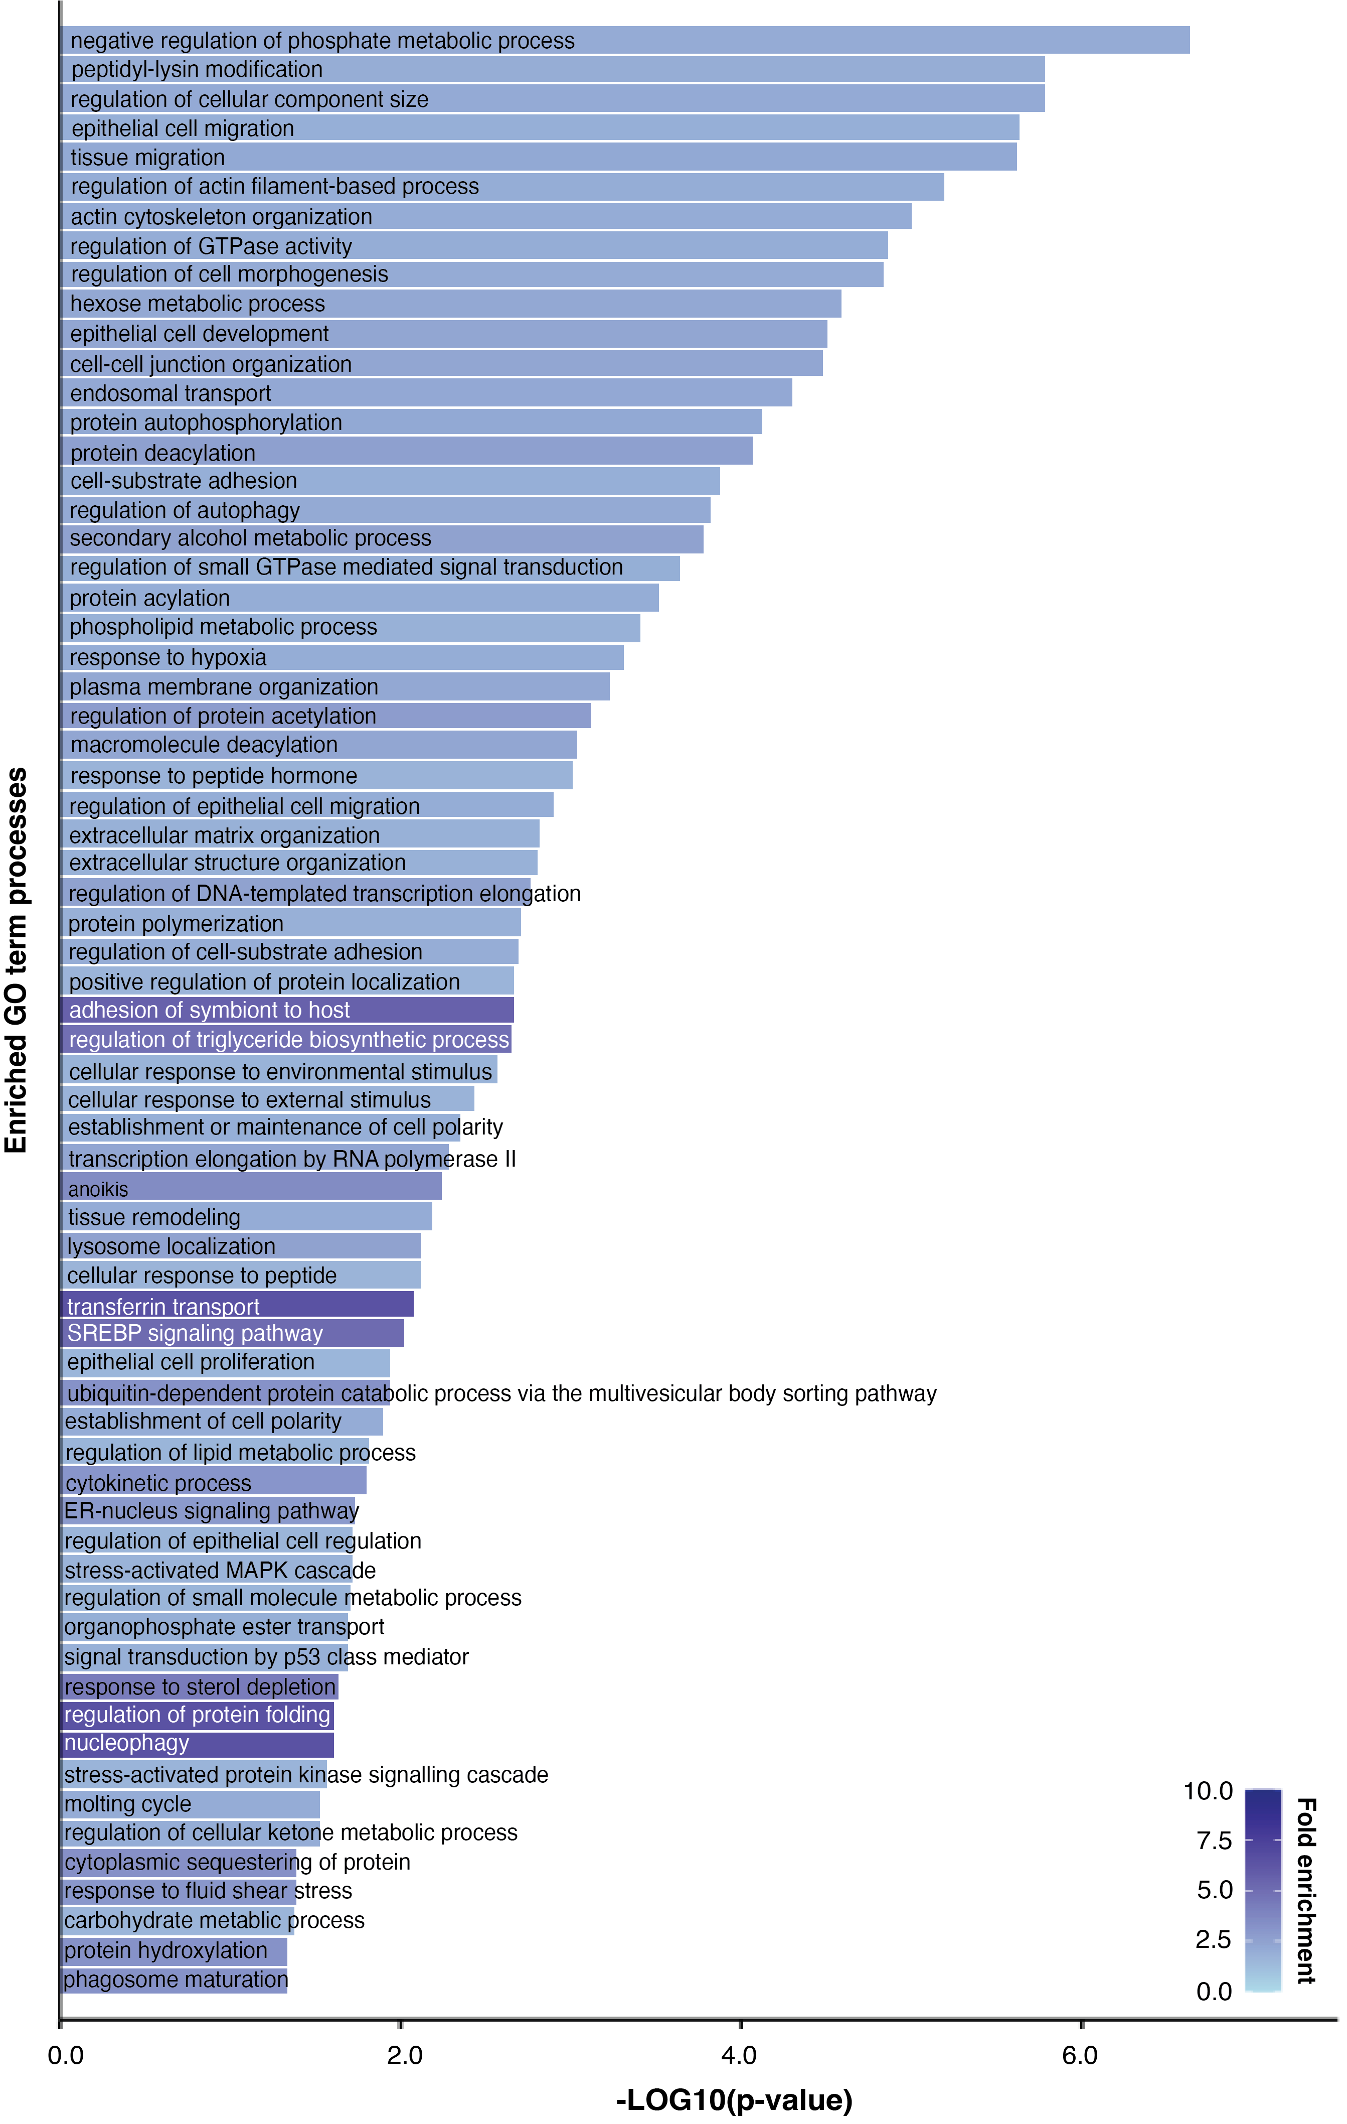
Fig. S5: Impact of S. cerevisiae strain 3458 on human transcriptional reprogramming: all down-regulated GO term processes. Gene Ontology (GO) term enrichment analysis of upregulated genes in VECs at 24 hpi, based on a Log2 fold change >1 or <−1 and a p-value <0.05. GO terms were identified using ShinyGO (http://bioinformatics.sdstate.edu/go/). Enriched biological processes are plotted according to the –Log10 p-value, derived from a Bonferroni-corrected distribution. Fold enrichment values are visualized using the color gradient. Data presented are from n = 3 biological replicates.
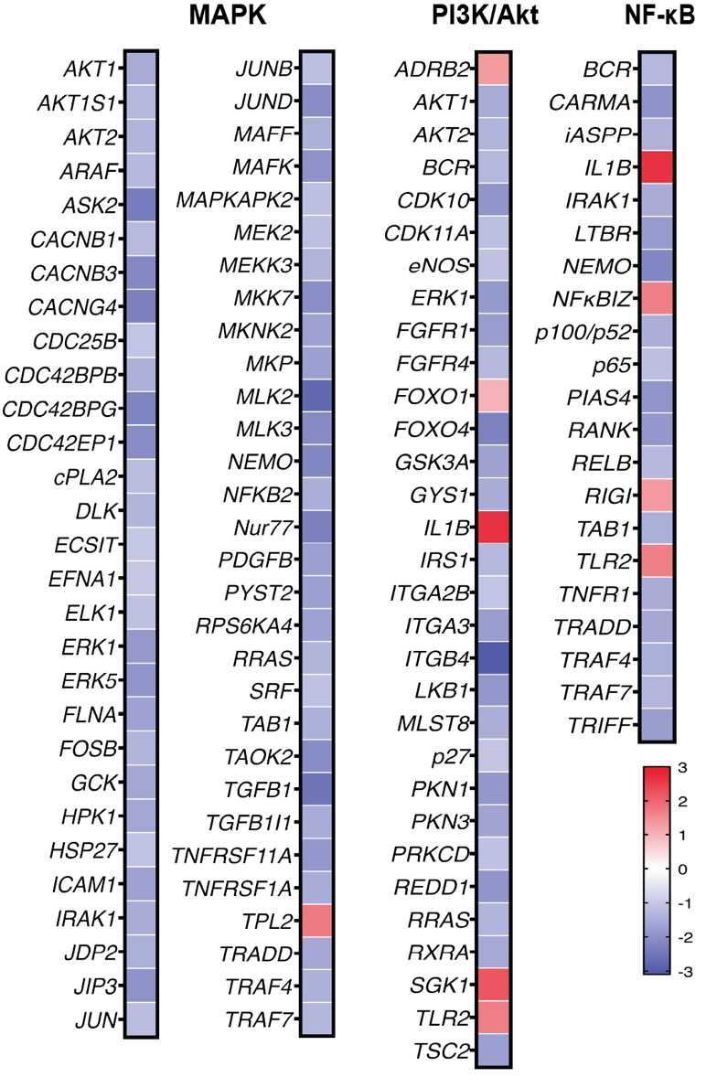
Fig. S6: S. cerevisiae downregulates immune and inflammatory signaling pathways in VECs during VVC. Heatmap depicting transcriptional changes in VECs at 24 hpi following exposure to Sc3458. Key pathways, including MAPK, PI3K/Akt, and NF-κB signaling, were predominantly downregulated. Color scale represents the Log2 fold change, with blue indicating downregulation and red indicating upregulation.

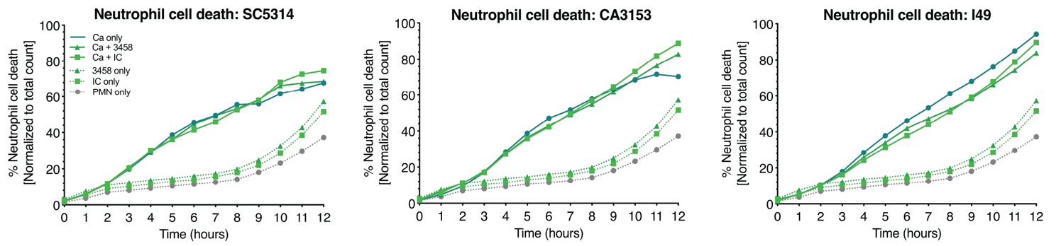
Fig. S7: The effect of S. cerevisiae on C. albicans-mediated neutrophil cell death. Neutrophil cell death induced by C. albicans strains SC5314, CA3153, and I49 in the presence of Sc3458 or with the industrial control (IC, CNCM I-3856). Cell death was quantified over 12 hours via Sytox Green fluorescence and normalized to the total neutrophil count.

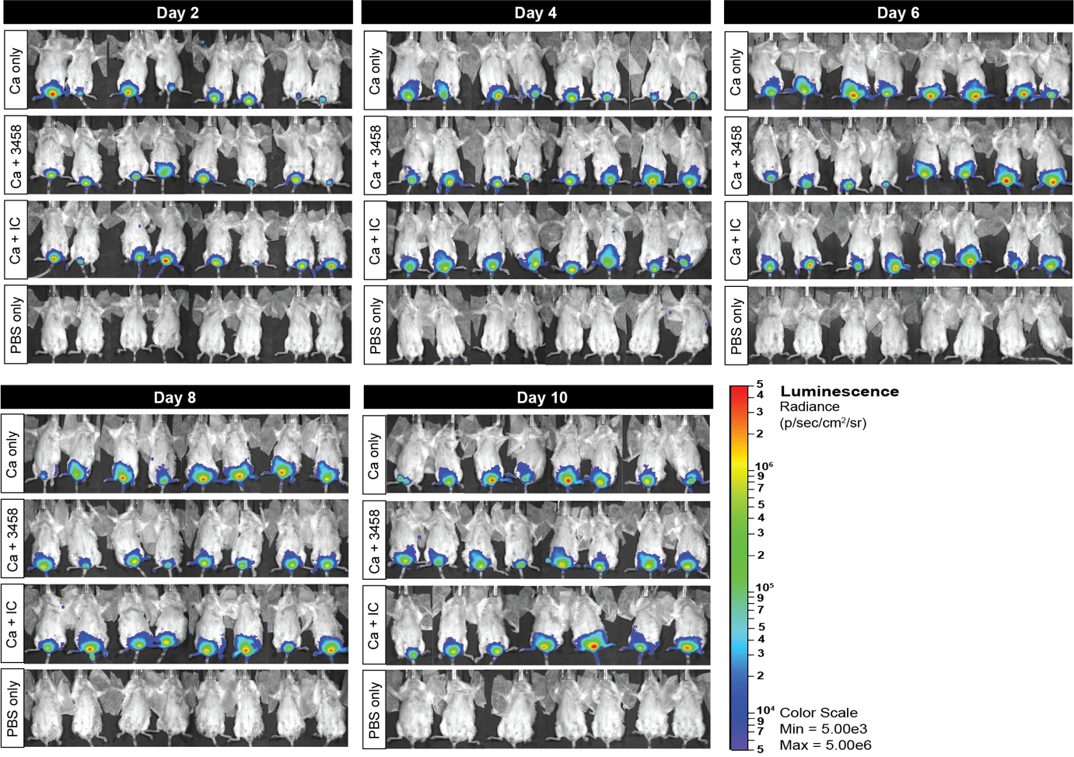
Fig. S8: Longitudinal BLI reveals sustained fungal control by S. cerevisiae 3458 in murine VVC. In vivo bioluminescence imaging (BLI): Total photon flux in C. albicans-infected mice treated with Sc3458, industrial control strain (IC, CNCM I-3856), or PBS, acquired on days 2, 4, 6, 8, and 10 post-infection (n ≥ 7). PBS-treated mice serve as uninfected baseline controls.

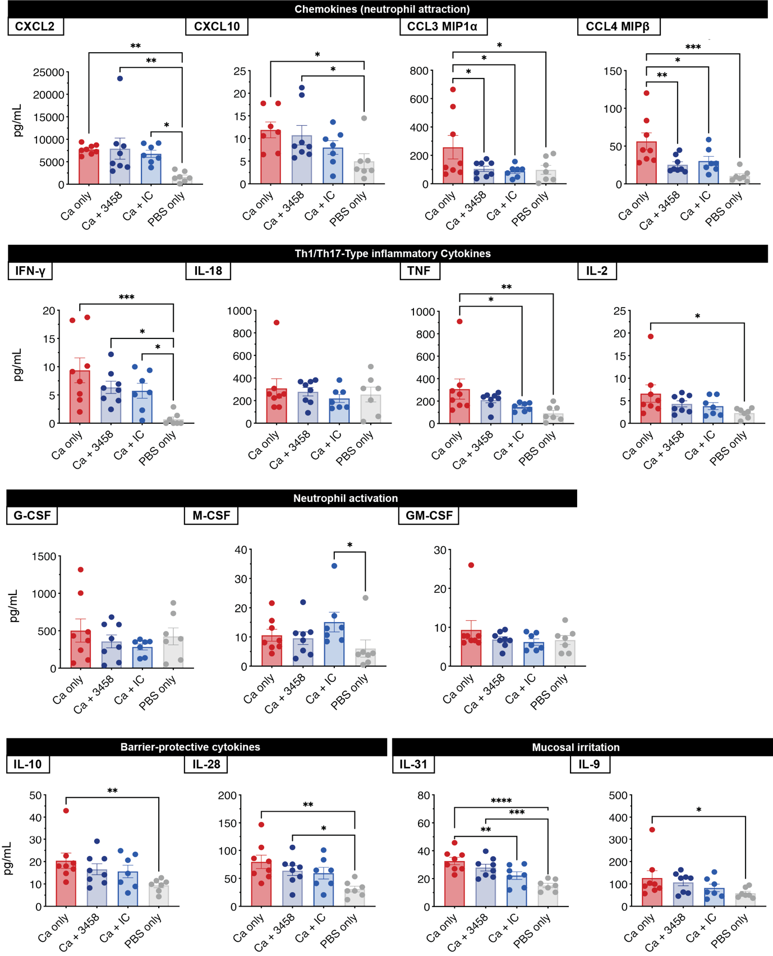
Fig. S9: S. cerevisiae 3458 modulates inflammatory mediators in the vaginal niche of VVC mice.
Cytokine and chemokine profiles in vaginal lavage fluids collected on day 10 from C. albicans-infected mice treated with Sc3458, the industrial control strain (IC, CNCM I-3856), or PBS. PBS-treated mice serve as uninfected baseline controls (n ≥ 7).

Supplementary Table 2. Composition of vagina simulative medium.
Component | Concentration | Supplier
NaCl | 3.51 g/L | Sigma-Aldrich
KOH | 1.40 g/L | Sigma-Aldrich
Ca(OH)2 | 0.222 g/L | Sigma-Aldrich
Urea | 0.4 g/L | Sigma-Aldrich
Bovine serum albumin (5%) | 40 mL/L | Sigma-Aldrich
Glycogen (20%) | 50 mL/L | Sigma-Aldrich
Mucin (1.33%) | 18.8 mL/L | Sigma-Aldrich
Glucose (40%) | 12.5 mL/L | Sigma Aldrich
Glycerol (98%v/v) | 0.13 mL/L | (VWR Chemicals)
Lactic acid (85%m/v) | 2.35 mL/L | Sigma Aldrich
Acetic acid (100%) | 0.952 mL/L | Ensure
Tween | 1 mL/L | Sigma Aldrich
α-Amylase (10 Units/mL) | 0.2 mL/L | Sigma Aldrich

Table 3. Antibodies and reagents used for flow cytometric analysis of murine vaginal lavage samples.
The table lists target antigens, fluorophores, suppliers, and relevant identifiers for antibodies used to define immune cell subsets, including neutrophils, macrophages, and eosinophils.
Antibody | Target Antigen | Fluorophore | Supplier | Clone number | Unique identity
Fc-receptor block | CD16/CD32 | unlabeled block) | Miltenyi Biotec |  | 130-092-575
Zombie Aqua | Viability dye | Aqua | BioLegend, USA |  | 423101
CD45-FITC | CD45 | FITC | Biolegend | 30-F11 | 103107
Ly6C-APC-Cy7 | Ly6C | APC-Cy7 | BD Biosciences | AL-21 | 560596
Ly6G-AF700 | Ly6G | AF700 | BD Biosciences | 1A8 | 561236
CD11b-eFluor450 | CD11b | eFluor450 | Invitrogen | M1/70 | 48-0112-82
CD11c-PE-Cy7 | CD11c | PE-Cy7 | Biolegend | N418 | 117318
F4/80-APC | F4/80 | APC | eBioscience | BM8 | 17-4801-82
CD64-PE | CD64 | PE | Biolegend | X54-5/7.1 | 139304
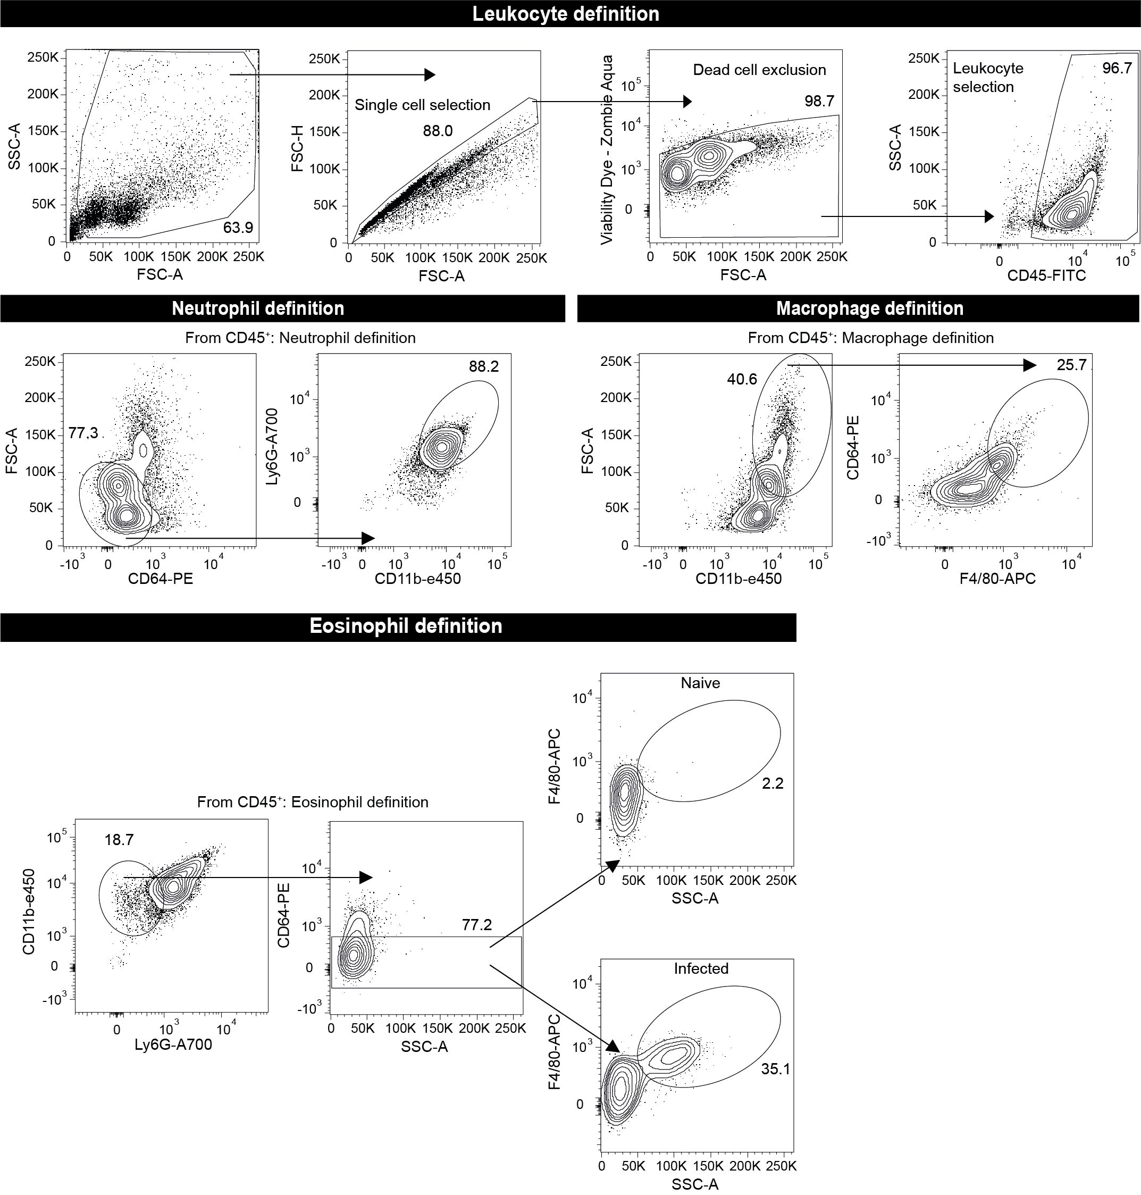
Fig. S10. Gating strategy for immune cell populations in vaginal lavage fluid from a murine VVC model. Flow cytometry gating strategy for identifying leukocytes (CD45⁺), neutrophils (CD11b⁺ Ly6G⁺ CD64⁻), macrophages (CD11b⁺ F4/80⁺ CD64⁺), and eosinophils (SiglecF⁺ Ly6G⁻) from vaginal lavage samples. Cells were gated based on size (FSC/SSC), single-cell discrimination, and viability (Zombie Dye⁻). Representative plots are shown for naïve and Candida albicans-infected mice.

