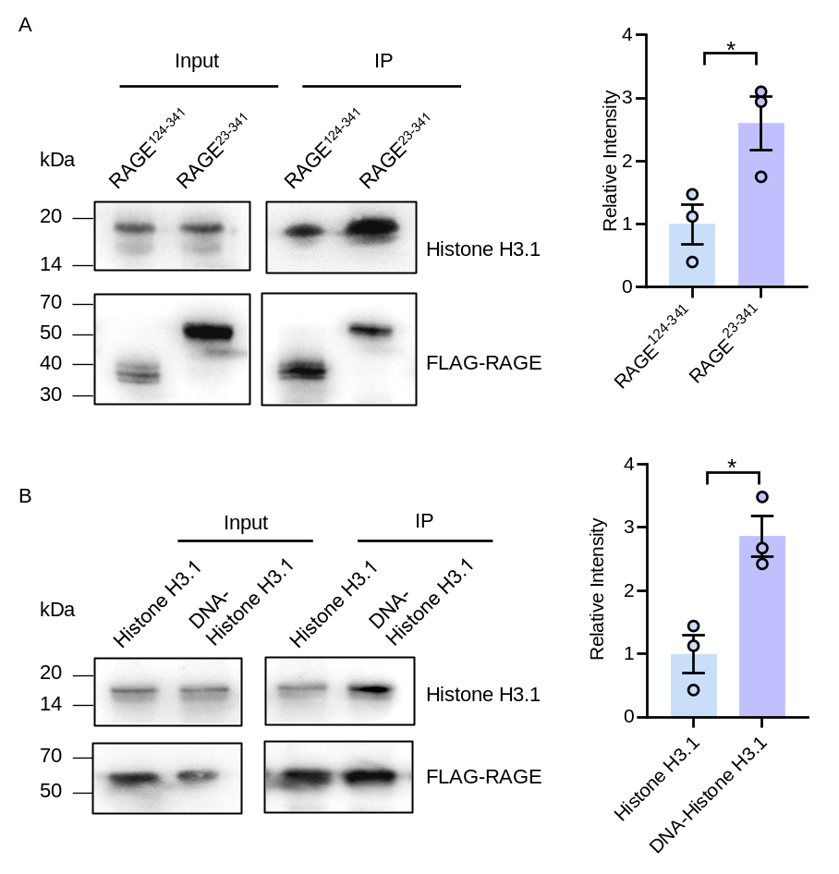
Supplementary Figure 1. Histone H3.1 directly binds to RAGE. (A) Recombinant histone H3.1 was precipitated with RAGE²³⁻³⁴¹-FLAG or RAGE¹²⁴⁻³⁴¹-FLAG attached to agarose beads. Left panels: Inputs and precipitated proteins were detected with an anti-histone H3 or an anti-FLAG antibody. Right panel: Quantification of histone H3.1 precipitated with truncated RAGEs. Histone H3.1 precipitated with RAGE¹²⁴⁻³⁴¹-FLAG was defined as 1, and the relative intensity of histones precipitated with RAGE²³⁻³⁴¹-FLAG is shown. (B) Recombinant histone H3.1 or DNA-histone H3.1 was precipitated with RAGE²³⁻³⁴¹-FLAG. Left panels: Inputs and precipitated proteins were detected with an anti-histone H3 or an anti-FLAG antibody. Right panel: Quantification of histone H3.1 precipitated with RAGE²³⁻³⁴¹-FLAG. Histone H3.1 precipitated with RAGE²³⁻³⁴¹-FLAG was defined as 1, and the relative intensity of DNA-histone H3.1 precipitated with RAGE²³⁻³⁴¹-FLAG is shown. Data are presented as mean ± SEM. n = 3. P values were derived from an unpaired two-tailed Student’s t-test. *P < 0.05.
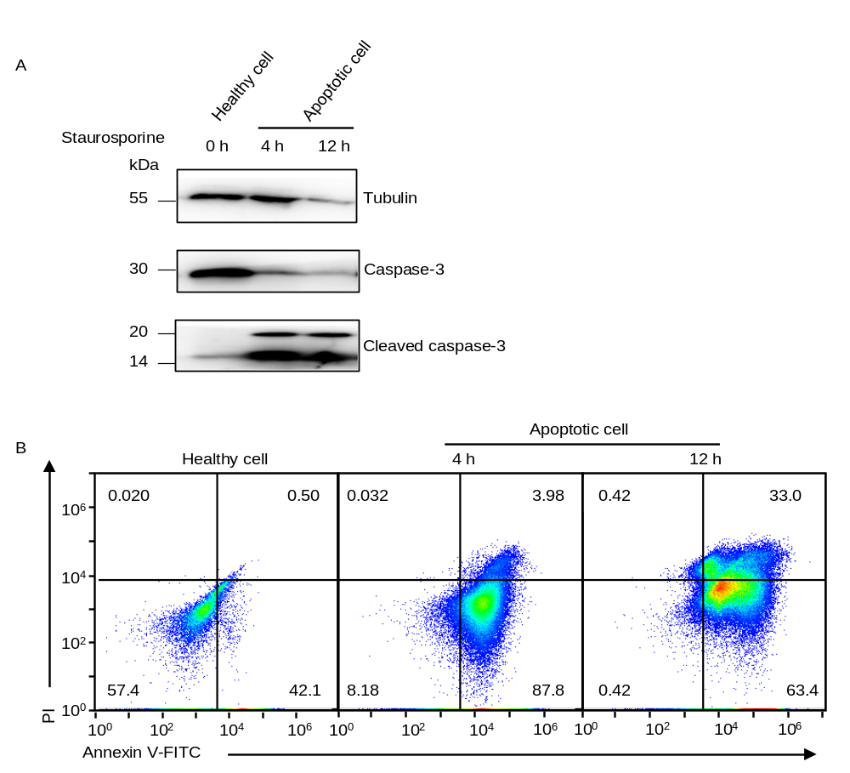
Supplementary Figure 2. Induction of apoptosis in Jurkat cells. (A) Jurkat cells expressing GFP were treated with staurosporine for 4 h or 12 h to induce apoptosis. Full-length and cleaved caspase-3 were detected by western blotting using an anti-caspase-3 and an anti-cleaved caspase-3 antibody, respectively. Tubulin is shown as a loading control. (B) Representative flow cytometry plots of PI and Annexin V-FITC staining of Jurkat cells treated with (apoptotic cell) or without (healthy cell) staurosporine.

Supplementary Figure 3. Histones are present on the surface of apoptotic cells. (A) Histones were detected in unpermeabilized healthy and apoptotic Jurkat cells expressing GFP under the fluorescence microscopy. Scale bars, 10 μm. (B) Violin plot showing the intensity of the histone signal. Lines in violins indicate 25th, medians, and 75th percentiles. Healthy cells, n = 72; apoptotic cells, n = 104. P < 0.001 according to an unpaired two-tailed Student’s t-test. ***P < 0.001.
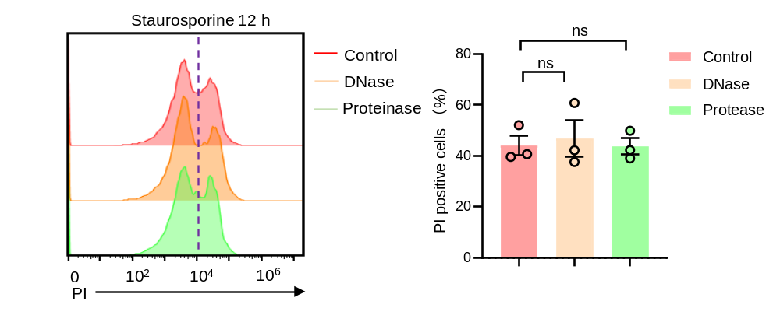
Supplementary Figure 4. PI staining of cells after treatment with hydrolytic enzymes. (A) Jurkat cells were treated with staurosporine for 12 h to induce apoptosis. Apoptotic cells treated with or without proteinase or DNase were stained with PI, and the cells were analyzed via flow cytometry. The percentages of PI-positive cells are shown in the right panel. Data are presented as mean ± SEM. n = 3. The statistical differences between the two groups were calculated using an unpaired t-test. ns not significant (P ≥ 0.05).

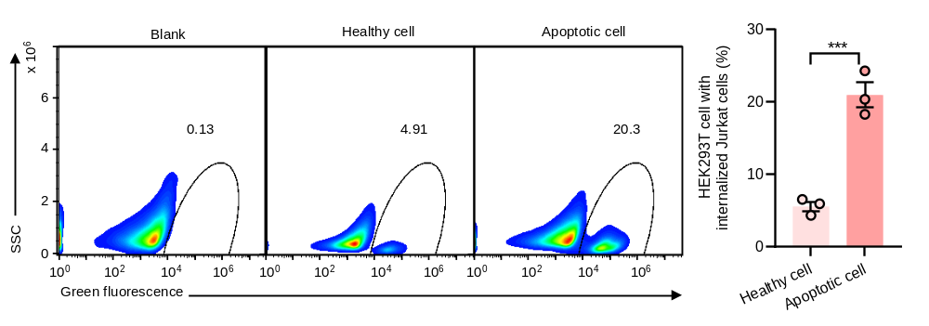
Supplementary Figure 5. Phagocytosis assays to analyze the internalization of apoptotic cells by HEK293T cells. Healthy or apoptotic Jurkat cells expressing GFP were incubated with HEK293T cells. HEK293T cells that internalized Jurkat cells were analyzed via flow cytometry. The percentages of HEK293T cells harboring Jurkat cells are shown in the right panel. Data are presented as mean ± SEM. n = 3. The statistical differences between the two groups were calculated using an unpaired t-test. ***P < 0.001.
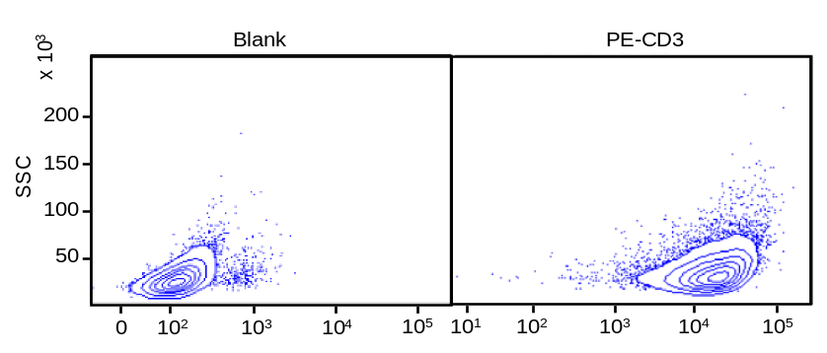
Supplementary Figure 6. CD3 antibody staining of Jurkat cells. Jurkat cells labeled with or without a PE-conjugated anti-CD3 antibody were analyzed by flow cytometry.

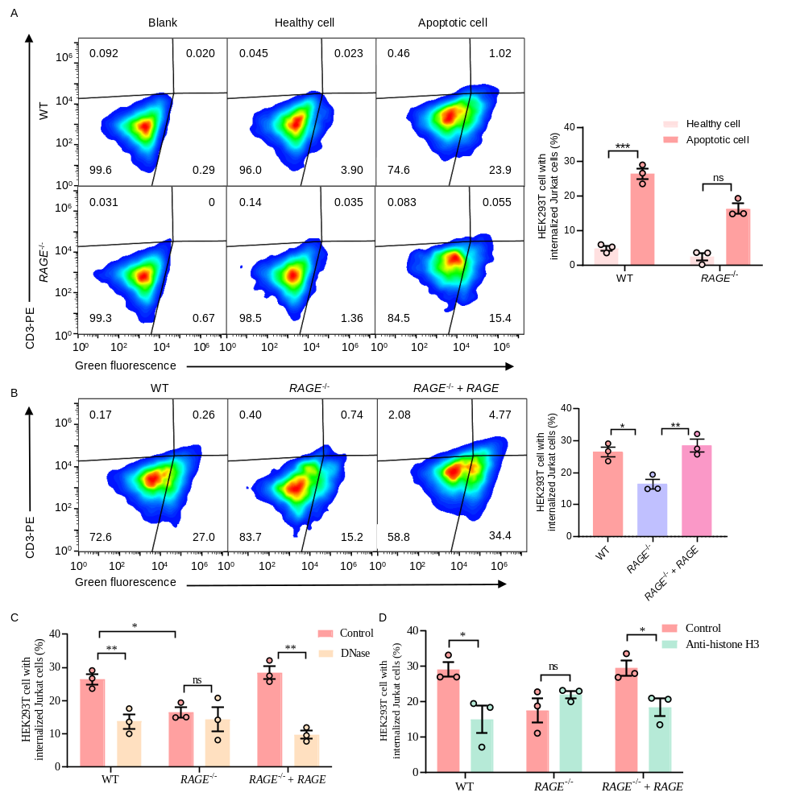
Supplementary Figure 7. Cell surface histones on apoptotic cells induce RAGE-mediated phagocytosis in HEK293T cells. (A) Jurkat cells were labeled with PKH67 green fluorescent dye. Healthy or apoptotic Jurkat cells were incubated with HEK293T cells. After 0.5 h incubation, Jurkat cells that were present outside of HEK293T cells were labeled with a PE-conjugated CD3 antibody. HEK293T cells that internalized Jurkat cells were analyzed via flow cytometry. The phagocytic index was calculated as the ratio of PKH67-positive/CD3-negative cells to all cells gated. The percentages of HEK293T cells harboring Jurkat cells are shown in the right panel. (B) Apoptotic Jurkat cells labeled with PKH67 were incubated with wild-type HEK293T cells, RAGE^{-/-} cells, or RAGE^{-/-} cells transfected with RAGE. HEK293T cells that internalized Jurkat cells were analyzed via flow cytometry. The percentages of PKH67-positive/CD3-negative cells are shown in the right panel. (C) Apoptotic cells were treated with or without DNase. These cells were incubated with wild-type HEK293T cells, RAGE^{-/-} cells, or RAGE^{-/-} cells transfected with RAGE, and PKH67-positive/CD3-negative cells were measured via flow cytometry. (D) Apoptotic cells were pretreated with an anti-histone H3 antibody or a nonspecific control IgG. The cells were incubated with wild-type HEK293T cells, RAGE^{-/-} cells or RAGE^{-/-} cells transfected with RAGE. The percentages of PKH67-positive/CD3-negative cells were measured via flow cytometry. Data are presented as mean ± SEM. n = 3. P values were derived from an unpaired two-tailed Student’s t-test. *P < 0.05; **P < 0.01; ***P < 0.001; ns not significant (P ≥ 0.05).

- 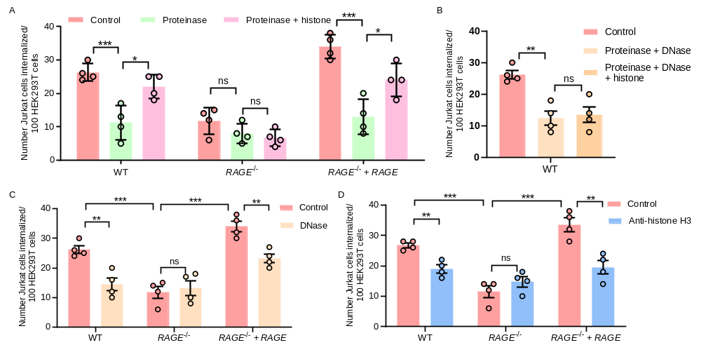
Supplementary Figure 8. Microscopy assays to analyze the internalization of apoptotic cells by HEK293T cells. Apoptotic Jurkat cells expressing GFP were incubated with HEK293T cells stained with LysoTracker for 0.5 h. HEK293T cells that internalized Jurkat cell-derived fragments in endocytic compartments were counted under the microscope. (A) Apoptotic Jurkat cells were treated with or without proteinase. Proteinase-treated cells were incubated with or without the purified histone complex. These cells were incubated with HEK293T, and the percentage of HEK293T cells harboring Jurkat cell-derived fragments were measured via a microscopy-based method. (B) Apoptotic cells were treated with proteinase or proteinase and DNase. Then, the samples were incubated with or without histones. These cells were incubated with wild-type HEK293T cells, and the percentage of HEK293T cells harboring Jurkat cell-derived fragments were measured via a microscopy-based method. (C) Apoptotic cells were treated with or without DNase. These cells were incubated with wild-type HEK293T cells, RAGE^{-/-} cells, or RAGE^{-/-} cells transfected with RAGE, and the percentage of HEK293T cells harboring Jurkat cell-derived fragments were measured via a microscopy-based method. (D) Apoptotic cells were pretreated with an anti-histone H3 antibody or a nonspecific control IgG. The cells were incubated with wild-type HEK293T cells, RAGE^{-/-} cells or RAGE^{-/-} cells transfected with RAGE. The percentage of HEK293T cells harboring Jurkat cell-derived fragments were measured via a microscopy-based method. Data are presented as mean ± SEM. n = 4. P values were derived from an unpaired two-tailed Student’s t-test. *P < 0.05; **P < 0.01; ***P < 0.001; ns not significant (P ≥ 0.05).

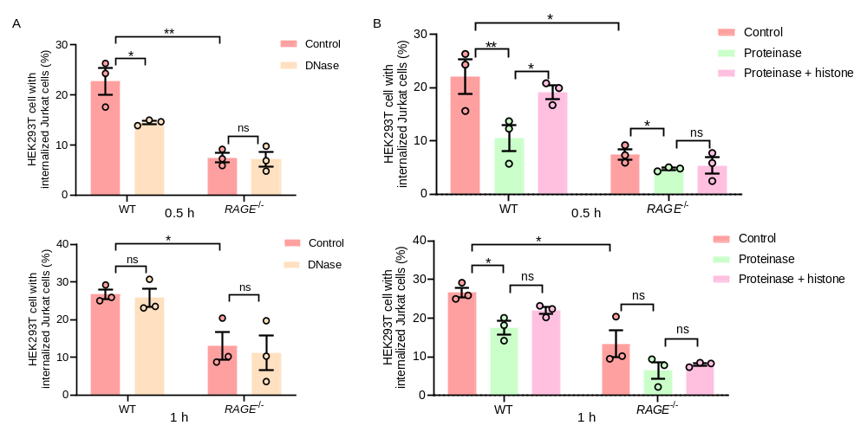
Supplementary Figure 9. Effects of DNase and proteinase treatments are decreased when the phagocytosis assay is performed with a longer incubation time. (A) Apoptotic Jurkat cells treated with DNase were incubated with wild-type or RAGE^{-/-} HEK293T cells for 0.5 or 1 h. HEK293T cells that internalized Jurkat cells were analyzed via flow cytometry. The percentages of HEK293T cells harboring Jurkat cells are shown. (B) Apoptotic Jurkat cells were treated with or without proteinase. Proteinase-treated cells were incubated with or without the purified histone complex. These cells were incubated with wild-type or RAGE^{-/-} HEK293T cells for 0.5 or 1 h. HEK293T cells that internalized Jurkat cells were analyzed via flow cytometry. The percentages of HEK293T cells harboring Jurkat cells are shown. Data are presented as mean ± SEM. n = 3. P values were derived from an unpaired two-tailed Student’s t-test. *P < 0.05; **P < 0.01; ns not significant (P ≥ 0.05).

- 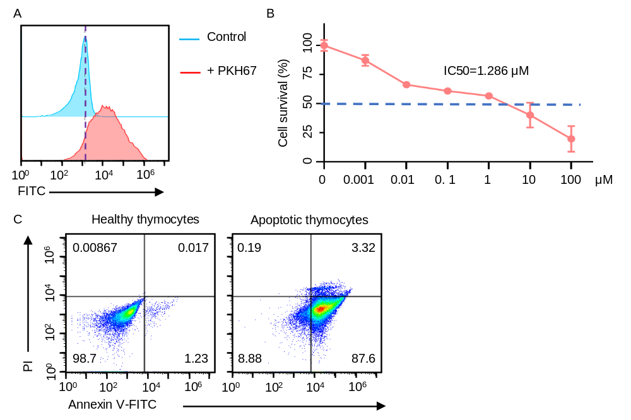
- Supplementary Figure 10. Preparation of apoptotic primary thymocytes. (A) Representative flow cytometry histogram of mouse primary thymocytes labelled with or without PKH67. (B) Thymocytes labelled with PKH67 were treated with dexamethasone. Their viability was measured and the IC50 was calculated. (C) Representative flow cytometry plots of PI and Annexin V-FITC staining of thymocytes treated with or without 2.5 µM dexamethasone.
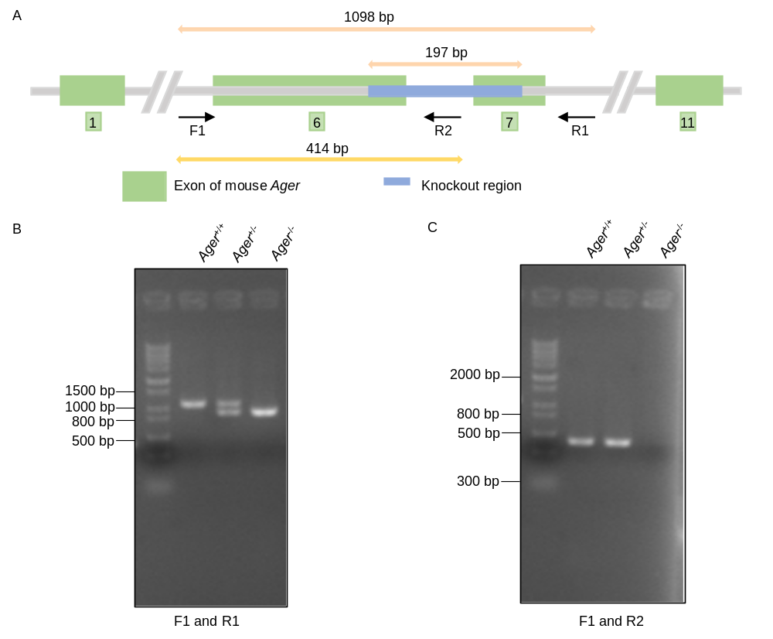
- Supplementary Figure 11. Construction of Ager (mouse RAGE) knockout mice. (A) Schematic diagram of the knockout of Ager and the locations of the verification primers F1, R1, and R2. (B) Knockout of Ager was verified via PCR using primers F1 and R1 (left panel) and F1 and R2 (right panel).

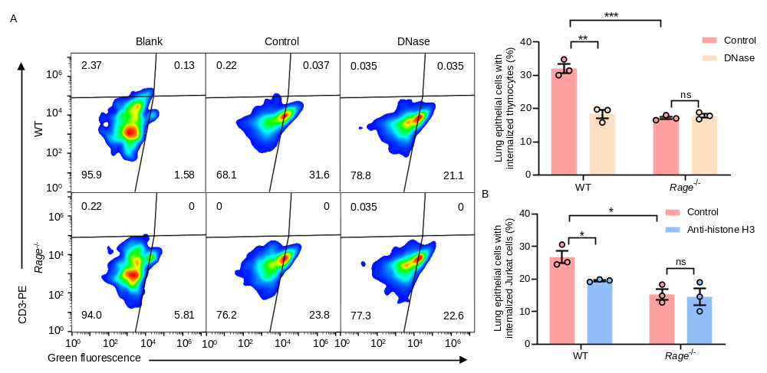
Supplementary Figure 12. Histone-induced and RAGE-mediated phagocytosis occurs in mouse primary lung epithelial cells. (A) Jurkat cells were labeled with PKH67. Apoptotic Jurkat cells were treated with or without DNase and they were incubated with primary lung epithelial cells. After 0.5 h incubation, Jurkat cells that were present outside of lung epithelial cells were labeled with a PE-conjugated CD3 antibody. Lung epithelial cells that internalized Jurkat cells were analyzed via flow cytometry. The phagocytic index was calculated as the ratio of PKH67-positive/CD3-negative cells to all cells gated. The percentages of lung epithelial cells harboring Jurkat cells are shown in the right panel. (B) Apoptotic Jurkat cells were pretreated with an anti-histone H3 antibody or a nonspecific control IgG. The internalization of these cells (PKH67-positive/CD3-negative cells) in lung epithelial cells was analyzed via flow cytometry. Data are presented as mean ± SEM. n = 3. P values were derived from an unpaired two-tailed Student’s t-test. *P < 0.05; **P < 0.01; ***P < 0.001; ns not significant (P ≥ 0.05).
Supplementary Table 1. Oligo DNAs used in this study
Name | Sequence (5’-3’) | Restriction enzyme site
Ager-F1 | GAGGTCTCCATTCTTTCTCCAGGTG
Ager-R1 | GAGACTTAGAAACGCTGTGCATG
Ager-R2 | CTGGGATTGACTCTTGCCTCCCTC
H1 | CTGCGGAATTCATGGCTGCCGGAACAGC | EcoRI
H2 | CTAGCGGCCGCCTAGTGGTGGTGGTGGTGGTGGCCTGCCCCGGCTCCTGCAGGCCCTCCAGTACTACTCTCG | NotI
V1 | AAATGCTCGAGCCAGAAATTGTAGATTCTGC | XhoI
S1 | AAATGCTCGAGATGGCTGCCGGAACAGCAGTTG | XhoI
S2 | CATTTACGCGTGTGGTGGTGGTGGTGGTGGCCTGCTAGAGTTCCCAGCCCTGATC | MluI
Rg1 | CACCCAAGAAACCACCCCAGCGGC | BpiI
Rg2 | AAACGCCGCTGGGGTGGTTTCTTG | BpiI
Rg3 | CACCTCTTACGGTAGACACGGACT | BpiI
Rg4 | AAACAGTCCGTGTCTACCGTAAGA | BpiI

Supplementary Table 2. Plasmids used in this study.
Name | Parental plasmid | Description | Cloning sites
pME-RAGE-His | pME-RAGE-His | Gene, RAGE; Primers, H1 and H2 | EcoRI/NotI
pLIB2-mEGFP-BSD | pLIB2 -BSD | Gene, mEGFP from pME-mEGFP | EcoRI/NotI
pX330EGFP-hU6-RAGE  gRNA1-hSpCas9 | pX330EGFP-hU6-gRNA-  hSpCas9 | Gene, CAAGAAACCACCCCAGCGGC; Primers, Rg1 and Rg2 | BpiI
pX330EGFP-hU6-RAGE  gRNA2-hSpCas9 | pX330EGFP-hU6-gRNA-  hSpCas9 | Gene, TCTTACGGTAGACACGGACT; Primers, Rg3 and Rg4 | BpiI
pME-RAGE¹²⁴⁻³⁴¹-His | pME-His-Flag | Gene, sRAGE; Primers, V1 and S2 | XhoI/MluI
pME-RAGE²³⁻³⁴¹-His | pME-His-Flag | Gene, sRAGE; Primers, S1 and S2 | XhoI/MluI
pGP | pGP | For retrovirus transfection
pLC-VSVG | pLC-VSVG | For retrovirus transfection

