Supplementary Information
Table of Contents
- Supplemental Methods.
- Supplemental Table 1. All of Us Research Program data used in analyses.
- Supplemental Figure 1. Consort diagram showing inclusion/exclusion criteria for Fitbit activity analysis.
- Supplemental Figure 2. Consort diagram showing inclusion/exclusion criteria for Fitbit sleep analysis.

This supplemental material has been provided by the authors to give readers additional information about their work.

Supplemental Methods.

Activity and Seasonality Analysis Methods:

- Data Sources

Activity Summary Table: Used for analyzing the 'steps' variable that captures the total steps taken per day for each participant.

Steps Intraday Table: Used for analyzing the 'steps' variable that captures the number of steps taken on a minute level for each participant.

Wear Study Table: Used for analyzing the 'resultsconsent_wear' and 'wear_consent_start_date' variables that capture participants who were consented for the WEAR Study.

- Inclusion Criteria

Age Requirement: Participants included in the analysis were required to be 18 years or older on the date of their earliest step record. This was to ensure that all analysis results were applicable to adult populations. For instance, if a participant's first data record was on October 10, 2009, but they were 12 years old on that date, they were excluded from all analyses.

Device Use Compliance: Participants needed to wear their Fitbit device for at least 10 hours per day for that day to be included in the analysis. This allowed for the evaluation of days with consistent Fitbit use throughout the day.

Daily Step Count Requirements: Participants were required to log at least 100 steps but less than 100,000 steps per day for that day to be included in the analysis.

Minimum Days of Valid Activity Data: Each participant needed to meet the above criteria for at least four days throughout the observation period.

Seasonality Requirement: To account for seasonal variation in physical activity, participants needed to meet all general activity eligibility criteria (all 4 criteria above) for at least seven days in any given calendar month for that month of data to be included.

- Study Period

The data included in the activity analysis was available from 10/04/2009 through 10/01/2023. For the seasonality analysis data from 11/18/2009 through 09/30/2023 was included and the figure was subset to 01/01/2018 through 09/30/2023.

- Data Processing and Analysis

Statistical Analysis: R version 4.4.0 and Python version 3.10.12 programming languages were used to conduct all the analyses on the All of Us Researcher Workbench. Python was used for calculation of the demographic classifications and for the datatype overlap analysis so that existing Python code and custom packages from the CDR v8 Data Characterization Report featured workspace ¹³ could be leveraged. All remaining data processing and analyses were conducted in R.

Data Extraction: SQL queries were utilized to extract relevant data including person ids, dates, step counts, and wear study consent from the activity_summary, steps_intraday, and wear_study tables to carry out activity and seasonality analysis.

Age at Earliest Step Record: Age at earliest step record was determined using participants' date of birth from the person table and date of their earliest step record with greater than 0 steps from the activity_summary table. All calculated ages were floored to obtain the participant age.

Device Use and Step Count Compliance: The amount of time participants wore their Fitbit device was determined using the steps_intraday table, where the hourly step counts were checked, by creating a 'has_hour' variable that was coded 1 if greater than 0 steps were taken in the hour and 0 if no steps were taken. This variable was then summed to create a 'use compliant' variable that was coded as TRUE for 10 or more hours of step data and FALSE for days with less than 10 hours of data. The total number of steps participants took each day was determined using the activity_summary table. Participants’ data for each day were only included in the analysis if the 'use compliant' variable was TRUE and they took between 100 and 99,999 steps that day. If participants who met the age requirement had less than 4 days of data meeting the Device Use and Step Count Compliance requirement, they were excluded from the general activity analyses entirely. Furthermore, if participants who met the age requirement had less than 7 days of data per month (for all months between January 2018 and September 2023) meeting the Device Use and Step Count Compliance requirement, they were excluded from the seasonality analysis entirely (see Supplemental Figure 1 for Consort Diagram).

Determining BYOD versus WEAR status: WEAR status was determined by completion of the WEAR consent process using variables' resultsconsent_wear' and 'wear_consent_start_date' from the wear_study table. Participants without a WEAR consent were assigned to BYOD. In a subset of cases participants that completed a WEAR consent previously contributed Fitbit data through BYOD. These participants were reassigned to BYOD by determining the minimum date step counts were reported in the activity_summary table if this date was before the participants WEAR consent date 'wear_consent_start_date' from the wear_study table they were assigned to BYOD.

Fitbit Data Contribution Analysis: The cumulative number of participants with Fitbit activity data over time was determined based on the minimum date that step count data was available for in the activity_summary table.

Demographic Analysis: Demographic characteristics were extracted and analyzed from the relevant demographic tables, ensuring a comprehensive understanding of the participant cohort (Supplemental Table 1). Self-reported race/ethnicity, self-reported sex at birth, household income, and educational attainment were collected via the Basics survey and extracted from the ds_survey table. All six disability related questions were collected via the Basics survey or the Life Functioning survey and extracted from the ds_survey table. Participant age on the date of their first step data record was calculated using their date of birth which is recorded during the All of Us Research Program consent process and extracted from the person table.

Seasonality Analysis: For the seasonality analysis the 'steps' and 'date' variables from the activity_summary table were used to calculate the cohort median and interquartile range of participants' median daily step count per month from January 2018 and September 2023. Seasons were defined as follows: Winter: December, January, February; Spring: March, April, May; Summer: June, July, August; Fall: September, October, November.

Sleep Analysis Methods:

- Data Sources

Sleep Daily Summary Table: Used for analyzing the 'minute_asleep' variable that captures the total duration of sleep for each participant per day. The 'is_main_sleep' variable was also used to subset the data to participants' main sleep, removing any naps.

- Inclusion Criteria

Age Requirement: Participants included in the analysis were required to be 18 years or older on the date of their earliest sleep record. This was to ensure that all analysis results were applicable to adult populations. For instance, if a participant's first sleep data record was on October 10, 2009, but they were 12 years old on that date, they were excluded from all analyses.

Main Sleep: Only the main sleep period of each day was considered for analysis to ensure consistency and relevance in sleep duration assessment (i.e., is_main_sleep = true from sleep_daily_summary table).

Minimum Sleep Duration: Participants needed to have at least four hours of sleep on 70% or more of the days they contributed data. This criterion was set as a quality control measure, since sleeping less than four hours for 30% or more days has previously been reported to be physiologically not sustainable ³⁰.

Minimum Days of Valid Sleep Data: Each participant needed to meet the above criteria for at least four days throughout the observation period.

- Study Period

The data was subset to include sleep records from 10/01/2022 through 09/30/2023.

- Data Processing and Analysis

Statistical Analysis: All data processing and analysis were conducted in R version 4.4.0.

Data Extraction: SQL queries were utilized to extract daily sleep durations in minutes 'minute_asleep' variable for participants' main sleep 'is_main_sleep' variable from the sleep_daily_summary table.

Age at Earliest Sleep Record: Age at earliest sleep recorded was calculated using participants' date of birth from the person table and date of their earliest sleep record from the sleep_daily_summary table. All calculated ages were floored to obtain the participant age.

Minimum Sleep Duration: The number of days each person slept less than 4 hours was determined using the 'minute_alseep' and ‘is_main_sleep’ variables from the sleep_daily_summary table. The number of days with a sleep duration of less than 4 hours was divided by the total number of days contributed by each participant. Participants that slept for less than 4 hours on 30% or more days were removed from analysis.

Sleep Analysis: Participants median sleep duration from 10/01/2022 through 09/30/2023 was determined by taking the median of the 'minute_asleep' variable for sleeps indicated as ‘is_main_sleep’ from the sleep_daily_summary table for each participant. The cohort median sleep duration and interquartile range was determined by taking the median and interquartile range of participant median sleep durations. Participants were grouped into one of four sleep groups based on their median sleep duration. Participants were assigned to the "Very short sleep" group if they had a median sleep duration of less than 5 hours. Participants with a median sleep duration of 5 or more but less than 7 hours of sleep were assigned to the "Short sleep" group. Those with a median sleep duration of 7 or more but less than 9 hours of sleep were assigned to the "Normal sleep" group while those with median sleep duration of 9 or more hours of sleep were assigned to the "Long sleep" group.

Variables used for key analyses | Source | Data table | Data elements
Activity Analysis
Step counts and valid day criteria >=100 and <100,000 steps / day | Fitbit | activity_summary | steps
WEAR study enrollment | Fitbit | wear_study | resultsconsent_wear, wear_consent_start_date
Valid day criteria 10 hours of data | Calculated | steps_intraday | steps, datetime
Sleep Analysis
Sleep duration | Fitbit | sleep_daily_summary | minute_asleep
Date of sleep | Fitbit | sleep_daily_summary | sleep_date
Main sleep | Fitbit | sleep_daily_summary | is_main_sleep
Demographic Characteristics
Self-Identified Race / Ethnicity | The Basics | person_ext | self_reported_category_source_value
Age | Consent Process | person | date_of_birth
Self-reported Sex at Birth | The Basics | ds_survey | question_concept_id = 1585845
Gender Identity | The Basics | ds_survey | question_concept_id = 1585838
Household Annual Income | The Basics | ds_survey | question_concept_id = 1585375
Educational Attainment | The Basics | ds_survey | question_concept_id = 1585940
Healthcare Access and Utilization | Calculated | ds_survey | Complex calculation references the CDR V8 data characterization report featured workspace ¹³. The following are used in the calculation: Where any of the follow answers is 'yes' for question_concept_id is 1585386 or 43530593 and answer_concept_id is 1585388 or 43528803, OR question contains "delayed medical care" and answer_concept_id is 43530010, 43530025, 43530052, or 43530110, OR question contains "can't afford" and answer_concept_id is 43530105, 43530082, 43530034, 43530028, 43530041, 43530054, 43530237, or 43530046, OR question_concept_id is 43530416, 43530417, or 43530415 and answer contains 'yes', OR question contains "delayed medical care" and answer_concept_id is 43530258, 43530254, 43530014, or 43530033 AND question_concept_id is 43529899 and answer_concept_id is 43528387, 43529239, or 43529844
Are you blind or do you have serious difficulty seeing, even when wearing glasses? | The Basics, Life Functioning Survey | ds_survey | question_concept_id = 903574
Are you deaf or do you have serious difficulty hearing? | The Basics, Life Functioning Survey | ds_survey | question_concept_id = 903573
Because of physical, mental, or emotional condition, do you have serious difficulty concentrating, remembering or making decisions? | The Basics, Life Functioning Survey | ds_survey | question_concept_id = 903575
Do you have serious difficulty walking or climbing stairs? | The Basics, Life Functioning Survey | ds_survey | question_concept_id = 903576
Do you have difficulty dressing or bathing? | The Basics, Life Functioning Survey | ds_survey | question_concept_id = 903577
Because of physical, mental, or emotional condition, do you have difficulty doing errands alone such as visiting the doctor’s office or shopping? | The Basics, Life Functioning Survey | ds_survey | question_concept_id = 903578
Other Data Types
Any Fitbit data | All of Us Metadata (Internally generated) | cb_search_person | has_fitbit
Electronic health records | All of Us Metadata (Internally generated) | cb_search_person | has_ehr_data
Core surveys | All of Us Metadata (Internally generated) | cb_search_person | has_ppi_survey_data
Physical measurements | All of Us Metadata (Internally generated) | cb_search_person | has_physical_measurement_data
Genomics | All of Us Metadata (Internally generated) | cb_search_person | has_whole_genome_variant, has_array_data
Social Determinants of Health | Calculated | ds_survey | survey = 'Social Determinants of Health'
Supplemental Table 1. All of Us Research Program data used in analyses. The table describes the source, table, and element of All of Us Research Program data used for each variable in each analysis.
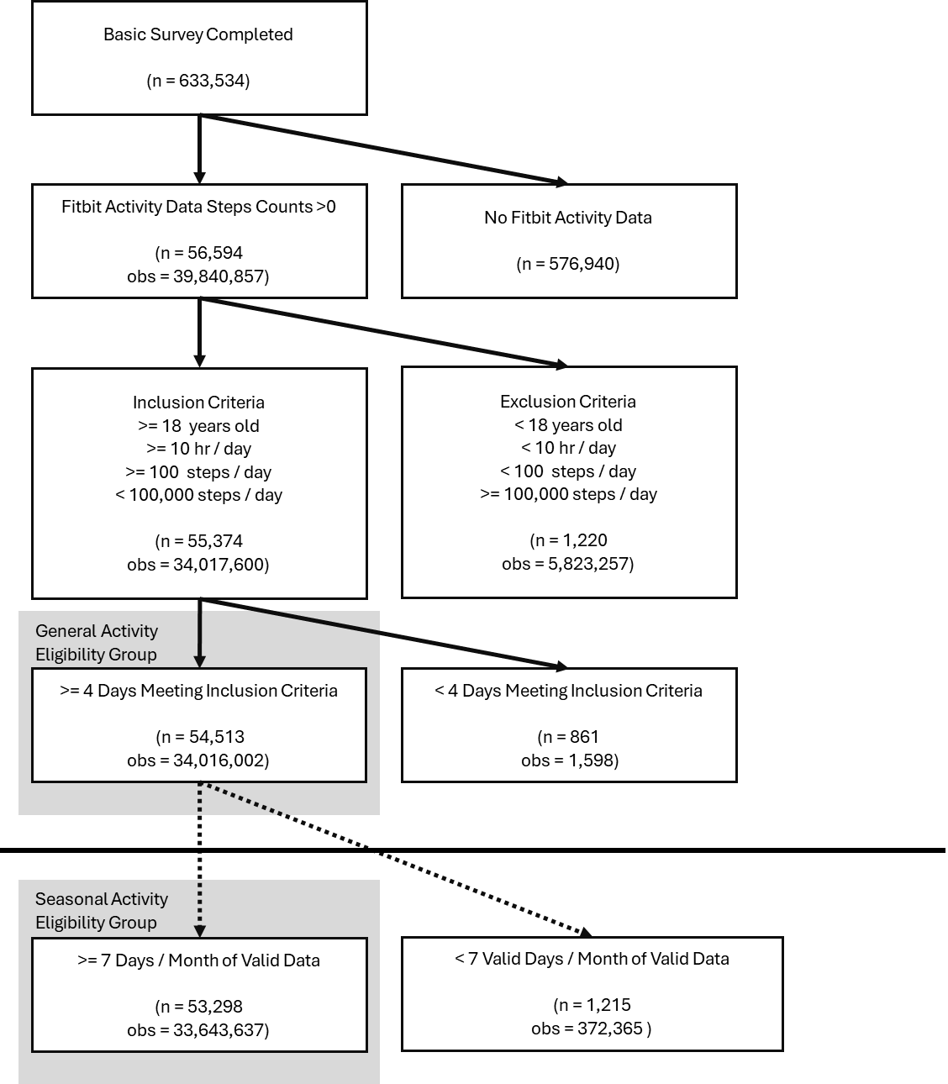
Supplemental Figure 1. Consort diagram showing exclusion criteria for Fitbit activity analysis. The flow diagram depicts the steps utilized to produce the analytical cohort that met the exclusion criteria. The exclusion criteria above the horizontal line includes the general activity eligibility group while the criteria below the line are applied to the seasonal activity eligibility group.

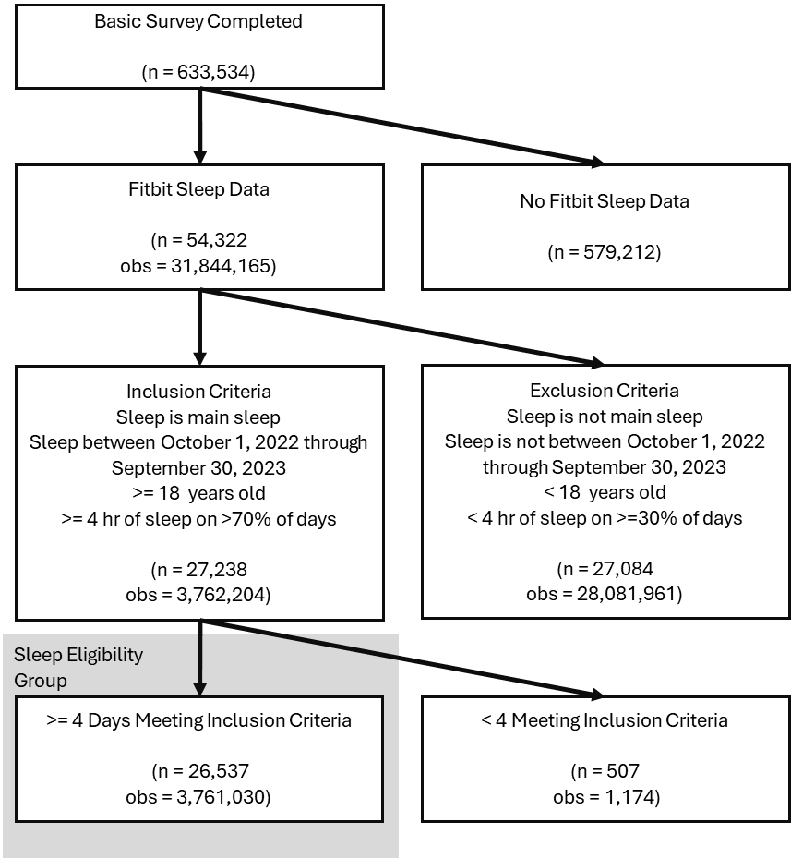
Supplemental Figure 2. Consort diagram showing exclusion criteria for Fitbit sleep analysis. The flow diagram depicts the sequential application of exclusion criteria producing the sleep eligibility group.

