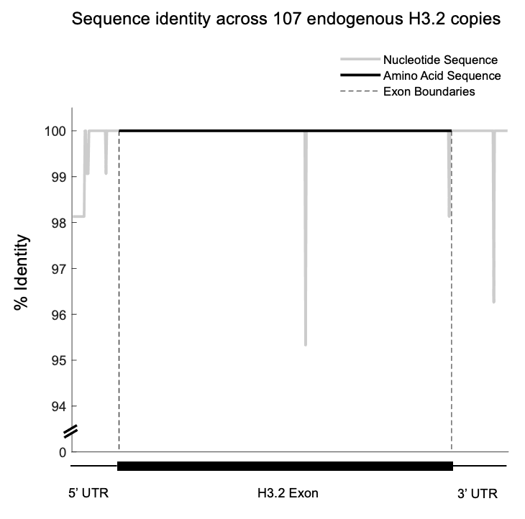

Supplemental Figure 1. Nucleotide and amino acid identity for endogenous histone H3.2 copies. Line plots indicating sequence identity across 107 copies of endogenous H3.2 in D. melanogaster. Nucleotide sequence identity is plotted in grey. Protein sequence identity is plotted in black. A diagram of the H3.2 untranslated regions and coding sequence is shown at the bottom. Vertical dashed lines indicate the boundaries of the single H3.2 exon.

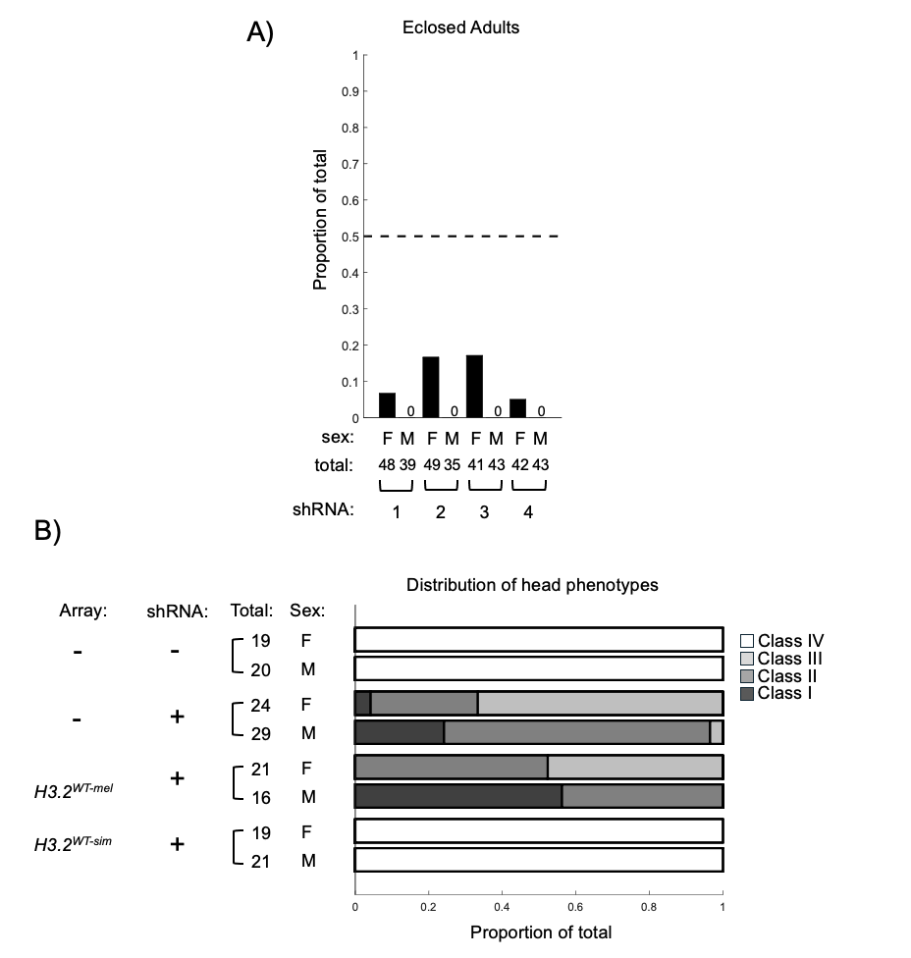

Supplemental Figure 2. H3.2 shRNA expression during eye-antennal disc development reduces adult viability and phenotypic rescue of defects in head morphology by H3.2^{WT-sim} (A) Bar chart of adult viability for ey-GAL4 H3.2 shRNA expressing animals as a proportion of all eclosed animals. Females (F) and males (M) are plotted separately for each shRNA. (B) Stacked bar chart depicting the proportion of pharate adults in four phenotypic classes of head defects. shRNA expression driven by ey-GAL4 with or without histone replacement transgenes. Females (F) and males (M) are plotted separately for each condition.

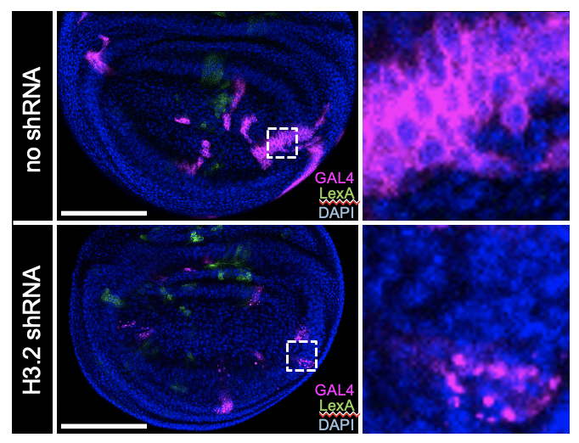

Supplemental Figure 3. H3.2 shRNA expressing clones are small and fragmented. Confocal images of 3rd instar wing imaginal disc clones expressing GAL4 (CD8::RFP, magenta) and LexA (CD8::GFP, green) using the CoinFLP system. Control GAL4 clones (top) and shRNA-expressing GAL4 clones (bottom) are shown. Scale bars – 100 micrometers.
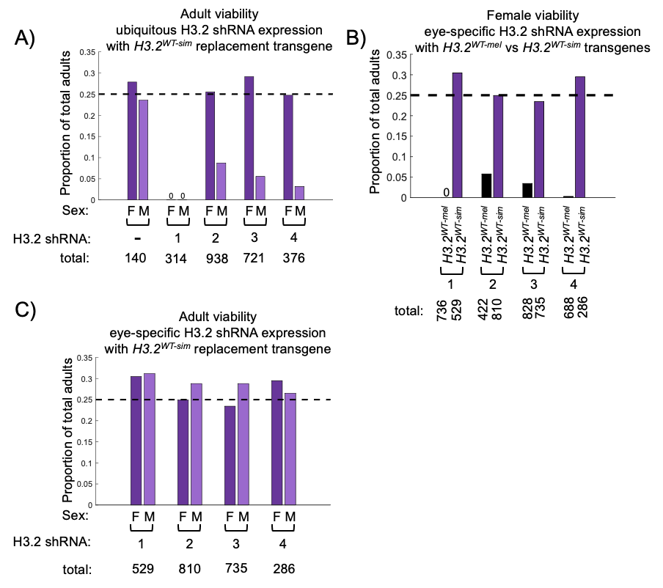

Supplemental Figure 4. H3.2^{WT-sim} replacement transgene differentially supports female viability but male viability varies. (A) Bar chart depicting proportion of eclosed progeny by sex with ubiquitous H3.2 shRNA expression in H3.2^{WT-sim} replacement flies. (B) Bar chart depicting proportion of eclosed female progeny with ey-GAL4 H3.2 shRNA expression in H3.2^{WT-mel} and H3.2^{WT-sim} replacement flies. (C) Bar chart depicting proportion of eclosed progeny by sex with ey-GAL4 H3.2 shRNA expression in H3.2^{WT-sim} replacement flies.

