Extended Data 1: a) SDS-PAGE of SF9 cells transfected with recombinant baculovirus containing BALF2. Cells were transfected at ~1.0 x 10⁶ cells/ml at 0 hours, and at indicated timepoints aliquots were removed, lysed, and centrifuged to separate insoluble (Ins) and soluble (Sol) fractions. A band representing BALF2 is indicated by the red arrow 72 hours post-transfection. b,c) Chromatogram and corresponding SDS-PAGE of BALF2 purification by C-tag affinity chromatography. BALF2 expression culture was lysed after 72 hours post-transfection, and the soluble fraction passed down a CaptureSelect™ affinity column. The column was washed with 500 mM NaCl before the bound fraction eluted with 2M MgCl₂. Insoluble (I), soluble (S), unbound flow-through (FT), wash elution (W), elution (E). Marker (M) in both gels a and c is Precision Plus Protein Dual Color Standard (Bio-Rad), with weights in kDa. A red arrow indicates BALF2 position in gels at ~123 kDa.
ing a BALF2 site-size of 15 nt).
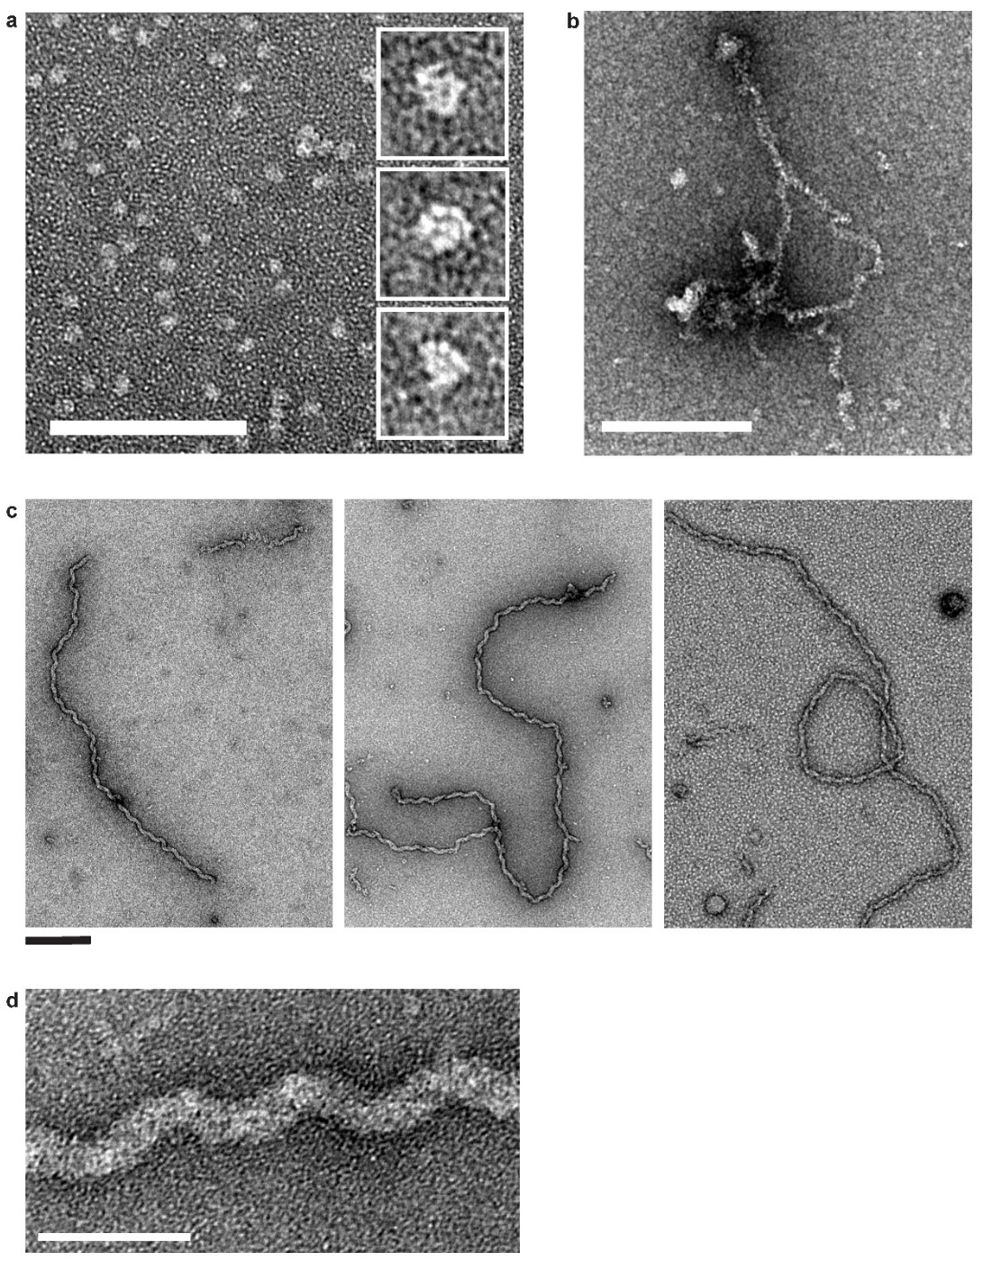
Extended Data 2: Negative-staining electron microscopy of BALF2 oligomeric complexes. a) BALF2 monomers. Scale bar = 100 nm. b) Irregular protein-only filaments, formed under reducing conditions. Scale bar = 200 nm. c) BALF2 regular nucleoprotein filaments, formed on 60-mer oligonucleotide O2. Filaments could be very long and were often ruptured (left); could branch (middle); and could loop back on themselves (right). Scale bar = 200 nm. d) BALF2 nucleoprotein filament, showing regular turn. Scale bar = 50 nm.

Extended Data 3: Negative-staining electron microscopy of BALF2 binding to ssDNA. a) BALF2 at sub-saturating levels initially binds to M13 DNA in short stretches in a cooperative manner. BALF2 monomers are visible on the DNA and appear as beads (white arrows). Scale bar = 50 nm. b) At saturating concentrations, BALF2 immediately coats M13 DNA in a rapid and highly cooperative manner, holding it in an extended conformation. Scale bar = 200 nm. c) BALF2 coats short oligonucleotides similarly and appears as beaded rods (white arrows). Scale bar = 100 nm. a much shorter substrate O3 (Extended Data 3c).
Extended Data 4: Time-course assay of BALF2-faciliated annealing of 1 kb thermally denatured dsDNA. At the indicated timepoints, aliquots were analysed by negative-staining electron-microscopy. Initially, BALF2 appears to coat short segments and form a mixture of thick filaments and thin BALF2-coated ssDNA (black arrow). As the incubation continued, the regular filaments increased in stability and length and at points split apart to reveal they were composed of two BALF2 protofilaments. Scale bar = 200 nm.
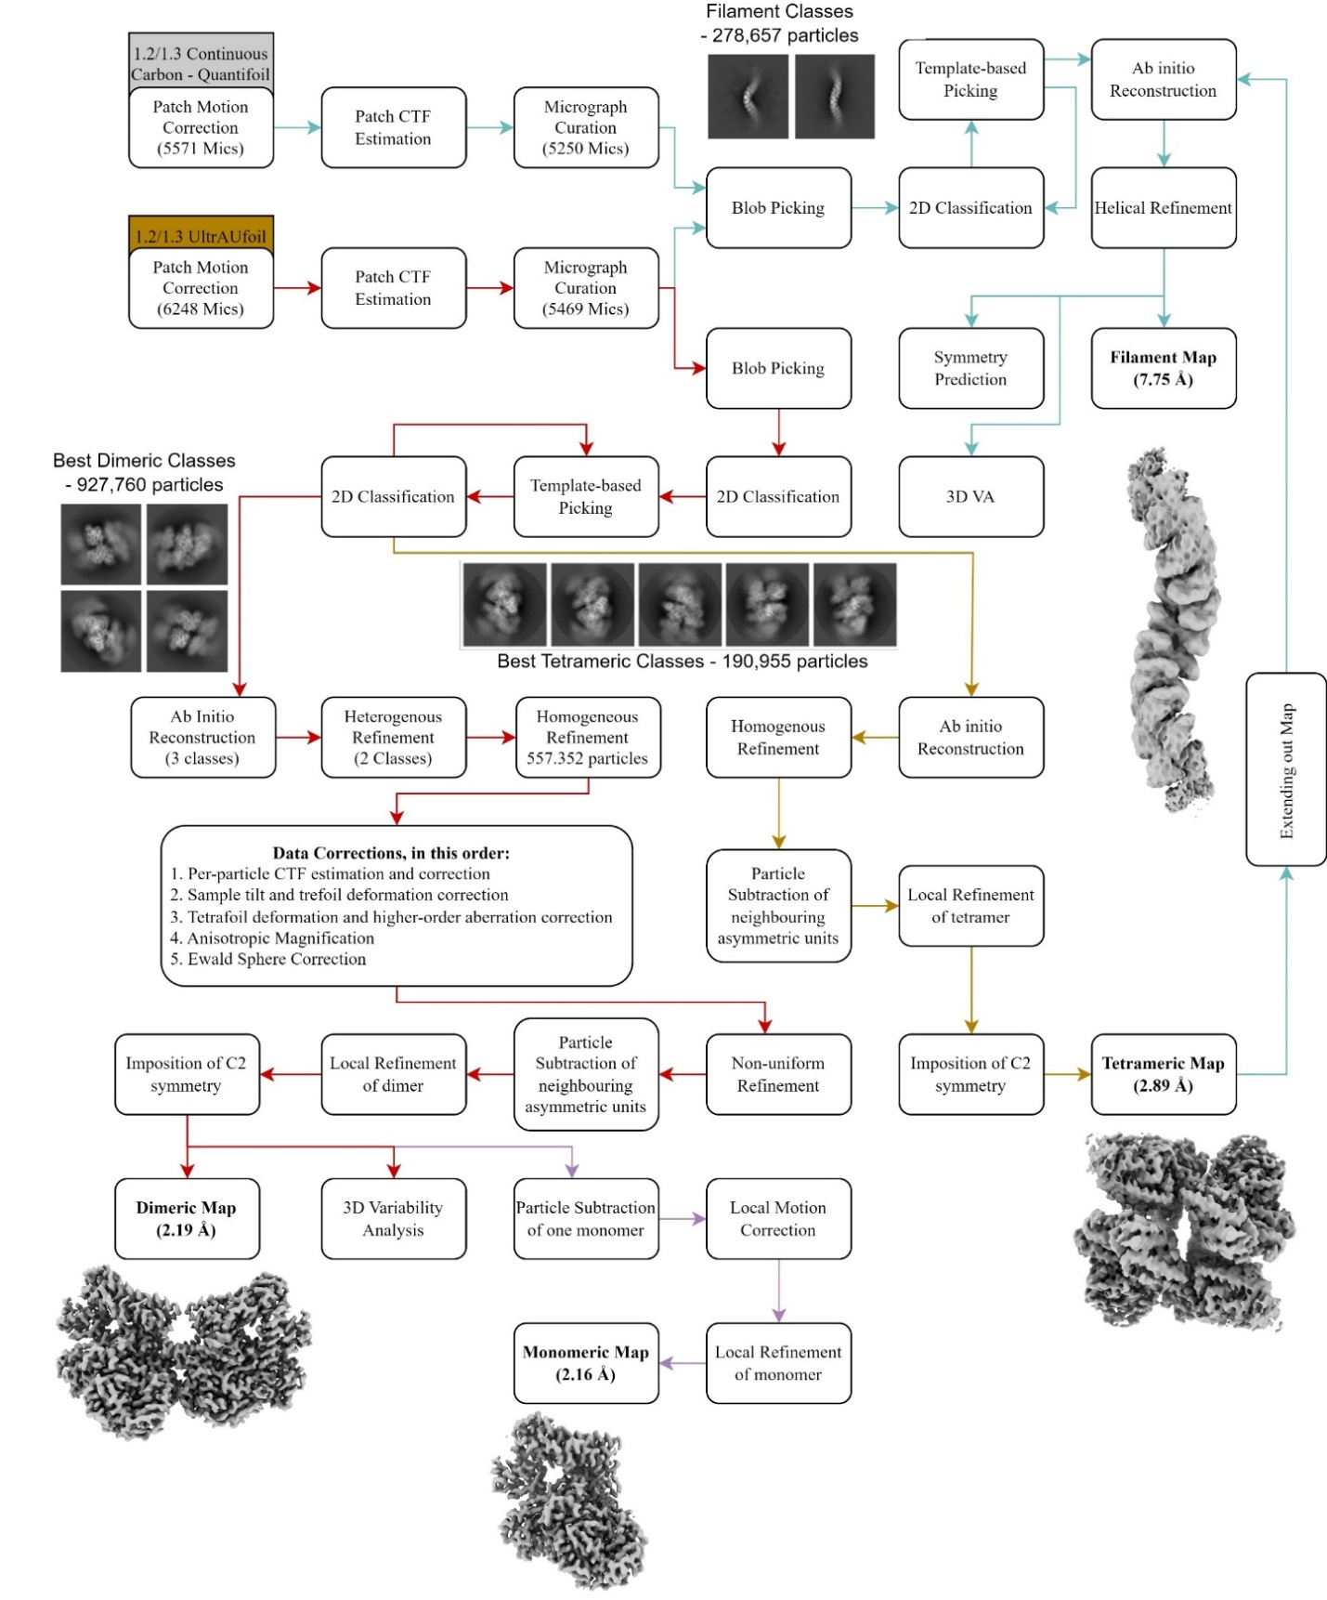
Extended Data 5: Processing workflow of BALF2 cryo-EM Data. In total, 2 datasets were collected and processed to render 4 different maps. The reported resolution by gold-standard FSC cutoff from CryoSPARC v4.0 is included near each map. A traditional single-molecule reconstruction approach was used to generate maps of the asymmetric unit of the filaments, by masking out neighbouring dimers. Both the dimeric and monomeric reconstructions were used to solve the structure of BALF2. The tetrameric map was used to generate a model for use in molecular dynamics simulations and was fed back into the processing pipeline to generate an initial model for helical reconstruction. Colours indicate processing pipelines for monomer (purple), dimer (red), tetramer (brown), and filament (cyan).

Extended Data 6: Fitting of DNA bases and uracil into position 3. Each nucleotide base was individually modelled in using ISOLDE and the existing density as a guide. The purines (a adenosine, b cytosine) fit into the site through the promiscuous architecture, namely S849 and the backbone atoms of V726, V727, F728, T729. The pyrimidines (c guanine, d thymine, e uracil) are additionally bound through a water molecule.

Extended Data 7: a) Structural homologues of BALF2, as determined by the DALI protein structure comparison server (Holm et al., 2023). Hits were generated using either the BALF2 N-terminal domain (*) or OB-fold (^) as the query structure. RMSD: root mean squared deviation in distance between Cα of query and search result. LALI: number of equivalent residues between query and search result. b) Overlay of the BALF2 OB-fold with the corresponding region from each relevant hit in the DALI search, showing the high structural likeness. PDB ID and colour key for each structure is provided. c) Comparison of the conformation of ssDNA (grey) in Enc34 SSB and BALF2, coloured as in b. Both structures are bound to ssDNA with all bases directed towards the protein, except for 3 bases at approximately the same point which are directed outward.
Extended Data 8: Molecular dynamics simulations of BALF2 monomer in absence and presence of a Zn²⁺ at the zinc binding site. a) The monomer backbone positional root-mean-square deviations (RMSD) from the initial structure along the simulation time and b) the Cα atom positional root-mean-square fluctuations (RMSF) in the absence (no_zn) and presence of Zn²⁺ bound to C453, C456, and C464 (zn). Increased flexibility at the zinc binding site region comprised of residues 440 to 472 (shaded in grey) is observed in absence of a Zn²⁺. For each system, RMSD and RMSF are averages of five independent simulations. c) The VolMap average water density at the zinc binding site showing the Zn²⁺ (blue) coordinated by the three Cys (C453, C456, and C464) and two water molecules (isovalue= 0.6). The average distance between the Zn²⁺ and the closer water molecule at the binding site from the five independent simulations = 1.9 ± 0.05 Å. The other water molecule that interacts with Y443 and T467 was exchangeable during the simulations. d) Radial distribution function between the Zn²⁺ and water molecules.
Extended Data 9: Molecular dynamics simulations of BALF2 tetramer. a) The tetramer four N-terminal domains (residues 8–983) backbone positional root-mean-square deviations (RMSD) from the initial structure along the simulation time. b) A monomer N-terminal domain (residues 8–983) backbone positional RMSD from the initial structure along the simulation time. c) The Cα atom positional root-mean-square fluctuations (RMSF) of a monomer N-terminal domain (residues 8–983). For each system, RMSD and RMSF are averages of five independent simulations. Region comprising loop 2 (residues 950–960) is shaded in grey.
Extended Data 10: Individual channels for FRET-based EMSA annealing assay. Cy5 = red; Cy3 = cyan; FRET = blue. a) Assay run in the presence of MgCl₂. b) Assay run in the absence of MgCl₂ and presence of EDTA.

